Supplementary information
Local timing of rainfall predicts the timing of moult within a single locality and the progress of moult among localities that vary in the onset of the wet season in a year-round breeding tropical songbird
Chima J. Nwaogu^{1,2,3,4*} and Will Cresswell^{2,3}
¹Groningen Institute for Evolutionary Life Sciences, University of Groningen, P.O. Box 11103, 9700 CC, Groningen, The Netherlands.
² School of Biology, University of St Andrews, Harold Mitchell Building, St Andrews Fife KY16 9TH, UK.
³ A.P. Leventis Ornithological Research Institute, Jos, Nigeria.
⁴Fitzpatrick Institute of African Ornithology, University of Cape Town, 7701, Rondebosch, Cape Town, South Africa.
*Corresponding author: c.j.nwaogu@rug.nl

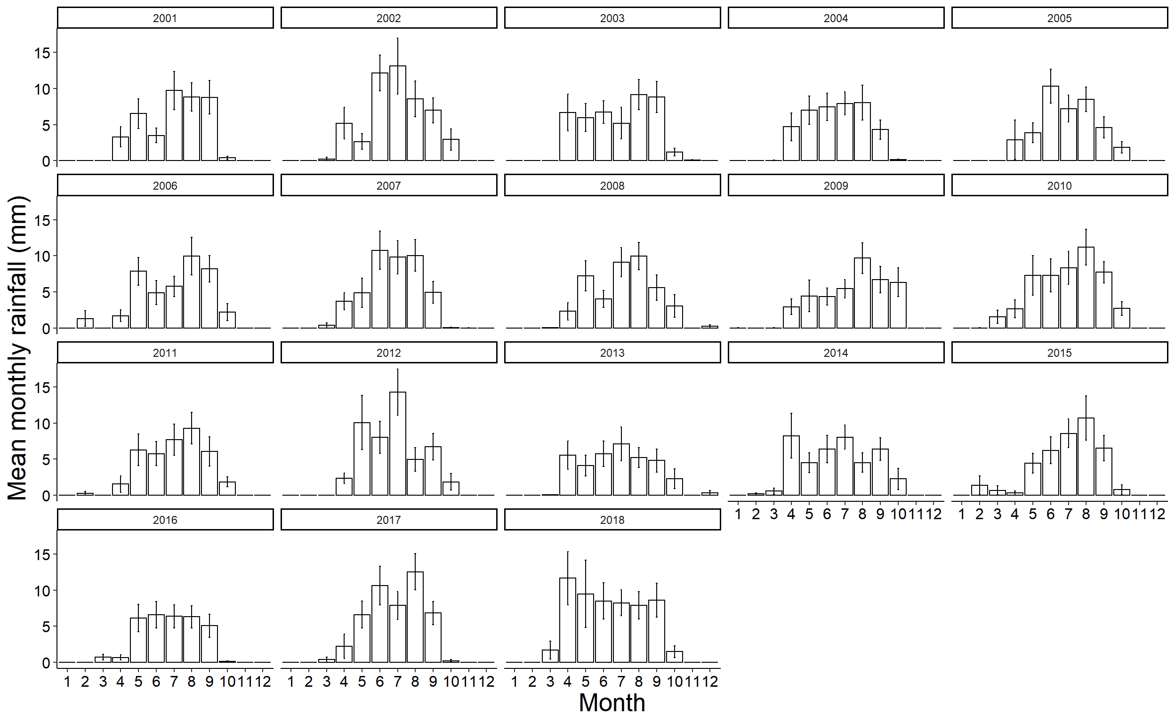
Figure S1: Seasonal rainfall pattern in Jos, north-central Nigeria between January 2001, and December 2018. Daily rainfall data was provided by the Nigerian Meteorological Agency at the Jos airport, located 26 km from the A. P. Leventis Ornithological Research institute where Common Bulbuls where studied. Rainfall is seasonal and predictable: the wet season is approximately six months, usually from mid-April and mid-October.
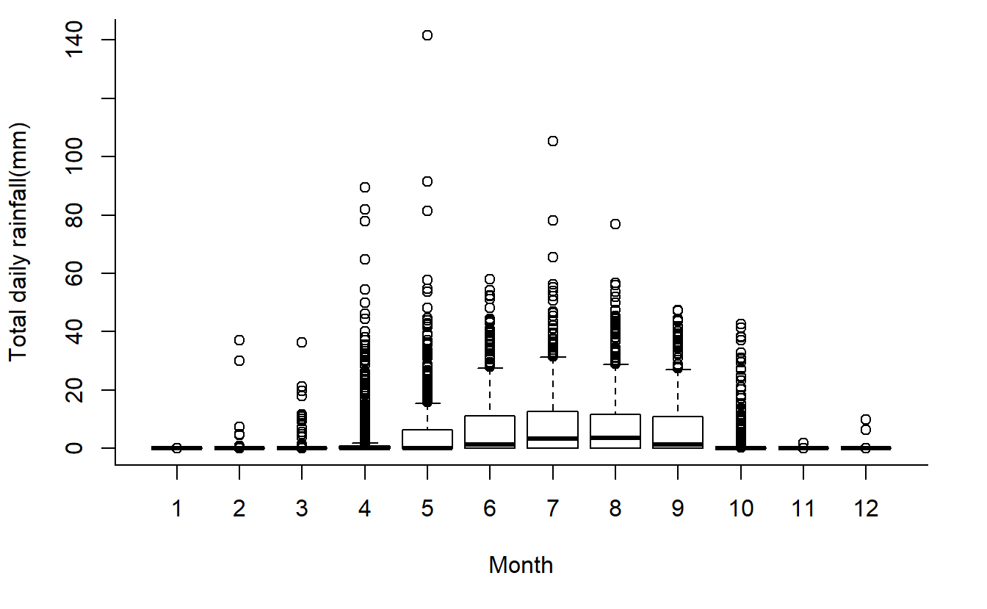 Figure S2: Daily rainfall across calendar Months in Jos, central Nigeria from 2000 to 2018. Data was provided by the Nigerian Meteorological Agency at the Jos airport, located 26 km from the A. P. Leventis Ornithological Research institute. The wet season is approximately six months, usually from mid-April and mid-October. Rain may occur, but rarely does, from November to March. Overall, April received 8.73% of the total rainfall recorded in Jos from 2000 to 2018.

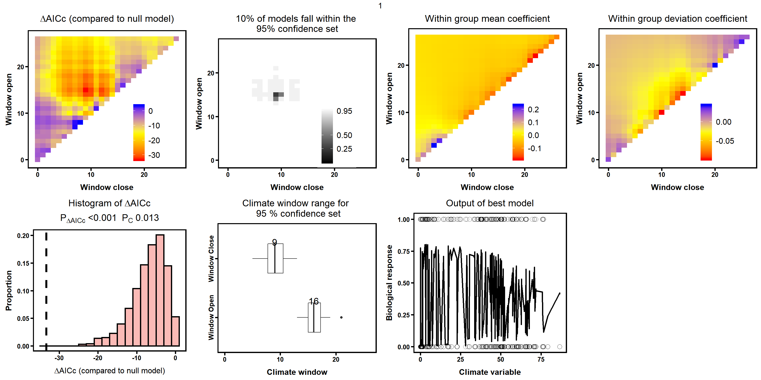

Figure S3: Output from Climwin package showing overall model performance and output for selecting the most relevant rainfall window explaining the occurrence of moult in the Common Bulbul population in Jos. Window open and window close refer to the number of weeks within which prior variation in total rainfall explains the occurrence of moult. The top left-most panel shows the landscape of AIC values for all models tested using climwin. The top second from left shows the percentage of models within the 95% confidence set (low percentages imply more specific signal). The two top rights show the slopes of each window for the within and the among-year effects of rainfall. The bottom left compares the delta AICs of 1000 models from randomised data to the AIC of the selected top model with the relevant rainfall effect. The bottom middle panel depicts the median window of the 95% confidence set. Finally, the bottom right depicts the fit of the best model, showing the linear relationship between total rainfall (climate) and occurrence of moult (biological variable). Note however, that the bottom right plot does not output a smoothed line due to a ‘bug’ associated with the presence of additional predictor variables (day and day² from February 1st) in the climwin model. Thus, the relationship between the likelihood of moult occurrence and day, within and among-year variation in rainfall are extracted and plotted separately in Figure 2.

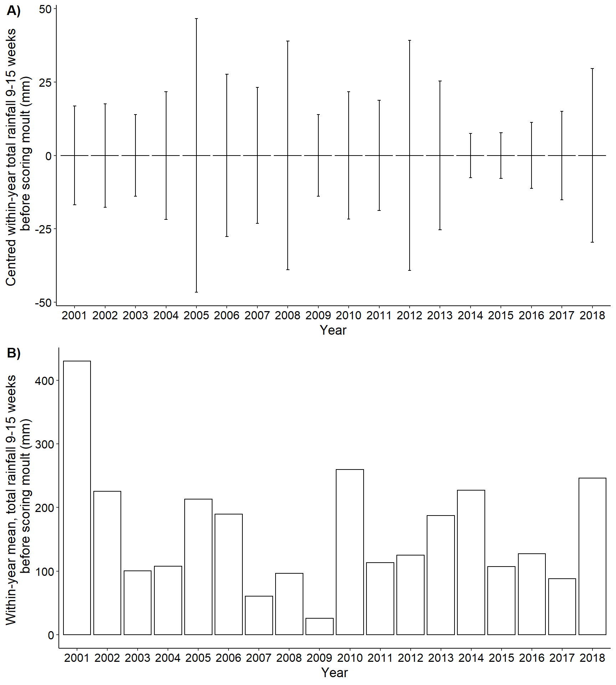
Figure S4: Variation within and among-year the rainfall predictors identified that predict the likelihood of finding a moulting Common Bulbul in Jos, Nigeria. A) Centred within-year variation in total rainfall 9-15 weeks before scoring moult in Jos. B) Within-year mean, total rainfall 9-15 weeks before scoring moult. Both parameters were extracted from the top climate envelope model predicting the effect of rainfall on the occurrence of moult in Common Bulbuls in Jos. We used relative time windows to test the effect of rainfall on the occurrence of moult, and relative time windows explain both within and among year effects of rainfall on the likelihood of moult occurrence. Thus, we applied within-subject centering to our models to separate the effect of the within from the among-year effects of rainfall.

