Supplement
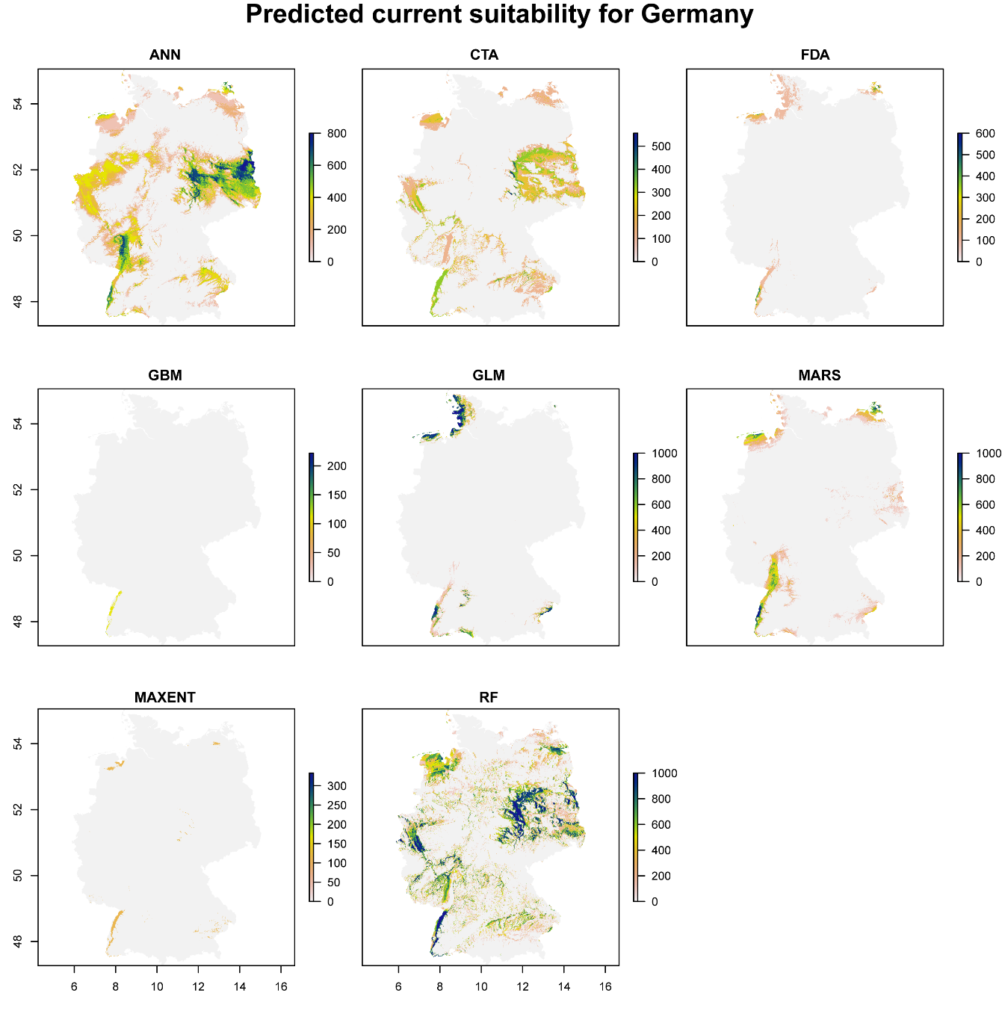
Figure S1: Current potential distribution of the European Bee-eater in Germany for eight different model algorithms.

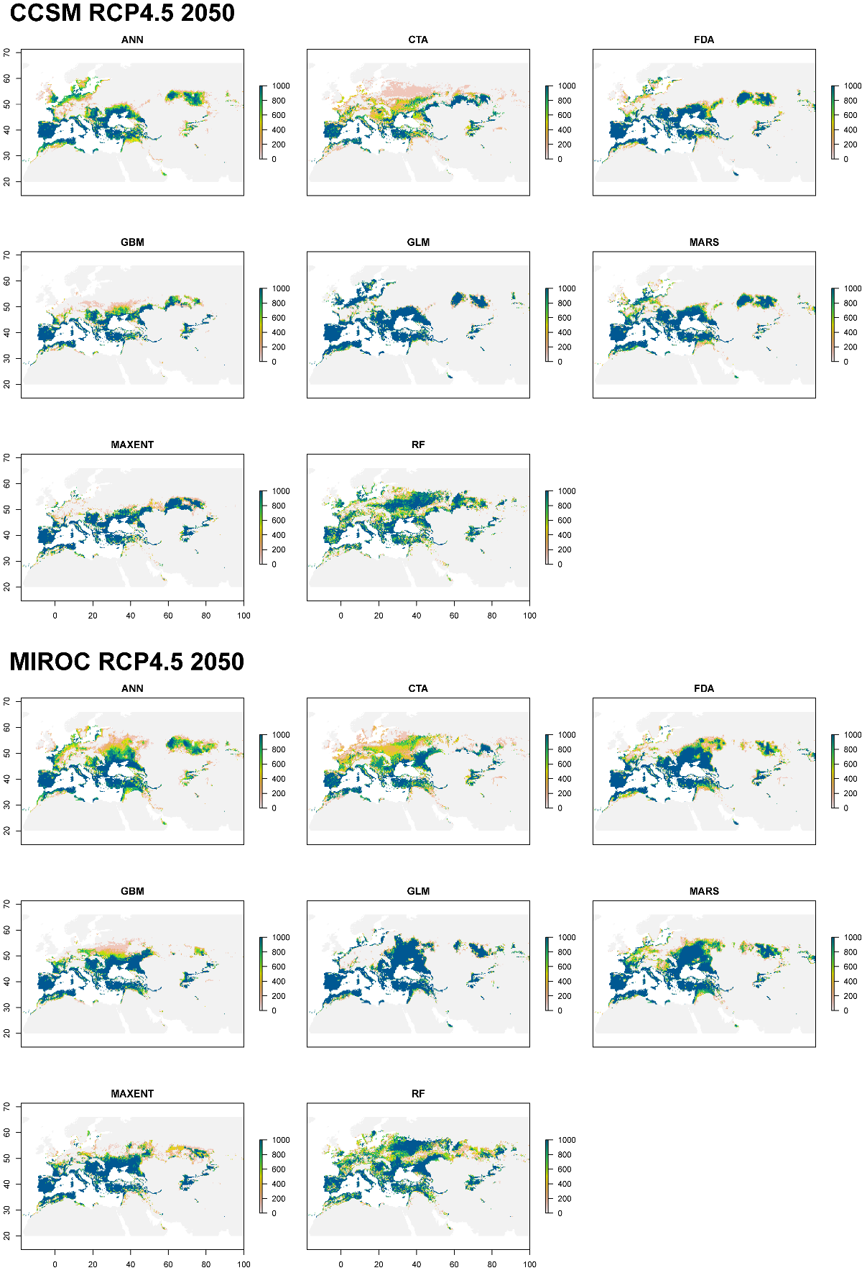
Figure S2: Future potential distribution for each model algorithm under the RCP4.5 scenario for two different GCMs - CCSM (top) and MIROC (bottom). Colours show standardised suitability values with green colours areas more suitable.

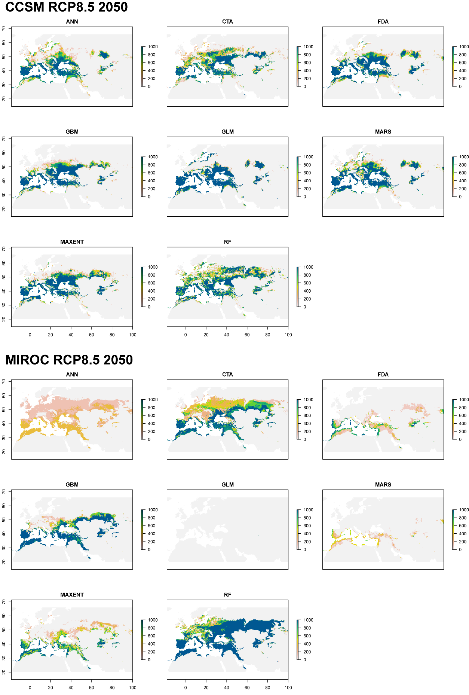
Figure S3: Future potential distribution for each model algorithm under the RCP8.5 scenario for two different GCMs - CCSM (top) and (a) MIROC (bottom). Colours show standardised suitability values with green colours areas more suitable.

