Supplementary information

The impact of Sosnowsky’s hogweed on feeding guilds of birds
Emilia Grzędzicka (0000-0002-3954-4895) ¹, Jiří Reif (0000-0003-2553-7333) ^{2,3}
¹ Institute of Systematics and Evolution of Animals, Polish Academy of Sciences, Sławkowska 17, 31-016 Kraków, Poland
² Institute for Environmental Studies, Faculty of Science, Charles University, Prague, Benatska 2, 128 01 Praha 2, Czech Republic
³ Department of Zoology and Laboratory of Ornithology, Faculty of Science, Palacky University in Olomouc, Olomouc, 17. listopadu 50, 77146 Olomouc, Czech Republic
corresponding addresses: grzedzicka@isez.pan.krakow.pl, jirireif@natur.cuni.cz

Table S1. Sosnowsky’s hogweed invasion characteristics that potentially change as weeds develop and the information on their effects on birds that was attempted by measuring each parameter
Variable | Description
Heracleum cover | informs whether the presence or absence of gaps between patches of hogweeds and the possible availability of other plants next to them affects the number of birds per site; lower cover corresponds to higher alien patchiness on site due to a lower competition between hogweeds per patch and their stronger spatial development connected also with wide edge effect of the patch; all of those phenomena may e.g. support the visibility of arthropods (Walker 2008)
Heracleum number | informs if more hogweeds per study site (density) affects the number of birds; a higher number of hogweeds creates dense thickets with a sharp edge of each patch on site providing gaps with native vegetation and low invasion patchiness potentially decreasing the access to arthropods on hogweeds (Osborne et al. 2012), not supporting also the visibility of arthropods due to competition and weaker leaf development of individual aliens in contrast to strongly developed hogweeds that provide higher coverage and insect visibility (Walker 2008)
Heracleum height | informs whether the highest hogweeds that stand out from others in the patch attract or distract the attention of birds; highest invasive plants can be physical barriers for aerial insects (Aravind et al. 2010) or aerial insects can avoid hogweeds due to their chemical properties (Jõgar et al. 2006) and thus may negatively affect birds catching food items in flight
Heracleum flowering number | informs what is the effect of the presence of flowering specimens on the abundance of birds from different feeding guilds
Table S2. Results of Kruskal-Wallis test showing no differences between two groups of sites (control, Heracleum) concerning their land cover characteristics measured in hectares using Google Maps
Variable | Control (Mean±SD) | Heracleum (Mean±SD) | Kruskal-Wallis test
Open area | 0.38±0.26 | 0.37±0.27 | χ²= 0.049, df = 1, P = 0.825
Bush/tree area | 0.33±0.23 | 0.34±0.24 | χ²= 0.099, df = 1, P = 0.752
Linear elements | 0.06±0.09 | 0.07±0.09 | χ²= 0.400, df = 1, P = 0.527
Built area | 0.01±0.02 | 0.01±0.01 | χ²= 0.275, df = 1, P = 0.600

Table S3. List of bird species with classification to bird feeding guilds; bird species not observed at Heracleum sites are marked with red font; species noted during third count with Sosnowsky’s hogweed during flowering period are bold; species noted only at Heracleum sites (not at control ones) is marked with blue font

Species | foraging habitat | feeding guilds
Phasianus colchicus | ground/ herb | granivore
Columba palumbus | trees | granivore
Streptopelia decaocto | ground/ herb | granivore
Cuculus canorus | trees | bush/tree insectivore
Crex crex | ground/ herb | ground/herb insectivore
Jynx torquilla | trees | bush/tree insectivore
Picus canus | trees | bush/tree insectivore
Picus viridis | trees | bush/tree insectivore
Dryocopus martius | trees | bush/tree insectivore
Dryobates minor | trees | bush/tree insectivore
Dendrocopos major | trees | bush/tree insectivore
Oriolus oriolus | trees | bush/tree insectivore
Garrulus glandarius | trees | omnivore
Pica pica | ground/ herb | omnivore
Corvus monedula | ground/ herb | omnivore
Corvus frugilegus | ground/ herb | omnivore
Corvus corax | ground/ herb | omnivore
Corvus cornix | ground/ herb | omnivore
Periparus ater | trees | bush/tree insectivore
Poecile palustris | trees | bush/tree insectivore
Cyanistes caeruleus | trees | bush/tree insectivore
Parus major | trees | bush/tree insectivore
Alauda arvensis | ground/ herb | ground/herb insectivore
Locustella naevia | ground/ herb | ground/herb insectivore
Hippolais icterina | bush | bush/tree insectivore
Acrocephalus scirpaceus | ground/ herb | ground/herb insectivore
Delichon urbicum | ground/ herb | ground/herb insectivore
Hirundo rustica | ground/ herb | ground/herb insectivore
Phylloscopus sibilatrix | trees* | bush/tree insectivore
Phylloscopus trochilus | bush | bush/tree insectivore
Phylloscopus collybita | bush | bush/tree insectivore
Aegithalos caudatus | bush | bush/tree insectivore
Sylvia atricapilla | trees* | bush/tree insectivore
Sylvia borin | bush | bush/tree insectivore
Sylvia nisoria | bush | bush/tree insectivore
Sylvia curruca | bush | bush/tree insectivore
Sylvia communis | bush | bush/tree insectivore
Sitta europaea | trees | bush/tree insectivore
Certhia familiaris | trees | bush/tree insectivore
Troglodytes troglodytes | ground/ herb | ground/herb insectivore
Sturnus vulgaris | ground/ herb | ground/herb insectivore
Muscicapa striata | trees | bush/tree insectivore
Erithacus rubecula | ground/ herb | ground/herb insectivore
Ficedula hypoleuca | trees | bush/tree insectivore
Ficedula albicollis | trees | bush/tree insectivore
Phoenicurus. phoenicurus | trees | bush/tree insectivore
Phoenicurus ochruros | ground/ herb | ground/herb insectivore
Saxicola rubetra | ground/ herb | ground/herb insectivore
Saxicola rubicola | ground/ herb | ground/herb insectivore
Turdus philomelos | ground/ herb | omnivore
Turdus merula | ground/ herb | omnivore
Turdus pilaris | ground/ herb ** | omnivore
Prunella modularis | ground/herb | ground/herb insectivore
Passer domesticus | ground/herb | omnivore
Passer montanus | ground/herb | omnivore
Anthus trivialis | ground/herb | ground/herb insectivore
Anthus pratensis | ground/herb | ground/herb insectivore
Motacilla flava | ground/herb | ground/herb insectivore
Motacilla cinerea | ground/herb | ground/herb insectivore
Motacilla alba | ground/herb | ground/herb insectivore
Fringilla coelebs | trees | bush/tree insectivore
Coccothraustes coccothraustes | bush | bush/tree insectivore
Erythrina erythrina | bush | bush/tree insectivore
Pyrrhula pyrrhula | bush | granivore
Chloris chloris | bush | granivore
Linaria cannabina | ground/herb | granivore
Carduelis carduelis | ground/herb | granivore
Serinus serinus | bush | granivore
Spinus spinus | bush | granivore
Emberiza calandra | ground/herb | omnivore
Emberiza citrinella | ground/herb | omnivore
Emberiza schoeniclus | ground/herb | omnivore

Note: * foraging above the nest location; ** foraging below the nest location

Table S4. Results of the CCA anova model concerning first two bird counts (before Sosnowsky’s hogweed flowering). Total variance in species distribution (inertia) for CCA summary model = 0.294
 | df | χ² | F | p-value
Heracleum cover  Heracleum number  Heracleum height | 1  1  1 | 0.068  0.079  0.147 | 0.965  1.135  2.097 | 0.533  0.297  0.002

Table S5. Results of the CCA anova model concerning bird counts during Sosnowsky’s hogweed flowering period. Total variance in species distribution (inertia) for CCA summary model = 0.547
 | df | χ² | F | p-value
Heracleum cover  Heracleum number  Heracleum height  Heracleum flowering number | 1  1  1  1 | 0.136  0.202  0.159  0.051 | 1.827  2.717  2.138  0.683 | 0.013  0.005  0.005  0.687

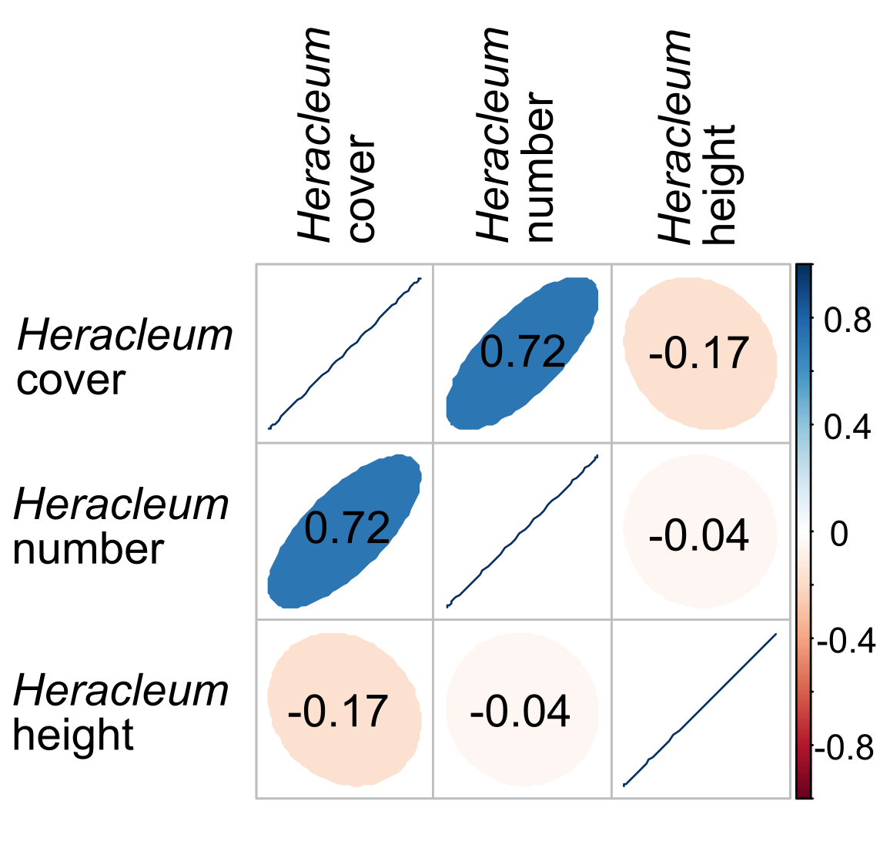
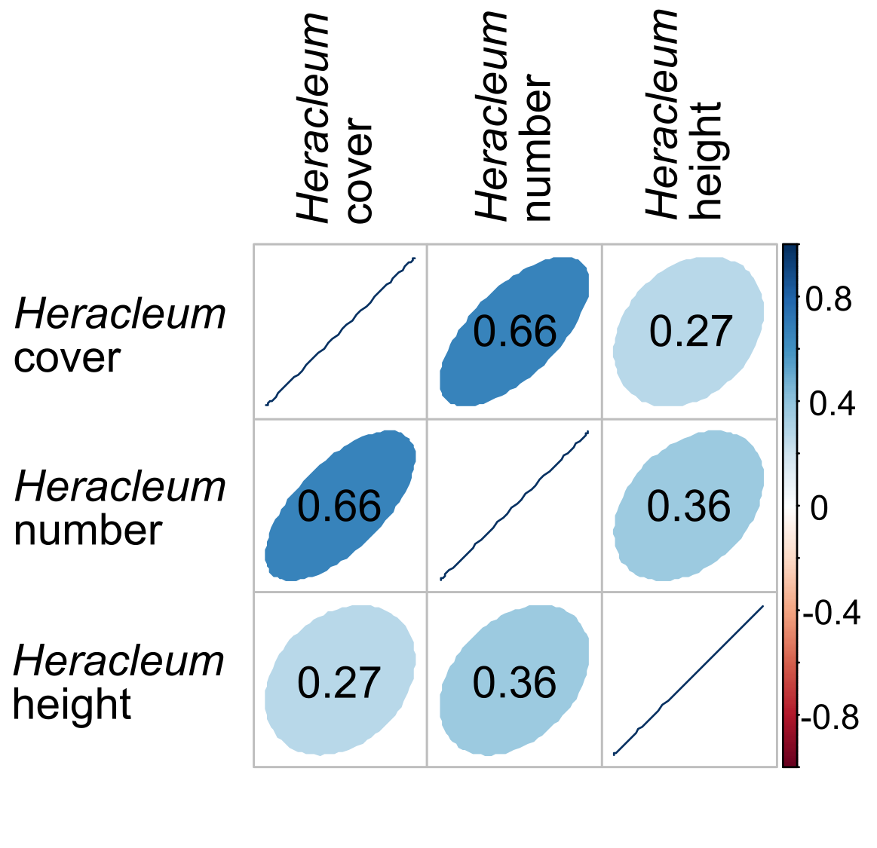
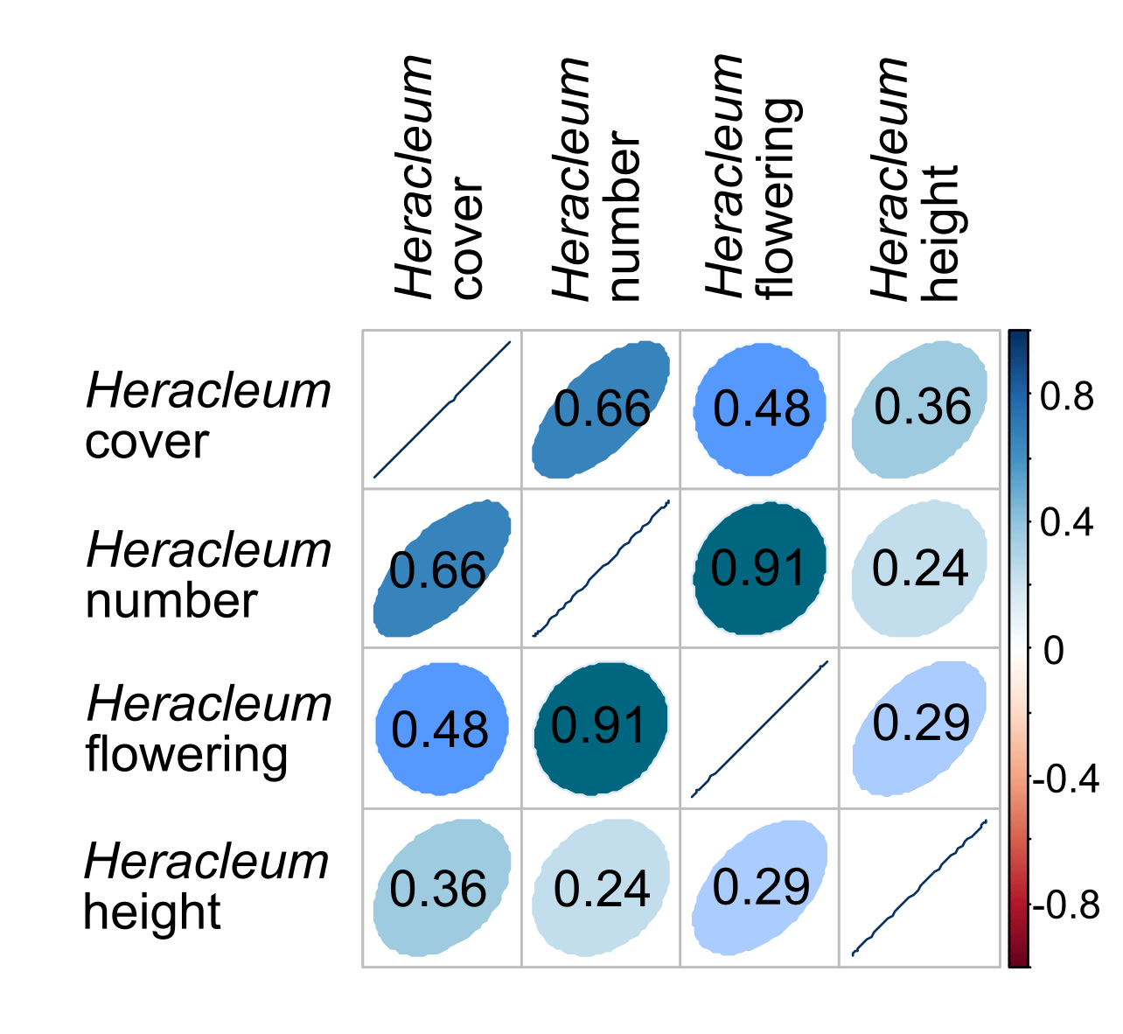
Fig. S1. Correlation coefficients between Sosnowsky’s hogweed characteristics noted during particular development stages of the invasion, calculated during the first, second and third counts (from top to bottom, respectively); note that Heracleum flowering = number of flowering hogweeds

