Supplementary Material
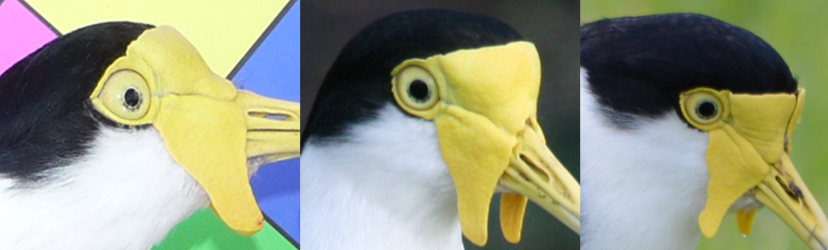
Supplementary Fig. 1. Images of right eye of a single male Masked Lapwing (flag, KW) showing change in heterochromia across an eight year period. The left standardised photograph was taken in 2010 (i.e. captured when incubating; 30/6/2010), the right two images were taken when the free-living individually marked bird was encountered (middle image, 5/8/2010, not long after capture). The rightmost photograph was taken in 2018 (20/6/2018). The bird was only captured once, it likely bred annually and remained on or near its territory year round (Cardilini et al. 2019).

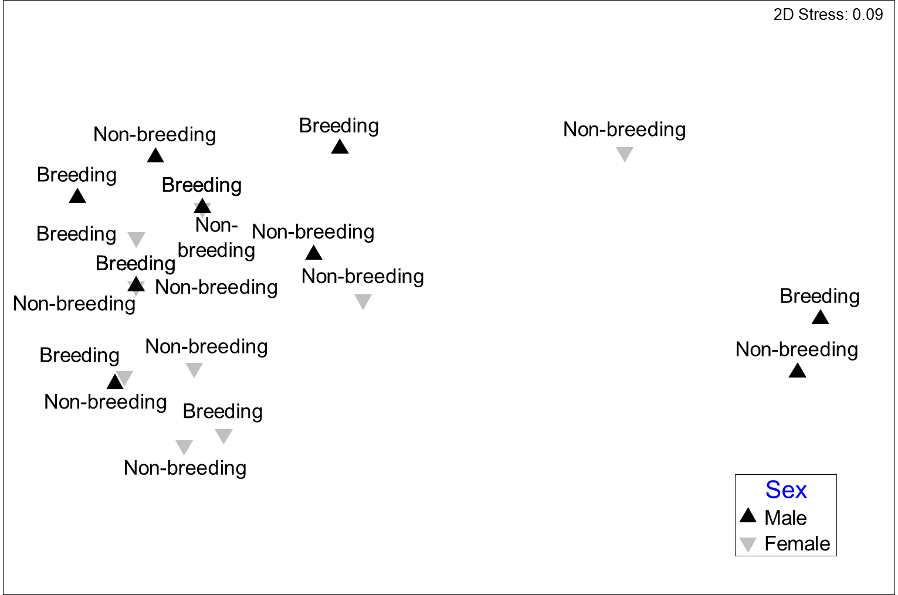
Supplementary Fig. 2. Analysis of stomach contents of 21 adult Masked Lapwing stomachs (33 invertebrate taxa; all samples from Phillip Island) revealed no difference in diet composition between sex (R = -0.119, p = 0.945) or breeding/non-breeding season (R = -0.126, p = 0.957; two-way Analysis of Similarity (ANOSIM) on zero-inflated Bray-Curtis resemblance matrix; nMDS plot shown). Stomachs were sourced from naturally and recently killed birds, sex was established by dissection.

