SUPPORTING INFORMATION
Assessing genetic diversity patterns at neutral and adaptive loci to inform population reinforcement of an endangered migratory vulture.

Table S1. Neutral and non-neutral loci amplified in this study and their properties. Fluorescent-labeled primers are in bold.
Locus | Primers (5'-3') | Repeat motifs | Tm | Product range | No of alleles | Modification | Multiplex
BV6 | F: AATCTGCATCCCAGTTCTGC | (CA)11 | 58 | 93-135 | 12 | FAM | 2
BV6 | R: CCGGAGACTCTCAGAACTTAAC
BV13 | F: AAAACAGAGTTTTCACATTTTCATAAG | (CA)16 | 50 | 169-177 | 5 | VIC | 1
BV13 | R: TTCAGGAAACAGAAGCATGAAC
BV14 | F: GGCAGTGTGGAGCCTACATC | (CA)16 | 55 | 159-161 | 2 | VIC | 2
BV14 | R: CTCCAGGGTCCTTGTTTGC
BV20 | F: GAACAGCACTGAACGTGAGC | (CA)13 | 55 | 132-138 | 4 | VIC | 1
BV20 | R: GTTTCTCCTGACAGTGAAATAACTC
Np51 | F: TTGCAATTACTGCGCTATCC | (GT)10 | 50 - 52 | 139-151 | 4 | FAM | 2
Np51 | R: GTGGATATTCGTGCCCACAT
Np163 | F: ACCATTCCTTAAGATTGAGAACAC | (GT)6TT(GT)8 | 53-55 | 216-232 | 5 | FAM | 2
Np163 | R: CATGCAGGACAGGAAAACAAATAG
Np166 | F: TGCAGTCAAACAGAGTAAAAGG | (CA)11 | 52-54 | 185-197 | 7 | VIC | 2
Np166 | R: CTAGCTCCACACTGAGACACAA
Np229 | F: AGGCACCTCACTGACACGTA | (CTAT)5CTAC(CTAT)4 | 53-55 | 163-183 | 6 | FAM | 2
Np229 | R: AACAAAAATCCCGTATCACGA
Np249 | F: TTTCCCCTTCCTTTCTCCAC | (GT)12 | 50-52 | 233-243 | 6 | FAM | 1
Np249 | R: CCGACAGGGAGAGACAAATC
Np257 | F: GATTGTCAGGGGTTGCTCAT | (TA)4(TG)8(TA)2 | 50-52 | 104-106 | 2 | FAM | 1
Np257 | R: CTAGCGCCATTTGTGAAGGT
Np259 | F: AAAATGAGTGAAAATAACAAGTAGC | (TG)10 | 50-52 | 121-129 | 4 | FAM | 1
Np259 | R: CTGGAAGAGGTCTGCATTAAAA
Np296 | F: CATACGCCTCTTCCTTCTGC | (GT)14 | 52-54 | 160-182 | 10 | FAM | 1
Np296 | R: CCATGGCCAGCTATTGATCT
ADCYAP1 | F: GATGTGAGTAACCAGCCACT | (CT)5TT(CT)12–16 | 51 | 152-158 | 4 | PET | 3
ADCYAP1 | R: ATAACACAGGAGCGGTGA
CLOCK | F: TTTTCTCAAGGTCAGCAGCTTGT | (CAA)2(CAG)5–9(CAA)1–2CAGCAA |  | 262 | 1 | FAM | 3
CLOCK | R: CTGTAGGAACTGTTGYGGKTGCTG
CREB1 | F: GGTCAGGCAGTTAAGATATTG | (CA)6–7CC(CA)3(CC)0–1((CA)3CC)0–1 (CA)2–9 TC/CC(CA)3 | 53 | 536-542 | 4 | FAM | 3
CREB1 | R: GTCTTACCAGTGGTTCCTTTAR
NPAS2 | F: CTGTGGTAAATTTGATGATTCTGA | CAG(CAA)0–1(CAG)4–7(CAA)0–1CAGCAACAG(CAA)2 | 55 | 163-166 | 2 | VIC | 3
NPAS2 | R: ACACCAAGTTCTTTGCACAATG

Table S2. Life history, demographic and management parameters used as input in AlleleRetain simulations for the Egyptian Vulture.
Input Parameter | Description | Value
Source population
q0 | Frequency of rare allele in the source population | 0.05
source N | Size of source population | Infinite
Starting population
startN | Number of starters | 100
startAge | Age class of starters and supplementals | "Adult"; "Juvenile"
startSR | Sex ratio (proportion male) of starters and supplementals. | 0.5
exactSSR | Whether startSR gives the exact sex ratio of individuals released (“TRUE”) or sexes are assigned randomly based on the probability given by startSR (“FALSE”). | FALSE
Translocated individuals
inisurv | Initial survival rate of starters and supplementals immediately post-release (separate from annual mortality). | 0.95; 0.68
addN | Numbers of individual (supplementals) to release | 0, 9
addyrs | Year in which to release supplementals | 1-20
addSR | Sex ratio of supplementals | 0.5
exactASR | Whether addSR gives the exact sex ratio of individuals released (TRUE) or sexes are assigned randomly based on the probability given by addSR (FALSE) | FALSE
Characteristics of the established population
K | Carrying capacity | 1000
Klag | Number of years for which population is held at or below initial size (breeding  still occurs) | 0
Kadults | TRUE (K = number of adults) or FALSE (K = total individuals, including subadults, nonbreeders, and helpers). | FALSE
reprolag | Number of years after establishment in which no breeding occurs | 0
Species life history traits
mature | Average age (in years) at sexual maturity (first breeding) | 6
matingSys | Mating system | monogamy
matingLength | Determines whether individuals retain the same  mate from year to year or divorce | lifelong
reproAgeM | List of ages at which males can breed | 6:21
MaxAge | Maximum allowable lifespan (in years) | 21
SenesAge | Age (in years) after which annual survival will be reduced by senescence. | 20
Expected demography of the new population
adsurvivalF | Annual survival rate of adult females. | 0.95
adsurvivalM | Annual survival rate of adult males. | 0.95
nonbrsurv | Annual survival rate of nonbreeders | 0.7
juvsurv | First year survival (from the stage described by youngperF, below, to the beginning of the next breeding season) | 0.32
youngperF | Average number of offspring produced per mating each year (averaged over  all females in the population) | 1.11
SDypF | Among-individual standard deviation of youngperF | 0.13
MAXypF | Maximum annual number of offspring per individual | 2
youngSR | Proportion of offspring that are male. | 0.5
Simulation specifications
trackall | Whether to track all individuals from the population through the simulation | FALSE
GeneCount | Which individuals should be included (“all”, or only breeding “adults”) when the number of rare alleles is counted in the population each year. | "Adult"
nyears | Number of years to run the simulation. | 20
nrepl | Number of replicates to run. | 1000

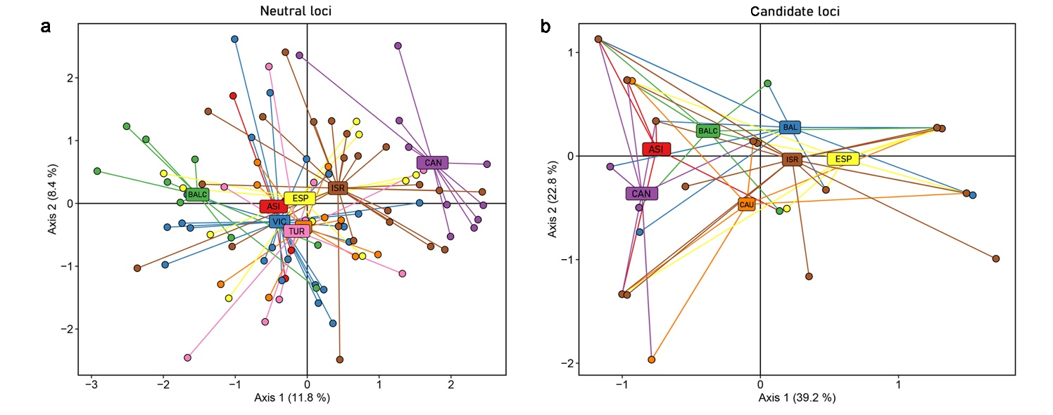
Figure S1: PCA clustering results for individual Egyptian Vultures both the neutral (a) and the non-neutral (b) dataset.

Table S3. Summarizing Evanno table for all assumed putative clusters (K) across 10 replicates based on the neutral dataset.
K | Reps | Mean LnP(K) | Stdev LnP(K) | Ln'(K) | |Ln''(K)| | Delta K
1 | 10 | -2615.9 | 0.2211 | NA | NA | NA
2 | 10 | -2574.35 | 2.5065 | 41.55 | 89.74 | 35.80224
3 | 10 | -2622.54 | 35.3991 | -48.19 | 34.75 | 0.981663
4 | 10 | -2635.98 | 26.4053 | -13.44 | 14.93 | 0.565418
5 | 10 | -2634.49 | 44.0151 | 1.49 | 4 | 0.090878
6 | 10 | -2637 | 39.879 | -2.51 | 5.54 | 0.13892
7 | 10 | -2645.05 | 16.2438 | -8.05 | 28.87 | 1.777295
8 | 10 | -2624.23 | 13.9108 | 20.82 | 44.66 | 3.210448
9 | 10 | -2648.07 | 21.8426 | -23.84 | NA | NA

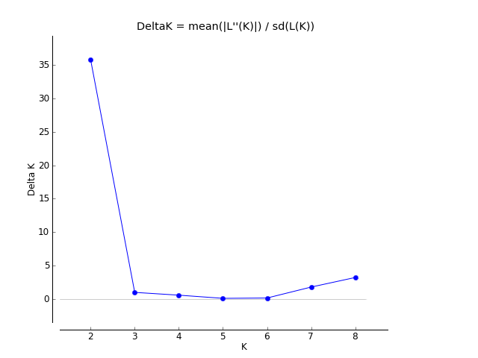

Figure S2: Summary of the clustering result from the Bayesian analysis of population structure implemented in STRUCTURE software, based on the neutral loci dataset of all populations. ΔK-values for several numbers of putative clusters (K) suggest K = 2 as the most likely structure.
Table S4. Summarizing Evanno table for all assumed putative clusters (K) across 10 replicates based on the non-neutral dataset.
K | Reps | Mean LnP(K) | Stdev LnP(K) | Ln'(K) | |Ln''(K)| | Delta K
1 | 10 | -332.56 | 0.6257 | NA | NA | NA
2 | 10 | -323.08 | 15.6779 | 9.48 | 111.49 | 7.111273
3 | 10 | -425.09 | 64.2728 | -102.01 | 61.94 | 0.963705
4 | 10 | -465.16 | 97.1354 | -40.07 | 113.51 | 1.168575
5 | 10 | -391.72 | 68.7637 | 73.44 | 43.89 | 0.638273
6 | 10 | -362.17 | 28.495 | 29.55 | 1.88 | 0.065977
7 | 10 | -334.5 | 4.0483 | 27.67 | 27.6 | 6.817644
8 | 10 | -334.43 | 2.2141 | 0.07 | NA | NA

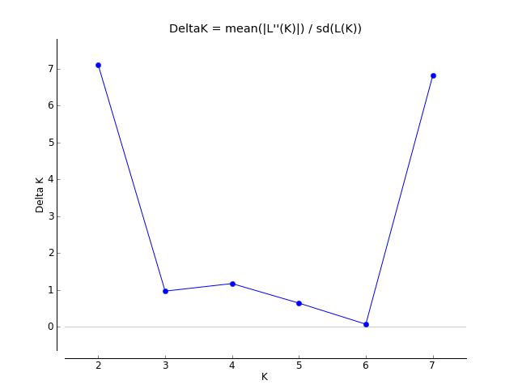

Figure S3: Summary of the clustering result from the Bayesian analysis of population structure implemented in STRUCTURE software, based on the non-neutral loci dataset of all populations. ΔK-values for several numbers of putative clusters (K) suggest K = 2 as the most likely structure.

Table S5. Pairwise Fst values (below diagonal) and Jost's D values (above diagonal) among Egyptian Vulture populations calculated based on the neutral dataset (12 microsatellite loci). Significant Fst values after calculation of 95% Confidence Intervals (using 1000 bootstrap iterations) are given in bold.

 | CAN | ESP | BAL | BALC | TUR | ISR | CAU | ASI
CAN | * | 0.068 | 0.112 | 0.228 | 0.105 | 0.047 | 0.114 | 0.140
ESP | 0.0703 | * | 0.002 | 0.059 | 0.026 | 0.002 | 0.032 | 0.061
BAL | 0.1007 | 0.0002 | * | 0.029 | 0.009 | 0.017 | 0.000 | 0.008
BALC | 0.1989 | 0.0416 | 0.0230 | * | 0.073 | 0.096 | 0.069 | 0.095
TUR | 0.1065 | 0.0156 | 0.0073 | 0.0541 | * | 0.035 | 0.013 | 0.054
ISR | 0.0433 | 0.0000 | 0.0126 | 0.0680 | 0.0252 | * | 0.022 | 0.048
CAU | 0.1134 | 0.0228 | 0.0016 | 0.0514 | 0.0109 | 0.0158 | * | 0.005
ASI | 0.1492 | 0.0359 | 0.0070 | 0.0652 | 0.0359 | 0.0320 | 0.0033 | *

Table S6. Pairwise Fst values (below diagonal) and Jost's D values (above diagonal) among Egyptian Vulture populations calculated based on the non-neutral dataset (4 candidate genes). Significant Fst values after calculation of 95% Confidence Intervals (using 1000 bootstrap iterations) are given in bold.
 | CAN | ESP | BAL | BALC | ISR | CAU | ASI
CAN | * | 0.1086 | 0.0637 | 0.0139 | 0.0588 | 0.0097 | 0.0000
ESP | 0.2557 | * | 0.0070 | 0.0417 | 0.0015 | 0.0319 | 0.0721
BAL | 0.1881 | 0.0156 | * | 0.0066 | 0.0008 | 0.0304 | 0.0254
BALC | 0.0380 | 0.1095 | 0.0171 | * | 0.0143 | 0.0173 | 0.0000
ISR | 0.1267 | 0.0000 | 0.0000 | 0.0197 | * | 0.0149 | 0.0307
CAU | 0.0044 | 0.0627 | 0.0821 | 0.0303 | 0.0102 | * | 0.0000
ASI | 0.0000 | 0.1684 | 0.0730 | 0.0000 | 0.0438 | 0.0000 | *

