Electronic Supplementary Material
Adamík P*, Wong JB, Hahn S, Krištín S Non-breeding sites, loop migration and flight activity patterns over the annual cycle in the Lesser Grey Shrike Lanius minor from a north-western edge of its range. J Orn.
*Correspondence author. E-mail: peter.adamik@upol.cz

Table S1 Ringing recoveries of Lesser Grey Shrike over 100 km. Variable names follow the EURING Exchange code 2000. EURING – The European Union for Bird Ringing (2010). The EURING Exchange Code 2000+. Thetford, U.K. ISBN 978-1-9085581-51-8

Table S2 Median calibration parameters used for individual 22UL in SGAT.
Zenith angle for zero deviation (deg) | 95.775
Most frequent median deviation (deg) | 91.018
Log mean shape (error distribution parameter) | 2.451
Log standard deviation rate (error distribution parameter) | 0.066

Table S3 Parameters used for individual 16KN in GeoPressureR. Explanations for each parameter can be found here: https://github.com/Rafnuss/GeoPressureTemplate/blob/main/README.md
thr_dur | 48
extent_N | 50
extent_W | 10
extent_S | -40
extent_E | 50
map_scale | 5
map_max_sample | 300
map_margin | 30
prob_map_s | 1
prob_map_thr | 0.9
shift_k | 0
calib_lon | 19.509
calib_lat | 48.5877
calib_1_start | 6/20/17
calib_1_end | 8/22/17
prob_light_w | 0.1
thr_prob_percent | 0.9
thr_gs | 120

Fig. S1 Changes in ambient air pressure values for the bird 16KN during a period when crossing the sea and the Sahara Desert.
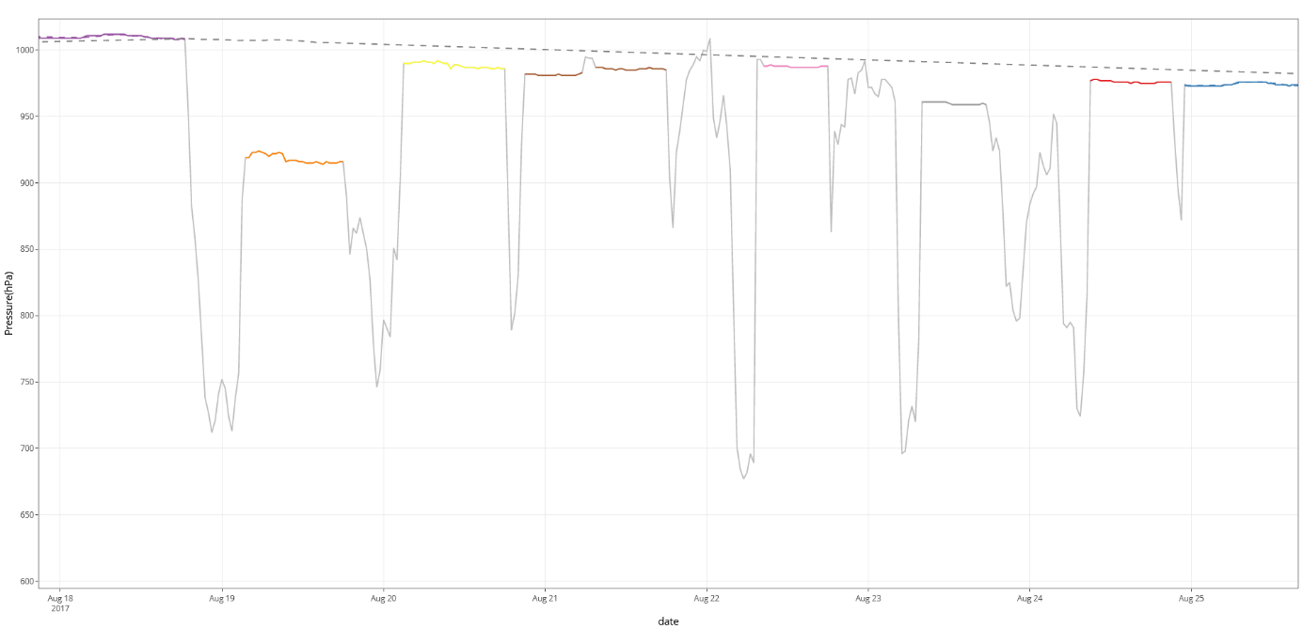

Fig. S2 Altitude estimates at 30 min intervals over the annual cycle in the Lesser Grey Shrike (bird 16KN).

