Electronic Supplementary Material

Long-term trends of local bird populations based on monitoring schemes: are they suitable for justifying management measures?

Antonio J. Hernández-Navarro¹, Francisco Robledano¹, María V. Jiménez-Franco^{2,3*}, J. Andrew Royle⁴ & José F. Calvo¹.

¹Departamento de Ecología e Hidrología, Facultad de Biología, Universidad de Murcia, 30100 Murcia, Spain
²Departamento de Biología Aplicada, Universidad Miguel Hernández, 03202 Elche, Spain
³Centro de Investigación e Innovación Agroalimentaria y Agroambiental (CIAGRO-UMH), Universidad Miguel Hernández, Elche, Spain.
⁴U.S. Geological Survey Eastern Ecological Science Center, Laurel, MD 20708, USA

*Corresponding author: María V. Jiménez-Franco, maria.jimenezf@umh.es

USGS standard product disclaimer: Any use of trade, product, or firm names is for descriptive purposes only and does not imply endorsement by the U.S. Government.
Table S1. Spanish and European population trends, phenological status in the study area, functional group, main habitat type and species specialization index (SSI) for the bird species studied.
Species | Spanish trend¹ | European trend² | Status³ | Functional group³ | Habitat³ | SSI⁴
Aegithalos caudatus | -1.2 | -4 | Resident | Insectivore | Forest | 2.663
Alectoris rufa | -1.3 | -44 | Resident | Granivore | Open | 6.892
Athene noctua | -4.5 | – | Resident | Insectivore | Forest | 2.897
Burhinus oedicnemus | 0.1 | -36 | Resident | Insectivore | Open | 3.196
Carduelis carduelis | -1.4 | 9 | Resident | Granivore | Forest | 3.221
Cecropis daurica | 1.1 | 54 | Migrant | Insectivore | Anthropic | 2.663
Chloris chloris | 1.8 | -10 | Resident | Granivore | Forest | 2.663
Columba livia | 0.3 | – | Resident | Granivore | Rocky | 6.892
Columba palumbus | 2.1 | 13 | Resident | Granivore | Forest | 2.626
Corvus monedula | -5.3 | 8 | Resident | Omnivore | Rocky | 2.975
Coturnix coturnix | -1.7 | – | Migrant | Omnivore | Open | 4.220
Cuculus canorus | 1.2 | -8 | Migrant | Insectivore | Forest | 1.833
Delichon urbicum | 1.0 | 3 | Migrant | Insectivore | Anthropic | 2.663
Emberiza calandra | -0.4 | -10 | Resident | Granivore | Open | 2.663
Emberiza cia | 0.0 | -8 | Resident | Granivore | Open | 2.989
Emberiza cirlus | -1.7 | 22 | Resident | Granivore | Forest | 2.807
Erithacus rubecula | 0.8 | 6 | Resident | Insectivore | Forest | 2.477
Falco tinnunculus | -2.1 | -16 | Resident | Carnivore | Open | 2.418
Fringilla coelebs | 3.2 | 2 | Resident | Omnivore | Forest | 2.770
Galerida cristata | -1.2 | 0 | Resident | Omnivore | Open | 2.663
Galerida theklae | 2.2 | 43 | Resident | Omnivore | Open | 3.661
Hippolais polyglotta | 2.5 | 0 | Migrant | Insectivore | Scrubland | 3.172
Hirundo rustica | -0.8 | 1 | Migrant | Insectivore | Anthropic | 3.286
Lanius meridionalis | -7.2 | – | Resident | Insectivore | Open | 2.984
Lanius senator | -1.6 | 5 | Migrant | Insectivore | Open | 2.584
Linaria cannabina | -1.1 | 38 | Resident | Granivore | Open | 2.663
Lophophanes cristatus | -0.1 | 0 | Resident | Omnivore | Forest | 2.663
Loxia curvirostra | 4.2 | – | Resident | Granivore | Forest | 7.031
Luscinia megarhynchos | 2.1 | 3 | Migrant | Insectivore | Forest | 2.575
Merops apiaster | -0.4 | 16 | Migrant | Insectivore | Rocky | 3.315
Monticola solitarius | -4.9 | – | Resident | Insectivore | Rocky | 4.358
Motacilla alba | -3.0 | -7 | Resident | Insectivore | Anthropic | 2.487
Muscicapa striata | -1.2 | -2 | Migrant | Insectivore | Forest | 2.303
Oenanthe hispanica | -2.0 | -20 | Migrant | Insectivore | Open | 2.663
Oenanthe leucura | -6.7 | – | Resident | Insectivore | Rocky | 2.663
Oriolus oriolus | 3.7 | -6 | Migrant | Insectivore | Forest | 2.514
Parus major | 1.2 | 13 | Resident | Insectivore | Forest | 2.436
Passer domesticus | -1.2 | -5 | Resident | Omnivore | Anthropic | 2.302
Periparus ater | 1.7 | 8 | Resident | Insectivore | Forest | 2.663
Petronia petronia | 1.3 | 37 | Resident | Granivore | Open | 4.368
Pica pica | -1.1 | 3 | Resident | Omnivore | Forest | 2.611
Picus sharpei | -2.6 | – | Resident | Insectivore | Forest | 2.663
Ptyonoprogne rupestris | 0.0 | 22 | Resident | Insectivore | Rocky | 5.622
Pyrrhocorax pyrrhocorax | 1.4 | 34 | Resident | Insectivore | Rocky | 3.584
Saxicola rubicola | -4.0 | 13 | Resident | Insectivore | Scrubland | 2.663
Serinus serinus | -1.7 | 0 | Resident | Granivore | Forest | 2.419
Streptopelia decaocto | 15.3 | 21 | Resident | Granivore | Anthropic | 2.686
Streptopelia turtur | -1.8 | -17 | Migrant | Granivore | Forest | 2.473
Sturnus unicolor | 1.2 | -8 | Resident | Omnivore | Anthropic | 3.055
Sylvia atricapilla | 4.0 | 21 | Resident | Omnivore | Forest | 2.641
Sylvia hortensis | 6.8 | 84 | Migrant | Insectivore | Forest | 3.456
Sylvia melanocephala | -0.3 | 7 | Resident | Insectivore | Scrubland | 2.871
Sylvia undata | -4.6 | -15 | Resident | Insectivore | Scrubland | 4.344
Tachymarptis melba | – | – | Migrant | Insectivore | Rocky | 2.663
Troglodytes troglodytes | 0.8 | 1 | Resident | Insectivore | Scrubland | 2.155
Turdus merula | 1.2 | 14 | Resident | Omnivore | Forest | 2.234
Turdus viscivorus | 0.7 | 10 | Resident | Omnivore | Forest | 3.143
Upupa epops | -0.7 | 9 | Resident | Insectivore | Forest | 2.555
¹ Average yearly change in %, from 1998 to 2011 (in %). Source: Carrascal & del Moral 2020.
² Ten-year percent population change (2008-2017). Source: PanEuropean Common Bird Monitoring Scheme (EBCC/BirdLife/RSPB/CSO, 2019).
³ Species characteristics. Source: https://seo.org/listado-aves-2/
⁴ Species specialization index. Source: Le Viol et al. 2012. Note that anthropic habitat means habitat used by human (urban areas, houses, etc.).

Table S2. Best models of population trend analyses for bird species in both study areas La Muela and Carracoy (southeastern Spain) surveyed during 21 and 15 years, respectively as part of the Spanish national monitoring programme for common breeding bird species (SACRE). Dynamics refers to the population dynamics model type (see the Methods section for details); mixture refers to the selected latent abundance distribution (Poisson or zero-inflated Poisson. ZIP); and detectability refers to models estimating constant or survey-dependent detection probabilities. A total of 46 and 49 species were modelled for La Muela and Carrascoy, respectively. Note that species that were not observed or modelled in one study area are shown with dashes.
 | La Muela |  |  | Carrascoy
Species | Dynamics | Mixture | Detectability | Dynamics | Mixture | Detectability
Aegithalos caudatus | Ricker | Poisson | Survey-dependent | Trend | ZIP | Survey-dependent
Alectoris rufa | Ricker | Poisson | Survey-dependent | Trend | ZIP | Survey-dependent
Athene noctua | Trend | ZIP | Survey-dependent | Constant | ZIP | Constant
Burhinus oedicnemus | No-trend | ZIP | Constant | Trend | Poisson | Constant
Carduelis carduelis | Trend | Poisson | Survey-dependent | Trend | Poisson | Constant
Cecropis daurica | Gompertz | Poisson | Survey-dependent | Trend | ZIP | Survey-dependent
Chloris chloris | Trend | Poisson | Constant | Trend | Poisson | Constant
Columba livia | Trend | Poisson | Survey-dependent | – | – | –
Columba palumbus | Trend | ZIP | Survey-dependent | Gompertz | Poisson | Constant
Corvus monedula | Constant | ZIP | Survey-dependent | Ricker | ZIP | Survey-dependent
Coturnix coturnix | – | – | – | Ricker | Poisson | Survey-dependent
Cuculus canorus | Trend | Poisson | Survey-dependent | Constant | Poisson | Survey-dependent
Delichon urbicum | – | – | – | Ricker | Poisson | Constant
Emberiza calandra | Trend | ZIP | Survey-dependent | Trend | ZIP | Survey-dependent
Emberiza cia | Gompertz | Poisson | Constant | Trend | ZIP | Constant
Emberiza cirlus | Gompertz | Poisson | Survey-dependent | – | – | –
Erithacus rubecula | – | – | – | Trend | Poisson | Survey-dependent
Falco tinnunculus | – | – | – | No-trend | Poisson | Constant
Fringilla coelebs | Trend | Poisson | Constant | Gompertz | ZIP | Survey-dependent
Galerida cristata | Trend | ZIP | Survey-dependent | Gompertz | Poisson | Survey-dependent
Galerida theklae | Trend | ZIP | Constant | Gompertz | ZIP | Survey-dependent
Hippolais polyglotta | Constant | ZIP | Survey-dependent | Gompertz | Poisson | Constant
Hirundo rustica | Trend | ZIP | Survey-dependent | Trend | ZIP | Survey-dependent
Lanius meridionalis | Ricker | ZIP | Constant | No-trend | ZIP | Constant
Lanius senator | Ricker | Poisson | Constant | Trend | ZIP | Constant
Linaria cannabina | Gompertz | Poisson | Constant | Trend | ZIP | Survey-dependent
Lophophanes cristatus | – | – | – | Ricker | Poisson | Constant
Loxia curvirostra | – | – | – | Trend | Poisson | Survey-dependent
Luscinia megarhynchos | Gompertz | Poisson | Survey-dependent | Constant | ZIP | Survey-dependent
Merops apiaster | Ricker | Poisson | Survey-dependent | Trend | ZIP | Constant
Monticola solitarius | Trend | Poisson | Constant | – | – | –
Motacilla alba | Trend | Poisson | Survey-dependent | Trend | ZIP | Constant
Muscicapa striata | Trend | Poisson | Survey-dependent | Trend | ZIP | Survey-dependent
Oenanthe hispanica | Trend | ZIP | Survey-dependent | – | – | –
Oenanthe leucura | Trend | Poisson | Constant | Trend | Poisson | Constant
Oriolus oriolus | Constant | ZIP | Survey-dependent | Constant | Poisson | Constant
Parus major | Constant | ZIP | Survey-dependent | No-trend | ZIP | Survey-dependent
Passer domesticus | Trend | ZIP | Survey-dependent | Trend | ZIP | Survey-dependent
Periparus ater | – | – | – | No-trend | ZIP | Constant
Petronia petronia | Gompertz | Poisson | Survey-dependent | – | – | –
Pica pica | – | – | – | Trend | Poisson | Survey-dependent
Picus sharpei | Constant | ZIP | Constant | No-trend | Poisson | Constant
Ptyonoprogne rupestris | Trend | ZIP | Constant | – | – | –
Pyrrhocorax pyrrhocorax | Gompertz | Poisson | Constant | – | – | –
Saxicola rubicola | Trend | Poisson | Survey-dependent | – | – | –
Serinus serinus | Trend | Poisson | Survey-dependent | Gompertz | Poisson | Survey-dependent
Streptopelia decaocto | Trend | Poisson | Constant | Trend | ZIP | Constant
Streptopelia turtur | Gompertz | ZIP | Survey-dependent | Trend | ZIP | Survey-dependent
Sturnus unicolor | Trend | ZIP | Survey-dependent | Trend | ZIP | Survey-dependent
Sylvia atricapilla | – | – | – | Trend | Poisson | Constant
Sylvia hortensis | – | – | – | No-trend | Poisson | Constant
Sylvia melanocephala | Constant | ZIP | Constant | Auto-regressive | Poisson | Survey-dependent
Sylvia undata | Gompertz | Poisson | Constant | Trend | Poisson | Constant
Tachymarptis melba | Trend | ZIP | Survey-dependent | – | – | –
Troglodytes troglodytes | – | – | – | Trend | Poisson | Constant
Turdus merula | No-trend | ZIP | Survey-dependent | Auto-regressive | Poisson | Survey-dependent
Turdus viscivorus | – | – | – | Trend | Poisson | Survey-dependent
Upupa epops | Constant | ZIP | Survey-dependent | Constant | ZIP | Survey-dependent

Table S3. Population growth rates (λ) calculated using estimated abundances from the best model for each bird species in both study areas La Muela and Carracoy (southeastern Spain) surveyed during 21 and 15 years, respectively as part of the Spanish national monitoring programme for common breeding bird species (SACRE). A total of 46 and 49 species were modelled for La Muela and Carrascoy, respectively. Note that species that were not observed or modelled in one study area are shown with dashes.
 | La Muela |  | Carrascoy
Species | λ | 95% CI | λ | 95% CI
Aegithalos caudatus | 1.061 | (0.888–1.266) | 1.023 | (0.949–1.104)
Alectoris rufa | 1.010 | (0.970–1.050) | 1.084 | (1.055–1.114)
Athene noctua | 0.988 | (0.958–1.019) | 0.975 | (0.858–1.109)
Burhinus oedicnemus | 1.022 | (1.003–1.042) | 1.162 | (1.082–1.248)
Carduelis carduelis | 1.000 | (0.949–1.053) | 1.095 | (1.028–1.167)
Cecropis daurica | 1.095 | (1.057–1.134) | 1.069 | (0.980–1.166)
Chloris chloris | 0.989 | (0.928–1.054) | 1.037 | (0.981–1.096)
Columba livia | 1.123 | (0.948–1.331) | – | –
Columba palumbus | 1.033 | (0.980–1.089) | 1.072 | (1.015–1.133)
Corvus monedula | 0.976 | (0.945–1.008) | 0.896 | (0.809–0.992)
Coturnix coturnix | – | – | 0.738 | (0.428–1.275)
Cuculus canorus | 0.927 | (0.904–0.951) | 0.973 | (0.957–0.989)
Delichon urbicum | – | – | 1.423 | (1.094–1.852)
Emberiza calandra | 0.924 | (0.844–1.011) | 0.912 | (0.733–1.134)
Emberiza cia | 1.033 | (0.972–1.098) | 0.956 | (0.841–1.085)
Emberiza cirlus | 1.087 | (0.975–1.212) | – | –
Erithacus rubecula | – | – | 1.085 | (0.980–1.201)
Falco tinnunculus | – | – | 1.004 | (0.886–1.137)
Fringilla coelebs | 1.134 | (1.035–1.243) | 1.036 | (1.006–1.067)
Galerida cristata | 1.038 | (1.003–1.075) | 1.179 | (1.037–1.340)
Galerida theklae | 0.997 | (0.955–1.042) | 1.057 | (0.929–1.203)
Hippolais polyglotta | 0.978 | (0.930–1.029) | 1.126 | (0.992–1.279)
Hirundo rustica | 1.002 | (0.954–1.053) | 1.026 | (0.874–1.203)
Lanius meridionalis | 0.951 | (0.877–1.031) | 1.033 | (0.975–1.094)
Lanius senator | 1.022 | (0.982–1.063) | 0.959 | (0.873–1.054)
Linaria cannabina | 1.054 | (0.993–1.119) | 1.067 | (0.983–1.158)
Lophophanes cristatus | – | – | 1.146 | (1.066–1.233)
Loxia curvirostra | – | – | 1.072 | (0.982–1.170)
Luscinia megarhynchos | 1.086 | (1.004–1.175) | 1.126 | (0.958–1.324)
Merops apiaster | 0.954 | (0.882–1.032) | 0.931 | (0.840–1.032)
Monticola solitarius | 1.053 | (0.973–1.139) | – | –
Motacilla alba | 1.029 | (0.963–1.101) | 0.989 | (0.920–1.063)
Muscicapa striata | 0.998 | (0.962–1.035) | 0.987 | (0.924–1.054)
Oenanthe hispanica | 0.813 | (0.760–0.868) | – | –
Oenanthe leucura | 0.967 | (0.919–1.017) | 0.628 | (0.528–0.747)
Oriolus oriolus | 1.009 | (0.981–1.037) | 1.075 | (1.019–1.134)
Parus major | 1.004 | (0.989–1.020) | 1.021 | (1.001–1.041)
Passer domesticus | 1.050 | (1.003–1.099) | 1.058 | (0.972–1.151)
Periparus ater | – | – | 1.078 | (1.033–1.125)
Petronia petronia | 1.082 | (1.004–1.165) | – | –
Pica pica | – | – | 1.133 | (1.082–1.185)
Picus sharpei | 0.927 | (0.909–0.946) | 1.000 | (0.976–1.024)
Ptyonoprogne rupestris | 1.027 | (0.962–1.096) | – | –
Pyrrhocorax pyrrhocorax | 1.073 | (0.998–1.153) | – | –
Saxicola rubicola | 1.018 | (0.913–1.136) | – | –
Serinus serinus | 1.014 | (0.981–1.049) | 1.044 | (0.987–1.104)
Streptopelia decaocto | 1.088 | (1.032–1.148) | 1.041 | (0.978–1.108)
Streptopelia turtur | 1.030 | (0.990–1.072) | 1.016 | (0.970–1.064)
Sturnus unicolor | 1.072 | (0.982–1.171) | 0.991 | (0.866–1.133)
Sylvia atricapilla | – | – | 1.199 | (1.029–1.397)
Sylvia hortensis | – | – | 1.014 | (0.877–1.173)
Sylvia melanocephala | 1.002 | (0.990–1.014) | 1.007 | (0.979–1.037)
Sylvia undata | 1.072 | (0.971–1.183) | 1.033 | (0.929–1.148)
Tachymarptis melba | 1.037 | (0.954–1.127) | – | –
Troglodytes troglodytes | – | – | 1.045 | (0.859–1.271)
Turdus merula | 1.012 | (0.990–1.034) | 1.036 | (1.008–1.065)
Turdus viscivorus | – | – | 1.014 | (0.939–1.095)
Upupa epops | 0.972 | (0.950–0.993) | 1.028 | (1.001–1.057)

Table S4. Estimated individual detection probabilities from the best models for each species in both study areas La Muela and Carracoy (southeastern Spain) surveyed during 21 and 15 years, respectively as part of the Spanish national monitoring programme for common breeding bird species (SACRE). Note that species that were not observed or modelled in one study area are shown with dashes in all values of p, whereas dashes just in the values of p_{survey2} means that the detection part of the best models was constant (p_{constant}, with just one value for the survey period).
Species | La Muela |  |  |  | Carrascoy
 | p_{constant} or p_{survey 1} (SE) |  | p_{survey 2} (SE) |  | p_{constant} or p_{survey 1} (SE) |  | p_{survey 2} (SE)
Aegithalos caudatus | 0.035 | (0.015) | 0.058 | (0.024) | 0.064 | (0.013) | 0.056 | (0.012)
Alectoris rufa | 0.021 | (0.006) | 0.010 | (0.003) | 0.019 | (0.006) | 0.014 | (0.005)
Athene noctua | 0.007 | (0.004) | 0.010 | (0.005) | 0.072 | (0.065) | – | –
Burhinus oedicnemus | 0.069 | (0.018) | – | – | 0.008 | (0.004) | – | –
Carduelis carduelis | 0.067 | (0.009) | 0.089 | (0.011) | 0.054 | (0.012) | – | –
Cecropis daurica | 0.005 | (0.002) | 0.008 | (0.003) | 0.039 | (0.009) | 0.058 | (0.012)
Chloris chloris | 0.064 | (0.009) | – | – | 0.052 | (0.010) | – | –
Columba livia | 0.078 | (0.009) | 0.089 | (0.010) | – | – | – | –
Columba palumbus | 0.025 | (0.007) | 0.021 | (0.006) | 0.044 | (0.011) | – | –
Corvus monedula | 0.023 | (0.005) | 0.064 | (0.014) | 0.022 | (0.012) | 0.045 | (0.023)
Coturnix coturnix | – | – | – | – | 0.393 | (0.145) | 0.071 | (0.053)
Cuculus canorus | 0.007 | (0.005) | 0.000 | (0.000) | 0.184 | (0.044) | 0.119 | (0.030)
Delichon urbicum | – | – | – | – | 0.007 | (0.007) | – | –
Emberiza calandra | 0.041 | (0.013) | 0.004 | (0.002) | 0.067 | (0.021) | 0.035 | (0.012)
Emberiza cia | 0.026 | (0.007) | – | – | 0.002 | (0.011) | – | –
Emberiza cirlus | 0.009 | (0.004) | 0.017 | (0.008) | – | – | – | –
Erithacus rubecula | – | – | – | – | 0.015 | (0.011) | 0.006 | (0.005)
Falco tinnunculus | – | – | – | – | 0.146 | (0.063) | – | –
Fringilla coelebs | 0.012 | (0.007) | – | – | 0.084 | (0.019) | 0.094 | (0.021)
Galerida cristata | 0.049 | (0.008) | 0.060 | (0.009) | 0.075 | (0.016) | 0.058 | (0.013)
Galerida theklae | 0.069 | (0.010) | – | – | 0.137 | (0.028) | 0.177 | (0.035)
Hippolais polyglotta | 0.179 | (0.060) | 0.175 | (0.058) | 0.016 | (0.009)
Hirundo rustica | 0.030 | (0.006) | 0.046 | (0.009) | 0.097 | (0.013) | 0.141 | (0.018)
Lanius meridionalis | 0.001 | (0.011) | – | – | 0.032 | (0.020)
Lanius senator | 0.019 | (0.005) | – | – | 0.057 | (0.017)
Linaria cannabina | 0.012 | (0.004) | – | – | 0.027 | (0.006) | 0.042 | (0.009)
Lophophanes cristatus | – | – | – | – | 0.036 | (0.009)
Loxia curvirostra | – | – | – | – | 0.019 | (0.005) | 0.033 | (0.009)
Luscinia megarhynchos | 0.020 | (0.011) | 0.004 | (0.003) | 0.259 | (0.078) | 0.163 | (0.050)
Merops apiaster | 0.083 | (0.014) | 0.055 | (0.010) | 0.093 | (0.015) | – | –
Monticola solitarius | 0.009 | (0.005) | – | – | – | – | – | –
Motacilla alba | 0.003 | (0.002) | 0.007 | (0.004) | 0.036 | (0.014) | – | –
Muscicapa striata | 0.002 | (0.001) | 0.017 | (0.006) | 0.002 | (0.002) | 0.014 | (0.009)
Oenanthe hispanica | 0.021 | (0.014) | 0.009 | (0.006) | – | – | – | –
Oenanthe leucura | 0.029 | (0.008) | – | – | 0.065 | (0.044) | – | –
Oriolus oriolus | 0.048 | (0.019) | 0.095 | (0.036) | 0.262 | (0.041) | – | –
Parus major | 0.045 | (0.022) | 0.025 | (0.012) | 0.089 | (0.026) | 0.072 | (0.021)
Passer domesticus | 0.101 | (0.010) | 0.133 | (0.014) | 0.081 | (0.008) | 0.147 | (0.014)
Periparus ater | – | – | – | – | 0.047 | (0.030) | – | –
Petronia petronia | 0.008 | (0.004) | 0.017 | (0.007) | – | – | – | –
Pica pica | – | – | – | – | 0.001 | (0.002) | 0.000 | (0.000)
Picus sharpei | 0.059 | (0.018) | – | – | 0.085 | (0.020) | – | –
Ptyonoprogne rupestris | 0.009 | (0.005) | – | – | – | – | – | –
Pyrrhocorax pyrrhocorax | 0.036 | (0.006) | – | – | – | – | – | –
Saxicola rubicola | 0.005 | (0.003) | 0.002 | (0.001) | – | – | – | –
Serinus serinus | 0.074 | (0.012) | 0.045 | (0.007) | 0.158 | (0.022) | 0.130 | (0.018)
Streptopelia decaocto | 0.052 | (0.009) | – | – | 0.083 | (0.015)
Streptopelia turtur | 0.036 | (0.009) | 0.057 | (0.014) | 0.046 | (0.009) | 0.062 | (0.012)
Sturnus unicolor | 0.038 | (0.006) | 0.052 | (0.008) | 0.065 | (0.008) | 0.104 | (0.012)
Sylvia atricapilla | – | – | – | – | 0.003 | (0.002)
Sylvia hortensis | – | – | – | – | 0.089 | (0.060)
Sylvia melanocephala | 0.155 | (0.025) | – | – | 0.192 | (0.033) | 0.213 | (0.037)
Sylvia undata | 0.012 | (0.005) | – | – | 0.044 | (0.014) | – | –
Tachymarptis melba | 0.008 | (0.003) | 0.022 | (0.007) | – | – | – | –
Troglodytes troglodytes | – | – | – | – | 0.022 | (0.013) | – | –
Turdus merula | 0.153 | (0.025) | 0.194 | (0.031) | 0.140 | (0.036) | 0.166 | (0.043)
Turdus viscivorus | – | – | – | – | 0.004 | (0.003) | 0.002 | (0.002)
Upupa epops | 0.079 | (0.019) | 0.055 | (0.014) | 0.013 | (0.017) | 0.020 | (0.027)

Figure S1. Map of the province of Murcia with the location of the study areas, which correspond to 10 × 10 Universal Transverse Mercator (UTM) squares XG6060 (La Muela) and XG5090 (Carrascoy). Coordinates are indicated as UTM 30S (metres). Elevation data and outline maps were obtained from public national data sources (https://www.ign.es/web/cbg-area-cartografia). The figure was created in R (version 3.6.3, https://www.R-proje ct.org/) and assembled with GIMP (version 2.10.14, https://www.gimp.org/).
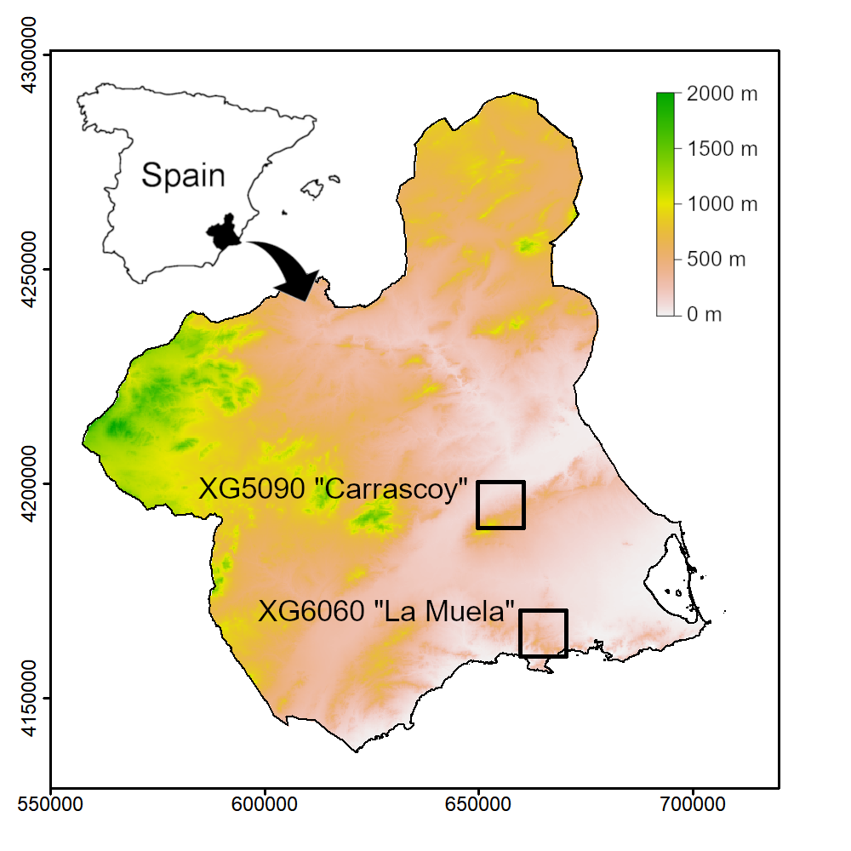

Figure S2. Population trends for bird populations in two study areas in southeastern Spain. Lines represent observed abundances (blue), estimated abundances (black) with 95% Confidence Intervals (grey shadow), and best model curves (red). The figure was created in R (version 3.6.3, https://www.R-proje ct.org/) and assembled with GIMP (version 2.10.14, https://www.gimp.org/). A total of 46 and 49 species were modelled for La Muela and Carrascoy, respectively. Note that species that were not observed or modelled in one study area are shown with dashes.

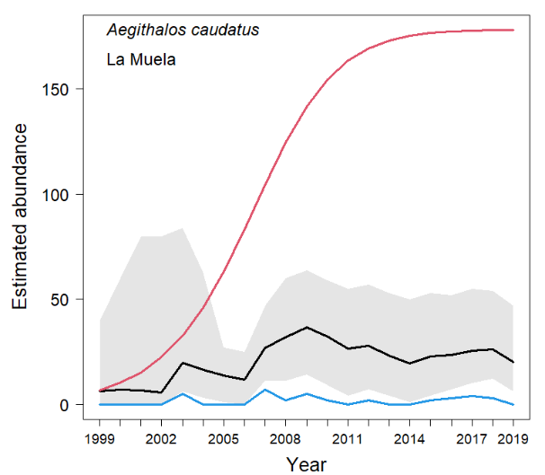 | 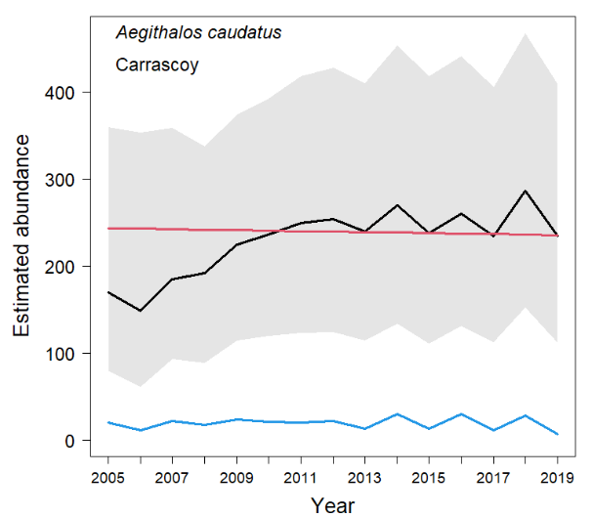
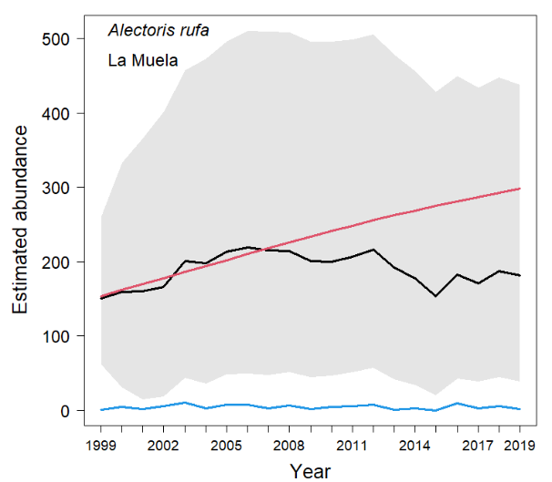 | 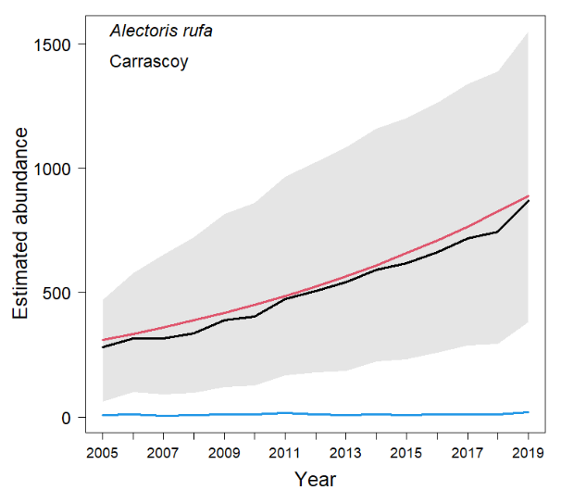
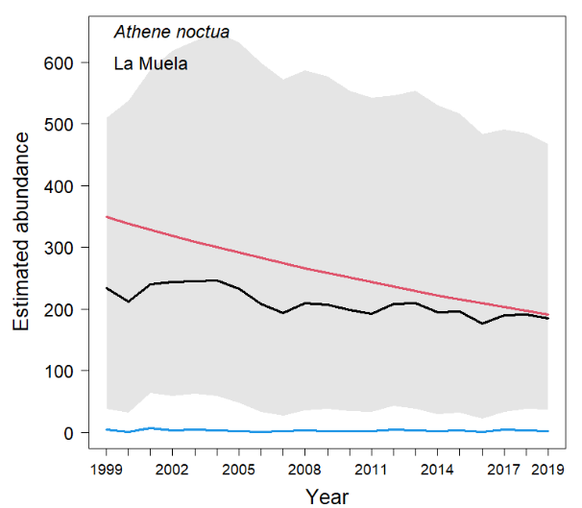 | 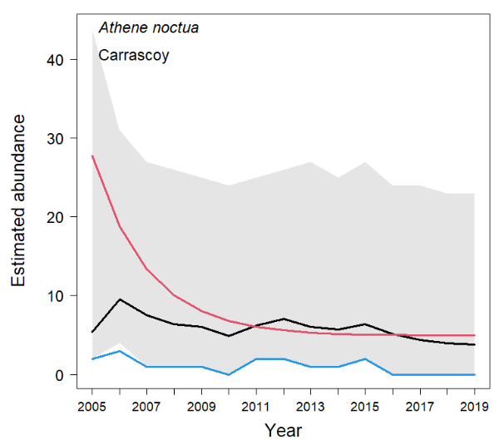
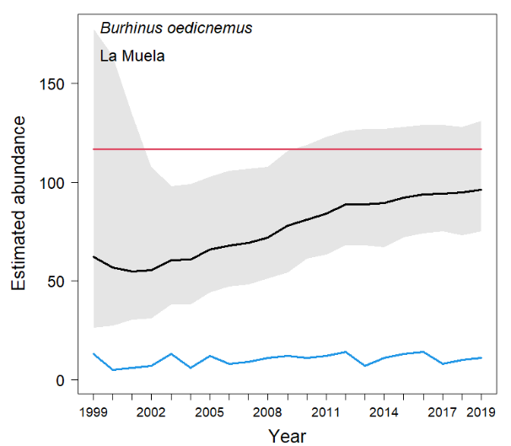 | 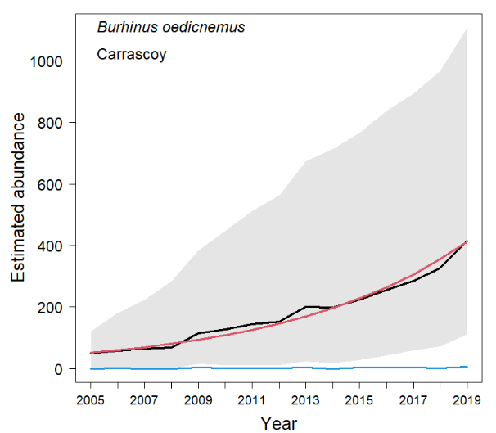
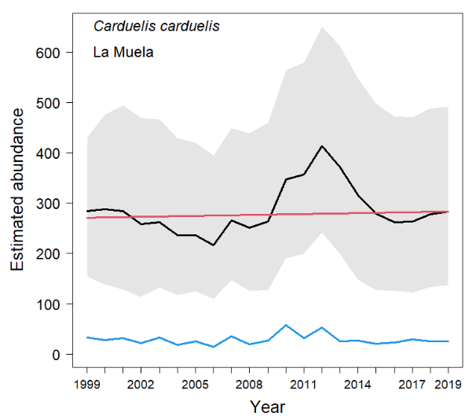 | 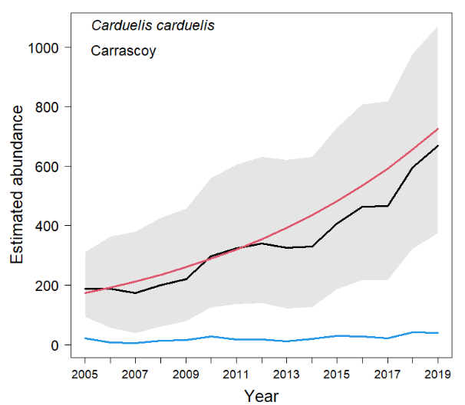
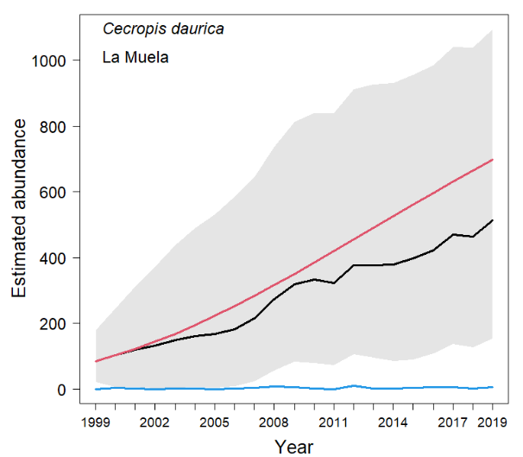 | 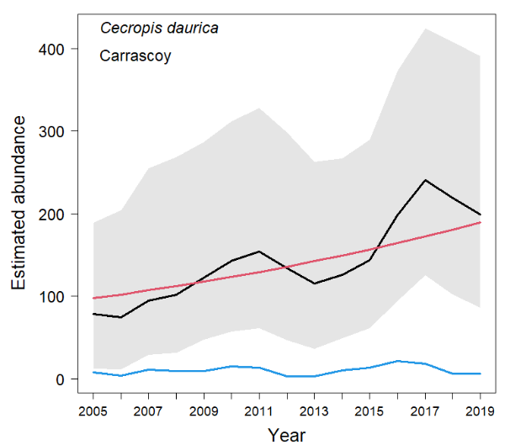
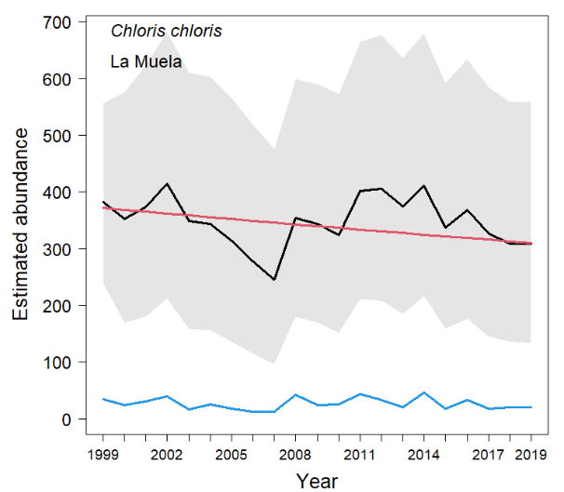 | 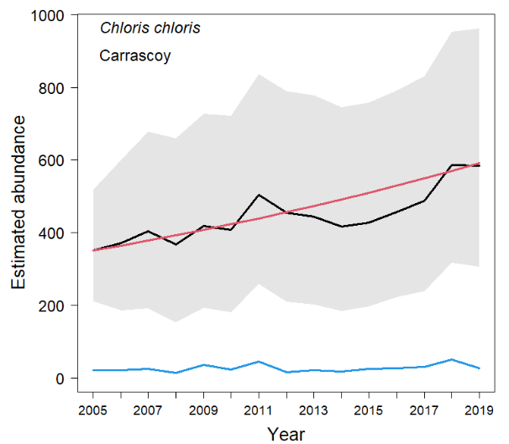
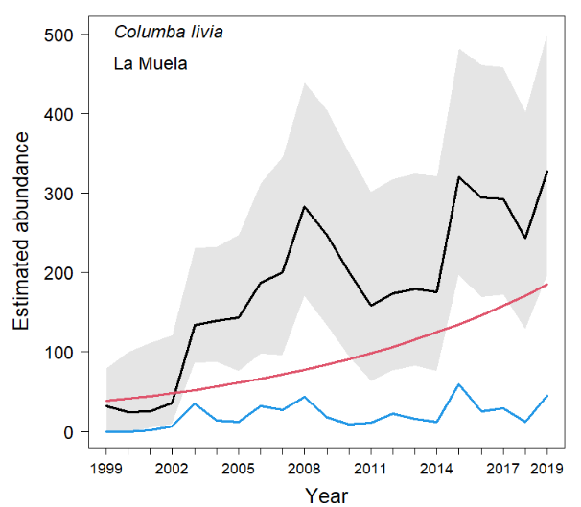 | Columba livia - Carrascoy  Not modelled
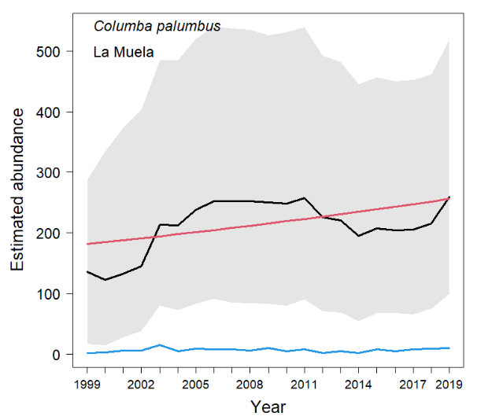 | 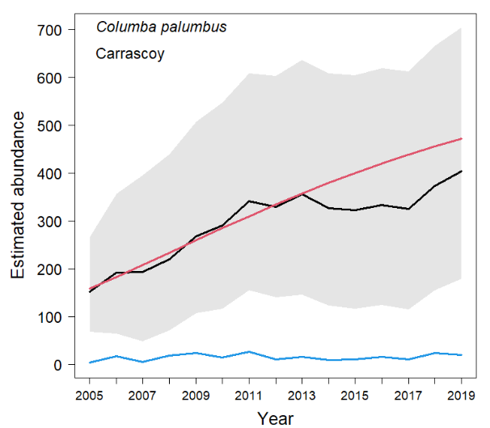
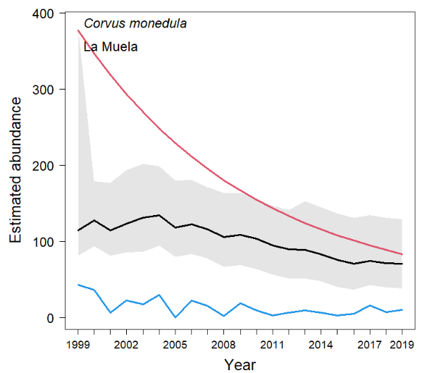 | 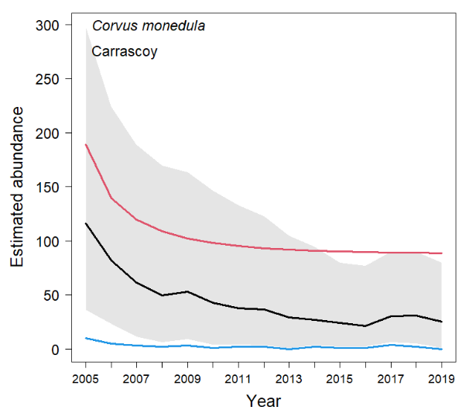
Coturnix coturnix - La Muela  Not modelled | 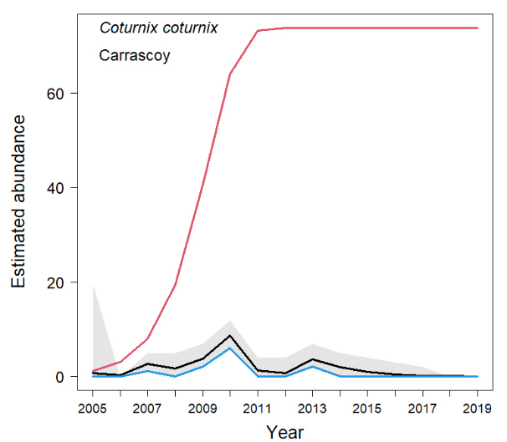
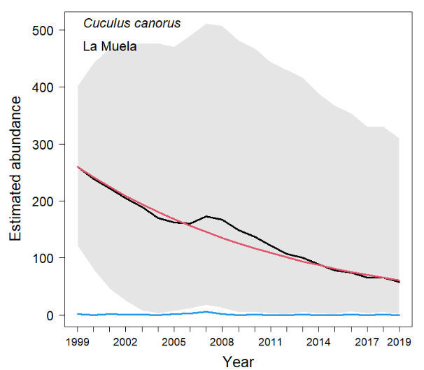 | 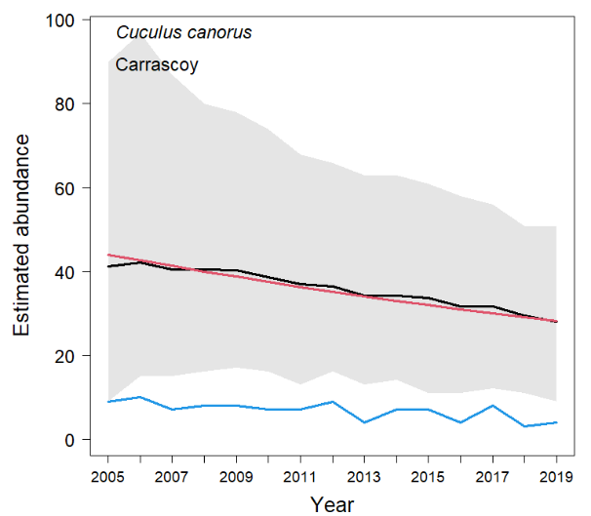
Delichon urbicum - La Muela  Not modelled | 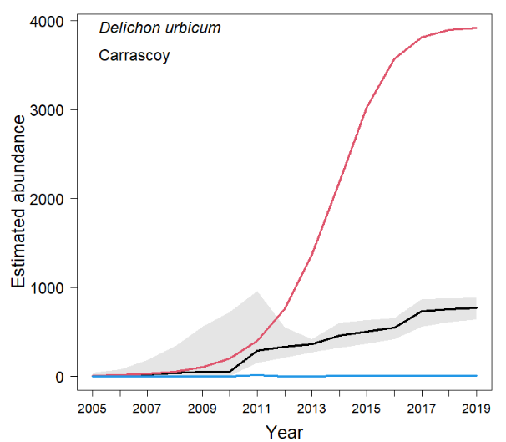
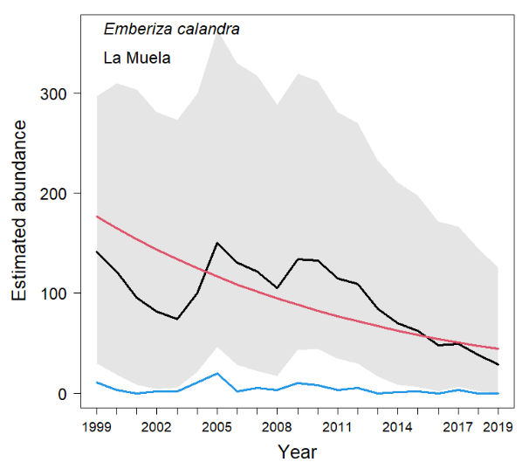 | 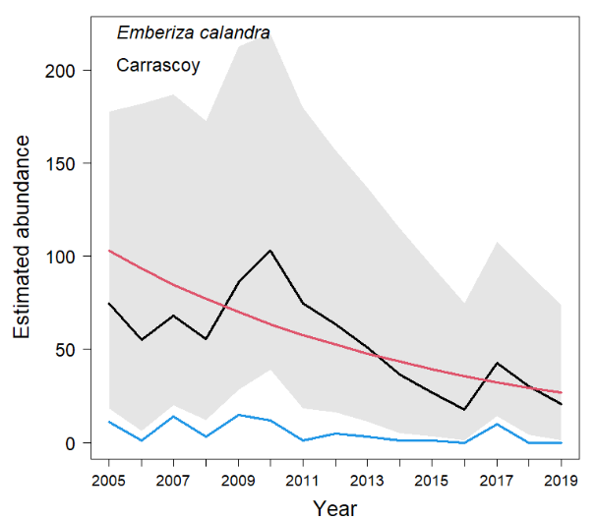
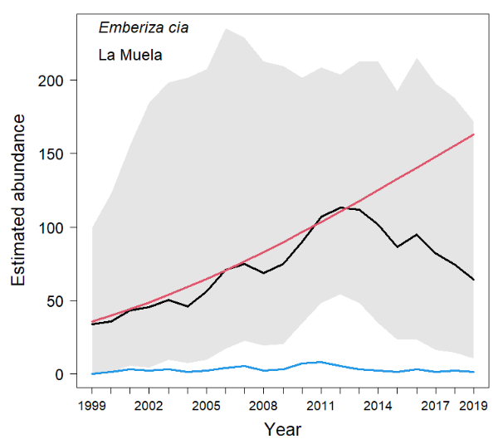 | 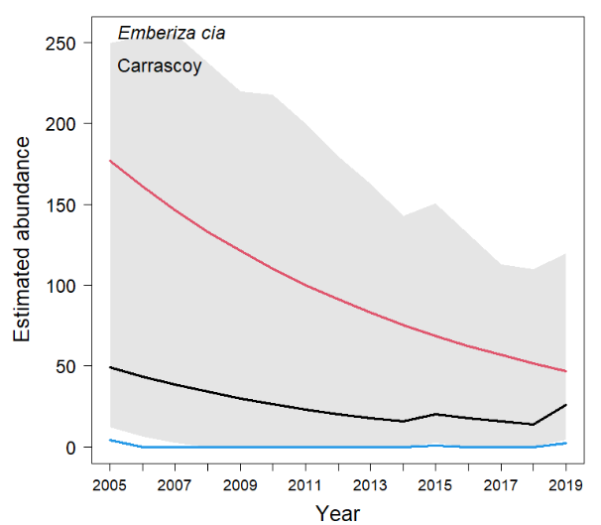
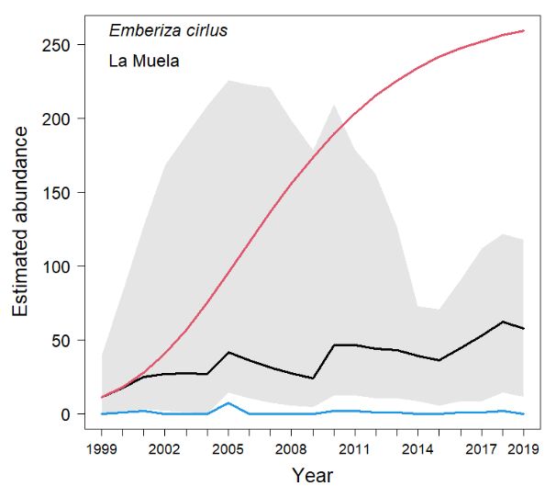 | Emberiza cirlus - Carrascoy  Not modelled
Erithacus rubecula - La Muela  Not modelled | 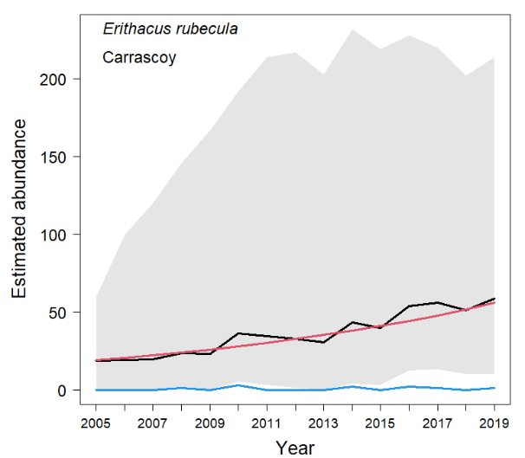
Falco tinnunculus - La Muela  Not modelled | 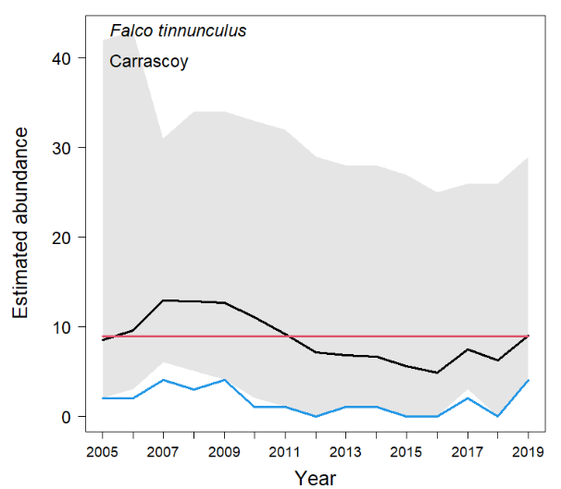
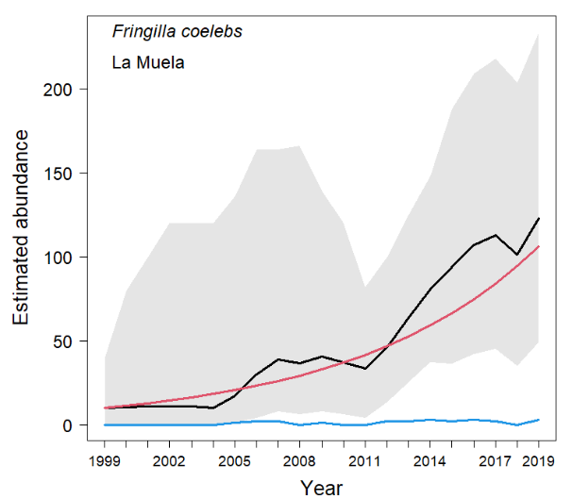 | 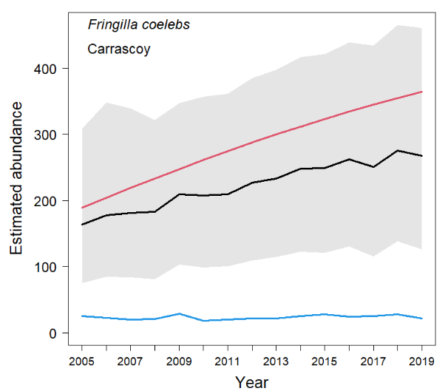
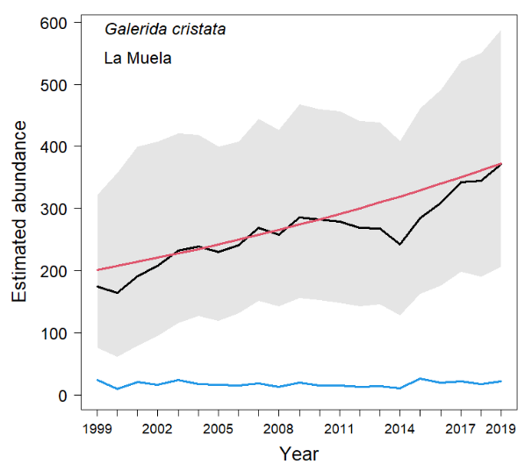 | 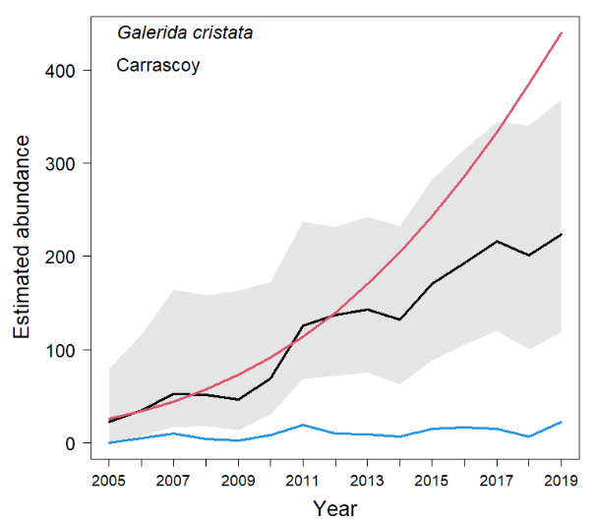
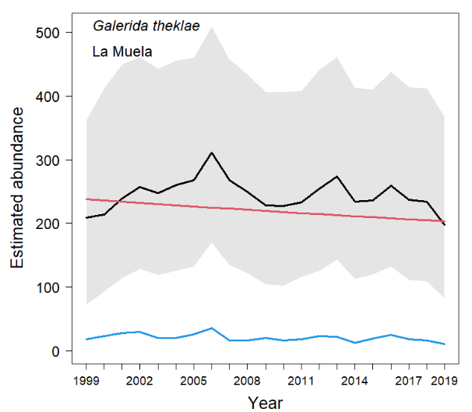 | 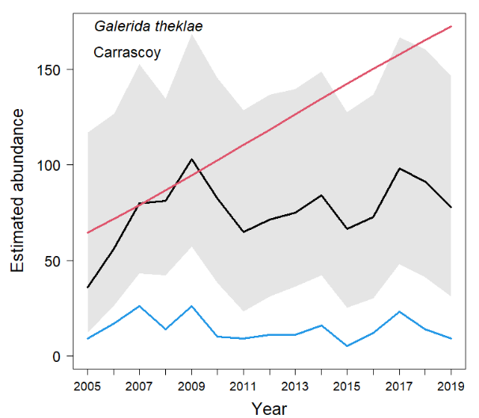
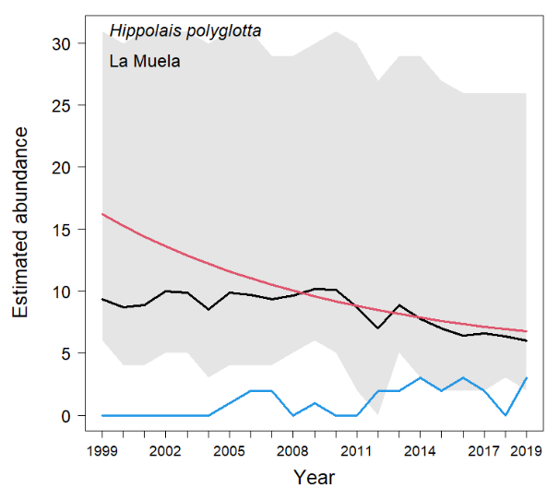 | 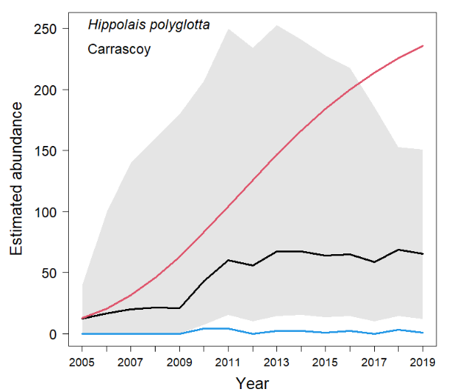
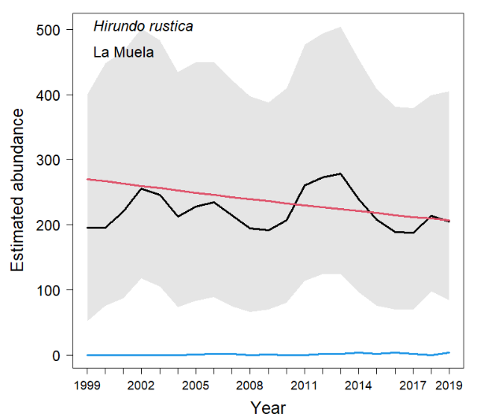 | 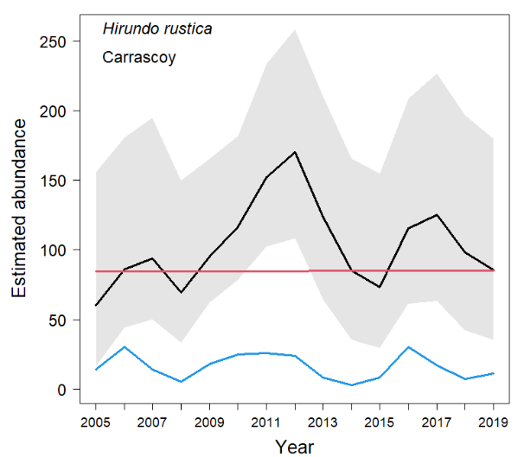
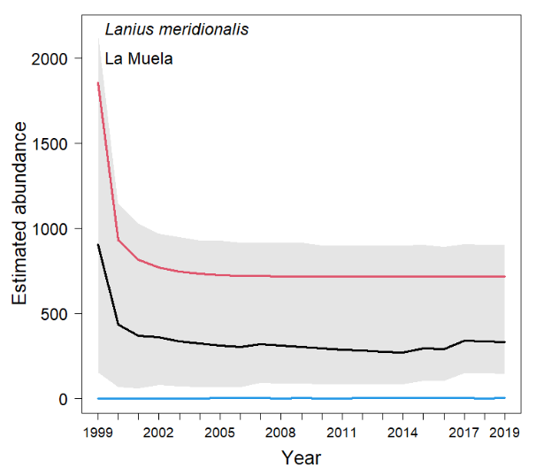 | 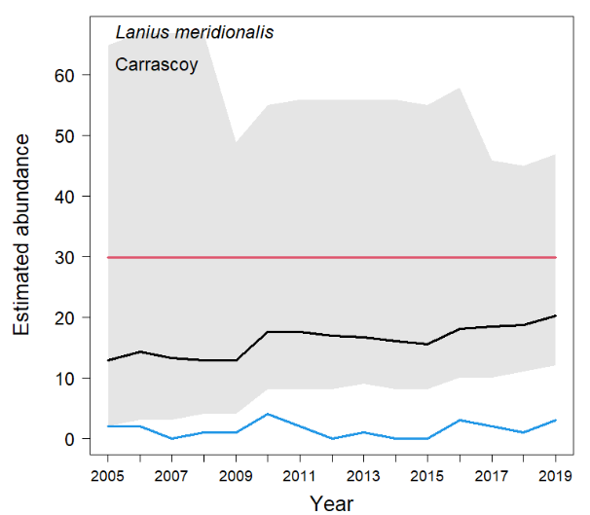
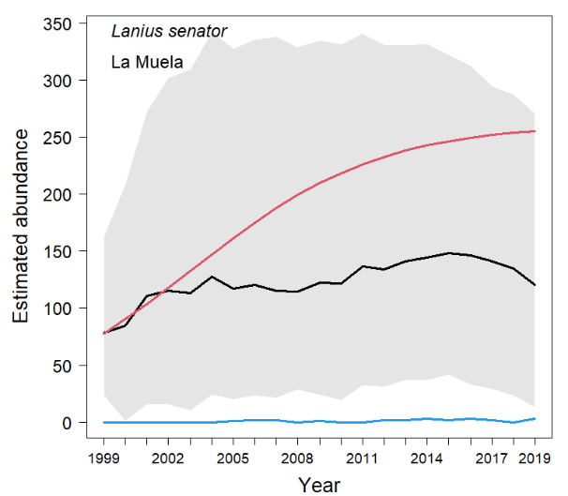 | 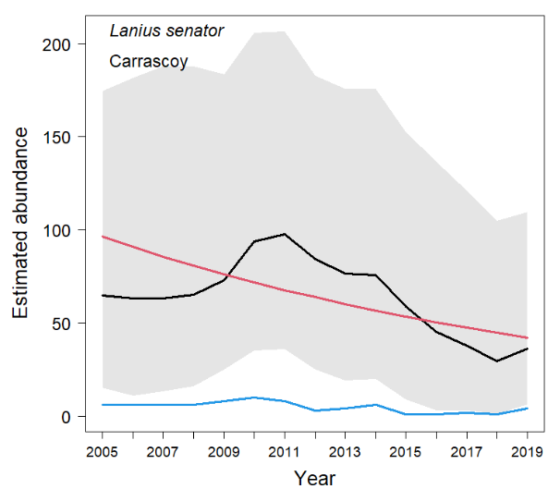
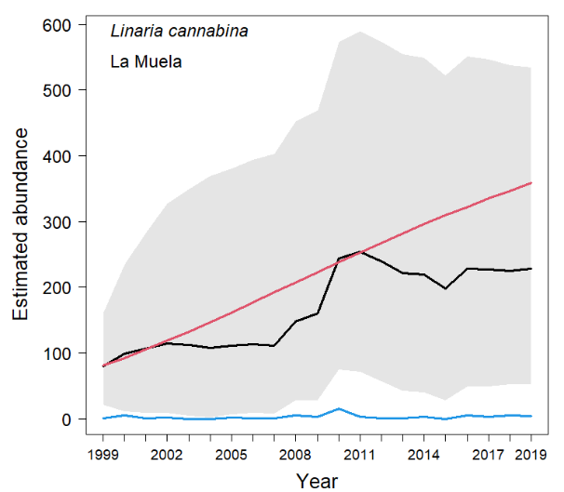 | 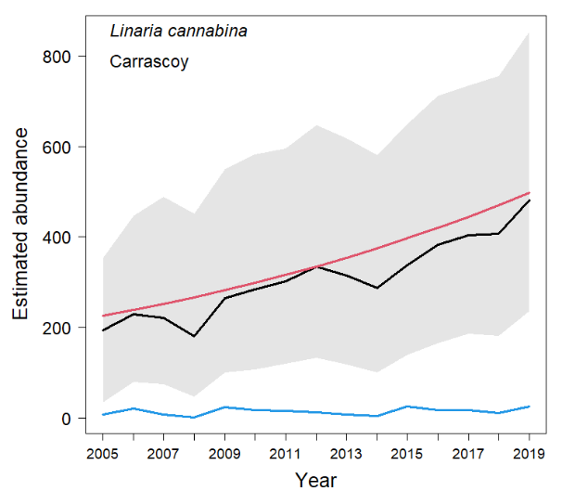
Lophophanes cristatus - La Muela  Not modelled | 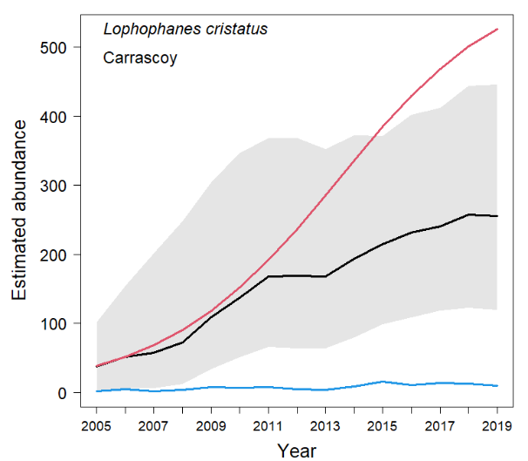
Loxia curvirostra - La Muela  Not modelled | 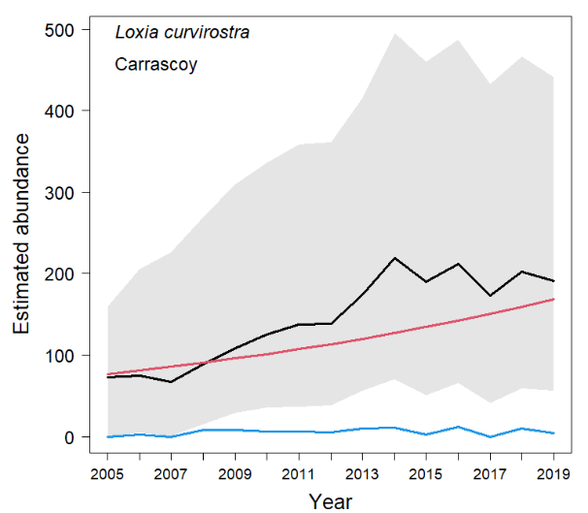
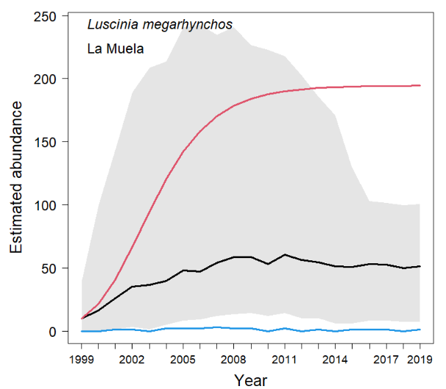 | 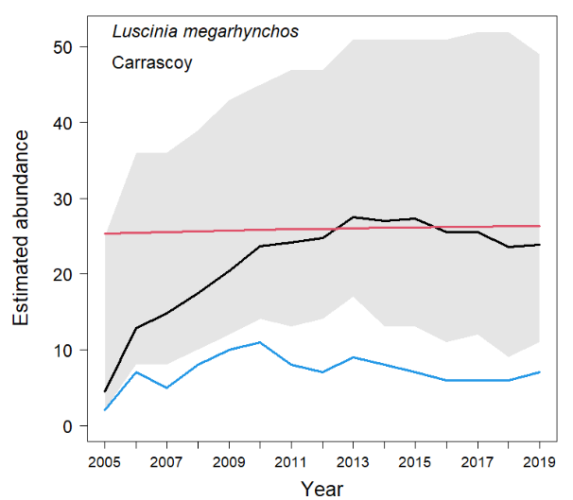
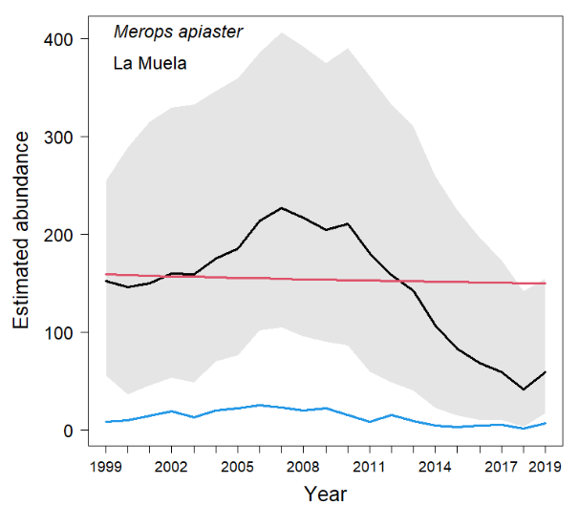 | 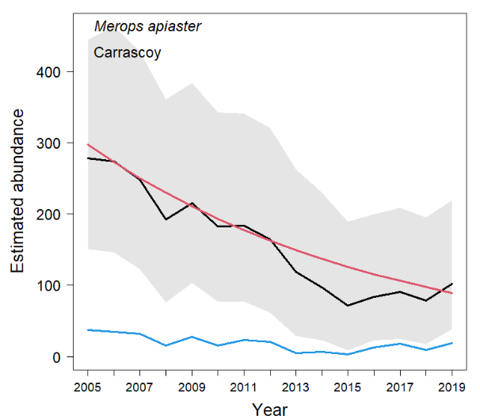
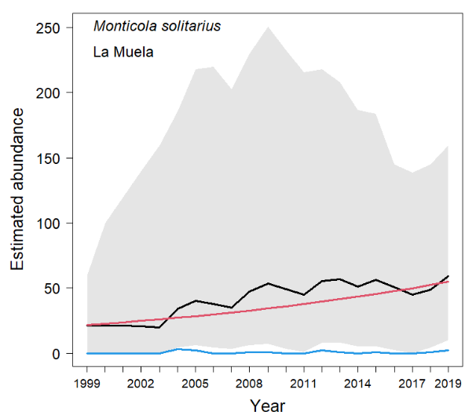 | Monticola solitarius - Carrascoy  Not modelled
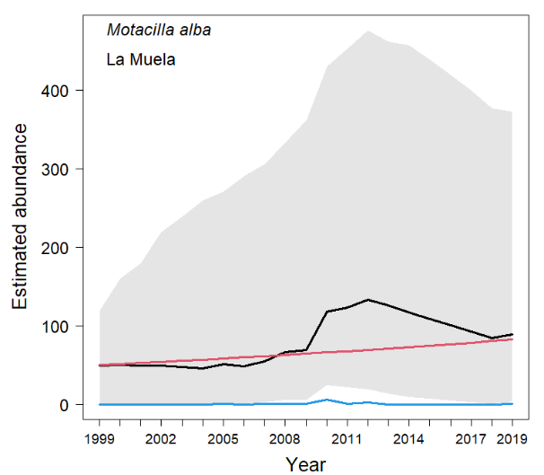 | 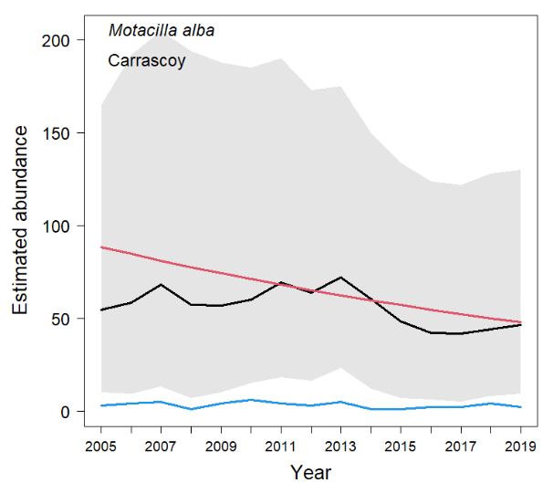
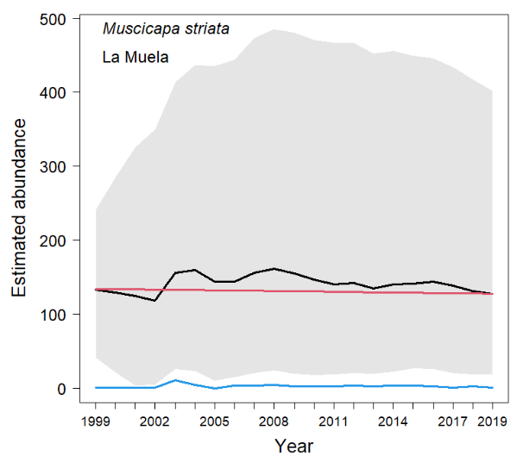 | 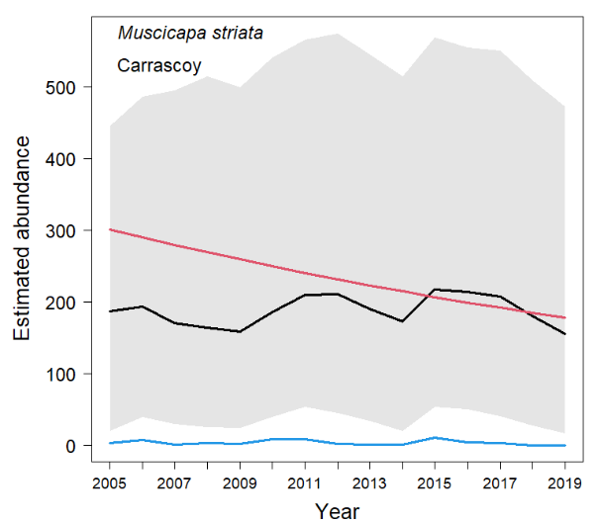
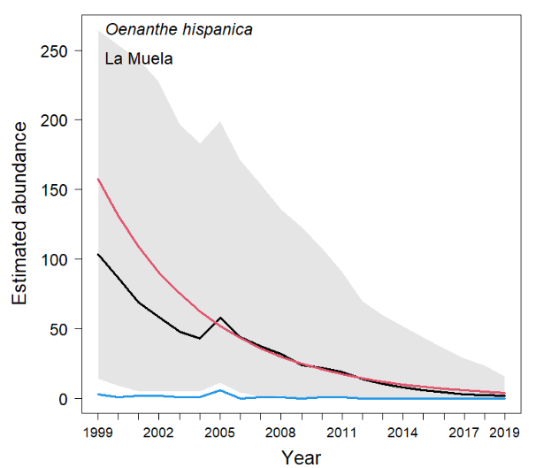 | Oenanthe hispanica - Carrascoy  Not modelled
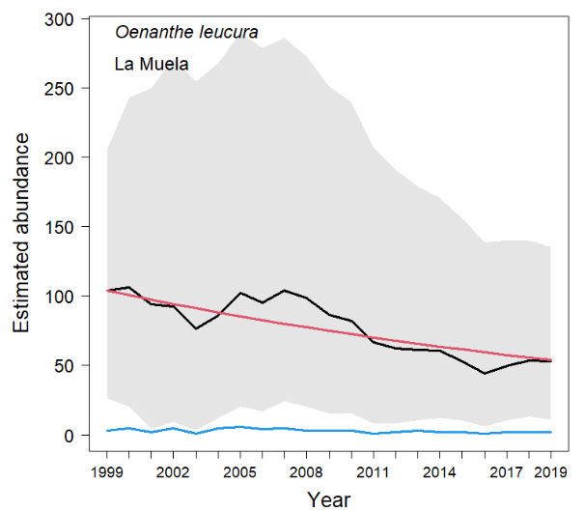 | 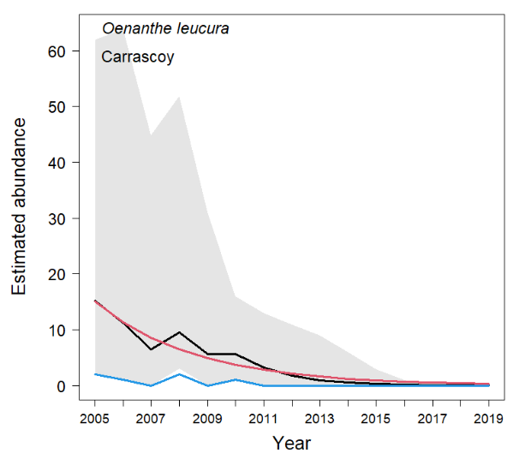
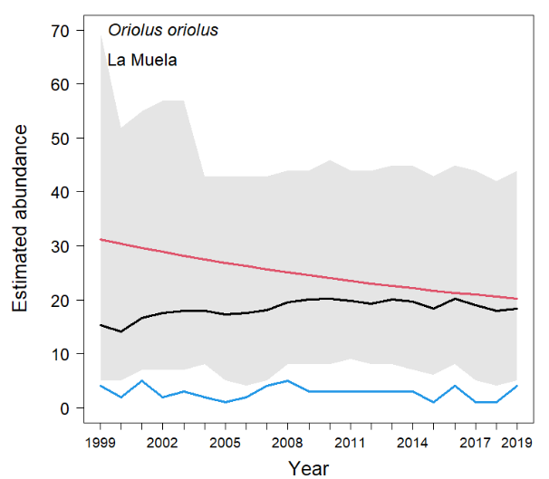 | 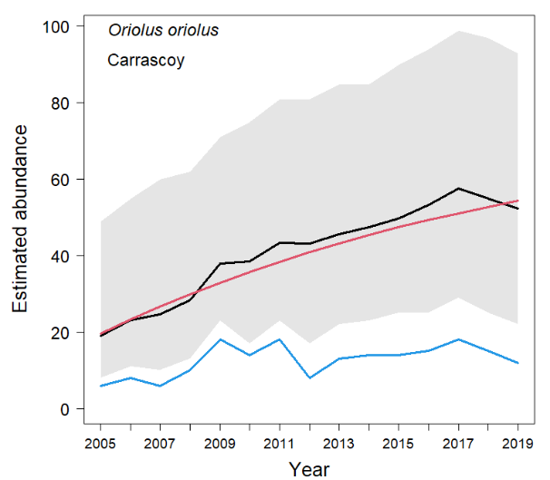
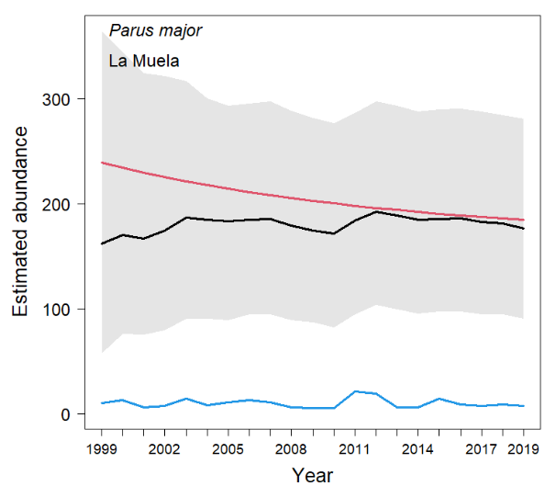 | 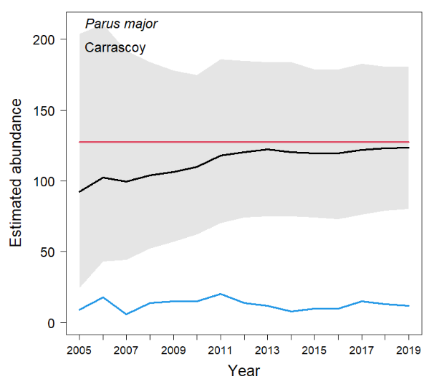
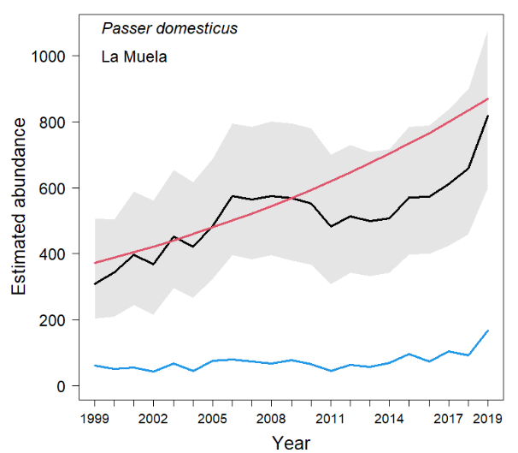 | 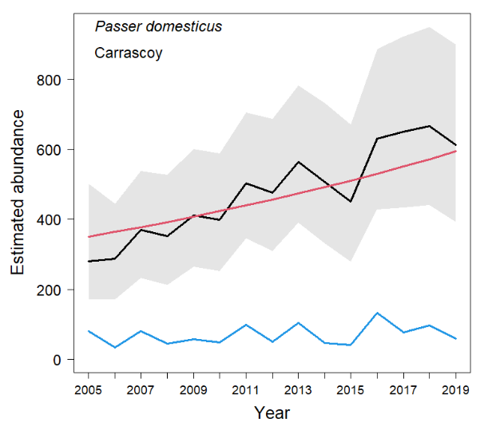
Periparus ater - La Muela  Not modelled | 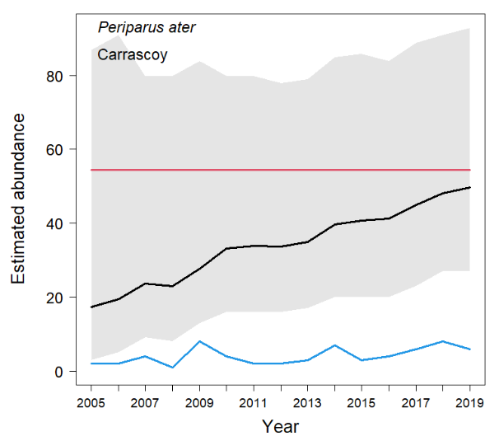
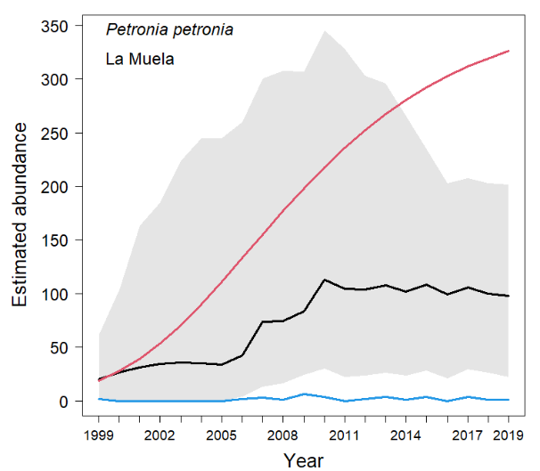 | Petronia petronia - Carrascoy  Not modelled
Pica pica - La Muela  Not modelled | 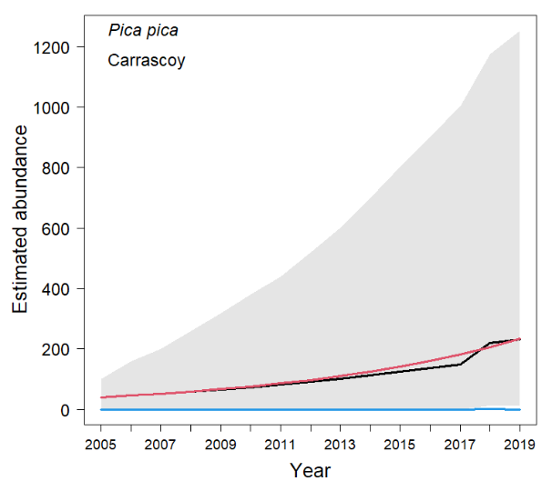
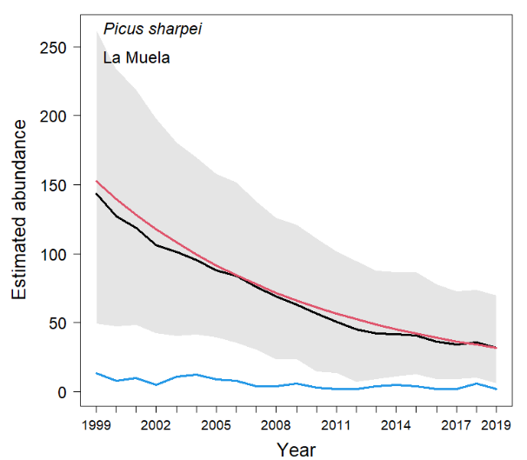 | 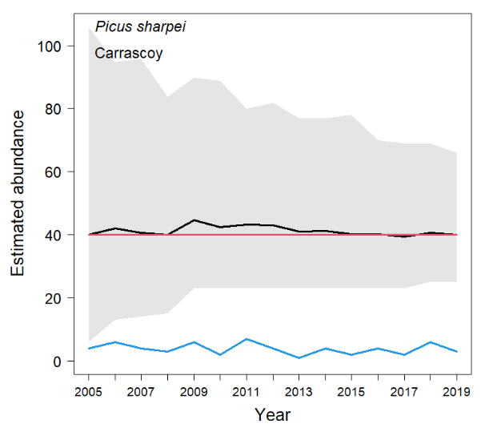
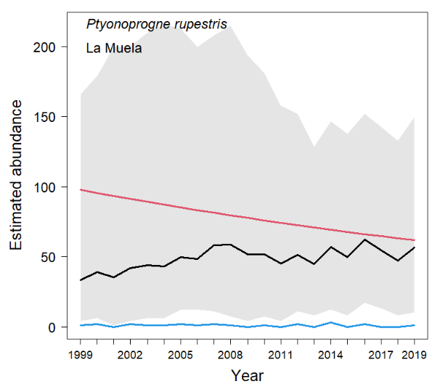 | Ptyonoprogne rupestris - Carrascoy  Not modelled
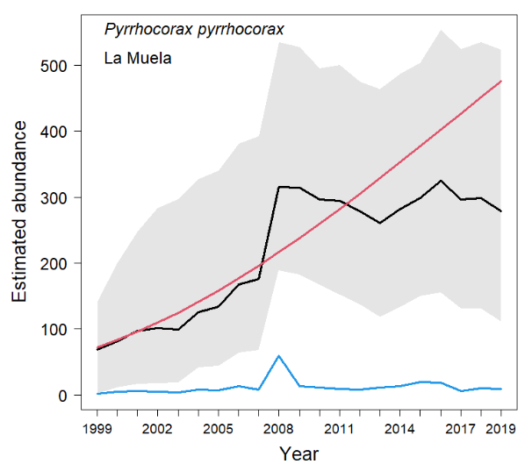 | Pyrrhocorax pyrrhocorax - Carrascoy  Not modelled
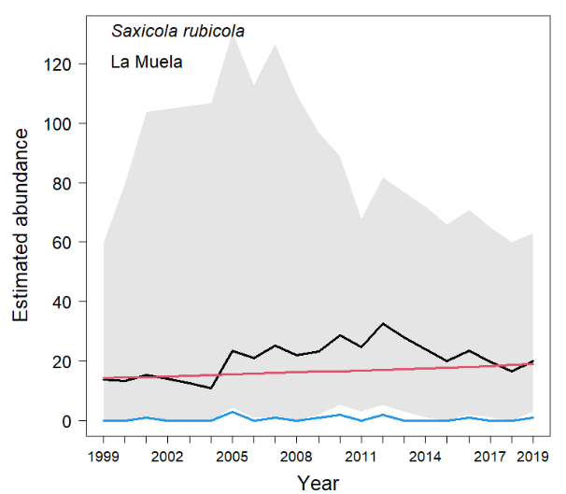 | Saxicola rubicola - Carrascoy  Not modelled
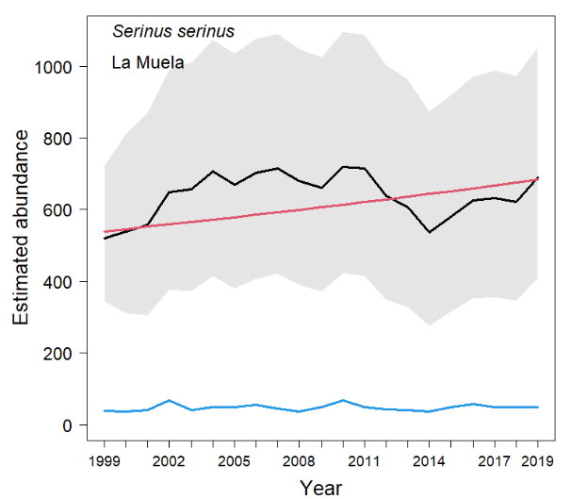 | 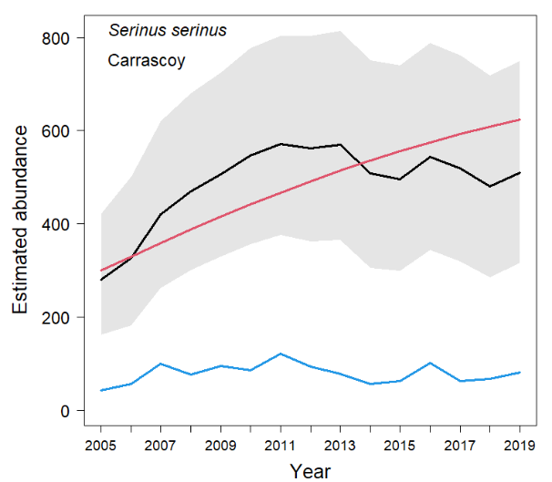
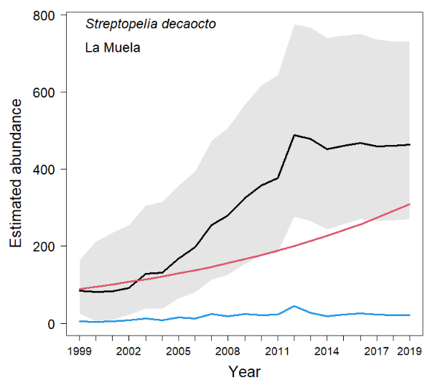 | 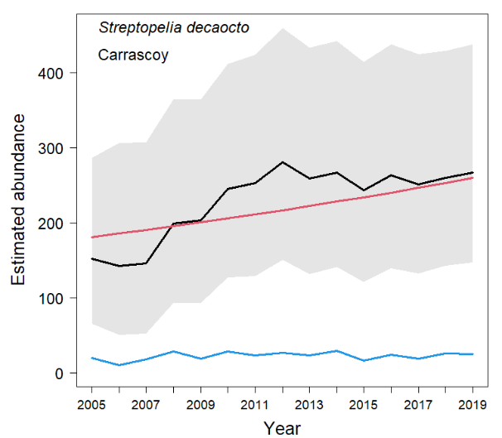
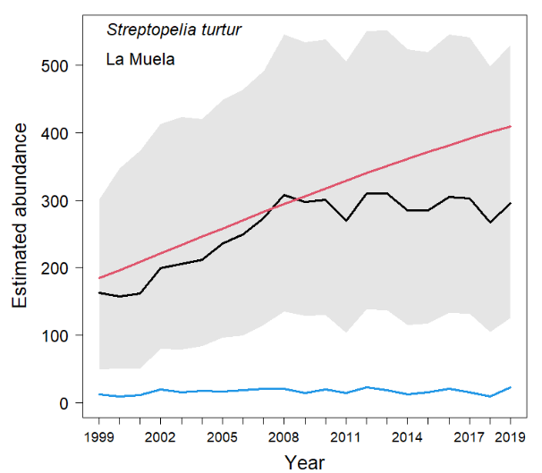 | 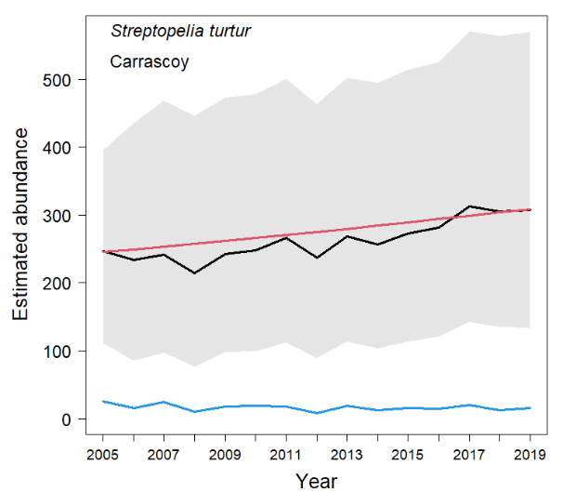
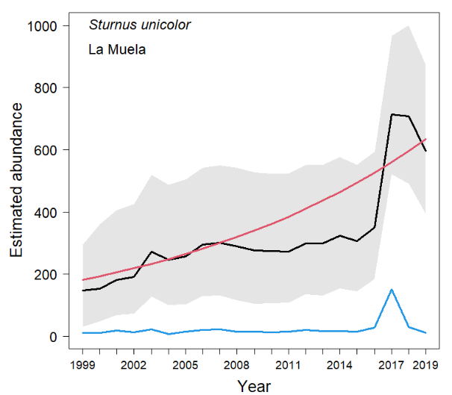 | 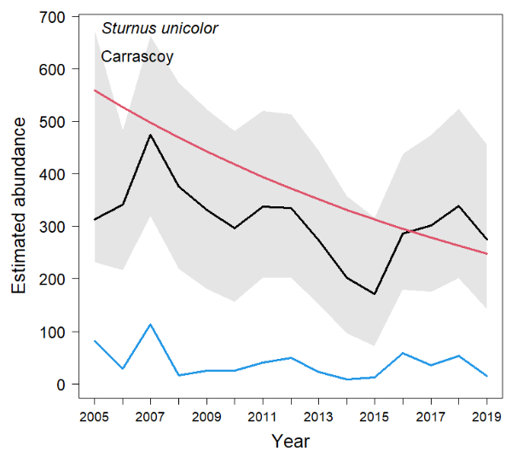
Sylvia atricapilla - La Muela  Not modelled | 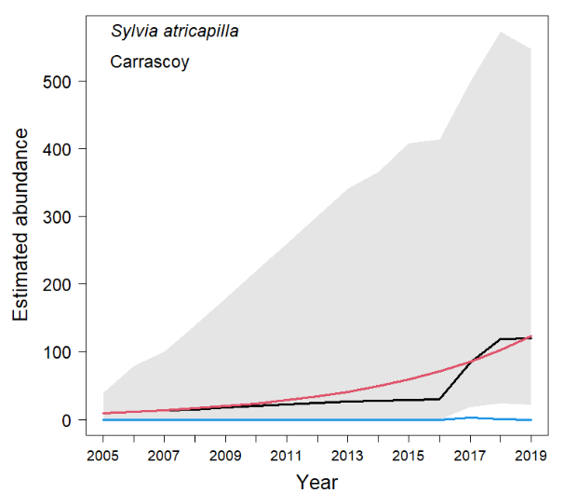
Sylvia hortensis - La Muela  Not modelled | 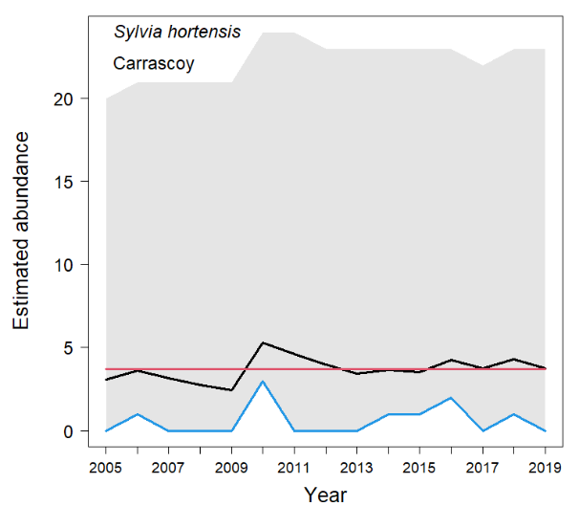
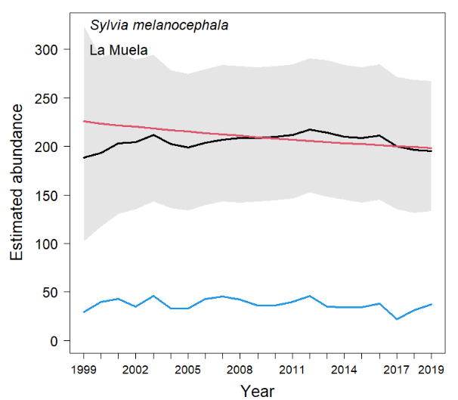 | 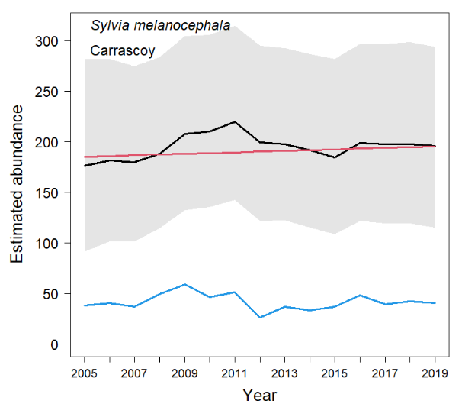
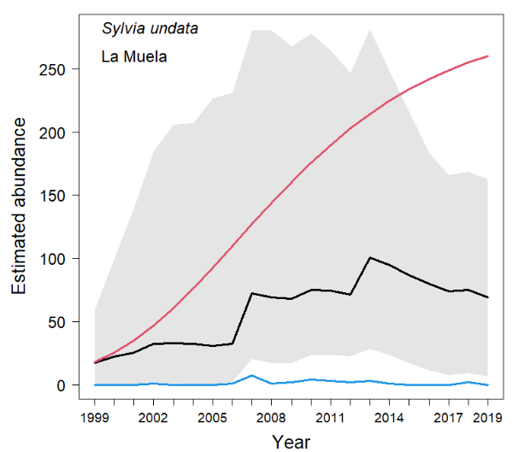 | 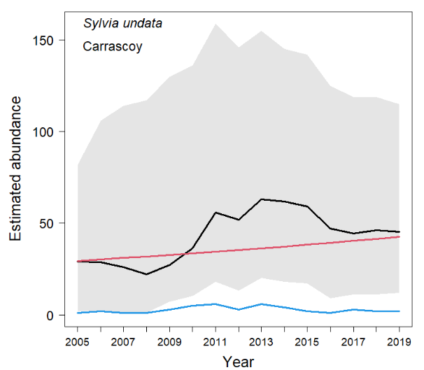
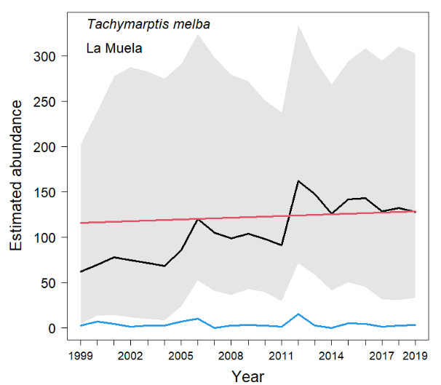 | Tachimarptis melba - Carrascoy  Not modelled
Troglodytes troglodytes - La Muela  Not modelled | 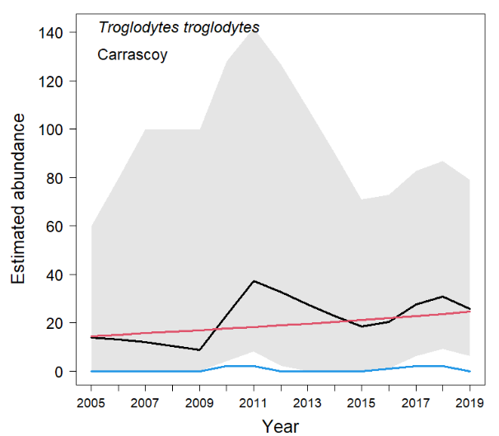
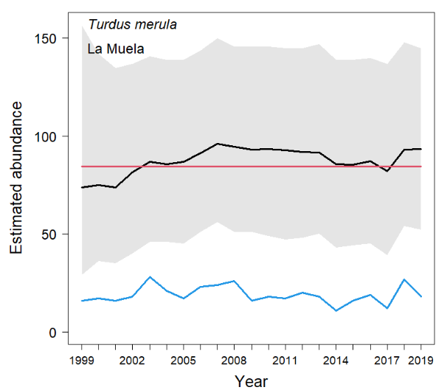 | 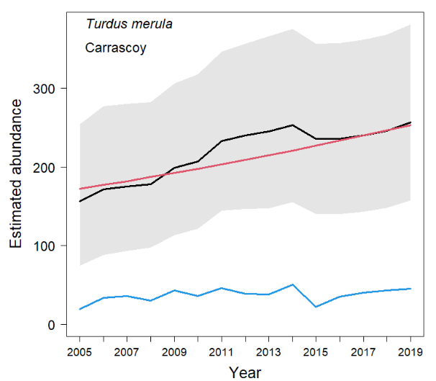
Turdus viscivorus - La Muela  Not modelled | 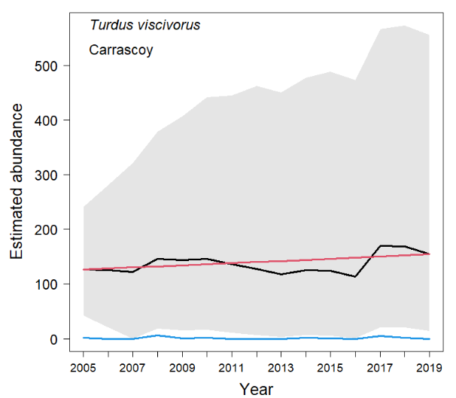
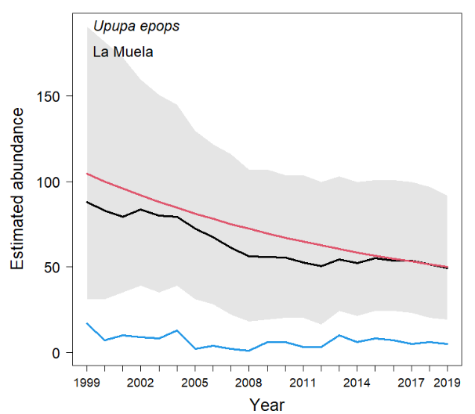 | 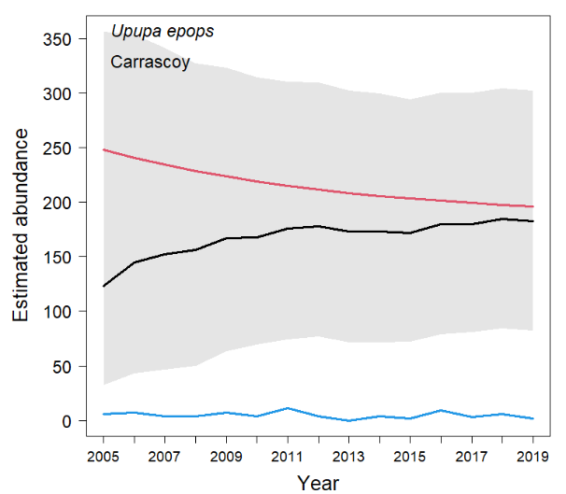

Figure S3. Model estimates of population growth rates (λ) for species which the best model was the classical exponential growth model (Trend model) for birds populations in two study areas species La Muela and Carracoy (southeastern Spain) surveyed during 21 and 15 years, respectively as part of the Spanish national monitoring programme for common breeding bird species (SACRE). Segments represent 95% Confidence Intervals. The figure was created in R (version 3.6.3, https://www.R-proje ct.org/) and assembled with GIMP (version 2.10.14, https://www.gimp.org/).
