Fig. S1: Sex-differences in between-season breeding dispersal for cases of certain dispersal only.

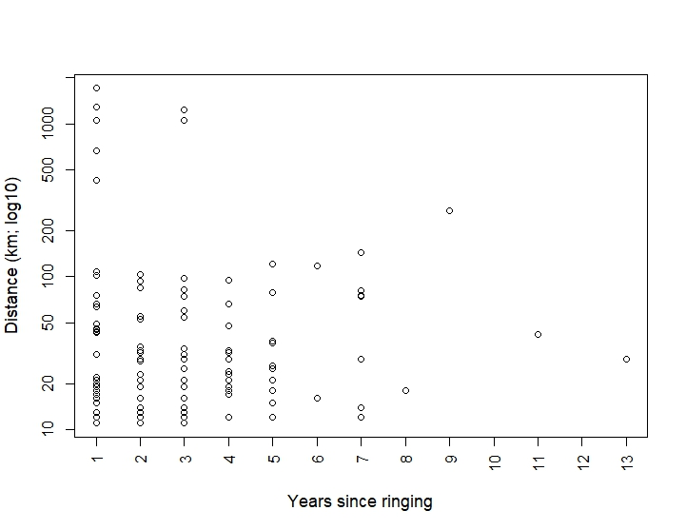
Fig. S2: Between-season dispersal distance in relation to elapsed time since ringing (no effect; LM: t = 0.26, p = 0.80, parameter estimate: 0.005 ± SE 0.02).

