Do the rain calls of chaffinches indicate rain?
Léna de Framond, Rebecca Müller, Luca Feuerriegel, Henrik Brumm

Supplementary information

Contents
I- Supplementary methods 2
II- Supplementary results 2
Table S1 2
III- Weather logger accuracy 3
III-a. Measurement differences between sun and shade 3
III-b. Measurement accuracy 3

Supplementary methods
Automatic recorder programming
Since sunrise and sunset times (Thorsen, 1995–2022) change during the two weeks of recording and the AudioMoth can only work with time instructions, we programmed the AudioMoth to record during three ~1-hour time slots per day (after sunrise, around solar noon and before sunset) which captured the targeted time points for the whole two-week period. During the recording periods, the device was programmed to create multiple subsequent recordings of 115 seconds each with a break of another 5 seconds allocated to saving the data to its SD card. After data transfer, the six recordings closest to the targeted time points relative to sunrise and sunset were selected by an automated R script.

Supplementary results
Table S1 Results (estimates and 95% credible intervals (CrI)) of the logistic regressions (binomial GLMM) investigating the rain call probability in relation to the number of vocalising neighbours. To estimate the effect of the presence and density of vocalising birds on the rain calling probability, we reanalysed the longitudinal dataset used a logistic GLMM in which we modelled the presence of chaffinch vocalisations as a function of the vocalisation type (rain call or song), and the minimum number of birds heard in the recordings. Predictors whose credible intervals did not overlap with zero are presented in bold.
Predictor | Estimate (95% CrI)
Intercept | -1.41 (-1.76, -1.07)
Vocalisation (song) | 1.57 (0.82, 2.25)
Number of birds | 0.18 (-0.06, 0.42)
Number of birds x vocalisation type | 1.47 (0.86, 2.16)
Time of day (hour) | 0.02 (0.00, 0.03)
Location (Augsburg) | -0.57 (-1.08, -0.08)
Observer 1 | -0.08 (-0.34, 0.17)
Observer 2 | 0.43 (-0.04, 0.92)

Weather logger accuracy

III-a. Measurement differences between sun and shade
To test how direct sunlight exposure distorts temperature measurements on the automatic weather loggers, we placed five weather loggers into full sun and five others as much into the shade as possible. After three days, we collected them and calculated the difference between the mean temperature in the sun and in the shade (Fig. S1a). The same calculation was made for relative humidity (Fig S1b). The results show that weather loggers rapidly heat up when exposed to full sun and measured temperature values may deviate as much as 35°C between direct sun and shade. This makes our correction of using official measurements whenever the local measurement was 5 °C off (or higher) relatively conservative. Humidity, however, is just as largely affected by the sun – for which we could not correct.
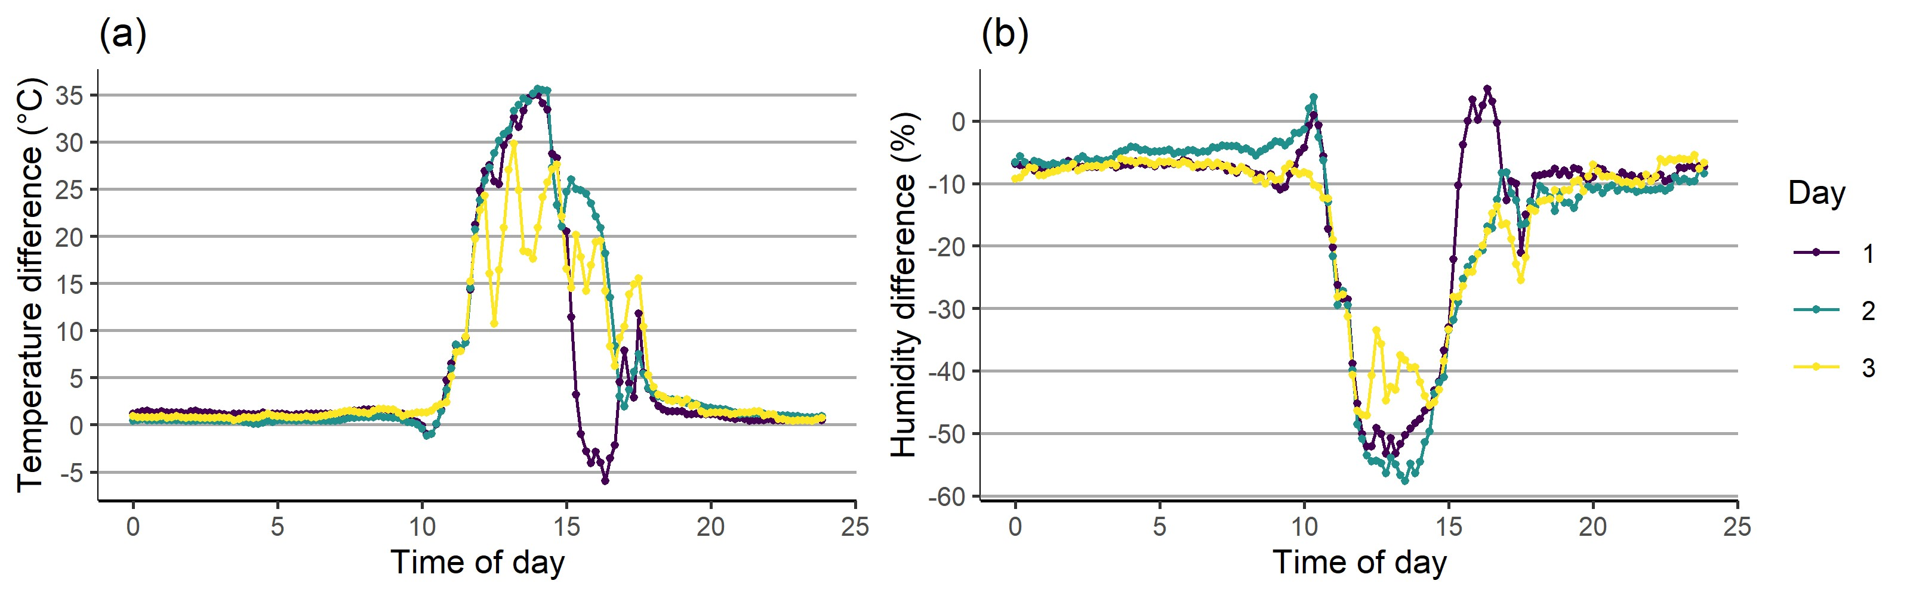
Figure S1: Difference in mean temperature (a) and humidity (b) between full sun and shade.

III-b. Measurement accuracy
To investigate if all weather loggers measure temperature and humidity in the same way and are comparable, we conducted another experiment. First, we left them lined up next to each other in one room for four hours, taking measurements every ten minutes. After that, we put them in a bag into the freezer for two hours and then into another room for another two hours. The results are shown in Fig S2. Measurements across weather loggers are very similar, although some recorders (5, 8) show a greater deviation in humidity. Furthermore, we calculated the correlations of temperature and humidity measurements between every pair of weather loggers. For temperature, all correlations were >0.99 indicating a very high repeatability. For humidity, 9% of correlations were >0.99 and 9% were lower than 0.90 with a minimum of 0.87. In conclusion, humidity measurements were still comparable but not as accurate as temperature measurements.

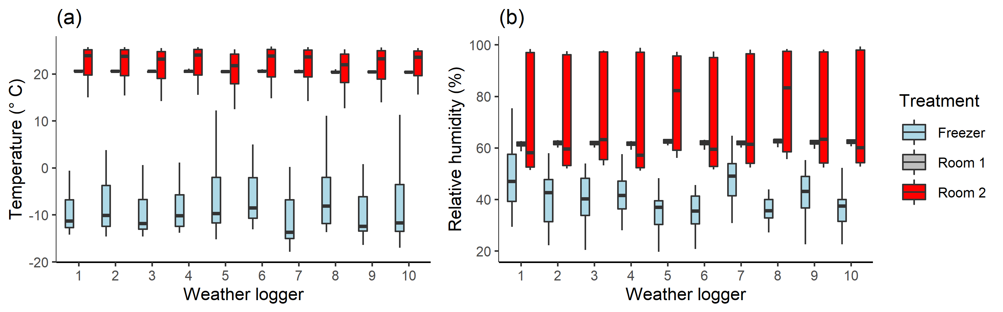
Figure S2: Comparison of weather logger measurements under standardised conditions: a) temperature, and b) relative humidity.

