Electronic Supplementary Material

Table S1. Magpie occurrence in the eBird checklists during the period 2001-2020 in the province of Cádiz.

Year | Checklists | Checklists with Magpie presence | Magpie occurrence (%)
2001 | 59 | 1 | 1.69%
2002 | 53 | 1 | 1.89%
2003 | 46 | 1 | 2.17%
2004 | 45 | 1 | 2.22%
2005 | 92 | 0 | 0.00%
2006 | 78 | 2 | 2.56%
2007 | 142 | 3 | 2.11%
2008 | 203 | 2 | 0.99%
2009 | 239 | 1 | 0.42%
2010 | 280 | 3 | 1.07%
2011 | 424 | 3 | 0.71%
2012 | 347 | 2 | 0.58%
2013 | 621 | 7 | 1.13%
2014 | 711 | 13 | 1.83%
2015 | 865 | 40 | 4.62%
2016 | 1,791 | 56 | 3.13%
2017 | 3,586 | 151 | 4.21%
2018 | 6,850 | 399 | 5.82%
2019 | 8,645 | 700 | 8.10%
2020 | 8,489 | 764 | 9.00%

Figure S1. Graph of the linear regression between the total number of eBird checklists and years. The red line represents the slope of the relationship. The R-squared value is displayed in blue.
Figure S2. Graph of the linear regression between the total number of eBird checklists with Magpie presence and years. The red line represents the slope of the relationship. The R-squared value is displayed in blue.

Figure S3. Graph of the linear regression between the percentage of eBird checklist with Magpie from the total number of checklists and years. The red line represents the slope of the relationship. The R-squared value is displayed in blue.

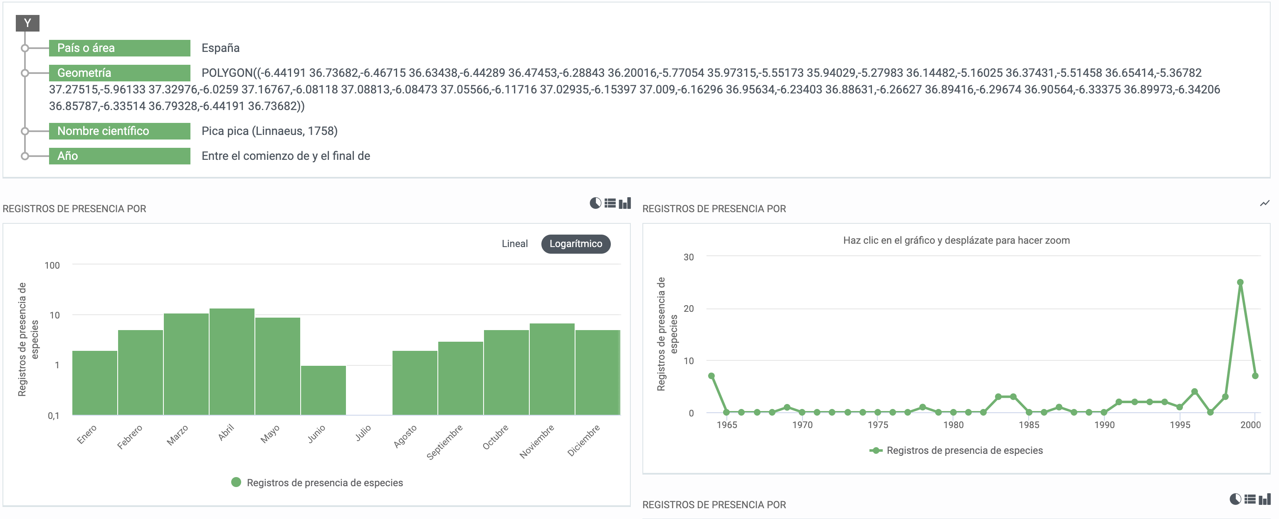
Figure S4. Screenshot of the GBIF (Global Biodiversity Information Facility) data website displaying Magpie records in Cadiz province prior to the year 2001 along with their metrics.

