Supplementary materials
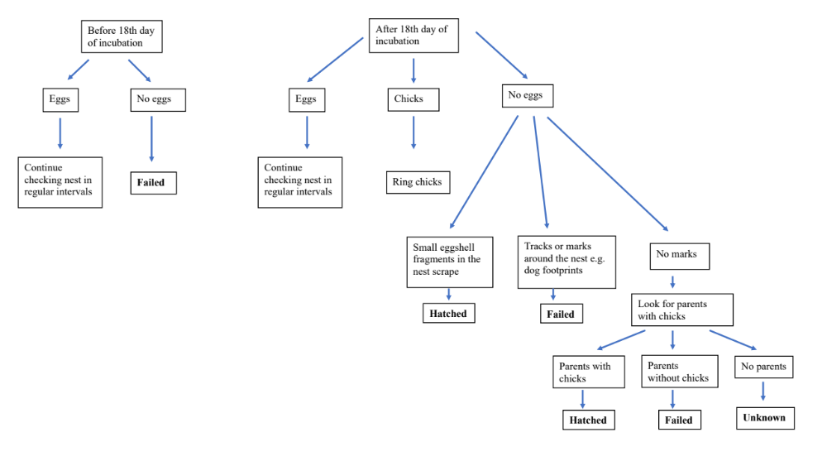
Figure S1. Nest fate determination flow chart used in this study (created by Engel and Székely, 2023)

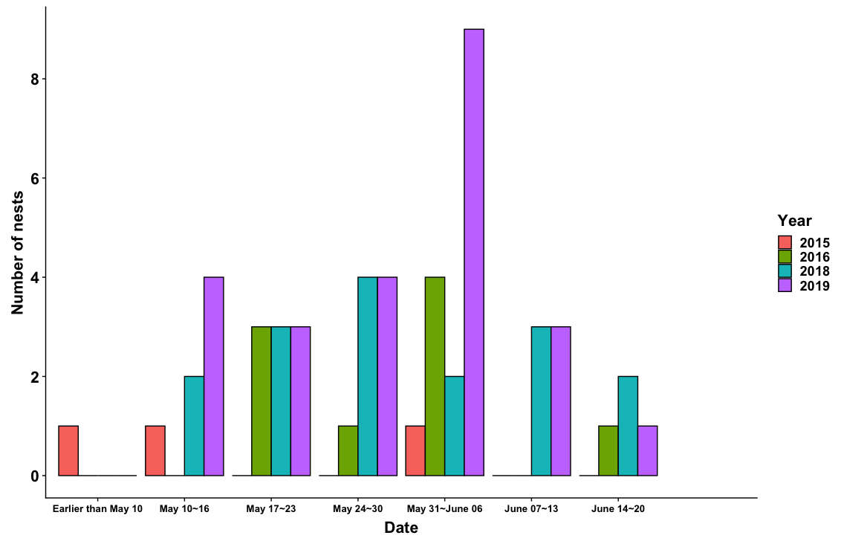
Figure S2. The number of nests laid per week during the period of each field work from 2015 to 2019. Data from 2017 were excluded due to its low quality resulting from a limited fieldwork effort.

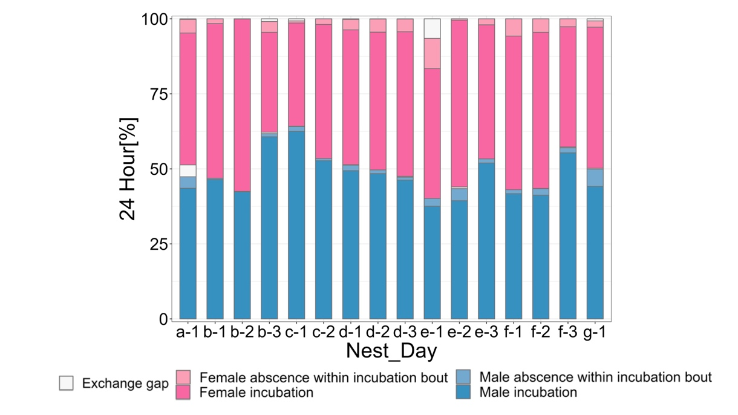
Figure S2. Between- and within-nest variation in overall nest attendance. Each bar represents one nest and daily proportion of female incubation bouts (dark pink), male incubation bouts (dark blue) and exchange gaps (gaps preceding female incubation bouts are above female bars and those preceding male incubation bouts are above male bars). The light colours indicate the absence of a parent (no incubation) within its incubation bouts (N = 7 nests).

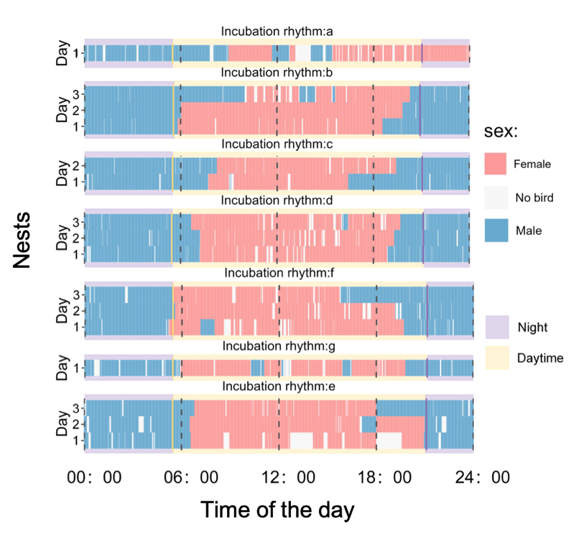
Figure S3. Incubation state of each nest on each day (N = 7 nests, 16 days). Each slice represents the incubation state of each minute of the day, pink for females incubation, blue for males incubation, light grey means no attendance. Yellow solid lines represent the time of sunrise every day, purple solid lines for sunset. Yellow and purple background colours represent the day and night respectively.

Table S1. Daily survival rates (DSR) of Tibetan Sand Plover nests at Qinghai Lake in 2018 and 2019 using the Kaplan-Meier estimate. Stand error (se) and 95% confidence intervals (CI) are shown.
Days | No. nests at the start of the day | No. nest failed | DSR | se | 95% CI
2018
1 | 16 | 1 | 0.94 | 0.06 | 0.83 – 1.00
2 | 15 | 1 | 0.88 | 0.08 | 0.73 – 1.00
4 | 12 | 1 | 0.80 | 0.10 | 0.62 – 1.00
5 | 11 | 1 | 0.73 | 0.12 | 0.53 – 0.99
7 | 10 | 1 | 0.66 | 0.13 | 0.45 – 0.96
12 | 8 | 1 | 0.57 | 0.13 | 0.36 – 0.91
13 | 6 | 1 | 0.48 | 0.14 | 0.27 – 0.86
22 | 2 | 1 | 0.24 | 0.18 | 0.05 – 1.00
2019
0 | 23 | 2 | 0.96 | 0.04 | 0.88 – 1.00
1 | 22 | 2 | 0.87 | 0.07 | 0.74 – 1.00
2 | 20 | 3 | 0.78 | 0.09 | 0.63 – 0.97
3 | 18 | 1 | 0.65 | 0.10 | 0.48 – 0.88
6 | 13 | 1 | 0.60 | 0.10 | 0.43 – 0.84
11 | 7 | 1 | 0.52 | 0.12 | 0.33 – 0.81
15 | 4 | 1 | 0.39 | 0.14 | 0.19 – 0.80

