Electronic Supplementary Material
Diel and seasonal vocal activity patterns revealed by passive acoustic monitoring
suggest expert recommendations for breeding bird surveys need adjustment
David Singer^{1,2,*}, Johannes Kamp³, Hermann Hondong³, Andreas Schuldt², Jonas Hagge^{1,2}

¹ Northwest German Forest Research Institute, Department of Forest Nature Conservation, Göttingen, Germany
² University of Göttingen, Department of Forest Nature Conservation, Göttingen, Germany
³ University of Göttingen, Department of Conservation Biology, Göttingen, Germany

* Corresponding author: d.singer@posteo.de

Study sites and climate
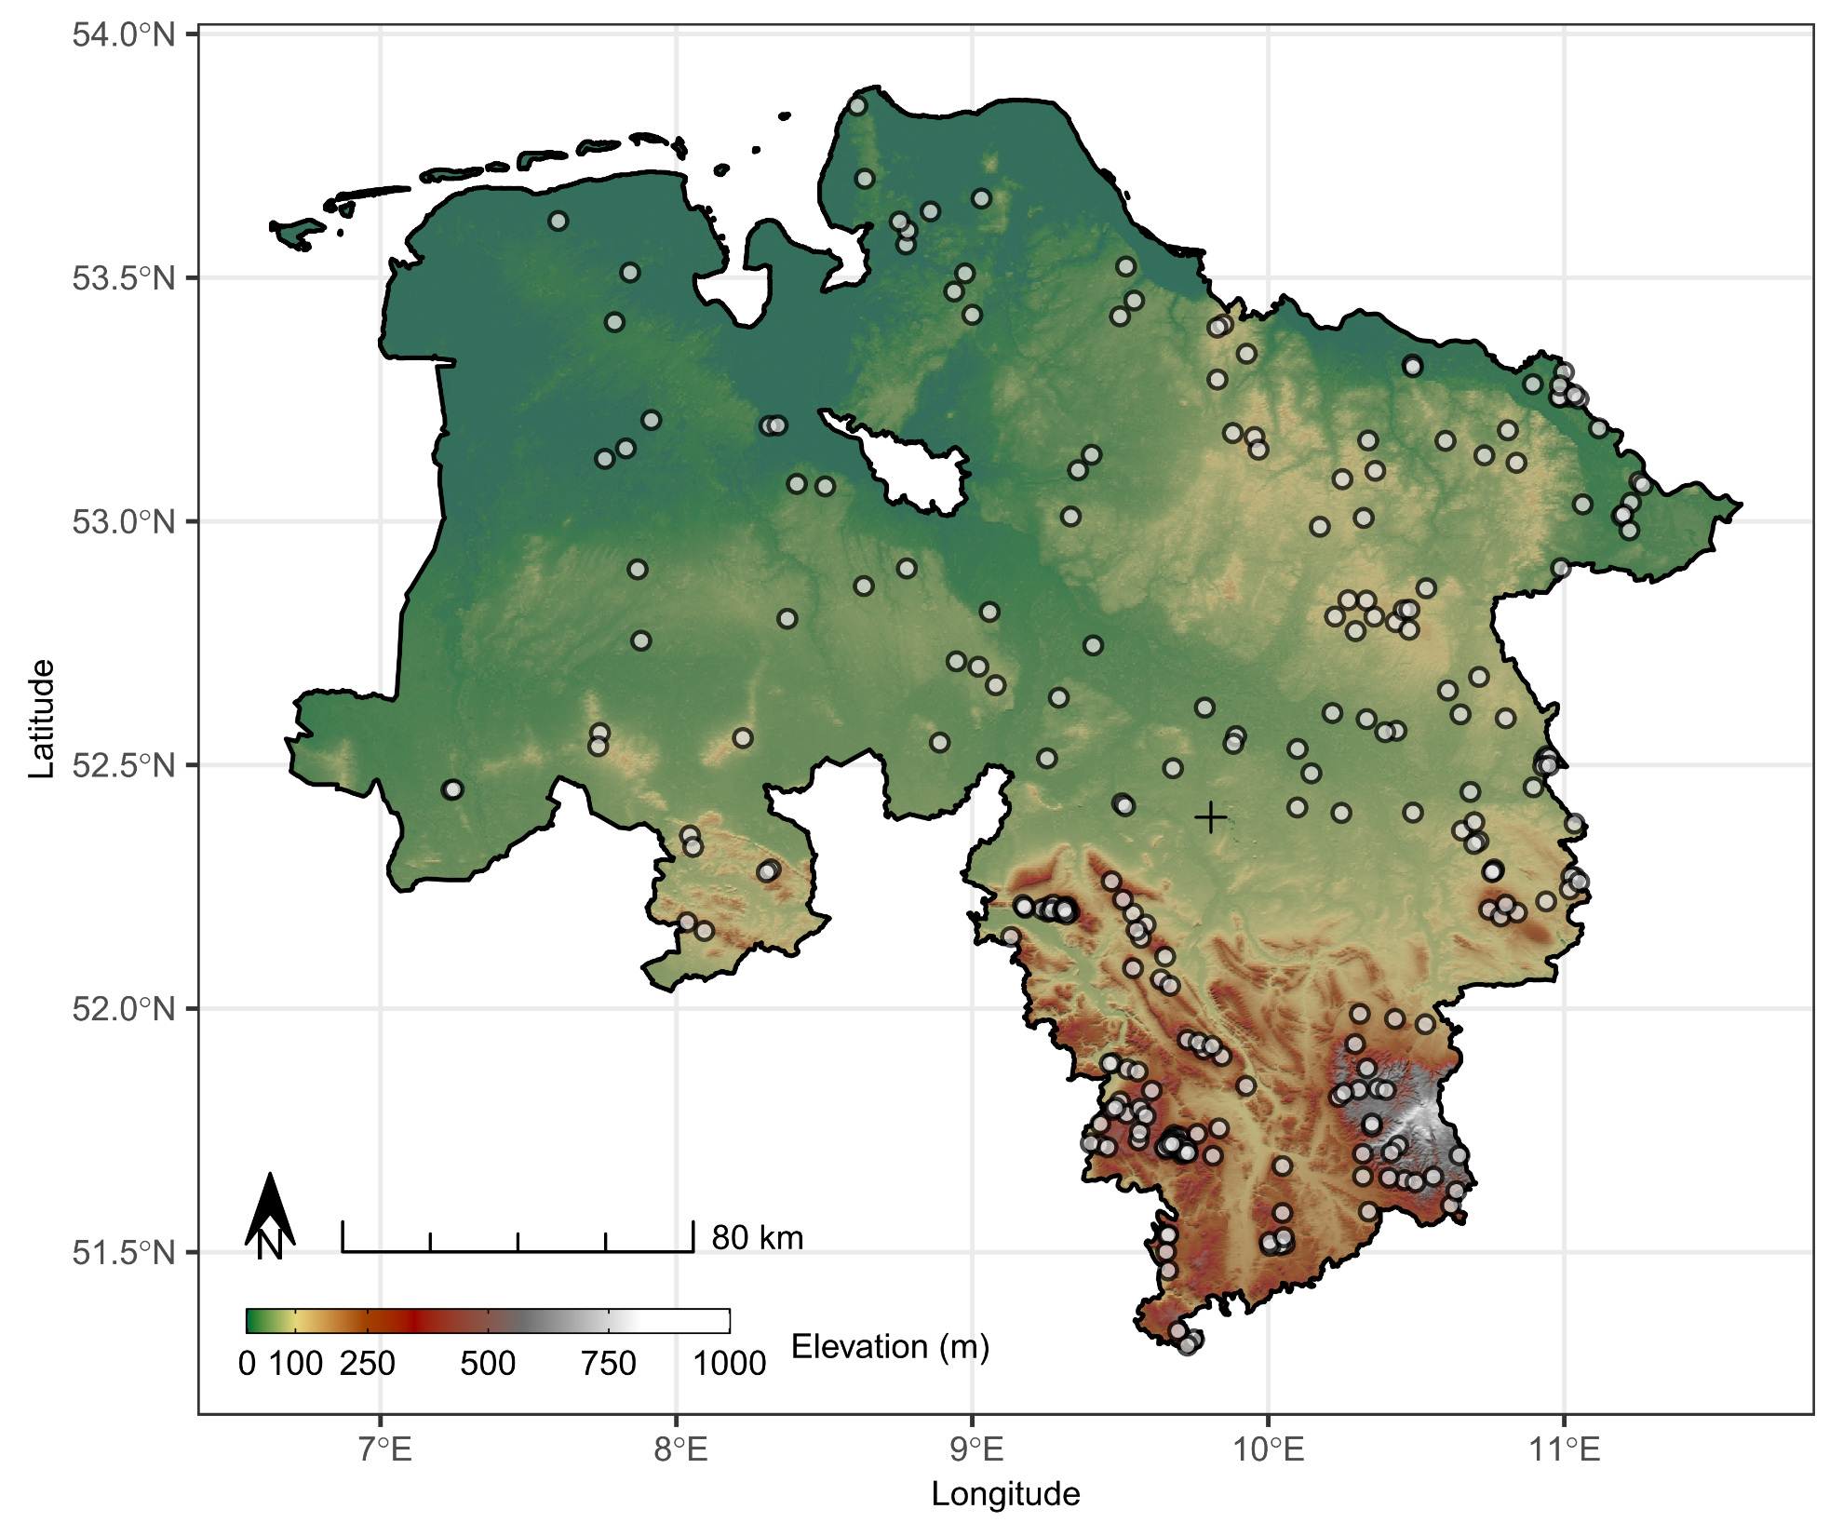
Fig. S1 Map of the study sites that were stratified randomly distributed in managed and unmanaged state forest area across Lower-Saxony, Germany. The cross marks the centroid of all study sites for which the average sunrise/sunset times were calculated, used in the analyses.
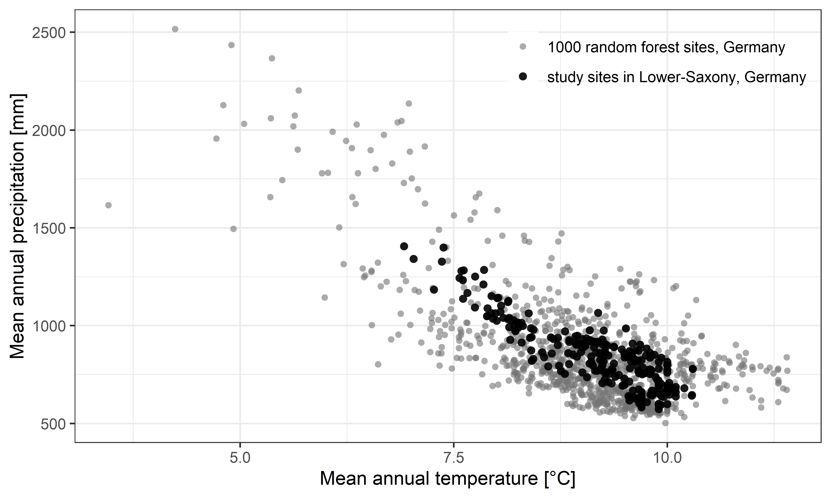
Fig. S2 Climatic conditions at the study sites in Lower-Saxony, compared to the conditions at 1000 random forest sites in Germany, based on multi-annual climate raster data 1991-2020 (DWD 2025).

Additional analysis on false negative detections
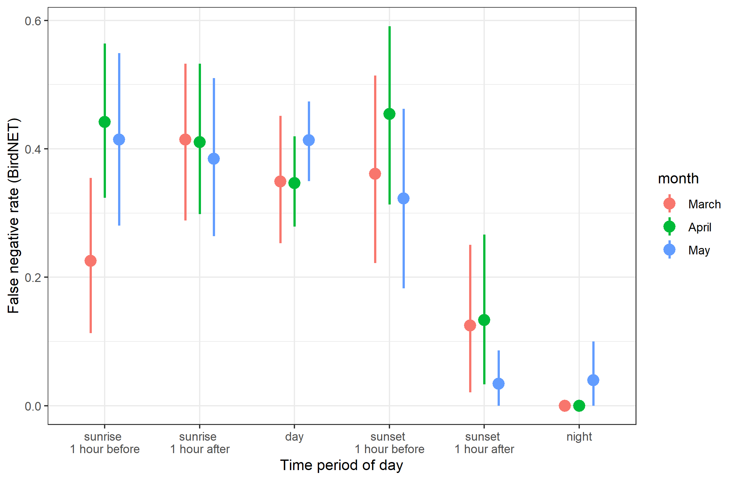
Fig. S3 False negative rates of BirdNET compared to a human listener per time period of the day and month. The analysis is based on 50 randomly chosen 30 sec audio files per month and daytime, in total 600 files à 30 sec. Sunrise and sunset period were post hoc split into two subperiods (1 hour before, 1 hour after) to demonstrate the differences before and after sunset/sunrise. We defined files without any bird detection by human listener and BirdNET as true positives. For species with at least five true positive detections in the human validated subset average recall was 0.64 while average precision was 0.70.

Basic results on species detections and sites
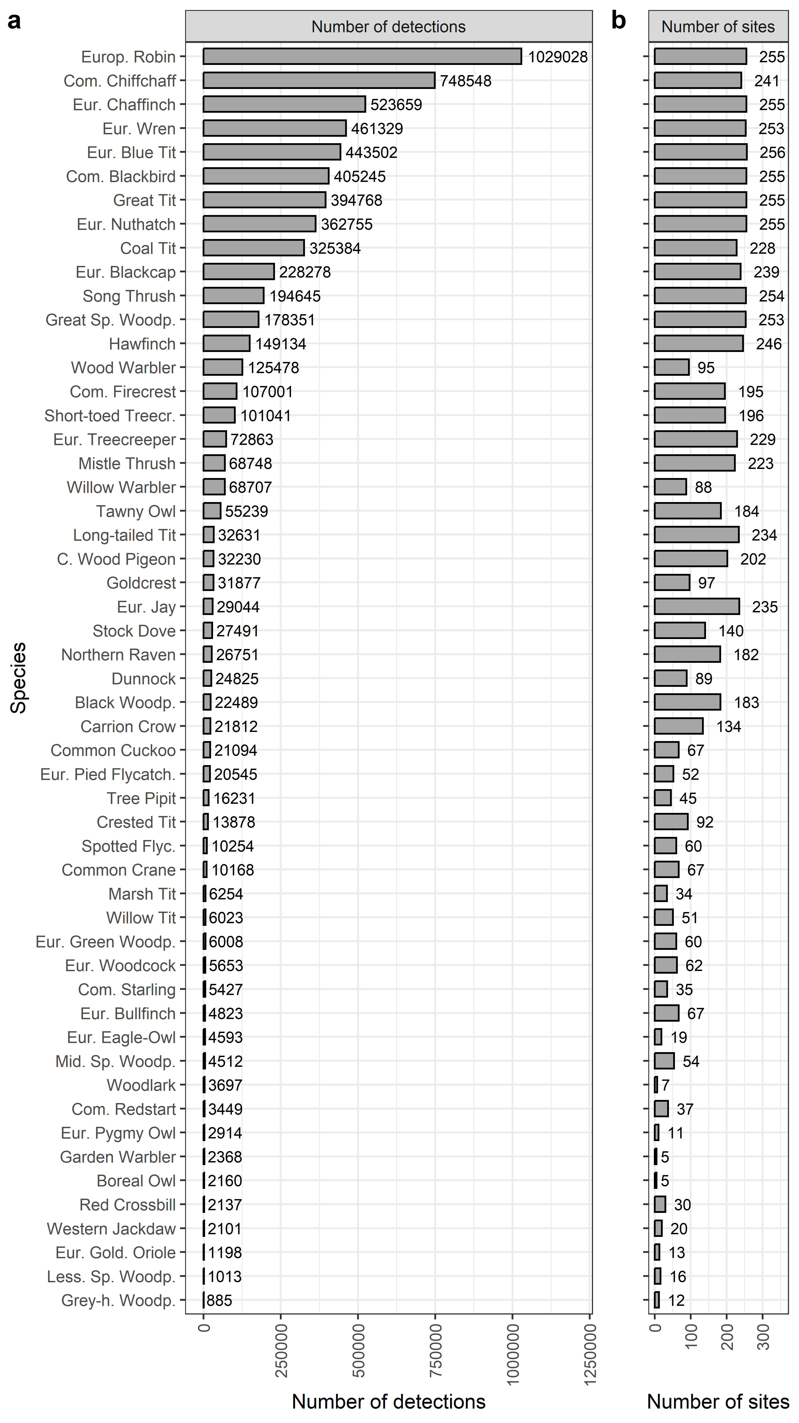
Fig. S4 a) Number of BirdNET detections per species after applying the species-specific thresholds, cf. Singer et al. (2024) and b) number of sites per species included in the analyses.
Comparison to expert knowledge
Fig. S5 Diel activity patterns of 53 European bird species per third of month. Dark blue rectangles mark the expert-knowledge based temporal survey recommendations from Südbeck et al. (2005), light blue rectangles mark their extended survey recommendations. The dashed line marks a relative detectability of 0.5, here defined as high detectability. Times of the day with high detectability are marked in dark orange, times of the day with low detectability are marked in light orange. Night times are marked in grey, the time between civil dawn and sunset/civil dusk and sunset with a lighter grey. Time of the day refers to Central European Time (UTC+1).

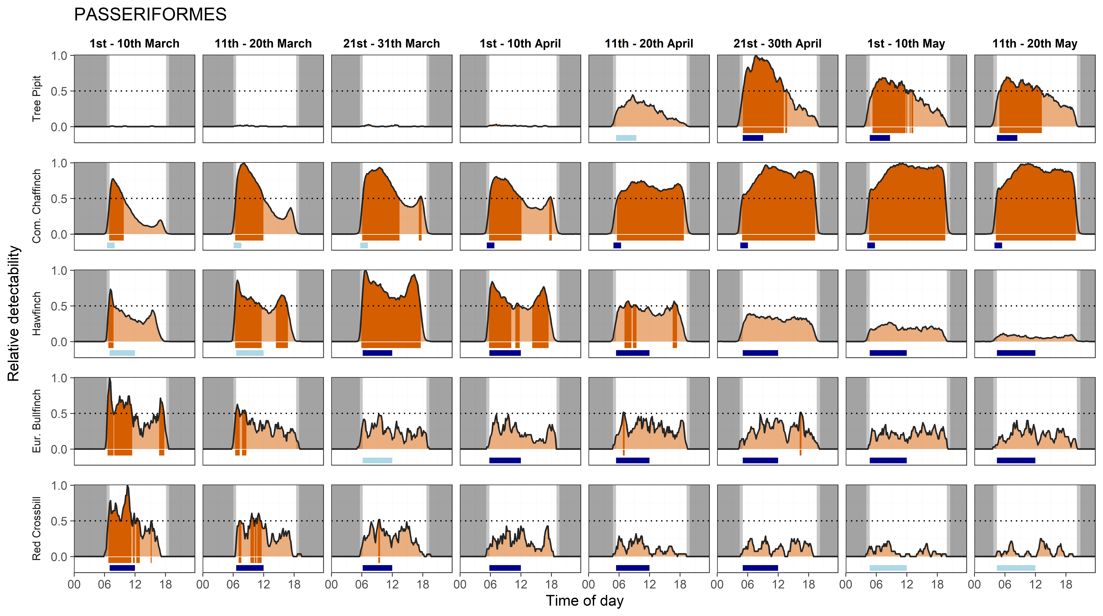

Tab. S1 Temporal alignment of high detectability of 53 European forest bird species (revealed by passive acoustic monitoring) and species-specific survey recommendations (Südbeck et al. 2005) and standard protocols for breeding bird surveys in Europe (Jiguet et al. 2012; Kamp et al. 2021), categories: A = Adequate temporal alignment, B = Benign temporal discrepancy, C1/C2 = Critical temporal discrepancy (cf. Fig. 2), for details see methodology.
Order | Scientific name | English name | Completenes Südbeck et al. | Specificity Südbeck et al. | Category Südbeck et al. | Completeness standard protocol | Specificity Standard protocol | Category standard protocol
CUCULIFORMES | Cuculus canorus | Common Cuckoo | 0.98 | 0.23 | C1 | 0.54 | 0.52 | A
COLUMBIFORMES | Columba oenas | Stock Dove | 0.51 | 0.74 | A | 0.74 | 0.90 | A
COLUMBIFORMES | Columba palumbus | C. Wood Pigeon | 0.47 | 0.73 | B | 0.68 | 0.80 | A
GRUIFORMES | Grus grus | Common Crane | 0.38 | 0.15 | C2 | 0.72 | 0.38 | C1
CHARADRIIFORMES | Scolopax rusticola | Eur. Woodcock | 0.20 | 0.31 | C2 | 0.00 | 0.00 | C2
STRIGIFORMES | Aegolius funereus | Boreal Owl | 0.30 | 0.06 | C2 | 0.00 | 0.00 | C2
STRIGIFORMES | Glaucidium passerinum | Eur. Pygmy Owl | 0.83 | 0.04 | C1 | 0.00 | 0.00 | C2
STRIGIFORMES | Bubo bubo | Eur. Eagle-Owl | 0.59 | 0.11 | C1 | 0.00 | 0.00 | C2
STRIGIFORMES | Strix aluco | Tawny Owl | 0.45 | 0.74 | B | 0.00 | 0.00 | C2
PICIFORMES | Dendrocoptes medius | Mid. Sp. Woodp. | 0.97 | 0.49 | C1 | 0.67 | 0.60 | A
PICIFORMES | Dryobates minor | Less. Sp. Woodp. | 0.92 | 0.10 | C1 | 0.92 | 0.23 | C1
PICIFORMES | Dendrocopos major | Great Sp. Woodp. | 0.91 | 0.27 | C1 | 0.91 | 0.49 | C1
PICIFORMES | Dryocopus martius | Black Woodp. | 0.55 | 0.50 | C1 | 0.48 | 0.64 | B
PICIFORMES | Picus viridis | Eur. Green Woodp. | 0.87 | 0.30 | C1 | 0.75 | 0.47 | C1
PICIFORMES | Picus canus | Grey-h. Woodp. | 0.89 | 0.08 | C1 | 0.89 | 0.24 | C1
PASSERIFORMES | Oriolus oriolus | Eur. Gold. Oriole | 0.48 | 0.43 | C2 | 0.57 | 0.65 | A
PASSERIFORMES | Garrulus glandarius | Eur. Jay | 0.62 | 0.39 | C1 | 0.86 | 0.68 | A
PASSERIFORMES | Corvus monedula | Western Jackdaw | 0.83 | 0.41 | C1 | 0.83 | 0.65 | A
PASSERIFORMES | Corvus corone | Carrion Crow | 0.34 | 0.12 | C2 | 0.74 | 0.66 | A
PASSERIFORMES | Corvus corax | Northern Raven | 0.66 | 0.62 | A | 0.39 | 0.67 | B
PASSERIFORMES | Periparus ater | Coal Tit | 0.12 | 0.52 | B | 0.30 | 0.70 | B
PASSERIFORMES | Lophophanes cristatus | Crested Tit | 0.39 | 0.50 | C2 | 0.50 | 0.83 | B
PASSERIFORMES | Poecile palustris | Marsh Tit | 0.30 | 0.03 | C2 | 0.30 | 0.04 | C2
PASSERIFORMES | Poecile montanus | Willow Tit | 0.36 | 0.06 | C2 | 0.36 | 0.05 | C2
PASSERIFORMES | Cyanistes caeruleus | Eur. Blue Tit | 0.18 | 0.46 | C2 | 0.22 | 0.62 | B
PASSERIFORMES | Parus major | Great Tit | 0.06 | 0.28 | C2 | 0.20 | 0.46 | C2
PASSERIFORMES | Lullula arborea | Woodlark | 0.77 | 0.28 | C1 | 0.77 | 0.35 | C1
PASSERIFORMES | Aegithalos caudatus | Long-tailed Tit | 0.55 | 0.22 | C1 | 0.30 | 0.71 | B
PASSERIFORMES | Phylloscopus sibilatrix | Wood Warbler | 0.37 | 1.00 | B | 0.37 | 1.00 | B
PASSERIFORMES | Phylloscopus trochilus | Willow Warbler | 0.22 | 0.96 | B | 0.29 | 0.97 | B
PASSERIFORMES | Phylloscopus collybita | Com. Chiffchaff | 0.13 | 0.98 | B | 0.35 | 0.99 | B
PASSERIFORMES | Sylvia atricapilla | Eur. Blackcap | 0.20 | 0.51 | B | 0.28 | 0.69 | B
PASSERIFORMES | Sylvia borin | Garden Warbler | 0.27 | 0.94 | B | 0.37 | 0.96 | B
PASSERIFORMES | Regulus ignicapilla | Com. Firecrest | 0.17 | 1.00 | B | 0.33 | 1.00 | B
PASSERIFORMES | Regulus regulus | Goldcrest | 0.23 | 0.63 | B | 0.06 | 0.02 | C2
PASSERIFORMES | Troglodytes troglodytes | Eur. Wren | 0.77 | 0.90 | A | 0.64 | 0.70 | A
PASSERIFORMES | Sitta europaea | Eur. Nuthatch | 0.51 | 0.60 | A | 0.51 | 0.97 | A
PASSERIFORMES | Certhia familiaris | Eur. Treecreeper | 0.30 | 0.05 | C2 | 0.42 | 0.08 | C2
PASSERIFORMES | Certhia brachydactyla | Short-toed Treecr. | 0.39 | 0.99 | B | 0.33 | 0.86 | B
PASSERIFORMES | Sturnus vulgaris | Com. Starling | 0.39 | 0.34 | C2 | 0.77 | 0.66 | A
PASSERIFORMES | Turdus philomelos | Song Thrush | 0.51 | 0.25 | C1 | 0.20 | 0.09 | C2
PASSERIFORMES | Turdus viscivorus | Mistle Thrush | 0.89 | 0.29 | C1 | 0.89 | 0.53 | A
PASSERIFORMES | Turdus merula | Com. Blackbird | 0.03 | 0.02 | C2 | 0.00 | 0.00 | C2
PASSERIFORMES | Muscicapa striata | Spotted Flyc. | 0.46 | 1.00 | B | 0.62 | 0.67 | A
PASSERIFORMES | Erithacus rubecula | Europ. Robin | 0.17 | 0.27 | C2 | 0.00 | 0.00 | C2
PASSERIFORMES | Ficedula hypoleuca | Eur. Pied Flycatch. | 0.42 | 0.48 | C2 | 0.28 | 0.85 | B
PASSERIFORMES | Phoenicurus phoenicurus | Com. Redstart | 0.14 | 0.38 | C2 | 0.16 | 0.27 | C2
PASSERIFORMES | Prunella modularis | Dunnock | 0.68 | 0.76 | A | 0.75 | 0.95 | A
PASSERIFORMES | Anthus trivialis | Tree Pipit | 0.46 | 0.92 | B | 0.46 | 0.92 | B
PASSERIFORMES | Fringilla coelebs | Eur. Chaffinch | 0.07 | 0.71 | B | 0.38 | 0.96 | B
PASSERIFORMES | Coccothraustes coccothraustes | Hawfinch | 0.41 | 0.32 | C2 | 0.47 | 0.74 | B
PASSERIFORMES | Pyrrhula pyrrhula | Eur. Bullfinch | 0.04 | 0.01 | C2 | 0.71 | 0.35 | C1
PASSERIFORMES | Loxia curvirostra | Red Crossbill | 0.88 | 0.20 | C1 | 0.70 | 0.49 | C1

Tab. S2 Summary of the temporal alignment of high detectability of 53 European forest bird species (revealed by passive acoustic monitoring) and species-specific survey recommendations (Südbeck et al. 2005) and standard protocols for breeding bird surveys in Europe (Jiguet et al. 2012; Kamp et al. 2021), categories: A = Adequate temporal alignment, B = Benign temporal discrepancy, C1/C2 = Critical temporal discrepancy (cf. Fig. 2), for details see methodology.
 | Species-specific recommendations (Südbeck et al. 2005) |  | Standard protocols (4 hours after sunrise)
Temporal alignment category | Number of species | Proportion of species | Number of species | Proportion of species
A | Adequate alignment | 5 | 0.09 | 14 | 0.26
B | Benign discrepancy | 14 | 0.26 | 17 | 0.32
C1 | Critical discrepancy | 16 | 0.30 | 8 | 0.15
C2 | Critical discrepancy | 18 | 0.34 | 14 | 0.26

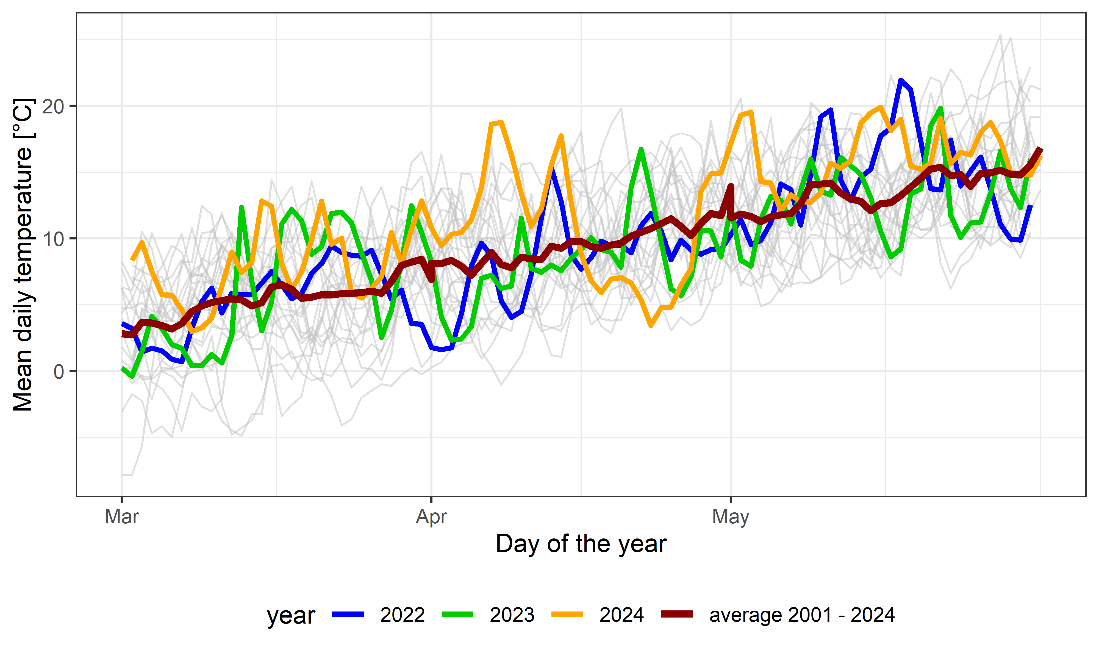
Fig. S6 Mean daily temperature in the study period at the climate weather station “Hannover” in the centre of the study area (DWD 2025). Trajectories of all years between 2001 and 2024 are shown in grey in the background. Trajectories of the years included in this study (2022, 2023, 2024) and the multi-year average are highlighted with bold lines.

