Electronic supplementary material

Movements throughout the full annual cycle of three migratory swift species breeding in the Levant

Daniel A. F. Bloche, Itai Bloch, Christoph M. Meier, Nir Sapir

¹Department of Evolutionary and Environmental Biology, Faculty of Natural Sciences, University of Haifa, Haifa, Israel
²Swiss Ornithological Institute, Sempach, Switzerland

*Corresponding author: danielbloche@hotmail.de

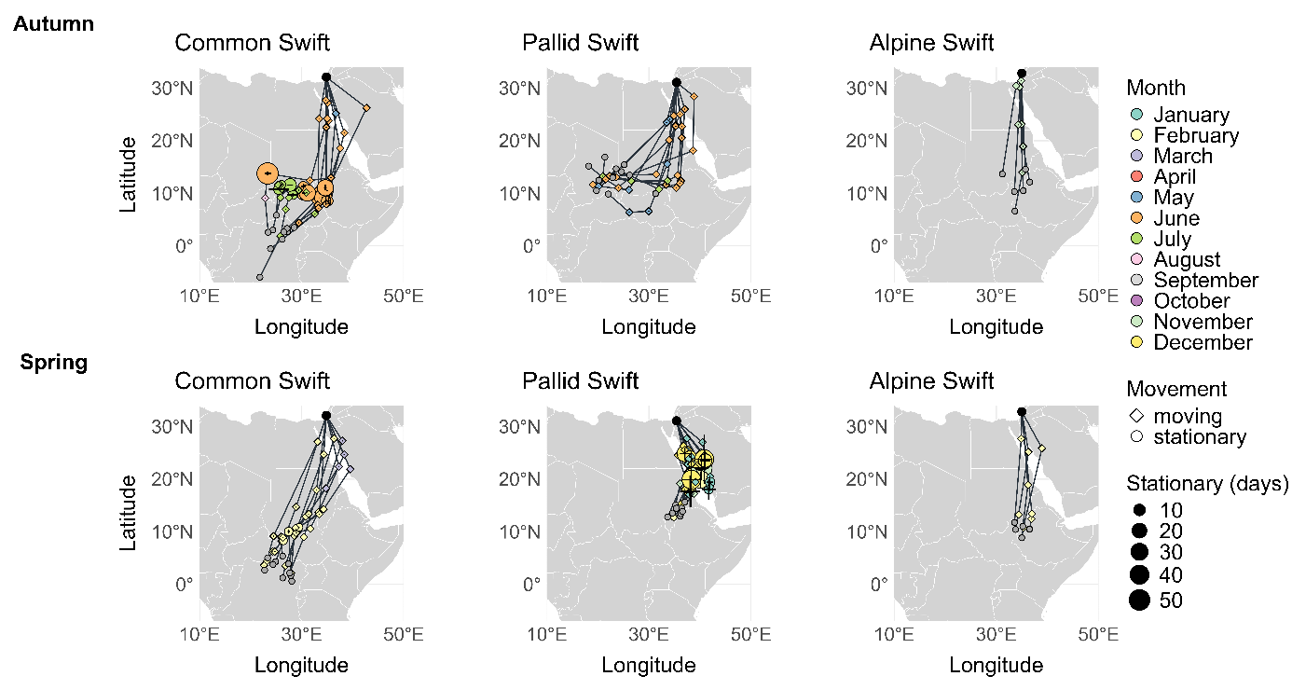
Fig. S1 Migratory movements of Common Swifts (Apus apus, n = 10), Pallid Swifts (A. pallidus, n = 12 in autumn and n = 10 in spring), and Alpine Swifts (Tachymarptis melba, n = 6 in autumn and n = 5 in spring), during their autumn (upper row), and spring migration (lower row).
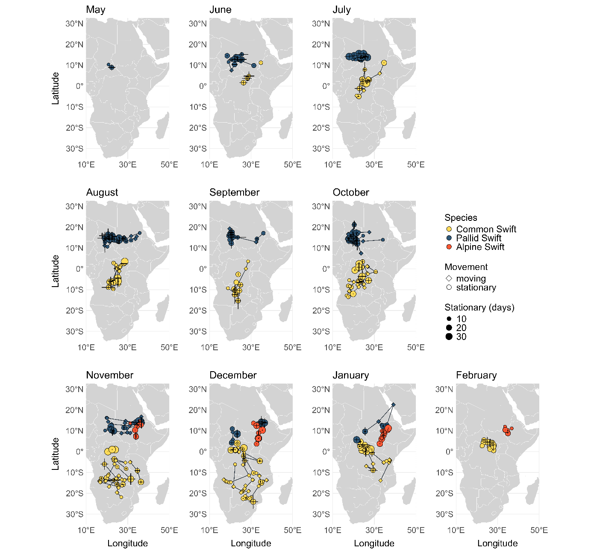
Fig. S2 Spatiotemporal movements of Common Swifts (Apus apus, n = 10), Pallid Swifts (A. pallidus, n = 10), and Alpine Swifts (Tachymarptis melba, n = 5) at their African non-breeding range between May and February.

Table S1 Parameters of the species-specific non-breeding season movement statistical models. The mean value is presented with the range in brackets. A significant difference between species is shown with the significance indicators (i.e. p < 0.0001 ‘***’ < 0.001 ‘**’ < 0.01 ‘*’ < 0.05 ‘ ’ ≥ 0.05) and with post-hoc labelling (a,b,c denoting p < 0.05) between each species. ANOVA and post-hoc Tukey tests, non-parametric Kruskal-Wallis and Dunn’s tests, or Games-Howell tests were used.
 | Common Swift | Pallid Swift | Alpine Swift | Sign.
Complete non-breeding season | (n = 10) | (n = 10) | (n = 5)
Total movement distance (km) | 15,063.34 a  (10,733–19,307) | 9973.00 b  (7,530–12,454) | 5678.04 c  (4,831–6,533) | ***
Autumn migration | (n = 10) | (n = 12) | (n = 6)
Departure time from breeding range (ordinal date) | 7th June a  (28th May – 16th June) | 9th June a  (14th May – 25th June) | 13th November b  (6th Nov. – 24th Nov.) | ***
Migration route distance (km) | 4,178 a  (3,433–6,011) | 3,304.20 b  (2,150–4,275) | 2,394.93 b  (2,025–2,914) | ***
Direct distance (km) | 3,491.63 a  (3,076–4,425) | 2,363.88 b  (2,020–2,791) | 2,389.58 b  (2,024–2,902) | ***
Detour of the migration route relative to direct distance (%) | 19.23 (6.3–37.4) a | 40.33 (1–88.8) a | 0.22 (0–0.4) b | ***
Migration duration (days) | 31.50 (11–57) a | 9.25 (3–20) b | 4.66 (3–9) b | ***
Stopover (days) | 18.10 (0–44) a | 0 (0–0) b | 0 (0–0) b | ***
Migration speed (km/day) | 166.63 (84–334) a | 431.09 (214–799) b | 570.24 (324–721) b | ***
Travel speed (km/day) | 340.04 (163–518) a | 431.09 (214–799) ab | 570.24 (324–721) b | *
Arrival at non-breeding range (ordinal date) | 8th July a  (19th June – 5th Aug.) | 17th June b  (23rd May – 10th July) | 17th November c  (8th Nov. – 26th Nov.) | ***
Non-breeding range | (n = 10) | (n = 10) | (n = 5)
Duration (days) at non-breeding range | 221.20 (187–243) a | 185.80 (132–234) b | 85.80 (69–94) c | ***
Movement (days) at non-breeding range | 28.50 (3–58) a | 11.30 (0–23) b | 3.20 (0–7) b | **
Movement distance (km) at non-breeding range | 7,295.93 a  (1,673–11,851) | 3,634.46 b  (2,001–5,559) | 630.3 c  (0–2,084) | ***
Travel speed (km/day) | 327.93  (102–558) | 448.45  (171–1,013) | 211.22  (23–313)
Spring migration | (n=10) | (n=10) | (n=5)
Departure time from non-breeding range (ordinal date) | 14th February  (7th Feb. – 21st Feb.) | 18th December  (18th Nov. – 26st Jan.) | 9th February  (2nd Feb. – 14th Feb.)
Migration route distance (km) | 3,588.83 a  (3,245–4,124) | 2,882.64 ab  (1,732–4,882) | 2,508.1 b  (2,336–2,788) | ***
Direct distance (km) | 3,348.15 a  (3,085–3,554) | 1,883.64 b  (1,715–2,034) | 2,471.21 c  (2,335–2,652) | ***
Detour of the migration route relative to direct distance (%) | 7.23 (0.1–20.3) ab | 53.65 (1–167) b | 1.42 (0.1–5.1) a | ***
Migration duration (days) | 14.90 (7–25) ab | 38.50 (7–62) b | 6.60 (4–8) a | **
Stopover (days) | 2.00 (0–8) a | 25.70 (0–54) b | 0.00 (0–0) a | **
Migration speed (km/day) | 282.62 (153–464) ab | 115.85 (34–305) b | 404.15 (314–621) a | **
Travel speed (km/day) | 307.50 (177–464) ab | 245.66 (157–305) b | 404.15 (314–621) a | *
Arrival at breeding range (ordinal date) | 28th February a  (18th Feb. – 6th Mar.) | 26th January b  (11th Jan. – 26th Feb.) | 15th February ab  (8th Feb. – 21st Feb.) | ***

Table S2 Comparisons of migration properties between autumn and spring, respectively for Common Swifts (n = 10), Pallid Swifts (n = 12 in autumn and n = 10 in spring), and Alpine Swifts (n = 6 in autumn and n = 5 in spring), using paired t-tests or non-parametric Wilcoxon signed-rank tests. Significant p-values are shown in bold.
 | t-value | Degree of freedom | V-value | p-value | Range of differences
Common Swift
Migration duration (days) | 3.107 | 9 |  | 0.013 | -7–45
Stopover (days) | 3.212 | 9 |  | 0.011 | -6–44
Migration route distance (km) |  |  | 40 | 0.577 | -52–2301
Detour of the migration route relative to direct distance (%) |  |  | 22 | 0.625 | 5.12–27.38
Migration speed (km/day) | -2.405 | 9 |  | 0.04 | -358–124
Travel speed (km/day) | 0.836 | 9 |  | 0.425 | -140–260
Pallid Swift
Migration duration (days) | -5.236 | 9 |  | < 0.001 | -46–4
Stopover (days) | -4.463 | 9 |  | 0.002 | -54–0
Migration route distance (km) | 1.379 | 9 |  | 0.201 | -1,668–1,899
Detour of the migration route relative to direct distance (%) | -0.473 | 9 |  | 0.648 | -119.7–74.62
Migration speed (km/day) | 4.776 | 9 |  | 0.001 | 24–685
Travel speed (km/day) | 3.019 | 9 |  | 0.015 | -43–438
Alpine Swift
Migration duration (days) | -1.907 | 4 |  | 0.129 | -4–1
Stopover (days) | NA | NA |  | NA | NA
Migration route distance (km) | -1.051 | 4 |  | 0.353 | -400–127
Detour of the migration route relative to direct distance (%) | -1.372 | 4 |  | 0.242 | -4.69–0.27
Migration speed (km/day) | 2.227 | 4 |  | 0.090 | -25–387
Travel speed (km/day) | 2.227 | 4 |  | 0.089 | -25–387

Table S3 Comparison of Common Swifts (n = 10) travel speed between autumn, spring, and stationary sites in the non-breeding range using repeated-measures ANOVA with Tukey’s post-hoc pairwise comparisons.
 | Degrees of freedom | Sum Sq | Mean Sq | F-value | p-value
Season | 2 | 5,411 | 2,705 | 0.187 | 0.830
Residuals | 26 | 375,267 | 14,433

Table S4 Comparison of the travel speed between autumn, spring, and stationary sites in the non-breeding range, for Pallid Swifts (n = 12 in autumn, and n = 10 throughout the full annual cycle), using a non-parametric Friedman test.
 | Degrees of freedom | Chi Sq | p-value
Season | 2 | 4.667 | 0.097

Table S5a Comparison of the travel speed between autumn, spring and between stationary sites at the non-breeding range, for Alpine Swifts (n = 6 in autumn, and n = 5 throughout the full annual cycle), using repeated-measures ANOVA with post-hoc pairwise comparisons using Tukey’s adjustment. Significant p-values are shown in bold.
 | Degrees of freedom | Sum Sq | Mean Sq | F-value | p-value
Season | 2 | 259,170 | 129,585 | 5.81 | 0.021
Residuals | 10 | 223,041 | 22,304

Table S5b Comparison of the travel speed (km/day) between autumn, spring, and stationary sites in the non-breeding range, for Alpine Swifts (n = 6 in autumn, and n = 5 throughout the full annual cycle), using repeated-measures ANOVA with Tukey’s post-hoc pairwise comparisons adjustment. Significant p-values are shown in bold.
 | Estimate | Standard error | Degrees of freedom | t-ratio | p-value | Range of differences
Autumn–spring | 166 | 87.2 | 6 | 1.904 | 0.218 | -25–387
Autumn – non-breeding range | 356 | 102.0 | 6 | 3.525 | 0.029 | 310–596
Spring – non-breeding range | 193 | 105.0 | 6 | 1.834 | 0.238 | 0–598

Table S6 Comparison of parameters of the non-breeding season movements between males and females, respectively for Common and Alpine Swifts, using Mann-Whitney U tests.
 | Common Swift |  | Alpine Swift
 | W-value | p-value | W-value | p-value
Complete non-breeding season | (n = 4 males, n = 6 females) |  | (n = 3 males, n = 2 females)
Total movement distance (km) | 11 | 0.914 | 4 | 0.800
Autumn migration | (n = 4 males, n = 6 females) |  | (n = 3 males. n = 3 females)
Departure from breeding range (ordinal date) | 15 | 0.610 | 3.5 | 0.825
Migration route distance (km) | 18 | 0.257 | 3 | 0.700
Direct distance (km) | 16 | 0.476 | 3. | 0.700
Detour of the migration route relative to direct distance (%) | 18 | 0.257 | 6 | 0.700
Migration duration (days) | 13 | 0.914 | 3 | 0.653
Stopover (days) | 14.5 | 0.669 | NA | NA
Migration speed (km/day) | 13 | 0.914 | 6 | 0.700
Travel speed (km/day) | 16 | 0.476 | 6 | 0.700
Arrival at non-breeding range | 14.5 | 0.668 | 5 | > 0.999
Non-breeding range | (n = 4 males, n = 6 females) |  | (n = 3 males, n = 2 females)
Duration (days) at non-breeding range | 8 | 0.476 | 2.5 | > 0.999
Movement (days) at non-breeding range | 7 | 0.352 | 2 | 0.767
Movement distance (km) at non-breeding range | 9 | 0.610 | 7 | 0.400
Travel speed (km/day) | 16 | 0.476 | NA | NA
Spring migration | (n = 4 males, n = 6 females) |  | (n = 3 males, n = 2 females)
Departure from non-breeding range (ordinal date) | 4 | 0.104 | 2.5 | > 0.999
Migration route distance (km) | 21 | 0.067 | 2 | 0.800
Direct distance (km) | 13 | 0.914 | 2 | 0.800
Detour of the migration route relative to direct distance (%) | 20 | 0.114 | 3 | > 0.999
Migration duration (days) | 18.5 | 0.120 | 3.5 | > 0.999
Stopover (days) | 16.5 | 0.292 | NA | NA
Migration speed (km/day) | 6 | 0.257 | 3 | > 0.999
Travel speed (km/day) | 8 | 0.476 | 3 | > 0.999
Arrival at breeding range (ordinal date) | 13 | 0.914 | 2.5 | > 0.999

Table S7 Testing linear relationships between parameters of non-breeding season movements and Common Swifts body size using Linear Regression analysis or generalized linear models (GLMs) with a Gamma or Quasi-poisson distribution.
 | Degrees of freedom | Adjusted r-squared | F-statistic | AIC | Estimate (Standard error) | p-value
Complete non-breeding season | (n = 10)
Total movement distance (km) | 8 | 0.073 | 1.706 |  | 1,210.400 (926.80) | 0.228
Autumn migration | (n = 10)
Departure from breeding range (ordinal date) | 8 | -0.125 | 0.002 |  | 0.087 (2.23) | 0.970
Migration route distance (km) | 9 |  |  | 163.7 | -0.021 (0.06) | 0.711
Direct distance (km) | 9 |  |  | 150.9 | 0.009 (0.03) | 0.794
Detour of the migration route relative to direct distance (%) | 8 | 0.012 | 1.108 |  | -3.521 (3.35) | 0.323
Migration duration (days) | 8 | -0.002 | 0.979 |  | -4.667 (4.72) | 0.352
Stopover (days) | 8 | -0.0548 | 0.533 |  | -3.244 (4.45) | 0.486
Migration speed (km/day) | 8 | 0.208 | 3.366 |  | 42.450 (23.14) | 0.104
Travel speed (km/day) | 8 | -0.076 | 0.361 |  | 18.510 (30.79) | 0.564
Arrival at non-breeding range (ordinal date) | 8 | 0.002 | 1.020 |  | -4.593 (4.55) | 0.342
Non-breeding range | (n = 10)
Duration (days) at non-breeding range | 8 | -0.029 | 0.746 |  | 4.885 (5.66) | 0.413
Movement (days) at non-breeding range | 8 | 0.207 | 3.355 |  | 8.664 (4.73) | 0.104
Movement distance (km) at non-breeding range | 8 | 0.075 | 1.726 |  | 1,357.000 (1,033.00) | 0.225
Travel speed (km/day) | 8 | 0.128 | 2.322 |  | -64.010 (42.00) | 0.166
Spring migration | (n = 10)
Departure from non-breeding range (ordinal date) | 8 | -0.120 | 0.034 |  | 0.292 (1.58) | 0.858
Migration route distance (km) | 8 | -0.031 | 0.729 |  | -63.350 (74.17) | 0.418
Direct distance (km) | 8 | -0.105 | 0.145 |  | 18.730 (49.23) | 0.714
Detour of the migration route relative to direct distance (%) | 8 | 0.041 | 1.388 |  | -2.357 (2.00) | 0.273
Migration duration (days) | 8 | 0.068 | 1.651 |  | -2.432 (1.89) | 0.235
Stopover (days) | 9 |  |  | NA | -0.265 (0.54) | 0.639
Migration speed (km/day) | 8 | -0.061 | 0.483 |  | 23.960 (34.48) | 0.507
Travel speed (km/day) | 8 | 0.007 | 1.060 |  | 29.180 (28.35) | 0.333
Arrival at breeding range (ordinal date) | 8 | 0.101 | 2.010 |  | -2.140 (1.51) | 0.194

Table S8 Testing linear relationships between parameters of non-breeding season movement and Pallid Swifts body size using Linear Regression analysis or generalized linear models (GLMs) with a Gamma distribution.
 | Degrees of freedom | Adjusted r-squared | F-statistic | AIC | Estimate (Standard error) | p-value
Complete non-breeding season | (n = 10)
Total movement distance (km) | 8 | 0.134 | 2.391 |  | 700.600 (453.00) | 0.161
Autumn migration | (n = 12)
Departure from breeding range (ordinal date) | 10 | 0.166 | 3.184 |  | -6.052 (3.39) | 0.105
Migration route distance (km) | 10 | 0.264 | 4.948 |  | 301.800 (135.70) | 0.051
Direct distance (km) | 10 | 0.078 | 1.925 |  | 83.150 (59.93) | 0.195
Detour of the migration route relative to direct distance (%) | 10 | 0.030 | 1.339 |  | 7.636 (6.60) | 0.274
Migration duration (days) | 10 | 0.121 | 2.508 |  | 1.862 (1.18) | 0.144
Stopover (days) | NA | NA | NA | NA | NA | NA
Migration speed (km/day) | 10 | 0.155 | 3.016 |  | -71.780 (41.33) | 0.113
Travel speed (km/day) | 10 | 0.155 | 3.016 |  | -71.780 (41.33) | 0.113
Arrival at non-breeding range (ordinal date) | 10 | 0.029 | 1.327 |  | -4.191 (3.64) | 0.276
Non-breeding range | (n = 10)
Duration (days) at non-breeding range | 8 | 0.049 | 0.419 |  | -5.524 (8.53) | 0.535
Movement (days) at non-breeding range | 8 | -0.050 | 0.570 |  | 1.872 (2.48) | 0.472
Movement distance (km) at non-breeding range | 10 | -0.099 | 0.011 |  | 28.370 (276.00) | 0.920
Travel speed (km/day) | 8 |  |  | 128.3 | -0.249 (0.20) | 0.254
Spring migration | (n = 10)
Departure from non-breeding range (ordinal date) | 10 | 0.342 | 5.194 |  | -10.362 (4.55) | 0.046
Migration route distance (km) | 9 |  |  | 166.5 | 0.174 (0.09) | 0.085
Direct distance (km) | 8 | -0.119 | 0.046 |  | -6.415 (30.07) | 0.836
Detour of the migration route relative to direct distance (%) | 9 |  |  | 101.2 | 0.800 (0.34) | 0.044
Migration duration (days) | 9 |  |  | 94.3 | 0.175 (0.15) | 0.262
Stopover (days) | 8 | 0.007 | 0.057 |  | 1.271 (5.32) | 0.817
Migration speed (km/day) | 8 | 0.995 | 0.884 |  | -26.310 (27.99) | 0.375
Travel speed (km/day) | 9 |  |  | 108.6 | -0.108 (0.05) | 0.049
Arrival at breeding range (ordinal date) | 8 | 0.173 | 2.878 |  | -6.256 (3.69) | 0.128

Table S9 Testing linear relationships between parameters of non-breeding season movement and Alpine Swifts body size using Linear Regression analysis or generalized linear models (GLMs) with a Gamma distribution.
 | Degrees of freedom | Adjusted r-squared | F-statistic | AIC | Estimate (Standard error) | p-value
Complete non-breeding season | (n = 5)
Total movement distance (km) | 3 | -0.178 | 0.397 |  | 201.400 (319.50) | 0.573
Autumn migration | (n = 6)
Departure from breeding range (ordinal date) | 4 | -0.246 | 0.013 |  | -0.319 (2.85) | 0.916
Migration route distance (km) | 5 |  |  | 86.7 | -0.084 (0.04) | 0.130
Direct distance (km) | 5 |  |  | 86.5 | -0.083 (0.04) | 0.129
Detour of the migration route relative to direct distance (%) | 4 | -0.201 | 0.165 |  | -0.030 (0.07) | 0.706
Migration duration (days) | 5 |  |  | 27.8 | -0.219 (0.19) | 0.321
Stopover (days) | NA | NA | NA | NA | NA | NA
Migration speed (km/day) | 4 | 0.003 | 1.016 |  | 61.700 (61.22) | 0.371
Travel speed (km/day) | 4 | 0.003 | 1.016 |  | 61.700 (61.22) | 0.371
Arrival at non-breeding range (ordinal date) | 4 | -0.198 | 0.174 |  | -1.129 (2.70) | 0.698
Non-breeding range | (n = 5)
Duration (days) at non-breeding range | 3 | -0.325 | 0.018 |  | -0.682 (5.06) | 0.901
Movement (days) at non-breeding range | 3 | -0.327 | 0.015 |  | 0.191 (1.59) | 0.912
Movement distance (km) at non-breeding range | 4 | 0.394 | 4.248 |  | 515.000 (249.90) | 0.108
Travel speed (km/day) | 1 | -0.142 | 0.752 |  | 69.900 (80.60) | 0.545
Spring migration | (n = 5)
Departure from non-breeding range (ordinal date) | 5 |  |  | 56.4 | 0.005 (0.02) | 0.833
Migration route distance (km) | 3 | -0.059 | 0.778 |  | -64.970 (73.65) | 0.443
Direct distance (km) | 3 | 0.044 | 1.182 |  | -52.430 (48.22) | 0.356
Detour of the migration route relative to direct distance (%) | 3 | -0.238 | 0.232 |  | -0.474 (0.98) | 0.663
Migration duration (days) | 3 | -0.291 | 0.097 |  | 0.250 (0.80) | 0.775
Stopover (days) | NA | NA | NA | NA | NA | NA
Migration speed (km/day) | 3 | -0.059 | 0.779 |  | -48.100 (54.49) | 0.442
Travel speed (km/day) | 3 | -0.059 | 0.779 |  | -48.100 (54.49) | 0.442
Arrival at breeding range (ordinal date) | 3 | -0.211 | 0.302 |  | -1.497 (2.72) | 0.621

