Electronic Supplementary Material

Table S1 Summary of all deployments, including species, location, deployment method, clamp variant, and date range. Seven types of clamps were used, weighing between 0.7 g (Ornitela6-mantle) and 3.3 g (Interrex12-tail; Table S2). All STL files and schematic PDFs used to 3D print the GPS attachment clamps are available at: https://doi.org/10.5281/zenodo.15167344.
Species | Place | Method | Clamp variant | Deployed | n
Black-headed Gull | Oslo | Mantle | ornitela6-mantle | 30.04.2024 | 5
Black-headed Gull | Stavanger | Mantle | ornitela6-mantle | 03.05.2024 - 04.05.2024 | 5
Common Gull | Bergen | Mantle | ornitela6-mantle | 10.05.2024 - 19.06.2024 | 5
Common Eider | Tvedestrand | Mantle | ornitela10D-mantle | 15.05.2024 - 20.05.2024 | 20
Great Skua | Hjelmsøya | Mantle | ornitela10-mantle | 06.06.2024 - 07.06.2024 | 5
Great Skua | Runde | Mantle | ornitela10-mantle | 13.06.2024 | 2
Great Skua | Runde | Tail | ornitela10-tail | 13.06.2024 - 14.06.2024 | 3
European Herring Gull | Karmøy | Mantle | interrex12-mantle | 23.05.2023 | 6
European Herring Gull | Karmøy | Mantle | ornitela10-mantle | 23.05.2023 | 4
European Herring Gull | Mandal | Mantle | interrex12-mantle | 19.05.2023 | 2
European Herring Gull | Mandal | Mantle | ornitela10-mantle | 19.05.2023 | 3
Lesser Black-backed Gull | Bergen | Mantle | interrex12-mantle | 11.05.2023 | 1
Lesser Black-backed Gull | Bergen | Mantle | ornitela10-mantle | 12.05.2023 - 01.08.2024 | 11
Lesser Black-backed Gull | Bergen | Tail | interrex12-tail | 12.05.2023 | 1
Lesser Black-backed Gull | Bergen | Tail | ornitela10-tail | 11.05.2023 | 1
Lesser Black-backed Gull | Karmøy | Mantle | interrex12-mantle | 23.05.2023 | 2
Lesser Black-backed Gull | Karmøy | Mantle | ornitela10-mantle | 23.05.2023 | 4
Lesser Black-backed Gull | Karmøy | Tail | interrexPCBA-tail | 23.05.2023 | 1
Lesser Black-backed Gull | Mandal | Mantle | interrex12-mantle | 19.05.2023 - 28.05.2023 | 3
Lesser Black-backed Gull | Mandal | Mantle | ornitela10-mantle | 19.05.2023 - 28.05.2023 | 2

Table S2 Clamp variants, their respective weights, and the GPS devices they are designed for. Total attachment mass is the combined mass of the device with the clamp. All STL files and schematic PDFs used to 3D print the GPS attachment clamps are available at: https://doi.org/10.5281/zenodo.15167344.
Clamp variant | Clamp mass (g) | Designed for device | Device mass (g) | Total attachment mass (g)
ornitela6-mantle | 0.5 | OT-6 (4GX-C74-S) | 5.7 | 6.2
ornitela10D-mantle | 1.7 | OT-10D (4GC-C76) | 11.6 | 13.3
ornitela10-mantle | 1.6 | OT-10 (4GC-C79-S) | 10.8 | 12.4
ornitela10-tail | 2.5 | OT-10 (4GC-C79-S) | 10.8 | 13.3
interrex12-mantle | 1.7 | INTERREX 4G 12 | 11.4 | 13.1
interrex12-tail | 3.2 | INTERREX 4G 12 | 11.4 | 14.6
interrexPCBA-tail | 2.6 | INTERREX 4G PCBA | 7.5 | 10.1
ornitela10D-mantle_thinner | 0.9 | OT-10D (4GC-C76) | 11.6 | 12.5

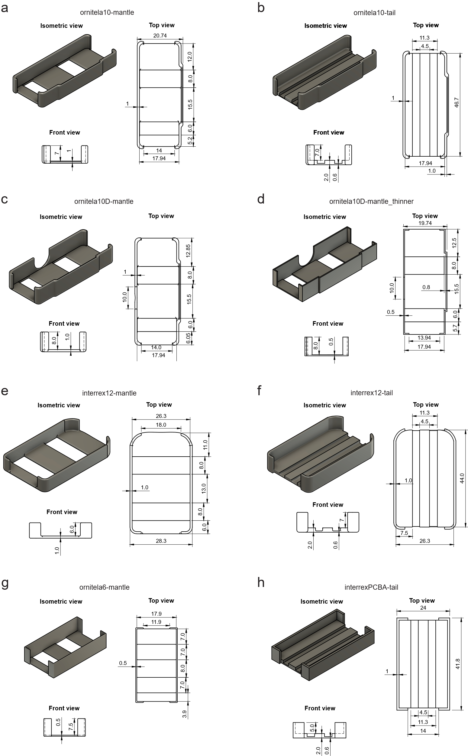
Fig. S1 Schematic drawings of all clamp designs used in this study, with measurements in millimeters (mm). (a) ornitela10-mantle, (b) ornitela10-tail, (c) ornitela10D-mantle, (d) ornitela10D-mantle_thinner, (e) interrex12-mantle, (f) interrex12-tail, (g) ornitela6-back, (h) interrexPCBA-tail.

