Electronic Supplementary Material
Table S1. Monthly utilization distribution size of marked Rüppell’s Vultures during the breeding season. Units are in km².
 | Adult male |  | Adult female |  | Immature
 | Core area (50% UD isopleth) | Home range area (95% UD isopleth) | Core area (50% UD isopleth) | Home range area (95% UD isopleth) | Core area (50% UD isopleth) | Home range area (95% UD isopleth)
November | 69.82 | 676.05 | 61.20 | 680.63 | 2,731.44 | 18,585.78
December | 123.70 | 749.52 | 0.85 | 7.56 | 447.97 | 2,845.74
January | 60.89 | 463.73 | 64.79 | 669.84 | 3,664.25 | 29,792.33
February | 638.20 | 3,560.41 | 1,544.65 | 6,673.27 | 3,545.86 | 26,624.62
March | 374.85 | 2721.44 | 8829.48 | 37,285.02 | 1,687.93 | 7,722.28
April | 1,993.90 | 11,716.26 | 16,288.38 | 62,610.82 | 18,403.34 | 134,026.27
May | 1,954.74 | 15,299.51 | 18,537.34 | 68,855.89 | 29,327.06 | 114,277.45

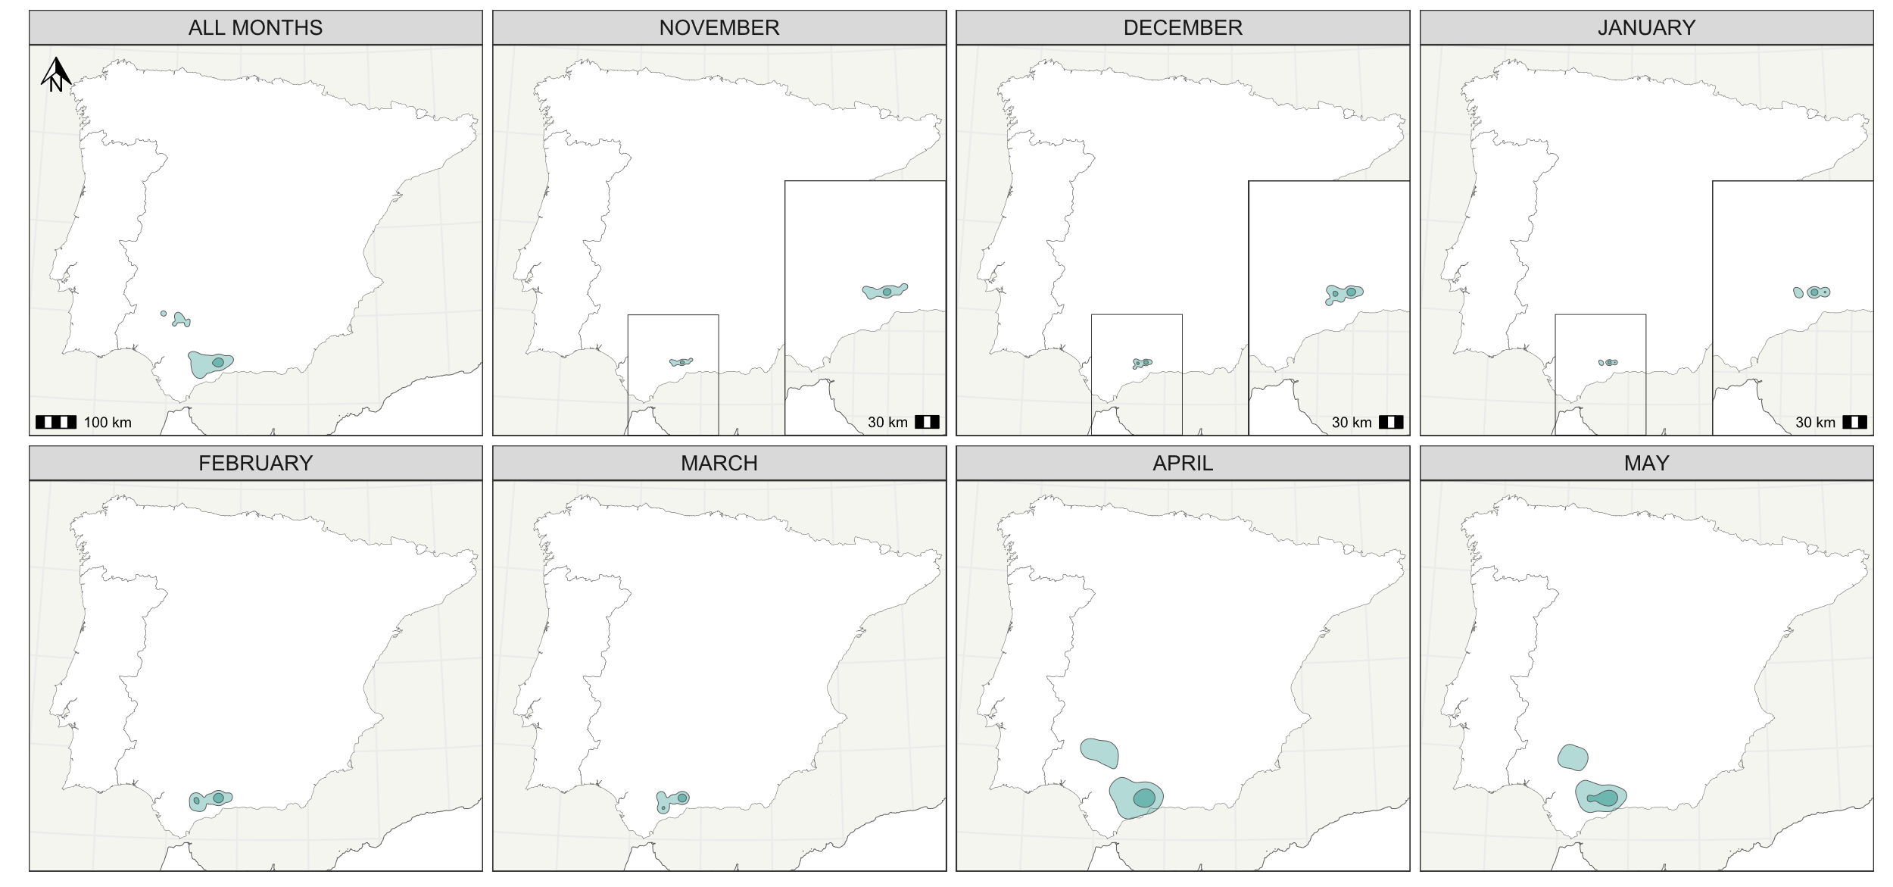
Figure S1. Geographic distribution of adult male. Total and monthly home ranges are shown, with core area (50% KDE, darker colour) and overall home ranges (95% KDE, lighter colour) calculated from GPS data.
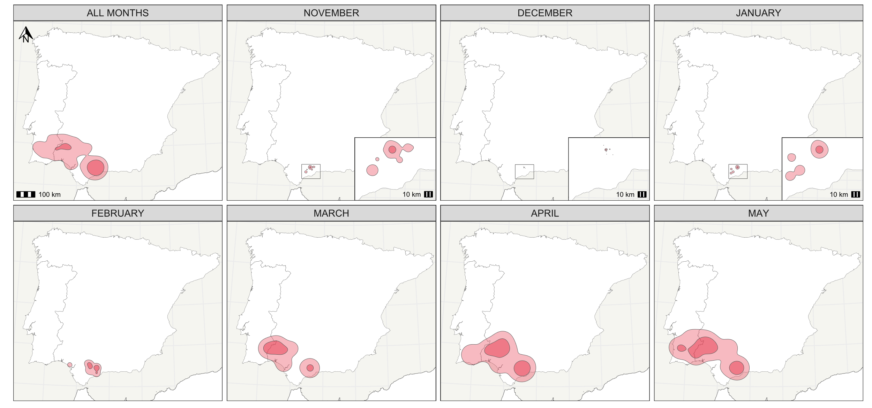
Figure S2. Geographic distribution of adult female. Total and monthly home ranges are shown, with core areas (50% KDE, darker colour) and overall home ranges (95% KDE, lighter colour), calculated from GPS data.

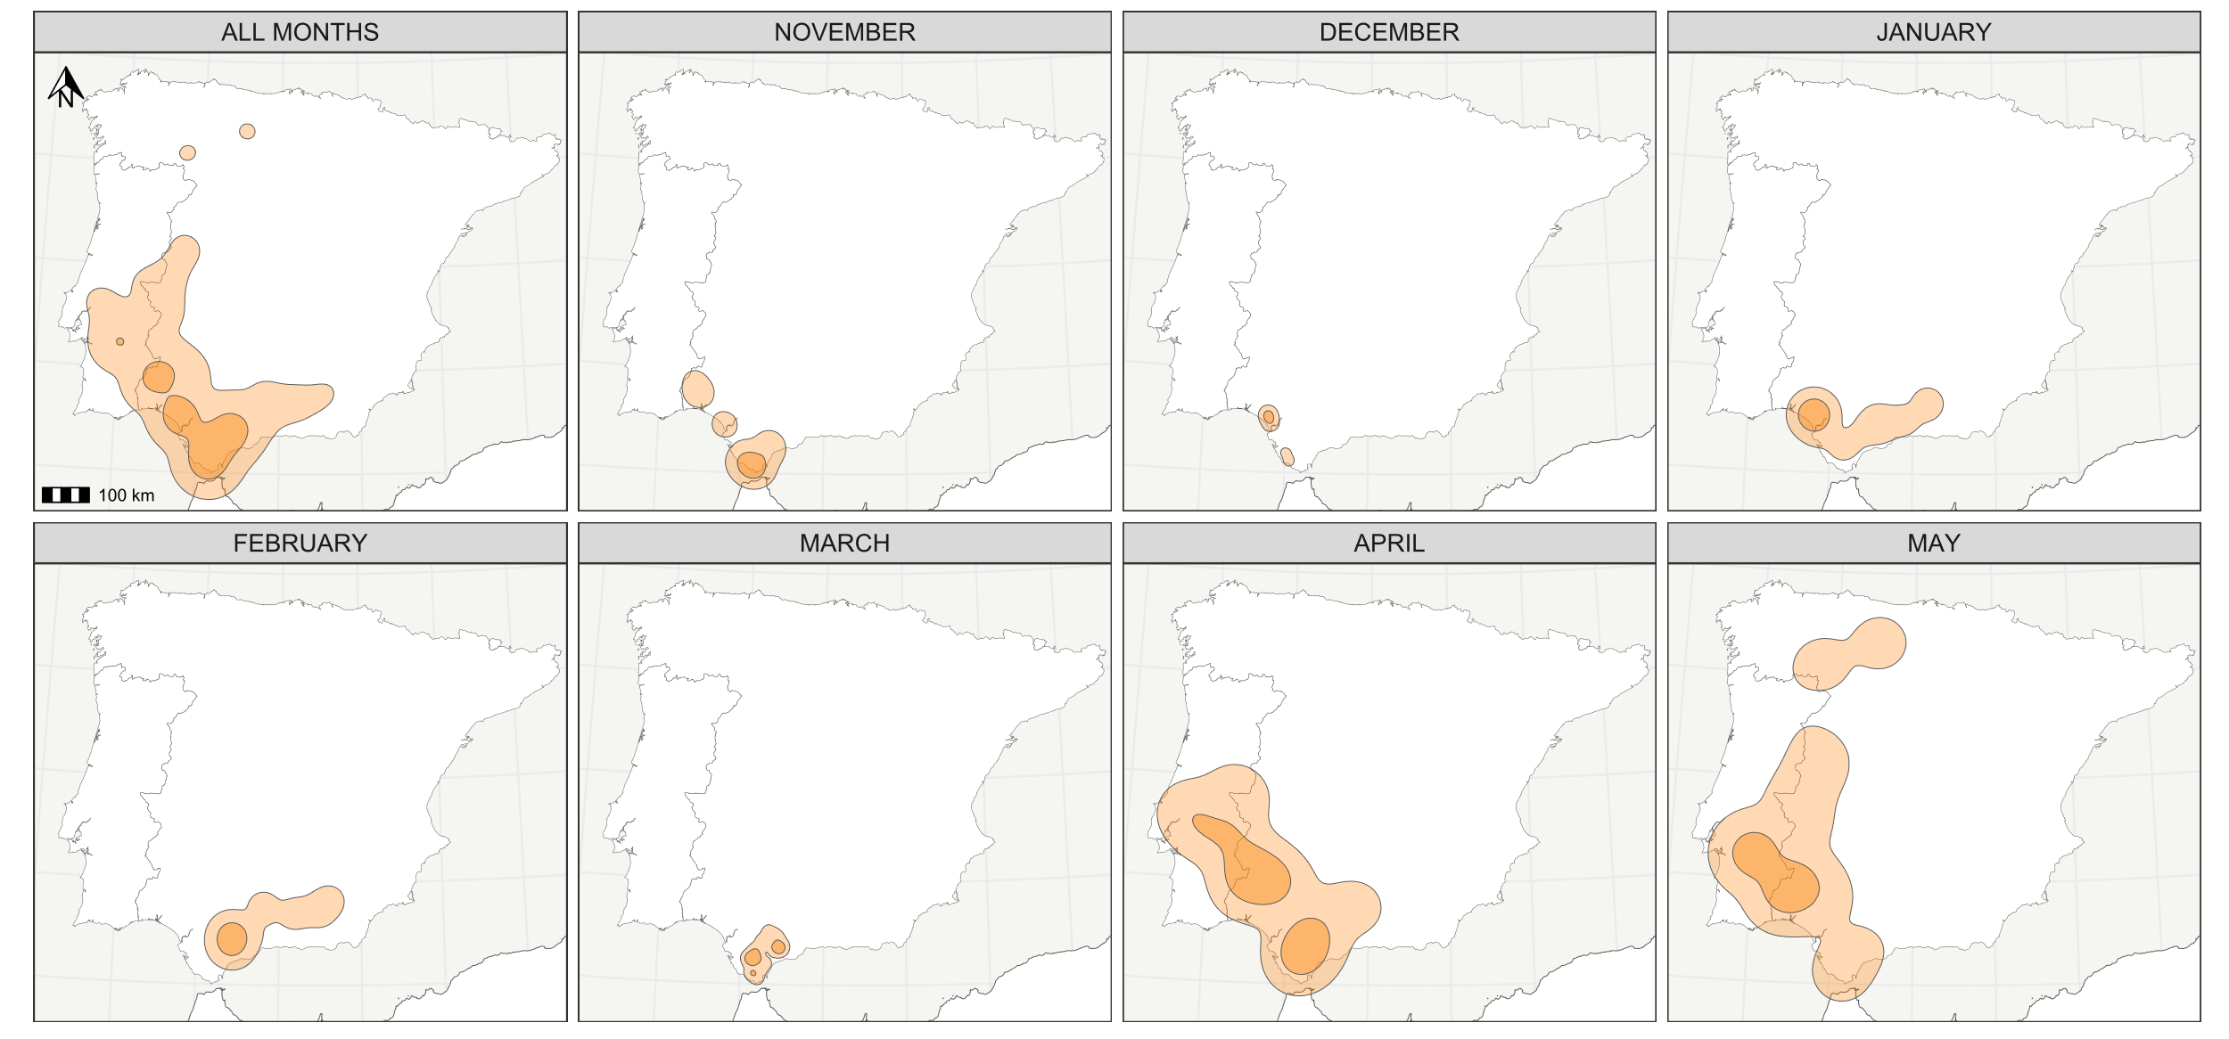
Figure S3. Geographic distribution of the immature male. Total and monthly home ranges are shown, with core areas (50% KDE, darker colour) and overall home ranges (95% KDE, lighter colour) calculated from GPS data.

