A)
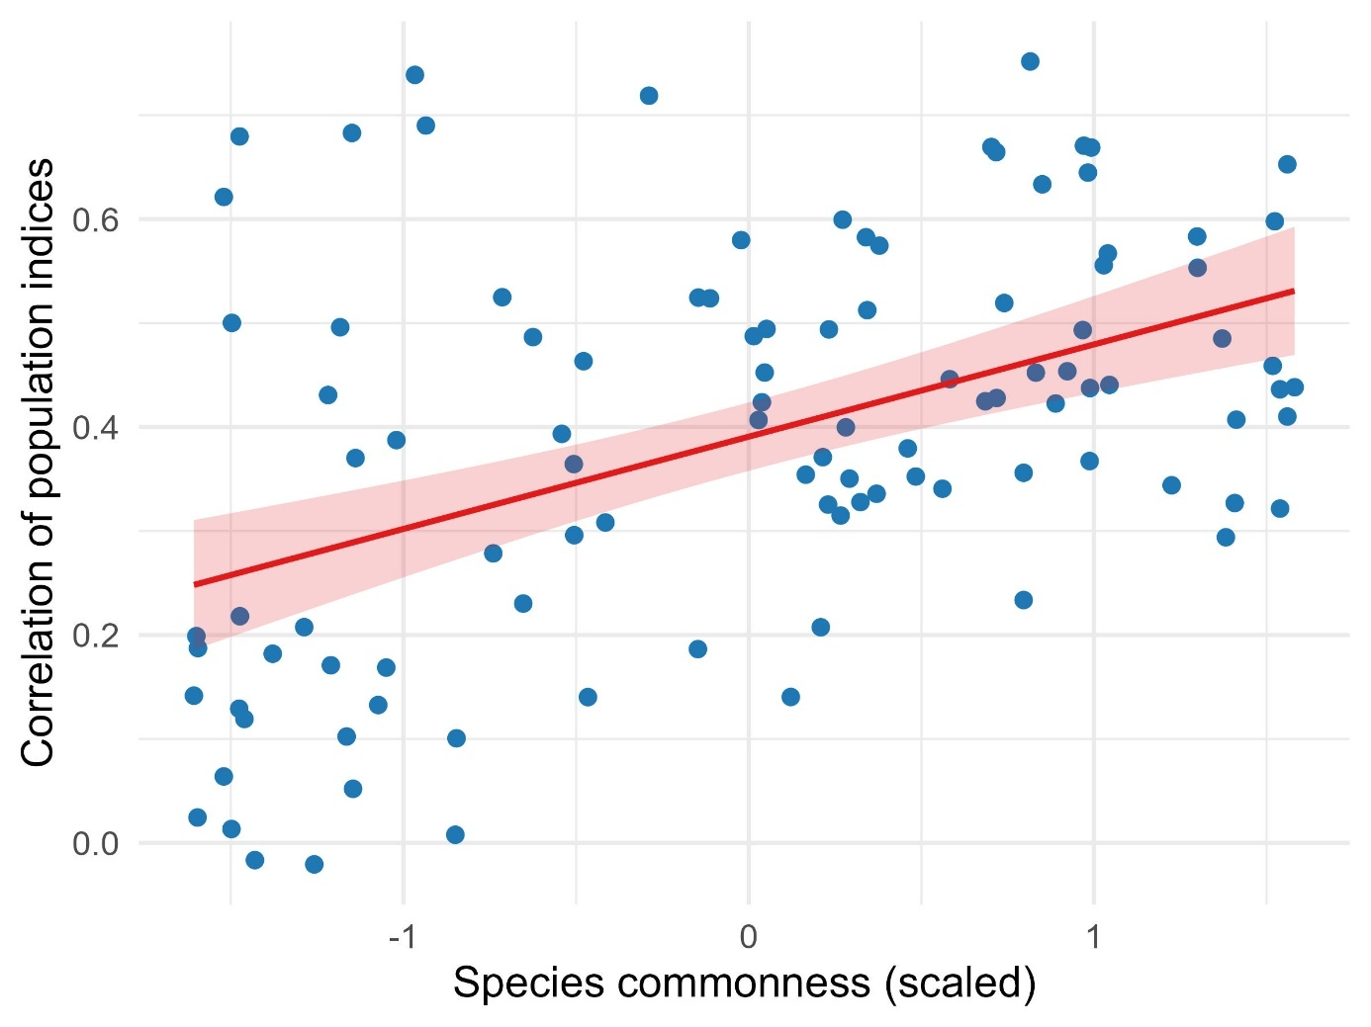
B)
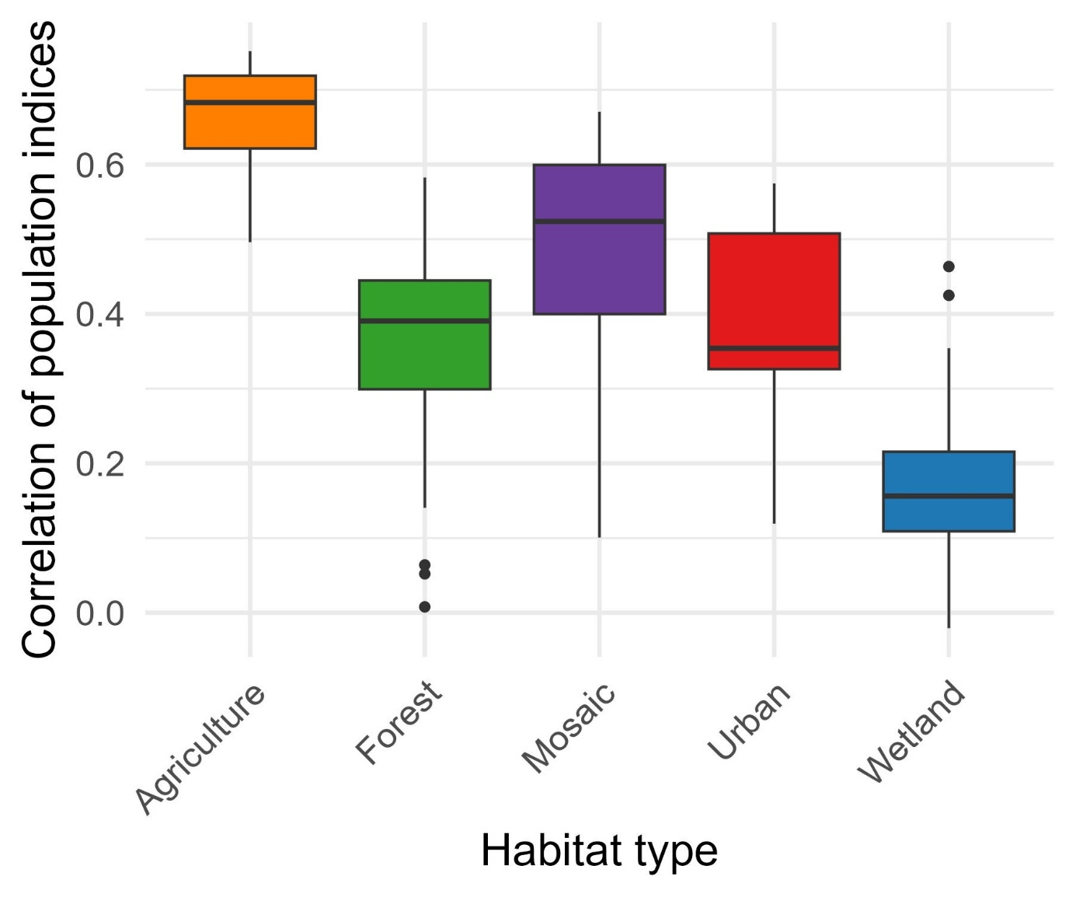
C)
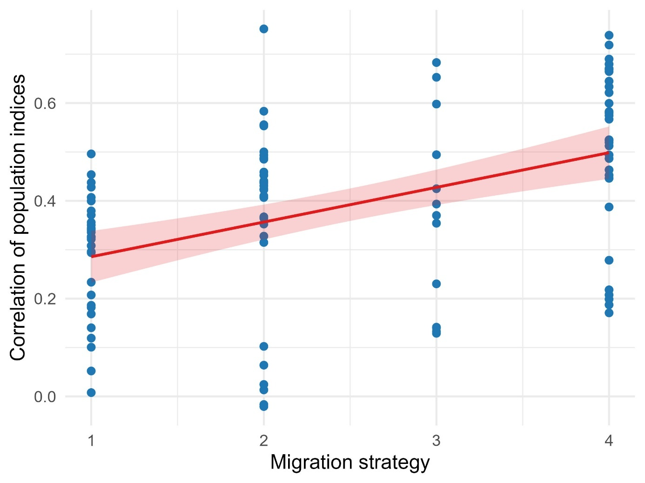
Fig. S2: Relationships of correspondence between population indices of 104 common bird species in Czechia to species characteristics: A) commonness; B) habitat preference; D) migration strategy (1 – residents, 2 – partial migrants, 3 – short-distance migrants, 4 – long-distance migrants). The correspondence was calculated for each species as a correlation of its annual population indices calculated independently using two different monitoring schemes in Czechia across years when the schemes were running simultaneously (2018-2024). Species commonness was expressed as a sum of proportions of sites occupied by a given species in respective schemes. See Table 2A for parameter estimates.

