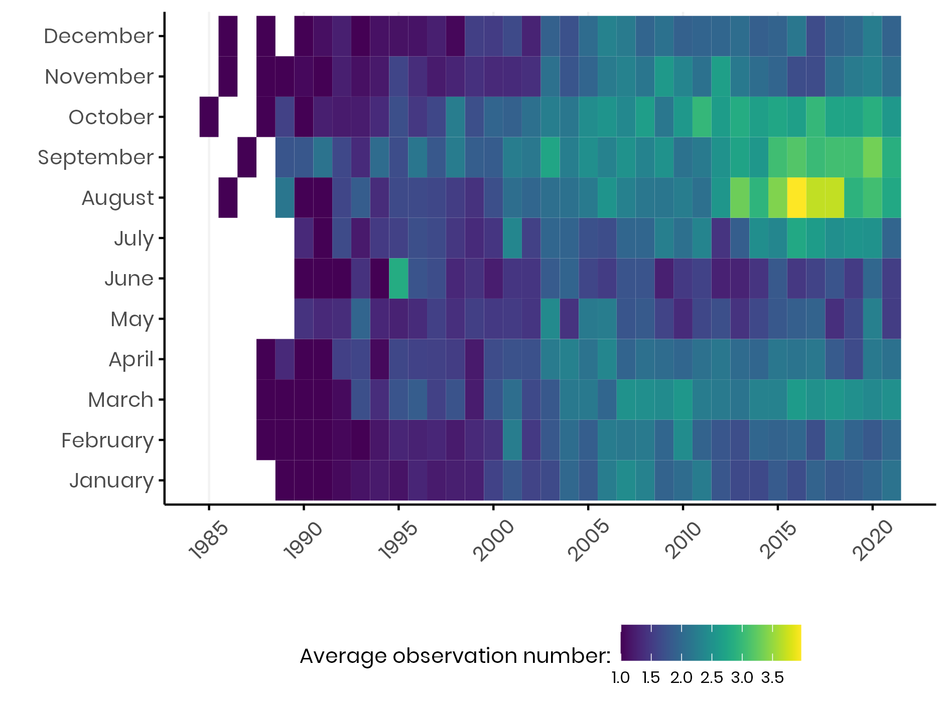
Electronic Supplementary Material

Figure S1. Average number of resightings per colour-banded Common Cranes per year and month.

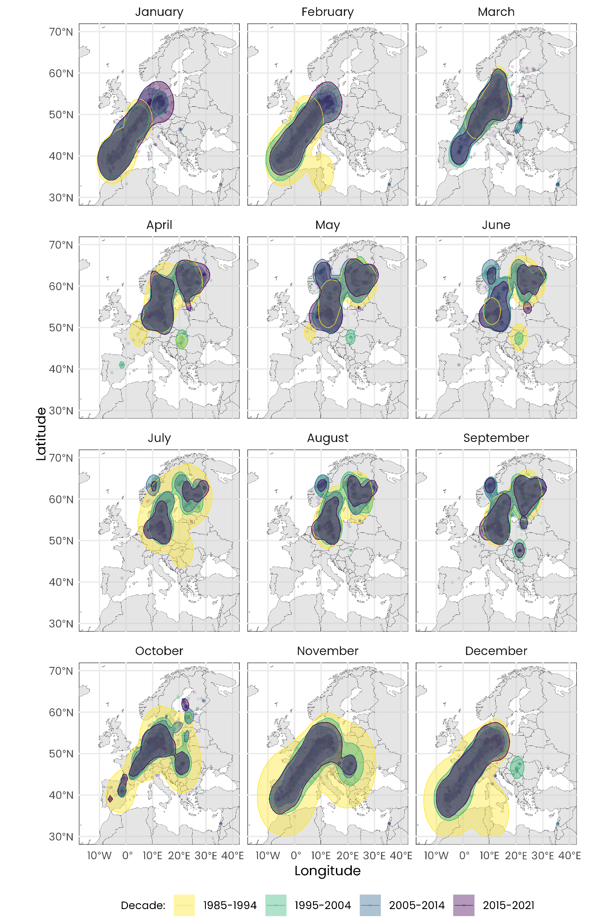Figure S2. Spatiotemporal distribution of cranes across months over four decades. Coloured areas represent the Volume Utilisation Distribution (VUD) of 95% at the different decades.

Table S1. Estimated slopes (± SE) describing year-to-year changes in the latitude for each month.
Month | slope | SE | df | t.ratio | p-value
January | 0.27 | 0.01 | 187,637.2 | 45.98 | < 0.001
February | 0.28 | 0.01 | 187,621.5 | 50.19 | < 0.001
March | 0.09 | 0.00 | 186,203.0 | 18.88 | < 0.001
April | -0.07 | 0.01 | 185,574.7 | -12.79 | < 0.001
May | -0.11 | 0.01 | 187,348.7 | -16.08 | < 0.001
June | -0.08 | 0.01 | 187,736.1 | -10.85 | < 0.001
July | -0.08 | 0.01 | 187,374.5 | -13.32 | < 0.001
August | -0.10 | 0.00 | 181,562.9 | -25.04 | < 0.001
September | -0.10 | 0.00 | 169,437.5 | -28.63 | < 0.001
October | 0.03 | 0.00 | 166,880.8 | 8.95 | < 0.001
November | 0.06 | 0.00 | 181,591.3 | 13.81 | < 0.001
December | 0.18 | 0.01 | 187,372.6 | 33.37 | < 0.001

