Electronic Supplementary Material

Intraguild predation and competition between avian top predators: do expanding Eagle Owls (Bubo bubo) contribute to the decline of Northern Goshawks (Accipiter gentilis)?

Kees H.T. Schreven, Gerhard J.D.M. Müskens, Rob P. Bos†, Fred G.J. van Duijnhoven†, Anna M. Hermsen, Youri H.T.H. van der Horst, Frank M. Peters, Johan B.M. Thissen, Dick Visser, Ronald Zollinger

† Deceased

Table S1. Importance of each bone type in determining individual prey numbers in (a subset of) Eagle Owl pellets. The number of individuals per prey species was determined by counting several bone types and taking the maximum number (left and right separate). This maximum number was most often reached by mandibles and tibiae. Here, each case represents a batch of pellets collected at a certain territory and date. Interpretation as follows: e.g. in 5 out of 26 batches of pellets, the highest number of Brown rats was reached by counting the femurs (left and right separate), while the other bone types were less numerous in those 5 batches.

Species | Scientific name | Skull/ maxilla | Mandible | Tibia | Femur | Pelvis | Total
Brown rat | Rattus norvegicus | 3 | 4 | 11 | 5 | 3 | 26
European rabbit / European hare | Oryctolagus cuniculus / Lepus europaeus |  | 4 | 1 | 2 |  | 7
European hedgehog | Erinaceus europaeus |  | 1 |  | 2 |  | 3
Wood mouse | Apodemus sylvaticus | 1 | 3 |  |  |  | 4
Common vole | Microtus arvalis |  | 3 |  |  |  | 3
Field vole | Microtus agrestis |  | 1 |  |  |  | 1

Table S2. Number of individuals of Brown rats based on each bone type, in Eagle Owl pellets. In these five batches, the number of individuals based on each of five bone types was noted. In total, numbers were similar for all bone types except pelvis. However, per case, the bone type that determined the maximum number of individuals varied.

Datum | Nest | Skull/maxilla | Mandible | Tibia | Femur | Pelvis | Maximum number by
2022-12-24 | A | 7 | 5 | 10 | 9 | 4 | Tibia
2023-07-02 | B | 27 | 25 | 20 | 19 | 18 | Skull/maxilla
2023-07-30 | C | 5 | 5 | 10 | 9 | 6 | Tibia
2023-08-13 | Around B | 15 | 15 | 15 | 17 | 12 | Femur
2023-08-13 | B | 3 | 8 | 3 | 2 | 7 | Mandible
 | Total | 57 | 58 | 58 | 56 | 47
Table S3. Sample size of Goshawk prey items per year and month. Number of prey individuals based on prey remains are given.
Year | J | F | M | A | M | J | J | A | S | O | N | D | Total
2019 |  | 7 | 21 | 153 | 82 | 21 | 23 | 14 | 6 |  |  |  | 328
2020 | 1 | 1 | 43 | 81 | 67 | 43 | 14 | 41 | 1 |  |  | 2 | 295
2021 | 1 | 8 | 46 | 78 | 145 | 64 | 63 | 6 |  |  |  |  | 415
2022 |  | 6 | 46 | 100 | 94 | 60 | 52 | 10 | 12 | 1 |  |  | 381
2023 |  | 8 | 12 | 90 | 38 | 53 | 27 |  | 1 |  |  |  | 230
Total | 2 | 30 | 168 | 502 | 426 | 241 | 179 | 71 | 20 | 1 | 0 | 2 | 1642

Table S4. Sample size of Eagle Owl prey items per year and month. Given is the number of prey individuals, based on the combined set of pellets and prey remains, excluding double counts. The 34 in December also included older pellets, hence those were not all December prey.
Year | J | F | M | A | M | J | J | A | S | O | N | D | Total
2019 |  | 2 |  |  |  |  |  |  |  |  |  |  | 2
2020 |  |  | 2 |  |  |  |  |  | 32 |  | 6 |  | 40
2021 | 1 |  | 31 | 17 | 6 | 4 | 13 |  | 3 |  |  |  | 75
2022 | 1 |  | 25 | 41 | 69 | 24 | 49 |  | 5 | 2 |  | 34 | 250
2023 |  | 17 | 15 | 42 | 22 | 18 | 120 | 49 | 2 |  |  | 3 | 288
Total | 2 | 19 | 73 | 100 | 97 | 46 | 182 | 49 | 42 | 2 | 6 | 37 | 655

Table S5. Eagle Owl diet composition based on data from pellets and prey remains. Here, double counts (overlap between prey remains and pellets during same territory visit) were not excluded, hence the sum is larger than the total number in the combined dataset. In three cases, families were merged to avoid uncertainly identified categories. Fisher’s exact test shows significant differences in bold (α=0.05). Overall diet composition differed between data sources (based on numbers, at family level: χ2=352.01, df=25, p<0.001).
Group | Scientific name | Pellet data |  |  | Prey remains data |  |  | Fisher's exact test (numbers)
Group | Scientific name | Number | Proportion (numbers) | Proportion (biomass) | Number | Proportion (numbers) | Proportion (biomass) | Fisher's exact test (numbers)
Geese, ducks | Anatidae | 2 | 0.0052 | 0.0071 | 19 | 0.0613 | 0.1163 | < 0.001
Grebes | Podicepidae | 1 | 0.0026 | 0.0013 | 1 | 0.0032 | 0.0012 | 1.000
Hawks, buzzards | Accipitridae | 0 | - | - | 8 | 0.0258 | 0.0377 | 0.001
Falcons | Falconidae | 0 | - | - | 1 | 0.0032 | 0.0011 | 0.445
Pheasants | Phasianidae | 0 | - | - | 3 | 0.0097 | 0.0160 | 0.088
Rails | Rallidae | 7 | 0.0181 | 0.0231 | 21 | 0.0677 | 0.0740 | 0.001
Waders | Scolopacidae, Charadriidae | 0 | - | - | 10 | 0.0323 | 0.0140 | < 0.001
Gulls | Laridae | 0 | - | - | 1 | 0.0032 | 0.0016 | 0.445
Pigeons | Columbidae | 50 | 0.1292 | 0.1242 | 152 | 0.4903 | 0.4647 | < 0.001
Cuckoos | Cuculidae | 0 | - | - | 2 | 0.0065 | 0.0015 | 0.197
Owls | Strigidae, Tytonidae | 10 | 0.0258 | 0.0207 | 16 | 0.0516 | 0.0255 | 0.106
Woodpeckers | Picidae | 1 | 0.0026 | 0.0005 | 2 | 0.0065 | 0.0023 | 0.588
Thrushes | Turdidae | 5 | 0.0129 | 0.0033 | 13 | 0.0419 | 0.0078 | 0.028
Crows | Corvidae | 26 | 0.0672 | 0.0722 | 35 | 0.1129 | 0.0958 | 0.042
Starling | Sturnidae | 0 | - | - | 3 | 0.0097 | 0.0015 | 0.088
Finches | Fringillidae | 0 | - | - | 1 | 0.0032 | 0.0004 | 0.445
Unknown birds | Aves indet. | 11 | 0.0284 | 0.0218 | 1 | 0.0032 | 0.0019 | 0.015
Hares, rabbits | Leporidae | 31 | 0.0801 | 0.2143 | 6 | 0.0194 | 0.0901 | < 0.001
Hedgehogs | Erinaceidae | 14 | 0.0362 | 0.0462 | 13 | 0.0419 | 0.0418 | 0.698
Moles | Talpidae | 2 | 0.0052 | 0.0013 | 0 | - | - | 0.505
Rats | Rattus | 175 | 0.4522 | 0.4270 | 2 | 0.0065 | 0.0048 | < 0.001
Muskrats | Ondatra | 1 | 0.0026 | 0.0086 | 0 | - | - | 1.000
Squirrels | Sciuridae | 1 | 0.0026 | 0.0023 | 0 | - | - | 1.000
Voles, mice | Apodemus, Microtus, Clethrionomys | 32 | 0.0827 | 0.0063 | 0 | - | - | < 0.001
Unknown mammals | Mammalia indet. | 3 | 0.0078 | 0.0198 | 0 | - | - | 0.258
Beetles | Coleoptera | 15 | 0.0388 | 0.0002 | 0 | - | - | < 0.001
Birds | Aves | 113 | 0.2920 | 0.2741 | 289 | 0.9323 | 0.8633 | < 0.001
Mammals | Mammalia | 259 | 0.6693 | 0.7257 | 21 | 0.0677 | 0.1367 | < 0.001
Insects | Coleoptera | 15 | 0.0388 | 0.0002 | 0 | - | - | < 0.001
Total |  | 387 | 1.0000 | 1.0000 | 310 | 1.0000 | 1.0000 | -

Table S6. Coefficient estimates and significance of additional models. For models not discussed in detail in the main text, data are given here. Dependent variables were either territory persistence or fledgling number. For territory persistence, three territory definitions were tested, see main text: wide (max. 1296 m), intermediate (max. 500 m), narrow (max. 250 m). Significant effects (p<0.05) are indicated in bold.

Dependent variable | Model | Variable | Estimate (β ± SE) | z-value | p-value
Territory persistence (wide definition) | Full period (’18-’24) | Eagle Owl (continuous) | 0.0031 ± 0.0062 | 0.502 | 0.616
Territory persistence (wide definition) | Full period (’18-’24) | Forest edge | -0.0227 ± 0.0167 | -1.358 | 0.175
Territory persistence (wide definition) | Before crash (≤’22) | Eagle Owl (continuous) | 0.0062 ± 0.0071 | 0.871 | 0.384
Territory persistence (wide definition) | Before crash (≤’22) | Forest edge | -0.0145 ± 0.0196 | -0.739 | 0.460
Territory persistence (wide definition) | Categorical Eagle Owl effect (’18-’24) | Eagle Owl (</> 1.5 km) | 0.1366 ± 0.4869 | 0.280 | 0.779
Territory persistence (wide definition) | Categorical Eagle Owl effect (’18-’24) | Forest edge | -0.0253 ± 0.0164 | -1.542 | 0.123
Territory persistence (intermediate definition) | Before crash (≤’22) | Forest edge | -0.0491 ± 0.0188 | -2.611 | 0.009
Territory persistence (intermediate definition) | Categorical Eagle Owl effect (’18-’24) | Forest edge | -0.0495 ± 0.0161 | -3.082 | 0.002
Territory persistence (narrow definition) | Full period (’18-’24) | Eagle Owl (continuous) | -0.0034 ± 0.0060 | -0.573 | 0.567
Territory persistence (narrow definition) | Full period (’18-’24) | Forest edge | -0.0568 ± 0.0163 | -3.475 | 0.0005
Territory persistence (narrow definition) | Before crash (≤’22) | Eagle Owl (continuous) | -0.0026 ± 0.0072 | -0.367 | 0.714
Territory persistence (narrow definition) | Before crash (≤’22) | Forest edge | -0.0615 ± 0.0189 | -3.259 | 0.001
Territory persistence (narrow definition) | Categorical Eagle Owl effect (’18-’24) | Eagle Owl (</> 1.5 km) | 0.0904 ± 0.4670 | 0.194 | 0.847
Territory persistence (narrow definition) | Categorical Eagle Owl effect (’18-’24) | Forest edge | -0.0548 ± 0.0159 | -3.445 | 0.0006
Fledgling number per nest | Categorical Eagle Owl effect, </>1.5 km (’18-’24) | Forest edge | -0.0169 ± 0.0056 | -3.015 | 0.003
Fledgling number per nest | Categorical Eagle Owl effect, </>3.5 km (’18-’24) | Forest edge | -0.0140 ± 0.0057 | -2.462 | 0.014

Table S7. List of species, body masses, and frequency in the Goshawk and Eagle Owl diets. Sources of body masses were: (1) Wassink and Hingmann 2010, based on Bijlsma (1993) and Lange et al. (1994), (2) adjusted from Wassink and Hingmann 2010, based on own data (see text), (3) Demongin 2016, (4) Ndlovu et al. 2010. For Eagle Owl, the combined set of prey remains and pellets was taken.
Group | Species | Body mass (gram) | Source of body mass | Goshawk diet (number) | Eagle Owl diet (number)
Anatidae | Anser spec. | 2000 | 1 | 1 | 0
Anatidae | Alopochen aegyptiaca | 2200 | 4 | 2 | 1
Anatidae | Aix galericulata | 350 | 1 | 0 | 1
Anatidae | Anas platyrhynchos | 1050 | 1 | 9 | 12
Anatidae | Mareca strepera | 750 | 3 | 2 | 2
Anatidae | Mareca penelope | 750 | 1 | 1 | 0
Anatidae | Anas crecca | 350 | 1 | 0 | 2
Anatidae | Anas spec. | 720 | 1 | 1 | 1
Podicepidae | Tachybaptus ruficollis | 190 | 1 | 0 | 1
Accipitridae | Buteo buteo | 800 | 1 | 3 | 6
 | Pernis apivorus | 890 | 1 | 2 | 0
 | Accipiter gentilis | 850 | 1 | 4 | 1
 | Accipiter gentilis / Buteo buteo (chick) | 200 | 1 | 1 | 0
 | Accipiter nisus | 200 | 1 | 36 | 1
Falconidae | Falco subbuteo | 200 | 1 | 1 | 0
Falconidae | Falco tinnunculus | 175 | 1 | 5 | 1
Phasianidae | Gallus gallus f. domestica | 300 | 1 | 1 | 0
Phasianidae | Perdix perdix | 285 | 1 | 0 | 1
Phasianidae | Phasianus colchicus | 1100 | 1 | 0 | 2
Rallidae | Fulica atra | 700 | 1 | 7 | 15
Rallidae | Gallinula chloropus | 300 | 1 | 2 | 10
Scolopacidae, Charadriidae | Scolopax rusticola | 300 | 1 | 18 | 3
Scolopacidae, Charadriidae | Gallinago gallinago | 110 | 3 | 0 | 1
Scolopacidae, Charadriidae | Lymnocryptes minimus | 60 | 3 | 0 | 1
Scolopacidae, Charadriidae | Vanellus vanellus | 220 | 1 | 2 | 5
Laridae | Chroicocephalus ridibundus | 250 | 1 | 15 | 1
Laridae | Larus spec. | 310 | 1 | 1 | 0
Columbidae | Columbidae spec. | 400 | 1 | 1 | 15
Columbidae | Columba livia f. domestica | 300 | 1 | 376 | 15
Columbidae | Columba oenas | 300 | 1 | 23 | 7
Columbidae | Columba palumbus | 500 | 1 | 425 | 133
Columbidae | Streptopelia decaocto | 140 | 1 | 76 | 6
Cuculidae | Cuculus canorus | 115 | 1 | 0 | 2
Strigidae, Tytonidae | Strix aluco | 450 | 1 | 12 | 0
Strigidae, Tytonidae | Asio otus | 275 | 1 | 15 | 9
Strigidae, Tytonidae | Asio flammeus | 320 | 1 | 1 | 0
Strigidae, Tytonidae | Athene noctua | 170 | 1 | 6 | 7
Strigidae, Tytonidae | Tyto alba | 320 | 1 | 8 | 2
Strigidae, Tytonidae | Strix / Asio / Tyto spec. | 350 | 1 | 0 | 5
Psittaciformes | Nymphicus hollandicus | 100 | 1 | 1 | 0
Psittaciformes | Psittaciformes indet. | 100 | 1 | 2 | 0
Picidae | Dryocopus martius | 275 | 1 | 1 | 1
Picidae | Picus viridis | 190 | 1 | 8 | 0
Picidae | Dendrocopos major | 75 | 1 | 88 | 2
Picidae | Dryobates minor | 22 | 1 | 1 | 0
Motacillidae | Anthus spec. | 22 | 1 | 1 | 0
Turdidae | Turdus merula | 100 | 1 | 61 | 9
Turdidae | Turdus torquatus | 110 | 1 | 2 | 0
Turdidae | Turdus pilaris | 115 | 1 | 0 | 1
Turdidae | Turdus iliacus | 70 | 3 | 1 | 1
Turdidae | Turdus viscivorus | 130 | 3 | 15 | 1
Turdidae | Turdus philomelos | 75 | 3 | 17 | 3
Turdidae | Erithacus rubecula | 18 | 1 | 1 | 0
Paridae | Parus major | 18 | 1 | 4 | 0
Paridae | Cyanistes caeruleus | 12 | 1 | 1 | 0
Sittidae | Sitta europaea | 22 | 1 | 1 | 0
Corvidae | Corvus corax | 1150 | 1 | 0 | 1
Corvidae | Corvus frugilegus | 475 | 1 | 0 | 2
Corvidae | Corvus corone | 520 | 1 | 30 | 31
Corvidae | Pica pica | 210 | 1 | 94 | 3
Corvidae | Coloeus monedula | 225 | 1 | 53 | 1
Corvidae | Garrulus glandarius | 160 | 1 | 127 | 9
Corvidae | Pica / Coloeus / Garrulus spec. | 200 | 1 | 0 | 4
Sturnidae | Sturnus vulgaris | 80 | 1 | 50 | 3
Fringillidae | Fringilla coelebs | 23 | 1 | 8 | 0
Fringillidae | Fringilla montifringilla | 25 | 1 | 3 | 0
Fringillidae | Coccothraustes coccothraustes | 60 | 3 | 6 | 1
Turdidae/Sturnidae | Turdus / Sturnus spec. | 90 | 1 | 0 | 2
Aves indet. | Aves spec. (middle-sized) | 300 | 1 | 1 | 12
Leporidae | Lepus europaeus | 2500 | 1 | 3 | 7
Leporidae | Oryctolagus cuniculus | 1500 | 2 | 2 | 2
Leporidae | Lepus / Oryctolagus spec. (small) | 1000 | 2 | 0 | 30
Erinaceidae | Erinaceus europaeus | 500 | 1 | 0 | 26
Talpidae | Talpa europaea | 100 | 1 | 0 | 2
Rattus | Rattus norvegicus | 370 | 1 | 1 | 181
Sciuridae | Sciurus vulgaris | 350 | 1 | 2 | 1
Apodemus, Clethrionomys, Microtus | Apodemus sylvaticus | 30 | 2 | 0 | 13
Apodemus, Clethrionomys, Microtus | Clethrionomys glareolus | 30 | 1 | 0 | 1
Apodemus, Clethrionomys, Microtus | Microtus arvalis | 30 | 1 | 0 | 14
Apodemus, Clethrionomys, Microtus | Microtus agrestis | 30 | 1 | 0 | 2
Apodemus, Clethrionomys, Microtus | Apodemus / Clethrionomys / Microtus spec. | 30 | 1 | 0 | 2
Ondatra | Ondatra zibethicus | 1300 | 1 | 0 | 1
Mammalia indet. | Mammalia spec. (middle-sized) | 1000 | 1 | 0 | 2
Coleoptera | Geotrupidae spec. | 0.3 | 2 | 0 | 1
Coleoptera | Lucanus cervus | 5 | 2 | 0 | 4
Coleoptera | Coleoptera spec. (small) | 0.3 | 2 | 0 | 10
Total |  |  |  | 1642 | 655
Figure S1. Diet composition of Eagle Owls based on two methods (nest cameras and pellets/prey remains). The proportion of mammals, calculated as “mammals / (mammals + birds)”, was correlated between both methods. Two nests were monitored each in two years. Sample sizes of prey individuals are given in brackets (pellets/prey remains, nest camera). Camera observation periods per nest were: A ’21 (14 May-26 Jun), A ’22 (6 Feb-30 May), B ’22 (24 Apr-10 Jul), B ’23 (9 Apr-27 Apr). For accurate comparison, camera footage and pellets/prey remains from the same period were considered.

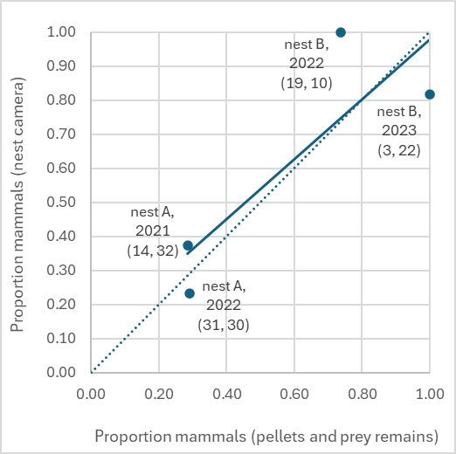

Figure S2. Diet composition of Eagle Owls based on four methods. The proportion of mammals, calculated as “mammals / (mammals + birds)” was highest in pellets and lowest in prey remains, and intermediate in the combined data set, which resembled the camera data best. This was based on the same nests as in Fig. S1. Sample sizes (mammal and bird prey) of each data source were: 41, 94, 67, 26. With nest cameras, 17 prey remained unidentified (mammal or bird) and were not included in the calculation. Different letters indicate a significant difference (tested by binomial GLM).
Significances were: camera vs. pellets (z=1.431, p=0.152), camera vs. combined (z=–0.654, p=0.513), camera vs. prey remains (z=3.145, p=0.002), pellets vs. prey remains (z=3.726, p<0.001), combined vs. prey remains (z=2.763, p=0.006).

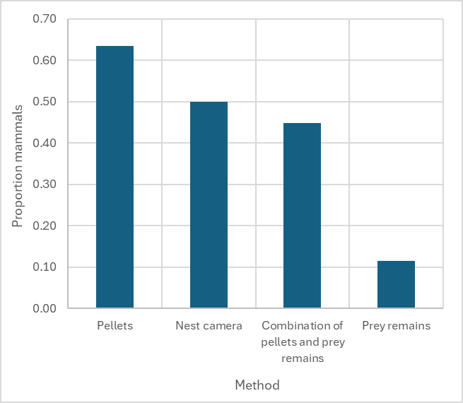
a a a b
Figure S3. Intraspecific nearest neighbour distances (panels a-b) and the distance between Goshawk nests and their nearest Eagle Owl nest (c). Only distances between nests occupied in the same year are calculated and included. In Eagle Owls, values could only be calculated for 2020-2024 because only 1 nest occurred in 2019. Please note, that we used distance from Goshawks in year ‘t’ to the nearest Eagle Owl nest in the years ‘t’ and ‘t+1’ combined, for the analyses of the effect of Eagle Owls on Goshawks (see main text). Depicted are means (diamonds) and boxplots.
(a)
(b)
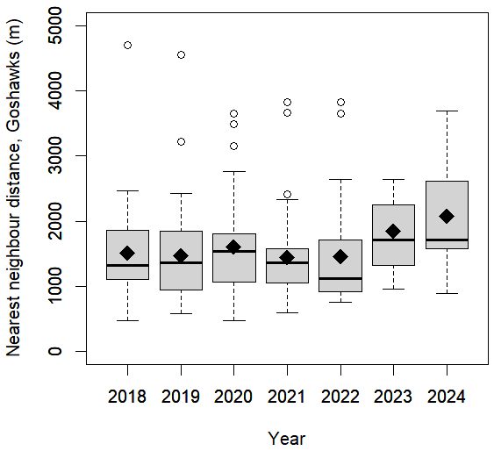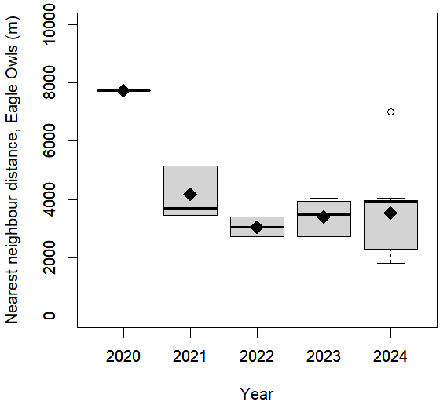
(c)
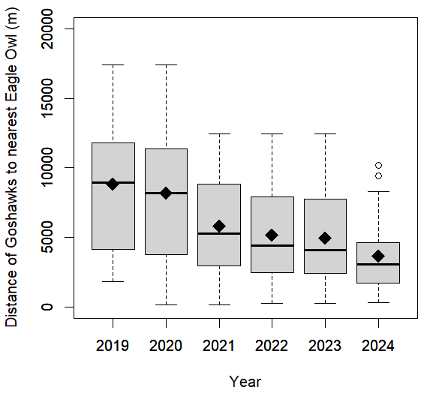

Figure S4. Distance from nests of Goshawks and Eagle Owls to the nearest forest edge. We used the distance to the edge of a forest complex, so that the edge of non-forest patches (e.g. heathlands, fields or buildings) surrounded by forest were not counted as forest edge. For Eagle Owls, the nest in a quarry (480 m outside the forest, present in 2019-2024) was excluded. Depicted are means (diamonds) and boxplots.
(b)
(a)
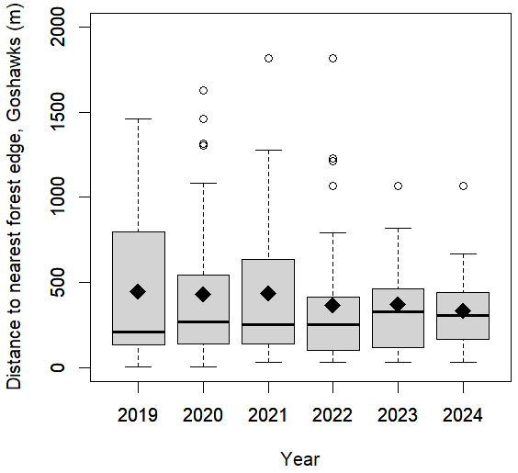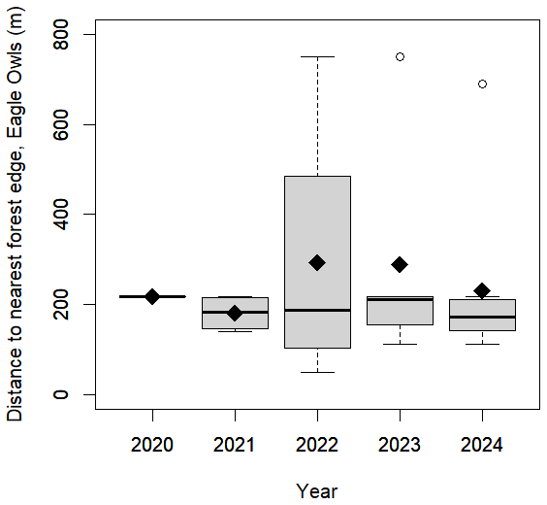

Figure S5. The effect of the distance to nearest Eagle Owl nest (in the same and following year combined), and distance to nearest forest edge, on Goshawk territory persistence (the probability that an active breeding territory is active again next year). Results shown here are from using the wider territory definition (i.e. a cluster of alternately, never simultaneously, occupied neighbouring nests, panels a-b), and the narrower territory definition (i.e. restricting a cluster to nests of max. 250 m apart, panels c-d). Distance was a continuous variable, and both effects were tested simultaneously, in binomial GLMs with a random intercept of year. Solid line: significant, dashed line: not significant. For coefficients, see Table S6.
(a)
(b)

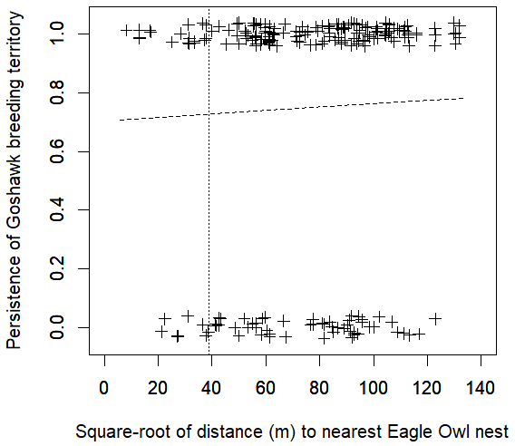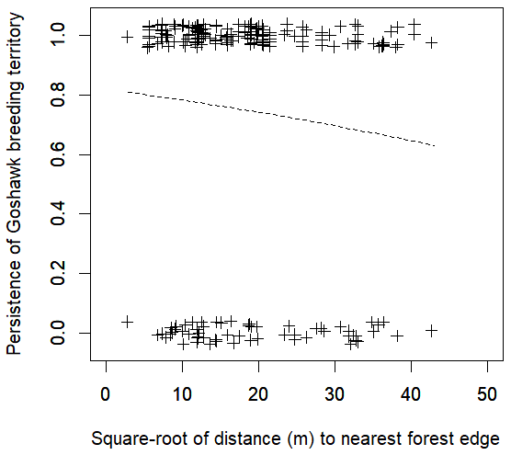
(d)
(c)

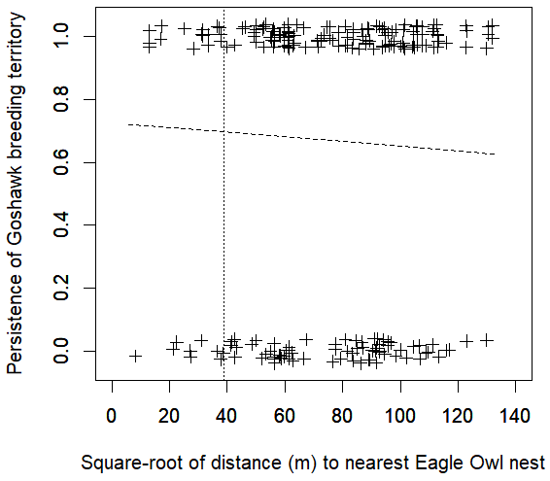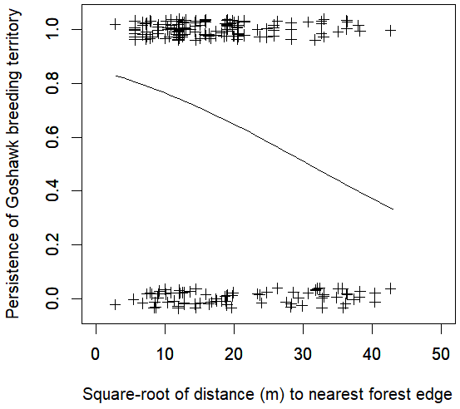

Figure S6. The effect of distance to nearest Eagle Owl nest in years ‘t’ and ‘t+1’ combined (as categorical variable, </> 3.5 km) on the number of fledged Goshawks per clutch in year ‘t’. When analysed as categorical variable with a lower cut-off (</> 1.5 km), the effect was not significant, but with cut-offs of at least 3.5 km, the effect became significant. This indicates that the significant trend (when taking distance to Eagle Owl as continuous variable, see main text) is due to a difference at a larger distance. This effect is corrected for the effect of distance to nearest forest edge (see Table S6).

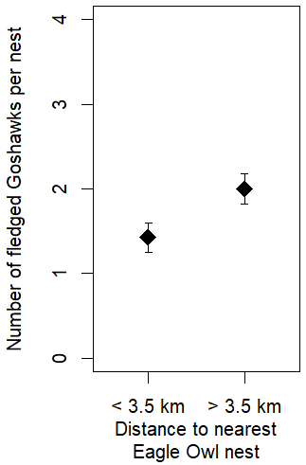
p = 0.016

