Electronic Supplementary Material

Who chooses the nest? An experimental test of nest cover selection

Hela Boughdiri¹, Grant C. McDonald², Tamás Székely^{1,3,4}, András Kosztolányi²

¹ Department of Evolutionary Zoology and Human Biology, University of Debrecen, Debrecen, Egyetem tér 1., 4032, Hungary
² Department of Zoology, University of Veterinary Medicine Budapest, Budapest, Rottenbiller u. 50., 1077, Hungary
³ Milner Centre for Evolution, Department of Life Sciences, University of Bath, Bath, BA2 7AY UK
⁴ HUN-REN-DE Reproductive Strategies Research Group, Department of Evolutionary Zoology and Human Biology, University of Debrecen, Debrecen, Egyetem tér 1., 4032, Hungary

Supplementary text
Captivity details
We constructed three aviaries, each with a base area of 4 m² (2 m x 2 m) and a height of 60 cm designed to accommodate up to 14 plovers at once, with a maximum of 5-6 birds per aviary (Fig. S4). The aviaries were built using chicken wire with small holes to prevent escapes and protect against predators. The interior was lined with a thick textile layer to minimize injury risk, reduce stress, and provide shade for the plovers. The plovers were monitored and fed twice daily, with approximately two tablespoons of food distributed in shallow dishes throughout the aviary. Their diet included finely chopped sausage, boiled eggs, Prosecto Insectivorous™ (Haith’s, Louth, UK) wild bird food, and live worms and small copepods (freshly collected from the sea). Water was provided ad libitum in shallow dishes, replaced twice daily, and supplemented with liquid bird vitamins (BiogenicPet Bird Multivitamin Drops, Alpha-Vet Állatgyógyászati Kft., Székesfehérvár, Hungary). Dishes were strategically placed to ensure all birds had easy access to food and water while reducing competition among the captive plovers.

Local temperatures across the breeding season
We obtained climate data for our study site (Mahres fishpond) from the CRU dataset, version 4.09 (Harris et al. 2020) (Fig. S1). We analysed the monthly average of daily mean temperatures (°C) from March to July between 2021 and 2024, using a Gaussian linear model (LM) with month and year as predictors. The results of the model showed that the monthly mean temperature increased significantly over the breeding season (March–July; month effect: F(1, 17) = 635.19, p <0.001), while no significant trend across years was detected (year effect: F(1, 17) = 0.22, p = 0.64) (Fig. S1).

Seasonal consistency of nest cover choice in male and female experimental plovers
In the main text we report models comparing the absolute difference in the nest cover of original and subsequent nests (i.e. original nest cover percentage minus second nest cover percentage) between males and females. If one sex consistently expressed a stronger influence on nest cover choice towards their preferred cover, we expect that sex will have a smaller absolute difference in nest cover between their first and second nest on average. However, we also identified a decline in nest cover over the breeding season, which may also contribute to the absolute difference between first and second nests. To account for this, we repeated the same overall model structure as in the main text but replaced the absolute nest cover change of males and females with residuals from the model of nest cover percentage on Julian laying date. Specifically, we predicted nest cover percentage for each Julian date of the breeding season based on the Gaussian linear model performed on the natural Kentish Plovers group (used the examine the seasonal effect i.e. see Natural nest cover variation section and Fig. 2a in the main text). We then computed residuals by subtracting the predicted values of nest cover from the observed values for the first and second nests in the experimental group. For each individual we calculated the difference between residuals of the first and second nests, which represents their deviation from the seasonal trend. We computed the deviation based on the residual signs: if both were positive, we subtracted the smaller from the larger; if they had opposite signs, we used the absolute value of the negative and we added it to the positive; and if both were negative, we subtracted the smaller from the larger and took the absolute value (see hypothetical example in Fig. S7). We then fitted a Gaussian linear model with the difference between residuals as the response variable and sex as explanatory variable. We found no significant difference between males and females in the nest cover deviation from the seasonal trend (LM, sex: F(1,18) = 0.31, p = 0.58), which indicates no clear consistency in males or females in their nest cover decision. These results correspond to the LM model in the main text in which we used the absolute nest cover difference between first and second nest as the response variable.

Captivity duration effect on experimental plovers
Among the experimental plovers, 13 individuals were released immediately (parent 1) and 7 individuals (parent 2) were held under standardized conditions, with captivity durations of 27-35 days for all individuals except for one individual that has been captive for 9 days only. To test whether captivity duration affected experimental plovers, we performed a Gaussian linear model (LM) with arcsine square root transformed absolute difference in nest cover (i.e. the absolute value of the original nest cover percentage minus second nest cover percentage) as the response variable and the sex and the captivity duration in days as the explanatory variables (non-captive birds were given zero duration). The results of the model showed that neither sex nor the captivity duration affected the nest cover difference of experimental plovers (LM, sex: F(1,17) = 0.15, p = 0.70; captivity duration: LM, F(1,17) = 1.59, p = 0.22).

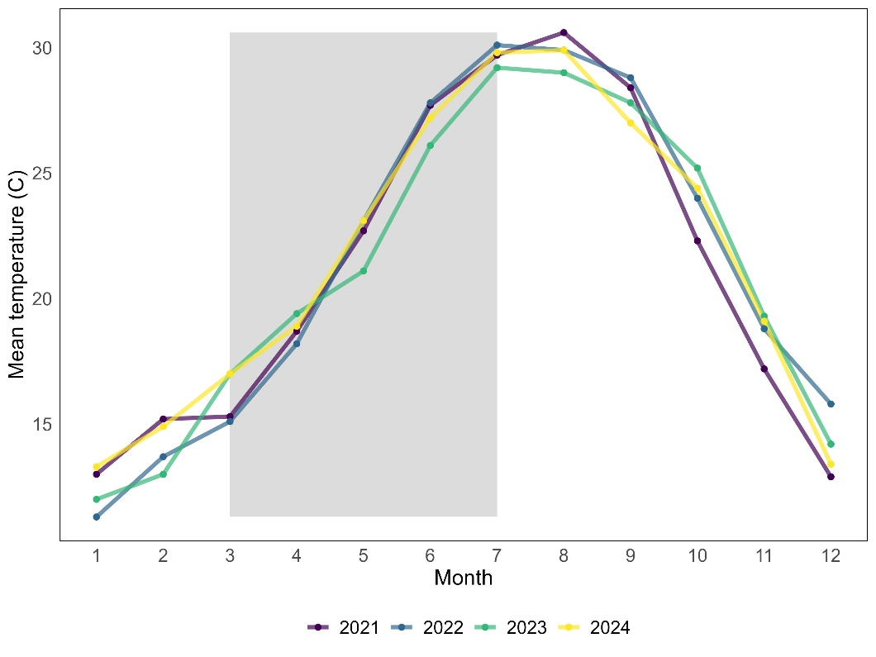
Fig. S1 Plot showing the monthly average daily mean temperature degrees Celsius for the region of our study (Mahres fishpond) between 2021 and 2024, grey area highlights study period breeding season

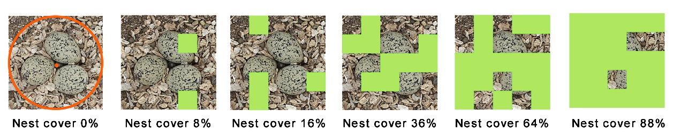
Fig. S2 Nest Cover Estimation (0-100%). The first image shows a 3-egg Kentish Plover clutch with the nest center marked with a dot and a one-egg-length radius around it, indicating the area for nest cup cover estimation. We estimated from a height of one meter above the nest the percentage of nest coverage by assessing the percentage of the nest radius covered by overhanging vegetation

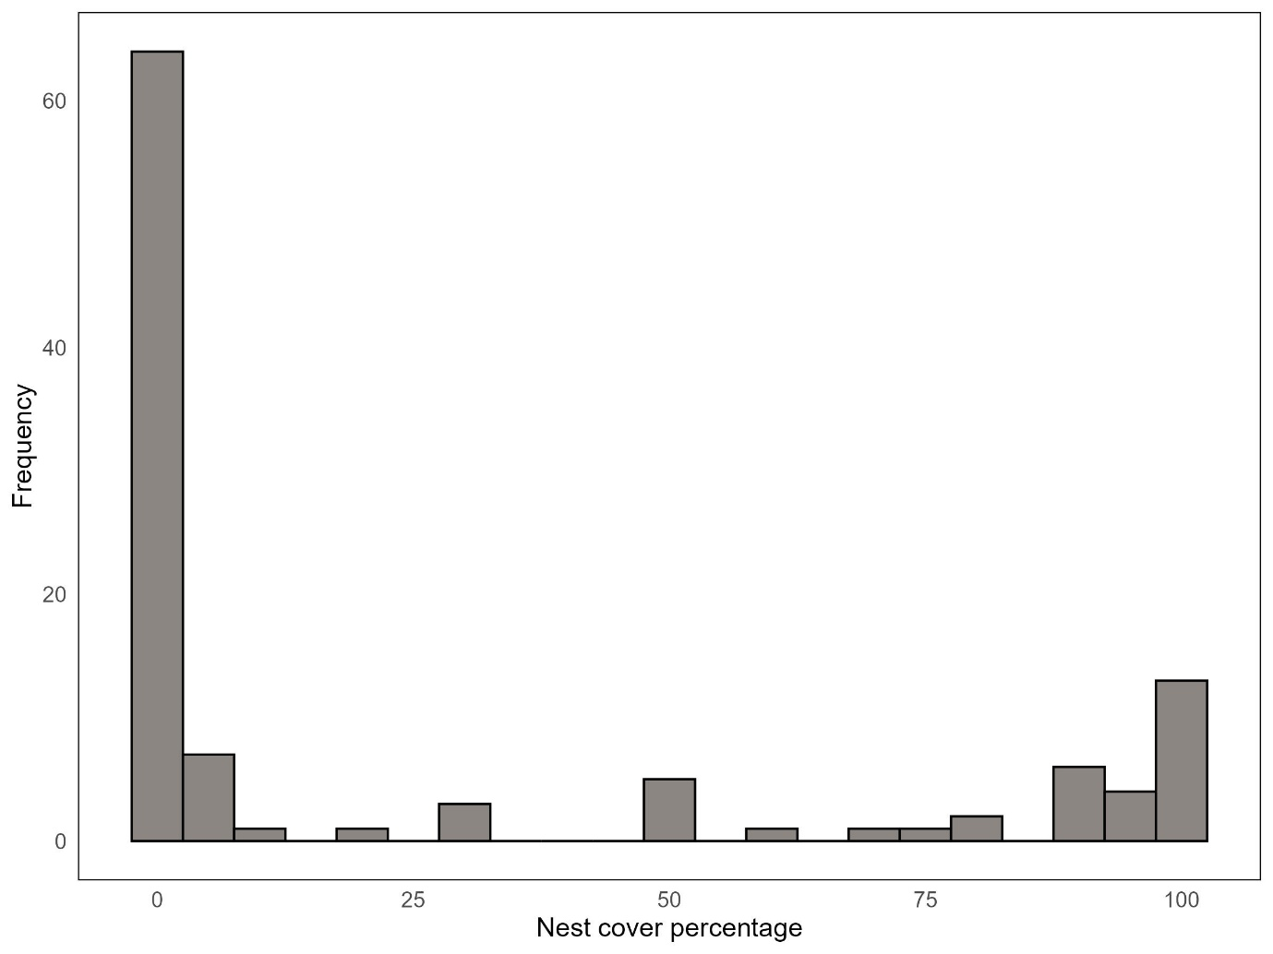
Fig. S3 Histogram of nest cover percentages for all found nests of Kentish Plovers in Mahres fishpond- Tunisia (N=109 nests)

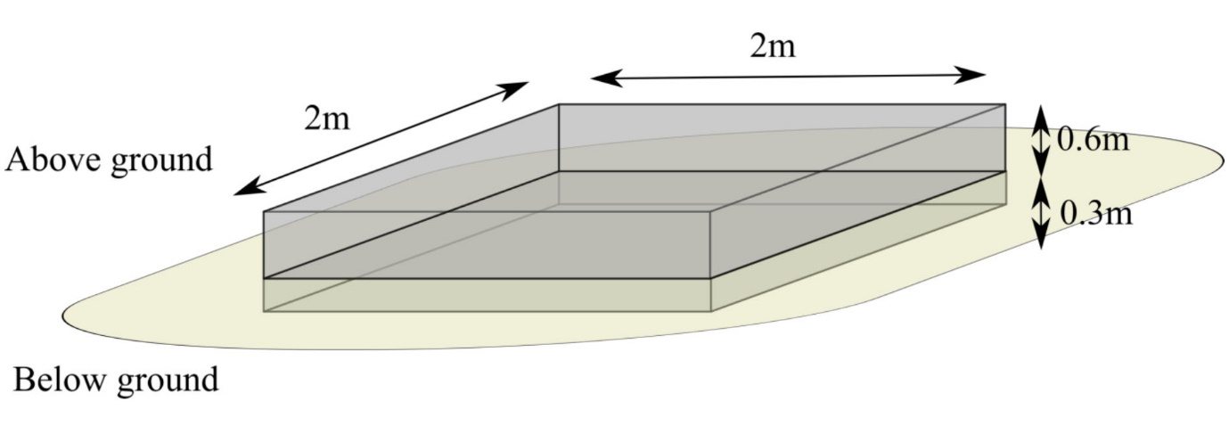
Fig. S4 Schematic structure of captivity aviary. Metal wire is embedded 30 cm below ground, and Hessian fabric lines the inside of the enclosure

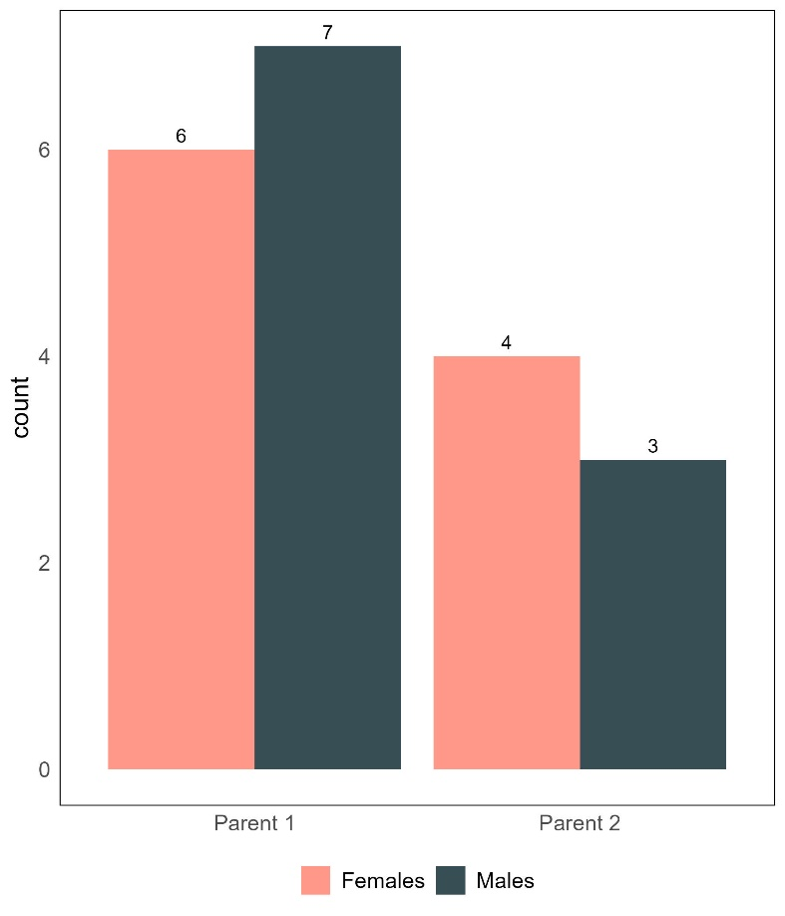
Fig. S5 Plot showing the distribution of first and second released parents. Parent 1 is the first released parent and parent 2 is the second released parent. The pink colour shows the female parents and the dark blue colour shows the males parents

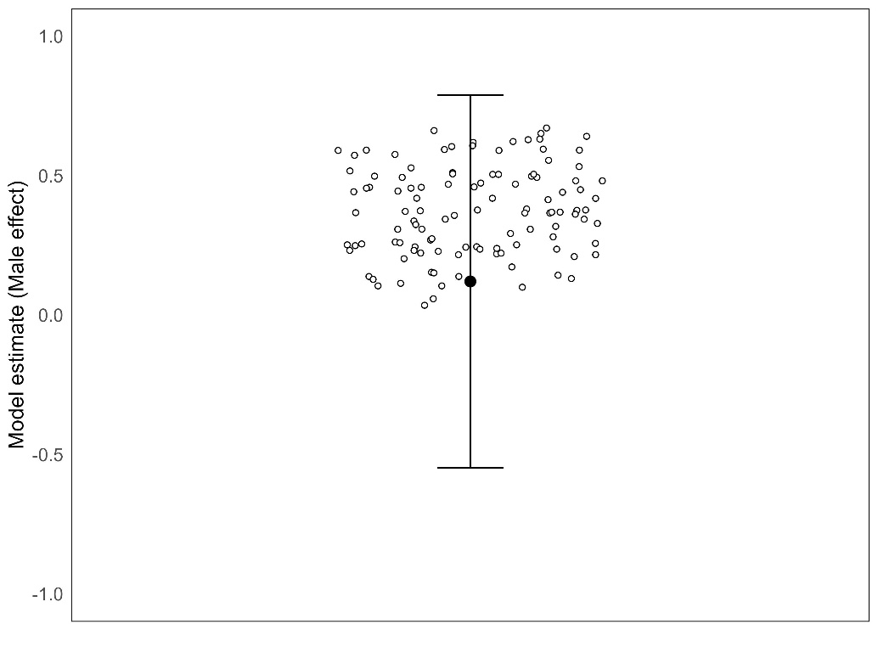
Fig. S6 Plot showing the model coefficient for the effect of being male from each of 112 independent datasets and the model coefficient from the full dataset. White points show model coefficients (i.e. effect of being male) across all independent datasets. Black point and error bars show model coefficient based on the full dataset and associated 95% confidence intervals. Results confirm that all coefficients fall within the 95% confidence interval of the full dataset underlining the robustness of our full dataset results

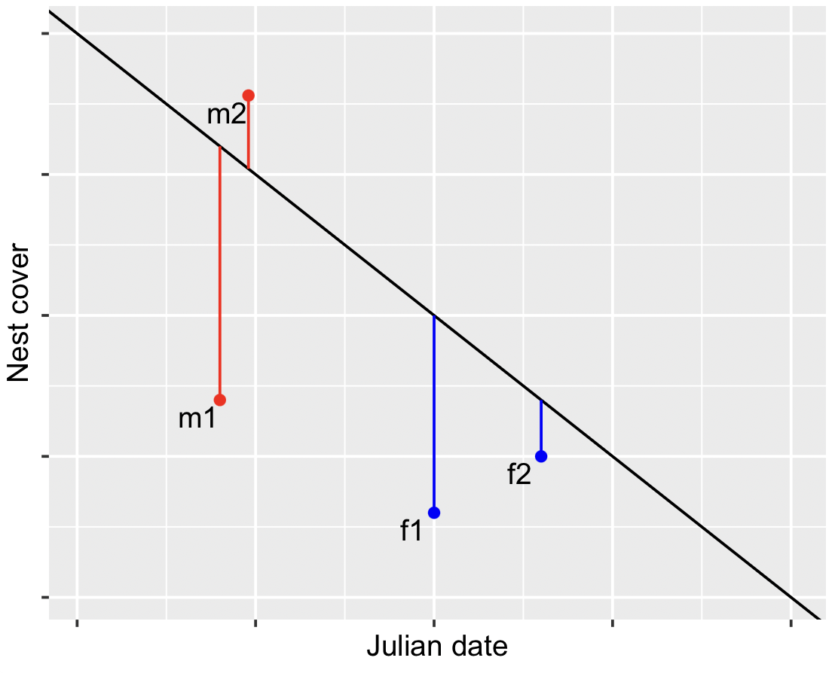
Fig. S7 Hypothetical example of residuals in nest cover for a male (red) and a female (blue). Residuals are coloured vertical lines extending from a seasonal decline in nest cover (black line) shown for first and second nests for the male and female. Total residual difference for male between his first and second nest is absolute value of residual m1 plus residual m2. Total residual difference for female is the absolute value of residual f1 minus residual f2

References
Harris I, Osborn TJ, Jones P, Lister D (2020) Version 4 of the CRU TS monthly high-resolution gridded multivariate climate dataset. Scientific data 7:109. doi:10.1038/s41597-020-0453-3

