Journal of Pest Science

Supplementary material

Diamide resistance: 10 years of lessons from Lepidopteran pests

Ewan B. Richardson¹, Bartlomiej J. Troczka^{1,2}, O. Gutbrod³, T.G. Emyr Davies^{1,*}, Ralf Nauen^{3,*}

¹Department of Biointeractions and Crop Protection, Rothamsted Research, Harpenden, UK
²Present address: College of Life and Environmental Sciences, Biosciences, University of Exeter, Penryn Campus, Penryn, UK
³Bayer AG, Crop Science Division, R&D, 40789 Monheim, Germany

Author ORCID:
Ralf Nauen: https://orcid.org/0000-0002-7525-8589
T.G. Emyr Davies: https://orcid.org/0000-0002-9452-2947
Ewan B. Richardson: https://orcid.org/0000-0002-9937-4197

*Correspondence to:
T.G. Emyr Davies: emyr.davies@rothamsted.ac.uk
Ralf Nauen: ralf.nauen@bayer.com

Methods

Assessment of diamide resistance and calculations
Two scores were used to assess diamide resistance episodes: Resistance Ratio (RR) and %_{RD}. Each provides unique information on the nature of the resistance episode.
RR is a common assessment of resistance, an indication of the efficacy of the insecticide against a resistant strain in comparison to a baseline efficacy in an insecticide susceptible reference strain that pre-dates resistance (Lethal Ratio Test (Robertson 2007)). RR indicates the scale of insecticide resistance that is taking place within the organism, information that is particularly valuable in combination with a biochemical understanding of resistance mechanisms. However, reliance on baseline toxicity measurements makes RR a poor quantifier of absolute insecticide resistance. Baseline measurements are variable within populations of a species, and even more so between different species, and such variation becomes problematic when it is amplified 100- or 1000- fold during calculation of RR. This can result in dramatic misdiagnosis of resistance severity, as shown in Table S1, in which the Brazilian P. xylostella population registers a lower chlorantraniliprole (CLR) LD50 than the Chinese C. suppressalis, whilst comparison by RR alone would suggest that the P. xylostella is experiencing a considerably more severe resistance.
When the goal of resistance monitoring is to predict control failure we utilised %_{RD.} As outlined in previous studies (Silva et al. 2011; Guedes 2016), this score is based upon comparing the LD₈₀ (lethal dose for 80%) of the population with the Recommended field Dose (RD) of the insecticide. %_{RD} is therefore an expression of the “LD₈₀ as a percentage of the RD”, and gives a direct estimation of the probability of control failure. If the estimated LD₈₀ is higher than the label rate of the commercial formulation, control failure will probably take place. Such a score has basis in European and Brazilian law, where new synthetic insecticides are required to kill >80% of their target population at their prescribed RD. On this scale, If a population registers a %_{RD} <100% against a given insecticide, this is an indication that control is currently effective; it matches or exceeds the minimum expectations of European and Brazilian insecticide registration requirements (Silva et al. 2011). A score of >100% indicates a significant risk that control failure will occur, based on the assumption that non-controlled (resistant) phenotypes will proliferate and increase within the population.
%_{RD} is calculated using the following equation: %RD = (LD₈₀ / RD) x 100. Where LD₈₀ is not listed in the literature, it is calculated via the following equation (GraphPad 2019):

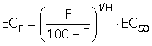

Calculations of LD₈₀ were validated against studies of known LD₈₀, e.g. (Roditakis et al. 2018). Calculated values are generally much lower, at just 60-80% of actual values, such that likelihood of control failure is expected to be far higher than reported here. Disparities between calculated and actual values are likely to be caused by early plateau of the logarithmic phase of the dose-response curve.
RD were extracted from the insecticide labels for flubendiamide (BELT®) and chlorantraniliprole (Coragen®) (Table S2). For simplicity's sake, the RD is taken to be that of the 'Lepidopteran Dilution'. BELT values calculated based on the given recommended spray volumes of 75-150ml/ha of 480g/L BELT formulation. CORAGEN values calculated based on the given recommended spray volumes of 0.046 - 0.098lb/acre. The Lepidoptera application rate for chlorantraniliprole has been calculated based on the median spray, 82.5g/ha. For comparability with the literature and with flubendiamide, this value was converted to 82.5mg/L following the arbitrary conversion listed in the BELT480 product label, i.e. 48g/ha: 48mg/L. It should be recognised that spraying practices and guidelines vary between localities, crops and pests. Although they are unlikely to exceed the spray limits listed here, the (mal)practise of under-dosing is common in some regions (Troczka et al. 2017), such that control failures may be significantly more likely than reported here.

Computational modelling
Taking into account the publication of Yan et al. (Yan et al. 2015) who described the (closed-state) conformational model of the European rabbit RyR1 in complex with FKBP12 at 3.8 Å resolution determined by single particle cryo-electron microscopy (cryo-EM), a multiple amino acid alignment of the RyR wildtype sequence of P. xylostella (UniProt G8EME3; Guo et al., 2012) and the rabbit structure (PDB 3J8H) was used to map the known mutation sites linked to diamide resistance (Troczka et al. 2012; Guo et al. 2014b; Guo et al. 2014a). As PDB 3J8H does not cover the complete sequence of the rabbit RyR1 (due to structural disorder), another but complete sequence of Oryctolagus cuniculus RyR1 (UniProt P11716) was added to the pairwise alignment to map the gaps in the structure determined by cryo-EM. A homology model for the P. xylostella RyR was constructed using the Advanced Homology Modeling tool within the software suite Maestro (Maestro 2019). To correct for van der Waals clashes and distortions in the local structure, the raw model was subjected to an energy refinement procedure with the MacroModel minimization module (Low-memory Broyden-Fletcher-Goldfarb-Shanno (LBFGS) method, 5000 iterations). The illustrations from the resulting 3D models shown in this review were generated from the Maestro modeling suite.

References
(those citations not listed below can be found in the references section of the main article)
Maestro (2019) Maestro Software, Schrödinger Release 2019-2. LLC, New York
Robertson JL, Russell RM, Preisler HK, Savin NE (2007) Bioassays with arthropods. CRC Press, Boca Raton

Fig S1 RyR-activating insecticides. Diamides derive their name from the double amide groups, located on positions 1 and 2 (yellow) of the central benzene ring. FLB, Flubendiamide, is a phthalic acid derivative and its name is derived from the terminal hepta-fluoryl group (red). CLR, Chlorantraniliprole, is an anthranilic acid derivative, differing from FLB by a reversal of the central amide bond (pink). CYA, Cyantraniliprole, possesses an almost identical structure to CLR, but differs in the replacement of a chlorine atom with a cyanide substituent (blue). T-CLR possesses an almost identical structure to CLR, but differs in the substitution of a methyl group for a bromide atom (green) and the addition of a cyclopropane ring (green). TET, Tetraniliprole, is the newest diamide release, and differs from CYA by the substitution of the bromide group with a large trifluoromethyl-tetrazolyl scaffold.

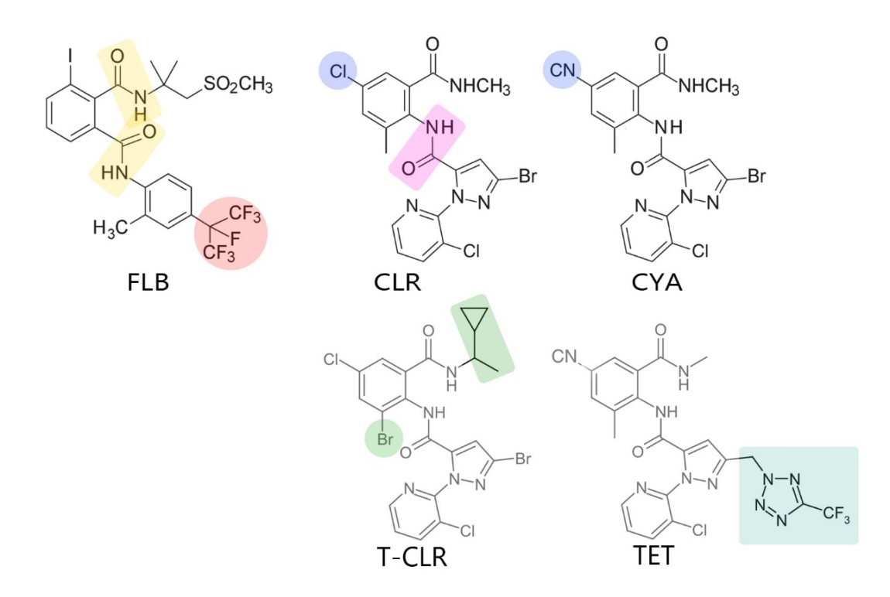

Table S1 Comparison of chlorantraniliprole (CLR) resistance across field strains from three lepidopteran species (taken from Table 1)
Species | Location | Compound | LD_{50 (mg/L)} | Slope | LD_{80 (mg/L)}ª | %_{RD} | RR
T. absoluta | Israel | CLR | 6998 | 2 | 17,438 | 21,137 | 22,573
P. xylostella | Brazil | CLR | 204 | 3.06 | 321 | 669 | 27,739
C. suppressalis | China | CLR | 214 | 1.94 | 437 | 530 | 153
ª LD expressed as ‘% of Recommended Dose (RD)’, where RD is 82.5mg/L for CLR

Table S2 Typical chlorantraniliprole (CLR; Coragen®) and flubendiamide (FLB; BELT®) spray dosage recommendations for the control of lepidopteran pests in various crops
 | FLB (BELT®) | CLR (Coragen®)
Minimum spray (g/ha) | 31 | 55
Maximum spray (g/ha) | 72 | 110
Recommended Dose (mg/L) | 48 | 82.5

Table S3 Lepidoptera segregate from other invertebrate and vertebrate species at the 4790 position of the ryanodine receptor (RyR; diamondback moth numbering)

