Supplementary Material
Title: Effects of Barley yellow dwarf virus infection on the interaction of virus susceptible and tolerant barley genotypes with different clones of the aphid species Rhopalosiphum padi

Authors: Maria Kern^{1,+}, Torsten Meiners^{2,+}, Edgar Schliephake¹, Antje Habekuss¹, Frank Ordon¹, Torsten Will^{1,*}

¹Julius Kuehn Institute (JKI), Federal Research Centre for Cultivated Plants, Institute for Resistance Research and Stress Tolerance, Erwin-Baur-Str. 27, 06484 Quedlinburg, Germany
²Julius Kuehn Institute (JKI), Federal Research Centre for Cultivated Plants, Institute for Ecological Chemistry, Plant Analysis and Stored Product Protection, Königin-Luise-Str. 19, 14195 Berlin, Germany
⁺shared first author.

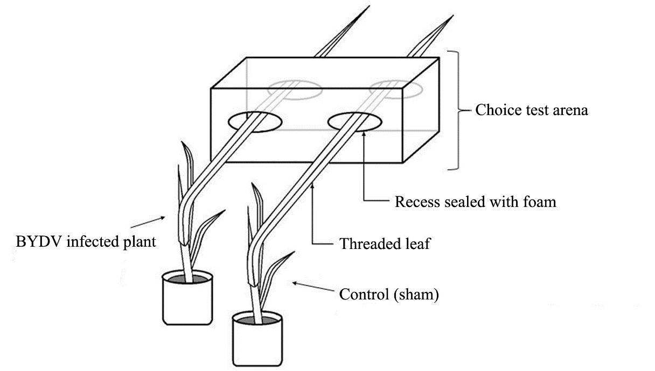

Fig. S1 Schematic illustration of the choice test setup. A soft plastic box (Height 9 cm, Length 10 cm, Width 7.5 cm), functioning as choice arena, was prepared by cutting holes in opposite sides. Intact leaves of H. vulgare (BYDV-infected and control (sham)) were thread through the opposite holes that were subsequently sealed with foam. The arena was lined with filter paper and after placing the aphids in the centre of the base, the arena was closed with Parafilm® M (Bemis Company, Neenah, Wisconsin, USA). The illustration is not drawn to scale.
Fig. S2 DAS-ELISA extinction of BYDV infected H. vulgare cv. ‘Rubina’ (n = 38) and ‘Vixen’ (n = 9) used for choice tests. The red dots indicate the mean values and black lines the median. Statistical test: ANOVA, Tukey HSD post hoc test: p < 0.05. The asterisk indicates a significant difference.

Volatiles analysis of H. vulgare cv. ‘Vixen’ and ‘Rubina’ (BYDV-infected and sham)
Methods: To compare the volatiles of virus free and infested ‘Vixen’ and ‘Rubina’ barley plants, the air of the headspace was collected from the differentially treated plants. BYDV-PAV infected vs. uninfected ‘Vixen’ and ‘Rubina’ plants were analysed. Following Kegge et al. (2015) barley plants were grown with 11 plants per pot to produce sufficient biomass to generate measureable amounts of VOCs per pot.
The abiotic conditions during headspace collections were 20 °C ± 1 °C, about 50% ± 5% relative humidity (RH) with daylight. Plant volatile collections were started between 9:00 and 12:00 o`clock local time. The entire setup was wrapped in a flexible polyethylene bag (Toppits ®, Cofresco Frischhalteprodukte GmbH & Co. KG, Minden, Germany). The bag was closed at the top by a cable tie. Prior to tightly closing the top, two Teflon tubes were inserted into the opening. Through one of these devices an adsorption tube (5 mg activated charcoal filters, Gränicher and Quartero, Daumazan, France) was inserted into the bag. Air was pulled through the adsorption tube with the use of an air-sampling pump (SKC 224-PCXR8KV series, SKC Inc., Houston, TX, USA) for 24 h at 0.5 l/min. The flow was measured by a battery-operating flowmeter (Aalborg® Model GFM17, 0-1000 ml/min He, Aalborg Instruments & Controls Inc., NY, USA). Through the other tube charcoal-filtered air could passively enter into the experimental setup. The VOCs were eluted from the filters with 50/50 % methanol/dichloromethane containing an internal standard (1 ng/µl 1-Bromooctane, Aldrich, purity 97%). The samples were stored at -20 °C. Prior to analysis by gas chromatography (see below), the eluted samples were concentrated under a stream of nitrogen to a volume of approx. 6 µl.
Extracts sampled from 11 plants were analysed by an Agilent 7890A gas chromatograph (Agilent, Santa Clara, CA, USA) in the splitless mode, coupled to a TOF mass spectrometer GCT Premier (Waters Corporation, Eschborn, Germany) equipped with a 30 m×0.25 mm (inner diameter (i.d.)), 0.25μm, HP-5MS column. Column temperature was programmed from 45 to 210°C at a rate of 3K/min and held for 5 min at start and 21.5 min at end temperature. Carrier gas was helium with a constant flow rate of 1 mL/min. Injector and detector temperatures were set at 250 and 230°C, respectively. Mass spectra were recorded in EI+ mode with mass range 1-800 m/z, scan time 0,9s, inter scan delay 0,1s, in centroid mode. The ionization energy was set at 70 eV.
Identification of the detected compounds was based on their relative retention times and their mass spectra in comparison with those observed for pure standard substances. The other compounds were tentatively identified by comparison of mass spectra and retention indices (calculated according to van den Dool and Kratz (1963)) with those recorded in the Adams and NIST mass spectral databases and the previously published data (Adams 2014; NIST Chemistry WebBook 2002). The retention indices of individual components were calculated using a series of n-alkenes (C8-C40). The percentage composition of the volatile fraction was computed from the GC peak areas according to the 100% method without using any correction factors.
Results: A principal component analysis (PCA) was used to compare the volatile patterns of plants of the cultivars ‘Vixen’ and ‘Rubina’ not infected and infected with BYDV-PAV with respect to the relative quantities of their volatile compounds . The results are visualised in a score (scatter) plot (Fig. S3). A total of 47.6% of the variance of the data is significantly explained by the first (PC1-30.2%) and the second (PC2-17.4%) principal component. The score plot of the relative amount of volatile compounds of the two different treatments and two varieties showed that plants of the genotype ‘Vixen’ (V+, V-) cluster together and plants of the genotype ‘Rubina’ (R+, R-) cluster together independently of their infection status. Sham and BYDV-infected plants could not be separated in trial 1 where 11 plants were grown per pot.

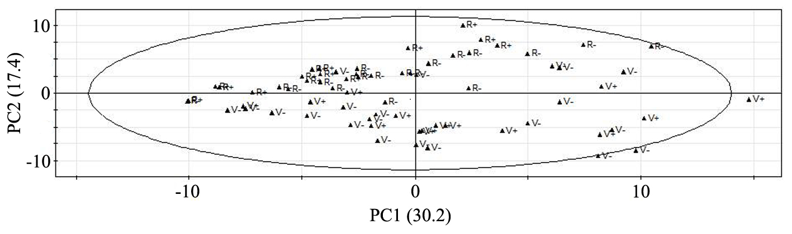
Fig. S3 Volatile pattern of differently treated barley plants. Score plot of ‘Rubina’ non-infested (R-), ‘Vixen’ non-infested (V-), ‘Rubina’ virus infested (R+), ‘Vixen’ virus infested (V+) plants (Trial 1, 11 plants grown per pot); A total of 47.6 % of the variance in the data is explained by the two significant principal components, as judged by cross-validation. The ellipse shown in the score plot defines the Hotelling’s T2 confidence region (95 %).

Discussion: Regarding the volatile blend, we were able to separate the plant cultivars ‘Vixen’ and ‘Rubina’ from each other on the basis of their volatile emissions by PCA, but a discrimination of sham and BYDV infected plants was not possible during a first trial. Possibly, barley plants might have experienced competition due to density-effects via roots or airborne signals (Ninkovic et al. 2016), masking an effect of BYDV infestation.

References
Adams RP (2014) Identification of essential oil components by gas chromatography/mass spectrometry (Vol. 456). Carol Stream, IL: Allured Publishing Corporation.
Kegge W, Ninkovic V, Glinwood R, Welschen RA, Voesenek LA, Pierik R (2015) Red: far-red light conditions affect the emission of volatile organic compounds from barley (Hordeum vulgare), leading to altered biomass allocation in neighbouring plants. Ann Bot 115:961-970
Ninkovic V, Markovic D, Dahlin I (2016) Decoding neighbour volatiles in preparation for future competition and implications for tritrophic interactions. Perspect Plant Ecol Syst 23:11-17
NIST Chemistry WebBook, SRD 69. (2002) NIST Standard Reference Database Number 69. National Institute of Standards and Technology, Gaithersburg, USA.
van Den Dool H, Kratz PD (1963) A generalization of the retention index system including linear temperature programmed gas—liquid partition chromatography. J Chromatogr A 11:463-471

