Supplementary material
Figures
Fig. 1.- Cluster dendrogram used to check multicollinearity between variables. One predictor (in red) for each cluster below the 0.5 threshold (in red) was selected for climate suitability modelling. 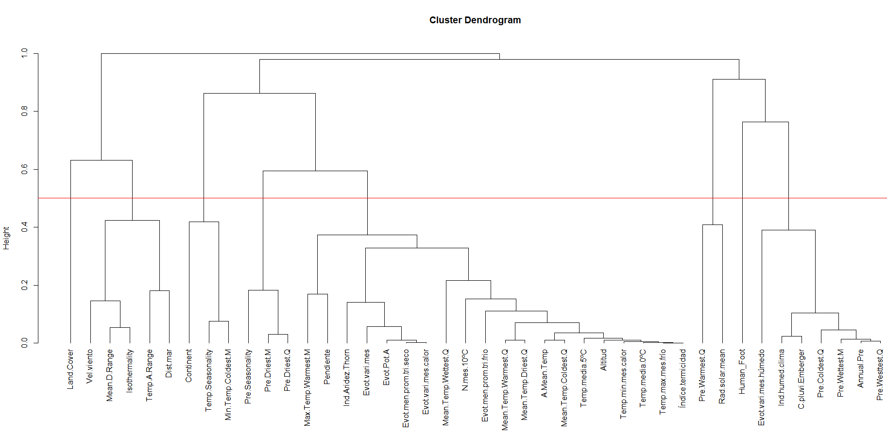

Land Cover, Vel.viento = Wind speed, Mean.D.Range = Mean Diurnal range, Isothermality, Temp.A.Range = Temperature Annual Range, Dist.mar = Distance to the sea, Continent = Continentality, Temp.Seasonality = Temperature Seasonality, Min.Temp.Coldest.M = Min Temperature of Coldest Month, Pre.Seasonality = Precipitation Seasonality, Pre.Driest.M = Precipitation of Driest Month, Pre.Driest.Q = Precipitation of Driest Quarter, Max.Temp.Warmest.M = Max Temperature of Warmest Month, Pendiente = Slope, Ind.Aridez.Thorn = Thornthwaite aridity index, Evot.vari.mes = Monthly variability in potential evapotranspiration, Evot.Pot.A = Annual potential evapotranspiration, Evot.men.prom.tri.seco = Mean monthly precipitation of driest quarter, Evot.vari.mes.calor = Mean monthly precipitation of warmest quarter, Mean.Temp.Wettest.Q = Mean Temperature of Wettest Quarter, N.mes.10ºC = Months with a mean temperature greater than 10℃, Evot.men.prom.tri.frio = Mean monthly precipitation of coldest quarter, Mean.Temp.Warmest.Q = Mean Temperature of Warmest Quarter, Mean.Temp.Driest.Q = Mean Temperature of Driest Quarter, A.mean.Temp = Annual Mean Temperature, Mean.Temp.Coldest.Q = Mean Temperature of Coldest Quarter, Temp.media.5ºC = Mean monthly temperature for months with mean temperature greater than 5℃ multiplied by number of days, Altitud = Altitude, Temp.min..mes.calor = Min temperature of the warmest month, Temp.media.0ºC = Mean monthly temperature for months with mean temperature greater than 0℃ multiplied by number of days, Temp.max.mes.frio = Max temperature of the coldest month, Indice.termicidad = Compensated thermicity index, Pre.Warmest.Q = Precipitation of Warmest Quarter, Rad.solar.mean = Solar radiation, Human_foot = Human footprint, Evot.vari.mes.humedo = Mean monthly precipitation of wettest quarter, Ind.humed.clima = Climatic moisture index, C.pluvi.Emberger = Emberger's pluviothermic quotient, Pre.Coldest.Q = Precipitation of Coldest Quarter, Pre.Wettest.M = Precipitation of Wettest Month, Annual.Pre = Annual Precipitation, Pre.Wettest.Q = Precipitation of Wettest Quarter

Fig. 2 – Comparing the distributions of V. velutina presence with environmental background over the environmental predictors.
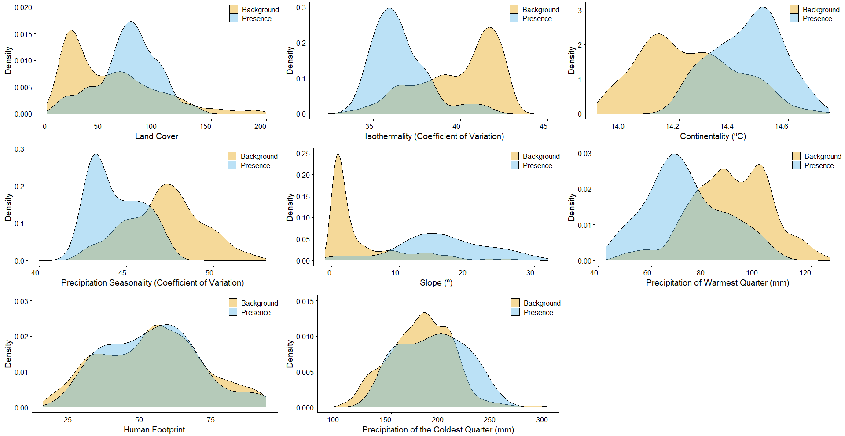

Fig. 3.- Density plot representing number of km² for each potential suitability value in the Mediterranean islands used in this study.
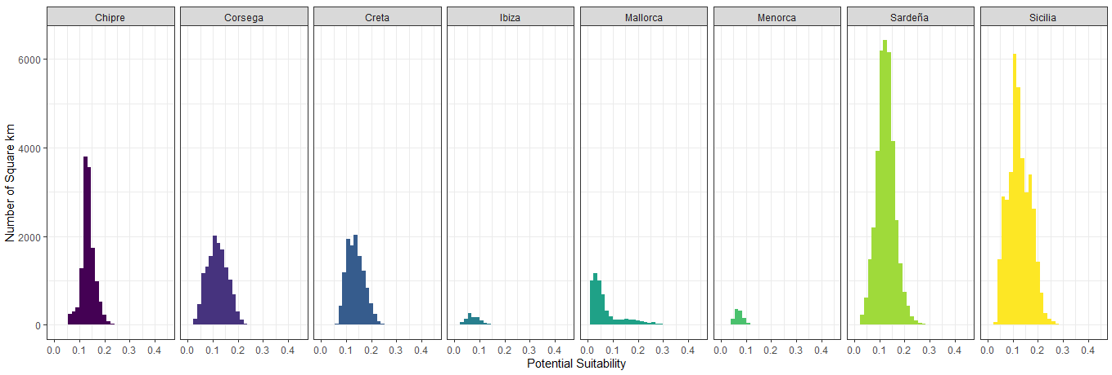

Tables
Table 1.- Variables included in the analysis and variables used in the study are in bold. Average values in Mallorca shown together with the values where species presence was recorded. Source of data and references are included.
Type of variable | Variables | Mallorca min-max | Presences min-max | References
Climatic  (n=37)  Data source:  - Worldclim 2.0 (Fick and Hijmans, 2017)  - ENVIREM (Title and Bemmels, 2018) | Annual Mean Temperature (ºC) | 10.79 – 17.23 | 12.74 – 16.40 | Barbet-Massin et al., 2013; Bessa et al., 2016; de Medeiros et al., 2018; Fournier et al., 2017; Rodríguez-Flores et al., 2019; Villemant, Barbet-Massin, et al., 2011; Villemant, Muller, et al., 2011
 | Mean Diurnal Range | 7.61 – 11.53 | 8.38 – 10.73
 | Isothermality | 33.17 – 43.10 | 34.29 – 41.25
 | Temperature Seasonality | 521.60 – 620.00 | 545.10 – 606.00
 | Max Temperature of Warmest Month (ºC) | 23.40 – 30.60 | 25.50 – 29.60
 | Min Temperature of Coldest Month (ºC) | -1.60 – 6.70 | 0.50 – 4.80
 | Temperature Annual Range | 21.70 – 27.00 | 23.40 – 26.00
 | Mean Temperature of Wettest Quarter (ºC) | 7.67 – 18.53 | 9.70 – 14.05
 | Mean Temperature of Driest Quarter (ºC) | 18.95 – 24.05 | 20.68 – 23.33
 | Mean Temperature of Warmest Quarter (ºC) | 18.95 – 24. 20 | 20.68 – 23.70
 | Mean Temperature of Coldest Quarter (ºC) | 4.20 – 11.48 | 6.15 – 10.27
 | Annual Precipitation (mm) | 404.00 – 934.00 | 505.00 – 796.00
 | Precipitation of Wettest Month (mm) | 69.00 – 120.00 | 80.00 – 105.00
 | Precipitation of Driest Month (mm) | 4.00 – 17.00 | 8.00 – 14.00
 | Precipitation Seasonality | 42.04 – 53.62 | 42.65 – 46.88
 | Precipitation of Wettest Quarter (mm) | 164.00 – 348.00 | 197.00 – 301.00
 | Precipitation of Driest Quarter (mm) | 32.00 – 92.00 | 48.00 – 78.00
 | Precipitation of Warmest Quarter (mm) | 43.00 – 127.00 | 48.00 – 101.00
 | Precipitation of Coldest Quarter (mm) | 104.00 – 296.00 | 146.00 – 246.00
 | Wind speed (km/h) | 2.63 – 5.00 | 2.98 – 4.27 | This study
 | Solar radiation (kJ/m2*day) | 15320 – 16009 | 15592 – 15901 | This study
 | Compensated thermicity index (ºC) | 193.00 – 381.00 | 258.00 – 377.00 | This study
 | Annual potential evapotranspiration (mm/year) | 801.50 – 1010.00 | 864.60 – 994.80 | This study
 | Thornthwaite aridity index | 51.80 – 73.34 | 56.00 – 70.11 | This study
 | Climatic moisture index | -0.56 – -0.13 | -0.52 – -0.1 | This study
 | Continentality (ºC) | 13.85 – 14.75 | 14.25 – 14.65 | This study
 | Emberger's pluviothermic quotient | 67.14 – 144.38 | 74.78 – 36.53 | This study
 | Mean monthly temperature for months with mean temperature greater than 0℃ multiplied by number of days | 46134 - 73422 | 55476 - 72918 | This study
 | Mean monthly temperature for months with mean temperature greater than 5℃ multiplied by number of days | 35760 - 73422 | 55476 - 72918 | This study
 | Max temperature of the coldest month (ºC) | 7.70 – 14.20 | 9.90 – 14.00 | This study
 | Min temperature of the warmest month (ºC) | 14.90 – 20.60 | 16.90 – 20.50 | This study
 | Months with a mean temperature greater than 10℃ | 6.00 – 12.00 | 7.00 – 12.00 | This study
 | Mean monthly precipitation of coldest quarter (mm/month) | 26.79 – 37.33 | 30.00 – 36.53 | This study
 | Mean monthly precipitation of driest quarter (mm/month) | 117.10 – 139.10 | 123.10 – 136.50 | This study
 | Monthly variability in potential evapotranspiration (mm/month) | 3739.00 – 4254.00 | 3870.00 – 4167.00 | This study
 | Mean monthly precipitation of warmest quarter (mm/month) | 106.60 – 126.30 | 112.10 – 123.60 | This study
 | Mean monthly precipitation of wettest quarter (mm/month) | 34.40 – 69.42 | 37.96 – 67.74 | This study
Topography (n=2)  Data source:  - SRTM 90m Digital Elevation Database v4.1 (Jarvis et al. 2008) | Altitude (m) | 0.00 – 1229.50 | 78.50 – 825.50 | Bertolino et al., 2016; de Medeiros et al., 2018; Rodríguez-Flores et al., 2019
 | Slope (º) | 0.00 – 35.34 | 0.69 – 28.87 | This study
Remote sensing⁴ (n=1)  Data source:  - GlobCover 2009 | Land cover | 11.00 – 200.00 | 14.00 – 130.62 | de Medeiros et al., 2018; Fournier et al., 2017; Lioy et al., 2019
Hidrography  (n=1) | Distance to the sea (km) | 0.00 – 24.00 | 0.50 – 15.80 | This study
Anthropogenic (n=1)  Data source:  - Human Footprint, 2018 Release (2009) (Venter et al., 2009; 2016) | Human footprint | 15.00 – 93.00 | 30.29 – 88.32 | de Medeiros et al., 2018; Robinet et al., 2017

