Supplementary information for the manuscript
“Species-specific effects of ethanol concentration on host colonization by four common species of ambrosia beetles”
By: Giacomo Cavaletto, Christopher M. Ranger, Micheal E. Reding, Lucio Montecchio, Davide Rassati

Tables S1 and S2
Figure S1 to S2

Table S1: Tree diameter (dbh), ethanol concentration (%), amount of solution injected every two weeks (ml), and amount of ethanol in the injected solution (ml) for each of the 40 trees used in this experiment. The amount of solution injected in each tree was calculated based on the value 75 ml for a 4.5 cm diameter tree used in previous ethanol-injection experiments (Ranger et al. 2010; Reding et al. 2013b). This value was then adjusted based on the tree volume, calculated as diameter x tree height
Tree number | Tree diameter (cm) | Ethanol concentration  (%) | Amount of injected solution (ml) | Amount of ethanol in injected solution (ml)
1 | 4 | 75 | 59 | 44
2 | 4.5 | 75 | 75 | 56
3 | 4.2 | 90 | 65 | 59
4 | 3.8 | 25 | 53 | 13
5 | 3.4 | 90 | 43 | 39
6 | 3.7 | 5 | 51 | 3
7 | 4.2 | 5 | 65 | 3
8 | 4.5 | 90 | 75 | 68
9 | 5 | 50 | 93 | 46
10 | 3.5 | 25 | 45 | 11
11 | 3.9 | 50 | 56 | 28
12 | 4.2 | 25 | 65 | 16
13 | 4 | 90 | 59 | 53
14 | 4 | 5 | 59 | 3
15 | 3.6 | 75 | 48 | 36
16 | 4.6 | 90 | 78 | 71
17 | 4.3 | 5 | 68 | 3
18 | 3.5 | 50 | 45 | 23
19 | 4 | 90 | 59 | 53
20 | 5.1 | 90 | 96 | 87
21 | 4.5 | 5 | 75 | 4
22 | 5.4 | 75 | 108 | 81
23 | 5.1 | 25 | 96 | 24
24 | 4.6 | 5 | 78 | 4
25 | 5 | 75 | 93 | 69
26 | 4.8 | 50 | 85 | 43
27 | 4.9 | 75 | 89 | 67
28 | 4.9 | 90 | 89 | 80
29 | 4.6 | 25 | 78 | 20
30 | 4 | 25 | 59 | 15
31 | 3.8 | 5 | 53 | 3
32 | 4 | 50 | 59 | 30
33 | 4.5 | 25 | 75 | 19
34 | 3.6 | 5 | 48 | 2
35 | 4.5 | 50 | 75 | 38
36 | 4.2 | 50 | 65 | 33
37 | 4 | 50 | 59 | 30
38 | 4 | 75 | 59 | 44
39 | 4.5 | 75 | 75 | 56
40 | 3.7 | 25 | 51 | 13

Table S2: Results of the statistical analysis testing the effect of the distance from the injection site on the amount of ejected sawdust and offspring production in the four targeted ambrosia beetle species.

Species | Sawdust |  | Offspring
Species | H | P | H | P
Anisandrus dispar | 4.31 | 0.22 | 0.78 | 0.85
Xyleborinus saxesenii | 2.95 | 0.39 | 4.82 | 0.18
Xylosandrus crassiusculus | 1.03 | 0.79 | 5.76 | 0.12
Xylosandrus germanus | 0.57 | 0.90 | 3.15 | 0.36

Fig. S1: Photographs showing (A) arrangement of potted trees at the experimental site, (B) the BITE system and the syringe used to inject ethanol solution, (C) the catheter bag connected to the BITE system used to fill the syringe with water over the period between two consecutive injections, and (D) attachment of Falcon tubes used to cage adult females and collect emerging offspring were attached to tree stem.

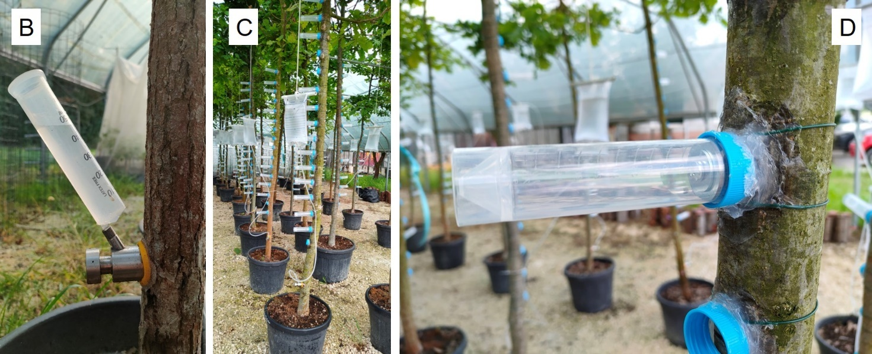

Fig. S2: Scheme showing how adult females of the different species were caged on the tree stem (A) and photographs of (B) sawdust emitted from the entry holes, (C) the technique used to collect and then measure ejected sawdust, and (D) adults emerged from the gallery and collected into the Falcon tubes.

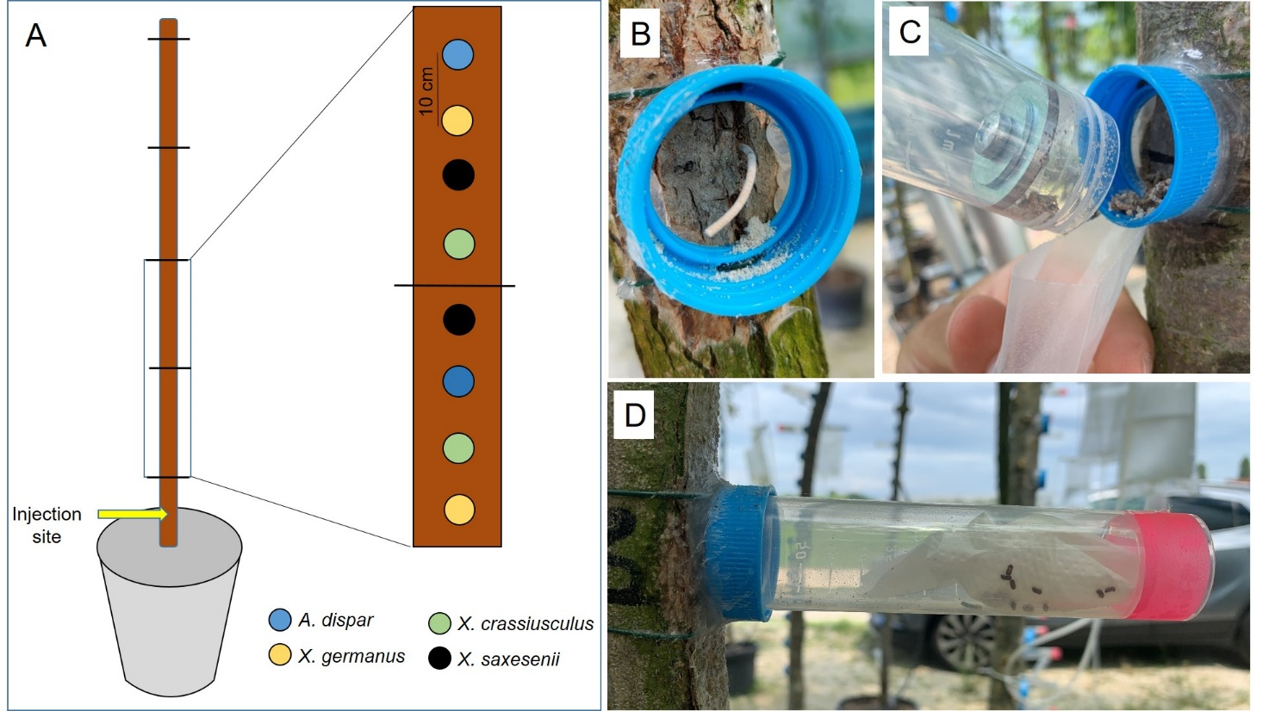

Fig. S3: Hand-made panel traps used to collect living ambrosia beetle individuals.

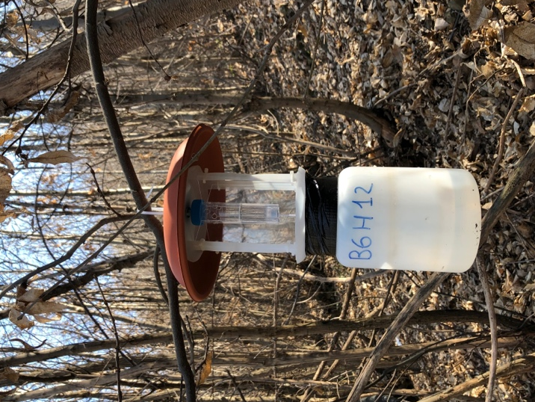

Fig. S4: Photographs depicting the three categories used to classify beetle galleries

