Disentangling arthropod and plant resources consumed by Orius spp. in peach and alfalfa crops by metagenomic analysis

Iván Batuecasª, Oscar Alomarª, Cristina Castañéª, Josep Piñol^{b,c}, Lorena Gallardo-Montoyaª, Nuria Agustíª

a Sustainable Plant Protection, IRTA, Cabrils, Spain
b Univ. Autònoma Barcelona, Cerdanyola del Vallès, Spain
c CREAF, Cerdanyola del Vallès, Spain

∗ Correspondence to: Nuria Agustí, IRTA, Ctra. de Cabrils, Km. 2, E-08348 Cabrils, Barcelona, Spain. Tel: +34 937507511; E-mail: nuria.agusti@irta.cat

ORCID of the authors:
Iván Batuecas: https://orcid.org/0000-0002-9792-2129
Oscar Alomar: https://orcid.org/0000-0002-8756-871X
Cristina Castañé: https://orcid.org/0000-0002-1080-1253
Josep Piñol: https://orcid.org/0000-0002-4067-3301
Lorena Gallardo: https://orcid.org/0000-0002-2148-0678
Nuria Agustí: https://orcid.org/0000-0002-5908-4873

Table S1. Arthropod (ZBJ-ArtF1c/ZBJ-ArtR2c and mlCOIintF/HC02198) and plant (ITS-S2F/ITS4R and cA49325/trnL110R) primer pairs used in this study. Also indicated the sequence of each forward (F) and reverse (R) primer and the length of the amplified fragment.
 | Sequence 5´- 3´(F) | Sequence 5´- 3´(R) | Reference | Fragment (bp)
ZBJ-ArtF1c/ZBJ-ArtR2c | AGATATTGGAACWTTATATTTTATTTTTGG | WACTAATCAATTWCCAAATCCTCC | Zeale et al. 2011 | 157
mlCOIintF/HC02198 | GGWACWGGWTGAACWGTWTAYCCYCC | TAAACTTCAGGGTGACCAAAAAATCA | Leray et al. 2013/Folmer et al. 1994 | 313
ITS-S2F/ITS4R | ATGCGATACTTGGTGTGAAT | TCCTCCGCTTATTGATATGC | Chen et al. 2010/White et al. 1990 | 350
cA49325/trnL110R | CGAAATCGGTAGACGCTACG | GATTTGGCTCAGGATTGCCC | Taberlet et al. 2007/Borsch et al. 2003 | 80

Table S2. Accession numbers of the sequences from the databases used as reference to obtain the percentages of similarity.
Accession number | species | Databases used
MG007856.1 | Orius laevigatus | GenBank
MG007857.1 | Orius laevigatus | GenBank
KM021482.1 | Orius niger | GenBank
KM021745.1 | Orius niger | GenBank
KM021890.1 | Orius niger | GenBank
KM022197.1 | Orius niger | GenBank
KM022760.1 | Orius niger | GenBank
KM022882.1 | Orius niger | GenBank
KM022999.1 | Orius niger | GenBank
SONE138-11 | Orius majusculus | Bold
SONE141-11 | Orius majusculus | Bold

Table S3. Taxa obtained from each library and with each primer pair. NT= not tested. NAmp = Not amplified.
species/sample | Crop | Date | # of individuals/ Sample size | Library # | Arthropod primer pairs |  | Plant primer pairs
 |  |  |  |  | ZBJ-ArtF1c/ZBJ-ArtR2c | mlCOIintF/HC02198 | ITS-S2F/ITS4R | CA49325/trnL110R
Orius laevigatus | Peach | June-2016 | 7 | L1 | Orius laevigatus  Aphididae | Orius  Orius laevigatus  Frankliniella occidentalis | NT | NT
 |  |  |  | L2 | NT | NT | Prunus persica | Solanaceae  Pinus  Rosaceae  Fabaceae
Orius majusculus | Peach | June-2016 | 21 | L3 | Orius laevigatus  Orius majusculus | Orius  Orius majusculus | NT | NT
 |  |  |  | L4 | NT | NT | NAmp | Asteraceae  Pinus  Fabaceae  Rosaceae
Orius niger | Alfalfa | June-2016 | 9 | L5 | Hypera  Tanytarsus volgensis  Orthocladiinae  Liriomyza  Orius laevigatus  Orius niger | Orius niger  Frankliniella occidentalis | NT | NT
 |  |  |  | L6 | NT | NT | Streptophyta | Streptophyta Caryophyllales  Fabaceae  Pinus
Orius niger | Alfalfa | June-2016 | 25 | L7 | Hypera  Orthocladiinae  Liriomyza  Orius niger  Aeolothrips intermedius | Liriomyza  Orius niger  Frankliniella occidentalis  Aeolothrips intermedius | NT | NT
 |  |  |  | L8 | NT | NT | Medicago sativa | Asparagales Asteraceae  Poaceae  Pinus  Fabaceae
Orius niger | Alfalfa | July-2017 | 13 | L9 | Orius  Orius niger  Cicadellidae | Orius  Orius niger | NT | NT
 |  |  |  | L10 | NT | NT | NAmp | Fabaceae
Orius niger | Alfalfa | September-2017 | 22 | L11 | Orius  Orius laevigatus  Orius niger  Cicadellidae | Aedes caspius  Ceratopogonidae  Orius  Orius niger  Therioaphis trifolii  Cicadellidae  Frankliniella occidentalis | NT | NT
 |  |  |  | L12 | NT | NT | Medicago sativa  Prunus persica | Streptophyta  Asteraceae  Fabaceae  Rosaceae  Poa annua
Prunus persica | Peach |  | 1 cm² | L13 | NT | NT | Prunus persica | Rosaceae
Medicago sativa | Alfalfa |  | 1 cm² | L14 | NT | NT | Medicago sativa | Fabaceae

Table S4. Percentages of similarity means by pairs from the region amplified by each arthropod primer pair used calculated from the sequences obtained in the databases of three amplified Orius species.
Species comparison | ZBJ-ArtF1c/ZBJ-ArtR2c (%) | mlCOIintF/HC02198 (%)
O. majusculus - O. laevigatus | 92,04 | 87,29
O. majusculus - O. niger | 92,42 | 90,85
O. laevigatus - O. niger | 94,34 | 91,53

Table S5. Mean of the calculated percentages of similarity between the obtained number of OTUs for the predator (O. majusculus or O. niger) and for the prey (other Orius species) using the ZBJ-ArtF1c/ZBJ-ArtR2c pair of primers.
Predator species | Prey species | Library | # Predator  OTUs | # Prey  OTUs | Mean % similarity  between OTUs
O. majusculus | O. laevigatus | L3 | 5 | 5 | 91,90
O. niger | O. laevigatus | L5 | 6 | 1 | 92,73
O. niger | O. laevigatus | L11 | 2 | 1 | 93,94

Table S6. Number of reads and OTUs obtained per library regarding the amplified Orius species, and the taxon finally assigned with each pair of arthropod primer used. The species with the highest number of reads and OTUs within a library and pair of primer used is indicated in grey.

17- Asteraceae, 18- Fabaceae, 19- Asparagales, 20- Caryophyllales, 21- Medicago lupulina,
22- Oryza sativa, 23- Astragalus sp, 24- Solanaceae, 25- Streptophyta, 26- Plantago ,
27- Convolvulaceae, 28- Poa annua, 29- Lolium , 30- Poaceae, 31- Prunus persica,
32- Malva , 33- Medicago sativa, 34- Pinus , 35- Rosaceae

Predator | Library | Primer pair | Orius species
Predator | Library | Primer pair | # Reads | # OTUs | Taxon assigned
Orius laevigatus | L1 | ZBJ-ArtF1c/ZBJ-ArtR2c | 56868 | 23 | O. laevigatus
Orius laevigatus | L1 | mlCOIintF/HC02198 | 2015 | 3 | O. laevigatus
Orius majusculus | L3 | ZBJ-ArtF1c/ZBJ-ArtR2c | 24906 | 5 | O. majusculus
Orius majusculus | L3 | ZBJ-ArtF1c/ZBJ-ArtR2c | 6668 | 5 | O. laevigatus
Orius majusculus | L3 | mlCOIintF/HC02198 | 1635 | 2 | O. majusculus
Orius niger | L5 | ZBJ-ArtF1c/ZBJ-ArtR2c | 109935 | 6 | O. niger
Orius niger | L5 | ZBJ-ArtF1c/ZBJ-ArtR2c | 15 | 1 | O. laevigatus
Orius niger | L5 | mlCOIintF/HC02198 | 10679 | 2 | O. niger
Orius niger | L7 | ZBJ-ArtF1c/ZBJ-ArtR2c | 79012 | 3 | O. niger
Orius niger | L7 | mlCOIintF/HC02198 | 21255 | 2 | O. niger
Orius niger | L9 | ZBJ-ArtF1c/ZBJ-ArtR2c | 25677 | 1 | O. niger
Orius niger | L9 | mlCOIintF/HC02198 | 19202 | 1 | O. niger
Orius niger | L11 | ZBJ-ArtF1c/ZBJ-ArtR2c | 38716 | 2 | O. niger
Orius niger | L11 | ZBJ-ArtF1c/ZBJ-ArtR2c | 3668 | 1 | O. laevigatus
Orius niger | L11 | mlCOIintF/HC02198 | 23446 | 38 | O. niger
 |  | Total | 423697 | 95

Table S7. Number of template-mismatches of each arthropod pair of primers with each amplified taxon. NS = no sequence present in the databases.
 | mlCOIintT/HC02198 |  | ZBJ-ArtF1c/ ZBJ-ArtR2c
Taxon | Forward  (mlCOIintT) | Reverse  (HC02198) | Forward  (ZBJ-ArtF1c) | Reverse  (ZBJ-ArtR2c)
Hypera | 1 | NS | 0 | 2
Liriomyza | 1 | 3 | 1 | 1
Tanytarsus volgensis | 1 | NS | 3 | 8
Orthocladiinae | 0 | NS | 0 | 6
Ceratopogonidae | 1 | NS | 3 | 4
Aedes caspius | 1 | 1 | 1 | 5
Orius | 2 | 4 | 3 | 3
Orius laevigatus | 0 | NS | 1 | 0
Orius majusculus | 1 | NS | 1 | 0
Orius niger | 0 | NS | 0 | 2
Aphididae | 1 | NS | 3 | 2
Therioaphis trifolii | 2 | NS | 3 | 8
Cicadellidae | 1 | NS | 4 | 2
Aeolothrips intermedius | 0 | NS | 3 | 6
Frankliniella occidentalis | 1 | NS | 4 | 5

Figure S1. Percentage of predator and prey taxa amplified by each arthropod primer pairs from each library: (A) Taxa amplified by ZBJ-ArtF1c/ZBJ-ArtR2c primer pairs; (B) Taxa amplified by mlCOIintF/HC02198 primer pairs. Predator (green); Prey (orange).

- (B)
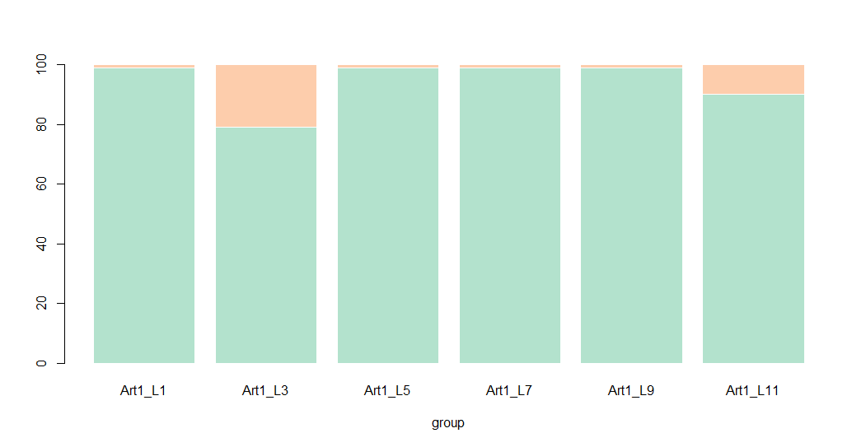
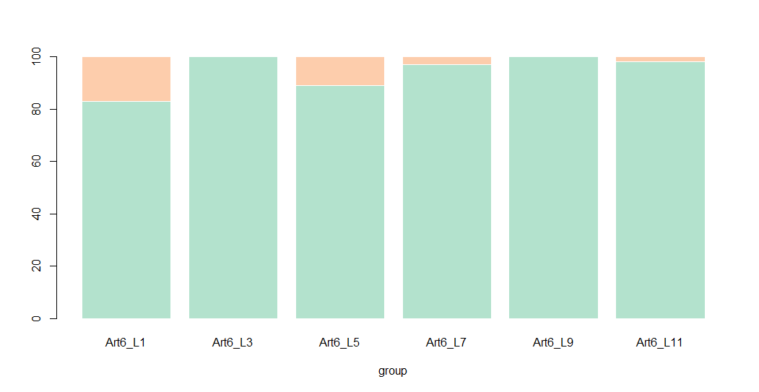
Libraries
%
L1 L3 L5 L7 L9 L11
100
60
80
40
20
0
99% 79% 99% 99% 99% 90%
21%
10%
1%
1%
1%
1%
Libraries
100
60
80
40
20
0
83% 100% 89% 97% 100% 98%
L1 L3 L5 L7 L9 L11
17%
11%
3%
2%
%

Figure S2. Percentage of frequency of occurrence (FOO%) of the (A) arthropod taxa resources items consumed by all analysed Orius; (B) arthropod taxa resources items consumed by Orius niger; (C) plant taxa resources items consumed by all Orius; (D) of the plant taxa resources items consumed by Orius niger.
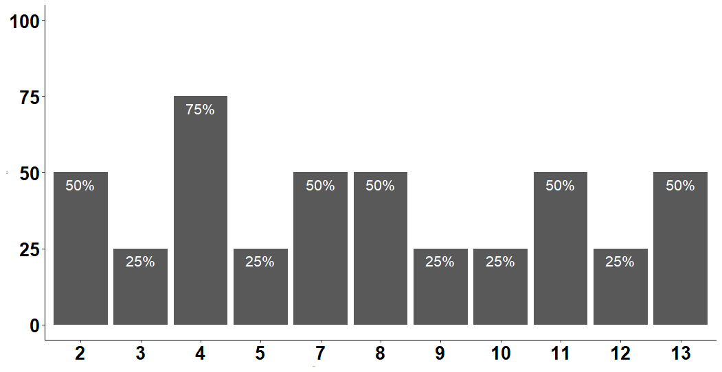
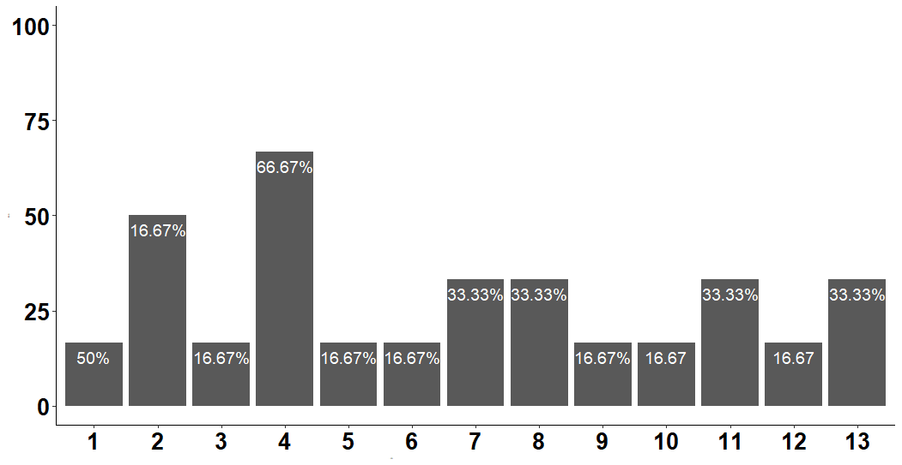
(A) (B)
Taxa
Taxa

1-Orius
2-Orius laevigatus
3-Aeolothrips intermedius
4-Frankliniella occidentalis
5-Aphididae
6- Therioaphis trifolii
7-Hypera
8-Liriomyza
9- Aedes caspius
10- Tanytarsus volgensis
11- Orthocladiinae
12- Ceratopogonidae
13-Cicadellidae

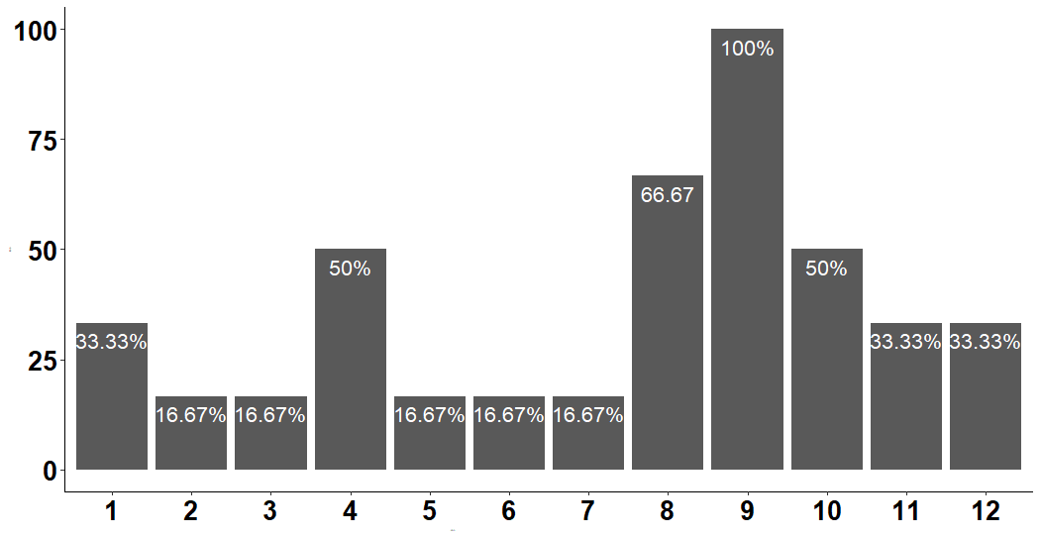
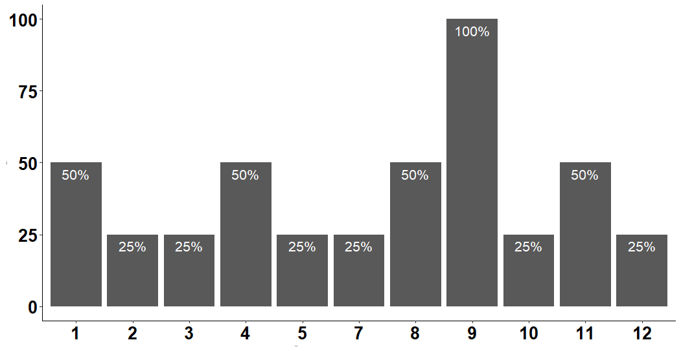
(C) (D)
Taxa
%
Taxa
%

1-Streptophyta
2-Asparagales
3-Caryophyllales

4-Asteraceae
5-Poaceae
6-Solanaceae

7-Poa annua
8-Pinus
9-Fabaceae

10-Rosaceae
11-Medicago sativa
12-Prunus persica

