SUPPLEMENTARY DATA

Structural characterization of carboxyatractyloside and acaricidal activity of natural ent-kaurene diterpenoids isolated from Chamaeleon gummifer against Tetranychus urticae

Natale Badalamenti¹, Maurizio Bruno^{1,2}, Roman Pavela^{3,4}, Filippo Maggi⁵, and Giovanni Benelli^{6,}*

¹ Dipartimento di Scienze e Tecnologie Biologiche, Chimiche e Farmaceutiche (STEBICEF), Università degli Studi di Palermo, Viale delle Scienze, I-90128 Palermo, Italy; natale.badalamenti@unipa.it; maurizio.bruno@unipa.it
² Centro Interdipartimentale di Ricerca “Riutilizzo bio-based degli scarti da matrici agroalimentari” (RIVIVE), Università degli Studi di Palermo, Viale delle Scienze, I-90128 Palermo, Italy
³ Crop Research Institute, Drnovska 507, 161 06, Prague 6, Czech Republic; pavela@vurv.cz
⁴ Department of Plant Protection, Czech University of Life Sciences Prague, Kamycka 129, 165 00 Praha 6, Suchdol, Czech Republic
⁵ Chemistry Interdisciplinary Project (ChIP), School of Pharmacy, University of Camerino, Via Madonna delle Carceri 9/B, 62032 Camerino, Italy filippo.maggi@unicam.it
⁶ Department of Agriculture, Food and Environment, University of Pisa, Via del Borghetto 80, 56124 Pisa, Italy

* Corresponding author. E-mail address: giovanni.benelli@unipi.it (G. Benelli)

Fig. S1. ¹H-NMR spectrum of compound 2.
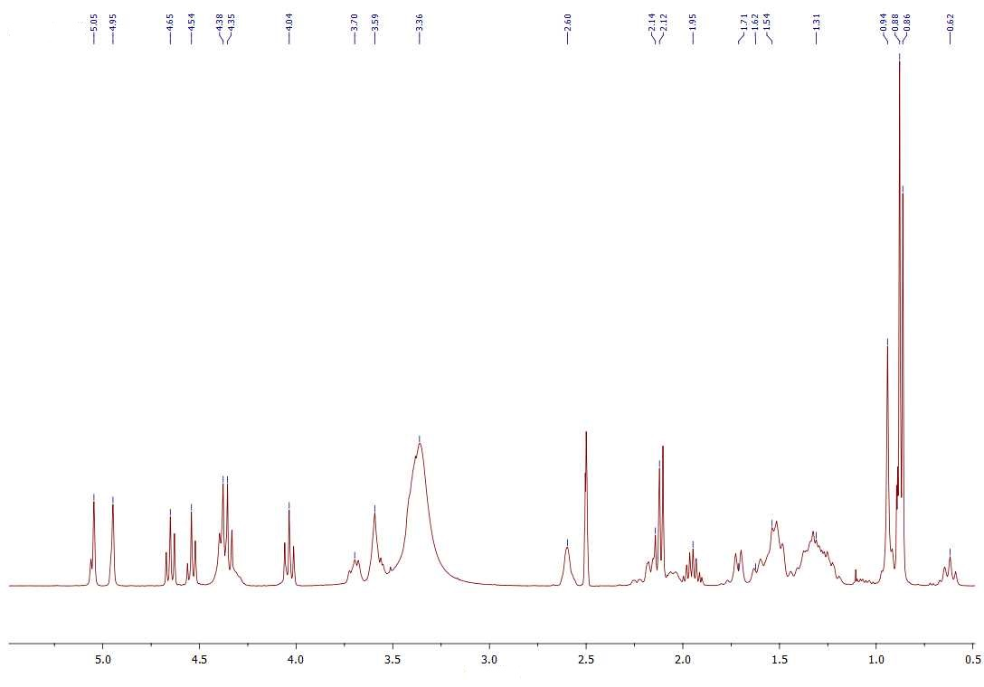

Fig. S2. ¹³C-NMR spectrum of compound 2.

