Journal of Pest Science
Running Title: Date palm food webs

Supplementary Material

Plant-herbivore-natural enemy trophic webs in date palm agro-ecosystems
K.S. Shameer^{1,2}, Tarik Almandhari^{3,4} & Ian C.W. Hardy^{1,3}

¹Department of Agricultural Sciences, P.O. Box 27, University of Helsinki, FI-00014, Finland
²Insect Ecology and Ethology Laboratory, Department of Zoology, University of Calicut, Calicut University P.O., Malappuram, Kerala 673635, India
³School of Biosciences, University of Nottingham, Sutton Bonington Campus, LE12 5RD, UK
⁴Ministry of Agriculture, Fisheries and Water Resources, P.O. Box 467, P.C. 100, Muscat, Oman

Supplementary Table 1 Insect herbivores of date palm in Oman
HERBIVORES | Order & Family
1. Phonopate frontalis Fahraeus (Frond Borer) | Coleoptera: Bostrichidae
2. Julodis euphratica Castelnau and Gory (Metalic Beetle) | Coleoptera: Buprestiae
3. Acanthophorus arabicus Thomson | Coleoptera: Cerambycidae
4. Jebusea hammerschmidti Reiche (Longhorn date palm stem-borer) | Coleoptera: Cerambycidae
5. Macrocoma sp. (Inflorescence beetle) | Coleoptera: Chrysomelidae
6. Rhynchophorus ferrugineus (Olivier) (Red palm weevil) | Coleoptera: Curculionidae
7. Carpophilus dimidiatus (Fabricius) (Dry fruit Beetle) | Coleoptera: Nitidulidae
8. Carpophilus hemipterus (Linnaeus) (Two-dots dry fruit beetle) | Coleoptera: Nitidulidae
9. Oryctes agamemnon Burmeister (Fruit Stalk Borer) | Coleoptera: Scarabaeidae
10. Oryctes elegans Prell. (Elegant Rhinoceros Beetle) | Coleoptera: Scarabaeidae
11. Oryctes rhinoceros (Linnaeus) (Rhinoceros Beetle) | Coleoptera: Scarabaeidae
12. Strategus julianus Burmeister (Young date palm borer) | Coleoptera: Scarabaeidae
13. Coccotrypes dactyliperda (Fabricius) (Date stone beetle) | Coleoptera: Scolytidae
14. Oryzaepphilus surinamensis (Linnaeus) (Saw-tothed grain beetle) | Coleoptera: Silvanidae
15. Drosophila melanogaster Meigen (Fruit fly) | Diptera: Drosophilidae
16. Ceratitis capitata Wied (Mediterranean Fruit fly) | Diptera: Tephritidae
17. Ommatissus lybicus Bergevin (Dubas Bug) | Hemiptera: Tropiduchidae
18. Asterolecanium phoenicis (Ramachandra Rao) (Green soft scale) | Hemiptera: Asterolecaniidae
19. Platypleura arabica Myers (Arabian Cicada) | Hemiptera: Cicadidae
20. Perindus binudatus Emeljanov (Date palm leafhopper) | Hemiptera: Cixiidae
21. Aonidiella orientalis (Newstead) (Oriental Yellow Scale) | Hemiptera: Diaspididae
22. Aspidiotus destructor Sign | Hemiptera: Diaspididae
23. Fiorinia linderae Takagi (Date palm brown flat scale) | Hemiptera: Diaspididae
24. Fiorinia phoenicis Balachowsky (Date Palm brown flat scale) | Hemiptera: Diaspididae
25. Parlatoria blanchardi (Targioni Tozzetti) (Parlatoria Date Scale) | Hemiptera: Diaspididae
26. Pseudospidoproctus hyphaniacus (Hall) (Date palm mealybug) | Hemiptera: Margarodidae
27. Maconellicoccus hirsutus (Green) (Pink hibiscus mealybug) | Hemiptera: Pseudococcidae
28. Nipaecoccus viridis (Newstead) (Spherical mealybug) | Hemiptera: Pseudococcidae
29. Planococcus citri Risso (Citrus mealybug) | Hemiptera: Pseudococcidae
30. Vespa orientalis L. (Red wasp/ Oriental wasp) | Hymenoptera: Vespidae
31. Batrachedra amydraula Meyrick (Lesser date moth) | Lepidoptera: Batrachedridae
32. Deudorix livia Klug (Pomegranate Butterfly) | Lepidoptera: Lycaenidae
33. Arenipses sabella Hampson (Greater Date Moth) | Lepidoptera: Pyralidae
34. Cadra cautella Walker (Almond moth) | Lepidoptera: Pyralidae
35. Cadra calidella Guenee (Currant Moth) | Lepidoptera: Pyralidae
36. Cadra elutella Hübner (Tobacoo moth) | Lepidoptera: Pyralidae
37. Cadra figulilella Gregson (Raisin moth) | Lepidoptera: Pyralidae
38. Ectomyelois ceratoniae Zeller (Carab moth) | Lepidoptera: Pyralidae
39. Ephestia dowsoniella (Richard & Thompson) (Dawsonella moth) | Lepidoptera: Pyralidae
40. Plodia interpunctella (Hübner) (Indian-Meal moth) | Lepidoptera: Pyralidae
41. Anacridium melanorhodon arabafrum Dirsh (Egyptian Locust) | Orthopetra: Acrididae
42. Schistocera gregaria (Forskal) (Desert locust) | Orthopetra: Acrididae
43. Adiheteothrips jambudvipae Ramok (Inflorescence Thrips) | Thysanoptera: Thripidae
44. Franklinella schultuzei (Trybom) (Flowering Thrips) | Thysanoptera: Thripidae

Supplementary Table 2 Insect natural enemies (parasitoids and predators) of insect herbivores of date palm in Oman
PARASITOIDS
Species | Order & Family
1. Aphytis lingnanensis Compére | Hymenoptera: Aphelinidae
2. Aphytis sp. | Hymenoptera: Aphelinidae
3. Archenomus arabicus Ferriere | Hymenoptera: Aphelinidae
4. Euryischia sp. | Hymenoptera: Aphelinidae
5. Cephalonomia tarsalis (Ashmead) | Hymenoptera: Bethylidae
6. Goniozus omanensis Polaszek | Hymenoptera: Bethylidae
7. Apanteles sp. | Hymenoptera: Braconidae
8. Habrobracon brevicornis Wesm. | Hymenoptera: Braconidae
9. Habrobracon hebetor (Say) | Hymenoptera: Braconidae
10. Phanerotoma flavitestacea Fisher | Hymenoptera: Braconidae
11. Aphanogmus sp. | Hymenoptera: Ceraphronidae
12. Brachymeria aegyptiaca Masi | Hymenoptera: Chalcididae
13. Achrysopophagus aegyptiacus Mercet | Hymenoptera: Encyrtidae
14. Anagyrus bohemani Westwood | Hymenoptera: Encyrtidae
15. Anagyrus kamali Moursi | Hymenoptera: Encyrtidae
16. Anagyrus pseudococci Girault | Hymenoptera: Encyrtidae
17. Comperiella leminscata Compere & Annecke | Hymenoptera: Encyrtidae
18. Habrolepis sp. | Hymenoptera: Encyrtidae
19. Leptomastix doctylopii Howard | Hymenoptera: Encyrtidae
20. Ooencyrtus sp. | Hymenoptera: Encyrtidae
21. Procheeiloneurus aegyptiacus Mercet | Hymenoptera: Encyrtidae
22. Achrysocharella tormosa (Westwood) | Hymenoptera: Eulophidae
23. Aprostocetus sp. | Hymenoptera: Eulophidae
24. Euderus nr. arenarius Erdos | Hymenoptera: Eulophidae
25. Pediobius sp. | Hymenoptera: Eulophidae
26. Eupelmus sp. nr. elongatus Risbec | Hymenoptera: Eupelmidae
27. Archirileya femorata (Boucek) | Hymenoptera: Eurytomidae
28. Eurytoma sp. | Hymenoptera: Eurytomidae
29. Crematogaster sp. | Hymenoptera: Formicidae
30. Venturia canescens (Gravenhorst) | Hymenoptera: Ichneumonidae
31. Pachyneuron sp. | Hymenoptera: Pteromalidae
32. Telenomus nizwaensis Polaszek | Hymenoptera: Scelionidae
33. Scolia erratica (Smith) | Hymenoptera: Scoliidae
34. Chartocerus kurdiyumovi (Nikol) | Hymenoptera: Signiphoridae
35. Pseuderimerus sp. | Hymenoptera: Torymidae
36. Oligosita sp. | Hymenoptera: Trichogrammatidae
37. Trichogramma brassicae Bedenko | Hymenoptera: Trichogrammatidae
38. Trichogramma evanescens Westwood | Hymenoptera: Trichogrammatidae
39. Trichogramma sp. | Hymenoptera: Trichogrammatidae
40. Microphthalma disjuncta Wied. | Diptera: Tachinidae
PREDATORS
41. Cheilomenes sexmaculata Fabricius | Coleoptera: Coccinellidae
42. Chilocorus baileyii Blackburn | Coleoptera: Coccinellidae
43. Chilocorus circumdatus (Gyllenhal) | Coleoptera: Coccinellidae
44. Chilocorus nigritus Fabricius | Coleoptera: Coccinellidae
45. Cryptolaemus montrouzieri Mulsant | Coleoptera: Coccinellidae
46. Diomus rubidus (Motsch) | Coleoptera: Coccinellidae
47. Exochomus nigripennis Er. | Coleoptera: Coccinellidae
48. Hyperaspis pumila Mulsant | Coleoptera: Coccinellidae
49. Nephus bipunctatus Kugelann | Coleoptera: Coccinellidae
50. Nephus hiekei Fursch | Coleoptera: Coccinellidae
51. Nephus nigricans Weise | Coleoptera: Coccinellidae
52. Pharoscymnus numidicus Pic. | Coleoptera: Coccinellidae
53. Pharoscymnus tristiculus Sicard | Coleoptera: Coccinellidae
54. Pharoscymnus sp. | Coleoptera: Coccinellidae
55. Rodolia cardinalis (Mulsant) | Coleoptera: Coccinellidae
56. Cybocephalus rutitrons Rtl. | Coleoptera: Cybocephalidae
57. Cyrtosus cyanipennis (Erichson) | Coleoptera: Melyridae
58. Chelisoches morio (Fabricius) | Dermaptera: Forficulidae
59. Dicrodiplosis manihoti Harris | Diptera: Cecidomyiidae
60. Dicrodiplosis pseudococci (Felt) | Diptera: Cecidomyiidae
61. Sarcophaga fuscicauda Bottcher | Diptera: Sarcophagidae
62. Anthocorid sp. | Hemiptera: Anthocoridae
63. Chrysoperla carnea (Stephens) | Neuroptera: Chrysopidae

Supplementary Table 3 Natural enemy overlap among herbivores of date palm of Oman. The numbers of natural enemies shared between each possible pair of herbivores species are shown. The proportion of pairs sharing at least one natural enemy is 0.011, and that of the parasitoid and predator separately are 0.0063 and 0.0042 respectively. Herbivore species identities are as given in Supplemenatary Table 1.

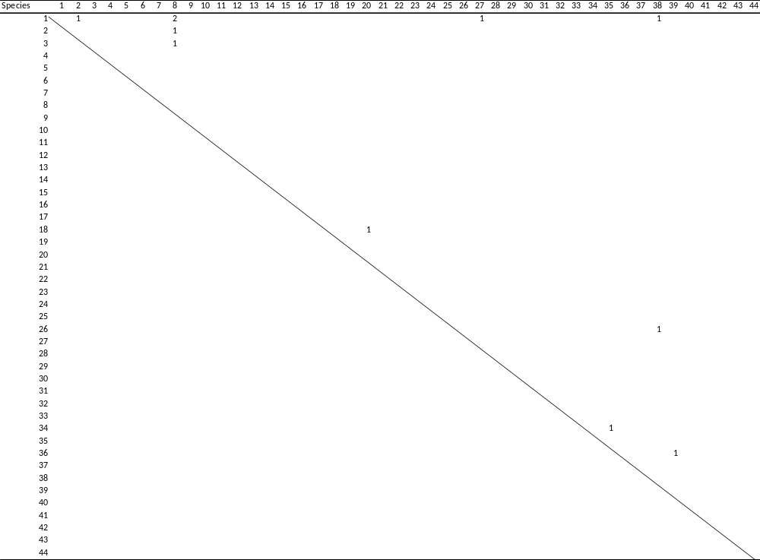
Supplementary Table 4 Insect herbivores of Date Palm of the Middle East
HERBIVORES | Order & Family
1. Phonopate frontalis Fahraeus (Frond Borer) | Coleoptera: Bostrichidae
2. Julodis euphratica Castelnau and Gory (Metalic Beetle) | Coleoptera: Buprestiae
3. Acanthophorus arabicus Thomson | Coleoptera: Cerambycidae
4. Jebusaea hammerschmidti Reiche (Longhorn date palm stem-borer) | Coleoptera: Cerambycidae
5. Macrotoma palmata F. (Sunt borer) | Coleoptera: Cerambycidae
6. Macrocoma sp. (Inflorescence beetle) | Coleoptera: Chrysomelidae
7. Rhynchophorus ferrugineus (Olivier) (Red palm weevil) | Coleoptera: Curculionidae
8. Carpophilus dimidiatus (Fabricius) (Dry fruit Beetle) | Coleoptera: Nitidulidae
9. Carpophilus hemipterus (Linnaeus) (Two-dots dry fruit beetle) | Coleoptera: Nitidulidae
10. Oryctes agamemnon Burmeister (Fruit Stalk Borer) | Coleoptera: Scarabaeidae
11. Oryctes elegans Prell. (Elegant Rhinoceros Beetle) | Coleoptera: Scarabaeidae
12. Oryctes rhinoceros (Linnaeus) (Rhinoceros Beetle) | Coleoptera: Scarabaeidae
13. Strategus julianus Burmeister (Young date palm borer) | Coleoptera: Scarabaeidae
14. Coccotrypes dactyliperda (Fabricius) (Date stone beetle) | Coleoptera: Scolytidae
15. Oryzaepphilus surinamensis (Linnaeus) (saw-toothed grain beetle | Coleoptera: Silvanidae
16. Drosophila melanogaster Meigen (Fruit fly) | Diptera: Drosophilidae
17. Ceratitis capitata Wied (Med. Fruit fly) | Diptera: Tephritidae
18. Ommatissus lybicus Bergevin (Dubas Bug) | Hemiptera: Tropiduchidae
19. Asterolecanium phoenicis (Ramachandra Rao) (Green soft scale) | Hemiptera: Asterolecaniidae
20. Platypleura arabica Myers (Arabian Cicada) | Hemiptera: Cicadidae
21. Perindus binudatus Emeljanov (Date palm leafhopper) | Hemiptera: Cixiidae
22. Aonidiella aurantii (Mask) (Red scale) | Hemiptera: Diaspididae
23. Aonidiella orientalis (Newstead) (Oriental Yellow Scale) | Hemiptera: Diaspididae
24. Aspidiotus destructor Signoret (Coconut scale) | Hemiptera: Diaspididae
25. Chrysomphalus aonidum L. (Florida red scale) | Hemiptera: Diaspididae
26. Fiorinia fioriniae (Targioni Tozzetti) (Date palm brown flat scale) | Hemiptera: Diaspididae
27. Fiorinia linderae Takagi (Date palm brown flat scale) | Hemiptera: Diaspididae
28. Fiorinia phoenicis Balachowsky (Date Palm brown flat scale) | Hemiptera: Diaspididae
29. Parlatoria blanchardi (Targioni Tozzetti) (Parlatoria Date Scale) | Hemiptera: Diaspididae
30. Phoenicoccus marlatti (CkII.) (Date palm red (wax) scale) | Hemiptera: Diaspididae
31. Pseudospidoproctus hyphaniacus (Hall) (Date palm mealybug) | Hemiptera: Margarodidae
32. Maconellicoccus hirsutus (Green) (Pink hibiscus mealybug) | Hemiptera: Pseudococcidae
33. Nipaecoccus viridis (Newstead) (Spherical mealybug) | Hemiptera: Pseudococcidae
34. Planococcus citri Risso (Citrus mealybug) | Hemiptera: Pseudococcidae
35. Vespa orientalis L. (Red wasp or Oriental wasp) | Hymenoptera: Vespidae
36. Batrachedra amydraula Meyrick (Lesser date moth) | Lepidoptera: Batrachedridae
37. Paysandisia archon Burmeister (Palm borer moth) | Lepidoptera: Castniidae
38. Zophopetes dysmephila (Trimen) (Leaf skipper) | Lepidoptera: Hesperiidae
39. Deudorix livia Klug (Pomegranate Butterfly) | Lepidoptera: Lycaenidae
40. Arenipses sabella Hampson (Greater Date Moth) | Lepidoptera: Pyralidae
41. Cadra cautella Walker (Almond moth) | Lepidoptera: Pyralidae
42. Cadra calidella Guenee (Currant Moth) | Lepidoptera: Pyralidae
43. Cadra elutella Hubner (Tobacoo moth) | Lepidoptera: Pyralidae
44. Cadra figulilella Gregson (Raisin moth) | Lepidoptera: Pyralidae
45. Ectomyelois ceratoniae Zeller (Carab moth) | Lepidoptera: Pyralidae
46. Ephestia dowsoniella (Richard & Thompson) (Dawsonella moth) | Lepidoptera: Pyralidae
47. Plodia interpunctella (Hubner) (Indian-Meal moth) | Lepidoptera: Pyralidae
48. Anacridium melanorhodon arabafrum Dirsh (Egyptian Locust) | Orthoptera: Acrididae
49. Schistocera gregaria (Forskal) (Desert locust) | Orthoptera: Acrididae
50. Adiheteothrips jambudvipae Ramok (Inflorescence Thrips) | Thysanoptera: Thripidae
51. Heliothrips haemorrhoidalis (Bouche) (Greenhouse Thrips) | Thysanoptera: Thripidae
52. Franklinella schultuzei (Trybom) (Flowering Thrips) | Thysanoptera: Thripidae

Supplementary Table 5 Insect natural enemies (parasitoids and predators) of herbivores of date palm of the Middle East
PARASITOIDS
Species | Order & Family
1. Aphytis lingnanensis Compére | Hymenoptera: Aphelinidae
2. Aphytis mytilaspides (Le Baron) | Hymenoptera: Aphelinidae
3. Aphytis phoenicis Debaels & Rosen | Hymenoptera: Aphelinidae
4. Aphytis sp. | Hymenoptera: Aphelinidae
5. Archenomus arabicus Ferriere | Hymenoptera: Aphelinidae
6. Encarsia citrina (Craw) | Hymenoptera: Aphelinidae
7. Euryischia sp. | Hymenoptera: Aphelinidae
8. Cephalonomia tarsalis (Ashmead) | Hymenoptera: Bethylidae
9. Goniozus gallicola Fouts | Hymenoptera: Bethylidae
10. Goniozus omanensis Polaszek | Hymenoptera: Bethylidae
11. Goniozus swirskiana (Argaman) | Hymenoptera: Bethylidae
12. Apanteles sp. | Hymenoptera: Braconidae
13. Habrobracon brevicornis Wesmael | Hymenoptera: Braconidae
14. Habrobracon hebetor Say | Hymenoptera: Braconidae
15. Macrocentrus sp. | Hymenoptera: Braconidae
16. Microctonus nitidulidis Loan | Hymenoptera: Braconidae
17. Phanerotoma flavitestacea Fischer | Hymenoptera: Braconidae
18. Phanerotoma leucobasis Kreichbaumer | Hymenoptera: Braconidae
19. Phanerotoma ocularis Kohl | Hymenoptera: Braconidae
20. Psyttalia concolor (Szépligeti) | Hymenoptera: Braconidae
21. Aphanogmus sp. | Hymenoptera: Ceraphronidae
22. Antrocephalus mitys (Walker) | Hymenoptera: Chalcididae
23. Brachymeria aegyptiaca Masi | Hymenoptera: Chalcididae
24. Achrysopophagus aegyptiacus Mercet | Hymenoptera: Encyrtidae
25. Anagyrus bohemani Westwood | Hymenoptera: Encyrtidae
26. Anagyrus kamali Moursi | Hymenoptera: Encyrtidae
27. Anagyrus pseudococci Girault | Hymenoptera: Encyrtidae
28. Comperiella leminscata Compere & Annecke | Hymenoptera: Encyrtidae
29. Habrolepis sp. | Hymenoptera: Encyrtidae
30. Leptomastix doctylopii Howard | Hymenoptera: Encyrtidae
31. Metaphycus sp. | Hymenoptera: Encyrtidae
32. Ooencyrtus sp. | Hymenoptera: Encyrtidae
33. Procheiloneurus aegyptiacus Mercet | Hymenoptera: Encyrtidae
34. Achrysocharella tormosa (Westwood) | Hymenoptera: Eulophidae
35. Aprostocetus sp. | Hymenoptera: Eulophidae
36. Euderus near arenarius Erdos | Hymenoptera: Eulophidae
37. Pediobius sp. | Hymenoptera: Eulophidae
38. Eupelmus sp. nr. elongatus Risbec | Hymenoptera: Eupelmidae
39. Archirileya femorata (Boucek) | Hymenoptera: Eurytomidae
40. Eurytoma sp. | Hymenoptera: Eurytomidae
41. Hymenobosmina sp. | Hymenoptera: Ichneumonidae
42. Venturia canescens (Gravenhorst) | Hymenoptera: Ichneumonidae
43. Brachyserphus abruptus Say | Hymenoptera: Proctotrupidae
44. Habrocytus sp. | Hymenoptera: Pteromalidae
45. Pachyneuron sp. | Hymenoptera: Pteromalidae
46. Telenomus nizwaensis Polaszek | Hymenoptera: Scelionidae
47. Scolia erratica (Smith) | Hymenoptera: Scoliidae
48. Chartocerus kurdiyumovi (Nikol) | Hymenoptera: Signiphoridae
49. Pseuderimerus sp. | Hymenoptera: Torymidae
50. Oligosita sp. | Hymenoptera: Trichogrammatidae
51. Pseudoligosita babylonica Viggiani | Hymenoptera: Trichogrammatidae
52. Trichogramma bourarachae Pintureau & Babault | Hymenoptera: Trichogrammatidae
53. Trichogramma brassicae Bedenko | Hymenoptera: Trichogrammatidae
54. Trichogramma cacoeciae Marchal | Hymenoptera: Trichogrammatidae
55. Trichogramma cordubensis Vargas & Cabella | Hymenoptera: Trichogrammatidae
56. Trichogramma embryophagum Harty | Hymenoptera: Trichogrammatidae
57. Trichogramma evanescens Westwood | Hymenoptera: Trichogrammatidae
58. Trichogramma oleae (Voegele & Pointel) | Hymenoptera: Trichogrammatidae
59. Trichogramma sp. | Hymenoptera: Trichogrammatidae
60. Megaselia sp. | Diptera: Phoridae
61. Microphthalma disjuncta Wied. | Diptera: Tachinidae
PREDATORS
62. Cheilomenes sexmaculata Fabricius | Coleoptera: Coccinellidae
63. Cheilomenes propinqua vicina (Mulsant) | Coleoptera: Coccinellidae
64. Chilocorus baileyii Blackburn | Coleoptera: Coccinellidae
65. Chilocorus bipustulatus Linnaeus | Coleoptera: Coccinellidae
66. Chilocorus cacti L. | Coleoptera: Coccinellidae
67. Chilocorus circumdatus (Gyllenhal) | Coleoptera: Coccinellidae
68. Chilocorus nigritus Fabricius | Coleoptera: Coccinellidae
69. Coccinella quinquepunctata Linnaeus | Coleoptera: Coccinellidae
70. Coccinella septempunctata Linnaeus | Coleoptera: Coccinellidae
71. Coccinella undecimunctata Linnaeus | Coleoptera: Coccinellidae
72. Cryptolaemus montrouzieri Mulsant | Coleoptera: Coccinellidae
73. Diomus rubidus (Motsch) | Coleoptera: Coccinellidae
74. Exochomus nigripennis (Erichson) | Coleoptera: Coccinellidae
75. Hyperaspis pumila Mulsant | Coleoptera: Coccinellidae
76. Nephus bipunctatus Kugelann | Coleoptera: Coccinellidae
77. Nephus hiekei Fursch | Coleoptera: Coccinellidae
78. Nephus nigricans Weise | Coleoptera: Coccinellidae
79. Nephus puadrimaenlatus Hbst. | Coleoptera: Coccinellidae
80. Pharoscymnus anchorago Fairmaire | Coleoptera: Coccinellidae
81. Pharoscymnus flexibilis (Muls.) | Coleoptera: Coccinellidae
82. Pharoscymnus horni (Weise) | Coleoptera: Coccinellidae
83. Pharoscymnus numidicus Pic. | Coleoptera: Coccinellidae
84. Pharoscymnus ovoideus Sicard | Coleoptera: Coccinellidae
85. Pharoscymnus pharoides Marseu | Coleoptera: Coccinellidae
86. Pharoscymnus setulosus Chevrolat | Coleoptera: Coccinellidae
87. Pharoscymnus smirnovi Dobzha | Coleoptera: Coccinellidae
88. Pharoscymnus sp. | Coleoptera: Coccinellidae
89. Pharoscymnus tristiculus Sicard | Coleoptera: Coccinellidae
90. Pharoscymnus varius (Kirsch) | Coleoptera: Coccinellidae
91. Pullus ebner Weise | Coleoptera: Coccinellidae
92. Rhyzobius lophanthae (Blaisdell) | Coleoptera: Coccinellidae
93. Rodolia cardinalis (Mulsant) | Coleoptera: Coccinellidae
94. Scymnus bipunctata Kugelann | Coleoptera: Coccinellidae
95. Scymnus punetillum Weise | Coleoptera: Coccinellidae
96. Cybocephalus aegyptiacus Endrody-Younga | Coleoptera: Cybocephalidae
97. Cybocephalus micans Reitter | Coleoptera: Cybocephalidae
98. Cybocephalus nigriceps (Sahlberg) | Coleoptera: Cybocephalidae
99. Cybocephalus palmarum Peyesh. | Coleoptera: Cybocephalidae
100. Cybocephalus pullus Endrody-Younga | Coleoptera: Cybocephalidae
101. Cybocephalus rufifrons Reitter | Coleoptera: Cybocephalidae
102. Cybocephalus seminulum Bau. | Coleoptera: Cybocephalidae
103. Cybocephalus flavipes Motschulsky | Coleoptera: Cybocephalidae
104. Teretrius pulex Fairmaire | Coleoptera: Histeridae
105. Cyrtosus cyanipennis (Erichson) | Coleoptera: Melyridae
106. Atheta coriaria (Kraatz) | Coleoptera: Staphylinidae
107. Chelisoches morio (Fabricius) | Dermaptera: Forficulidae
108. Dicrodiplosis manihoti Harris | Diptera: Cecidomyiidae
109. Dicrodiplosis pseudococci (Felt) | Diptera: Cecidomyiidae
110. Sarcophaga fuscicauda Bottcher | Diptera: Sarcophagidae
111. Anthocorid sp. | Hemiptera: Anthocoridae
112. Xylocoris flavipes (Reuter) | Hemiptera: Anthocoridae
113. Peregrinator biannulipes (Montrouzier & Signoret) | Hemiptera: Reduviidae
114. Platymeris laevicollis Distant | Hemiptera: Reduviidae
115. Crematogaster sp. | Hemiptera: Formicidae
116. Pogonomyrmex californicus (Buckley) | Hemiptera: Formicidae
117. Calidomantis savigny (Saussure) | Dictyoptera: Mantidae
118. Chrysoperla carnea (Stephens) | Neuroptera: Chrysopidae
119. Chrysopa vulgaris Schon. | Neuroptera: Chrysopidae

Supplementary Table 6 Natural enemy overlap among herbivores of date palm of the Middle East. The numbers of natural enemies shared between each possible pair of herbivores species are shown. The proportion of pairs sharing at least one natural enemy is 0.0151, and that of parasitoid and predator separately are 0.0068 and 0.0090 respectively. Herbivore species identities are as given in Supplementary Table 4.
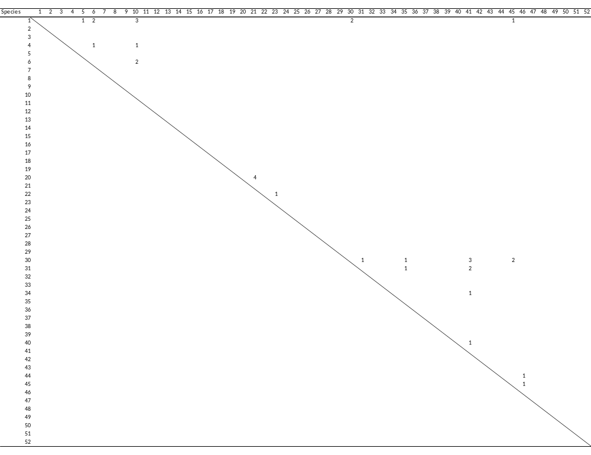

Supplementary Table 7 Date palm and intercrop plants in Oman
No. | Family | Species | Common Name | Host type | Type of plant
1. | Amaranthaceae | Spinacia oleracea L. | Spinach | Vegetable | Herb
2. | Amaryllidaceae | Allium cepa L. | Onion | Vegetable | Herb
3. | Amaryllidaceae | Allium sativum L. | Garlic | Vegetable | Herb
4. | Anacardiaceae | Annona squamosa L. | Custard apple | Fruit | Tree
5. | Anacardiaceae | Mangifera indica L. | Mango | Fruit | Tree
6. | Apiaceae | Daucus carota subsp. Sativus | Carrot | Vegetable | Herb
7. | Arecaceae | Cocos nucifera L. | Coconut | Seed crop | Palm
8. | Arecaceae | Phoenix dactylifera L. | Date Palm | Fruit | Palm
9. | Brassicaceae | Brassica oleracea L. | Cabbage | Vegetable | Herb
10. | Brassicaceae | Brassica oleracea var. botrytis L. | Cauliflower | Vegetable | Herb
11. | Brassicaceae | Brassica oleracea var. italica | Broccoli | Vegetable | Herb
12. | Brassicaceae | Raphanus sativus L. | Radish | Vegetable | Herb
13. | Caricaceae | Carica papaya L. | Papaya | Fruit | shrub
14. | Convolvulaceae | Ipomoea batatas (L.) Lam. | Sweet potato | Tuber crop | Climber
15. | Cucurbitaceae | Cucumis melo L. | Muskmelon | Fruit | Herb
16. | Cucurbitaceae | Cucumis sativus L. | Cucumber | Vegetable | Climber
17. | Cucurbitaceae | Cucurbita pepo L. | Field Pumpkin/ Squash | Vegetable | Climber
18. | Cucurbitaceae | Citrullus lanatus (Thunb.) Matsum. & Nakai | Watermelon | Fruit | Herb
19. | Fabaceae | Medicago sativa L. | Alfalfa/ Lucerne | Fodder crop | Herb
20. | Fabaceae | Phaseolus vulgaris L. | Common Beans | Vegetable | Herb
21. | Fabaceae | Vachellia (Acacia) tortilis (Forssk.) Galasso & Banfi | Acacia | Timber crop | Tree
22. | Fabaceae | Vigna unguiculata (L.) Walp. | Cowpea | Vegetable | Climber
23. | Graminae | Saccharum officinarum L. | Sugarcane | Crop | Herb
24. | Lythraceae | Punica granatum L. | Pomegranate | Fruit | Shrub
25. | Malvaceae | Abelmoschus esculentus (L.) Moench | Okra/ Lady’s Finger | Vegetable | Herb
26. | Moraceae | Ficus carica L. | Fig | Fruit | Tree
27. | Musaceae | Musa paradisiaca L. | Banana | Fruit | Herb
28. | Myrtaceae | Psidium guajava L. | Guava | Fruit | Tree
29. | Poaceae | Avena sativa L. | Oats | Cereal crop | Herb
30. | Poaceae | Chloris gayana Kunth | Rhodes grass | Fodder crop | Herb
31. | Poaceae | Hordeum vulgare L. | Barley | Cereal crop | Herb
32. | Poaceae | Sorghum bicolor (L.) Moench | Sorghum/ Great Millet | Cereal crop | Herb
33. | Poaceae | Triticum aestivum L. | Wheat | Cereal crop | Herb
34. | Poaceae | Zea mays L. | Corn | Cereal crop | Herb
35. | Rosaceae | Malus domestica Borkh | Apple | Fruit | Tree
36. | Rosaceae | Prunus amygdalus Batsch | Almond | Fruit | Tree
37. | Rosaceae | Prunus armeniaca (Scop.) Koch | Apricot | Fruit | Tree
38. | Rosaceae | Prunus persica (L.) Batsch | Peach | Fruit | Tree
39. | Rosaceae | Pyrus sp. | Pear | Fruit | Tree
40. | Rosaceae | Rosa sp. | Rose | Flower crop | Shrub
41. | Rutaceae | Citrus aurantiifolia (Chistm. & Panz.) Swingle | Key Lime | Fruit | Shrub
42. | Rutaceae | Citrus limetta Risso | Sweet Lemon | Fruit | Shrub
43. | Rutaceae | Citrus limon (L.) Osbeck | Lemon | Fruit | Shrub
44. | Rutaceae | Citrus × sinensis (L.) Osbeck | Orange | Fruit | Shrub
45. | Rutaceae | Capsicum annuum L. | Chilli/Sweet Pepper | Vegetable | Herb
46. | Rutaceae | Lycopersicum esculentum Mill. | Tomato | Vegetable | Herb
47. | Solanaceae | Solanum melongena L. | Eggplant/ Aubergine | Vegetable | Shrub
48. | Solanaceae | Nicotiana tabacum L. | Tobacco | Medicinal | Herb
49. | Solanaceae | Solanum tuberosum L. | Potato | Vegetable | Herb
50. | Vitaceae | Vitis vinifera L. | Grapes | Fruit | Shrub

Supplementary Table 8 Insect herbivores of date palm and intercrop plants in Oman
Herbivore | Oder & Family
1. Phonopate frontalis Fahraeus (Frond borer) | Coleoptera: Bostrichidae
2. Julodis euphratica Castelnau and Gory (Metalic beetle) | Coleoptera: Buprestidae
3. Acanthophorus arabicus Thomson | Coleoptera: Cerambycidae
4. Jebusea hammerschmidti Reiche (Longhorn date palm stem-borer) | Coleoptera: Cerambycidae
5. Macrocoma sp. (Inflorescence beetle) | Coleoptera: Chrysomelidae
6. Rhynchophorus ferrugineus (Olivier) (Red palm weevil) | Coleoptera: Curculionidae
7. Carpophilus dimidiatus (Fabricius) (Dry fruit beetle) | Coleoptera: Nitidulidae
8. Carpophilus hemipterus (Linnaeus) (Two-dots dry fruit beetle) | Coleoptera: Nitidulidae
9. Oryctes agamemnon Burmeister (Fruit stalk borer) | Coleoptera: Scarabaeidae
10. Oryctes elegans Prell. (Fruit stalk borer, Elegant rhinoceros beetle) | Coleoptera: Scarabaeidae
11. Oryctes rhinoceros (Linnaeus) (Rhinoceros beetle) | Coleoptera: Scarabaeidae
12. Strategus julianus Burmeister (Young date palm borer) | Coleoptera: Scarabaeidae
13. Coccotrypes dactyliperda (Fabricius) (Date stone beetle) | Coleoptera: Scolytidae
14. Oryzaepphilus surinamensis (Linnaeus) (Saw-toothed grain beetle) | Coleoptera: Silvanidae
15. Liriomyza sp. (Leaf miners) | Diptera: Agromyzidae
16. Procontarinia matteiana Kieff. & Cecc. | Diptera: Cecidomyiidae
17. Drosophila melanogaster Meigen (Fruit fly) | Diptera: Drosophilidae
18. Ceratitis capitata Wied (Mediterranean Fruit fly) | Diptera: Tephritidae
19. Aleurocanthus woglumi Ashby (Citrus blackfly) | Hemiptera: Aleyrodidiae
20. Bemisia tabaci (Genn.) | Hemiptera: Aleyrodidiae
21. Aleurodicus dispersus Russell (Whitefly) | Hemiptera: Aleyrodidiae
22. Aphis craccivora Koch (Black legumes aphid, Cowpea aphid) | Hemiptera: Aphididae
23. Aphis gossypii Glover (Melon aphid, Cotton aphid) | Hemiptera: Aphididae
24. Aphis nerii Boyer de Fonscolombe (Sweet pepper aphid) | Hemiptera: Aphididae
25. Brevicoryne brassicae (Linnaeus) (Cabbage aphid) | Hemiptera: Aphididae
26. Ceratovacuna lanigera Zehntner (Sugarcane woolly aphid) | Hemiptera: Aphididae
27. Hysteroneura setariae (Thomas) (Grass aphid) | Hemiptera: Aphididae
28. Lipaphis erysimi (Kaltenbach) (Mustard aphid) | Hemiptera: Aphididae
29. Macrosiphum euphorbiae (Thomas) (Tomato aphid/ Potato aphid) | Hemiptera: Aphididae
30. Macrosiphum rosae L. (Rose aphid) | Hemiptera: Aphididae
31. Myzus persicae (Sulzer) (Green peach aphid) | Hemiptera: Aphididae
32. Pentalonia negronervosa Coquerel (Banana aphid) | Hemiptera: Aphididae
33. Rhopalosiphum maidis (Fitch) (Corn leaf aphid) | Hemiptera: Aphididae
34. Rhopalosiphum nymphaeae L. (Plum aphid) | Hemiptera: Aphididae
35. Rhopalosiphum padi (L.) (Grain aphid) | Hemiptera: Aphididae
36. Rhopalosiphum rufiabdominalis (Sasaki) (Rice root aphid) | Hemiptera: Aphididae
37. Asterolecanium phoenicis (Ramachandra Rao) (Green soft scale) | Hemiptera: Asterolecaniidae
38. Amritodus atkinsoni Lethierry (Mango leafhopper) | Hemiptera: Cicadellidae
39. Platypleura arabica Myers (Arabian cicada) | Hemiptera: Cicadidae
40. Perindus binudatus Emeljanov (Date palm leafhopper) | Hemiptera: Cixiidae
41. Ceroplastes floridensis Comstock (Soft scale) | Hemiptera: Coccidae
42. Aonidiella orientalis (Newstead) (Oriental yellow scale) | Hemiptera: Diaspididae
43. Aspidiotus destructor Sign (Coconut scale) | Hemiptera: Diaspididae
44. Fiorinia linderae Takagi (Date palm brown flat scale) | Hemiptera: Diaspididae
45. Fiorinia phoenicis Balachowsky (Date palm brown flat scale) | Hemiptera: Diaspididae
46. Lepidosaphes gloverii (Packard) | Hemiptera: Diaspididae
47. Parlatoria blanchardi (Targioni Tozzetti) (Parlatoria date scale) | Hemiptera: Diaspididae
48. Unaspis citri Comst. (Citrus snow scale) | Hemiptera: Diaspididae
49. Pseudospidoproctus hyphaniacus (Hall) (Date palm mealybug) | Hemiptera: Margarodidae
50. Maconellicoccus hirsutus (Green) (Pink hibiscus mealybug) | Hemiptera: Pseudococcidae
51. Nipaecoccus viridis (Newstead) (Spherical mealybug) | Hemiptera: Pseudococcidae
52. Planococcus citri Risso (Citrus mealybug) | Hemiptera: Pseudococcidae
53. Pseudococcus maritimus (Ehrhorn) (Grape mealybug) | Hemiptera: Pseudococcidae
54. Ommatissus lybicus Bergevin (Dubas bug) | Hemiptera: Tropiduchidae
55. Nezara viridula (Linn.) (Green stink bug) | Heteroptera: Pentatomidae
56. Vespa orientalis L. (Red wasp, Oriental wasp) | Hymenoptera: Vespidae
57. Batrachedra amydraula Meyrick (Lesser date moth) | Lepidoptera: Batrachedridae
58. Anarsia lineatella Zeller (Peach twig borer) | Lepidoptera: Gelechiidae
59. Pthorimaea operculella (Zeiler) (Potato tuber moth) | Lepidoptera: Gelechiidae
60. Deudorix livia Klug (Pomegranate butterfly) | Lepidoptera: Lycaenidae
61. Spodoptera exempta (Walker) (Black armyworm) | Lepidoptera: Noctuidae
62. Spodoptera frugiperda (J. E. Smith) (Fall armyworm) | Lepidoptera: Noctuidae
63. Spodoptera littoralis (Boisduval) (Cotton leafworm) | Lepidoptera: Noctuidae
64. Opisina arenosella Walker (Coconut lead eating caterpillar) | Lepidoptera: Oecophoridae
65. Papilio demoleus Linn. | Lepidoptera: Papilionidae
66. Phyllocnistis citrella Stainton | Lepidoptera: Phyllocnistidae
67. Plutella xylostella (Linnaeus) (Diamond back moth) | Lepidoptera: Plutellidae
68. Arenipses sabella Hampson (Greater date moth) | Lepidoptera: Pyralidae
69. Cadra cautella Walker (Almond moth) | Lepidoptera: Pyralidae
70. Cadra calidella Guenee (Currant moth) | Lepidoptera: Pyralidae
71. Cadra elutella Hübner (Tobacoo moth) | Lepidoptera: Pyralidae
72. Cadra figulilella Gregson (Raisin moth) | Lepidoptera: Pyralidae
73. Ectomyelois ceratoniae Zeller (Carab moth) | Lepidoptera: Pyralidae
74. Ephestia dowsoniella (Richard & Thompson) (Dawsonella moth) | Lepidoptera: Pyralidae
75. Plodia interpunctella (Hübner) (Indian meal moth) | Lepidoptera: Pyralidae
76. Hippotion celerio (Linnaeus) (Vine hawk-moth) | Lepidoptera: Sphingidae
77. Anacridium melanorhodon arabafrum Dirsh (Tree locust) | Orthopetra: Acrididae
78. Schistocera gregaria (Forskal) (Desert locust) | Orthopetra: Acrididae
79. Adiheteothrips jambudvipae Ramok (Inflorescence thrips) | Thysanoptera: Thripidae
80. Franklinella schultuzei (Trybom) (Flowering thrips) | Thysanoptera: Thripidae

Supplementary Table 9 Insect natural enemies of date palm and intercrop plants in Oman
PARASITOIDS
Species | Order & Family
1. Ablerus sp. | Hymenoptera: Aphelinidae
2. Aphelinus albipodus Hayat & Fatima | Hymenoptera: Aphelinidae
3. Aphytis lingnanensis Compére | Hymenoptera: Aphelinidae
4. Aphytis mytilaspidis (Le Baron) | Hymenoptera: Aphelinidae
5. Aphytis sp. | Hymenoptera: Aphelinidae
6. Archenomus arabicus Ferriere | Hymenoptera: Aphelinidae
7. Azotus sp. nr. elegantulus Sliv. | Hymenoptera: Aphelinidae
8. Coccobius reticulatus (Comp & Ann.) | Hymenoptera: Aphelinidae
9. Coccophagus sp. | Hymenoptera: Aphelinidae
10. Encarsia citrina (Craw) | Hymenoptera: Aphelinidae
11. Encarsia lutea (Mas.) | Hymenoptera: Aphelinidae
12. Encarsia opulenta Silvestri | Hymenoptera: Aphelinidae
13. Encarsia sp. | Hymenoptera: Aphelinidae
14. Encarsia strenua Silvestri | Hymenoptera: Aphelinidae
15. Encarsia transvena (Timberlake) | Hymenoptera: Aphelinidae
16. Eretmocerus mundus Mercet | Hymenoptera: Aphelinidae
17. Euryischia sp. | Hymenoptera: Aphelinidae
18. Marietta leopardina Motschulsky | Hymenoptera: Aphelinidae
19. Cephalonomia tarsalis (Ashmead) | Hymenoptera: Bethylidae
20. Goniozus omanensis Polaszek | Hymenoptera: Bethylidae
21. Apanteles litae Nixon | Hymenoptera: Braconidae
22. Apanteles sp. | Hymenoptera: Braconidae
23. Aphidius sp. | Hymenoptera: Braconidae
24. Bracon sp. | Hymenoptera: Braconidae
25. Diaeretielta rapae (M'Intosh) | Hymenoptera: Braconidae
26. Disophrys lutea Brulle | Hymenoptera: Braconidae
27. Dolichogenidea sp. | Hymenoptera: Braconidae
28. Ephedrus persicae Froggatt | Hymenoptera: Braconidae
29. Habrobracon brevicornis Wesm. | Hymenoptera: Braconidae
30. Habrobracon hebetor Say | Hymenoptera: Braconidae
31. Mycroplitis plutellae Muesebeck | Hymenoptera: Braconidae
32. Phanerotoma flavitestacea Fisher | Hymenoptera: Braconidae
33. Aphanogmus sp. | Hymenoptera: Ceraphronidae
34. Brachymeria aegyptiaca Masi | Hymenoptera: Chalcididae
35. Brachymeria excarinata Gahan | Hymenoptera: Chalcididae
36. Brachymeria lasus (Walker) | Hymenoptera: Chalcididae
37. Achrysopophagus aegyptiacus Mercet | Hymenoptera: Encyrtidae
38. Anagyrus agraensis Saraswat | Hymenoptera: Encyrtidae
39. Anagyrus bohemani Westwood | Hymenoptera: Encyrtidae
40. Anagyrus dactylopii (Howard) | Hymenoptera: Encyrtidae
41. Anagyrus kamali Moursi | Hymenoptera: Encyrtidae
42. Anagyrus mirzai Agarwal | Hymenoptera: Encyrtidae
43. Anagyrus pseudococci Girault | Hymenoptera: Encyrtidae
44. Comperiella aspidiotiphaga Sub.Rao | Hymenoptera: Encyrtidae
45. Comperiella leminscata Compere & Annecke | Hymenoptera: Encyrtidae
46. Habrolepis sp. | Hymenoptera: Encyrtidae
47. Leptomastix doctylopii Howard | Hymenoptera: Encyrtidae
48. Metaphycus sp. nr. zebratus (Merc.) | Hymenoptera: Encyrtidae
49. Ooencyrtus sp. | Hymenoptera: Encyrtidae
50. Prochiloneurus aegyptiacus Mercet | Hymenoptera: Encyrtidae
51. Prochiloneurus pulchellus Silvestri | Hymenoptera: Encyrtidae
52. Syrphophagus aphidivorus (Mayr) | Hymenoptera: Encyrtidae
53. Thomsonisca pakistanensis (Ahmad) | Hymenoptera: Encyrtidae
54. Aprostocetus sp. | Hymenoptera: Eulophidae
55. Chrysonotomyia pulcherrima (Kerr.) | Hymenoptera: Eulophidae
56. Cirrospilus quadristriatus (Subba Rao & Ramamani) | Hymenoptera: Eulophidae
57. Citrostichus phyllocnistoides (Narayanan) | Hymenoptera: Eulophidae
58. Diglyphus isaea (Wlk.) | Hymenoptera: Eulophidae
59. Euderus nr. arenarius Erdos | Hymenoptera: Eulophidae
60. Eutetrastichus sp. | Hymenoptera: Eulophidae
61. Hemiptarsenus varicornis (Girault) | Hymenoptera: Eulophidae
62. Neochrysocharis formosa (Westwood) | Hymenoptera: Eulophidae
63. Oomyzus scaposus (Thomson) | Hymenoptera: Eulophidae
64. Oomyzus sokolowskii (Kurdjumov) | Hymenoptera: Eulophidae
65. Pediobius sp. (Eulophidae: Hymenoptera) | Hymenoptera: Eulophidae
66. Eupelmus sp. nr. elongatus Risbec | Hymenoptera: Eupelmidae
67. Archirileya femorata (Boucek) | Hymenoptera: Eurytomidae
68. Eurytoma sp. | Hymenoptera: Eurytomidae
69. Crematogaster sp. | Hymenoptera: Formicidae
70. Diplazon laetatorius (Fab.) | Hymenoptera: Ichneumonidae
71. Venturia canescens (Gravenhorst) | Hymenoptera: Ichneumonidae
72. Caphaleta bruniventris | Hymenoptera: Pteromalidae
73. Mesopeltita truncatipennis (Waterston) | Hymenoptera: Pteromalidae
74. Pachyneuron aphidis (Bouche) | Hymenoptera: Pteromalidae
75. Pachyneuron sp. | Hymenoptera: Pteromalidae
76. Scutellista caerulea (Fronscolo.) | Hymenoptera: Pteromalidae
77. Telenomus nizwaensis Polaszek | Hymenoptera: Scelionidae
78. Telenomus sp. | Hymenoptera: Scelionidae
79. Scolia erratica (Smith) | Hymenoptera: Scoliidae
80. Chartocerus kurdiyumovi (Nikol) | Hymenoptera: Signiphoridae
81. Chartocerus sp. | Hymenoptera: Signiphoridae
82. Pseuderimerus sp. | Hymenoptera: Torymidae
83. Oligosita sp. | Hymenoptera: Trichogrammatidae
84. Trichogramma brassicae Bedenko | Hymenoptera: Trichogrammatidae
85. Trichogramma evanescens Westwood | Hymenoptera: Trichogrammatidae
86. Trichogramma sp. | Hymenoptera: Trichogrammatidae
87. Desmometopa sp. | Diptera: Milichiidae
88. Atherigona sp. | Diptera: Muscidae
89. Sphaerophoria sp. | Diptera: Syrphidae
90. Microphthalma disjuncta Wied. | Diptera: Tachinidae
PREDATORS
91. Cheilomenes sexmaculata Fabricius | Coleoptera: Coccinellidae
92. Chilocorus baileyii Blackburn | Coleoptera: Coccinellidae
93. Chilocorus circumdatus (Gyllenhal) | Coleoptera: Coccinellidae
94. Chilocorus nigritus Fabricius | Coleoptera: Coccinellidae
95. Coccinella septempunctata Linnaeus | Coleoptera: Coccinellidae
96. Coccinella undecimpunctata Linn. | Coleoptera: Coccinellidae
97. Cryptolaemus montrouzieri Mulsant | Coleoptera: Coccinellidae
98. Diomus rubidus (Motsch) | Coleoptera: Coccinellidae
99. Exochomus nigripennis Erichson | Coleoptera: Coccinellidae
100. Exochomus pubescens Kuster | Coleoptera: Coccinellidae
101. Hyperaspis polita Weise | Coleoptera: Coccinellidae
102. Hyperaspis pumila Mulsant | Coleoptera: Coccinellidae
103. Hyperaspis vinciguerrae Capra | Coleoptera: Coccinellidae
104. Nephus bipunctatus Kugelann | Coleoptera: Coccinellidae
105. Nephus hiekei Fursch | Coleoptera: Coccinellidae
106. Nephus nigricans Weise | Coleoptera: Coccinellidae
107. Nephus sp. | Coleoptera: Coccinellidae
108. Pharoscymnus numidicus Pic. | Coleoptera: Coccinellidae
109. Pharoscymnus tristiculus Sicard | Coleoptera: Coccinellidae
110. Pharoscymnus sp. | Coleoptera: Coccinellidae
111. Rodolia cardinalis (Mulsant) | Coleoptera: Coccinellidae
112. Scymnus coccivora Ayyar | Coleoptera: Coccinellidae
113. Scymnus latemaculatus Motschulsky | Coleoptera: Coccinellidae
114. Cybocephalus rutitrons Rtl. | Coleoptera: Cybocephalidae
115. Cybocephalus sp. | Coleoptera: Cybocephalidae
116. Phradonoma nobile (Reitter) | Coleoptera: Dermestidae
117. Cyrtosus cyanipennis (Erichson) | Coleoptera: Melyridae
118. Paederus alfieri Koch. | Coleoptera: Staphylinidae
119. Chelisoches morio (Fabricius) | Dermaptera: Forficulidae
120. Dicrodiplosis manihoti Harris | Diptera: Cecidomyiidae
121. Dicrodiplosis pseudococci (Felt) | Diptera: Cecidomyiidae
122. Sarcophaga fuscicauda Bottcher | Diptera: Sarcophagidae
123. Ischiodon aegyptius (Wiedemann) | Diptera: Syrphidae
124. Anthocorid sp. | Hemiptera: Anthocoridae
125. Buchananiella sp. near crassicornis | Hemiptera: Anthocoridae
126. Orius sp. | Hemiptera: Anthocoridae
127. Chrysoperla carnea (Stephens) | Neuroptera: Chrysopidae

Supplementary Table 10 Herbivore overlap among date palm and the 49 species of intercrops of Oman. The numbers of herbivore species shared between each possible pair of plants are shown. The proportion of pairs sharing at least one herbivore was 0.18. Plant species identities are as given in Supplementary Table 7.
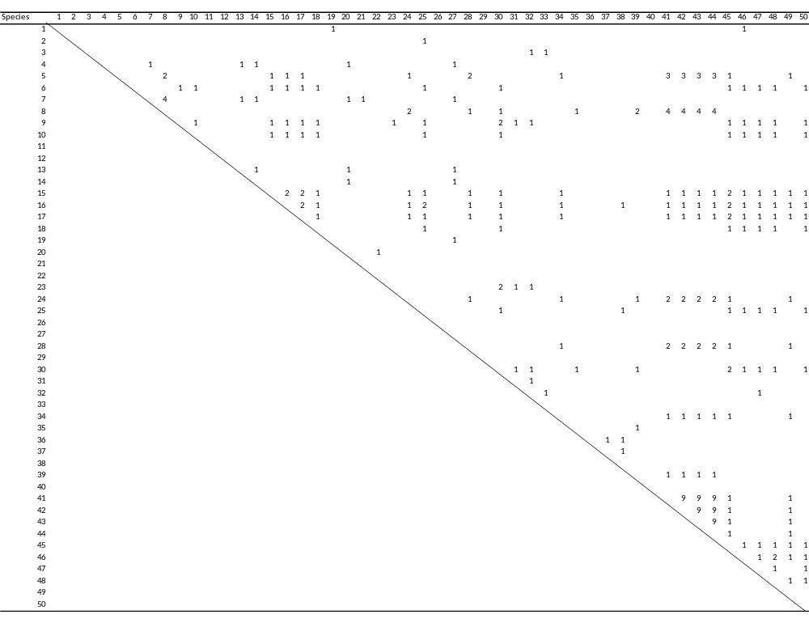

Supplementary Table 11 Natural enemy overlap among herbivores of date palm and intercrops of Oman. The numbers of natural enemies shared between each possible pair of herbivores species are shown. The proportion of pairs sharing at least one natural enemy is 0.051, and that of parasitoid and predator separately are 0.034 and 0.021 respectively. Herbivore species identities are as given in Supplementary Table 8.
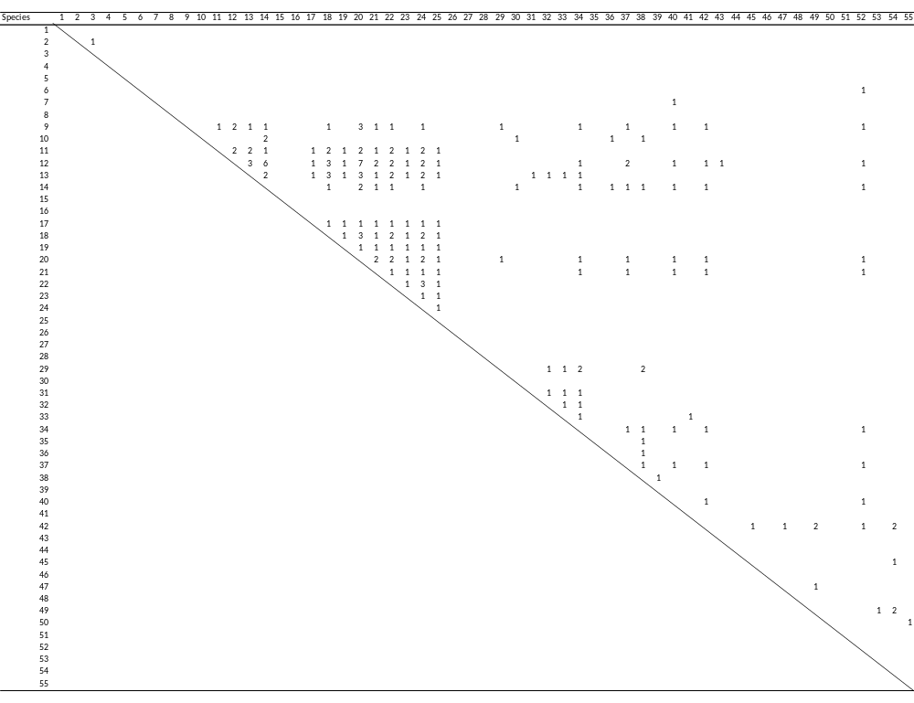
Supplementary Table 12 Date palm and intercrop plants in the Middle East
No. | Family | Species | Common Name | Host type | Type of plant
1. | Amaranthaceae | Beta vulgaris L. | Sugar beet | Sugar Crop | Herb
2. | Amaranthaceae | Spinacia oleracea L. | Spinach | Vegetable | Herb
3. | Amaryllidaceae | Allium cepa L. | Onion | Vegetable | Herb
4. | Amaryllidaceae | Allium sativum L. | Garlic | Vegetable | Herb
5. | Anacardiaceae | Annona squamosa L. | Custard apple | Fruit | Tree
6. | Anacardiaceae | Mangifera indica L. | Mango | Fruit | Tree
7. | Apiaceae | Daucus carota subsp. Sativus | Carrot | Vegetable | Herb
8. | Arecaceae | Cocos nucifera | Coconut | Seed crop | Palm
9. | Arecaceae | Phoenix dactylifera L. | Date Palm | Fruit | Palm
10. | Asteraceae | Carthamus tinctorius L. | Safflower | Oilseed crop | Herb
11. | Asteraceae | Helianthus annuus L. | Sunflower | Oilseed crop | Herb
12. | Asteraceae | Lactuca sativa L. | Lettuce | Vegetable | Herb
13. | Brassicaceae | Brassica oleracea L. | Cabbage | Vegetable | Herb
14. | Brassicaceae | Brassica oleracea var. botrytis L. | Cauliflower | Vegetable | Herb
15. | Brassicaceae | Brassica oleracea var. italica | Broccoli | Vegetable | Herb
16. | Brassicaceae | Brassica rapa var. rapa L. | Turnip | Vegetable | Herb
17. | Brassicaceae | Raphanus sativus L. | Radish | Vegetable | Herb
18. | Caricaceae | Carica papaya L. | Papaya | Fruit | Shrub
19. | Convolvulaceae | Ipomoea batatas (L.) Lam. | Sweet potato | Tuber crop | Climber
20. | Cucurbitaceae | Cucumis melo L. | Muskmelon | Fruit | Herb
21. | Cucurbitaceae | Cucumis sativus L. | Cucumber | Vegetable | Climber
22. | Cucurbitaceae | Cucurbita pepo L. | Field Pumpkin/ Squash | Vegetable | Climber
23. | Cucurbitaceae | Citrullus lanatus (Thunb.) Matsum. & Nakai | Watermelon | Fruit | Herb
24. | Fabaceae | Arachis hypogaea L. | Groundnut | Legume | Herb
25. | Fabaceae | Cicer arietinum L. | Chickpea | Legume | Herb
26. | Fabaceae | Glycine max (L.) Merr. | Soybean | Legume | Herb
27. | Fabaceae | Lens culinaris Medik. | Lentil | Legume | Herb
28. | Fabaceae | Medicago sativa L. | Alfalfa/ Lucerne | Fodder crop | Herb
29. | Fabaceae | Phaseolus vulgaris L. | Common beans | Vegetable | Herb
30. | Fabaceae | Pisum sativum L. | Pea | Seed crop | Herb
31. | Fabaceae | Vachellia (Acacia) tortilis (Forssk.) Galasso & Banfi | Acacia | Timber crop | Tree
32. | Fabaceae | Vicia faba L. | Faba bean | Legume | Herb
33. | Fabaceae | Vigna unguiculata (L.) Walp. | Cowpea | Vegetable | Climber
34. | Graminae | Saccharum officinarum L. | Sugarcane | Sugar Crop | Grass
35. | Juglandaceae | Juglans regia L. | Walnut | Seed crop | Tree
36. | Lauraceae | Persea Americana Mill. | Avocado | Fruit | Tree
37. | Lythraceae | Punica granatum L. | Pomegranate | Fruit | Shrub
38. | Malvaceae | Abelmoschus esculentus (L.) Moench | Okra/ Lady’s fingers | Vegetable | Herb
39. | Malvaceae | Gossypium arboretum L. | Cotton | Fibre crop | Shrub
40. | Moraceae | Ficus carica L. | Fig | Fruit | Tree
41. | Musaceae | Musa paradisiaca L. | Banana | Fruit | Herb
42. | Myrtaceae | Psidium guajava L. | Guava | Fruit | Tree
43. | Oleaceae | Olea europaea L. | Olive | Seed crop | Tree
44. | Poaceae | Avena sativa L. | Oats | Cereal crop | Herb
45. | Poaceae | Chloris gayana Kunth | Rhodes grass | Fodder crop | Herb
46. | Poaceae | Hordeum vulgare L. | Barley | Cereal crop | Herb
47. | Poaceae | Oryza sativa L. | Rice, Paddy | Cereal crop | Herb
48. | Poaceae | Sorghum bicolor (L.) Moench | Sorghum/ Great Millet | Cereal crop | Herb
49. | Poaceae | Triticum aestivum L. | Wheat | Cereal crop | Herb
50. | Poaceae | Zea mays L. | Maize/ Corn | Cereal crop | Herb
51. | Rhamnaceae | Ziziphus mauritiana Lam. | Jujube | Fruit | Tree
52. | Rosaceae | Malus domestica Borkh | Apple | Fruit | Tree
53. | Rosaceae | Prunus amygdalus Batsch | Almond | Fruit | Tree
54. | Rosaceae | Prunus armeniaca (Scop.) Koch | Apricot | Fruit | Tree
55. | Rosaceae | Prunus domestica L. | Plum | Fruit | Tree
56. | Rosaceae | Prunus persica (L.) Batsch | Peach | Fruit | Tree
57. | Rosaceae | Pyrus sp. | Pear | Fruit | Tree
58. | Rosaceae | Rosa sp. | Rose | Flower crop | Shrub
59. | Rubiaceae | Coffea arabica L. | Coffee | Seed crop | Shrub
60. | Rutaceae | Citrus aurantiifolia (Chistm. & Panz.) Swingle | Key Lime | Fruit | Shrub
61. | Rutaceae | Citrus limetta Risso | Sweet Lemon | Fruit | Shrub
62. | Rutaceae | Citrus limon (L.) Osbeck | Lemon | Fruit | Shrub
63. | Rutaceae | Citrus × paradisi Macfad. | Grapefruit | Fruit | Tree
64. | Rutaceae | Citrus × sinensis (L.) Osbeck | Orange | Fruit | Shrub
65. | Solanaceae | Capsicum annuum L. | Chilli | Vegetable | Herb
66. | Solanaceae | Lycopersicum esculentum Mill. | Tomato | Vegetable | Herb
67. | Solanaceae | Solanum melongena L. | Eggplant/ Aubergine | Vegetable | Shrub
68. | Solanaceae | Nicotiana tabacum L. | Tobacco | Cash crop | Herb
69. | Solanaceae | Solanum tuberosum L. | Potato | Vegetable | Herb
70. | Vitaceae | Vitis vinifera L. | Grapes | Fruit | Shrub

Supplementary Table 13 Insect herbivores of date palm and intercrop plants of the Middle East
HERBIVORES | Family & Order
1. Phonopate frontalis Fahraeus (Frond borer) | Coleoptera: Bostrichidae
2. Acanthoscelides obtectus Say (Bean bruchid, bean weevil) | Coleoptera: Bruchidae
3. Callosobruchus chinensis (Linnaeus) (Pulse beetle) | Coleoptera: Bruchidae
4. Caryedon serratus (Olivier) (Peanut beetle, Groundnut bruchid) | Coleoptera: Bruchidae
5. Julodis euphratica Castelnau and Gory (Metalic Beetle) | Coleoptera: Buprestiae
6. Acanthophorus arabicus Thomson | Coleoptera: Cerambycidae
7. Jebusaea hammerschmidti Reiche (Longhorn date palm stem-borer) | Coleoptera: Cerambycidae
8. Macrotoma palmata F. (Sunt borer) | Coleoptera: Cerambycidae
9. Macrocoma sp. (Inflorescence beetle) | Coleoptera: Chrysomelidae
10. Acytopeus curvirostris persicus Thompson (Melon weevil) | Coleoptera: Curculionidae
11. Hypothenemus hampei (Ferrari) (Coffee berry borer) | Coleoptera: Curculionidae
12. Rhynchophorus ferrugineus (Olivier) (Red palm weevil) | Coleoptera: Curculionidae
13. Carpophilus dimidiatus (Fabricius) (Dry fruit beetle) | Coleoptera: Nitidulidae
14. Carpophilus hemipterus (Linnaeus) (Two-dots dry fruit beetle) | Coleoptera: Nitidulidae
15. Oryctes agamemnon Burmeister (Fruit stalk borer) | Coleoptera: Scarabaeidae
16. Oryctes elegans Prell. (Fruit stalk borer/ Elegant rhinoceros beetle) | Coleoptera: Scarabaeidae
17. Oryctes rhinoceros (Linnaeus) (Rhinoceros beetle) | Coleoptera: Scarabaeidae
18. Strategus julianus Burmeister (Young date palm borer) | Coleoptera: Scarabaeidae
19. Coccotrypes dactyliperda (Fabricius) (Date stone beetle) | Coleoptera: Scolytidae
20. Oryzaepphilus surinamensis (Linnaeus) (Saw-toothed grain beetle) | Coleoptera: Silvanidae
21. Chromatomyia horticola Goureau (Pea leafminer) | Diptera: Agromyzidae
22. Liriomyza sp. (Leafminer) | Diptera: Agromyzidae
23. Procontarinia matteiana Kieff. & Cecc. | Diptera: Cecidomyiidae
24. Drosophila melanogaster Meigen (Fruit fly) | Diptera: Drosophilidae
25. Acanthiophilus helianthi (Rossi) (Safflower capsule fly) | Diptera: Tephritidae
26. Anastrepha suspensa (Loew) (Caribbean fruit fly) | Diptera: Tephritidae
27. Ceratitis capitata Wied (Mediterranean fruit fly) | Diptera: Tephritidae
28. Acaudaleyrodes rachipora (Singh) (Citrus black whitefly) | Hemiptera: Aleyrodidiae
29. Aleurocanthus woglumi Ashby (Citrus blackfly) | Hemiptera: Aleyrodidiae
30. Aleurodicus dispersus Russell (Spiralling whitefly) | Hemiptera: Aleyrodidiae
31. Aleurolobus olivinus (Silvestri) (Olive whitefly) | Hemiptera: Aleyrodidiae
32. Bemisia tabaci (Gennadius) (Tobacco whitefly) | Hemiptera: Aleyrodidiae
33. Acyrthosiphon pisum (Harris) (Pea aphid) | Hemiptera: Aphididae
34. Aphis craccivora Koch (Black legumes aphid, Cowpea aphid) | Hemiptera: Aphididae
35. Aphis fabae Scopoli (Black bean aphid) | Hemiptera: Aphididae
36. Aphis gossypii Glover (Melon aphid/ Cotton aphid) | Hemiptera: Aphididae
37. Aphis nerii Boyer de Fonscolombe (Sweet pepper aphid) | Hemiptera: Aphididae
38. Aphis punicae Passerini (Pomegranate aphid) | Hemiptera: Aphididae
39. Brachycaudus amygdalinus (Schouteden) (Short-tailed almond aphid) | Hemiptera: Aphididae
40. Brachycaudus schwartzi (Börner) (Peach curl aphid) | Hemiptera: Aphididae
41. Brevicoryne brassicae (Linnaeus) (Cabbage aphid) | Hemiptera: Aphididae
42. Ceratovacuna lanigera Zehntner (Sugarcane woolly aphid) | Hemiptera: Aphididae
43. Chromaphis juglandicola Kaltenbach (Walnut aphid) | Hemiptera: Aphididae
44. Hysteroneura setariae (Thomas) (Grass aphid) | Hemiptera: Aphididae
45. Lipaphis erysimi (Kaltenbach) (Mustard aphid) | Hemiptera: Aphididae
46. Macrosiphum euphorbiae (Thomas) (Tomato aphid/ Potato aphid) | Hemiptera: Aphididae
47. Macrosiphum rosae L. (Rose aphid) | Hemiptera: Aphididae
48. Myzus persicae (Sulzer) (Green peach aphid) | Hemiptera: Aphididae
49. Pentalonia negronervosa Coquerel (Banana aphid) | Hemiptera: Aphididae
50. Rhopalosiphum maidis (Fitch) (Corn leaf aphid) | Hemiptera: Aphididae
51. Rhopalosiphum nymphaeae L. (Plum aphid) | Hemiptera: Aphididae
52. Rhopalosiphum padi (L.) (Grain aphid) | Hemiptera: Aphididae
53. Rhopalosiphum rufiabdominalis (Sasaki) (Rice root aphid) | Hemiptera: Aphididae
54. Asterolecanium phoenicis (Ramachandra Rao) (Green soft scale) | Hemiptera: Asterolecaniidae
55. Amritodus atkinsoni Lethierry (Mango leafhopper) | Hemiptera: Cicadellidae
56. Platypleura arabica Myers (Arabian cicada) | Hemiptera: Cicadidae
57. Perindus binudatus Emeljanov (Date palm leafhopper) | Hemiptera: Cixiidae
58. Ceroplastes floridensis Comstock (Soft scale) | Hemiptera: Coccidae
59. Acanthomytilus sacchari (Hall) | Hemiptera: Diaspididae
60. Aonidiella aurantii (Mask) (Red scale) | Hemiptera: Diaspididae
61. Aonidiella orientalis (Newstead) (Oriental yellow scale) | Hemiptera: Diaspididae
62. Aspidiotus destructor Sign (Coconut scale) | Hemiptera: Diaspididae
63. Chrysomphalus aonidum L. (Florida red scale) | Hemiptera: Diaspididae
64. Fiorinia fioriniae (Targioni Tozzetti) (Date palm brown flat scale) | Hemiptera: Diaspididae
65. Fiorinia linderae Takagi (Date palm brown flat scale) | Hemiptera: Diaspididae
66. Fiorinia phoenicis Balachowsky (Date palm brown flat scale) | Hemiptera: Diaspididae
67. Lepidosaphes gloverii (Packard) (Glover scale) | Hemiptera: Diaspididae
68. Parlatoria blanchardi (Targioni Tozzetti) (Parlatoria date Scale) | Hemiptera: Diaspididae
69. Phoenicoccus marlatti (CkII.) (Date palm red (wax) scale) | Hemiptera: Diaspididae
70. Unaspis citri Comst. (Citrus snow scale) | Hemiptera: Diaspididae
71. Pseudospidoproctus hyphaniacus (Hall) (Date palm mealybug) | Hemiptera: Margarodidae
72. Maconellicoccus hirsutus (Green) (Pink hibiscus mealybug) | Hemiptera: Pseudococcidae
73. Nipaecoccus viridis (Newstead) (Spherical mealybug) | Hemiptera: Pseudococcidae
74. Planococcus citri Risso (Citrus mealybug) | Hemiptera: Pseudococcidae
75. Pseudococcus maritimus (Ehrhorn) (Grape mealybug) | Hemiptera: Pseudococcidae
76. Saccharicoccus sacchari (Cockerell) (Sugarcane mealybug) | Hemiptera: Pseudococcidae
77. Ommatissus lybicus Bergevin (Dubas bug) | Hemiptera: Tropiduchidae
78. Nezara viridula (Linn.) (Green stink bug) | Heteroptera: Pentatomidae
79. Vespa orientalis L. (Red wasp, Oriental wasp) | Hymenoptera: Vespidae
80. Batrachedra amydraula Meyrick (Lesser date moth) | Lepidoptera: Batrachedridae
81. Paysandisia archon Burmeister (Palm borer moth) | Lepidoptera: Castniidae
82. Palpita vitrealis (Rossi) (Jasmine moth) | Lepidoptera: Crambidaae
83. Chilo agamemnon Bleszynski (Lesser sugarcane borer) | Lepidoptera: Crambidaae
84. Anarsia lineatella Zeller (Peach twig borer) | Lepidoptera: Gelechiidae
85. Phthorimaea operculella (Zeiler) (Potato tuber moth) | Lepidoptera: Gelechiidae
86. Erionota thrax (Linnaeus) (Banana skipper) | Lepidoptera: Hesperiidae
87. Zophopetes dysmephila (Trimen) (Leaf skipper) | Lepidoptera: Hesperiidae
88. Deudorix livia Klug (Pomegranate butterfly) | Lepidoptera: Lycaenidae
89. Helicoverpa armigera (Hübner) (Cotton bollworm) | Lepidoptera: Noctuidae
90. Spodoptera exempta (Walker) (Black armyworm) | Lepidoptera: Noctuidae
91. Spodoptera frugiperda (J. E. Smith) (Fall armyworm) | Lepidoptera: Noctuidae
92. Spodoptera littoralis (Boisduval) (Cotton leafworm) | Lepidoptera: Noctuidae
93. Opisina arenosella Walker (Coconut leaf eating caterpillar) | Lepidoptera: Oecophoridae
94. Papilio demoleus Linn. (Lemon butterfly) | Lepidoptera: Papilionidae
95. Phyllocnistis citrella Stainton (Citrus leafminer) | Lepidoptera: Phyllocnistidae
96. Plutella xylostella (Linnaeus) (Diamond back moth) | Lepidoptera: Plutellidae
97. Arenipses sabella Hampson (Greater date moth) | Lepidoptera: Pyralidae
98. Cadra calidella Guenee (Currant moth) | Lepidoptera: Pyralidae
99. Cadra cautella Walker (Almond moth) | Lepidoptera: Pyralidae
100. Cadra elutella Hübner (Tobacoo moth) | Lepidoptera: Pyralidae
101. Cadra figulilella Gregson (Raisin moth) | Lepidoptera: Pyralidae
102. Ectomyelois ceratoniae Zeller (Carab moth) | Lepidoptera: Pyralidae
103. Ephestia dowsoniella (Richard & Thompson) (Dawsonella moth) | Lepidoptera: Pyralidae
104. Plodia interpunctella (Hübner) (Indian meal moth) | Lepidoptera: Pyralidae
105. Hippotion celerio (Linnaeus) (Vine hawk-moth) | Lepidoptera: Sphingidae
106. Archips rosana (L.) (European leaf roller) | Lepidoptera: Tortricidae
107. Cydia pomonella Linnaeus (Codling moth, Walnut worm) | Lepidoptera: Tortricidae
108. Anacridium melanorhodon arabafrum Dirsh (Egyptian Locust) | Orthoptera: Acrididae
109. Schistocera gregaria (Forskal) (Desert locust) | Orthoptera: Acrididae
110. Adiheteothrips jambudvipae Ramok (Inflorescence thrips) | Thysanoptera: Thripidae
111. Heliothrips haemorrhoidalis (Bouche) (Greenhouse thrips) | Thysanoptera: Thripidae
112. Franklinella schultuzei (Trybom) (Flowering thrips) | Thysanoptera: Thripidae

Supplementary Table 14 Insect natural enemies of herbivores of date palm and intercrop plants of the Middle East
PARASITOIDS
Species | Order & Family
1. Ablerus sp. | Hymenoptera: Aphelinidae
2. Aphelinus albipodus Hayat & Fatima | Hymenoptera: Aphelinidae
3. Aphelinus sp. | Hymenoptera: Aphelinidae
4. Aphytis lingnanensis Compère | Hymenoptera: Aphelinidae
5. Aphytis mytilaspidis (Le Baron) | Hymenoptera: Aphelinidae
6. Aphytis phoenicis Debaels & Rosen | Hymenoptera: Aphelinidae
7. Aphytis sp. | Hymenoptera: Aphelinidae
8. Archenomus arabicus Ferriere | Hymenoptera: Aphelinidae
9. Azotus sp. nr. elegantulus Sliv. | Hymenoptera: Aphelinidae
10. Coccobius reticulatus (Comp & Ann.) | Hymenoptera: Aphelinidae
11. Coccophagus sp. | Hymenoptera: Aphelinidae
12. Encarsia citrina (Craw) | Hymenoptera: Aphelinidae
13. Encarsia lutea (Mas.) | Hymenoptera: Aphelinidae
14. Encarsia olivine (Masi) | Hymenoptera: Aphelinidae
15. Encarsia opulenta Silvestri | Hymenoptera: Aphelinidae
16. Encarsia perniciosi (Tower) | Hymenoptera: Aphelinidae
17. Encarsia sp. | Hymenoptera: Aphelinidae
18. Encarsia strenua Silvestri | Hymenoptera: Aphelinidae
19. Encarsia transvena (Timberlake) | Hymenoptera: Aphelinidae
20. Eretmocerus mundus Mercet | Hymenoptera: Aphelinidae
21. Euryischia sp. | Hymenoptera: Aphelinidae
22. Marietta leopardina Motschulsky | Hymenoptera: Aphelinidae
23. Pteroptrix aegyptica Evans and Abd-Rabou | Hymenoptera: Aphelinidae
24. Cephalonomia tarsalis (Ashmead) | Hymenoptera: Bethylidae
25. Goniozus gallicola Fouts | Hymenoptera: Bethylidae
26. Goniozus omanensis Polaszek | Hymenoptera: Bethylidae
27. Goniozus swirskiana (Argaman) | Hymenoptera: Bethylidae
28. Apanteles litae Nixon | Hymenoptera: Braconidae
29. Apanteles sp. | Hymenoptera: Braconidae
30. Aphidius sp. | Hymenoptera: Braconidae
31. Bracon sp. | Hymenoptera: Braconidae
32. Diaeretiella rapae (M'Intosh) | Hymenoptera: Braconidae
33. Disophrys lutea Brulle | Hymenoptera: Braconidae
34. Dolichogenidea sp. | Hymenoptera: Braconidae
35. Ephedrus persicae Froggatt | Hymenoptera: Braconidae
36. Habrobracon brevicornis Wesm. | Hymenoptera: Braconidae
37. Habrobracon hebetor Say | Hymenoptera: Braconidae
38. Itoplectis maculator (Fabricius) | Hymenoptera: Braconidae
39. Lysiphlebus fabarum (Marchall) | Hymenoptera: Braconidae
40. Macrocentrus sp. | Hymenoptera: Braconidae
41. Microctonus nitidulidis | Hymenoptera: Braconidae
42. Microplitis plutellae Muesebeck | Hymenoptera: Braconidae
43. Phanerotoma flavitestacea Fisher | Hymenoptera: Braconidae
44. Phanerotoma leucobasis Kreichbaumer | Hymenoptera: Braconidae
45. Phanerotoma ocularis Koll | Hymenoptera: Braconidae
46. Psyttalia concolor (Szépligeti) | Hymenoptera: Braconidae
47. Trioxys pallidus (Haliday) | Hymenoptera: Braconidae
48. Aphanogmus sp. | Hymenoptera: Ceraphronidae
49. Antrocephalus mitys (Walker) | Hymenoptera: Chalcididae
50. Brachymeria aegyptiaca Masi | Hymenoptera: Chalcididae
51. Brachymeria excarinata Gahan | Hymenoptera: Chalcididae
52. Brachymeria lasus (Walker) | Hymenoptera: Chalcididae
53. Achrysopophagus aegyptiacus Mercet | Hymenoptera: Encyrtidae
54. Anagyrus agraensis Saraswat | Hymenoptera: Encyrtidae
55. Anagyrus bohemani Westwood | Hymenoptera: Encyrtidae
56. Anagyrus dactylopii (Howard) | Hymenoptera: Encyrtidae
57. Anagyrus kamali Moursi | Hymenoptera: Encyrtidae
58. Anagyrus mirzai Agarwal | Hymenoptera: Encyrtidae
59. Anagyrus pseudococci Girault | Hymenoptera: Encyrtidae
60. Anagyrus sp. | Hymenoptera: Encyrtidae
61. Comperiella aspidiotiphaga Sub.Rao | Hymenoptera: Encyrtidae
62. Comperiella bifasciata Howard | Hymenoptera: Encyrtidae
63. Comperiella leminscata Compère & Annecke | Hymenoptera: Encyrtidae
64. Habrolepis aspidioti Compère and Annecke | Hymenoptera: Encyrtidae
65. Habrolepis sp. | Hymenoptera: Encyrtidae
66. Leptomastix doctylopii Howard | Hymenoptera: Encyrtidae
67. Leptomastix nigrocoxalis Compère | Hymenoptera: Encyrtidae
68. Metaphycus sp. | Hymenoptera: Encyrtidae
69. Ooencyrtus sp. | Hymenoptera: Encyrtidae
70. Prochiloneurus aegyptiacus Mercet | Hymenoptera: Encyrtidae
71. Prochiloneurus pulchellus Silvestri | Hymenoptera: Encyrtidae
72. Syrphophagus aphidivorus (Mayr) | Hymenoptera: Encyrtidae
73. Zeteticontus utilis Noyes | Hymenoptera: Encyrtidae
74. Achrysocharella tormosa (Westwood) | Hymenoptera: Eulophidae
75. Aprostocetus sp. | Hymenoptera: Eulophidae
76. Chrysonotomyia pulcherrima (Kerr.) | Hymenoptera: Eulophidae
77. Chrysonotomyia sp. | Hymenoptera: Eulophidae
78. Cirrospilus quadristriatus (Subba Rao & Ramamani) | Hymenoptera: Eulophidae
79. Citrostichus phyllocnistoides (Narayanan) | Hymenoptera: Eulophidae
80. Diglyphus horticola | Hymenoptera: Eulophidae
81. Diglyphus isaea (Wlk.) | Hymenoptera: Eulophidae
82. Euderus nr. arenarius Erdos | Hymenoptera: Eulophidae
83. Eutetrastichus sp. | Hymenoptera: Eulophidae
84. Hemiptarsenus varicornis (Girault) | Hymenoptera: Eulophidae
85. Neochrysocharis formosa (Westwood) | Hymenoptera: Eulophidae
86. Oomyzus scaposus (Thomson) | Hymenoptera: Eulophidae
87. Oomyzus sokolowskii (Kurdjumov) | Hymenoptera: Eulophidae
88. Pediobius sp. | Hymenoptera: Eulophidae
89. Pronotalia Gradwell | Hymenoptera: Eulophidae
90. Eupelmus cushmani (Crawford) | Hymenoptera: Eupelmidae
91. Eupelmus sp. nr. elongatus Risbec | Hymenoptera: Eupelmidae
92. Archirileya femorata (Boucek) | Hymenoptera: Eurytomidae
93. Eurytoma sp. | Hymenoptera: Eurytomidae
94. Crematogaster sp. | Hymenoptera: Formicidae
95. Diplazon laetatorius (Fab.) | Hymenoptera: Ichneumonidae
96. Hymenobosmina sp. | Hymenoptera: Ichneumonidae
97. Venturia canescens (Gravenhorst) | Hymenoptera: Ichneumonidae
98. Brachyserphus abruptus Say | Hymenoptera: Proctotrupidae
99. Caphaleta bruniventris Motschulsky | Hymenoptera: Pteromalidae
100. Dinarmus basalis (Rondani) | Hymenoptera: Pteromalidae
101. Habrocytus sp. | Hymenoptera: Pteromalidae
102. Mesopeltita truncatipennis (Waterston) | Hymenoptera: Pteromalidae
103. Pachyneuron aphidis (Bouche) | Hymenoptera: Pteromalidae
104. Pachyneuron sp. | Hymenoptera: Pteromalidae
105. Scutellista caerulea (Fronscolo.) | Hymenoptera: Pteromalidae
106. Telenomus nizwaensis Polaszek | Hymenoptera: Scelionidae
107. Telenomus sp. | Hymenoptera: Scelionidae
108. Scolia erratica (Smith) | Hymenoptera: Scoliidae
109. Chartocerus kurdiyumovi (Nikol) | Hymenoptera: Signiphoridae
110. Chartocerus sp. | Hymenoptera: Signiphoridae
111. Antistrophoplex acythopeusi (Risbec) | Hymenoptera: Torymidae
112. Antistrophoplex conthurnatus (Masi) | Hymenoptera: Torymidae
113. Pseuderimerus sp. | Hymenoptera: Torymidae
114. Torymoides kiesenwetteri (Mayr) | Hymenoptera: Torymidae
115. Oligosita sp. | Hymenoptera: Trichogrammatidae
116. Pseudoligosita babylonica Viggiani | Hymenoptera: Trichogrammatidae
117. Trichogramma bourarachae Pintureau & Babault | Hymenoptera: Trichogrammatidae
118. Trichogramma brassicae Bedenko | Hymenoptera: Trichogrammatidae
119. Trichogramma cacoeciae Marchal | Hymenoptera: Trichogrammatidae
120. Trichogramma cordubensis Vargas & Cabella | Hymenoptera: Trichogrammatidae
121. Trichogramma embryophagum Harty | Hymenoptera: Trichogrammatidae
122. Trichogramma evanescens Westwood | Hymenoptera: Trichogrammatidae
123. Trichogramma oleae (Voegele & Pointel) | Hymenoptera: Trichogrammatidae
124. Trichogramma sp. | Hymenoptera: Trichogrammatidae
125. Megaselia sp. | Diptera: Phoridae
126. Desmometopa sp. | Diptera: Milichiidae
127. Atherigona sp. | Diptera: Muscidae
128. Sarcophaga fuscicauda Bottcher | Diptera: Sarcophagidae
129. Sphaerophoria sp. | Diptera: Syrphidae
130. Microphthalma disjuncta Wied. | Diptera: Tachinidae
PREDATORS
131. Cheilomenes sexmaculata Fabricius | Coleoptera: Coccinellidae
132. Cheilomenes propinqua | Coleoptera: Coccinellidae
133. Chilocorus baileyii Blackburn | Coleoptera: Coccinellidae
134. Chilocorus bipustulatus Linnaeus | Coleoptera: Coccinellidae
135. Chilocorus cacti L. | Coleoptera: Coccinellidae
136. Chilocorus circumdatus (Gyllenhal) | Coleoptera: Coccinellidae
137. Chilocorus nigritus Fabricius | Coleoptera: Coccinellidae
138. Coccinella quinquepunctata Linnaeus | Coleoptera: Coccinellidae
139. Coccinella septempunctata Linnaeus | Coleoptera: Coccinellidae
140. Coccinella undecimpunctata Linn | Coleoptera: Coccinellidae
141. Cryptolaemus montrouzieri Mulsant | Coleoptera: Coccinellidae
142. Diomus rubidus (Motsch) | Coleoptera: Coccinellidae
143. Exochomus nigripennis Erichson | Coleoptera: Coccinellidae
144. Exochomus pubescens Kuster | Coleoptera: Coccinellidae
145. Hyperaspis polita Weise | Coleoptera: Coccinellidae
146. Hyperaspis pumila Mulsant | Coleoptera: Coccinellidae
147. Hyperaspis vinciguerrae Capra | Coleoptera: Coccinellidae
148. Nephus bipunctatus Kugelann | Coleoptera: Coccinellidae
149. Nephus hiekei Fursch | Coleoptera: Coccinellidae
150. Nephus nigricans Weise | Coleoptera: Coccinellidae
151. Nephus puadrimaenlatus Hbst. | Coleoptera: Coccinellidae
152. Nephus sp. | Coleoptera: Coccinellidae
153. Pharoscymnus anchorago F. | Coleoptera: Coccinellidae
154. Pharoscymnus flexibilis (Muls.) | Coleoptera: Coccinellidae
155. Pharoscymnus numidicus Pic. | Coleoptera: Coccinellidae
156. Pharoscymnus horni (Weise) | Coleoptera: Coccinellidae
157. Pharoscymnus ovoideus Sicard | Coleoptera: Coccinellidae
158. Pharoscymnus pharoides Marseu | Coleoptera: Coccinellidae
159. Pharoscymnus setulosus Chevrolat | Coleoptera: Coccinellidae
160. Pharoscymnus smirnovi Dobzha | Coleoptera: Coccinellidae
161. Pharoscymnus tristiculus Sicard | Coleoptera: Coccinellidae
162. Pharoscymnus sp. | Coleoptera: Coccinellidae
163. Pharoscymnus varius (Kirsch) | Coleoptera: Coccinellidae
164. Rhyzobius lophanthae (Blaisdell) | Coleoptera: Coccinellidae
165. Rodolia cardinalis (Mulsant) | Coleoptera: Coccinellidae
166. Scymnus argentinicus (Weise) | Coleoptera: Coccinellidae
167. Scymnus bipunctata Kugelann | Coleoptera: Coccinellidae
168. Scymnus coccivora Ayyar | Coleoptera: Coccinellidae
169. Scymnus latemaculatus Motschulsky | Coleoptera: Coccinellidae
170. Scymnus punetillum Weise | Coleoptera: Coccinellidae
171. Cybocephalus aegyptiacus Endrödy-Younga | Coleoptera: Cybocephalidae
172. Cybocephalus micans Reitter | Coleoptera: Cybocephalidae
173. Cybocephalus flavipes Motschulsky | Coleoptera: Cybocephalidae
174. Cybocephalus nigriceps (Sahlberg) | Coleoptera: Cybocephalidae
175. Cybocephalus palmarum Peyesh | Coleoptera: Cybocephalidae
176. Cybocephalus pullus Endrody-Younga | Coleoptera: Cybocephalidae
177. Cybocephalus rutitrons Rtl. | Coleoptera: Cybocephalidae
178. Cybocephalus seminulum Bau. | Coleoptera: Cybocephalidae
179. Cybocephalus sp. | Coleoptera: Cybocephalidae
180. Phradonoma nobile (Reitter) | Coleoptera: Dermestidae
181. Teretrius pulex Fairmaire | Coleoptera: Histeridae
182. Cyrtosus cyanipennis (Erichson) | Coleoptera: Melyridae
183. Paederus alfieri Koch. | Coleoptera: Staphylinidae
184. Atheta coriaria (Kraatz) | Coleoptera: Staphylinidae
185. Chelisoches morio (Fabricius) | Dermaptera: Forficulidae
186. Calidomantis savigny | Dictyoptera: Mantidae
187. Dicrodiplosis manihoti Harris | Diptera: Cecidomyiidae
188. Dicrodiplosis pseudococci (Felt) | Diptera: Cecidomyiidae
189. Ischiodon aegyptius (Wiedemann) | Diptera: Syrphidae
190. Anthocorid sp. | Hemiptera: Anthocoridae
191. Buchananiella sp. near crassicornis | Hemiptera: Anthocoridae
192. Orius sp. | Hemiptera: Anthocoridae
193. Xylocoris flavipes | Hemiptera: Anthocoridae
194. Peregrinator biannulipes Montrouzier & Signoret | Hemiptera: Reduviidae
195. Platymeris laevicollis Distant | Hemiptera: Reduviidae
196. Pogonomyrmex californicus (Buckley) | Hymenoptera: Formicidae
197. Chrysoperla carnea (Stephens) | Neuroptera: Chrysopidae

Supplementary Table 15 Herbivore overlap among date palm and the 69 species of intercrops of the Middle East. The numbers of herbivore species shared between each possible pair of plants are shown. The proportion of pairs sharing at least one herbivore was 0.224. Plant species identities are as given in Supplementary Table 12.
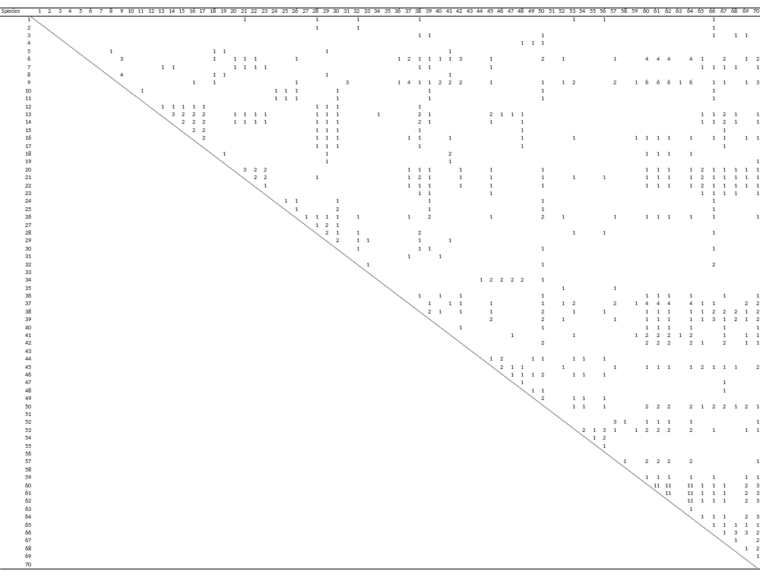

Supplementary Table 16 Natural enemies overlap among herbivores of date palm and intercrops of the Middle East. The numbers of natural enemies shared between each possible pair of herbivores species are shown. The proportion of pairs sharing at least one natural enemy is 0.080, and that of parasitoid and predator separately are 0.052 and 0.035 respectively. Herbivore species identities are as given in Supplementary Table 13.
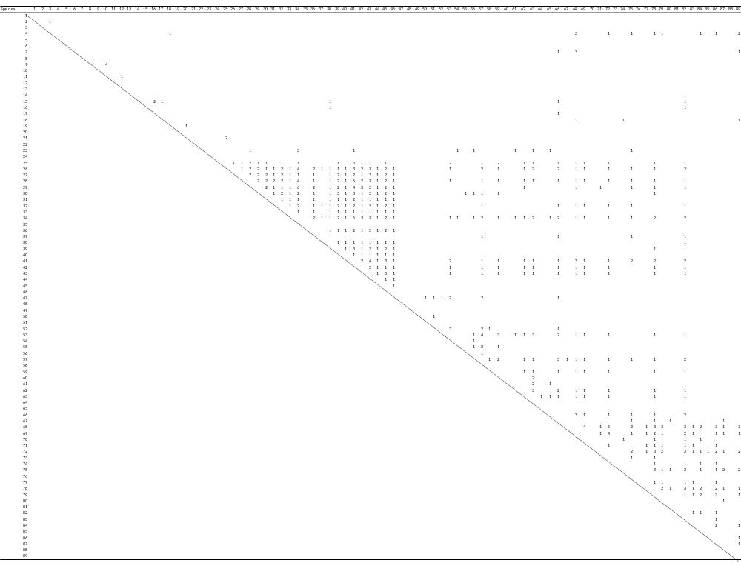

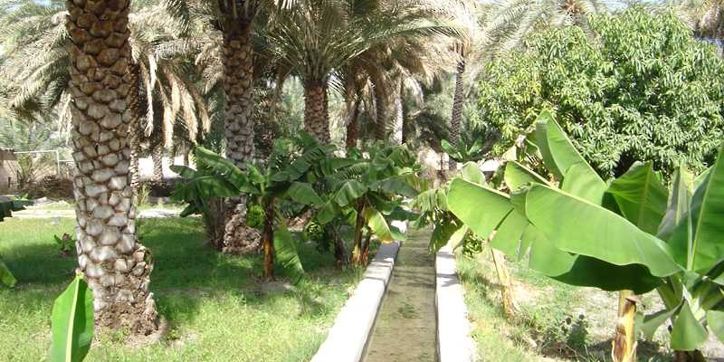
Supplementary Figure 1 The date palm agroecosystem in Oman (Photograph T. Almandhari, 2017). Many intercrops are grown along with date palm in different seasons of the year, depending on the suitability of the crops to the conditions.
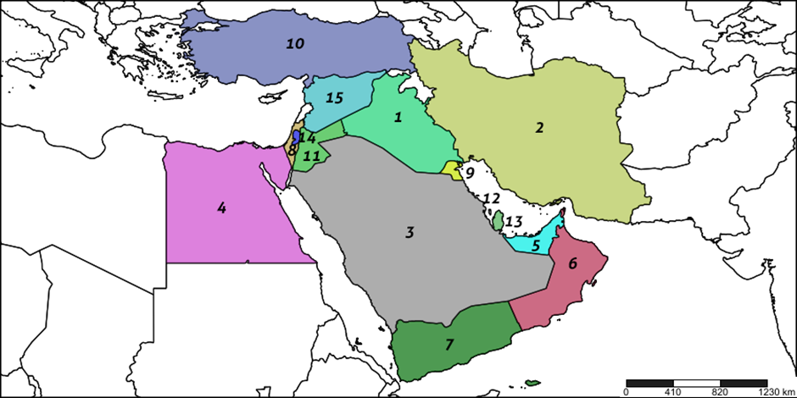

Supplementary Figure 2 Map of the Middle East showing the 15 date palm growing countries considered in this study, numbered in declining order of area of date palm cultivation (Table 1): 1. Iraq, 2. Iran, 3. Saudi Arabia, 4. Egypt, 5. UAE, 6. Oman, 7. Yemen, 8. Israel, 9. Kuwait, 10. Turkey, 11. Jordan, 12. Bahrain, 13. Qatar, 14. Palestine and 15. Syria. (Map constructed using SimpleMappr [Shorthouse, DP (2010) SimpleMappr, an online tool to produce publication-quality point maps. Available at: www.simplemappr.net], accessed: 20 January 2022).

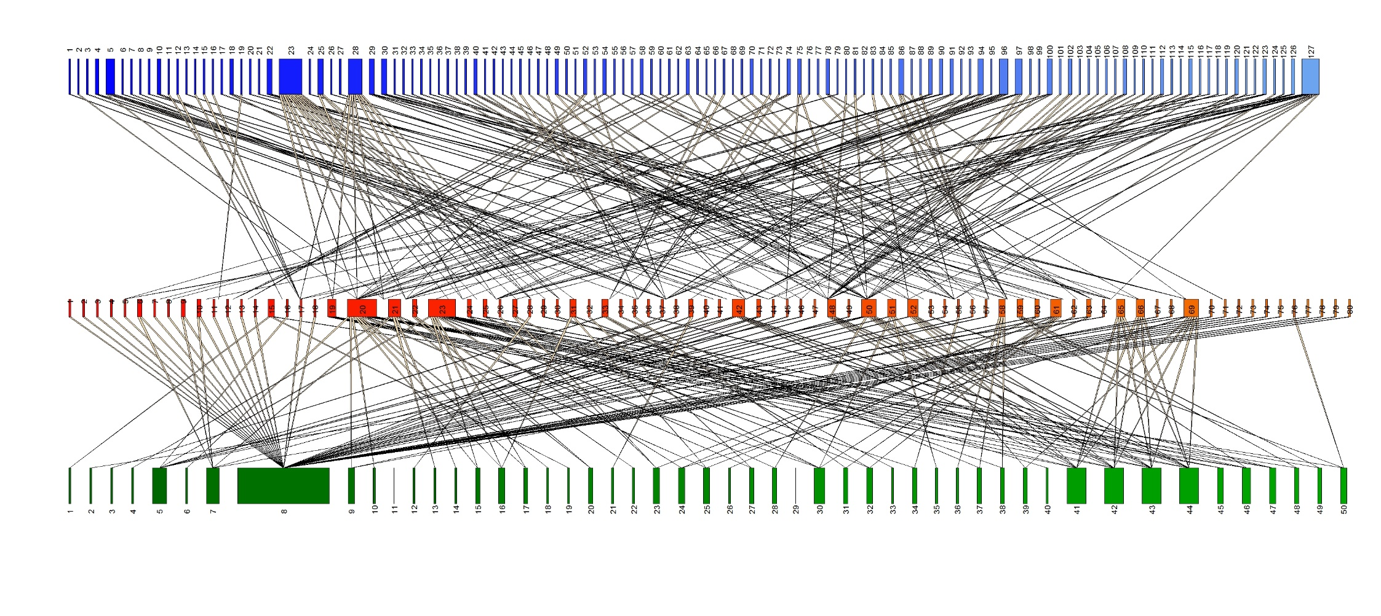
Supplementary Figure 3: Trophic interactions between plants, herbivores and natural enemies (parasitoids and predators) of date palms and intercrops in Oman (Web B in alternative format). This figure shows the same trophic interactions as depicted in Figure 5 of the main text but in the form of a single composite connectance web. Species are ordered numerically within each trophic level, resulting in the representation being visually more complex than in the associated two-panel representation (Figure 5). Herbivore species are shown in red, and their natural enemies in blue and plant species in green. Species identities are given in Supplementary Tables 7, 8 and 9.
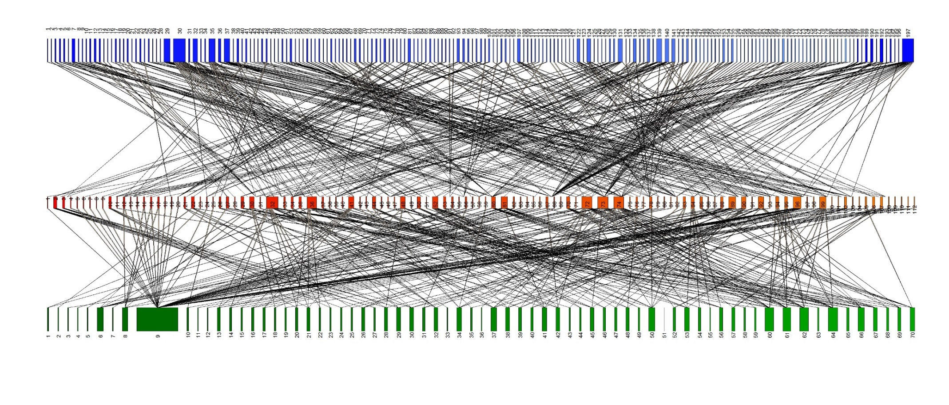
Supplementary Figure 4: Trophic interactions between plants, herbivores and natural enemies (parasitoids and predators) of date palms and intercrops across the Middle East (Web D in alternative format). This figure shows the same trophic interactions as depicted in Figure 4 of the main text but in the form of a single composite connectance web. Species are ordered numerically within each trophic level, resulting in the representation being visually more complex than in the associated two-panel representation (Figure 7). Herbivore species are shown in red, and their natural enemies in blue and plant species in green. Species identities are given in Supplementary Tables 12, 13 and 14.

Supplementary Reference List
Full list of sources of literature information used for constructing trophic webs in the date palm agro-ecosystem in Oman and across the Middle East.

Abbas MST, Shidi RH, Juma S, Al-Khatry SA (2008) Utilization of Goniozus sp. (Hym.: Bethylidae) as a bio-control agent against the lesser date moth, Batrachedra amydaraula (Meyrick) (Lep.: Batrachedridae) in date palm orchards in Sultanate of Oman. Egypt J Biol Pest Control 18:47–50
Abbas MST, Al-Khatry SA, Al Shidi RH, Al-Ajmi NA (2014) Natural enemies of the lesser date moth, Batrachedra amydraula Meyrick (Lepidoptera: Batrachedridae) with special reference to its parasitoid Goniozus sp. Egypt J Biol Pest Control 24:293–296
Abdel-Wahab W (1974) Notes on some of the biological enemies of the insect Alhumira (lesser date moth) on date palms in Iraq. In: Third International Conference of Date Palm - Baghdad 1974, p 9
Al Khatri S (2009) Date palm pests and their control, the blessed tree, pp 62–67
Al Sarai Al Alawi M (2015) Studies on the control of Dubas bug, Ommatissus lybicus DeBergevin (Homoptera: Tropiduchidae), a major pest of date palm in the Sultanate of Oman. PhD thesis, Imperial College London
Alyousuf A (2018) Study of lesser date moth infestation and economic losses on date palm. Batrachedra amydraula Meyrick. Basrah J Date Palm Res (in Arabic), 7
Atakan E, Uygur S (2005) Winter and spring abundance of Frankliniella spp. and Thrips tabaci Lindeman (Thysan., Thripidae) on weed host plants in Turkey. J Appl Entomol 129:17–26
CABI (2021) Invasive species compendium. Wallingford, UK: CAB International. www.cabi.org/isc (accessed on 22 Jan 2022)
Eitam A (2001) Oviposition behavior and development of immature stages of Parasierola swirskiana, a parasitoid of the lesser date moth Batrachedra amydraula. Phytoparasitica 29:405–412. doi: 10.1007/BF02981859
El-Shafie HAF, Abdel-Banat BMA, Al-Hajhoj MR (2017) Arthropod pests of date palm and their management. CAB Reviews 12, No. 049
FAO (2022) FAOSTAT. Available at: http://www.fao.org/faostat/en/#data/QC (Accessed: 09 February 2022)
Gerson U, Applebaum S (2019) Plant pests of the Middle East. URL: http://www.agri.huji.ac.il/mepests/pest/
Kinawy MM (1991) Biological control of the coconut scale insect (Aspidiotus destructor Sign, Homoptera: Diaspididae) in the southern region of Oman (Dhofar). Trop Pest Manag 37:387–389. https://doi.org/10.1080/09670879109371620
Kinawy MM (2005a) Date palm and date pests in Sultanate of Oman. Royal Court Affairs, Sultanate of Oman
Kinawy MM (2005b) Pests of palm and dates in the Sultanate of Oman (in Arabic). 1st edn. Director General of Royal Gardens and Farms, Royal Court Affairs, Sultanate of Oman
Kinawy MM, Arissian M, Guillon M (2015) First field evaluation of mass trapping system for males of the lesser date moth Batrachedra amydraula (Meyrick) (Lepidoptera: Batrachedridae) in Sultanate of Oman. Int J Agric Res Rev 3:223–232
Ministry of Agriculture and Fisheries (2008) Annual report and workshop on biological control of pests in Oman. Directorate of General Planning and Development, Muscat, Sultanate of Oman
Ministry of Agriculture and Fisheries (2014) Agricultural Census 2012/2013. Directorate General of Planning and Development, Muscat, Sultanate of Oman
Mokhtar AM (2005) Manual of aphid insects in the Sultanate of Oman (in Arabic). Ministry of Agriculture and Fisheries, Sultanate of Oman, pp 79.
Noyes JS (2015) Universal Chalcidoidea Database. URL http://www.nhm.ac.uk/our-science/data/chalcidoids/database/indexNamedHost.dsml. Accessed 20 January 2022
Polaszek A, Almandhari T, Fusu L, Al-Khatri SAH, Al Naabi S, Al Shidi RH, Russell S, Hardy ICW (2019) Goniozus omanensis (Hymenoptera: Bethylidae) an important parasitoid of the lesser date moth Batrachedra amydraula Meyrick (Lepidoptera: Batrachedridae) in Oman. PLoS ONE, 14:e0223761. https://doi.org/10.1371/journal. pone.0223761
Polaszek A, Al-Riyami A, Lahey Z, Al-Khatri SA, Al-Shidi RH, Hardy ICW (2021) Telenomus nizwaensis (Hymenoptera: Scelionidae), an important egg parasitoid of the pomegranate butterfly Deudorix livia Klug (Lepidoptera: Lycaenidae) in Oman. PLoS ONE 16:e0250464. https://doi.org/10.1371/journal.pone.0250464
Proceedings of the workshop on biological control of pests in Oman: Present situation, challenges and future perspectives (2008) Ministry of Agriculture, Muscat, Sultanate of Oman
Rakhshani E, Barahoei H, Ahmad Z, Starý P, Ghafouri-Moghaddam M, Mehrparvar M, Kavallieratos NG, Čkrkić J, Tomanović Z (2019) Review of Aphidiinae parasitoids (Hymenoptera: Braconidae) of the Middle East and North Africa: key to species and host associations. Eur J Taxon 552:1–132. https://doi.org/10.5852/ejt.2019.552
Saeed R, Razaq M, Hardy ICW (2015) The importance of alternative host plants as reservoirs of the cotton leaf hopper, Amrasca devastans, and its natural enemies. J Pest Sci 88:517–531
Zaid A (ed.) (2002) Date Palm Cultivation. FAO, Rome. Available at: http://www.fao.org/3/y4360e/y4360e00.htm

