Guardians within: Entomopathogenic fungi-driven antibiosis and compensatory growth combines to reduce the damage of herbivores to melon plants
Meelad Yousef-Yousef¹†*, Fabián García-Espinoza^{1,2}†, María José García del Rosal¹ and Enrique Quesada-Moraga¹*
¹Departamento de Agronomía, ETSIAM, Universidad de Córdoba, Campus de Rabanales, Edificio C4 Celestino Mutis, 14071 Córdoba, España; ²Departamento de Parasitología. Universidad Autónoma Agraria Antonio Narro – Unidad Laguna. Periférico Raúl López Sánchez S/N, 27054 Torreón, Coahuila, México.
Email: z12yonam@uco.es, ep2gaesf@uco.es, b92gadem@uco.es, cr2qumoe@uco.es
† MYY and FGE contributed equally to this work and share the first authorship.
*Corresponding authors: cr2qumoe@uco.es and z12yonam@uco.es
ORCID: MYY 0000-0002-1530-4483; FGE 0000-0002-1356-1048; MJG 0000-0002-2863-7922; EQM 0000-0003-4021-3900

Supplementary material
Guardians within: Entomopathogenic fungi-driven antibiosis and compensatory growth combines to reduce the damage of herbivores to melon plants
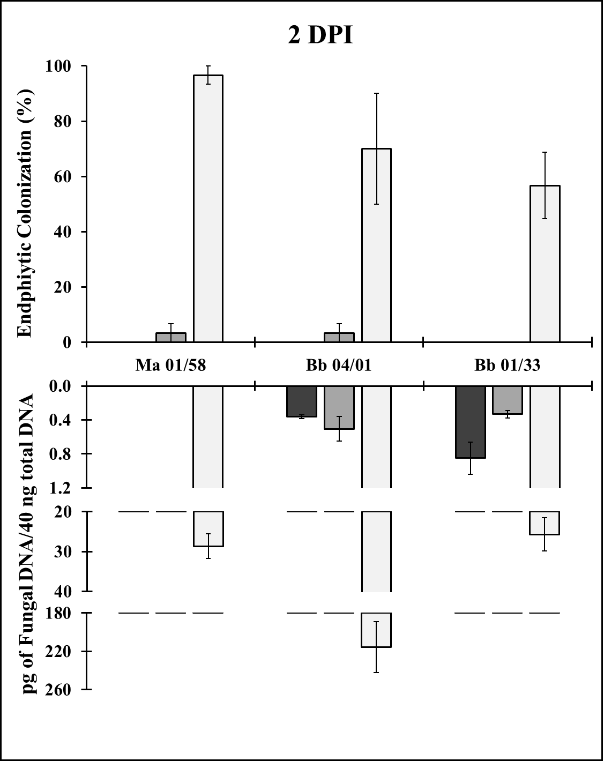
Figure S1. Endophytic colonization detected in melon leaves at 2 DPI after inoculation with EAMa 01/58-Su, EABb 04/01-Tip and EABb 01/33-Su strains following three application methods: seed coating, soil drenching and leaf spraying. Endophytic colonization was assessed by microbiological (upper graph) and by molecular techniques (lower graph) in samples collected prior to the first S. littoralis infestation. Endophytic colonization assessed by microbiological technique is expressed as a percentage of melon leaf fragments in which fungal growth was observed; molecular assessment and quantification is expressed in picograms (pg) of fungal DNA in 40 nanograms (ng) of total DNA per reaction (mean ± SE). Evaluation of endophytic colonization was done 2 days after leaf spraying or soil application in samples of basal true leaves; in the case of leaf spraying, samples came from sprayed leaves; in the case of seed coating, plants were inoculated at phenological stage 0 (germination); for soil application and foliar spray, plants were inoculated at the four-leaf stage.
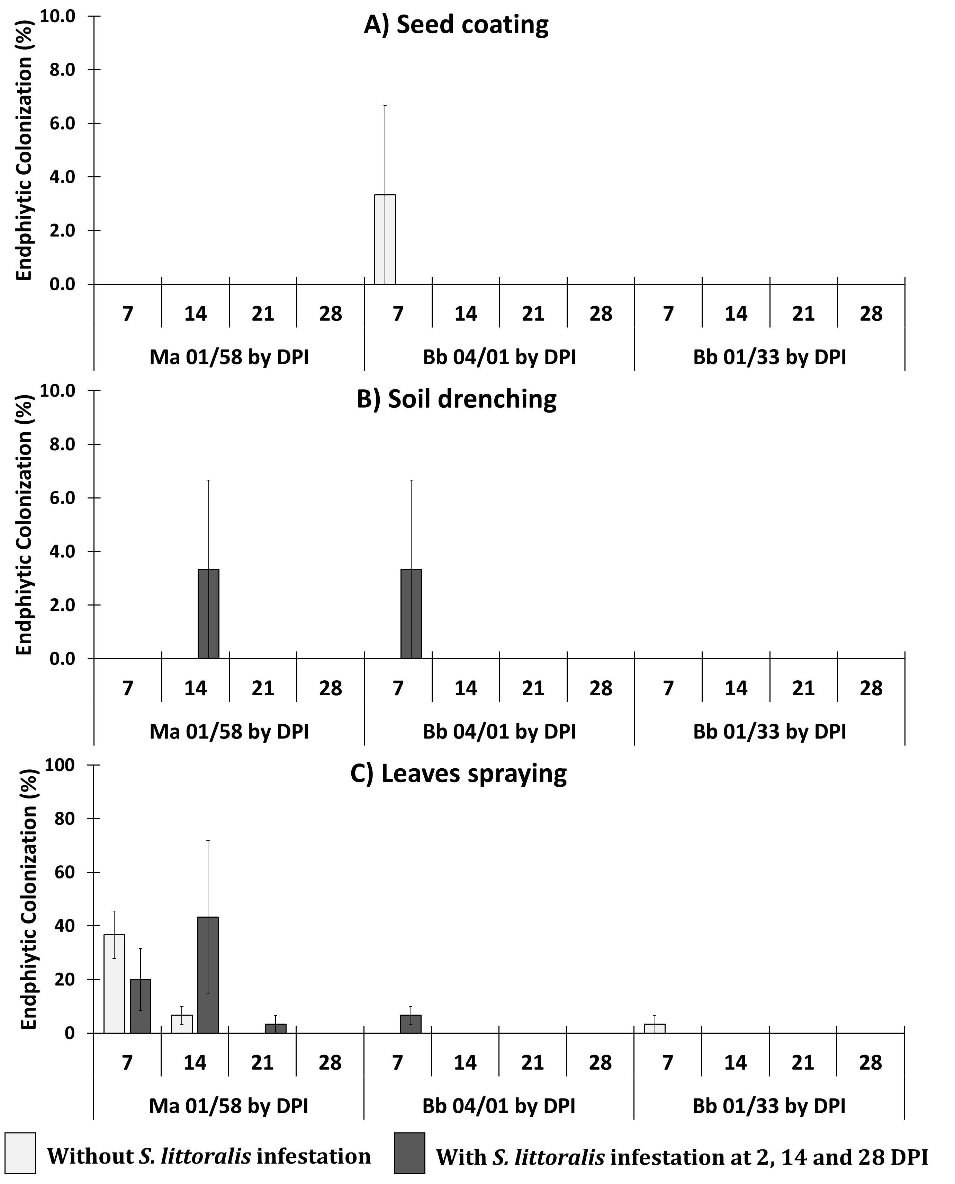
Figure S2. Progressive endophytic colonization detected by microbiological technique in melon leaves inoculated with EAMa 01/58-Su, EABb 04/01-Tip or EABb 01/33-Su strains using three application methods: seed coating (A), soil drenching (B) and leaf spraying (C). Endophytic colonization was assessed over time (7, 14, 21 and 28 DPI); endophytic presence of fungi was evaluated in plants without (clear bars) or with (dark bars) S. littoralis infestation. Endophytic colonization assessed by microbiological technique is expressed as a percentage of melon leaf fragments in which fungal growth was observed. Evaluation in this figure began 7 days after leaf spraying or soil application, with samples collected from non-sprayed leaves throughout the plant. In the case of seed coating, plants were inoculated at phenological stage 0 (germination); for soil application and leaf spraying, plants were inoculated at the four-leaf stage.

Relationship between endophytic colonization, gene expression and effects on S. littoralis
Although Pearson’s Coefficient indicated that, overall, there was no significant correlation between gene expression and endophytic presence of any of the strains or any of the inoculation methods used, it was apparent that, in some specific cases there was a direct correlation, particularly when strains EAMa 01/58-Su and EABb 01/33-Su were applied as seed coatings (Table S1). The strongest direct correlations were observed between expression of ACO3 and PAL genes and endophytic colonization of strain EAMa 01/58-Su applied by soil drenching. In most instances, neither soil drenching or leaf spraying (after which more endophytic colonization was observed for all strains) resulted in significant correlation between gene level expression and endophytic presence of strains (Table S1).

Table S1. Correlation coefficients (Pearson) between endophytic colonization and relative gene expression observed at 2, 7, 14, 21 and 28 DPI in plants inoculated with strains EAMa 01/58-Su, EABb 04/01-Tip and EABb 01/33-Su by seed coating (SCo), soil drenching (SoD) and leaf spraying (LSpr).
Strain | EAMa 01/58-Su |  |  |  |  |  | EABb 04/01-Tip |  |  |  |  |  | EABb 01/33-Su
Gene | SCo |  | SoD |  | LSpr |  | SCo |  | SoD |  | LSpr |  | SCo |  | SoD |  | LSpr
ACO1 | 0.63 | * | -0.15 |  | -0.47 |  | -0.50 |  | -0.22 |  | -0.40 |  | 0.52 | * | -0.36 |  | -0.44
ACO3 | 0.70 | ** | 0.99 | *** | -0.27 |  | -0.27 |  | -0.14 |  | -0.23 |  | 0.82 | ** | 0.45 |  | -0.24
EIN2 | 0.37 |  | -0.19 |  | -0.42 |  | 0.48 |  | -0.02 |  | -0.48 |  | 0.33 |  | 0.47 |  | -0.47
EIN3 | -0.13 |  | -0.44 |  | -0.44 |  | -0.18 |  | -0.38 |  | -0.62 | * | -0.54 | * | -0.39 |  | -0.47
PAL | 0.61 | * | 0.96 | *** | -0.42 |  | -0.48 |  | -0.26 |  | -0.30 |  | -0.35 |  | -0.08 |  | -0.42
LOX2 | 0.22 |  | 0.03 |  | -0.30 |  | -0.54 | * | -0.17 |  | -0.41 |  | 0.83 | ** | 0.50 |  | -0.34
*p<0.05; **p<0.01; ***p<0.001

Correlation coefficients between endophytic colonization and sublethal effects on S. littoralis (Table S2), and between relative gene expression and sublethal effects on S. littoralis (Table S3) were, overall, not significant. These results should be analyzed case by case since the values for each sublethal effect have relationships with both endophytic colonization and relative gene expression. Together, these results suggest that the most effective inoculation method to improve S. littoralis control by indirect mechanisms, would be soil drenching.

Table S2. Correlation coefficients (Pearson) between endophytic colonization and effects on S. littoralis fed at 2, 14 and 28 DPI during 3 days on plants inoculated with EAMa 01/58-Su, EABb 04/01-Tip and EABb 01/33-Su by seed coating, soil drenching and leaf spraying.
Isolate | Ma 01/58 |  |  |  |  |  | Bb 04/01 |  |  |  |  |  | Bb 01/33
Effect/Gene | SCo |  | SoD |  | LSpr |  | SCo |  | SoD |  | LSpr |  | SCo |  | SoD |  | LSpr
Mort | -0.26 |  | 0.09 |  | 0.23 |  | -0.50 |  | -0.44 |  | -0.45 |  | -0.23 |  | -0.13 |  | -0.62
LDev | -0.71 | * | 0.14 |  | 0.20 |  | -0.07 |  | -0.33 |  | -0.10 |  | -0.12 |  | -0.10 |  | -0.30
PWe | -0.11 |  | -0.65 |  | 0.23 |  | -0.17 |  | 0.30 |  | 0.21 |  | -0.79 | * | -0.45 |  | -0.01
Ad. Succ. | 0.26 |  | -0.86 | ** | 0.22 |  | 0.70 | * | 0.77 | * | 0.77 | * | 0.11 |  | 0.09 |  | 0.85 | **
*p<0.05; **p<0.01; ***p<0.001

Table S3. Correlation coefficients (Pearson) between relative gene expression and effects on S. littoralis fed at 2, 14 and 28 DPI during 3 days on plants inoculated with EAMa 01/58-Su, EABb 04/01-Tip and EABb 01/33-Su by seed coating, soil drenching and leaf spraying.
 | Isolate | Ma 01/58 |  |  |  |  |  | Bb 04/01 |  |  |  |  |  | Bb 01/33
Gene | Effect | SCo |  | SoD |  | LSpr |  | SCo |  | SoD |  | LSpr |  | SCo |  | SoD |  | LSpr
ACO1 | L. Mort | -0.05 |  | 0.01 |  | 0.08 |  | 0.56 |  | 0.31 |  | 0.52 |  | 0.33 |  | 0.49 |  | 0.29
 | LDev | -0.60 |  | 0.22 |  | -0.30 |  | 0.26 |  | 0.30 |  | 0.11 |  | 0.01 |  | 0.49 |  | -0.07
 | PWe | -0.18 |  | 0.65 |  | -0.45 |  | 0.51 |  | -0.72 | * | -0.24 |  | -0.57 |  | 0.55 |  | -0.42
 | Ad. Succ. | -0.02 |  | 0.00 |  | -0.30 |  | -0.85 | ** | -0.57 |  | -0.74 | * | -0.43 |  | -0.68 | * | -0.45
ACO3 | L. Mort | -0.17 |  | 0.23 |  | -0.17 |  | 0.11 |  | 0.20 |  | 0.78 | * | 0.10 |  | -0.25 |  | 0.00
 | LDev | -0.67 | * | 0.11 |  | -0.03 |  | -0.13 |  | 0.18 |  | -0.27 |  | -0.09 |  | 0.02 |  | -0.14
 | PWe | -0.11 |  | -0.63 |  | 0.08 |  | -0.32 |  | -0.77 | * | -0.90 | ** | -0.81 | ** | -0.66 |  | -0.60
 | Ad. Succ. | 0.13 |  | -0.86 | ** | -0.20 |  | 0.04 |  | -0.45 |  | -0.73 | * | -0.13 |  | 0.14 |  | 0.00
EIN2 | L. Mort | -0.43 |  | 0.21 |  | 0.10 |  | -0.01 |  | 0.32 |  | 0.61 |  | 0.25 |  | -0.20 |  | 0.10
 | LDev | -0.78 | * | 0.31 |  | -0.08 |  | 0.02 |  | 0.19 |  | -0.19 |  | 0.03 |  | -0.06 |  | -0.15
 | PWe | 0.00 |  | -0.12 |  | -0.22 |  | 0.32 |  | -0.79 | * | -0.71 | * | -0.55 |  | -0.48 |  | -0.53
 | Ad. Succ. | 0.52 |  | -0.75 | * | -0.35 |  | -0.29 |  | -0.58 |  | -0.96 | *** | -0.43 |  | 0.06 |  | -0.22
EIN3 | L. Mort | -0.59 |  | -0.18 |  | 0.36 |  | 0.34 |  | 0.34 |  | 0.21 |  | 0.29 |  | 0.41 |  | 0.72 | *
 | LDev | -0.29 |  | 0.06 |  | -0.20 |  | 0.24 |  | 0.44 |  | 0.60 |  | 0.20 |  | 0.58 |  | 0.30
 | PWe | 0.37 |  | 0.59 |  | -0.33 |  | 0.52 |  | 0.46 |  | 0.46 |  | 0.62 |  | 0.59 |  | 0.44
 | Ad. Succ. | 0.80 | * | 0.11 |  | -0.28 |  | -0.66 |  | -0.28 |  | -0.20 |  | -0.51 |  | -0.45 |  | -0.86 | **
PAL | Mort | 0.43 |  | 0.25 |  | 0.00 |  | 0.02 |  | 0.35 |  | 0.60 |  | 0.53 |  | 0.42 |  | 0.40
 | LDev | -0.31 |  | 0.16 |  | 0.01 |  | -0.07 |  | 0.08 |  | -0.02 |  | 0.22 |  | 0.47 |  | 0.05
 | PWe | -0.39 |  | -0.60 |  | -0.06 |  | -0.09 |  | -0.82 | ** | -0.55 |  | 0.53 |  | 0.42 |  | -0.49
 | Ad. Succ. | -0.63 |  | -0.90 | ** | -0.30 |  | -0.11 |  | -0.60 |  | -0.95 | *** | -0.49 |  | -0.62 |  | -0.31
LOX2 | Mort | -0.07 |  | 0.37 |  | -0.14 |  | 0.01 |  | 0.25 |  | 0.58 |  | 0.10 |  | -0.24 |  | -0.11
 | LDev | -0.57 |  | 0.28 |  | 0.02 |  | -0.12 |  | 0.19 |  | 0.21 |  | -0.09 |  | -0.07 |  | -0.23
 | PWe | -0.04 |  | -0.72 | * | 0.18 |  | -0.29 |  | -0.80 | ** | -0.31 |  | -0.82 | ** | -0.56 |  | -0.59
 | Ad. Succ. | -0.03 |  | -0.80 | * | -0.13 |  | -0.06 |  | -0.51 |  | -0.86 | ** | -0.09 |  | 0.13 |  | 0.00
*p<0.05; **p<0.01; ***p<0.001

