Supplementary material:

Significant uncertainty in bark beetle trap catches due to varying pheromone release from dispensers and local trap position

Sven Hofmann¹*, Markus Kautz¹, Sven Sonnemann², Lutz-Florian Otto²

Authors affiliations:
¹ Department of Forest Health Protection, Forest Research Institute Baden-Württemberg, Freiburg / Germany
² Competence Center for Wood and Forestry, Public Enterprise Sachsenforst, Pirna / Germany
*corresponding author (sven.hofmann@forst.bwl.de)

S1: The three pheromone dispenser products Pheroprax® (A), Chalcoprax® (B), and Curviwit® (C) used in the study; the arrow indicates the replacement line (10% relative filling weight W_{rel}) for Pheroprax®
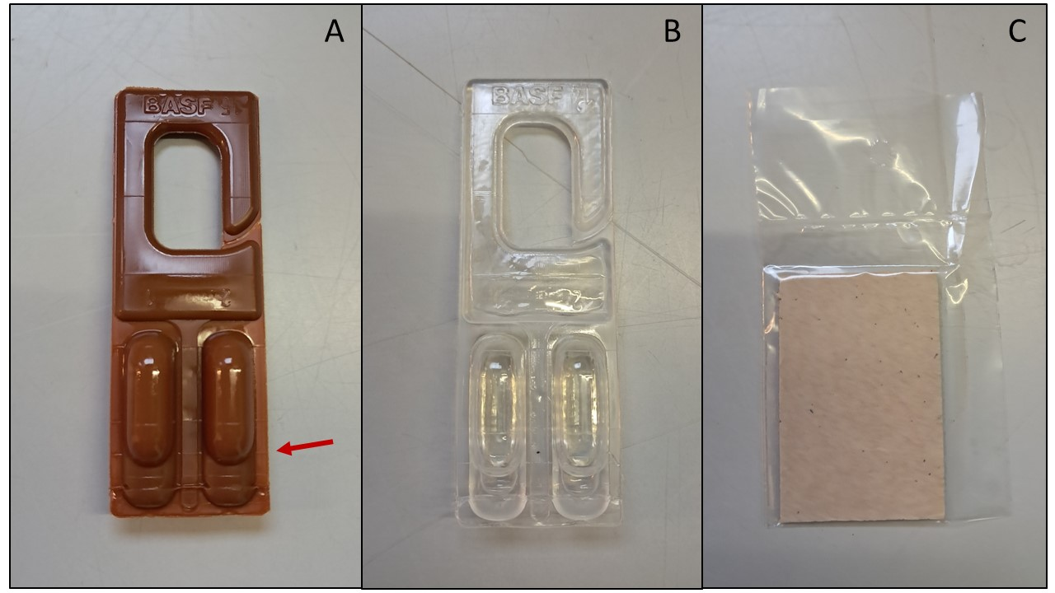

S2: Maps of the study sites Frauenstein (left) and Buggenried (right) with dot color according to the initial filling level (corresponds to relative filling weight, W_{rel}) of single traps. Source of aerial images: GeoSN 2022 (left) and LGL-BW 2023 (right)

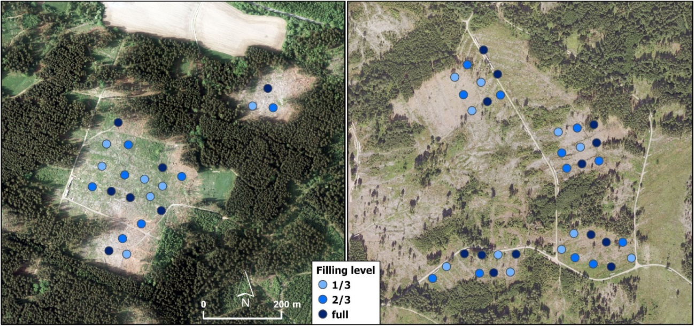

S3: Measurements of volume and weight of living and dry Ips typographus samples from a population close to Freiburg (48° N, 7.8° E) in 2021. ´Generation´ differentiates between the parental generation swarming after hibernation (P) and their filial generation (F1); ´sample´ indicates the sampling group; ´beetles (n)´ is the counted number of beetles included in the sample; ´volume (ml)´ is the volume of the beetles measured using a measuring cylinder; ´weight (mg)´ is the weight of the beetles measured using a fine scale; ´n/ml´ is the number of beetles divided by their volume (average = 39.4).
Generation | Sample | Beetles (n) | Volume (ml) | Weight (mg) | n/ml
P | 1 | 1000 | 26 | 9710 | 38.5
P | 2 | 1000 | 26 | 9635 | 38.5
P | 3 | 1000 | 26 | 9524 | 38.5
P | 4 | 1000 | 26 | 9613 | 38.5
P | 5 | 1000 | 25 | 9740 | 40.0
F1 | 1 | 1000 | 24 | 7654 | 41.7
F1 | 2 | 1000 | 26 | 7588 | 38.5
F1 | 3 | 1000 | 26 | 7534 | 38.5
F1 | 4 | 1000 | 25 | 7571 | 40.0
F1 | 5 | 1000 | 24 | 7632 | 41.7

S4: Weight of the envelope (i.e., empty dispenser) and of the pre-release filling (i.e., pheromone substance) for Pheroprax® (A), Chalcoprax® (B) and Curviwit® (C); note that y-axes differ among panels

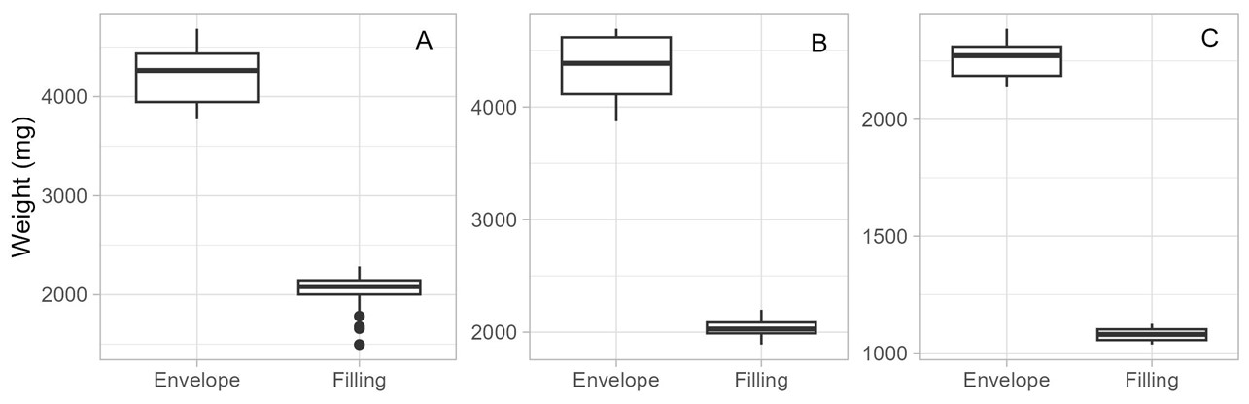

S5: Potential application periods (i.e., the time needed to deplete dispensers) for Pheroprax® (purple, solid), Chalcoprax® (blue, dashed) and Curviwit® (green, dotted) as assessed in the laboratory experiment

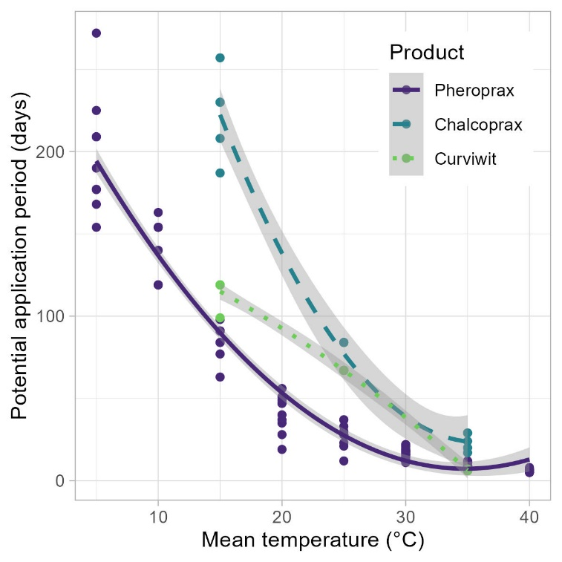

S6: Correlation between air temperature measured by a weather station and inside-trap temperature recorded by data loggers (HOBO Pendant) for daily mean (A) and maximum temperature (B) over the observation period May – August 2023 in Buggenried (n = 456); in black the identity line for comparison

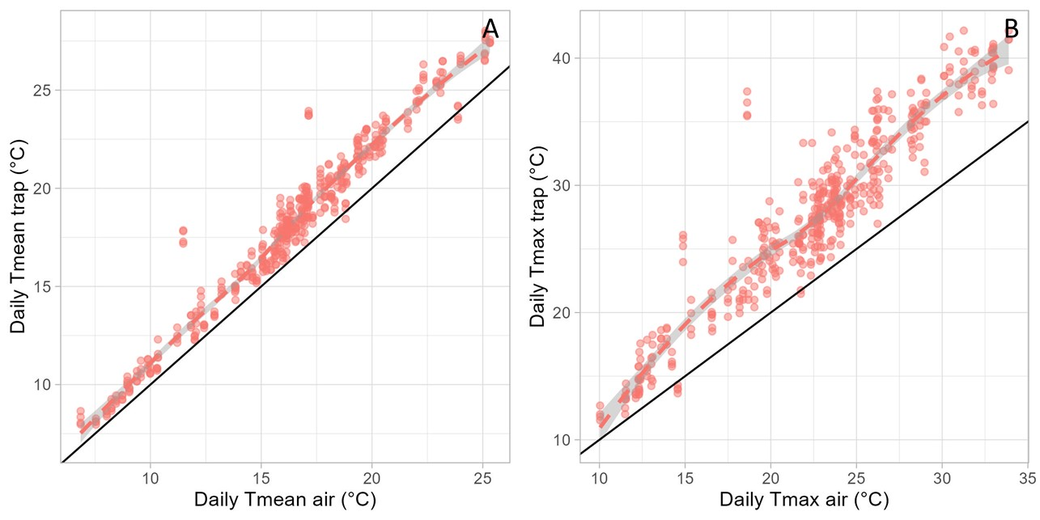

S7: Comparison of measured and predicted pheromone (Pheroprax®) release per day during sampling intervals in Buggenried; prediction is based on the findings from the laboratory experiment and daily mean temperatures inside traps (n = 672); in black the identity line for comparison

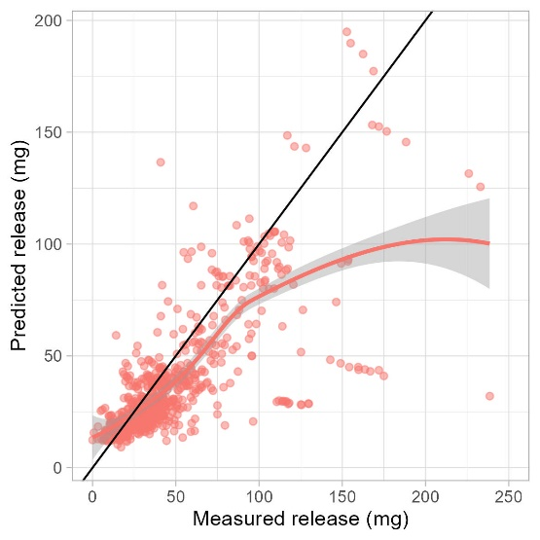

S8: Influence of the distance from the closest forest edge on median trap catches (Frauenstein: n = 21, Buggenried: n = 36)
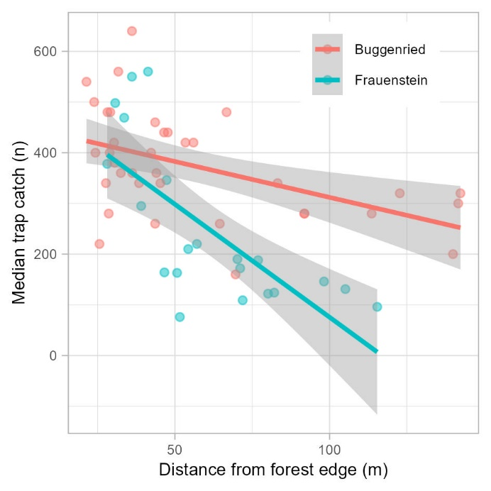

References

GeoSN (2022) Luftbild-Produkte. https://www.landesvermessung.sachsen.de/luftbild-produkte-4982.html. (assessed: Nov 2023)
LGL-BW (2023) Luftbildprodukte. https://www.lgl-bw.de/Produkte/Luftbildprodukte/index.html. (assessed: Nov 2023)

