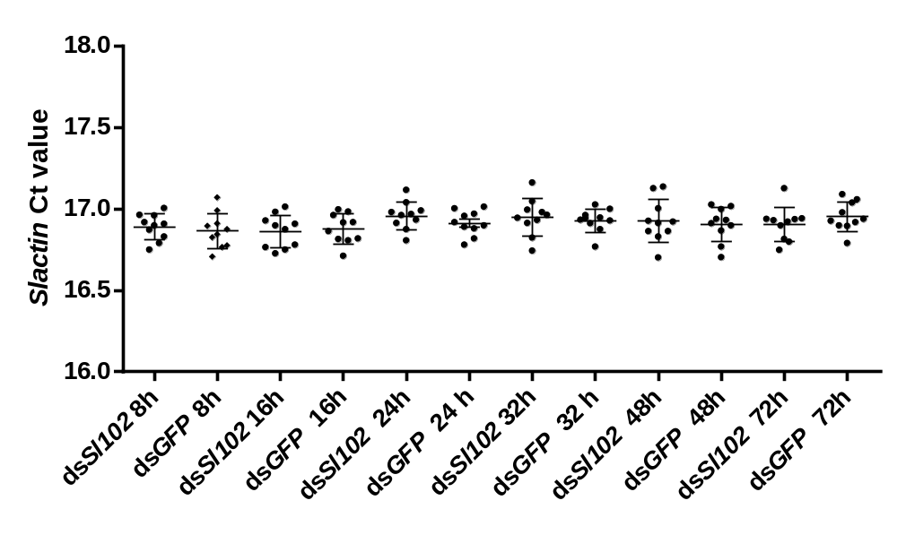
Supplementary Fig. S1. Expression profiles of Slactin during Spodoptera littoralis embryonic development. The internal reference resulted stable across the conditions used in different experimental sets. The values reported are the mean ± standard error. For punctual details see the Supplementary table S1.

Supplementary table S1: Number of replicates and values reported in Fig. S1.
Hours after soacking | Treatment | Number of values | Mean | Std. Error
6 | dsSl102 | 10 | 16.89 | 0.026
6 | dsGFP | 10 | 16.86 | 0.034
14 | dsSl102 | 10 | 16.86 | 0.032
14 | dsGFP | 10 | 16.88 | 0.029
24 | dsSl102 | 10 | 16.96 | 0.027
24 | dsGFP | 10 | 16.91 | 0.024
32 | dsSl102 | 10 | 16.95 | 0.036
32 | dsGFP | 10 | 16.93 | 0.022
48 | dsSl102 | 10 | 16.93 | 0.042
48 | dsGFP | 10 | 16.91 | 0.033
72 | dsSl102 | 10 | 16.9 | 0.033
72 | dsGFP | 10 | 16.95 | 0.028

Supplementary table S2: Sl102 gene transcript during Spodoptera littoralis embryonic development. Mean and Standard Error refer to data reported in Fig. 1 in the text.

Time post oviposition (hours) | Number of values | Mean | Standard Error
8 | 6 | 752.7 | 333.1
16 | 6 | 4229 | 2066
24 | 7 | 4364 | 1934
32 | 5 | 20318 | 4148
40 | 5 | 819.7 | 339.4
48 | 6 | 3919 | 2031
56 | 6 | 4886 | 2436
64 | 7 | 9681 | 3496
72 | 5 | 9228 | 5918

Supplementary table S3: Values reported in Fig. 3
 | dsGFP |  |  |  | dsSl102
Time of soaking (minutes) | Relative expression | Error + | Error - | n | Relative expression | Error + | Error - | n
15 | 1.00 | 0.44 | 0.35 | 20 | 1.07 | 0.31 | 0.30 | 20
30 | 1.06 | 0.40 | 0.33 | 20 | 0.82 | 0.46 | 0.33 | 20
60 | 1.08 | 0.45 | 0.25 | 20 | 0.56 | 0.13 | 0.17 | 20
120 | 1.23 | 0.39 | 0.41 | 20 | 0.02 | 0.01 | 0.01 | 20

Supplementary table S4: Sl102 relative expression in experimental Spodoptera littoralis eggs soaked with dsGFP or dsSl102 (reported in Fig. 3).
 | dsGFP |  |  | dsSl102
Time after soaking (hours) | Relative expression | Error + | Error - | Relative expression | Error + | Error -
6 | 1.00 | 0.48 | 0.32 | 0.66 | 0.32 | 0.22
14 | 5.52 | 2.04 | 1.49 | 0.50 | 0.81 | 0.31
24 | 5.70 | 2.99 | 1.96 | 0.09 | 0.25 | 0.15
32 | 25.97 | 7.92 | 7.06 | 0.07 | 0.10 | 0.05
48 | 5.32 | 1.84 | 1.37 | 0.01 | 0.08 | 0.01
72 | 13.14 | 4.58 | 4.25 | 0.009 | 0.09 | 0.01

Supplementary table S5: Sl102 relative expression in experimental Spodoptera littoralis eggs soaked with dsGFP or dsSl102 (reported in Fig. 6a).

 | dsGFP |  |  | dsSl102
Time after soaking (hours) | Relative expression | Error + | Error - | Relative expression | Error + | Error -
2 | 1.0 | 0.36 | 0.27 | 0.01 | 0.005 | 0.003

Supplementary table S6: Survival rate in experimental Spodoptera littoralis eggs soaked with dsGFP or dsSl102 (reported in Fig. 6b).

Percent survival
Day | dsGFP | dsSl102
2 | 100 | 100
3 | 97.26 | 19.05
4 | 91.78 | 14.29
5 | 87.67 | 4.76
6 | 86.3 | 4.76

