Supplementary material
Insect and plant material
The D. semiclausum French and Greek populations used in the study came from field collections conducted during the months preceding the study. The French population was collected in an organic farm near Montpellier, France (GPS coordinates: 43.7357, 3.8231), and the Greek population was collected on cruciferous crops near Thessaloniki, Greece (GPS coordinates: 40.5697, 22.9894). The Dutch population originated from a laboratory rearing maintained at the Laboratory of Entomology at Wageningen University (The Netherlands); this rearing was started using individuals collected from several local organic cabbage fields, and was refreshed yearly or every other year. DBM populations were collected in the same field sites as the parasitoid populations. Each parasitoid was reared using only hosts from its area of origin. We will refer to the DBM population originating from the same area as the parasitoid as the “original host population” and the DBM populations originating from the USA as “novel host populations” hereafter. Two DBM populations originating from the USA were used in the study, and they differed in insecticide resistance. One population, collected in an organic farm in Salinas (California), did not display insecticide resistance. The second one, collected in Camarillo (California), displayed resistance to Bt and to an anthranilic diamide (chlorantraniliprole). Insecticide resistance was evaluated following established testing protocols (Insecticide Resistance Action Committee - https://irac-online.org/methods/plutella-xylostella-larvae/) (Ian Grettenberger, personal communication). The DBM population from California resistant to insecticides will be referred to as “Cali R” and the one susceptible to insecticides will be referred to as “Cali S” hereafter.

The DBM populations were reared on Brassica rapa subsp. chinensis variety “Pak Choi” (Germisem®, Oliveira do Hospital, Portugal). Three-to-six-week old plants grown in potted soil (Huminsubstrat, Terreau N°2 P36 REF 185, Neuhaus®, Brussels, Belgium) with a weekly addition of fertilizer (BHS engrais plantes vertes, Agronutrition SAS®, Carbonne, France) were used. Plants were placed in rearing cages (Bugdorm® models 4F4545 and BD6E620, mesh size : 150 x 150 | 160 µm aperture; MegaView Science Co. Ltd, Taiwan) in a greenhouse set at a temperature of 23°C and 12:12 L:D photoperiod. Larvae were fed ad libitum, and plants were replaced when needed until the larvae pupated. A total of 200-400 newly emerged adults were placed in a new rearing cage with honey and water as food in a room set at a temperature of 21°C and 12:12 L:D photoperiod. As oviposition substrate, a cabbage leaf covered with 2 parafilm layers and pierced with small holes was placed in the cages with adults. After 24h to 72h, the oviposition substrate was removed and placed in a new rearing cage with new plant material to rear the next generation. The oviposition substrate could also be stored in a fridge for a few days before use if needed. For experiment #3, which required 50 DBM eggs to be deposited on individual plants, strips of parafilm from oviposition substrates containing the adequate number of eggs were cut 24h after oviposition. Eggs were counted under a stereomicroscope (Meiji 1.5, Meiji Techno America®, San Jose, USA).

Parasitoids were reared as follows: approx. 20 mated females (range: 10 – 55) were placed in a cage containing Brassica rapa subsp. chinensis plants infested with ca.1000 DBM 2nd instar larvae for 24h under the greenhouse conditions described above. Emerging adult parasitoids were kept in the cage for at least 24h with honey to allow feeding and mating. Parasitoids were then transferred to a rearing cage without plant or host material and with water, honey, and buckwheat flowers (grown from seeds: Ferri Luigi Sementi SARL®, Vignola, Italy) with a 3:1 female to male ratio. The rearing cage was placed in an incubator set at 12°C; 80% RH and a 12:12 L:D photoperiod to extend their longevity. Parasitoids were maintained under these conditions until they were needed to produce the next generation of parasitoids or for experiments.

Apart from the semi-field experiment, all experiments were conducted inside the quarantine facilities of the European Biological Control Laboratory (EBCL USDA-ARS) in Montferrier-sur-lez, France. All but two experiments were conducted with the three parasitoid populations. The semi-field experiment (experiment # 4) could only be done with the French D. semiclausum population and the French DBM population due to regulatory restrictions: DBM and parasitoid populations from outside France were considered exotic and could not be used in field cages. The experiment investigating competition between D. semiclausum and D. insulare (experiment # 5) could also only be done with the French D. semiclausum population due to practical constraints.

Molecular analyses

Genomic DNA (gDNA) of each individual was extracted using Qiagen DNeasy 96 Blood and Tissue Kit (Qiagen, Hilden, Germany) following the recommendations of the manufacturer. Grinding was made with a sterile blue polypropylene pestle and the lysis step was extended overnight. gDNA was eluted in a final volume of 50 µl. A negative control (no wasp tissue) was included in each extraction to detect potential contamination. The concentration of the extracted gDNA was estimated using the Qubit® dsDNA HS assay kit and the Qubit 4 ®Fluorometer (Invitrogen, France).
Candidate primers to diagnose Diadegma semiclausum and Diadegma insulare were designed based on the alignment of 22 different partial sequences of D. semiclausum, D. insulare and D. fenestrale of the nuclear internal transcribed spacer 2 (ITS2) located between the 5.8S rRNA and LSU rRNA genes retrieved from Genbank and of seven ITS2 sequences obtained in this study. The latter are deposited in Genbank (D. semiclausum PQ496817; PQ496818; D. insulare PQ496819; PQ496820; PQ496821; D. fenestrale PQ496822; PQ496823). D. fenestrale was included in the primer design step as it is part of a companion study not reported here. A total of five primers (Insu1F; 5’- GGCTGAGGGTCGTTTATGC-3’; Insu1R; 5’- CGGCTCGGTTCTCAAAGAGT-3’; Insu3R; 5’- GCGGGTCGTATCTGTCCTTC-3’; Fen3F; 5’-CGGCGTCGCTTGAAATGAAT-3’ and Fen3R; 5’-CTCGGACCGTCCACTTTTCA-3’) were designed in silico using Primer3 and AmplifX 2 softwares. Primers were designed on flanking region of indels in order to yield amplicons of different lengths for each species. The in vitro validation was performed by challenging the primers against DNA collection from a panel of D. semiclausum, D. isulare and D. fenestrale as well as DBM. Two End-point PCRs using multiplexed primer sets were conducted to simultaneously diagnose D. semiclausum and D insulare. Each PCR was done in a 15µl total volume, with 2µl of gDNA template, 0.15 µM of each primer of the PCR1 set (Insu1F/1R/Fen3F/Fen3R) or the PCR2 set (Insu1F/3R/Fen3F/Fen3R) , 0.2mM of each dNTP, 1X CoralLoad PCR buffer (including 1.5 mM of MgCl₂) and 1 Unit of Taq DNA polymerase (Qiagen), and run on an Applied biosystems 9700 thermocycler using the following thermal conditions: an initial denaturation step at 94°C for 3 min, followed by 35 cycles at 94°C for 15s, 64°C for 15s, 72°C for 15s, and a final elongation at 72°C for 7 min. PCR amplicons were resolved by 3% agarose electrophoresis for 30 min at 100 volts using 1kb DNA Ladder (Eurogentec © SmartLadder SF), stained with SybrSafe™ gel stain (Invitrogen Inc., Waltham, MA, USA), and visualized on a Fusion FX7 imaging system (Vilber, Marne la Vallée, France. With PCR1, samples were scored as positive for D. semiclausum and D. insulare when two amplicons of 290bp and 151bp and two amplicons of 393bp and 258bp respectively were visualized on the electrophoresis gel (Fig S2). With PCR2, samples were scored as positive for D. semiclausum and D. insulare when two amplicons of 415bp and 293bp and one amplicon of 382bp respectively were visualized on the electrophoresis gel. DBM did not display any band pattern.

Supplementary figures

Figure S1. Dry mass (Mean ± SE) of adult (A) females and (B) males of DBM from the different populations tested in the study (Cali S: California susceptible to insecticides; Cali R: California resistant to insecticides; H: The Netherlands; G: Greece; F: France). Means followed by a different letter are significantly different (Kruskal–Wallis test, α = 0.05)

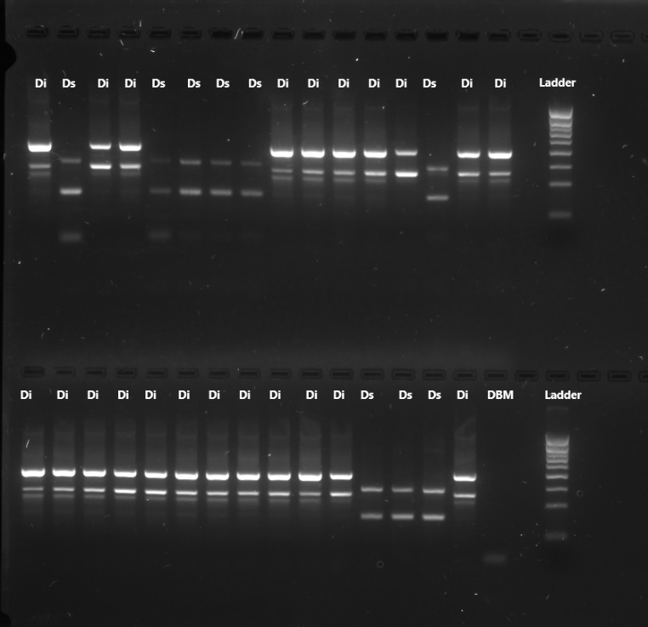
Figure S2. Multiplex PCR profiles using PCR1 primer set of adult Diadegma specimens obtained from experiment #5 (competition between D. semiclausum and D. insulare). Di: Diadegma insulare; Ds: Diadegma semiclausum; DBM: Diamondback moth. 1kb DNA Ladder (Eurogentec © SmartLadder SF)

Supplementary tables
Table S1. Mean mass (mg) of the offspring of parasitoids from three European D. semiclausum populations (DS France, DS Greece, and DS the Netherlands) that were allowed to parasitize two DBM populations from California, Cali R (i.e. resistant to insecticides) and Cali S (i.e. susceptible to insecticides). Male mass did not differ statistically across populations of DBM and parasitoids, nor did male mass (One-way ANOVA, α = 0.05). Female mass data could not be analyzed statistically due to low sample size for some parasitoid/host. Numbers in parentheses indicate the number of individuals measured.

DBM population | Parasitoid population | Female mass | Male mass
Cali R | DS France | 0.82 ± 0.03 (26) | 0.67 ± 0.02 (30)
Cali R | DS Greece | 0.80 ± 0.02 (32) | 0.70 ± 0.02 (53)
Cali R | DS the Netherlands | 0.60 ± 0.07 (5) | 0.62 ± 0.03 (20)
Cali S | DS France | 0.80 ± 0.03 (23) | 0.68 ± 0.02 (32)
Cali S | DS Greece | 0.68 ± 0.08 (2) | 0.62 ± 0.03 (20)
Cali S | DS the Netherlands | 0.89 ± 0.05 (12) | 0.71 ± 0.02 (44)

