Supplementary

Table S1: Average daily temperature (± SE) recorded in investigated orchards over the four years of the study. Different letters indicate significant differences from a χ² test on estimated marginal means (α = 0.05).
Year | Average daily temperature (°C)
2020 | 22.14 ± 0.14 | c
2021 | 22.17 ± 0.07 | c
2022 | 23.86 ± 0.14 | a
2023 | 23.24 ± 0.14 | b

Table S2: Results of the linear mixed models of T. japonicus and T. mitsukurii parasitism and A. sinicus hyperparasitism observed in the kiwifruit orchards investigated over a four-year period from 2020 to 2023.
Parasitism / hyperparasitism rates | Effect | χ² | d.f. | P
T. japonicus | H. halys egg abundance | 8.960 | 1 | 0.003
T. japonicus | Average daily temperature | 2.91 | 1 | 0.101
T. mitsukurii | H. halys egg abundance | 0.186 | 1 | 0.666
T. mitsukurii | Average daily temperature | 9.859 | 1 | 0.002
A. sinicus | T. mitsukurii abundance | 18.886 | 1 | < 0.001
A. sinicus | T. japonicus abundance | 6.966 | 1 | 0.008
A. sinicus | Average daily temperature | 9.818 | 1 | 0.001

Table S3: Means (± SE) of net reproductive rates (R₀) estimated from the stage-structured matrix models and percent reduction in R₀ (± SE) from the egg mortality scenario of no parasitism and no predation. Different letters indicate significant differences at Tukey test on estimated marginal means.

Variable | Egg mortality scenario | 2020 |  | 2021 |  | 2022 |  | 2023
1st generation R₀ | real scenario | 4.02 ± 0.31 | a | 4.38 ± 0.31 | ab | 4.53 ± 0.31 | abc | 5.22 ± 0.31 | cde
1st generation R₀ | with only T. japonicus | 4.78 ± 0.31 | abcd | 5.37 ± 0.31 | bcdef | 5.17 ± 0.31 | bcde | 5.43 ± 0.31 | bcdef
1st generation R₀ | with only T. mitsukurii | 4.03 ± 0.31 | a | 4.62 ± 0.31 | abc | 5.18 ± 0.31 | bcde | 6.21 ± 0.31 | ef
1st generation R₀ | native parasitism + predation | 4.78 ± 0.31 | abcd | 5.61 ± 0.31 | cdef | 5.8 ± 0.31 | def | 6.38 ± 0.31 | ef
1st generation R₀ | no parasitism, no predation | 4.87 ± 0.31 | cd | 5.84 ± 0.31 | def | 6.25 ± 0.31 | ef | 6.62 ± 0.31 | f
2nd generation R₀ | real scenario | 0.89 ± 0.04 | efgh | 0.59 ± 0.04 | a | 0.67 ± 0.04 | abc | 0.64 ± 0.04 | ab
2nd generation R₀ | with only T. japonicus | 1.07 ± 0.04 | gh | 0.73 ± 0.04 | abcdef | 0.7 ± 0.04 | abcde | 0.69 ± 0.04 | abcd
2nd generation R₀ | with only T. mitsukurii | 0.9 ± 0.04 | efgh | 0.65 ± 0.04 | abc | 0.72 ± 0.04 | abcde | 0.8 ± 0.04 | cdef
2nd generation R₀ | native parasitism + predation | 1.07 ± 0.04 | gh | 0.79 ± 0.04 | bcdef | 0.75 ± 0.04 | bcdef | 0.84 ± 0.04 | def
2nd generation R₀ | no parasitism, no predation | 1.09 ± 0.04 | h | 0.86 ± 0.04 | defg | 0.8 ± 0.04 | cdef | 0.92 ± 0.04 | fgh
Annual projection R₀ | real scenario | 2.36 ± 0.13 | abc | 2.15 ± 0.13 | a | 2.46 ± 0.13 | abcd | 2.43 ± 0.13 | abcd
Annual projection R₀ | with only T. japonicus | 2.82 ± 0.13 | cdefgh | 2.65 ± 0.13 | bcdef | 2.71 ± 0.13 | bcdef | 2.58 ± 0.13 | abcde
Annual projection R₀ | with only T. mitsukurii | 2.37 ± 0.13 | abc | 2.32 ± 0.13 | ab | 2.73 ± 0.13 | bcdefg | 2.97 ± 0.13 | efgh
Annual projection R₀ | native parasitism + predation | 2.83 ± 0.13 | cdefg | 2.81 ± 0.13 | cdefg | 2.97 ± 0.13 | efgh | 3.09 ± 0.13 | fgh
Annual projection R₀ | no parasitism, no predation | 2.87 ± 0.13 | defg | 2.99 ± 0.13 | efgh | 3.19 ± 0.13 | gh | 3.29 ± 0.13 | h
Percent reduction in R₀ | real scenario | 18.09 ± 4.18 | bcde | 25.69 ± 4.18 | de | 22.6 ± 4.18 | cde | 27.56 ± 4.18 | e
Percent reduction in R₀ | with only T. japonicus | 1.9 ± 4.18 | a | 11.34 ± 4.18 | abcd | 14.97 ± 4.18 | abcde | 21.29 ± 4.18 | cde
Percent reduction in R₀ | with only T. mitsukurii | 17.86 ± 4.18 | bcde | 21.83 ± 4.18 | cde | 14.04 ± 4.18 | abcde | 9.37 ± 4.18 | abc
Percent reduction in R₀ | native parasitism + predation | 1.68 ± 4.18 | a | 5.97 ± 4.18 | ab | 6.51 ± 4.18 | ab | 5.84 ± 4.18 | ab

Table S4: Results of linear mixed models of net reproductive rate (R₀) in the absence of egg parasitism and predation obtained from the 1st and 2nd generation matrices.

Effect | χ² | d.f. | P
H. halys generation | 893.217 | 1 | < 0.001
Average daily temperature | 25.695 | 1 | < 0.001
(Average daily temperature)² | 27.838 | 1 | < 0.001
Average daily temperature x H. halys generation | 5.686 | 1 | 0.017

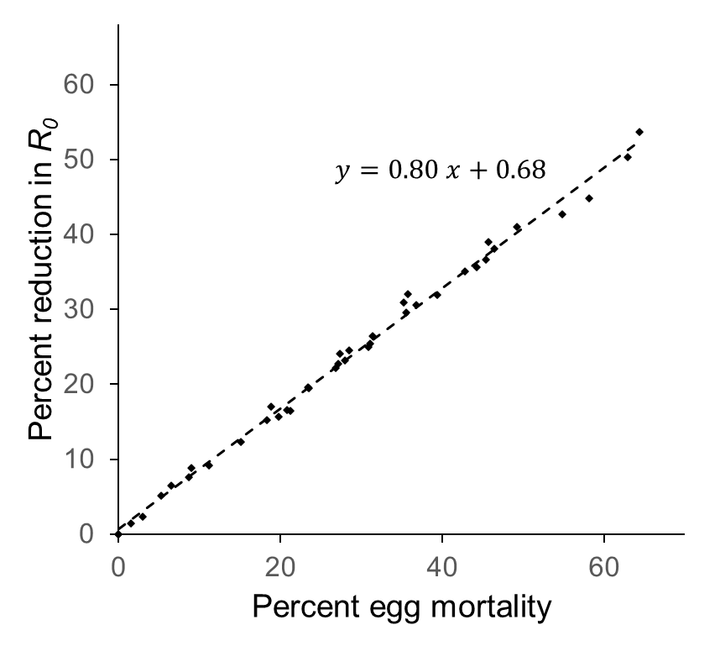
Figure S1: The match between population-level impact (percent reduction in net reproductive rate, R₀) and life-stage impact (percent egg mortality) for H. halys based on real egg mortality scenario from annual projections.

