Pine stand with critical sizes in Belgium
Table 1. Area classes of the Flemish pine stands
Area classes | Nb of stands
0-10 ha | 6492
10-50 ha | 420
50-100 ha | 100
100-200 ha | 41
200-500 ha | 31
500-1000 ha | 8
> 1000 ha | 3

Table 2. Details regarding the Pinus sp. stands with an area > 500 ha
Province | Locality | Longitude | Latitude | Area (ha)
Limburg | Zutendaal | 5.592 | 50.948 | 3836.65
Limburg | Eksel | 5.336 | 51.169 | 3197.82
Limburg | Dilsen | 5.667 | 51.031 | 1684.55
Limburg | Gruitrode | 5.586 | 51.063 | 950.36
Antwerpen | Kapellen | 4.479 | 51.343 | 728.33
Antwerpen | Lichtaart | 4.874 | 51.207 | 682.77
Limburg | Mechelen-aan-de-Maas | 5.659 | 50.977 | 664.45
Antwerpen | Mol | 5.196 | 51.275 | 663.10
Antwerpen | Arendonk | 5.094 | 51.356 | 636.00
Antwerpen | Essen | 4.439 | 51.420 | 598.90
Antwerpen | Beerse | 4.832 | 51.285 | 505.98
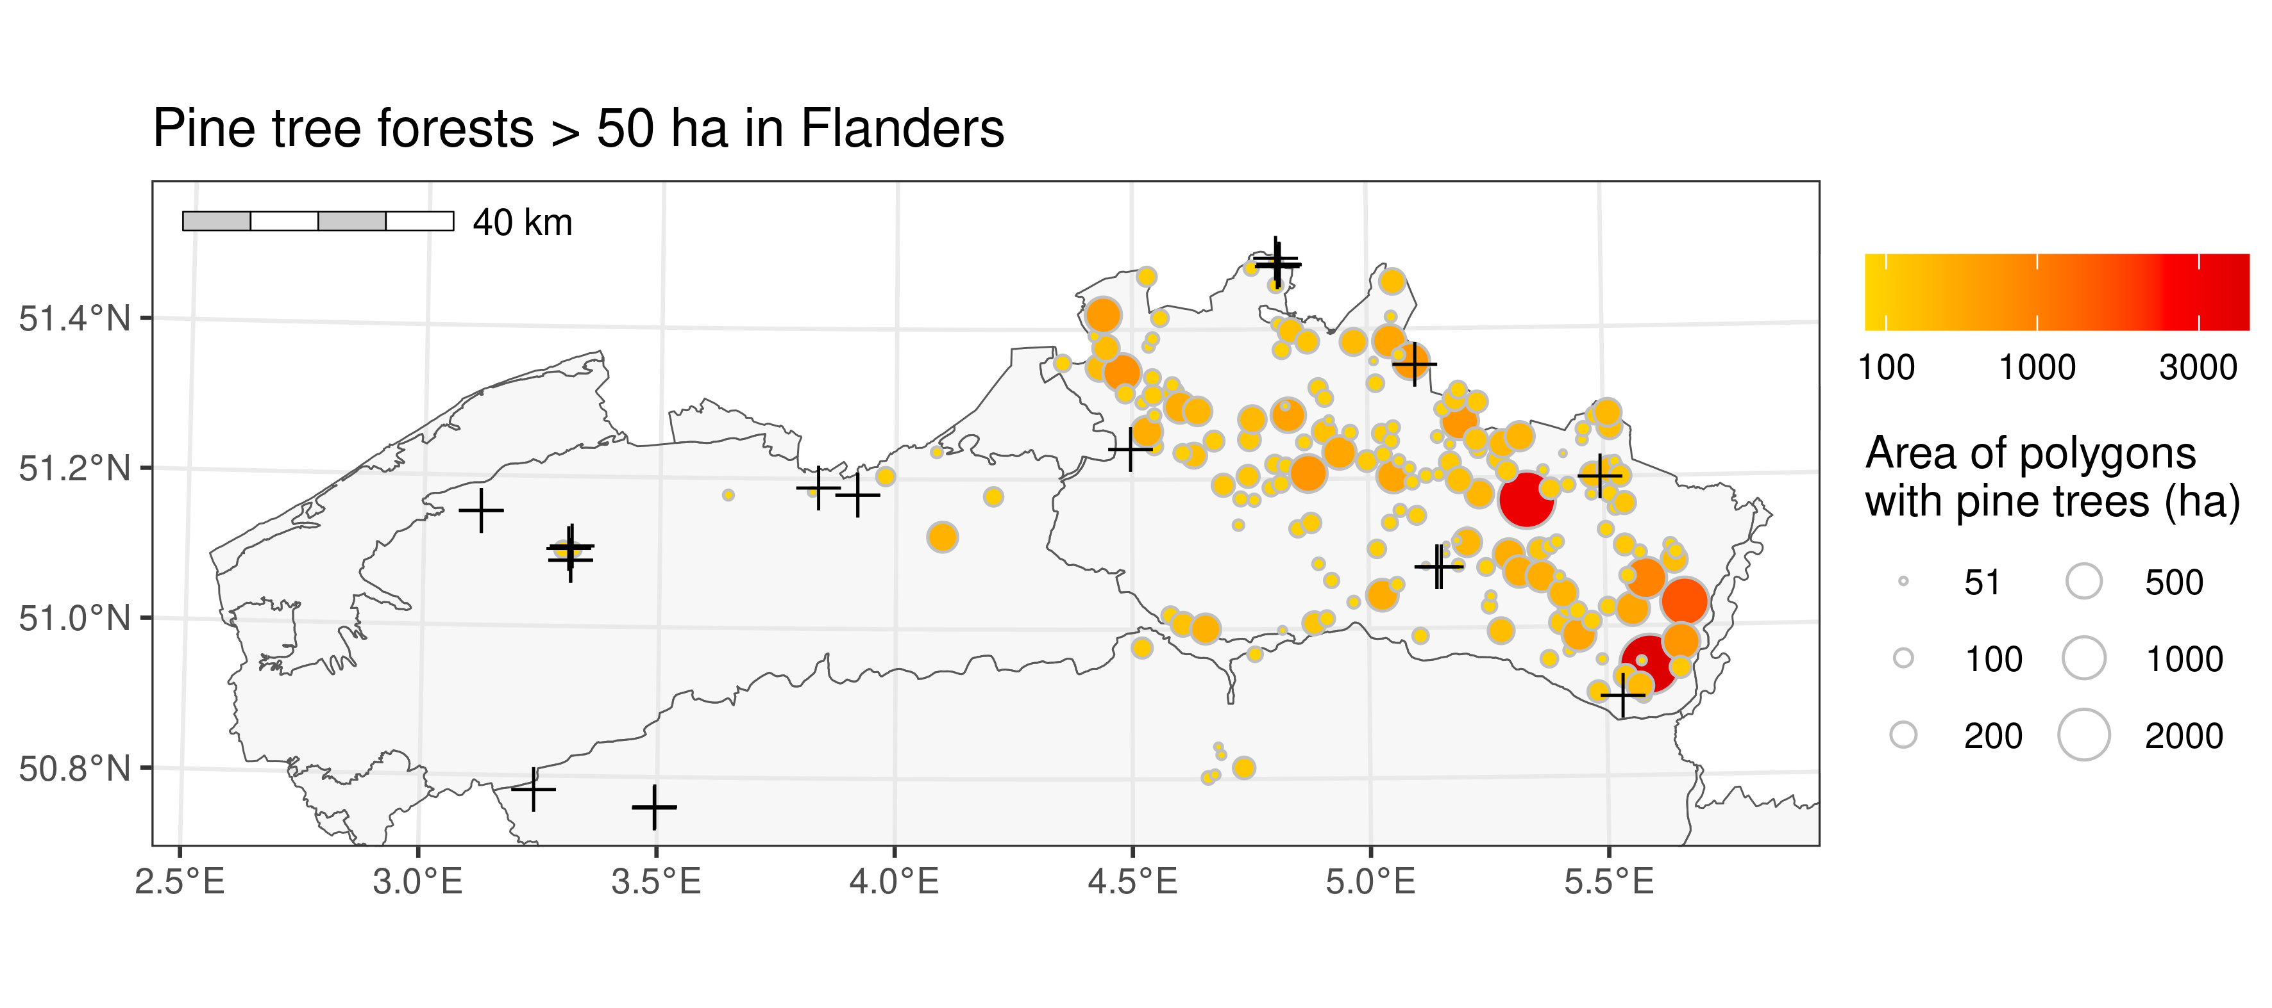
Figure 1. Pinus spp. stands larger than 50 ha in Flanders with locations of Monochamus sp. captures (black crosses)

