For submission to Journal of Pest Science // Original research paper

Leaf surface structure shapes herbivore preference and predation efficiency: leaf-mediated biocontrol in a soybean system

[Supporting information]
Table S1 (data corresponding to Fig. 2c)
ANOVA results for trichome density on the abaxial and adaxial leaf surfaces of soybean plants
 | Df | Sum Sq | Mean Sq | F value | Pr(>F)
Location | 1 | 116434 | 116434 | 628.2 | < 0.001
Residuals | 18 | 3336 | 185

Table S2 (data corresponding to Fig. 3a)
a. Results of the beta regression model testing the effect of leaf position (abaxial-lower, adaxial-upper, other) on aphid preference.
 | Estimate | Std. Error | z value | Pr(>F)
Intercept (Abaxial-lower) | -4.904 | 0.045 | -109.26 | < 0.001
Adaxial-upper | -1.588 | 0.106 | -15.01 | < 0.001
Other | -1.877 | 0.118 | -15.85 | < 0.001

b. Pairwise comparisons of leaf positions in aphid occupancy (beta regression).
 |  | Odds ratio | SE | z value | p-value
Abaxial-lower | Adaxial-upper | 4.89 | 0.52 | 15.01 | < 0.001
Abaxial-lower | Other | 6.54 | 0.77 | 15.85 | < 0.001
Adaxial-upper | Other | 1.34 | 0.19 | 2.01 | 0.11

Table S3 (data corresponding to Fig. 3b)
a. Aphid preference based on leaf positions (abaxial-lower, abaxial-upper, adaxial-lower, adaxial-upper, and other) by beta regression
Term | Estimate | Std. Error | z value | p-value
Intercept (Abaxial-lower) | -0.541 | 0.107 | -5.07 | < 0.001
Abaxial-upper | -0.454 | 0.157 | -2.90 | 0.003
Adaxial-lower | -1.141 | 0.173 | -6.59 | < 0.001
Adaxial-upper | -1.899 | 0.202 | -9.40 | < 0.001
Other | -1.532 | 0.187 | -8.20 | < 0.001

b. Pairwise comparisons of aphid preference based on leaf positions (abaxial-lower, abaxial-upper, adaxial-lower, adaxial-upper, and other) (beta regression).
 |  | Odds ratio | SE | z value | p-value
Abaxial-lower | Adaxial-lower | 3.13 | 0.54 | 6.59 | < 0.001
Abaxial-lower | Abaxial-upper | 1.58 | 0.25 | 2.90 | 0.030
Abaxial-lower | Adaxial-upper | 6.68 | 1.35 | 9.40 | < 0.001
Abaxial-lower | Other | 4.63 | 0.86 | 8.20 | < 0.001
Abaxial-upper | Adaxial-lower | 0.50 | 0.09 | -3.86 | 0.001
Abaxial-upper | Adaxial-upper | 4.24 | 0.87 | 7.02 | < 0.001
Abaxial-upper | Other | 0.34 | 0.07 | -5.64 | < 0.001
Adaxial-lower | Adaxial-upper | 2.13 | 0.46 | 3.50 | 0.004
Adaxial-lower | Other | 1.48 | 0.30 | 1.92 | 0.305
Adaxial-upper | Other | 1.44 | 0.33 | 1.62 | 0.483

Table S4 (data corresponding to Fig. 4a)
The number of aphids under 24-hr ladybeetle predation by beta regression.
 | Estimate | Std. Error | z value | p-value
Intercept (Lower side) | –6.70 | 0.174 | –38.61 | < 0.001
Upper side | 1.75 | 0.187 | 9.36 | < 0.001

Table S5 (data corresponding to Fig. 4b)
Fixed effects results from beta regression predicting the proportion of aphids (response variable) as a function of leaf surface, leaf orientation, and their interaction.
Effect | Estimate | Std. Error | z value | p-value
(Intercept) | -6.212 | 0.183 | -33.87 | <0.001
Surface | 0.567 | 0.221 | 2.56 | 0.010
Orientation | -0.144 | 0.255 | -0.57 | 0.571
Orientation × Surface | 0.064 | 0.336 | 0.19 | 0.849

b. The proportion of aphids under 24-hr ladybeetle predation (beta regression).
Comparison | Estimate | SE | z-ratio | p-value
Abaxial : Lower − Adaxial : Lower | −0.567 | 0.221 | −2.562 | 0.050
Abaxial : Lower − Abaxial : Upper | 0.144 | 0.255 | 0.566 | 0.942
Abaxial : Lower − Adaxial : Upper | −0.487 | 0.230 | −2.115 | 0.148
Adaxial : Lower − Abaxial : Upper | 0.711 | 0.230 | 3.096 | 0.010
Adaxial : Lower − Adaxial : Upper | 0.080 | 0.209 | 0.383 | 0.980
Abaxial : Upper − Adaxial : Upper | −0.631 | 0.248 | −2.548 | 0.050

Table S6 (data corresponding to Fig. 5)
Linear regression results for predation rate across varying trichome densities
Term | Estimate | Std. Error | t value | p-value
(Intercept) | 0.3859 | 0.0407 | 9.492 | <0.001
Trichome density | -0.00068 | 0.00027 | -2.535 | 0.017

Table S7 (data corresponding to Fig. S1)
ANOVA results for aphid predation efficiency on normal and overlapping leaves
 | Df | Sum Sq | Mean Sq | F value | Pr(>F)
Leaf type | 1 | 334 | 344.2 | 2.862 | 0.0979
Residuals | 43 | 5171 | 120.3

Table S8 (data corresponding to Fig. S2)
a. ANOVA results for aphid population size without predators after 24 hours, based on the location of soybean leaves (abaxial-lower, adaxial-upper, and other)
 | Df | Sum Sq | Mean Sq | F value | Pr(>F)
Time | 1 | 317 | 317 | 2.532 | 0.117
Location | 2 | 234355 | 117178 | 934.596 | < 0.001
Time: Location | 2 | 139 | 69 | 0.553 | 0.578
Residuals | 54 | 6770 | 125
b. Post hoc results for aphid population size without predators after 24 hours, based on the location of soybean leaves (abaxial-lower, adaxial-upper, and other)
Time - Orientation | diff | Lower CL | Upper CL | Pr(>F)
Abaxial-Lower (before - after) | -2.4 | -17.194 | 12.394 | 0.996
Adaxial-Upper (before - after) | -8.9 | -23.694 | 5.894 | 0.488
Other (before - after) | -2.5 | -17.294 | -12.294 | 0.995

Supplementary information

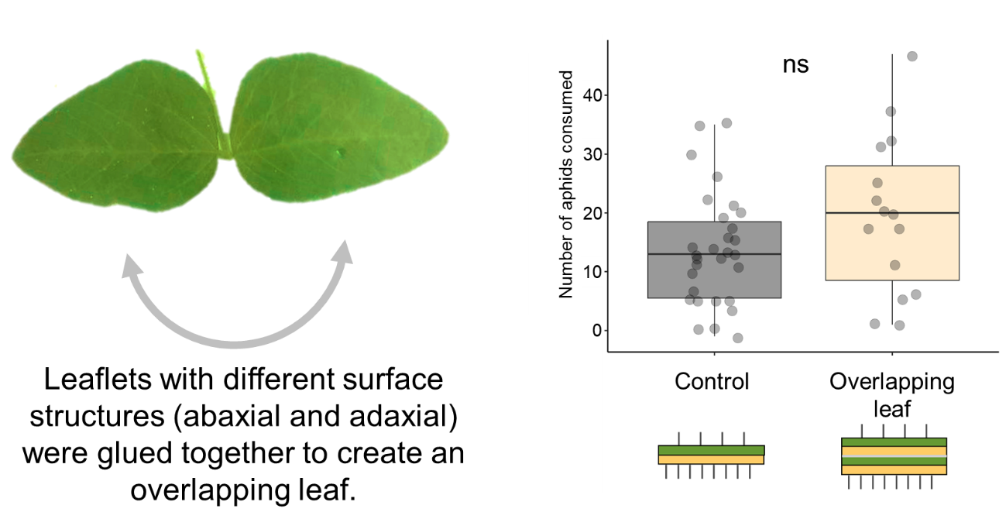 Figure S1. Predation rates of aphids by ladybeetles on the control leaf surface from the normal leaflet and overlapping leaflet groups. Note that the predation rates did not significantly differ between the two groups (P = 0.098). To avoid potential petiole damage in the overlapping leaflet group, this study used the normal leaflet group to represent the control leaf surface group (please see Materials and Methods for details).

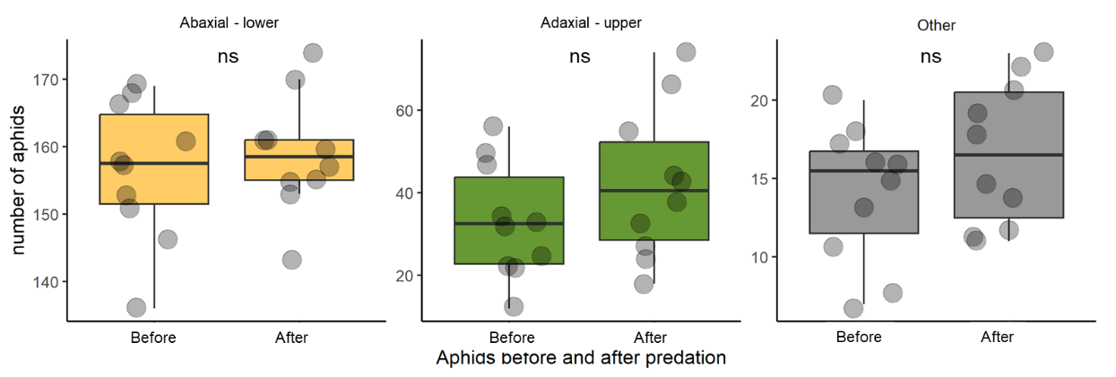
Figure S2. Aphid distribution in the control leaf surface group in the absence of ladybeetles. Distribution was assessed on the lower side of leaves, upper side of leaves, and other plant parts over a 24-hour study period (i.e., before vs. after). The corresponding P values were 0.996, 0.488 and 0.995, respectively, for the three plant parts.

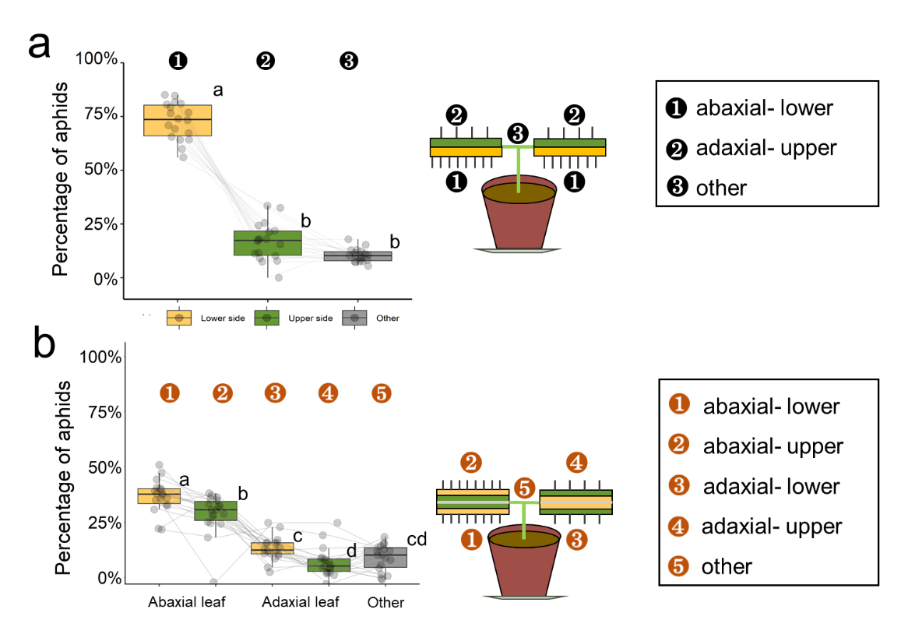
Figure S3. Alternative version of Fig. 3 in the main text. Linking points indicate data from the same plant individual.

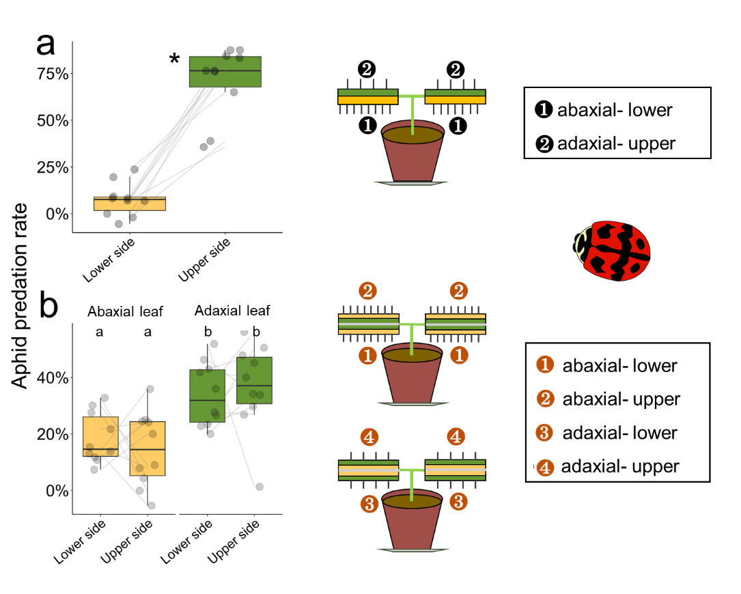
Figure S4. Alternative version of Fig. 4 in the main text. Linking points indicate data from the same plant individual.

