Supplementary Figures
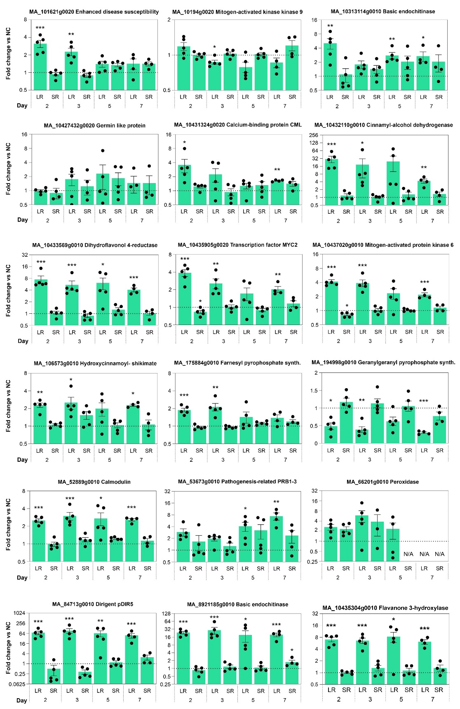
Supplementary Figure 1: RT-qPCR analysis of defense-related gene expression in Picea abies after Ips typographus exposure. Samples represent negative controls (NC), local response (LR), and systemic response (SR) collected at 2, 3, 5, and 7 days after exposure. Statistical significance was determined using an unpaired t-test with Welch’s correction; all comparisons were made against the corresponding NC group at each time point. Significance levels are indicated as follows: p < 0.05 (*), p < 0.01 (**), and p < 0.001 (***).
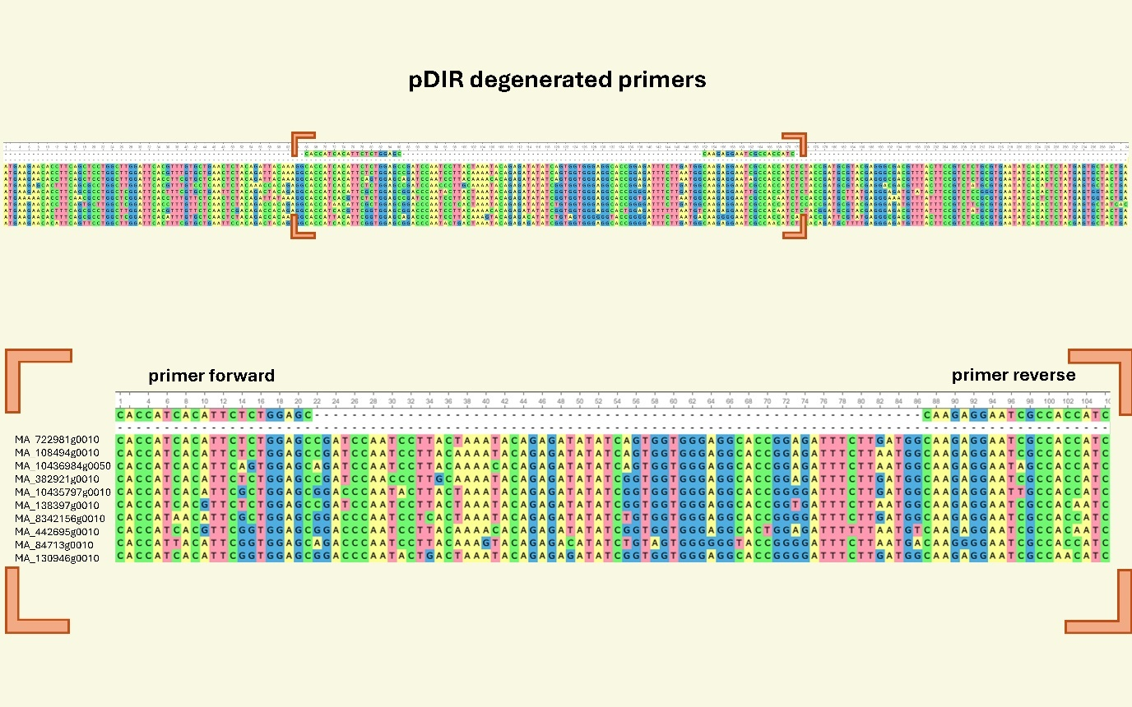
Supplementary Figure 2: Alignment of selected P. abies pDIR target gene sequences used for the design of degenerate pDIR primers. The degenerate forward and reverse primer sequences shown above the alignment correspond to conserved binding regions shared across the aligned target genes. Brackets indicate the primer-binding regions for visual guidance.
Supplementary Figure 3: Map of the experimental clonal trial site showing the positions of attack group trees, negative control group trees, and unused clonal trees. The numeric label indicates the geographic coordinates of the marked position.

Supplementary Figure 4: 3D render of the capsular pit used to place bark beetles on trees during infestation experiments.
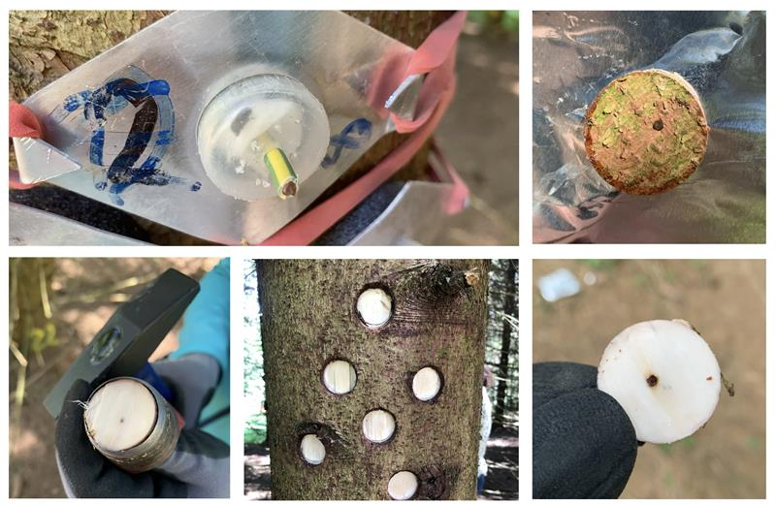
Supplementary Figure 5: Field setup and sample collection.
Bark beetles were confined to the stem using sealed capsular pits. Bark samples were collected from affected tissue for downstream molecular analyses.

