Supplementary Information

Climatic factors controlling stem growth of alien tree species at a mesic forest site: A multi-species approach

European Journal of Forest Research

Nils Hoffmann¹, Steffi Heinrichs¹, Peter Schall¹ and Torsten Vor¹
¹ Department of Silviculture and Forest Ecology of the Temperate Zones, Faculty of Forest Sciences and Forest Ecology, University of Göttingen, Büsgenweg 1, D-37077 Göttingen, Germany
Corresponding author. E-mail address: nhoffma@posteo.de (N. Hoffmann).

SI Introduction
Appendix 1: Selected references for species characterization
Selected references for characterization of species-specific properties and traits potentially related to climate sensitivity in Table 1

Acer rubrum
Abrams MD (1998) The Red Maple Paradox. BioScience, 48, 355–364.
Haag CL, Johnson JE, Erdmann GG (1989) Rooting Depths of Red Maple (Acer rubrum L.) on various sites in the Lake States. Research Note NC-347. St. Paul, MN: U.S. Dept. of Agriculture, Forest Service, North Central Forest Experiment Station.
Robin-Abbott MJ, Pardo LH (2017) How climatic conditions, site, and soil characteristics affect tree growth and critical loads of nitrogen for northeastern tree species. U.S. Department of Agriculture, Forest Service, Northern Research Station, Newtown Square, PA.
Smith KT, Dudzik KR (2011) Acer rubrum. In: Roloff A, Schütt P, Lang UM, Stimm B (eds) Enzyklopädie der Holzgewächse. Handbuch und Atlas der Dendrologie, Wiley-VCH, Weinheim, pp 1–9.
Thomsen J, Bohrer G, Matheny A, Ivanov V, He L, Renninger H, Schäfer K (2013) Contrasting Hydraulic Strategies during Dry Soil Conditions in Quercus rubra and Acer rubrum in a Sandy Site in Michigan. Forests, 4, 1106–1120.
Walters RS, Yawney HW (1990) Acer rubrum L., Red Maple. In: Burns RM, Honkala BH (eds) Silvics of North America. Volume 2, Hardwoods. Agriculture Handbook 654, U.S. Dept. of Agriculture, Forest Service, Washington, D.C., pp 60–69.

Betula maximowicziana
Ishii H, Azuma W, Nabeshima E (2013) The need for a canopy perspective to understand the importance of phenotypic plasticity for promoting species coexistence and light-use complementarity in forest ecosystems. Ecological Research, 28, 191–198.
Koike T, Kitao M, Quoreshi AM, Matsuura Y (2003) Growth characteristics of root-shoot relations of three birch seedlings raised under different water regimes. Plant and Soil, 255, 303–310.
LÖLF NRW (1986a) Betula maximowicziana Regel - Lindenblättrige Birke (1983). In: Landesanstalt für Ökologie, Landschaftsentwicklung und Forstplanung Nordrhein-Westfalen (ed) Merkblätter über fremdländische Baumarten, Recklinghausen.
Noack H (1993) Das Portrait: Betula maximowicziana Regel, Maximowiczs Birke, Lindenblättrige Birke. Mitteilungen der deutschen dendrologischen Gesellschaft, 81, 135–137.
Stephan BR, Liesebach M (2011) Betula maximowicziana. In: Roloff A, Schütt P, Lang UM, Stimm B (eds) Enzyklopädie der Holzgewächse. Handbuch und Atlas der Dendrologie, Wiley-VCH, Weinheim, pp 1–12.

Castanea sativa
Bottacci A (2011) Castanea sativa Miller. In: Roloff A, Schütt P, Lang UM, Stimm B (eds) Enzyklopädie der Holzgewächse. Handbuch und Atlas der Dendrologie, Wiley-VCH, Weinheim.
Buras A, Menzel A (2019) Projecting Tree Species Composition Changes of European Forests for 2061–2090 Under RCP 4.5 and RCP 8.5 Scenarios. Front. Plant Sci. 9,1986.
Conedera M, Tinner W, Krebs P, Rigo D de, Caudullo G (2016) Castanea sativa in Europe. distribution, habitat, usage and threats. In: San-Miguel-Ayanz J, Rigo Dd, Caudullo G, Durrant TH, Mauri A (eds) European atlas of forest tree species, Publication Office of the European Union, Luxembourg, pp 78–79.
Gomes-Laranjo J, Dinis L-T, Martins L et al. (2012) Characterization of Chestnut Behavior with Photosynthetic Traits. In: Najafpour M (ed) Applied Photosynthesis, pp 47–80. InTech.
Thurm EA, Hernandez L, Baltensweiler A et al. (2018) Alternative tree species under climate warming in managed European forests. Forest Ecology and Management, 430, 485–497.
Thurm EA, Heitz R (2018) Anbaueignung der Edelkastanie in Deutschland. LWF Wissen, 81, 31–39.

Cryptomeria japonica
Konôpka B, Noguchi K, Sakata T, Takahashi M, Konôpková Z (2006) Fine root dynamics in a Japanese cedar (Cryptomeria japonica) plantation throughout the growing season. Forest Ecology and Management, 225, 278–286.
Kumagai T’o, Aoki S, Otsuki K, Utsumi Y (2009) Impact of stem water storage on diurnal estimates of whole-tree transpiration and canopy conductance from sap flow measurements in Japanese cedar and Japanese cypress trees. Hydrological Processes, 23, 2335–2344.
LÖLF NRW (1986b) Cryptomeria japonica D. Don. - Sicherltanne (1986). In: Landesanstalt für Ökologie, Landschaftsentwicklung und Forstplanung Nordrhein-Westfalen (ed) Merkblätter über fremdländische Baumarten, Recklinghausen.
Matsumoto Y, Shigenaga H, Miura S, Nagakura J., Taoda H (2006) Mapping of Japanese Cedar (Cryptomeria japonica) Forests Vulnerable to Global Warming in Japan. Global Environmental Research, 10, 181–188.
Nagakura J, Shigenaga H, Akama A, Takahashi M (2004) Growth and transpiration of Japanese cedar (Cryptomeria japonica) and Hinoki cypress (Chamaecyparis obtusa) seedlings in response to soil water content. Tree Physiology, 24, 1203–1208.
Schober R, Spellmann H (2001) Von Anbauversuchen mit Tannen und anderen Koniferen aus Japan, Nordamerika und Europa. Sauerländer, Frankfurt am Main.
Shen Z (2011a) Cryptomeria fortunei. In: Roloff A, Schütt P, Lang UM, Stimm B (eds) Enzyklopädie der Holzgewächse. Handbuch und Atlas der Dendrologie, Wiley-VCH, Weinheim, pp 1–6.

Fagus sylvatica
Felbermeier B, Mosandl R (2011) Fagus sylvatica. In: Roloff A, Schütt P, Lang UM, Stimm B (eds) Enzyklopädie der Holzgewächse. Handbuch und Atlas der Dendrologie, Wiley-VCH, Weinheim, pp 1–20.
Hartl-Meier C, Zang C, Buntgen U, Esper J, Rothe A, Gottlein A, Dirnbock T, Treydte K (2015) Uniform climate sensitivity in tree-ring stable isotopes across species and sites in a mid-latitude temperate forest. Tree Physiology, 35, 4–15.
Kölling C, Walentowski H, Borchert H (2005) Die Buche in Mitteleuropa. AFZ-DerWald, 60, 696–701.
Michiels H-G, Aydin C-T, Bolte A, Hein S, Hussendörfer E, Mühlethaler U, Reif A, Schmidt W (2009) Ökologischer Steckbrief und waldbauliche Bewertung der Buche. Forst und Holz, 64, 18–21.
Pretzsch H, Schütze G, Biber P (2018) Drought can favour the growth of small in relation to tall trees in mature stands of Norway spruce and European beech. Forest Ecosystems, 5, 20 pp.
Zang C, Hartl-Meier C, Dittmar C, Rothe A, Menzel A (2014) Patterns of drought tolerance in major European temperate forest trees: climatic drivers and levels of variability. Global Change Biology, 20, 3767–3779.

Metasequoia glyptostroboides
Brodribb TJ, McAdam SA, Jordan GJ, Martins SC (2014) Conifer species adapt to low-rainfall climates by following one of two divergent pathways. Proceedings of the National Academy of Sciences of the United States of America, 111, 14489–14493.
Burrichter E, Schoenwald W (1968) Forstliche Anbauversuche mit der Metasequoia glyptostroboides im Raum Westfalen. VS Verlag für Sozialwissenschaften, Wiesbaden.
Chen L, Zhang Z, Ewers BE (2012) Urban tree species show the same hydraulic response to vapor pressure deficit across varying tree size and environmental conditions. PloS one, 7, e47882.
Leng Q, Fan S-h, Wang L et al. (2007) Database of Native Metasequoia glyptostroboides Trees in China Based on New Census Surveys and Expeditions. Bulletin of the Peabody Museum of Natural History, 48, 185–233.
LÖLF NRW (1986c) Metasequoia glyptostroboides Hu & Cheng (1982). In: Landesanstalt für Ökologie, Landschaftsentwicklung und Forstplanung Nordrhein-Westfalen (ed) Merkblätter über fremdländische Baumarten, Recklinghausen.
Shen Z (2011) Metasequoia glyptostroboides. In: Roloff A, Schütt P, Lang UM, Stimm B (eds) Enzyklopädie der Holzgewächse. Handbuch und Atlas der Dendrologie, Wiley-VCH, Weinheim, pp 1–10.
Vann DR (2005) Physiological Ecology of Metasequoia glyptostroboides Hu et Cheng. In: LePage BA, Williams CJ, Yang H (eds) The geobiology and ecology of Metasequoia, Springer, Dordrecht, pp 305–330.
Williams CJ (2005) Ecological Characteristics of Metasequoia glyptostroboides. In: LePage BA, Williams CJ, Yang H (eds) The geobiology and ecology of Metasequoia, Springer, Dordrecht, pp 285–302.

Picea abies
Brodribb TJ, McAdam SA, Jordan GJ, Martins SC (2014) Conifer species adapt to low-rainfall climates by following one of two divergent pathways. Proceedings of the National Academy of Sciences of the United States of America, 111, 14489–14493.
Caudullo G, Tinner W, de Rigo D (2016) Picea abies in Europe. Distribution, habitat, usage and threats. In: San-Miguel-Ayanz J, Rigo Dd, Caudullo G, Durrant TH, Mauri A (eds) European atlas of forest tree species, Publication Office of the European Union, Luxembourg, pp 114–116
Pâques, LE (2013) Forest tree breeding in Europe. Current state-of-the-art and perspectives. Springer, Dordrecht, New York.
Schmidt PA (2011) Picea abies. In: Roloff A, Schütt P, Lang UM, Stimm B (eds) Enzyklopädie der Holzgewächse. Handbuch und Atlas der Dendrologie, Wiley-VCH, Weinheim, pp 1–18.
Thurm EA, Hernandez L, Baltensweiler A et al. (2018) Alternative tree species under climate warming in managed European forests. Forest Ecology and Management, 430, 485–497.

Thuja plicata
Antos JA, Filipescu CN, Negrave RW (2016) Ecology of western redcedar (Thuja plicata). Implications for management of a high-value multiple-use resource. Forest Ecology and Management, 375, 211–222.
Grossnickle SC, Russell JH (2010) Ecophysiological processes of western redcedar (Thuja plicata) and yellow-cedar (Callitropsis nootkatensis). In: Harrington CA (ed) A Tale of Two Cedars: International Symposium on Western Redcedar and Yellow-Cedar. Gen. Tech. Rep. PNW-GTR-828, pp 33–36.
McCulloh KA, Johnson DM, Meinzer FC, Woodruff DR (2014) The dynamic pipeline: hydraulic capacitance and xylem hydraulic safety in four tall conifer species. Plant, cell & environment, 37, 1171–1183.
Minore D (1990) Thuja plicata Donn ex D. Don, Western Redcedar. In: Burns RM, Honkala BH (eds) Silvics of North America. Volume 1, Conifers. Agriculture Handbook 654, U.S. Dept. of Agriculture, Forest Service, Washington, D.C., pp 590–600.
Praciak A, Pasiecznik N, Sheil D et al. (2013) The CABI encyclopedia of forest trees. CABI, Wallingford.
Warren CR, Livingston NJ, Turpin DH (2003) Responses of gas exchange to reversible changes in whole-plant transpiration rate in two conifer species. Tree Physiology, 23, 793–803.
Wicker EF (2011) Thuja plicata. In: Roloff A, Schütt P, Lang UM, Stimm B (eds) Enzyklopädie der Holzgewächse. Handbuch und Atlas der Dendrologie, Wiley-VCH, Weinheim, pp 1–8.

Tsuga heterophylla
Bennett JN, Andrew B, Prescott CE (2002) Vertical fine root distributions of western redcedar, western hemlock, and salal in old-growth cedar–hemlock forests on northern Vancouver Island. Canadian Journal of Forest Research, 32, 1208–1216.
Gavin DG, Hu FS (2006) Spatial variation of climatic and non-climatic controls on species distribution. The range limit of Tsuga heterophylla. Journal of Biogeography, 33, 1384–1396.
Hennon PE (2011) Tsuga heterophylla. In: Roloff A, Schütt P, Lang UM, Stimm B (eds) Enzyklopädie der Holzgewächse. Handbuch und Atlas der Dendrologie, Wiley-VCH, Weinheim pp 1–8.
McCulloh KA, Johnson DM, Meinzer FC, Woodruff DR (2014) The dynamic pipeline: hydraulic capacitance and xylem hydraulic safety in four tall conifer species. Plant, cell & environment, 37, 1171–1183.
Packee EC (1990) Tsuga heterophylla (Raf.) Sarg., Western Hemlock. In: Burns RM, Honkala BH (eds) Silvics of North America. Volume 1, Conifers. Agriculture Handbook 654, U.S. Dept. of Agriculture, Forest Service, Washington, D.C., pp 613–622.
Praciak A, Pasiecznik N, Sheil D et al. (2013) The CABI encyclopedia of forest trees. CABI, Wallingford.
Schenck CA (1939b) Fremdländische Wald- und Parkbäume. Bd. 2: Die Nadelhölzer. Ein Buch für alle Forstwirte und Dendrologen. Parey, Berlin.

SI Material
Study site conditions
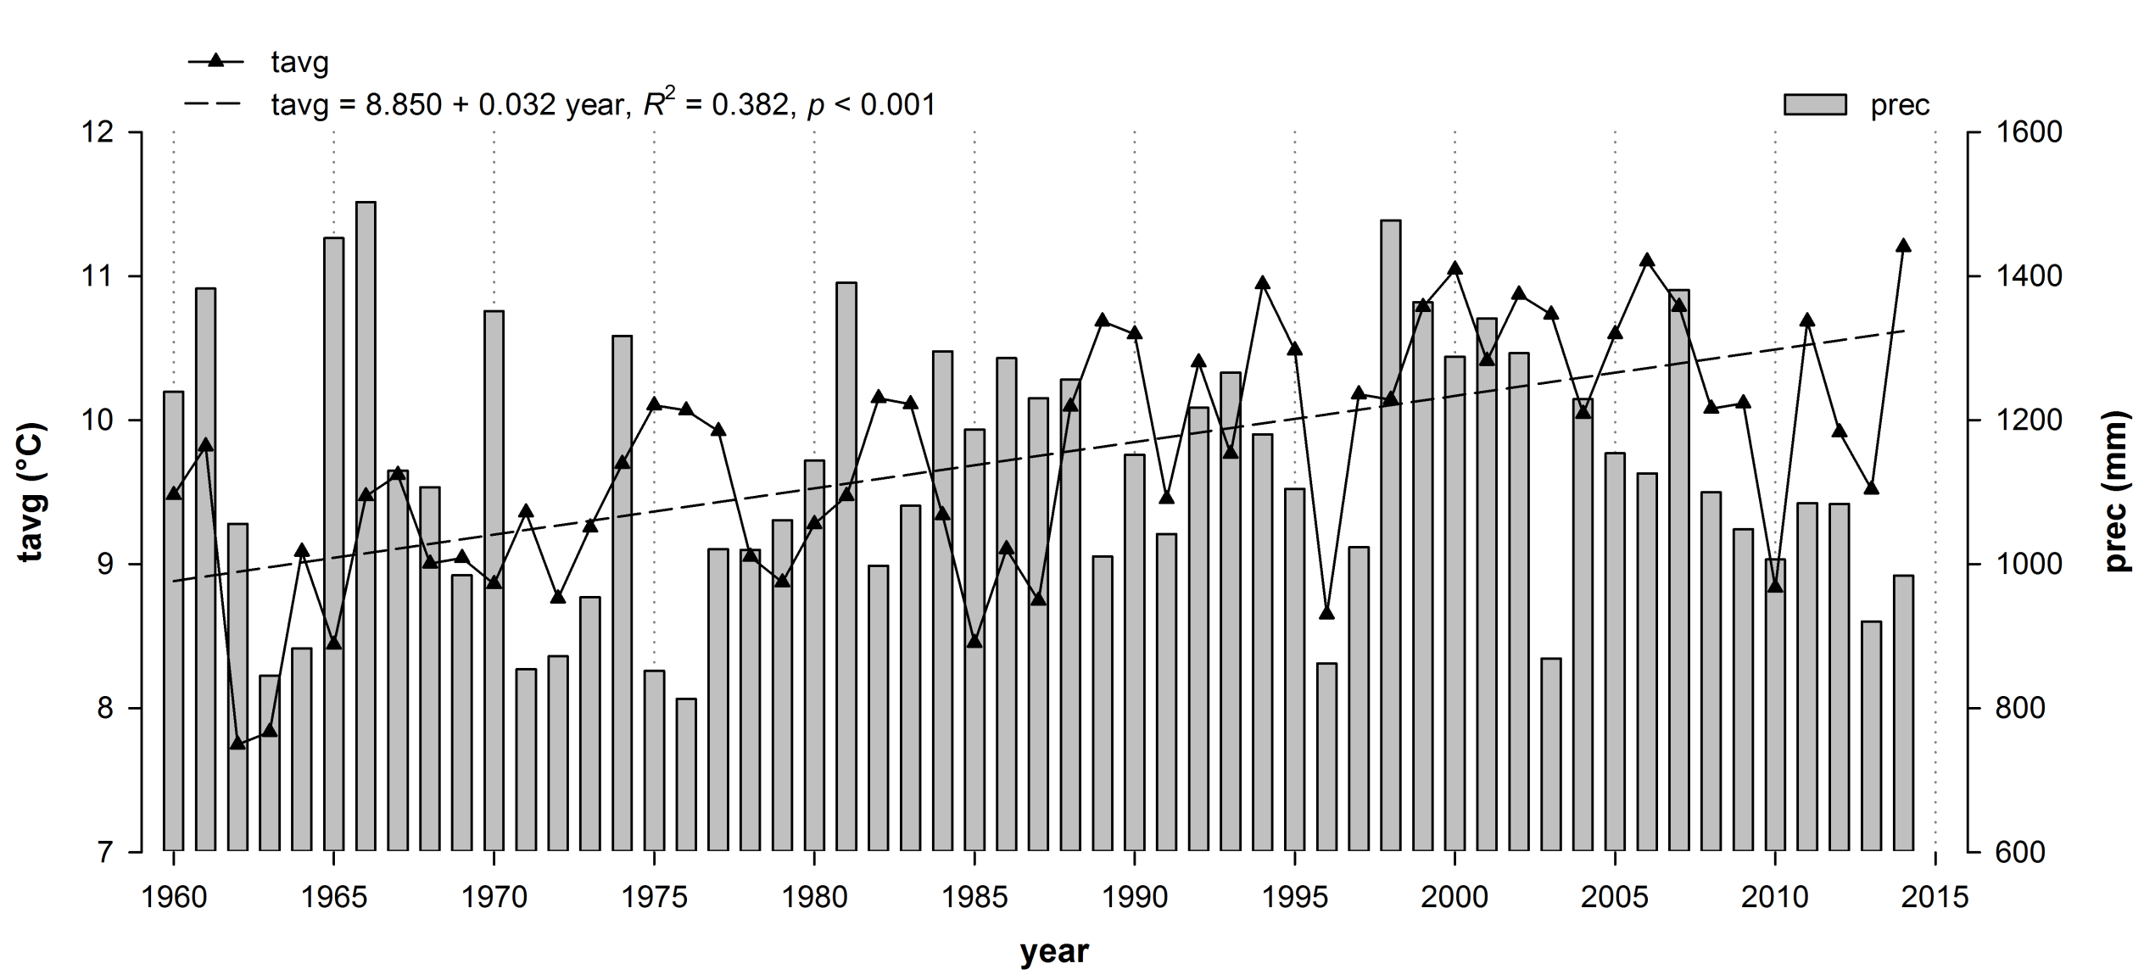Fig. S1: Annual mean temperature (tavg, triangles, solid line), linear 55-year temperature trend (dashed line) and annual precipitation sums (prec, bars) for the considered growth period of study trees (Source: National Meteorological Service of Germany, DWD)

Table S1: Stand conditions and basic information of study trees.
Attribute | Acer  rubrum  unit 432 H | Betula  maximowicziana  unit 435 G | Castanea  sativa  unit 403 K1 | Cryptomeria  japonica  unit 435 E | Fagus  sylvatica  unit 411 A1 | Metasequoia  glyptostroboides  unit 434 I | Picea  abies  unit 407 G | Thuja  plicta  unit 417 C | Tsuga  heterophylla  unit 424 A3
latitude, longitude | 51° 13.010'N,  7° 5.798'E | 51° 13.175'N,  7° 5.919'E | 51° 12.296'N,  7° 7.015'E | 51° 13.076'N,  7° 6.056'E | 51° 13.222'N,  7° 7.242'E | 51° 13.084'N,  7° 6.346'E | 51° 12.580'N,  7° 6.886'E | 51° 13.412'N,  7° 7.409'E | 51° 13.875'N,  7° 6.925'E
altitude (m) | 210 | 220 | 225 | 230 | 275 | 130 | 230 | 250 | 265
plot size (ha) | 0.45 | 0.55 | 0.90 | 2.51 | 5.65 | 1.40 | 0.60 | 1.25 | 0.60
exposition | NW – N | NO – SE | NW | NE – SE | W – E | NE – SE | N | W – NW | W – N
slope gradient | moderate to strong | weak | moderate | weak | weak | moderate to strong | weak | moderate | weak
age | 38 | 39 | 38 | 35–39 | 51-56 | 34–37 | 45 | 55 | 58
mixture (portion) | mixed (67 %) | pure (100 %) | pure (100 %) | mixed (66 %) | mixed (88 %) | pure (100 %) | pure (100 %) | mixed (85 %) | mixed (81 %)
admixed tree  species | B. lutea | - | - | P. abies  L. kaempferi  C. obtusa  B. japonica | A. pseudo.  T. plicata | - | - | M. glyptostro.  P. omorica  C. lawsoniana | T. plicata  L. decidua
number of stems  (n ha⁻¹) | 1167 | 636 | 487 | 495 | 821 | 613 | 591 | 630 | 409
basal area (m² ha⁻¹) | 26.7 | 22.6 | 30.3 | 42.1 | 28.9 | 47.3 | 40.6 | 75.0 | 39.2
sampling date | Nov. 2013 | Jul. 2013 | Jul. 2014 | Jul. 2013 | Mar. 2015 | Nov. 2013 | Mar. 2015 | Jul. 2014 | Jul. 2014
unit = forest management unit, B. lutea = Betula lutea, P. abies = Picea abies, L. kaempferi = Larix kaempferi, C. obtusa, Chamaecyparis obtusa, B. japonica, Betula japonica, A. pseudo. = Acer pseudoplatanus, T. plicata = Thuja plicata, M. glyptostro. = Metasequoia glyptostroboides, P. omorica = Picea omorica, C. lawsoniana = Chamaecyparis lawsoniana, L. decidua = Larix decidua

SI Methods
Appendix 2: Climate variables
The potential evapotranspiration (pet), a measure of the environmental demand for the transfer of water to the atmosphere (Kuttler 2009), was calculated using the Thornthwaite method (Thornthwaite 1948) as a function of mean monthly temperature and latitude. Based on the formula of Magnus (Eq. S1), we computed the vapor pressure deficit (vpd) as the difference between saturation and actual vapor pressure (Junzeng et al. 2012). This measure provides information on stomatal conductance and transpiration processes in plants (Junzeng et al. 2012). The degree day sum provides information on common thresholds for the activity of plant metabolism (Thomas 2018) and was calculated as the sum of the diﬀerences between daily mean temperatures > 5 °C and 5 °C (sum_{∆t05}) as well as > 10 °C and 10 °C (sum_{∆t10}), respectively. The number of frost days included all days during a month with minimum temperatures < 0 °C (nfr; DWD 2015). De Martonne aridity index (dmi; de Martonne 1926), a degree of regional drought, was calculated by the monthly values of prec and tavg (Eq. S2; Baltas 2007). A further drought index, the standardized precipitation evapotranspiration index (spei, Vicente-Serrano et al. 2010) identifies deficits (or surpluses) in precipitation taking into account the effect of temperature on drought development through a water balance calculation based on the difference of monthly prec and monthly pet sums (see Hoffmann et al. 2018 for details).

Eq. S1: $e_{s}=0.611 ×{10}^{\frac{7.45tavg}{\left(237.3+tavg\right)}}$, with es = saturation vapor pressure
Eq. S2: $dmi= \frac{prec}{\left(tavg +10\right)}$ , with dmi = de Martonne Index, prec = precipitation sum, tavg = average temperature

References (Climate variables)
Baltas E (2007) Spatial distribution of climatic indices in northern Greece. Meteorological Applications, 14, 69–78.
DWD (2015) Deutscher Wetterdienst. Wetter und Klima aus einer Hand. Available via http://www.dwd.de/; ftp://ftp-cdc.dwd.de/pub/CDC/observations_germany/climate/. Accessed 10 Jun 2015.
Hoffmann N, Schall P, Ammer C, Leder B, Vor T (2018) Drought sensitivity and stem growth variation of nine alien and native tree species on a productive forest site in Germany. Agri-cultural and Forest Meteorology, 256-257, 431–444.
Junzeng XU, Qi WEI, Shizhang P, Yanmei YU (2012) Error of Saturation Vapor Pressure Calculated by Different Formulas and Its Effect on Calculation of Reference Evapotranspiration in High Latitude Cold Region. Procedia Engineering, 28, 43–48.
Kuttler W (2009) Klimatologie. Schöningh, Paderborn, München, Wien, Zürich.
Thomas F (2018) Grundzüge der Pflanzenökologie. Springer Berlin Heidelberg, Berlin, Heidelberg.
Thornthwaite CW (1948) An Approach toward a Rational Classification of Climate. Geographical Review, 38, 55.
Vicente-Serrano SM, Beguería S, López-Moreno JI (2010) A Multiscalar Drought Index Sen-sitive to Global Warming. The Standardized Precipitation Evapotranspiration Index. Journal of Climate, 23, 1696–1718.

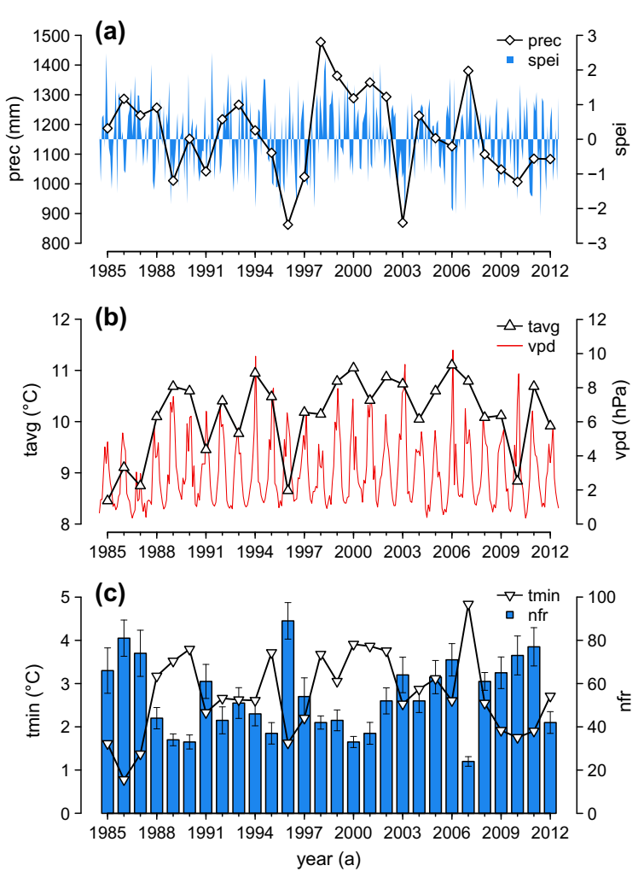
Fig. S2: Climatic characteristics in terms of water availability (a), temperature (b), and frost occurrence (c) of the study site for the period 1985–2012. (a) Annual precipitation sums and monthly standardized precipitation evapotranspiration index (spei, spei from 2.0 to -2.0 indicate extreme wetness to extreme drought), (b) annual mean temperature (tavg) and monthly vapor pressure deficit (vpd), and (c) mean minimum temperature (tmin) and number of frost days with monthly standard deviation in the cold months period (from October of the previ-ous year to April of the current year). Note that tmin and nfr of 1985 include the months October–December of the previous year 1984.

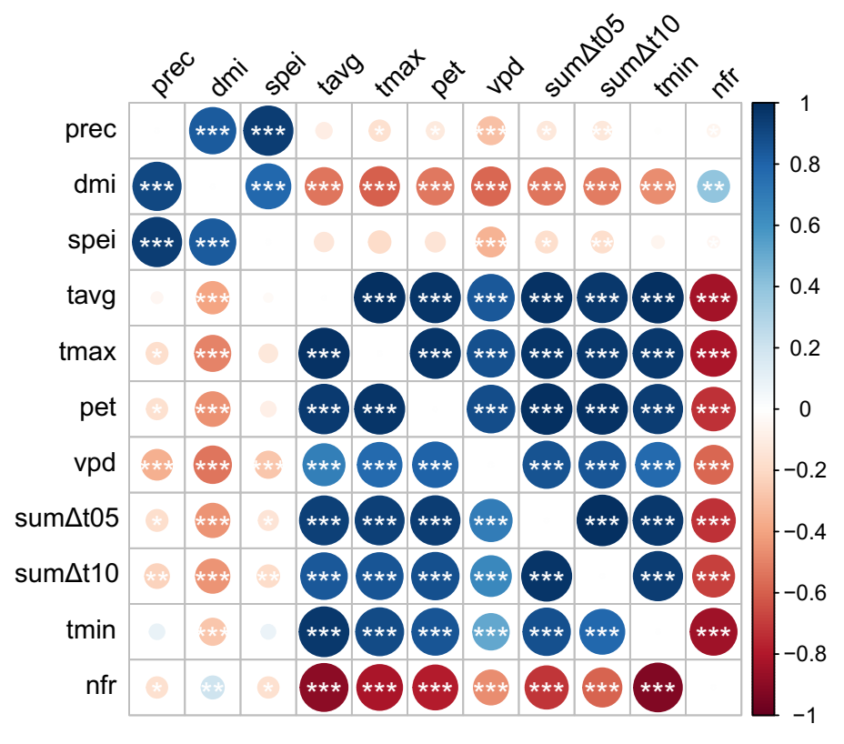
Fig. S3: Correlations between the 11 monthly climate parameters for the whole year (upper right) and for the cold month period (from October of the previous year to April of the current year; lower left) over the period 1985–2012. Asterisks indicate significant correlation coefficients (p < 0.001***, p < 0.01**, p < 0.05*). See Table 2 for abbreviations of climate variables.
Table S2: Correlations between monthly (ts = 1) or seasonal (ts = 3 and 6) spei, vpd and nfr over the period 1985–2012. Significant correlation coefficients are highlighted in bold (p < 0.001). ts = timescale (month).
ts |  | spei | vpd | nfr
 | spei |  | -0.34 | -0.05
1 | vpd | -0.28¹ |  | -0.58
 | nfr | -0.17¹ | -0.47¹
 | spei |  | -0.36 | 0.02
3 | vpd | -0.21¹ |  | -0.61
 | nfr | -0.24¹ | -0.38¹
 | spei |  | -0.48 | -0.01
6 | vpd | -0.30¹ |  | -0.43
 | nfr | -0.29¹ | -0.38¹
¹Correlation between spei, vpd and nfr in the cold months from October of the previous year to April of the current growth year

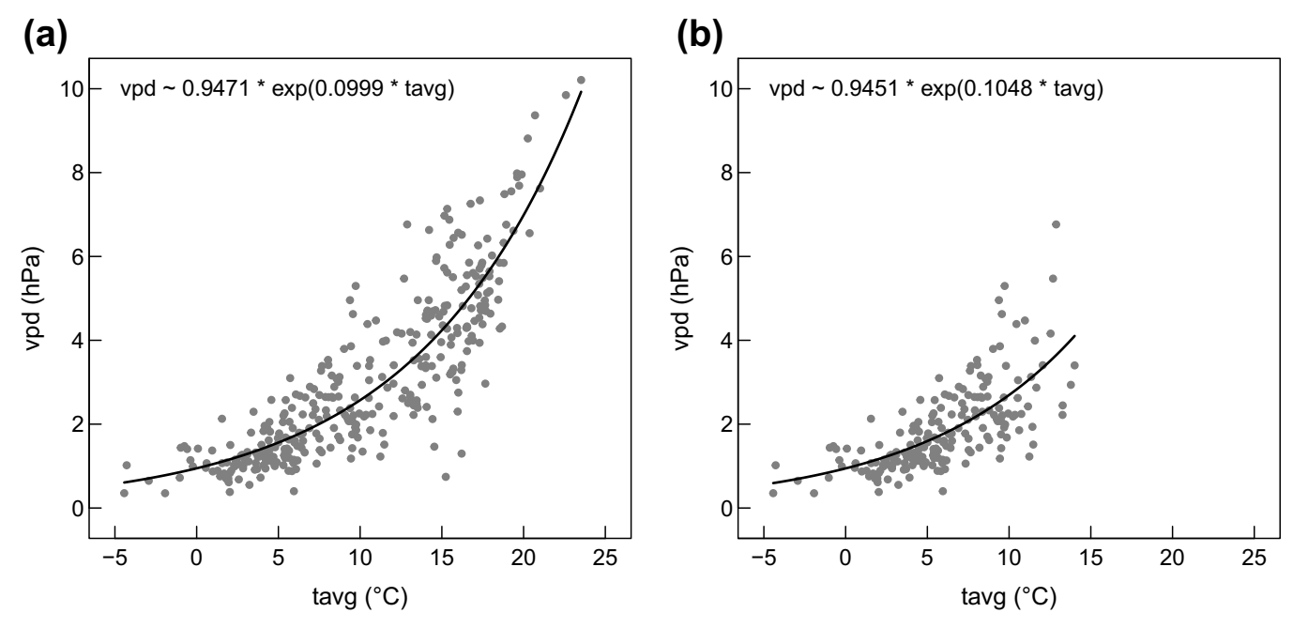
Fig. S4: Exponential relationships (1985–2012) between monthly vapor pressure deficit (vpd) and monthly mean temperature (tavg) (a) for the whole year as well as (b) in the cold month period (from October of the previous year to April of the current year).

SI Results
Growth chronologies
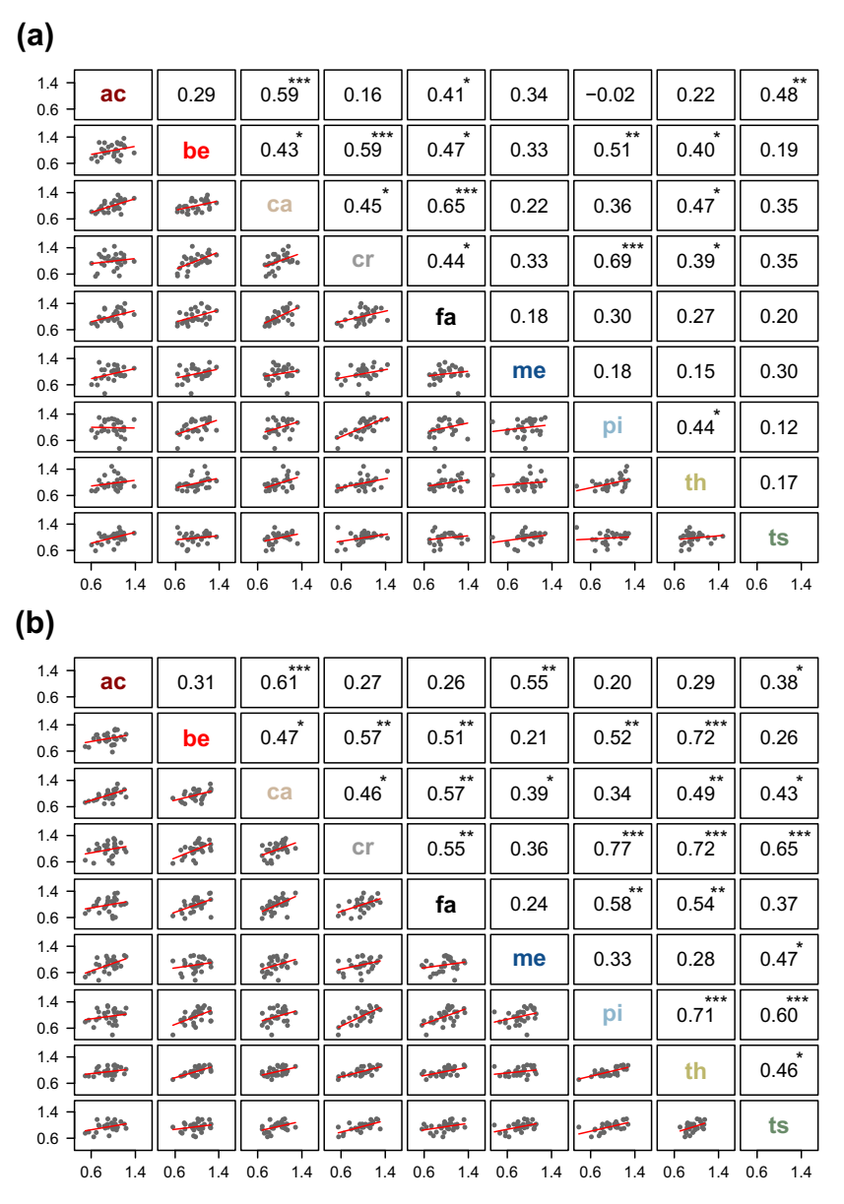
Fig. S5: Correlations between the detrended a) BAI or b) VI chronologies across individual tree species with linear relationships (lower left) and correlation coefficients (upper right), respectively. Asterisks indicate significant correlation coefficients (p < 0.001***, p < 0.01**, p < 0.05*). ac = Acer rubrum, be = Betula maximowicziana, ca = Castanea sativa, cr = Cryptomeria japonica, fa = Fagus sylvatica, me = Metasequoia glyptostroboides, pi = Picea abies, th = Thuja plicata, ts = Tsuga heterophylla

Climate-growth relationships
Table S3: Highest positive (pos) and lowest negative (neg) bootstrapped correlation coefficients (bcc) between the species’ basal area increment (BAI) or volume increment (VI) and the best explaining climate variable (variable) within the climatic categories water availability, temperature and frost at the month and timescale (ts) of the year at which the highest correlation was reached. Lower case abbreviations (apr–dec) denote months of the previous year (April–December), upper case abbreviations (JAN–SEP) indicate months of the current year (January–September). Significant bcc are highlighted in bold (p < 0.05).
species | category | incr | highest positive correlation |  |  | highest negative correlation
 |  |  | variable & ts | bcc |  | variable & ts | bcc
Acer | water availability | BAI | spei.JUL-SEP | 0.55 |  | spei.MAY | -0.56
 |  | VI | spei.JUN-SEP | 0.59 |  | spei.MAY | -0.41
 | temperature | BAI | vpd.MAY | 0.55 |  | sum∆t10.JUL | -0.58
 |  | VI | pet.JAN-MAY | 0.59 |  | pet.JUL | -0.61
 | frost | BAI | tmin.JAN-FEB | 0.45 |  | nfr.JAN-APR | -0.49
 |  | VI | tmin.JAN-FEB | 0.52 |  | nfr.JAN-FEB | -0.54
Betula | water availability | BAI | prec.FEB-JUL | 0.36 |  | dmi.nov-dec | -0.54
 |  | VI | prec.may-oct | 0.36 |  | dmi.AUG | -0.50
 | temperature | BAI | vpd.dec-JAN | 0.50 |  | vpd.JUN | -0.31
 |  | VI | vpd.dec-JAN | 0.47 |  | tmax.jul | -0.33
 | frost | BAI | tmin.oct-MAR | 0.35 |  | nfr.nov-APR | -0.41
 |  | VI | tmin.oct-MAR | 0.27 |  | nfr.oct-JAN | -0.35
Castanea | water availability | BAI | spei.JUL-SEP | 0.41 |  | dmi.MAY | -0.37
 |  | VI | spei.JUL | 0.39 |  | dmi.MAY | -0.41
 | temperature | BAI | sum∆t10.dec-FEB | 0.54 |  | sum∆t10.nov | -0.39
 |  | VI | sum∆t10.dec-FEB | 0.53 |  | sum∆t10.nov | -0.39
 | frost | BAI | tmin.JAN-FEB | 0.34 |  | nfr.JAN-MAR | -0.29
 |  | VI | tmin.JAN-FEB | 0.38 |  | nfr.JAN-FEB | -0.34
Cryptomeria | water availability | BAI | spei.APR-JUL | 0.46 |  | spei.nov-JAN | -0.36
 |  | VI | spei.FEB-JUL | 0.46 |  | spei.nov-JAN | -0.36
 | temperature | BAI | vpd.JAN | 0.46 |  | vpd.APR-JUL | -0.51
 |  | VI | vpd.JAN | 0.44 |  | vpd.APR-JUL | -0.44
 | frost | BAI | tmin.FEB | 0.13 |  | nfr.oct-FEB | -0.15
 |  | VI | tmin.FEB-APR | 0.19 |  | nfr.APR | -0.18
Fagus | water availability | BAI | spei.JUN-JUL | 0.37 |  | spei.may | -0.46
 |  | VI | prec.aug-sep | 0.34 |  | dmi.nov-MAR | -0.35
 | temperature | BAI | vpd.may | 0.71 |  | tmax.JUN-JUL | -0.38
 |  | VI | vpd.sep-FEB | 0.65 |  | sum∆t10.Nov | -0.34
 | frost | BAI | tmin.MAR-APR | 0.37 |  | nfr.MAR-APR | -0.38
 |  | VI | tmin.MAR-APR | 0.50 |  | nfr.MAR-APR | -0.44
Metasequoia | water availability | BAI | prec.aug-oct | 0.52 |  | prec.jun | -0.30
 |  | VI | prec.aug-sep | 0.58 |  | prec.jun | -0.33
 | temperature | BAI | pet.FEB-MAY | 0.52 |  | sum∆t10.oct-MAR | -0.44
 |  | VI | temp.FEB-MAY | 0.59 |  | sum∆t05.JUL | -0.33
 | frost | BAI | tmin.FEB-APR | 0.50 |  | nfr.FEB-APR | -0.50
 |  | VI | tmin.FEB-APR | 0.56 |  | nfr.JAN-APR | -0.55
Picea | water availability | BAI | spei.APR-JUL | 0.46 |  | dmi.dec | -0.39
 |  | VI | spei.APR-JUL | 0.48 |  | dmi.dec | -0.32
 | temperature | BAI | vpd.oct-JAN | 0.30 |  | vpd.APR-JUL | -0.33
 |  | VI | vpd.sep-JAN | 0.45 |  | vpd.APR-JUL | -0.30
 | frost | BAI | tmin.oct-nov | 0.29 |  | nfr.oct-nov | -0.32
 |  | VI | tmin.oct-nov | 0.30 |  | nfr.oct-nov | -0.28
Thuja | water availability | BAI | spei.aug-sep | 0.44 |  | prec.oct-dec | -0.27
 |  | VI | dmi.jul-sep | 0.38 |  | dmi.dec | -0.37
 | temperature | BAI | vpd.oct | 0.47 |  | sum∆t10.Nov | -0.21
 |  | VI | temp.JAN | 0.53 |  | tmax.Jul | -0.31
 | frost | BAI | tmin.dec | 0.29 |  | nfr.MAR-APR | -0.25
 |  | VI | tmin.MAR | 0.32 |  | nfr.MAR | -0.31
Tusga | water availability | BAI | spei.JUL | 0.67 |  | dmi.jul | -0.49
 |  | VI | spei.JUL | 0.52 |  | prec.jul | -0.31
 | temperature | BAI | vpd.Jul | 0.44 |  | sum∆t05.JUN-JUL | -0.68
 |  | VI | pet.aug | 0.39 |  | temp.JUL | -0.58
 | frost | BAI | tmin.FEB | 0.46 |  | nfr.FEB | -0.45
 |  | VI | tmin.FEB-APR | 0.38 |  | nfr.FEB | -0.40
incr = increment variable, see Table 2 for abbreviations of climate variables

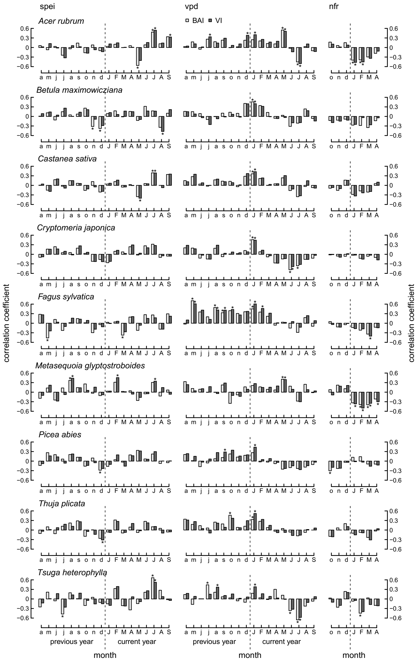
Fig. S6: Correlation coefficients between increment variables (basal area increment, BAI, and volume increment, VI) and monthly standardized precipitation evapotranspiration index (spei), vapor pressure deficit (vpd) and the number of frost days (nfr) for the period 1985–2012. Lower case abbreviations (a–d) denote months of the previous year (April–December), upper case abbreviations (J–S) indicate months of the current year (January–September). Significant correlation coefficients are highlighted by asterisks (p < 0.05).

Table S4: Highest positive (pos) and lowest negative (neg) bootstrapped correlation coefficients (bcc) between the species’ increment variables (basal area increment, BAI, and volume increment, VI) and the standardized precipitation evapotranspiration index (spei), vapor pressure deficit (vpd) and the number of frost days (nfr) at the month and timescale (ts) of the year at which the highest correlation was reached. Lower case abbreviations (apr–dec) denote months of the previous year (April–December), upper case abbreviations (JAN–SEP) indicate months of the current year (January–September). Significant bcc are highlighted in bold (p < 0.05).
species | incr | spei |  |  |  |  |  | vpd |  |  |  |  |  | nfr
 |  | highest positive correlation |  |  | highest negative correlation |  |  | highest positive correlation |  |  | highest negative correlation |  |  | highest positive correlation |  |  | highest negative correlation
 |  | month & ts | bcc |  | month & ts | bcc |  | month & ts | bcc |  | month & ts | bcc |  | month & ts | bcc |  | month & ts | bcc
Acer | BAI | JUL-SEP | 0.55 |  | MAY | -0.56 |  | MAY | 0.55 |  | JUL | -0.45 |  | oct-dec | 0.20 |  | JAN-APR | -0.49
 | VI | JUN-SEP | 0.59 |  | MAY | -0.41 |  | dec-MAY | 0.53 |  | JUL | -0.51 |  | oct | 0.11 |  | JAN-APR | -0.54
Betula | BAI | FEB-JUL | 0.35 |  | nov-dec | -0.49 |  | dec-JAN | 0.50 |  | JUN | -0.31 |  | dec | -0.09 |  | nov-APR | -0.41
 | VI | may-oct | 0.34 |  | AUG | -0.47 |  | dec-JAN | 0.47 |  | jul | -0.25 |  | FEB | -0.04 |  | oct-JAN | -0.35
Castanea | BAI | JUL-SEP | 0.41 |  | MAY | -0.36 |  | dec-JAN | 0.40 |  | JUL | -0.36 |  | dec | 0.16 |  | JAN-MAR | -0.29
 | VI | JUL | 0.39 |  | MAY | -0.40 |  | dec-JAN | 0.48 |  | JUL | -0.33 |  | dec | 0.16 |  | JAN-FEB | -0.34
Cryptomeria | BAI | APR-JUL | 0.46 |  | nov-JAN | -0.36 |  | JAN | 0.46 |  | APR-JUL | -0.51 |  | oct | -0.02 |  | oct-FEB | -0.15
 | VI | FEB-JUL | 0.46 |  | nov-JAN | -0.36 |  | JAN | 0.44 |  | APR-JUL | -0.44 |  | dec | 0.02 |  | APR | -0.18
Fagus | BAI | JUN-JUL | 0.37 |  | May | -0.46 |  | may | 0.71 |  | JUL | -0.29 |  | oct | 0.05 |  | MAR-APR | -0.38
 | VI | apr | 0.27 |  | MAR | -0.27 |  | sep-FEB | 0.65 |  | JUL | -0.13 |  | dec | -0.01 |  | MAR-APR | -0.44
Metasequoia | BAI | aug-oct | 0.52 |  | MAY | -0.26 |  | MAY | 0.41 |  | oct | -0.35 |  | oct-nov | 0.20 |  | FEB-APR | -0.50
 | VI | aug-sep | 0.51 |  | jun | -0.28 |  | APR-MAY | 0.43 |  | JUL | -0.30 |  | nov-dec | 0.21 |  | JAN-APR | -0.55
Picea | BAI | APR-JUL | 0.46 |  | dec-JAN | -0.29 |  | oct-JAN | 0.30 |  | APR-JUL | -0.33 |  | JAN-FEB | 0.15 |  | oct-nov | -0.32
 | VI | APR-JUL | 0.48 |  | oct-dec | -0.26 |  | sep-JAN | 0.45 |  | APR-JUL | -0.30 |  | JAN | -0.02 |  | oct-nov | -0.28
Thuja | BAI | aug-sep | 0.44 |  | dec | -0.26 |  | oct | 0.47 |  | JUL | -0.18 |  | Dec | 0.20 |  | MAR-APR | -0.25
 | VI | FEB-JUL | 0.35 |  | dec | -0.31 |  | JAN | 0.52 |  | JUN-JUL | -0.23 |  | dec | 0.11 |  | MAR | -0.31
Tsuga | BAI | JUL | 0.67 |  | jul | -0.47 |  | jul | 0.44 |  | JUL | -0.66 |  | Dec | 0.24 |  | FEB | -0.45
 | VI | JUL | 0.52 |  | nov-JAN | -0.27 |  | JAN | 0.38 |  | JUL | -0.58 |  | Dec | 0.21 |  | FEB | -0.40

Table S5: Relative importance of the predictor variable (RIV) in the multiple regression models. Lower case abbreviations (apr–dec) denote months of the previous year (April–December), upper case abbreviations (JAN–SEP) indicate months of the current year (January–September). The regression terms are listed in descending order according to its relative importance of the predictor variables (RIV).
species | incr |  | climate variable (descending RIV )
 |  |  | v1 | v2 | v3
Acer | BAI |  | spei.JUL-SEP | vpd.MAY
rubrum |  |  | 0.247 | 0.245
 | VI |  | spei.JUL | nfr.JAN | vpd.nov-JAN
 |  |  | 0.267 | 0.161 | 0.114
Betula | BAI |  | spei.dec | nfr.MAR-APR | spei.AUG
maximowicziana |  |  | 0.201 | 0.149 | 0.125
 | VI |  | spei.AUG | vpd.dec-JAN
 |  |  | 0.193 | 0.192
Castanea | BAI |  | vpd.dec-JAN | spei.JUL
sativa |  |  | 0.151 | 0.147
 | VI |  | vpd.dec-JAN | spei.JUL
 |  |  | 0.221 | 0.142
Cryptomeria | BAI |  | spei.FEB-JUL | vpd.JAN | vpd.apr-may
japonica |  |  | 0.234 | 0.167 | 0.092
 | VI |  | spei.FEB-JUL | vpd.JAN | vpd.apr-may
 |  |  | 0.239 | 0.154 | 0.113
Fagus | BAI |  | vpd.may | vpd.dec | spei.JUL
sylvatica |  |  | 0.450 | 0.120 | 0.073
 | VI |  | vpd.may-jun | vpd.dec-JAN
 |  |  | 0.299 | 0.275
Metasequoia | BAI |  | nfr.FEB-APR | spei.jul-oct | spei.JUL
glyptostroboides |  |  | 0.217 | 0.197 | 0.122
 | VI |  | nfr.FEB-APR | spei.aug-sep | spei.JUL-AUG
 |  |  | 0.257 | 0.221 | 0.111
Picea | BAI |  | spei.may-sep | vpd.oct-JAN
abies |  |  | 0.185 | 0.123
 | VI |  | spei.APR-JUL | vpd.oct-JAN | spei.aug-sep
 |  |  | 0.186 | 0.147 | 0.092
Thuja | BAI |  | spei.aug-sep | vpd.aug-JAN
plicata |  |  | 0.227 | 0.161
 | VI |  | vpd.JAN | vpd.apr-may | spei.MAR-JUL
 |  |  | 0.225 | 0.158 | 0.091
Tsuga | BAI |  | vpd.JUL | spei.JUL-AUG
heterophylla |  |  | 0.278 | 0.251
 | VI |  | vpd.JUL | spei.FEB | vpd.JAN
 |  |  | 0.311 | 0.130 | 0.112
incr = increment variable, BAI = basal area increment at breast height, VI = total stem volume increment, v1, v2, v3 = climate predictor variable, spei = standardized precipitation evapotranspiration index, vpd = vapor pressure deficit, nfr = number of frost days (< 0 °C).

