Supporting information
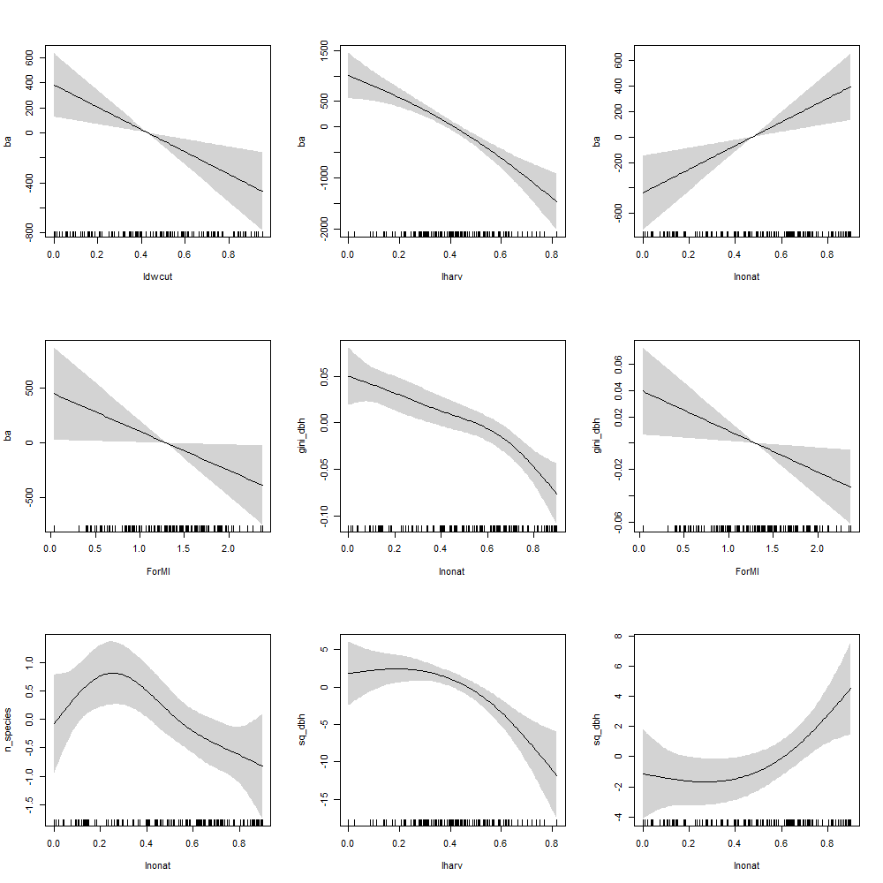
Figure SI 1 - Effect plots of the significant predictors of components of the stand structural attributes based on the results of the generalized additive models (GAMs). The basal area (ba) was significantly predicted by all components of and the forest management intensity index itself. The Gini coefficient of the DBH (gini_dbh) was predicted by the Inonat and the ForMI, while the number of tree species was predicted by the Inonat. The quadratic mean DBH (aq_dbh) was predicted by the Iharv and the Inonat. The greater the index values of the ForMI components, the greater the management intensity. The light-grey band indicates the 95% confidence interval. The rug plot at the bottom displays the observed values of the predictor.

