Supplementary Information
Role of environmental filtering and seed source availability in natural regeneration processes following large-scale disturbances in mountain forests
European Journal of Forest Research
Jerzy Szwagrzyk¹, Anna Gazda¹*, Tomasz Zwijacz-Kozica², Antoni Zięba², Barbara Ciesielska³, Janusz Szewczyk¹, Kacper Foremnik¹, Elżbieta Muter¹, Jan Bodziarczyk¹
¹Department of Forest Biodiversity, University of Agriculture in Krakow, al. 29-Listopada 46, 31-425 Krakow, Poland
²Tatra National Park, Kuźnice 1, 34–500 Zakopane, Poland
³Institute of Mathematics, Faculty of Mathematics and Computer Science, Jagiellonian University, ul. Łojasiewicza 6, 30-348 Krakow, Poland
* Corresponding author: Anna Gazda, Department of Forest Biodiversity, University of Agriculture in Krakow, al. 29-Listopada 46, 31-425 Krakow, Poland; anna.gazda@urk.edu.pl

Table S1 Characteristics of young trees density distributions in sample plots
 | Seedling density (ind./100 m²) | Short sapling density (ind./100 m²) | Tall sapling density (ind./100 m²)
Average value | 87.09 | 10.44 | 9.07
Standard deviation | 293.44 | 17.76 | 19.86
Frequency (% of plots) | 93 | 91 | 89
Median | 16.32 | 5.17 | 4.23
Skewness | 14.13 | 4.02 | 7.42
Coefficient of variation (%) | 337.00 | 170.00 | 219.00
Maximum value | 5968.00 | 153.00 | 295.00

Fig. S2 The species composition of mature trees and seedlings or short saplings in the Tatra N.P.
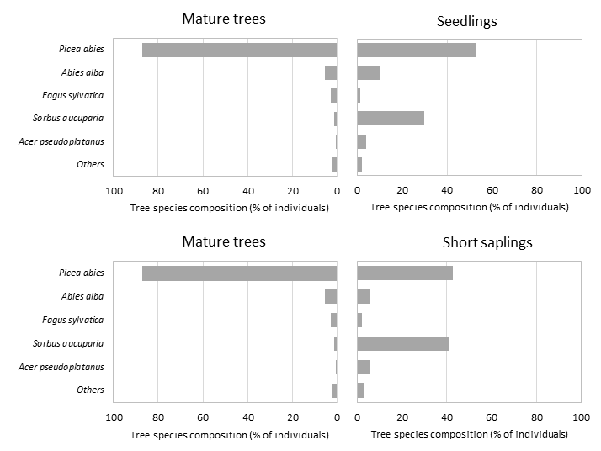
Fig. S3 Relationship between abundance of young trees (ind./sample plot) and elevation

