Appendix A1
Table A1: Specification of the ZANB model: assumptions regarding prior distributions and the distribution of the data
 | Parameters / Data | Distribution
Hyperparameters specifying the ZANB | Size k | PC prior’ such that the square root of 2 times the KL divergence of a mean 1 gamma distribution with shape r from one with shape approaching ∞, with suitable asymptotic scaling, has an exponential distribution with rate parameter 7 (Simpson et al. 2017)
Hyperparameters specifying the spatial random field | Variance rescaling parameter θ_{u1} = log(τ_{u}),  θ_{v1} = log(τ_{v}) | normal distribution N (8.25370, 10)
Hyperparameters specifying the spatial random field | Range θ_{u2} = log(κ_{u})  θ_{v2} = log(κ_{v}) | normal distribution N (-9.51921, 10)
fixed effects | $β_{0},…,β_{m}$ and $γ_{0},…,γ_{n}$ | normal distribution $N(0,1000)$
Random effects | Spatial field u_{i} and v_{i} | Joint normal distribution with mean zero and covariances ∑_{u} respectively ∑_{v}
numbers of seedlings | ${BD}_{i}$ ($i=1,…,n$) | such that $Pr({BD}_{i}=0)=1-π_{i}$ and $Pr({BD}_{i}=x)∝\frac{k+x-1}{x}⋯\frac{k}{1}{\left(\frac{μ_{i}}{k+μ_{i}}\right)}^{x}$ for $x=1,2,…$ (zero-altered negative binomial distribution)

Table A2: Random field hyperparameters for the ZANB model. u characterizes the spatial random field of the zero-truncated part of the model. v characterizes the spatial random field for the Bernoulli part of the model.
Model | spatial random field | Hyperparameter | mean | 0.025 quant | 0.975 quant
B0 | u | θ_{u1} | 4.330 | 4.140 | 4.430
B0 | u | θ_{u2} | -4.965 | -5.150 | -4.781
B0 | v | θ_{v1} | 7.295 | 7.287 | 8.120
B0 | v | θ_{v2} | -7.016 | -7.045 | -6.985
B1 | u | θ_{u1} | 4.218 | 4.012 | 4.455
B1 | u | θ_{u2} | -5.054 | -5.266 | -4.835
B1 | v | θ_{v1} | 7.046 | 6.941 | 7.217
B1 | v | θ_{v2} | -7.003 | -7.184 | -6.766
B2 | u | θ_{u1} | 4.952 | 4.891 | 10.236
B2 | u | θ_{u2} | -5.776 | -5.903 | -5.648
B2 | v | θ_{v1} | 6.512 | 6.422 | 6.622
B2 | v | θ_{v2} | -6.948 | -6.951 | -6.880

Table A3: Presentation of the validation indicators for the different size classes
Model | WAIC | AUC | Sum LCPO | mean LCPO | RMSE | E
B0 | 6617 | 0.872 | 3320 | 0.351 | 1.494 | -0.001546
B1 | 5982 | 0.855 | 3020 | 0.321 | 1.202 | -0.011533
B2 | 5434 | 0.869 | 2786 | 0.299 | 1.102 | -0.012507

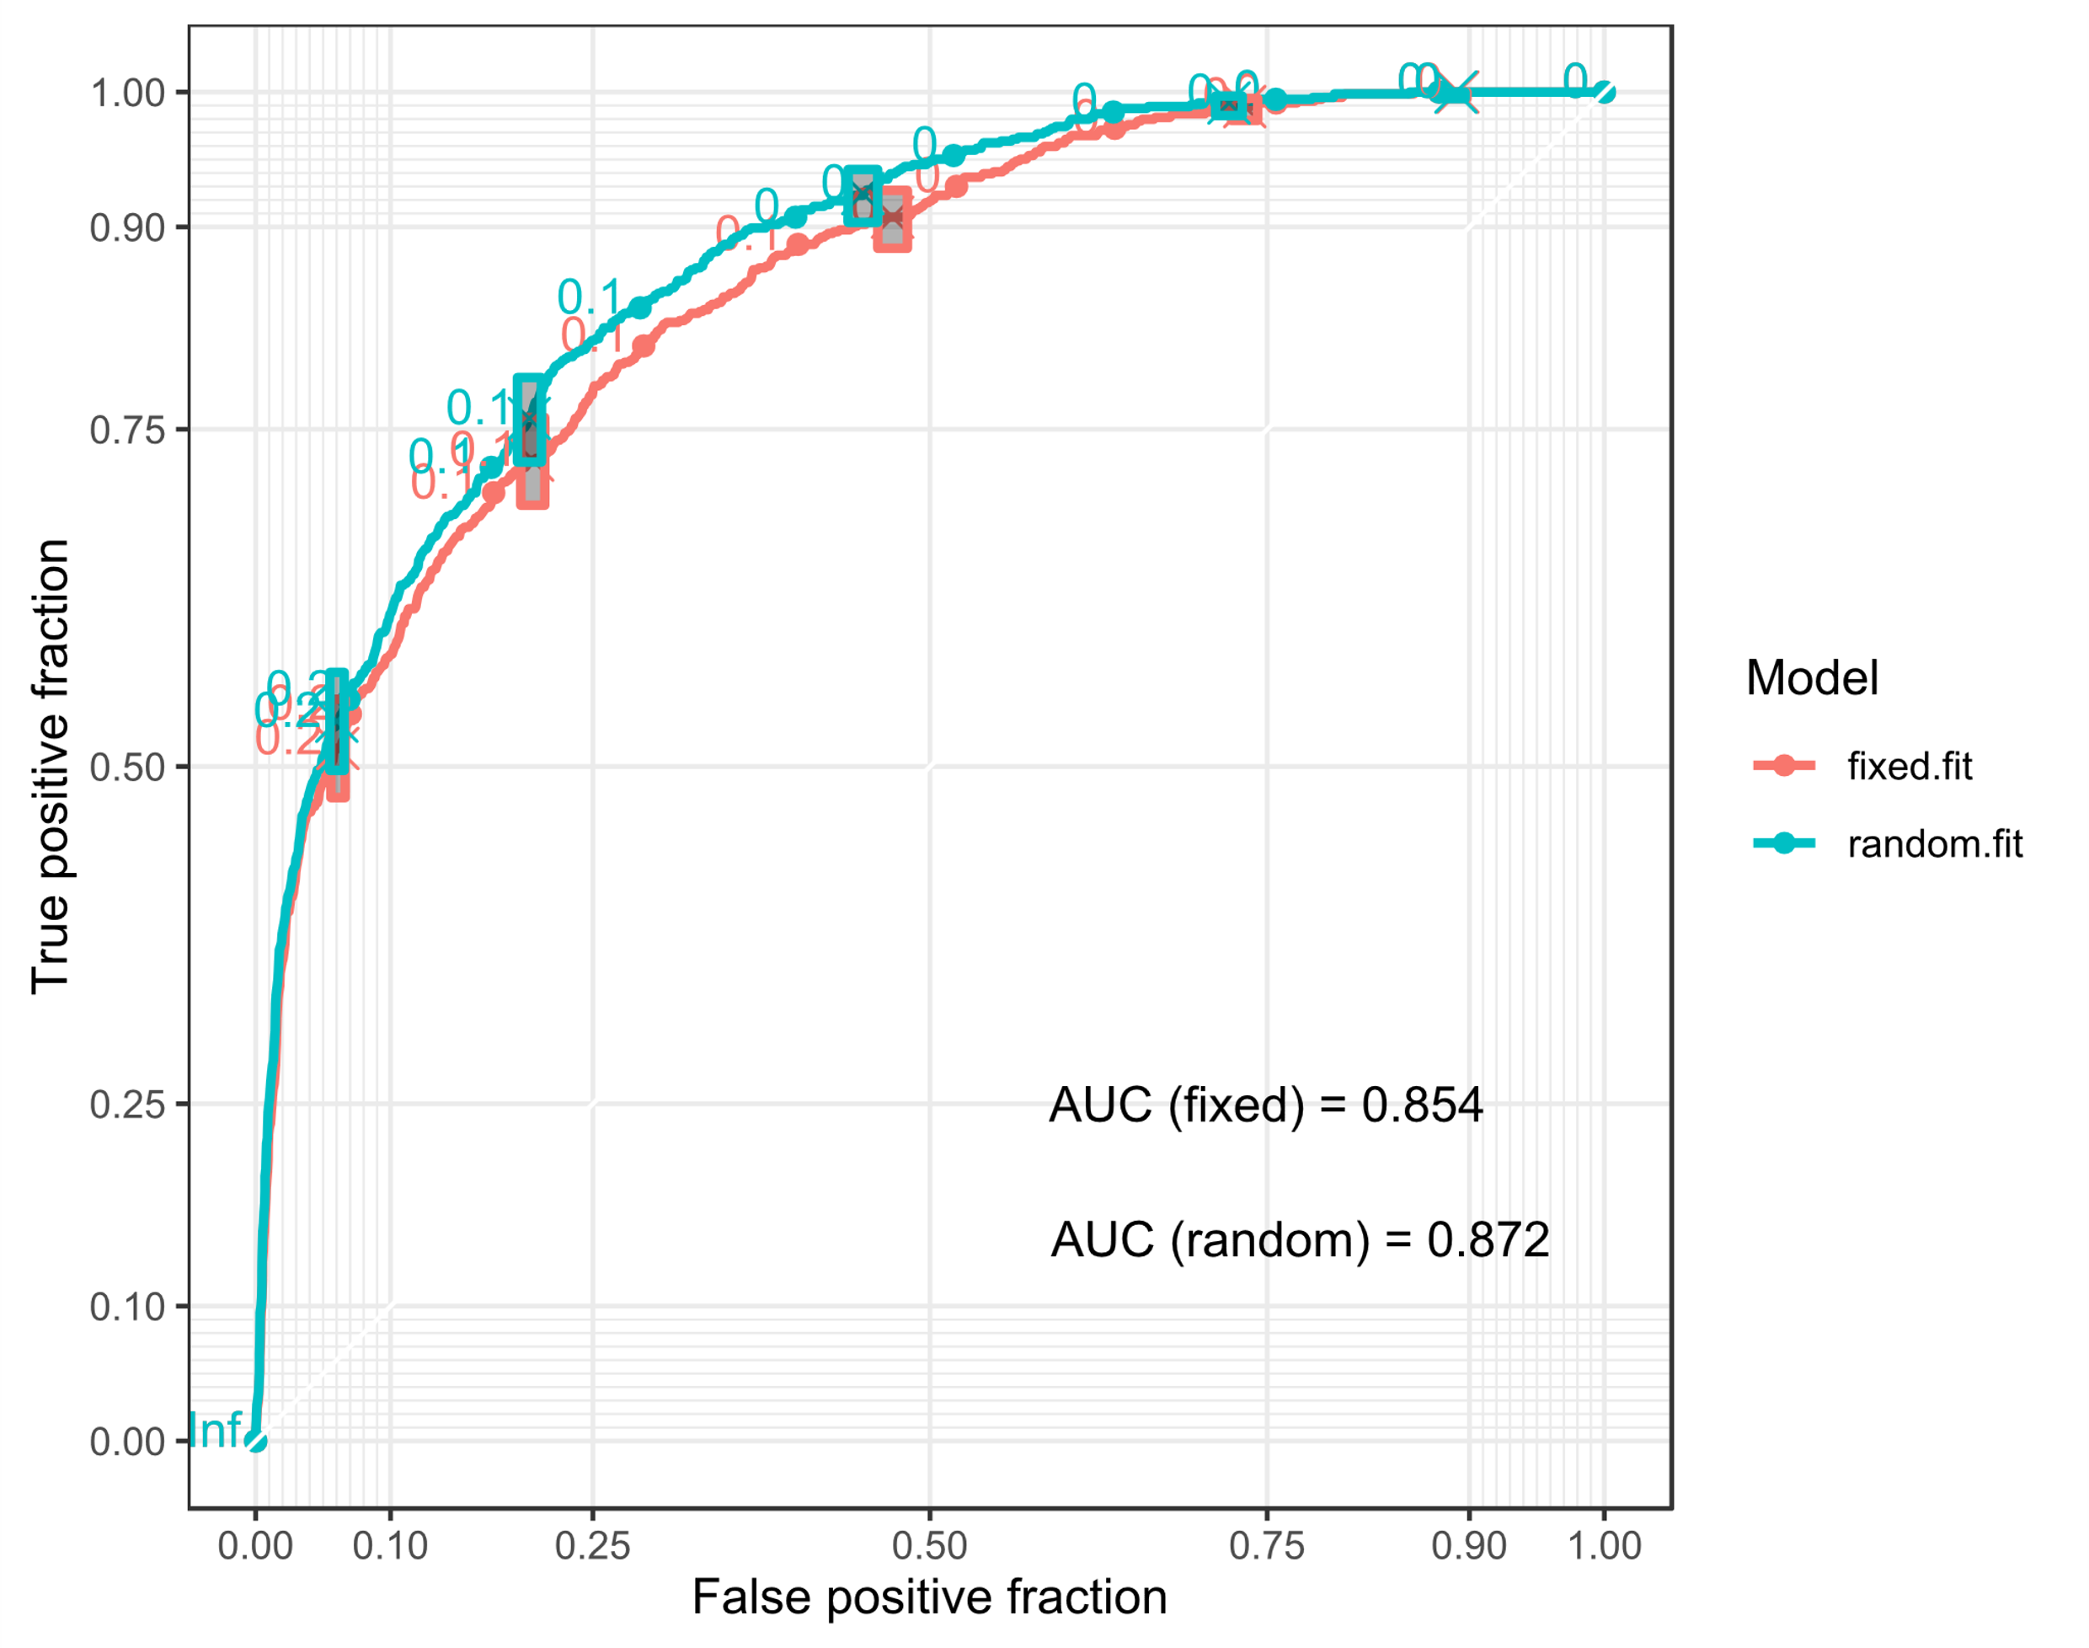
Figure A1: Receiver Operating Characteristic (ROC) curve for the binary part of the ZANB model for size class B0
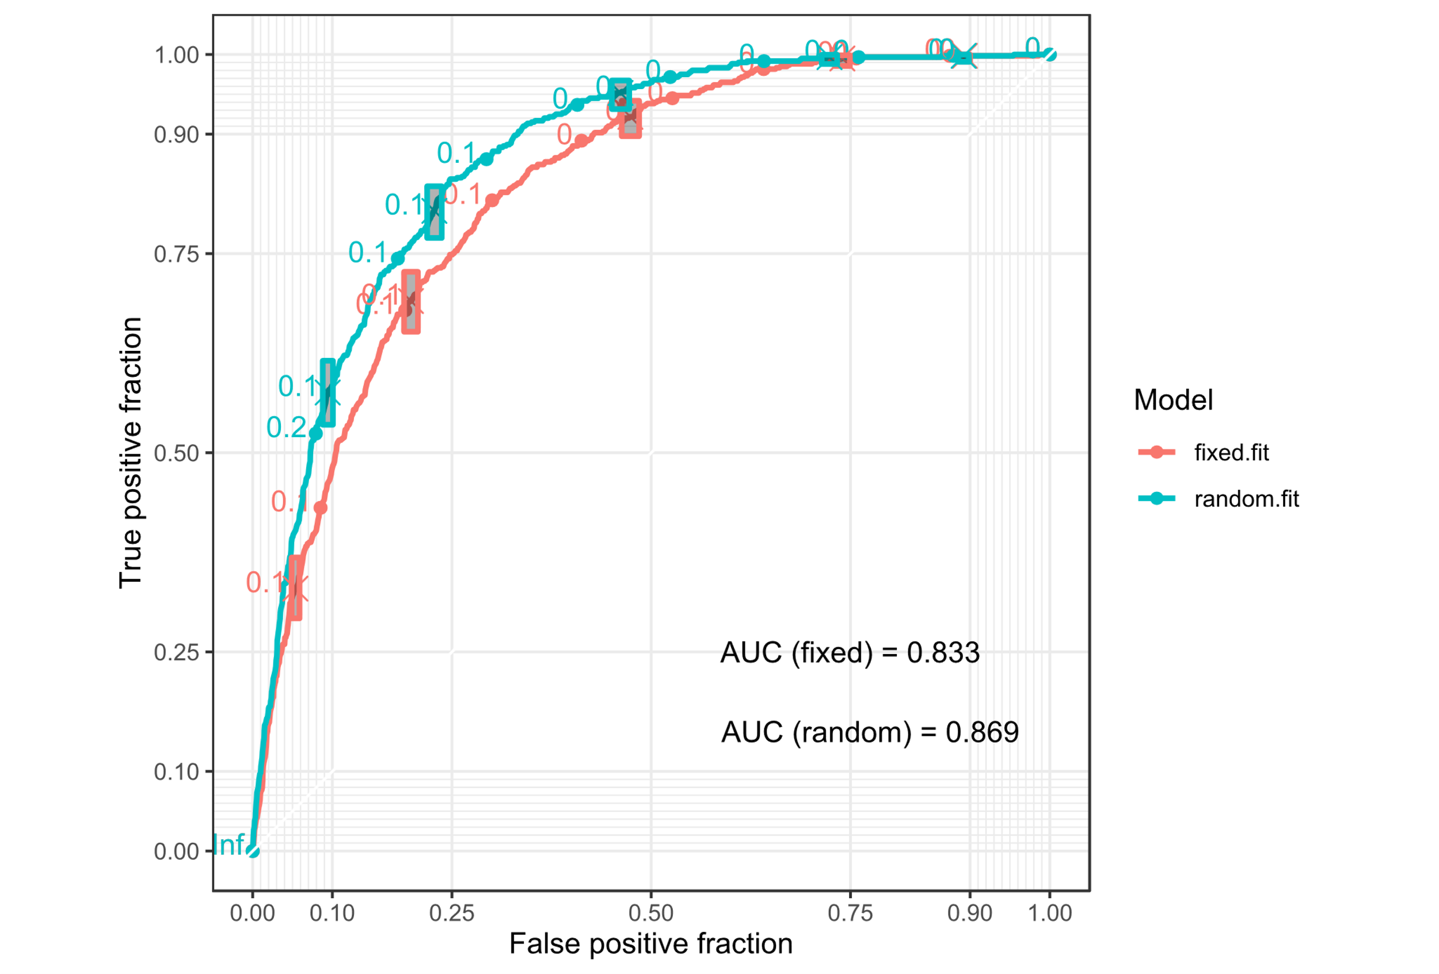
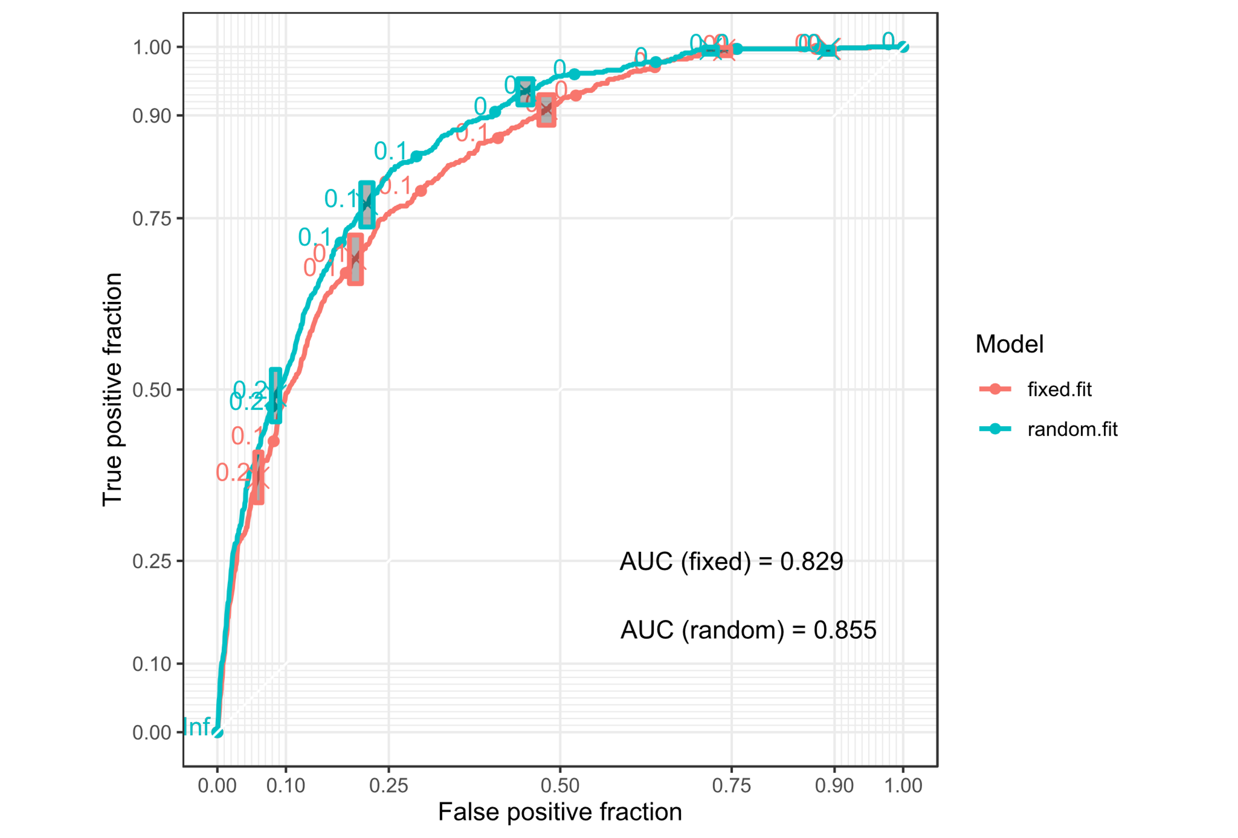
Figure A3: Receiver Operating Characteristic (ROC) curve for the binary part of the ZANB model for size class B2
Figure A2: Receiver Operating Characteristic (ROC) curve for the binary part of the ZANB model for size class B1

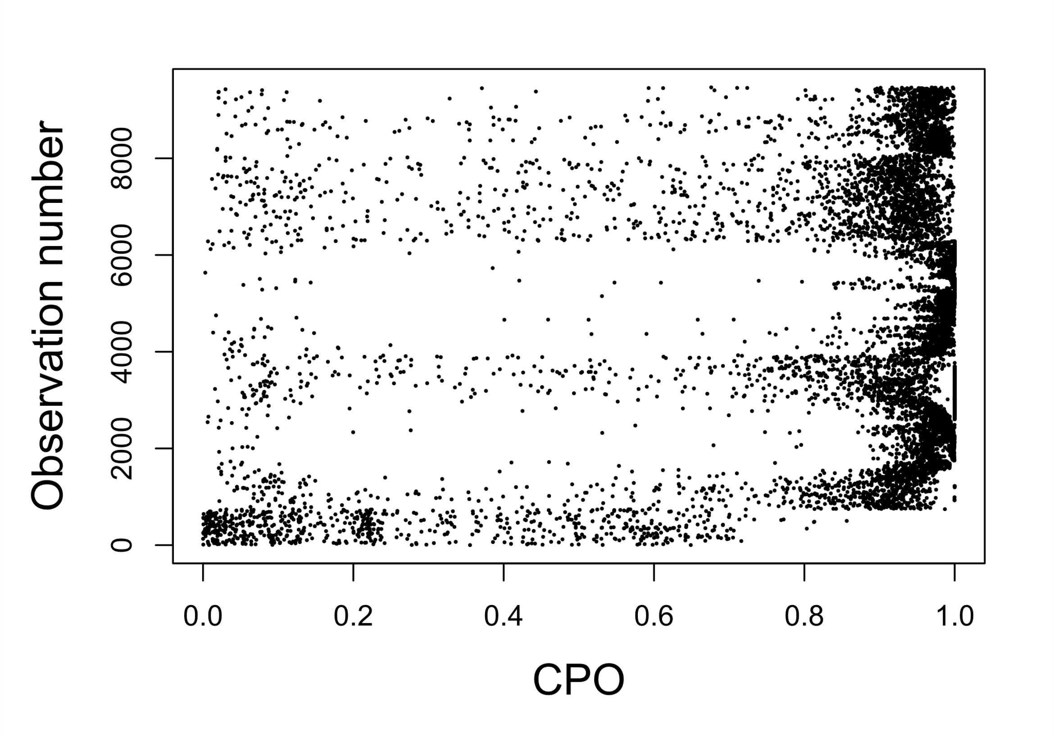
Figure A4: CPO values for the ZANB model for size class B0. The mean logarithm CPO value is about 0.3507.
Figure A5: CPO values for the ZANB model for size class B1. The mean logarithm CPO value is about 0.3215.
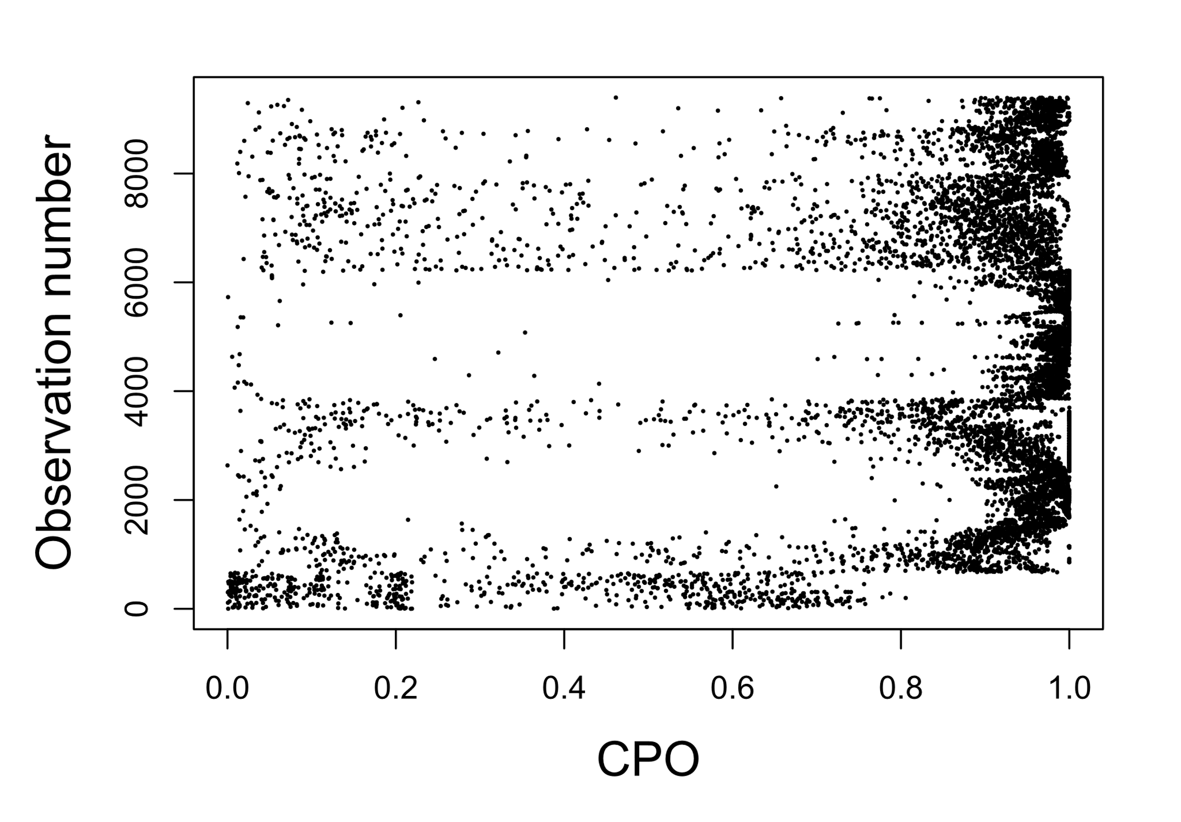
Figure A6: CPO values for the ZANB model for size class B2. The mean logarithm CPO value is about 0.2990.

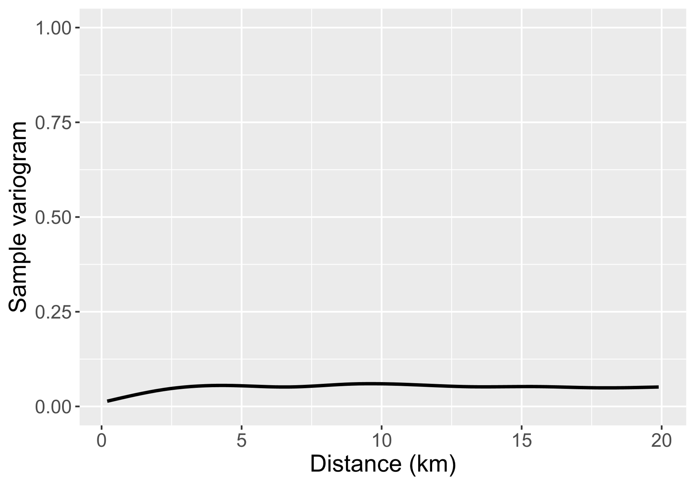
Figure A7: Sample variogram for the ZANB model of size class B0
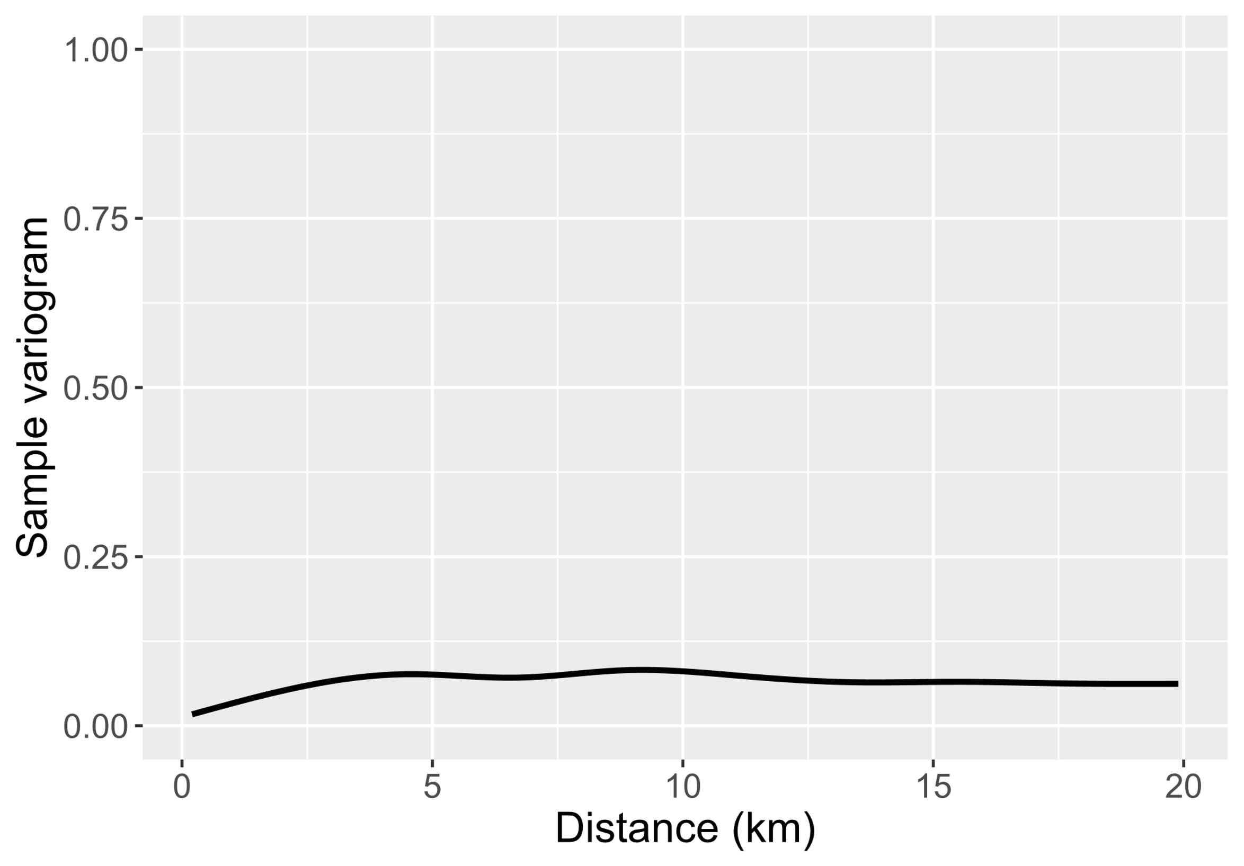
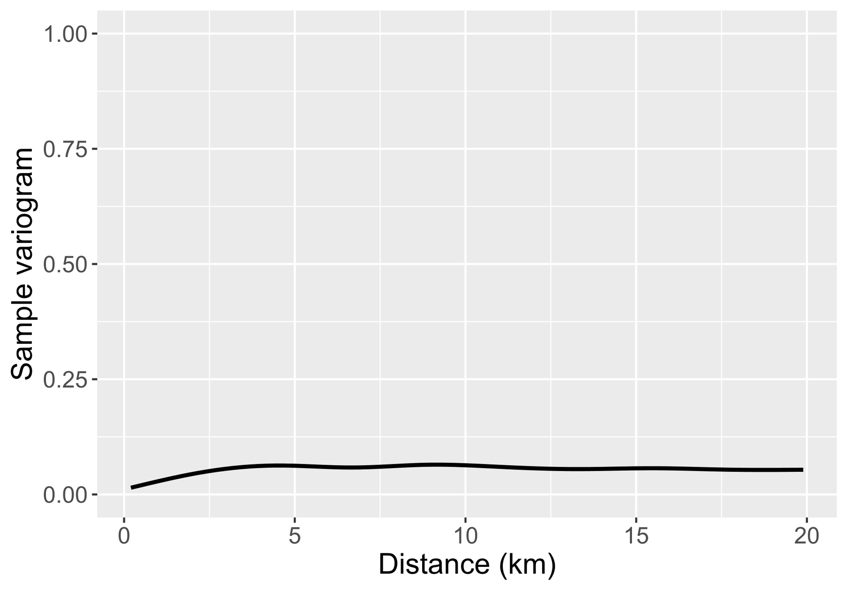
Figure A9: Sample variogram for the ZANB model of size class B2
Figure A8: Sample variogram for the ZANB model of size class B1

