Appendix. Supporting plots
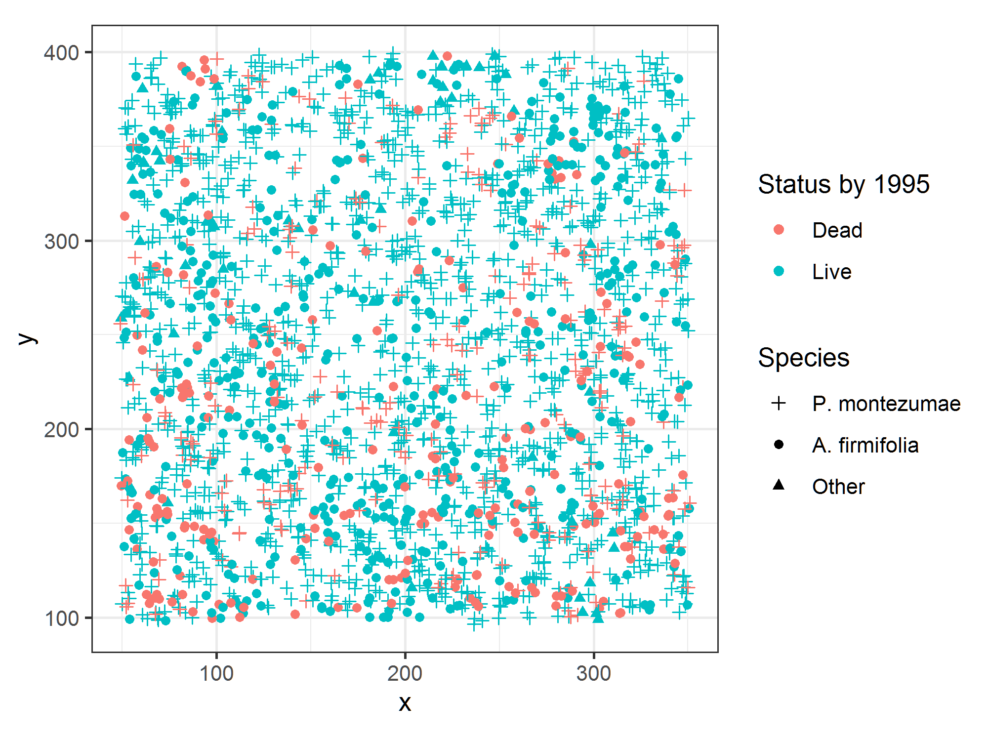
Appendix: Figure 1. Spatial distribution of all dead and alive trees by the end of the measurement period.

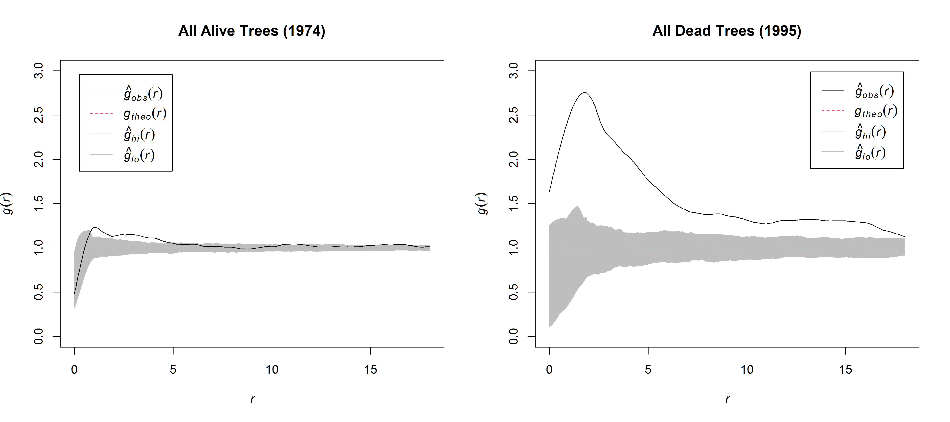
Appendix: Figure 2. Homogeneous pair-correlation function g(r) applied to the point pattern of all alive trees in 1974 and all dead trees by 1995, where the black solid line describes the observed g(r); the gray area is the 5th largest and lowest values of the point-wise simulation envelopes using 199 Monte Carlo randomizations of the CSR null model.
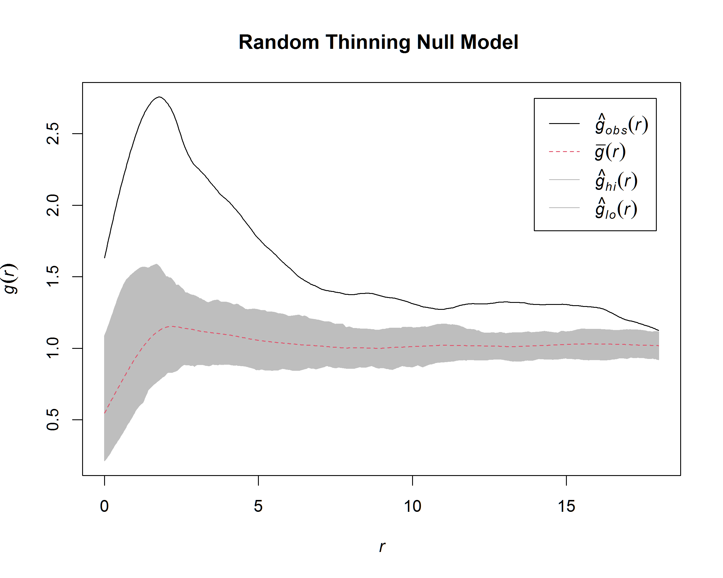
Appendix: Figure 3. Homogeneous pair-correlation function g(r) applied to the point pattern of all dead trees by 1995, where the black solid line describes the observed g(r); the gray area is the 5th largest and lowest values of the point-wise simulation envelopes using 199 Monte Carlo randomizations of the random thinning null model.

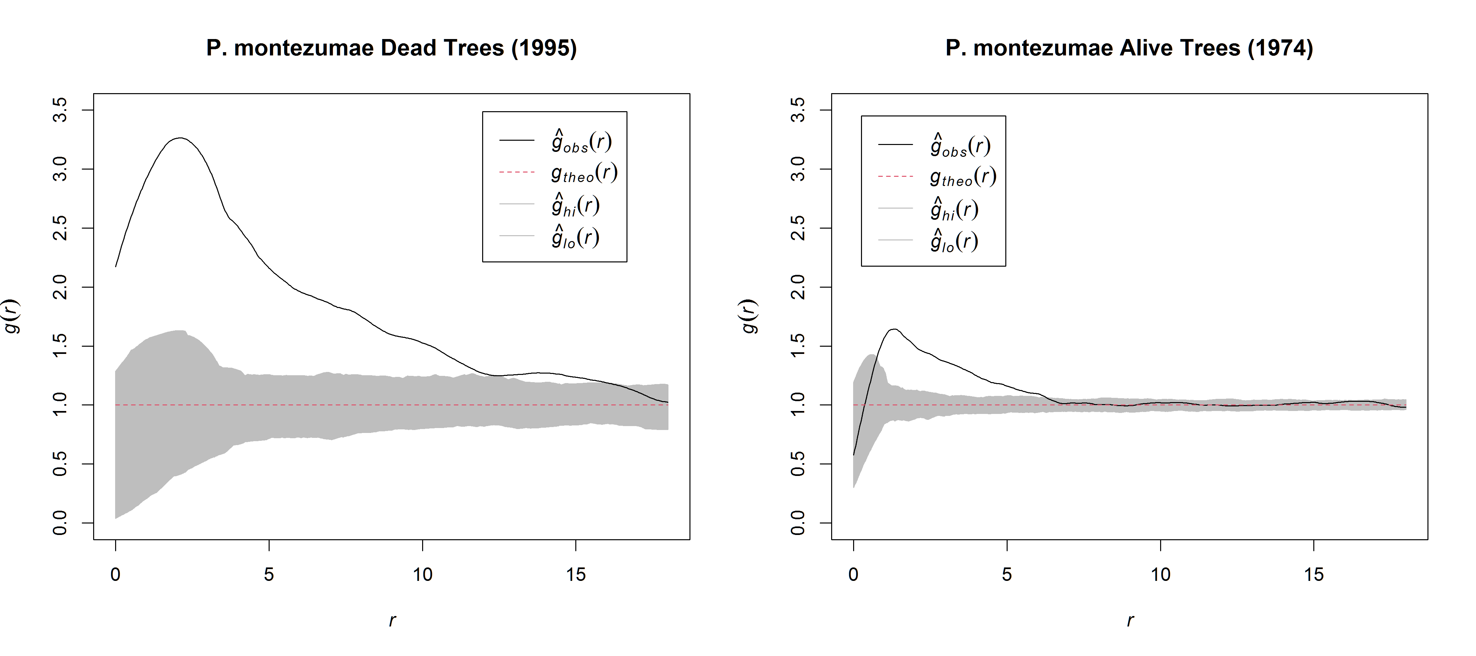
Appendix: Figure 4. Homogeneous pair-correlation function g(r) applied to the point pattern of the alive trees of P. montezumae in 1974 and the dead trees of P. montezumae by 1995, where the black solid line describes the observed g(r); the gray area is the 5th largest and lowest values of the point-wise simulation envelopes using 199 Monte Carlo randomizations of the CSR null model.

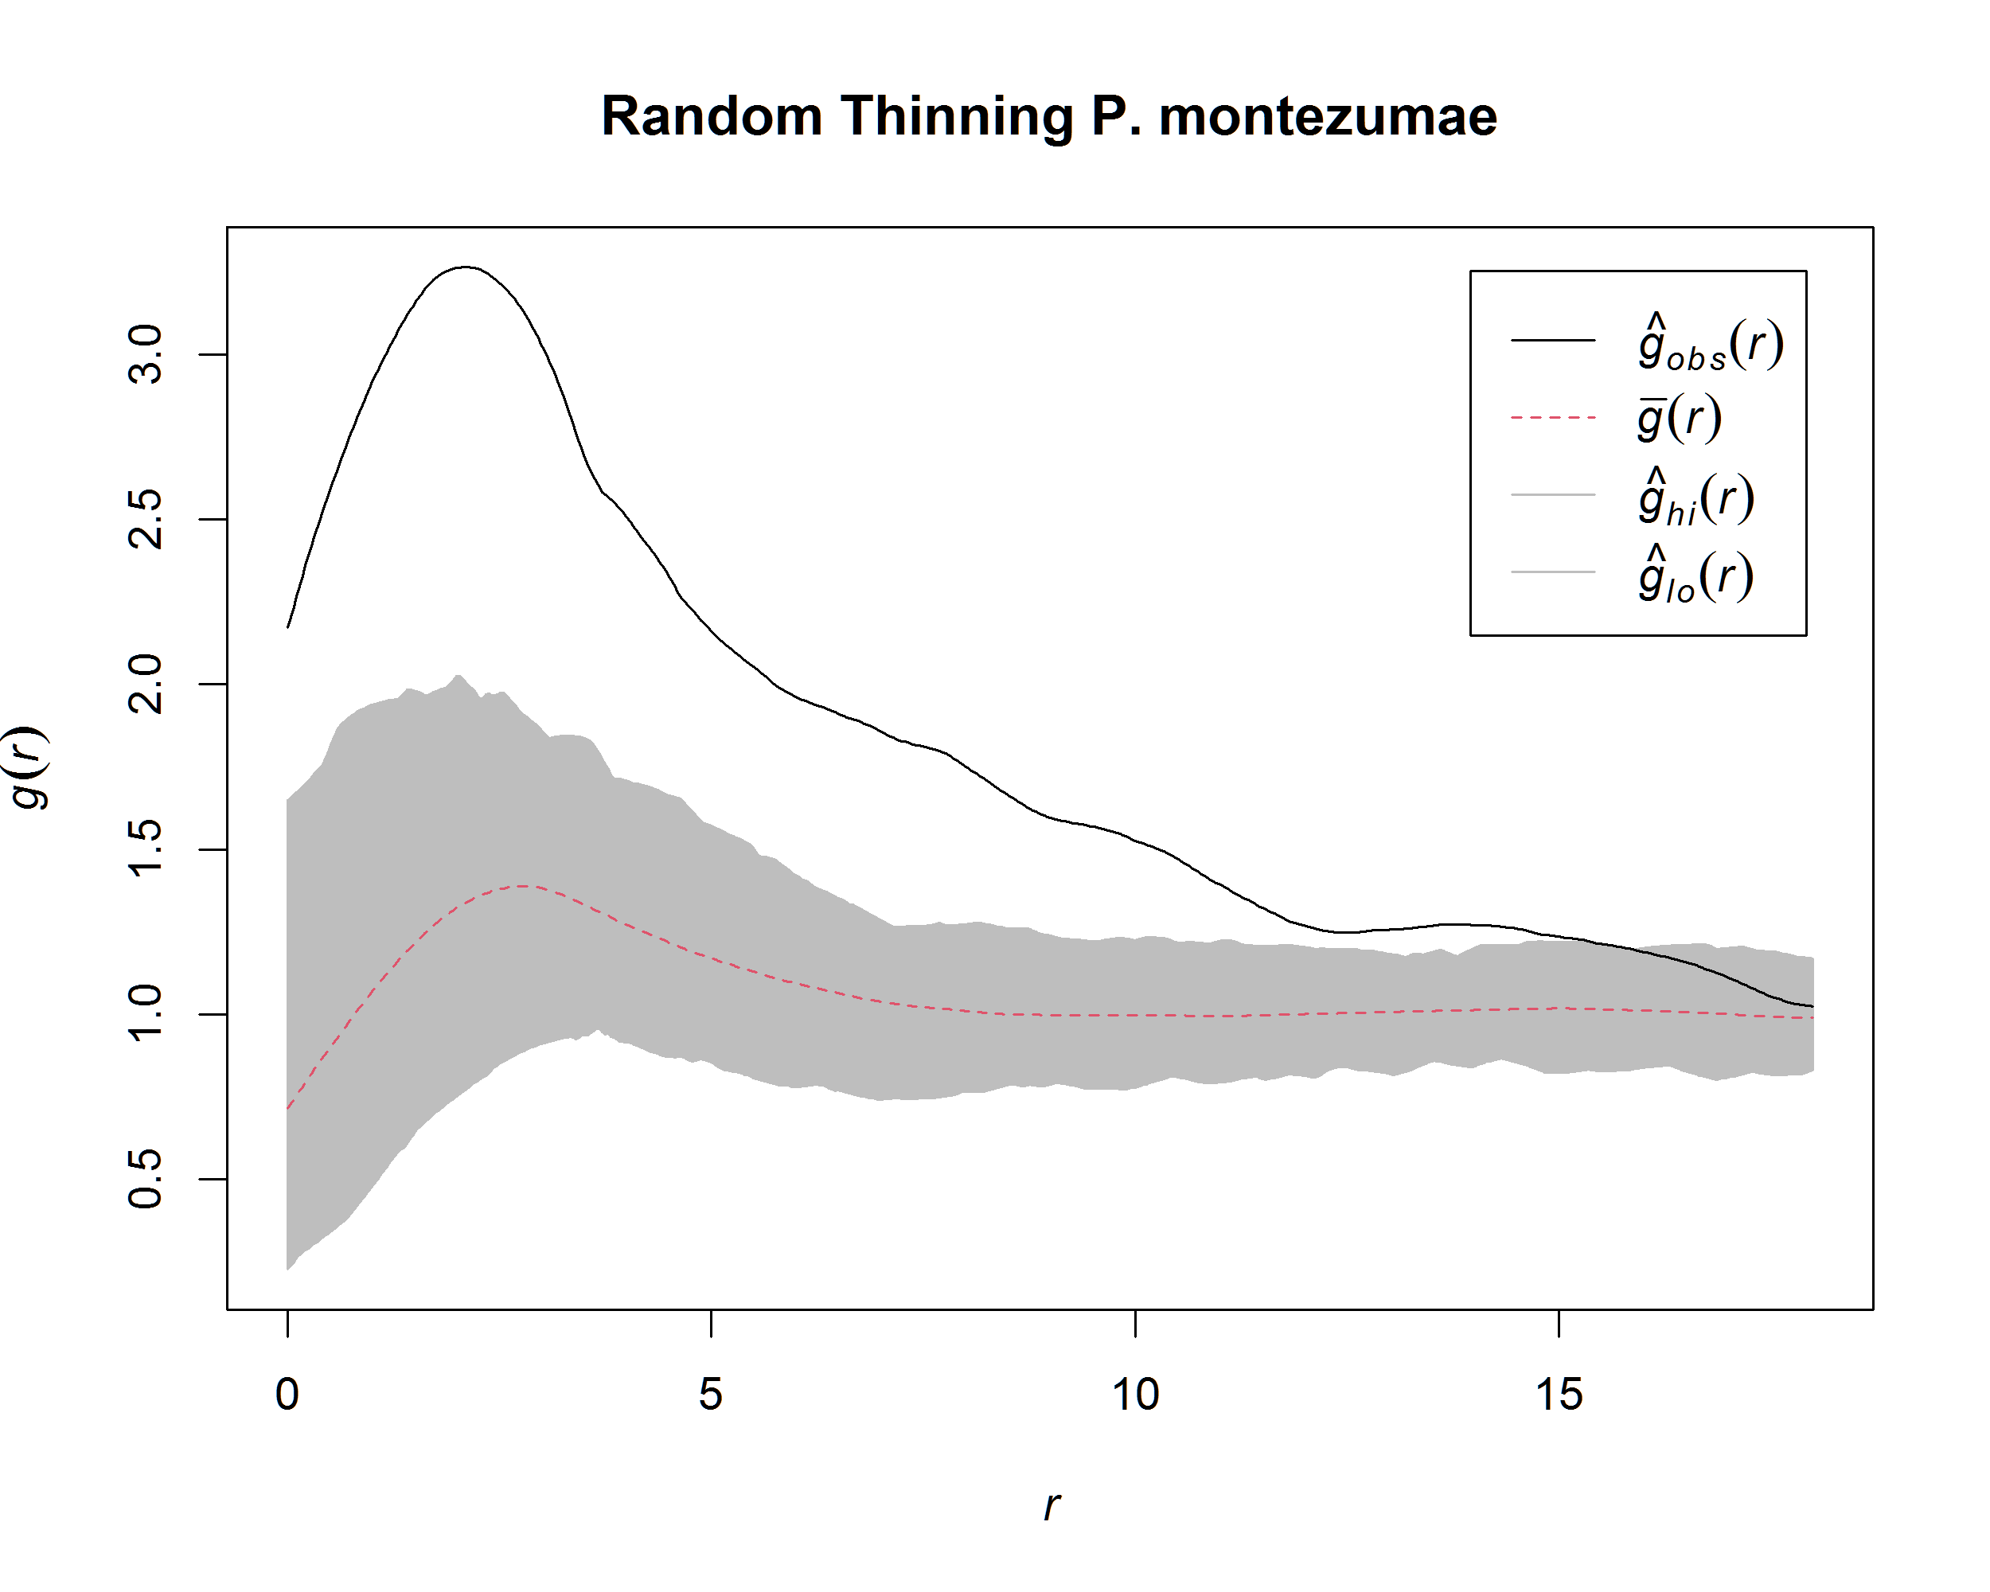
Appendix: Figure 5. Homogeneous pair-correlation function g(r) applied to the point pattern of P. montezumae dead trees by 1995, where the black solid line describes the observed g(r); the gray area is the 5th largest and lowest values of the point-wise simulation envelopes using 199 Monte Carlo randomizations of the random thinning null model.

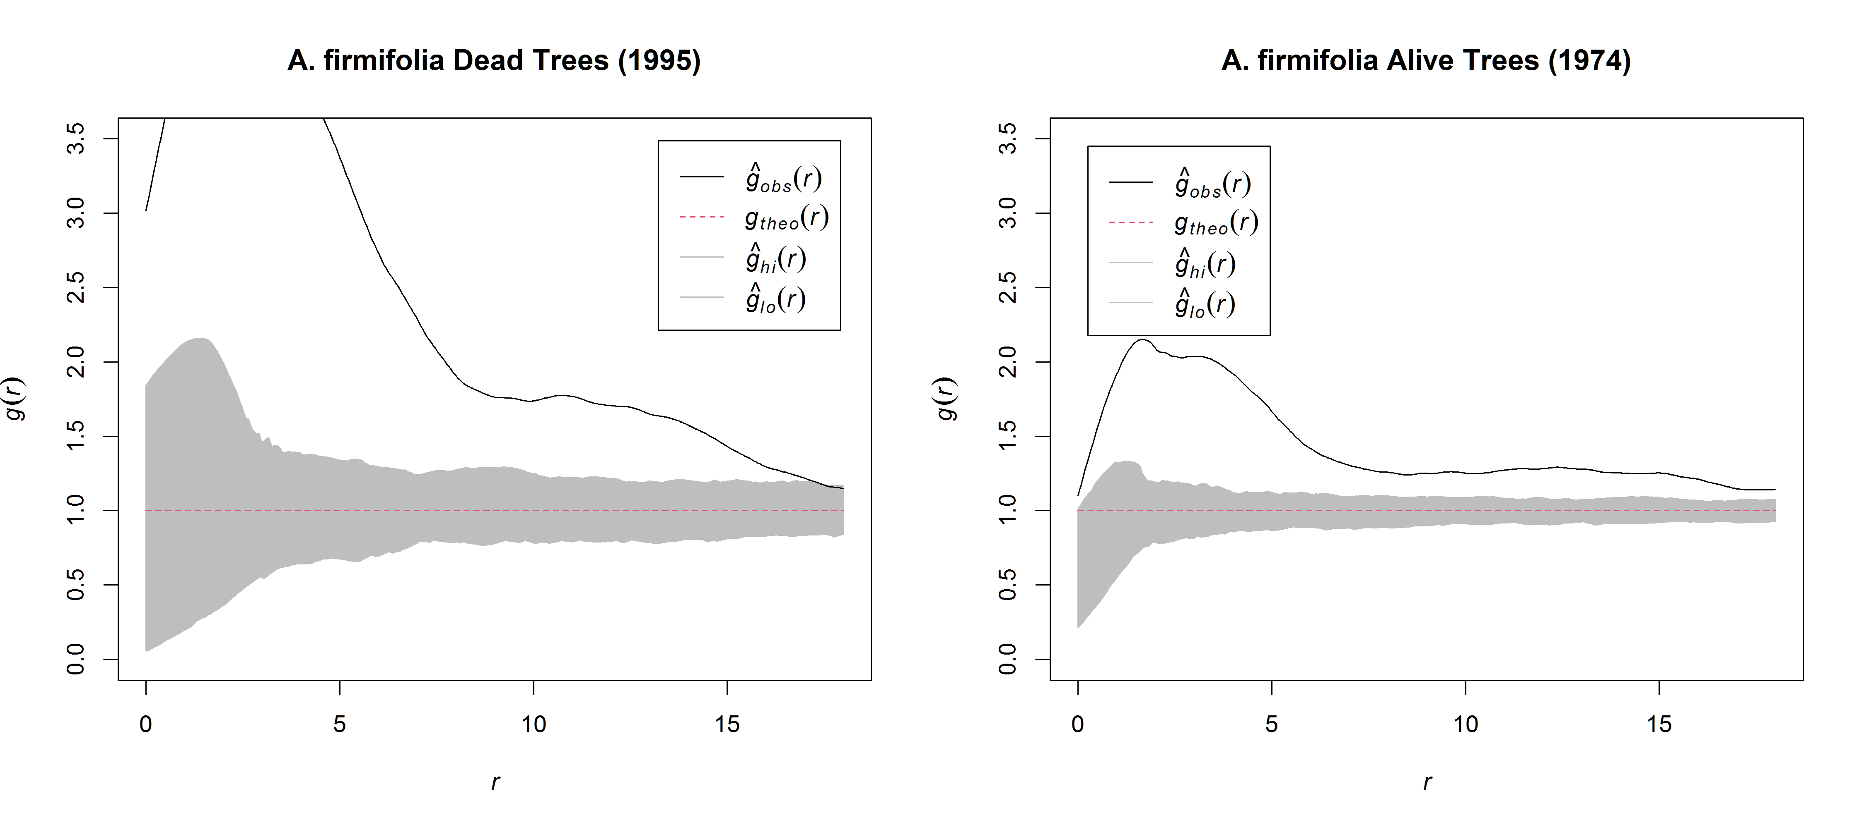
Appendix: Figure 6. Homogeneous pair-correlation function g(r) applied to the point pattern of the alive trees of A. firmifolia in 1974 and the dead trees of A. firmifolia by 1995, where the black solid line describes the observed g(r); the gray area is the 5th largest and lowest values of the point-wise simulation envelopes using 199 Monte Carlo randomizations of the CSR null model.

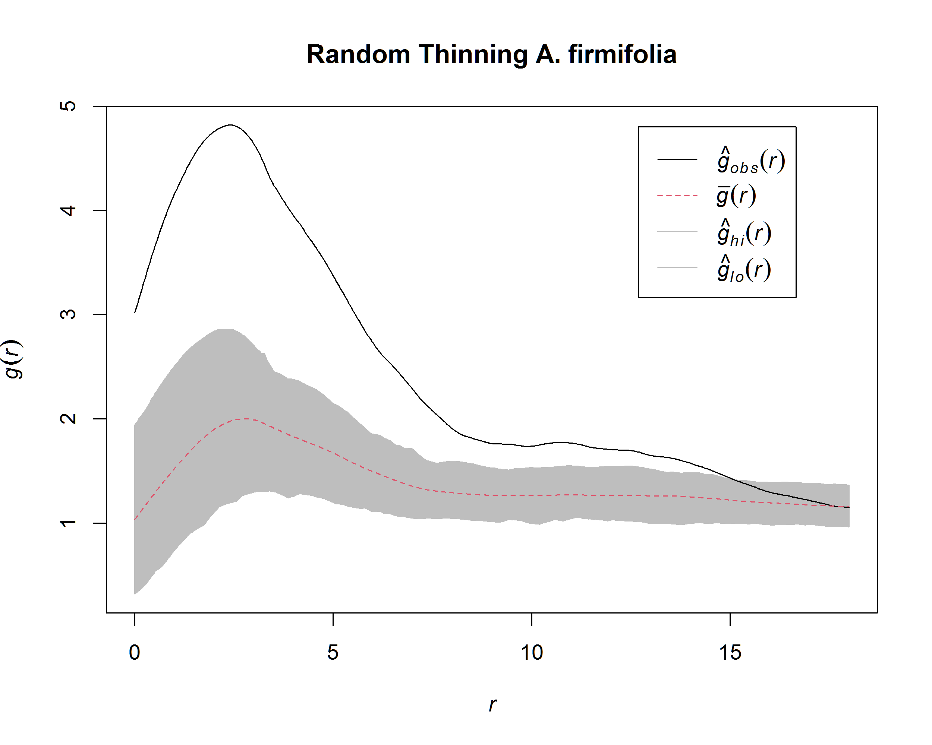
Appendix: Figure 7. Homogeneous pair-correlation function g(r) applied to the point pattern of A. firmifolia dead trees by 1995, where the black solid line describes the observed g(r); the gray area is the 5th largest and lowest values of the point-wise simulation envelopes using 199 Monte Carlo randomizations of the random thinning null model.

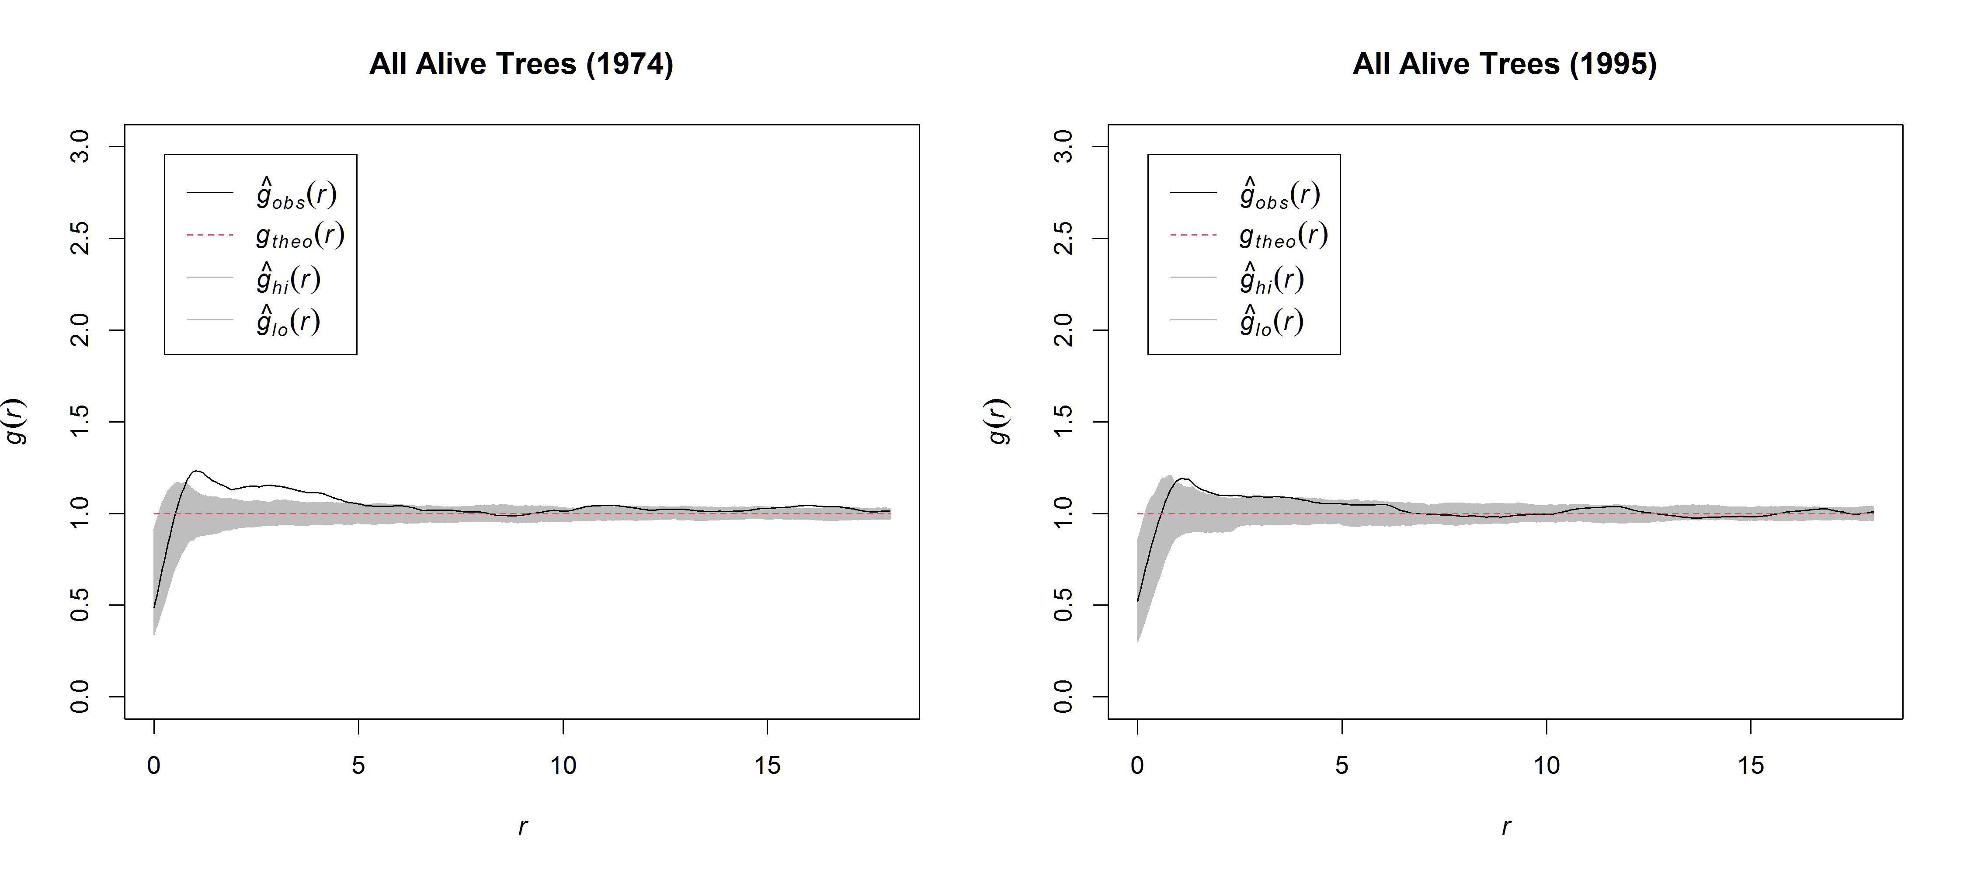
Appendix: Figure 8. Homogeneous pair-correlation function g(r) applied to the point pattern of all alive trees in the beginning (1974) and in the end (1995), where the black solid line describes the observed g(r); the gray area is the 5th largest and lowest values of the point-wise simulation envelopes using 199 Monte Carlo randomizations of the CSR null model.

