Supplementary data

Resin yield response to different tapping methods and stimulant pastes in Pinus pinaster Ait.
Journal name: European Journal of Forest Research
Óscar López-Álvareza,∗ (0000-0002-5254-7791), Rafael Zasb (0000-0001-6563-2461), Enrique Martínez Chamorroc (0000-0002-3531-3336), Manuel Marey-Pereza (0000-0002-8947-8355)
aResearch Group PROePLA GI-1716, Department of Plant Production and Engineering Projects, Higher Polytechnic School of Engineering, University of Santiago de Compostela, Campus Terra, 27002 Lugo, Spain
bMisión Biológica de Galicia, National Spanish Research Council (MBG-CSIC), Apdo 28 Pontevedra 36080, Spain
cCentro de Investigación Forestal de Lourizán, AGACAL-Xunta de Galicia, Apdo. 127, 36080 Pontevedra, Spain
* Corresponding autor
Email addresses: oscar.lopez.alvarez@rai.usc.es (Óscar López-Álvarez), rzas@mbg.csic.es (Rafael Zas), enrique.martinez.chamorro@xunta.gal (Enrique Martínez Chamorro), manuel.marey@usc.es (Manuel Marey-Perez)

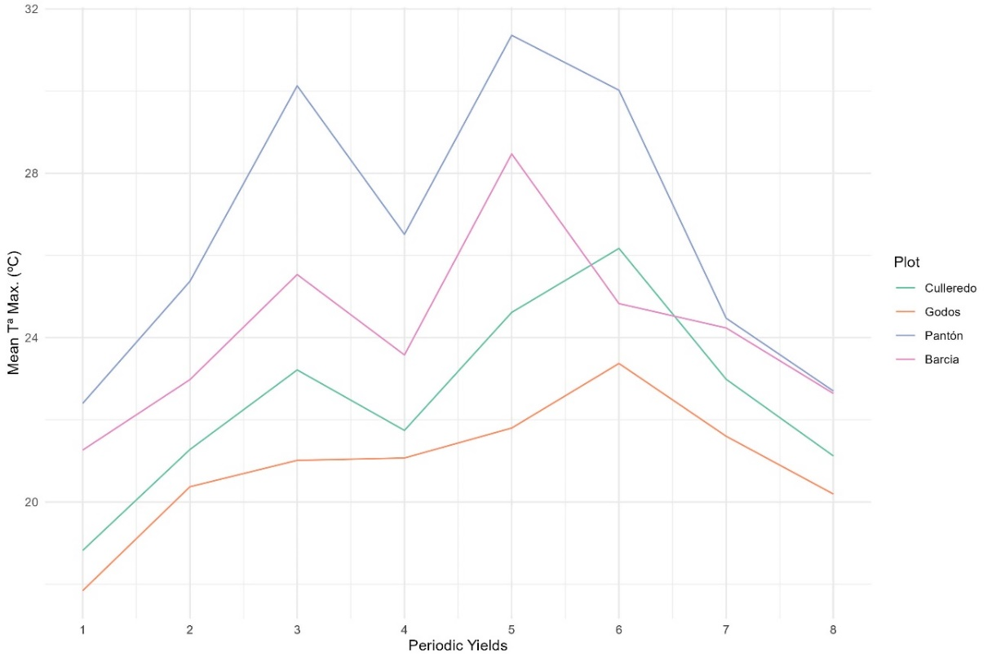
Fig S 1. Average of the maximum temperatures during the grooving period carried out in each of the plots

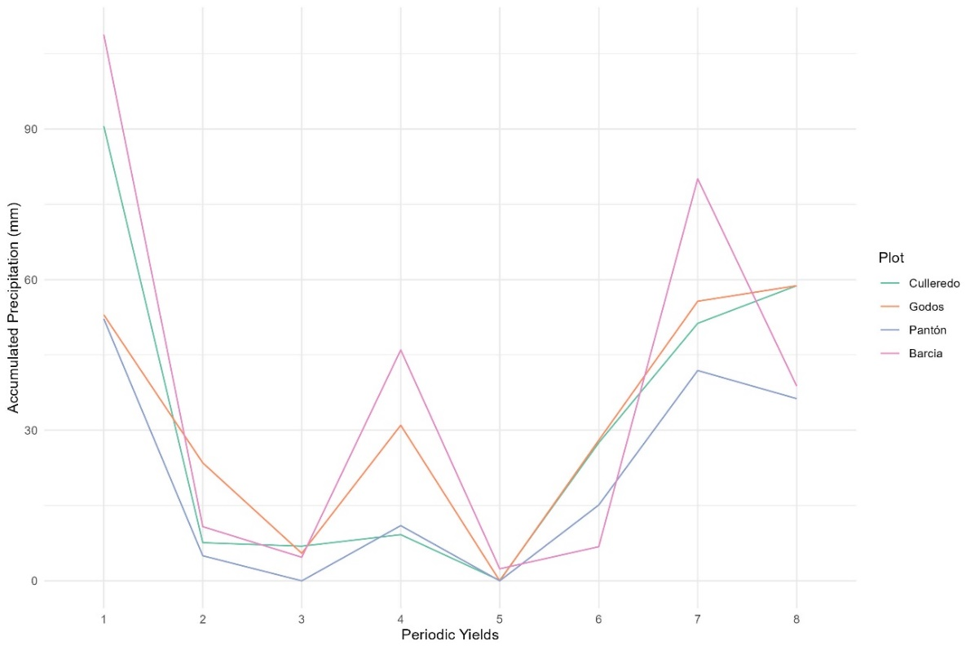
Fig S 2. Accumulated precipitation during the grooving period carried out in each of the plots.

Table S 1: Summary of closest weather stations to the plots consulted from two sources of information, the Spanish State Meteorological Agency (AEMET)(www.aemet.es) and the Galician Meteorologial Service (MeteoGalicia)(www.meteogalicia.gal). ID: MeteoGalicia and AEMET station id; Altitude: stations altitude (m); Tª min: average minimum temperatures (ºC); Tª mean: average mean temperatures (ºC); Tª max: average maximun temperatures (ºC); Precipitation: average accumulated precipitation (mm).
Plot | Meteorological Service | ID | Altitude (m) | Tª min (ºC) | Tª mean (ºC) | Tª max (ºC) | Precipitation (mm)
Culleredo | AEMET | 1387E | 98 | 9.4 | 13.8 | 18.1 | 1105.5
Pantón | MeteoGalicia | 10171 | 286 | 10.6 | 14.1 | 18.3 | 1236.4
Godos | MeteoGalicia | 19056 | 52 | 9.3 | 14.2 | 19.6 | 1156.6
Busfrio | AEMET | 1212E | 127 | 9.8 | 13.4 | 17 | 1018.8
Coca | AEMET | 2465 | 1005 | 6.9 | 12.5 | 18 | 479.4

