Title: Diversification of forest management can mitigate wind damage risk and maintain biodiversity

Supplementary material

1, 2 Mária Potterf* maria.potterf@tum.de 0000-0001-6763-1948
3, 4 Kyle Eyvindson kyle.eyvindson@nmbu.no 0000-0003-0647-1594
2, 5 Clemens Blattert clemens.blattert@wsl.ch 0000-0003-0892-8666
2, 5 María Triviño maria.m.trivino-delacal@jyu.fi 0000-0002-2420-3537
6 Ryan C. Burner rburner@usgs.gov 0000-0002-7314-9506
2, 5 Daniel Burgas daniel.d.burgas@jyu.fi 0000-0003-3512-8365
2, 5 Mikko Mönkkönen mikko.monkkonen@jyu.fi 0000-0001-8897-3314

*corresponding author

1 Ecosystem Dynamics and Forest Management Group, Technical University of Munich, Hans-Carl-von-Carlowitz-Platz 2, 85354 Freising, Germany
2 Department of Biological and Environmental Science, University of Jyvaskyla, P.O. Box 35, FI-40014 Jyvaskyla, Finland
3 Natural Resource Institute Finland (LUKE), Laatokartanonkaari 9, FI-00790 Helsinki, Finland
4 Faculty of Environmental Sciences and Natural Resource Management, Norwegian University of Life Sciences, Ås, Norway
5 School of Resource Wisdom, University of Jyvaskyla, P.O. Box 35, FI-40014 Jyvaskyla, Finland
6 U.S. Geological Survey, Upper Midwest Environmental Sciences Center, La Crosse, Wisconsin, USA, ORCID 0000-0002-7314-9506

Acknowledgements
We thank CSC - IT Center for Science LTD (cPouta, https://research.csc.fi) for providing the high performance computational resources to carry out the simulations of this study. M.P was supported by BioESSHealth. M.T. was supported by the Kone Foundation (application 201710545). MM, KE, DB, CB were supported by the ERA-NET Cofund ForestValue under the project MultiForest, and with the funding organization Academy of Finland (aka 326321). Any use of trade, firm, or product names is for descriptive purposes only and does not imply endorsement by the U.S. Government.

Supplementary tables
Table S1 Continuous and categorical predictors and parameter estimates from a binomial generalized linear wind damage probability model with logit-link function, from Suvanto et al. (2019). Predictors indicated by * varied based on forest stand development under various management regime. NA – no value.
Variable | Description | Unit/resolution | Estimates
Intercept | Model intercept | - | -14.690
Tree species* | Dominant species | Pine  Spruce  other | NA  -8.494  -9.314
Log(Tree height*) | Dominant tree height | Dm | 1.661
Time since thinning* | Years since the last thinning | 0-5  6-10  >10 years | NA  -0.298  -0.844
Log(Wind speed) | 10-year return level of max wind speed (Venäläinen et al. 2017a) | m/s, resolution 20m, calculated as mean per stand | 0.749
Open-edge* | True if dominant stand height is >5 m higher than heights of neighboring stands or if stand is located at landscape edge. | True  false | 0.310
Soil type | Differentiates between organic and mineral soils. | Mineral coarse, mineral fine, organic | NA  -0.356  -0.216
Soil depth | Mineral soil depth <30 cm | True/false | 0.214  NA
Site fertility | “Fertile” contained sites from herb-rich to mesic forests on mineral soils and from eutrophic to meso-oligothrophic peatlands. Less fertile classes were included in the “Poor” fertility class (Reclassified based on Tomppo et al. 2011) | Fertile/poor | -0.425  NA
Temperature sum | Total annual temperature sum with threshold of +5°C over 100-degree days (Aalto et al. 2016)); average 1985-2018 | Resolution 10 km | 0.096
Species_{spruce}×log(tree height) | [Interaction of terms from above] |  | 1.634
Species_{other}×log(tree height) | [Interaction of terms from above] |  | 1.625

Source: Suvanto S, Peltoniemi M, Tuominen S, et al (2019) High-resolution mapping of forest vulnerability to wind for disturbance-aware forestry. For Ecol Manage 453:117619. https://doi.org/10.1016/j.foreco.2019.117619

Table S2 The effects of changes in management regimes on several stand covariates across Finland. Shown are means for indicators (wind damage probability, combined habitat suitability index = HSI, and deadwood volume) and averaged sums (harvested log and pulp volume, m³/ha) and net present value (NPV) ± standard deviations over the entire 100-year (2013-2113) simulation period. REF – reference climate. RCP – Representative Concentration Pathway, CCF – Continuous Cover Forestry, GTR – Green Tree Retention, ext_30 and ext_10 extension of rotation length by 30 or 10 years, respectively, noThin – no thinning, short_10 and short_30 shortening of rotation length by 10 and 30 years, respectively. For full regime descriptions, refer to Table 2 in main text. Highlighted are the highest (in bold) and lowest values (underlined) per climate scenario.
 | Climate scenario | Regime | Wind damage risk [%] | Deadwood volume [m³/ha] | Combined  HSI | Harvested log [m³/ha] | Harvested pulp [m³/ha] |  | NPV  [€/ha]
 | REF | short_30 | 1.4±1.9 | 9.2±6.5 | 0.2±0.3 | 191±96 | 266±102 |  | 6306±3700
REF |  | short_10 | 2±2.2 | 12.6±8.6 | 0.3±0.4 | 209±114 | 210±73 | 5719±3515
REF |  | BAU | 2±2.1 | 15.3±10.5 | 0.3±0.4 | 207±111 | 187±66 | 5227±3277
REF |  | noThin | 1.7±1.6 | 15.2±10.5 | 0.4±0.4 | 204±128 | 131±76 | 5223±3353
REF |  | ext_10 | 2.1±2.1 | 18.3±12.6 | 0.4±0.4 | 203±96 | 166±60 | 4627±3114
REF |  | ext_30 | 2.3±2.1 | 25.1±16.7 | 0.4±0.4 | 212±80 | 133±57 | 3186±2448
REF |  | GTR | 2±2.1 | 17.3±12 | 0.3±0.4 | 201±109 | 185±66 | 5104±3280
 | REF | CCF | 5.2±3.7 | 19.2±13.6 | 0.5±0.3 | 355±91 | 109±64 |  | 7224±2862
 | RCP45 | short_30 | 1.7±2.2 | 9.8±6.9 | 0.2±0.3 | 283±130 | 257±83 |  | 6987±4002
RCP45 |  | short_10 | 2.2±2.5 | 13±8.7 | 0.3±0.3 | 271±148 | 217±66 | 6211±3745
RCP45 |  | BAU | 2.3±2.4 | 15.7±10.7 | 0.3±0.4 | 266±144 | 203±64 | 5531±3298
RCP45 |  | noThin | 1.8±1.6 | 15.7±10.7 | 0.5±0.4 | 227±148 | 128±72 | 5668±3570
RCP45 |  | ext_10 | 2.3±2.4 | 18.8±12.8 | 0.3±0.4 | 254±123 | 186±60 | 5007±3297
RCP45 |  | ext_30 | 2.4±2.2 | 25.7±17.1 | 0.4±0.4 | 250±99 | 151±59 | 3430±2591
RCP45 |  | GTR | 2.3±2.4 | 17.7±12 | 0.3±0.4 | 260±141 | 201±63 | 5546±3492
 | RCP45 | CCF | 5.6±4 | 20.1±13.9 | 0.5±0.3 | 433±110 | 123±63 |  | 8030±2951
 | RCP85 | short_30 | 1.9±2.4 | 9.9±6.9 | 0.2±0.3 | 332±155 | 259±80 |  | 7354±4155
RCP85 |  | short_10 | 2.4±2.6 | 13.2±8.7 | 0.3±0.3 | 310±163 | 220±65 | 6514±3882
RCP85 |  | BAU | 2.5±2.6 | 15.9±10.7 | 0.3±0.4 | 311±161 | 206±62 | 5705±3353
RCP85 |  | noThin | 1.9±1.7 | 15.8±10.8 | 0.5±0.4 | 243±173 | 125±68 | 5968±3697
RCP85 |  | ext_10 | 2.5±2.5 | 19.1±12.9 | 0.3±0.4 | 298±141 | 191±60 | 5278±3413
RCP85 |  | ext_30 | 2.5±2.3 | 26±17.3 | 0.4±0.4 | 284±115 | 155±61 | 3615±2709
RCP85 |  | GTR | 2.5±2.6 | 17.8±12 | 0.3±0.4 | 304±157 | 204±62 | 5844±3614
 | RCP85 | CCF | 5.8±4.2 | 20.6±14.1 | 0.6±0.3 | 485±134 | 128±62 |  | 8443±3046

Supplementary figures

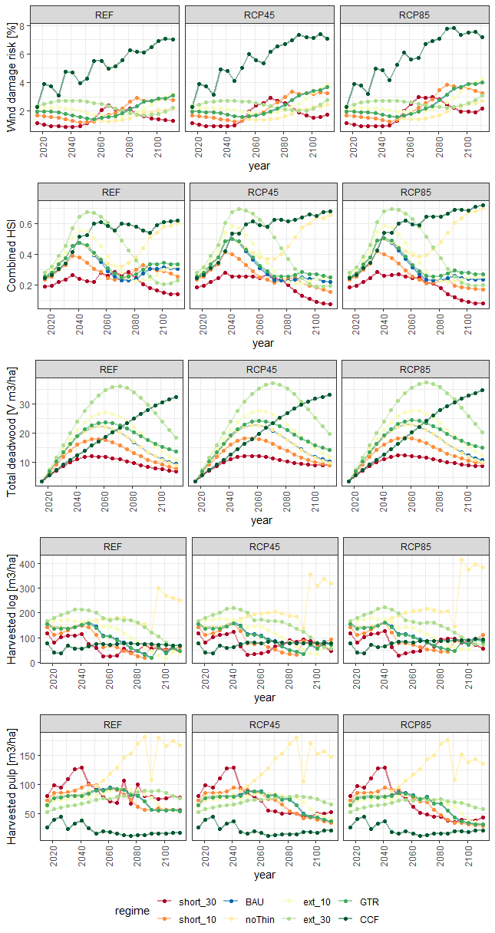
Figure S1 Temporal change in selected forest and biodiversity indicators. Lines represent the mean value per indicator (y-axis label) and year (x-axis) given specific climate change scenarios (facet headings). Line color indicates management adaptation (legend at bottom). Default rotation regime (business-as-usual, BAU) is often similar to dynamics of ext_10 (V total deadwood) or GRT (harvested pulp.) REF – reference climate, RCP – Representative Concentration Pathway, CCF – Continuous Cover Forestry, GTR – Green Tree Retention, ext_30 and ext_10 extension of rotation length by 30 or 10 years, respectively, noThin – no thinning, short_10 and short_30 shortening of rotation length by 10 and 30 years, respectively. For full regime descriptions, refer to Table 2 in main text.

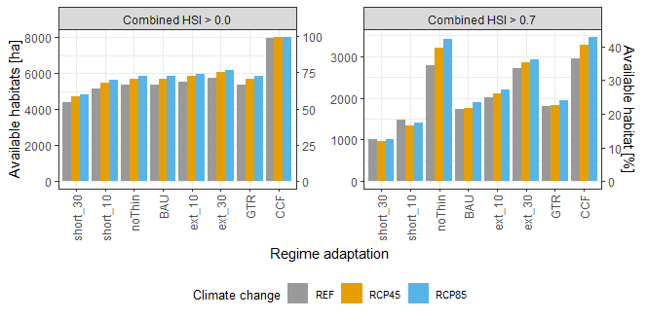
Figure S2 Effects of forest management adaptations on available combined habitat suitability index (HSI) for each climate scenario and management regime. Suitable habitats were defined at two thresholds. We have considered as suitable HSI > 0.0 (left) and HSI > 0.7 (right). Bars represent the area (in hectares, left y axis) and share (%, right y axis) of the suitable habitats from the total forest extent. REF – reference climate, RCP – Representative Concentration Pathway, CCF – Continuous Cover Forestry, GTR – Green Tree Retention, ext_30 and ext_10 extension of rotation length by 30 or 10 years, respectively, noThin – no thinning, short_10 and short_30 shortening of rotation length by 10 and 30 years, respectively. Note different ranges of y-axes.

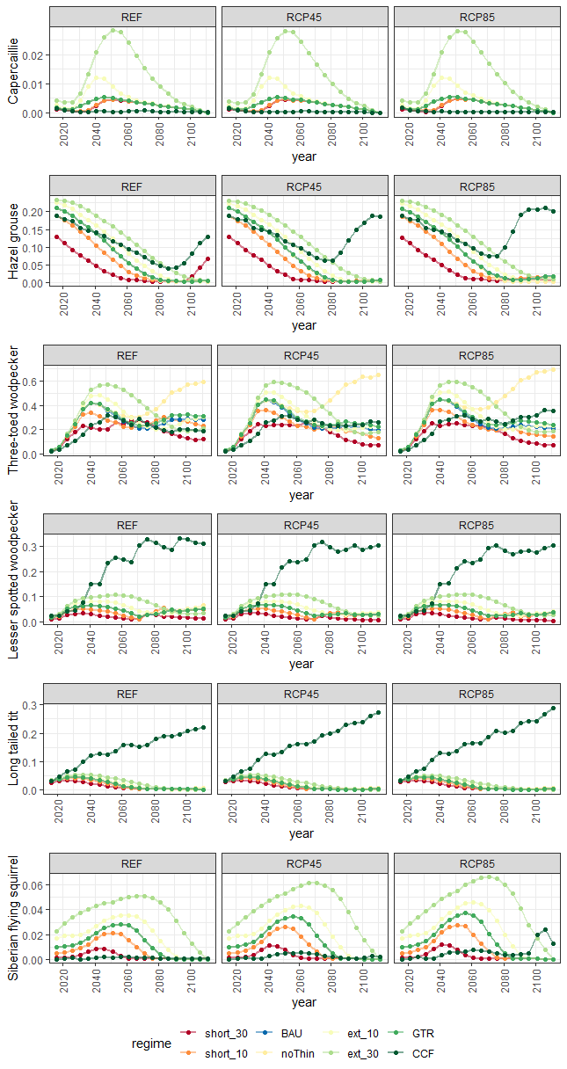
Figure S3 Temporal change in individual species’ habitat suitability indices. Lines represent the mean value per indicator (y-axis label) and year (x-axis) given specific climate change scenarios (facet headings). Line color indicates management adaptation (legend at bottom). Default rotation regime (BAU) is often similar to dynamics of ext_10 (V total deadwood) or GRT (harvested pulp.) REF – reference climate, RCP – Representative Concentration Pathway, CCF – Continuous Cover Forestry, GTR – Green Tree Retention, ext_30 and ext_10 extension of rotation length by 30 or 10 years, respectively, noThin – no thinning, short_10 and short_30 shortening of rotation length by 10 and 30 years, respectively. For full regime descriptions, refer to Table 2.
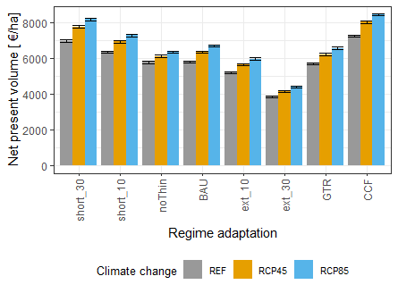
Figure S4 Average net present volume at a discount rate of 3% per stand for each regime and climate change scenario over 100 years. The whiskers represent 95% confidence intervals. REF – reference climate, RCP – Representative Concentration Pathway, CCF – Continuous Cover Forestry, GTR – Green Tree Retention, ext_30 and ext_10 extension of rotation length by 30 or 10 years, respectively, noThin – no thinning, short_10 and short_30 shortening of rotation length by 10 and 30 years, respectively.

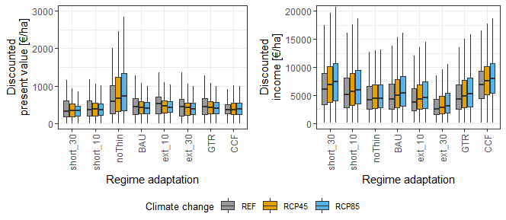
Figure S5 Discounted present value (value of the standing timber volume at the end of the simulation period) and discounted income (during the study period) at discount rate 3% for each climate change scenario. The whiskers represent 95% confidence intervals. REF – reference climate, RCP – Representative Concentration Pathway, CCF – Continuous Cover Forestry, GTR – Green Tree Retention, ext_30 and ext_10 extension of rotation length by 30 or 10 years, respectively, noThin – no thinning, short_10 and short_30 shortening of rotation length by 10 and 30 years, respectively. For full regime descriptions, refer to Table 2 in main text.

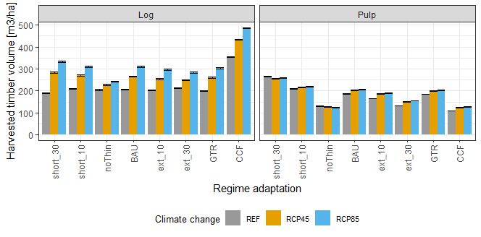
Figure S6 Average total harvested volume (sum of pulp and log harvested volume, m3/ha) per stand for each regime and climate change scenario over 100 years. The whiskers represent 95% confidence intervals. REF – reference climate, RCP – Representative Concentration Pathway, CCF – Continuous Cover Forestry, GTR – Green Tree Retention, ext_30 and ext_10 are extension of rotation length by 30 or 10 years, respectively, noThin – no thinning, short_10 and short_30 are shortening of rotation length by 10 and 30 years, respectively. For full regime descriptions, refer to Table 2 in main text.

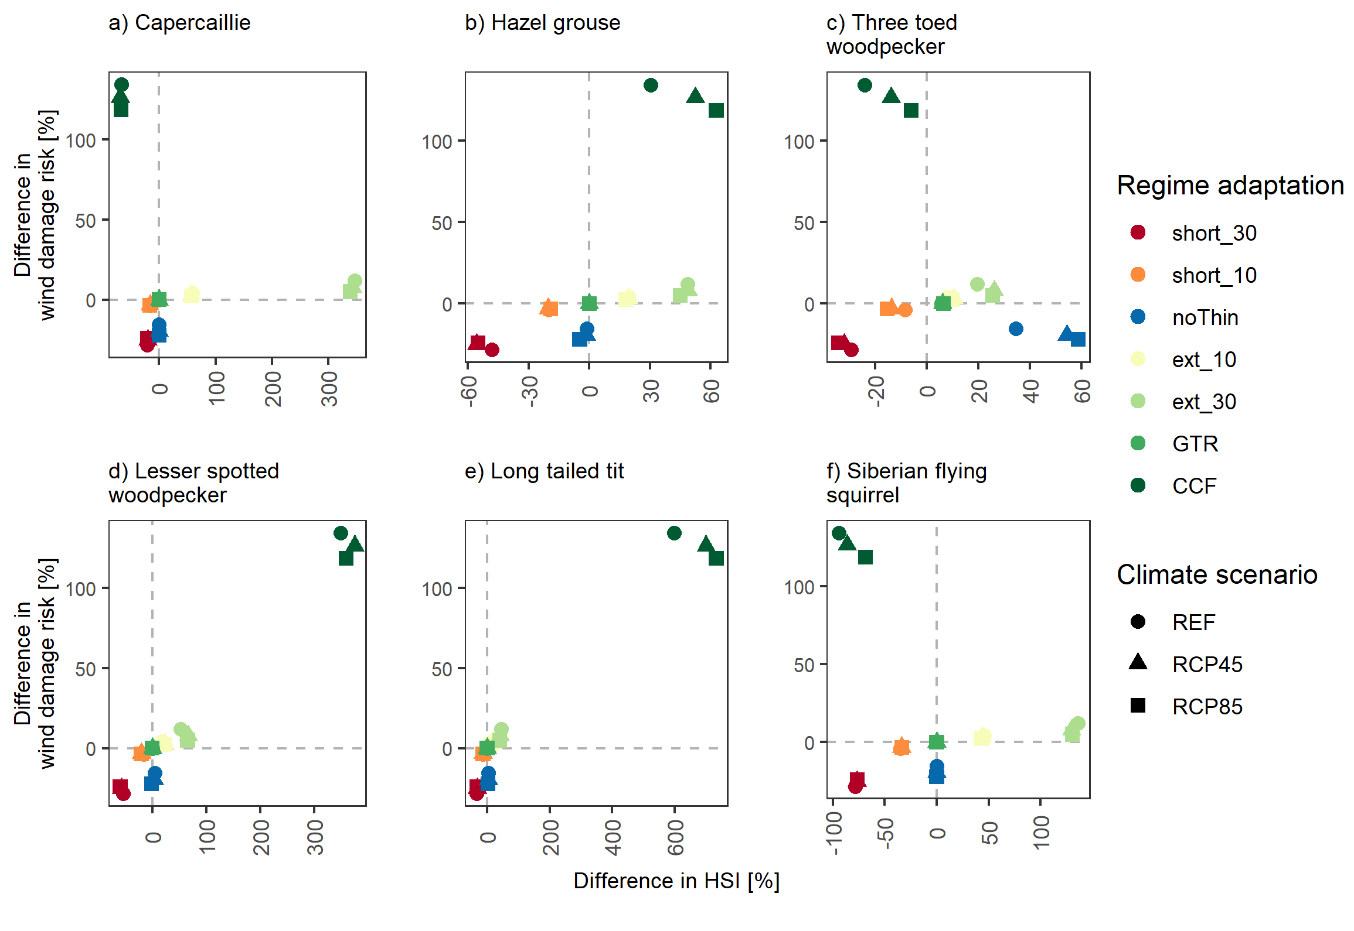
Figure S7 Effects of forest management adaptations on habitat suitability indices (HSI) for individual vertebrate species for each climate scenario., extending the Figure 4 which shows the averages across the climate scenarios. Each point represents the difference relative to the default business as usual (BAU) management adaptation for wind damage probability (y-axis) and species-specific HSI (x-axis). Dashed grey lines represent no difference from BAU. Point color indicates management regime and shape indicates climate scenario (refer to legend). REF – reference climate, RCP – Representative Concentration Pathway, CCF – Continuous Cover Forestry, GTR – Green Tree Retention, ext_30 and ext_10 are extension of rotation length by 30 or 10 years, respectively, noThin – no thinning, short_10 and short_30 are shortening of rotation length by 10 and 30 years, respectively. For full regime descriptions, refer to Table 2 in main text.
Note different ranges of x-axes.

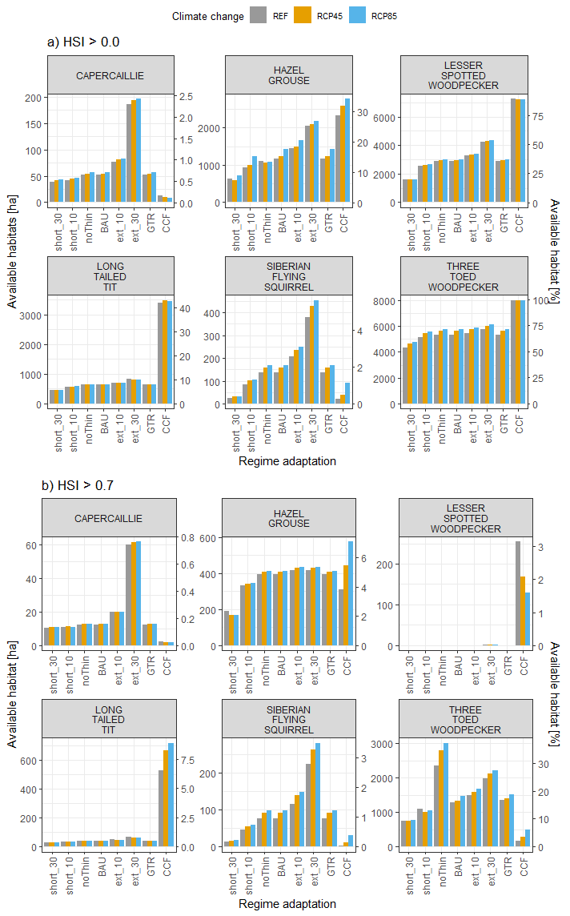
Figure S8 Effects of forest management adaptations on available species habitats for individual vertebrate species for each climate scenario and management regime. Suitable habitats were defined at two thresholds of habitat suitability index (HSI) for each species: as suitable, we have considered HSI > 0.0 (upper) and HSI > 0.7 (lower). Bars represent the area (in hectares, left y axis) and share (%, right y axis) of the suitable habitats from the total forest extent. REF – reference climate, RCP – Representative Concentration Pathway, CCF – Continuous Cover Forestry, GTR – Green Tree Retention, ext_30 and ext_10 are extension of rotation length by 30 or 10 years, respectively, noThin – no thinning, short_10 and short_30 are shortening of rotation length by 10 and 30 years, respectively. Species common and scientific names: capercaillie (Tetrao urogallus), hazel grouse (Tetrastes bonasia), three-toed woodpecker (Picoides tridactylus), lesser-spotted woodpecker (Dryobates minor), long-tailed tit (Aegithalos caudatus), Siberian flying squirrel (Pteromys volans). For full regime descriptions, refer to Table 2 in main text.Note different ranges of y-axes.

