Enhanced interannual drought resilience in mixed stands: unveiling possible complementarity effects between tree species of the Spanish Northern Plateau
European Journal of Forest Research
Przemysław A. Jankowski, Rafael Calama, Guillermo Madrigal, Marta Pardos
Institute for Forest Research (ICIFOR, INIA-CSIC), Ctra A Coruña km 7.5., Madrid 28040, Spain
Corresponding author. Przemysław A. Jankowski, przemyslawjankow@gmail.com

SPEI interpretation.
SPEI is a multiscalar drought index derived from the accumulated climatic water balance, calculated up to and including specific month. SPEI quantifies the deviation of the water balance from the established norm for a given period, in this study, 1996-2021. SPEI < 0 indicate dry conditions, SPEI = 0 represents normal conditions while SPEI > 0 indicate wet conditions. For instance, an SPEI₋₃ ≈ - 2, as observed in March 2012, signifies that the accumulated water balance from January to March 2012 was two standard deviations below the average for the 1996-2021 reference period, indicating significantly drier conditions (Table S2).

Plot backdating method.
The diameter at breast height (DBH) the non-cored trees had in the past years was crucial in order to completely reconstruct the past competition circumstances. The past DBH was derived from basal area increment (BAI). Separate models able to predict BAI for each timespan were constructed. The calculation of the diameter in year y is performed in several steps by a function written in R for Statistical Computing environment (R Core Team 2022), as follows:
a) Model Formulation: For each plot and species, a linear regression model is fitted for 5-year increments, represented as:
$log({BAI}_{timespan}) = α + β * log({DBH}_{2021}) + ε$ (1)
This model predicts the BAI based on the current DBH (in 2021).
b) Time Span Recognition: The function identifies the appropriate time span that includes the target year (y) for DBH reconstruction. For instance, to reconstruct DBH for a year within 2016-2021, the corresponding model for this period is employed.
c) BAI Calculation: The model computes the logarithm of BAI for the relevant period, such as 2021-2016.
d) Annual Increment Conversion: The logarithmic BAI result is then converted to an annual increment attained in a 5-year period, defined as:
${BAIav}_{timespan} = {log({BAI}_{timespan})}/5$ (2)
e) Increment Calculation: Using the average annual BAI for the period, the function calculates the total BAI from the present year (2021) to the target year (y):
${BAI}_{period} = {BAIav}_{timespan }× (2021 – y)$ (3)
e) Current Basal Area Estimation: The basal area of the tree in the present year (2021) is estimated:
${BA}_{2021} = {({DBH}_{2021})}^{2}×π/4$ (4)
f) Past Basal Area Determination: The basal area up to the target year is obtained by subtracting the BAI of the intervening period from the current basal area:
${BA}_{to.year }= {BA}_{2021 }– {BAI}_{period}$ (5)
g) The last step consists in transformation of the basal area on year y into diameter:
${DBH}_{y} = \sqrt{{(4× {BA}_{to.year}) }/π }$ (6)
For years prior to 2016, the method adapts by using the corresponding model for that timespan. For example, to estimate the DBH in 2012, the model for 2021-2016 first calculates the DBH for 2016. This DBH₂₀₁₆ value is then used as input for the model covering 2016-2011 to ultimately derive the desired DBH for 2012.

Table S1. Monthly average values of some principal climatic variables for the period 1996 -2021 measured on the meteorological station “Valbuena del Duero”, 5 km from the study site.
Month | T.avg. [°C] | T.min [°C] | T.max [°C] | Radiation [MJ/m2] | Precipitation sum [mm] | PET_{P-M} [mm] | CWB_{P-M} [mm]
I | 3.7 | -3.8 | 10.1 | 6.06 | 47.36 | 26 | 21.36
II | 5.2 | -4.4 | 15.2 | 9.93 | 26.75 | 40.54 | -13.79
III | 8.1 | -0.7 | 20.4 | 15.1 | 34.5 | 78.49 | -44
IV | 10.5 | 1.4 | 21.1 | 18.74 | 47.12 | 95.19 | -48.07
V | 14.3 | 3.8 | 24.2 | 23.4 | 45.03 | 129.15 | -84.12
VI | 19.1 | 8.2 | 30.7 | 26.37 | 27.4 | 168.06 | -140.66
VII | 21.6 | 10 | 32.5 | 27.56 | 18.13 | 193.85 | -175.72
VII | 21.3 | 10.2 | 32.9 | 24.28 | 20 | 176.59 | -156.59
IX | 17.5 | 7 | 29.4 | 18.3 | 26.19 | 118.26 | -92.06
X | 12.6 | 3.3 | 24.1 | 12.13 | 53.74 | 67.41 | -13.67
XI | 7.0 | -1.6 | 15.3 | 7.08 | 48.78 | 34.08 | 14.7
XII | 4.2 | -3.8 | 11.8 | 5.4 | 49.19 | 21.16 | 28.03
PET_{P-M} stands for potential evapotranspiration calculated by Penman – Monteith method. CWB is the climatic water balance, as a result of subtraction Precipitation – PET_{P-M}. T.avg, T.min and T.max refer to average, average minimal and average maximal monthly temperature.

Table S2. The lowest values of monthly SPEI indices within the identified drought years, calculated for accumulated periods of 1, 3, 6 and 12 months.
Drought year | SPEI-1_{min} (month) | SPEI-3_{min} (month) | SPEI-6_{min} (month) | SPEI-12_{min} (month) | Drought classif.  SPEI₋₁ | Drought classif.  SPEI₋₃ | Drought classif.  SPEI₋₆ | Drought classif.  SPEI₋₁₂
1999 | -1.29 (March) | -1.31 (July) | -1.34 (July) | -1.35 (July) | moderate | moderate | moderate | moderate
2002 | -1.44 (August) | - |  | -1.16 (May) | moderate | - | - | moderate
2005 | -1.13 (May) | -1.11 (May) | -1.34 (August) | -1.48 (August) | moderate | moderate | moderate | moderate
2009 | -2.51 (March) | -1.7 (March) | -1.76 (March) | - | extreme | severe | severe | -
2012 | -2.04 (March) | -1.97 (March) | -1.58 (March) | -2.03 (March) | extreme | severe | severe | extreme
2017 | -2.17 (October) | -1.66 (October) | -1.31 (October) | -1.57 (March) | extreme | severe | moderate | severe
The classification of each drought year (Haberstroh and Werner 2022) is given according to the lowest value of each SPEI index. The “-“ symbol means that using the given variant of SPEI a year could not be identified as drought year, as it did not show any month during hydrological season with SPEI ≤ -1.

Table S3. Descriptive statistics of increment cores used as data source, separately for their provenance: type of the stand and species. Jt = Juniperus thurifera; Pp = Pinus pinea;
Pt = Pinus pinaster; Qi = Quercus ilex.
 | Pure stands |  |  |  | Mixed stands
Variable | Jt | Pp | Pt | Qi | Jt | Pp | Pt | Qi
Number of cored trees | 30 | 37 | 37 | 14 | 42 | 81 | 33 | 11
Number of sampled cores/discs | 57 | 74 | 73 | 25 | 88 | 161 | 64 | 22
Mean length of series [years] | 55 | 53 | 33 | 41 | 44 | 51 | 43 | 40
Maximum length of series [years] | 101 | 82 | 38 | 67 | 94 | 114 | 63 | 61
Mean tree ring width [mm] | 0.81 | 2.08 | 3.09 | 0.64 | 1.14 | 2.20 | 2.08 | 0.67
Standard deviation of tree ring width [mm] | 0.54 | 1.31 | 1.81 | 0.48 | 0.63 | 1.43 | 1.59 | 0.52
Mean correlation between sampled cores | 0.39 | 0.69 | 0.69 | 0.38 | 0.43 | 0.59 | 0.44 | 0.43
Mean correlation between series of the same tree | 0.56 | 0.84 | 0.90 | 0.68 | 0.71 | 0.84 | 0.75 | 0.64
Mean correlation with master series | 0.63 | 0.81 | 0.78 | 0.56 | 0.58 | 0.70 | 0.65 | 0.56
Expressed Population Signal (EPS) | 0.96 | 0.99 | 0.99 | 0.91 | 0.97 | 0.99 | 0.97 | 0.91
Synchronous Growth Changes (SGC) | 0.63 | 0.78 | NaN | 0.70 | 0.66 | 0.79 | 0.75 | 0.79

Table S4. Spearman’s rank correlation values (ρ) between considered competition indices (CI) and basal area increment [cm²] values for periods of the last 5 and 10 years.
 | BAI_{2021 – 2016} |  |  |  | BAI_{2021 – 2011}
CI | AOI | HGCI | RVCI | RVCI.H | AOI | HGCI | RVCI | RVCI.H
ρ | -0.382 | -0.649 | -0.131 | -0.011 | -0.382 | -0.656 | -0.131 | 0.001
p -value | <0.001 | <0.001 | 0.022 | 0.853 | <0.001 | <0.001 | 0.022 | 0.988
AOI: Area Overlap Index (Tomé and Burkhart 1989); HGCI: Hegyi Competition Index (Hegyi 1974); RVCI: Rouvinen-Kuuluvainen Competition Index (diameter); RVCI.H: Rouvinen-Kuuluvainen Competition Index (height) (Rouvinen and Kuuluvainen 1997). For both periods, HGCI yields the highest correlation. Testing the probability of false assumption that
ρ = 0 at α = 0.05.

Table S5. Average competition rate (measured by Hegyi Competition Index) experienced by an exemplar single tree of a given species across all sample plots.
Species | Plot | HGCI | Jt_{CI} | Pp_{CI} | Pt_{CI} | Qi_{CI}
Juniperus  thurifera | 1 [m] | 3.84 (10) | 1.06 (3) | 2.27 (5) | 0.00 (0) | 0.43 (2)
Juniperus  thurifera | 2 [m] | 9.24 (8) | 1.04 (1) | 7.24 (6) | 0.00 (0) | 0.90 (1)
Juniperus  thurifera | 7 [p] | 3.91 (9) | 2.68 (7) | 0.99 (2) | 0.00 (0) | 0.00 (0)
Pinus pinea | 1 [m] | 1.65 (28) | 0.42 (9) | 0.71 (8) | 0.00 (0) | 0.39 (11)
Pinus pinea | 2 [m] | 2.37 (36) | 0.30 (12) | 1.83 (14) | 0.00 (0) | 0.13 (10)
Pinus pinea | 3 [m] | 4.51 (30) | 0.00 (0) | 2.47 (12) | 1.56 (13) | 0.23 (5)
Pinus pinea | 4 [p] | 3.29 (17) | 0.01 (0) | 3.19 (17) | 0.00 (0) | 0.01 (0)
Pinus pinea | 5 [p] | 1.47 (20) | 0.00 (0) | 0.40 (3) | 0.86 (14) | 0.12 (3)
Pinus pinea | 7 [p] | 1.62 (22) | 1.20 (19) | 0.26 (2) | 0.00 (0) | 0.03 (1)
Pinus pinaster | 3 [m] | 4.43 (34) | 0.00 (0) | 1.36 (10) | 2.59 (18) | 0.28 (6)
Pinus pinaster | 5 [p] | 2.19 (19) | 0.00 (0) | 0.21 (2) | 1.70 (15) | 0.11 (2)
Quercus ilex | 1 [m] | 8.29 (11) | 1.61 (2) | 4.02 (4) | 0.00 (0) | 2.62 (5)
Quercus ilex | 2 [m] | 13.81 (9) | 1.74 (1) | 8.05 (5) | 0.00 (0) | 3.94 (3)
Quercus ilex | 3 [m] | 8.55 (13) | 0.01 (0) | 3.04 (4) | 4.35 (7) | 1.11 (2)
Quercus ilex | 4 [p] | 8.42 (10) | 0.99 (1) | 5.78 (8) | 0.00 (0) | 1.51 (1)
Quercus ilex | 5 [p] | 6.36 (11) | 0.00 (0) | 0.75 (1) | 4.08 (9) | 1.22 (1)
Quercus ilex | 6 [p] | 8.22 (18) | 0.00 (0) | 0.00 (0) | 0.00 (0) | 8.05 (18)
Quercus ilex | 7 [p] | 4.79 (7) | 1.20 (4) | 1.69 (2) | 0.00 (0) | 1.89 (1)
The total competition index (HGCI) was subdivided into competition coming from neighbours of a certain species (Jt_{CI}, Pp_{CI}, Pt_{CI}, Qi_{CI}). In parentheses () average number of trees competing with the subject tree is given. In [], p comes from pure, m comes from mixed type of the plot. Species which share in stand basal area was less than 1% were excluded (Juniperus communis, Quercus faginea).

Table S6. Average growth recovery time presented separately for each species from each type of the stand (Thurm et al. 2016).
Type of the stand | Species | Average growth recovery time
MIXED | Jt | 1.40
MIXED | Pp | 1.89
MIXED | Pt | 2.06
MIXED | Qi | 1.10
PURE | Jt | 1.69
PURE | Pp | 2.17
PURE | Pt | 1.64
PURE | Qi | 2.17

Table S7. Average values (standard deviation) of each of the four complementary resilience indexes used in the study, calculated for differing reference periods.
Reference period (years) | Resistance | Recovery | Resilience | Relative resilience
2 | 0.60 (±0.27) | 2.08 (±3.71) | 1.00 (±0.44) | 0.40 (±0.41)
3 | 0.64 (±0.28) | 2.04 (±3.91) | 1.02 (±0.42) | 0.38 (±0.43)
4 | 0.63 (±0.26) | 2.04 (±3.89) | 1.00 (±0.28) | 0.37 (±0.33)
5 | 0.62 (±0.25) | 1.93 (±3.46) | 1.00 (±0.25) | 0.36 (±0.32)
6 | 0.63 (±0.24) | 1.93 (±3.85) | 1.01 (±0.25) | 0.37 (±0.32)
7 | 0.65 (±0.24) | 1.86 (±3.57) | 1.00 (±0.19) | 0.34 (±0.29)
8 | 0.64 (±0.24) | 1.89 (±3.55) | 1.00 (±0.16) | 0.34 (±0.28)
The table shows, that the reference period has a limited influence on the complementary resilience indices, calculated for our database. It is important to remember, that: 1) the trees in our plots were not exposed in the last 25 years to any process which could induce a strong growth (i.e. thinning); 2) the majority of the trees we cored were mature trees (Schwarz et al. 2020)
Table S8. Performance statistics of all fitted models in the framework of Hypotheses I & II, tested for all species.
Hypothesis | Response  variable | Conditional  distribution | Model | Random  effects | AIC | ΔAIC | wAIC
I | Rt | Gamma | Eq. 1 | b_{t} + b_{i} | -579.84 | 24.04 | 0.00
 |  |  | Eq. 2 |  | -577.88 | 26.03 | 0.00
 |  |  | Eq. 3 |  | -604.03 | 0.00 | 1.00
 | Rc | Gamma | Eq. 1 | b_{t} + b_{j} + b_{i} | 2994.26 | 5.51 | 0.06
 |  |  | Eq. 2 |  | 2996.19 | 7.48 | 0.02
 |  |  | Eq. 3 |  | 2988.59 | 0.00 | 0.92
 | Rs | Gamma | Eq. 1 | b_{t} | 700.92 | 8.94 | 0.01
 |  |  | Eq. 2 |  | 702.91 | 10.96 | 0.01
 |  |  | Eq. 3 |  | 691.84 | 0.00 | 0.98
 | RRs | Tweedie | Eq. 1 | b_{t} + b_{j} + b_{i} | 620.26 | 0.00 | 0.57
 |  | ξ = 1.35 | Eq. 2 |  | 622.20 | 1.98 | 0.21
 |  |  | Eq. 3 |  | 622.01 | 1.92 | 0.22
II | BAI | Tweedie | Eq. 4 | b_{t} + b_{j} + b_{i} | 7213.29 | 11.24 | 0.00
 |  | ξ = 1.76 | Eq. 5 |  | 7215.26 | 13.25 | 0.00
 |  |  | Eq. 6 |  | 7201.88 | 0.00 | 1.00
The best adjusted model for a given response variable in a hypothesis framework in bold. ξ = Tweedie index parameter (power) (Dunn and Smyth 2018). At the time of computing the performance indicators, the models were fitted via Maximum Likelihood (ML).

Table S9. Performance statistics of all fitted models within the framework of Hypotheses III - V, tested separately for each species.
 |  |  | Juniperus thurifera |  |  |  | Pinus pinea |  |  |  | Pinus pinaster |  |  |  | Quercus ilex
Hypoth. | Response  variable | Model | RE | AIC | ΔAIC | wAIC | RE | AIC | ΔAIC | wAIC | RE | AIC | ΔAIC | wAIC | RE | AIC | ΔAIC | wAIC
III | Rt | Eq. 7 | b_{t} | -57.87 | 0.00 | 0.45 | b_{t} | -797.21 | 37.87 | 0.00 | b_{t} | -184.50 | 35.89 | 0.00 | b_{t} | 42.22 | 0.00 | 0.47
 |  | Eq. 8 |  | -57.25 | 0.69 | 0.32 |  | -800.32 | 34.80 | 0.00 |  | -220.05 | 0.39 | 0.45 |  | 43.16 | 0.94 | 0.29
 |  | Eq. 9 |  | -56.74 | 1.30 | 0.23 |  | -835.17 | 0.00 | 1.00 |  | -220.50 | 0.00 | 0.55 |  | 43.57 | 1.35 | 0.24
 | Rc | Eq. 7 | b_{t} | 451.29 | 0.00 | 0.47 | b_{t} | 1257.57 | 1.64 | 0.24 | b_{t} | 603.36 | 30.00 | 0.00 | b_{t} | 480.43 | 0.00 | 0.65
 |  | Eq. 8 |  | 451.86 | 0.63 | 0.34 |  | 1255.90 | 0.00 | 0.55 |  | 573.57 | 0.20 | 0.48 |  | 482.26 | 1.83 | 0.26
 |  | Eq. 9 |  | 452.89 | 1.74 | 0.19 |  | 1257.88 | 2.02 | 0.20 |  | 573.37 | 0.00 | 0.52 |  | 484.48 | 4.05 | 0.09
 | Rs | Eq. 7 | b_{t} | 140.37 | 3.56 | 0.14 | b_{t} | 131.51 | 2.15 | 0.23 | b_{t} | 38.80 | 3.86 | 0.08 | b_{t} | 155.25 | 0.00 | 0.66
 |  | Eq. 8 |  | 142.14 | 5.39 | 0.05 |  | 133.10 | 3.76 | 0.10 |  | 34.94 | 0.00 | 0.58 |  | 157.38 | 2.13 | 0.23
 |  | Eq. 9 |  | 136.67 | 0.00 | 0.81 |  | 129.30 | 0.00 | 0.67 |  | 35.99 | 1.05 | 0.34 |  | 158.83 | 3.58 | 0.11
 | RRs | Eq. 7 | b_{t} | 115.32 | 0.72 | 0.36 | b_{t} | 160.14 | 0.00 | 0.63 | b_{t} | -35.34 | 0.00 | 0.50 | b_{t} | 181.45 | 1.60 | 0.25
 |  | Eq. 8 |  | 117.31 | 2.78 | 0.13 |  | 162.13 | 2.03 | 0.23 |  | -34.66 | 0.68 | 0.36 |  | 179.85 | 0.00 | 0.56
 |  | Eq. 9 |  | 114.44 | 0.00 | 0.51 |  | 162.98 | 2.93 | 0.15 |  | -32.74 | 2.60 | 0.14 |  | 181.96 | 2.11 | 0.19
IV | BAI | Eq. 10 | b_{t} + b_{j} + b_{i} | 3665.71 | 0.21 | 0.48 | b_{t} + b_{j} + b_{i} | 17060.74 | 0.98 | 0.38 | b_{t} + b_{j} + b_{i} | 11063.48 | 0.00 | 0.95 | b_{t} + b_{i} | 1387.42 | 0.00 | 0.54
 |  | Eq. 11 |  | 3665.53 | 0.00 | 0.52 |  | 17059.78 | 0.00 | 0.62 |  | 11069.34 | 5.84 | 0.05 |  | 1387.76 | 0.28 | 0.46
V | BAI | Eq. 11 |  | 3665.53 | 5.66 | 0.06 |  | 17059.78 | 99.55 | 0.00 |  | 11069.34 | 50.97 | 0.00 |  | 1387.76 | 0.22 | 0.47
 |  | Eq. 12 |  | 3659.87 | 0.00 | 0.89 |  | 16960.23 | 0.00 | 1.00 |  | 11018.37 | 0.00 | 1.00 |  | 1387.54 | 0.00 | 0.53
The best adjusted model for a given response variable within a hypothesis framework in bold. RE refers to random effects structure. At the time of computing the performance indicators, the models were fitted via Maximum Likelihood (ML).

Table S10. Coefficients of regression (standard errors in parenthesis) and quality statistics of the most adequate models (fitted by REML) selected for each species in order to corroborate Hypothesis IV (Eq. 10 - 11).
Significance levels marked as: .0.10 ≤ p < 0.05; * p ≤ 0.05; ** p ≤ 0.01; *** p ≤ 0.001.
Explanatory variable | J. thurifera | P. pinea | P. pinaster | Q. ilex
BA | 0.251*** (0.037) | 0.193*** (0.050) | 0.130*** (0.039) | 0.204** (0.075)
HGCI | - | - | -0.206*** (0.038) | -0.083** (0.026)
CI.inter | -0.082** (0.028) | -0.250*** (0.040) | - | -
CI.intra | -0.067. (0.038) | -0.252*** (0.028) | - | -
CWB | 0.180** (0.061) | 0.233*** (0.050) | 0.206*** (0.058) | 0.337*** (0.061)
Intercept | 1.128*** (0.230) | 3.192*** (0.188) | 3.204*** (4.560) | 0.922*** (0.209)
$${σ }_{f}^{2}$$ | 0.137 | 0.268 | 0.158 | 0.262
${σ }_{YEAR}^{2}$ | 0.095 | 0.064 | 0.056 | 0.083
${σ }_{PLOT}^{2}$ | 0.125 | 0.119 | 0.044 | -
${σ }_{TREE}^{2}$ | 0.110 | 0.110 | 0.102 | 0.231
${σ }_{ε}^{2}$ | 0.101 | 0.084 | 0.137 | 0.234
D₀ | 5829 | 21712 | 13040 | 1757
D_{M} | 3645 | 17119 | 11045 | 1371
D_{Expl.} | 2184 | 4672 | 1995 | 386
ξ | 1.68 | 1.62 | 1.62 | 1.77
R² Marginal | 0.241 | 0.416 | 0.319 | 0.323
R² Conditional | 0.822 | 0.870 | 0.724 | 0.711
Observations | 1443 | 2874 | 1713 | 588
The coefficient estimates and standard errors are given in the link function scale (log_{e}). Basal area of a single tree (BA) and climatic water balance (CWB) are centred with mean = 0 and standard deviation. = 1. ${σ }_{f}^{2}$ = variance explained by fixed effects; $σ_{YEAR/PLOT/TREE}^{2}$ = variance explained by a corresponding random effect;
$σ_{ε}^{2}$ = unexplained variance (random error). D_{Expl.}= deviance explained by the presented model, calculated as: D₀ - D_{M}, where: D₀ = deviance of the null (only intercept) model; D_{M} = deviance of the current model, calculated as: -2× LogLik(M).
ξ = Tweedie index parameter (power). Rest of abbreviates as explained in the text.

Table S11. Coefficients of regression (standard errors in parenthesis) and quality statistics of the most adequate models (fitted by REML) selected for each species in order to corroborate Hypothesis V (Eq. 11 - 12). Significance levels marked as: .0.10 ≤ p < 0.05; * p ≤ 0.05; ** p ≤ 0.01; *** p ≤ 0.001.
Explanatory variable | J. thurifera | P. pinea | P. pinaster | Q. ilex
BA | 0.256*** (0.038) | 0.189*** (0.031) | 0.111** (0.042) | 0.187* (0.074)
CI.inter | -0.073* (0.030) | -0.260*** (0.044) | -0.359*** (0.105) | -0.103. (0.056)
CI.intra | -0.069. (0.039) | -0.270*** (0.031) | -0.170*** (0.047) | -0.096*** (0.028)
CWB | 0.175** (0.061) | 0.215*** (0.050) | 0.171** (0.060) | 0.337*** (0.061)
Intercept | 1.099*** (0.220) | 3.214*** (0.190) | 3.224*** (0.158) | 0.922*** (0.209)
$${σ }_{f}^{2}$$ | 0.134 | 0.274 | 0.181 | 0.281
${σ }_{YEAR}^{2}$ | 0.097 | 0.062 | 0.086 | 0.064
${σ }_{YEAR,CI.intra}^{2}$ | 0.001 | 0.004 | 0.002 | <0.001
${σ }_{YEAR,CI.inter}^{2}$ | 0.001 | 0.006 | 0.058 | 0.004
${σ }_{PLOT}^{2}$ | 0.111 | 0.123 | 0.016 | <0.001
${σ }_{TREE}^{2}$ | 0.120 | 0.112 | 0.114 | 0.227
${σ }_{ε}^{2}$ | 0.177 | 0.070 | 0.140 | 0.223
D₀ | 5829 | 21712 | 13040 | 1757
D_{M} | 3636 | 16936 | 10996 | 1364
D_{Expl.} | 2193 | 4776 | 2044 | 394
ξ | 1.69 | 1.61 | 1.56 | 1.73
R² Marginal | 0.294 | 0.465 | 0.388 | 0.379
R² Conditional | 0.784 | 0.882 | 0.722 | 0.717
Observations | 1443 | 2874 | 1713 | 588
The coefficient estimates and standard errors are given in the link function scale (log_{e}). Basal area of a single tree (BA) and climatic water balance (CWB) are centred with mean = 0 and standard deviation. = 1. ${σ }_{f}^{2}$ = variance explained by fixed effects; $σ_{YEAR/PLOT/TREE}^{2}$ = variance explained by a corresponding random effect; $σ_{ε}^{2}$ = unexplained variance (random error).
D_{Expl.}= deviance explained by the presented model, calculated as: D₀ - D_{M}, where: D₀ = deviance of the null (only intercept) model; D_{M} = deviance of the current model, calculated as: -2× LogLik(M).
ξ = Tweedie index parameter (power).
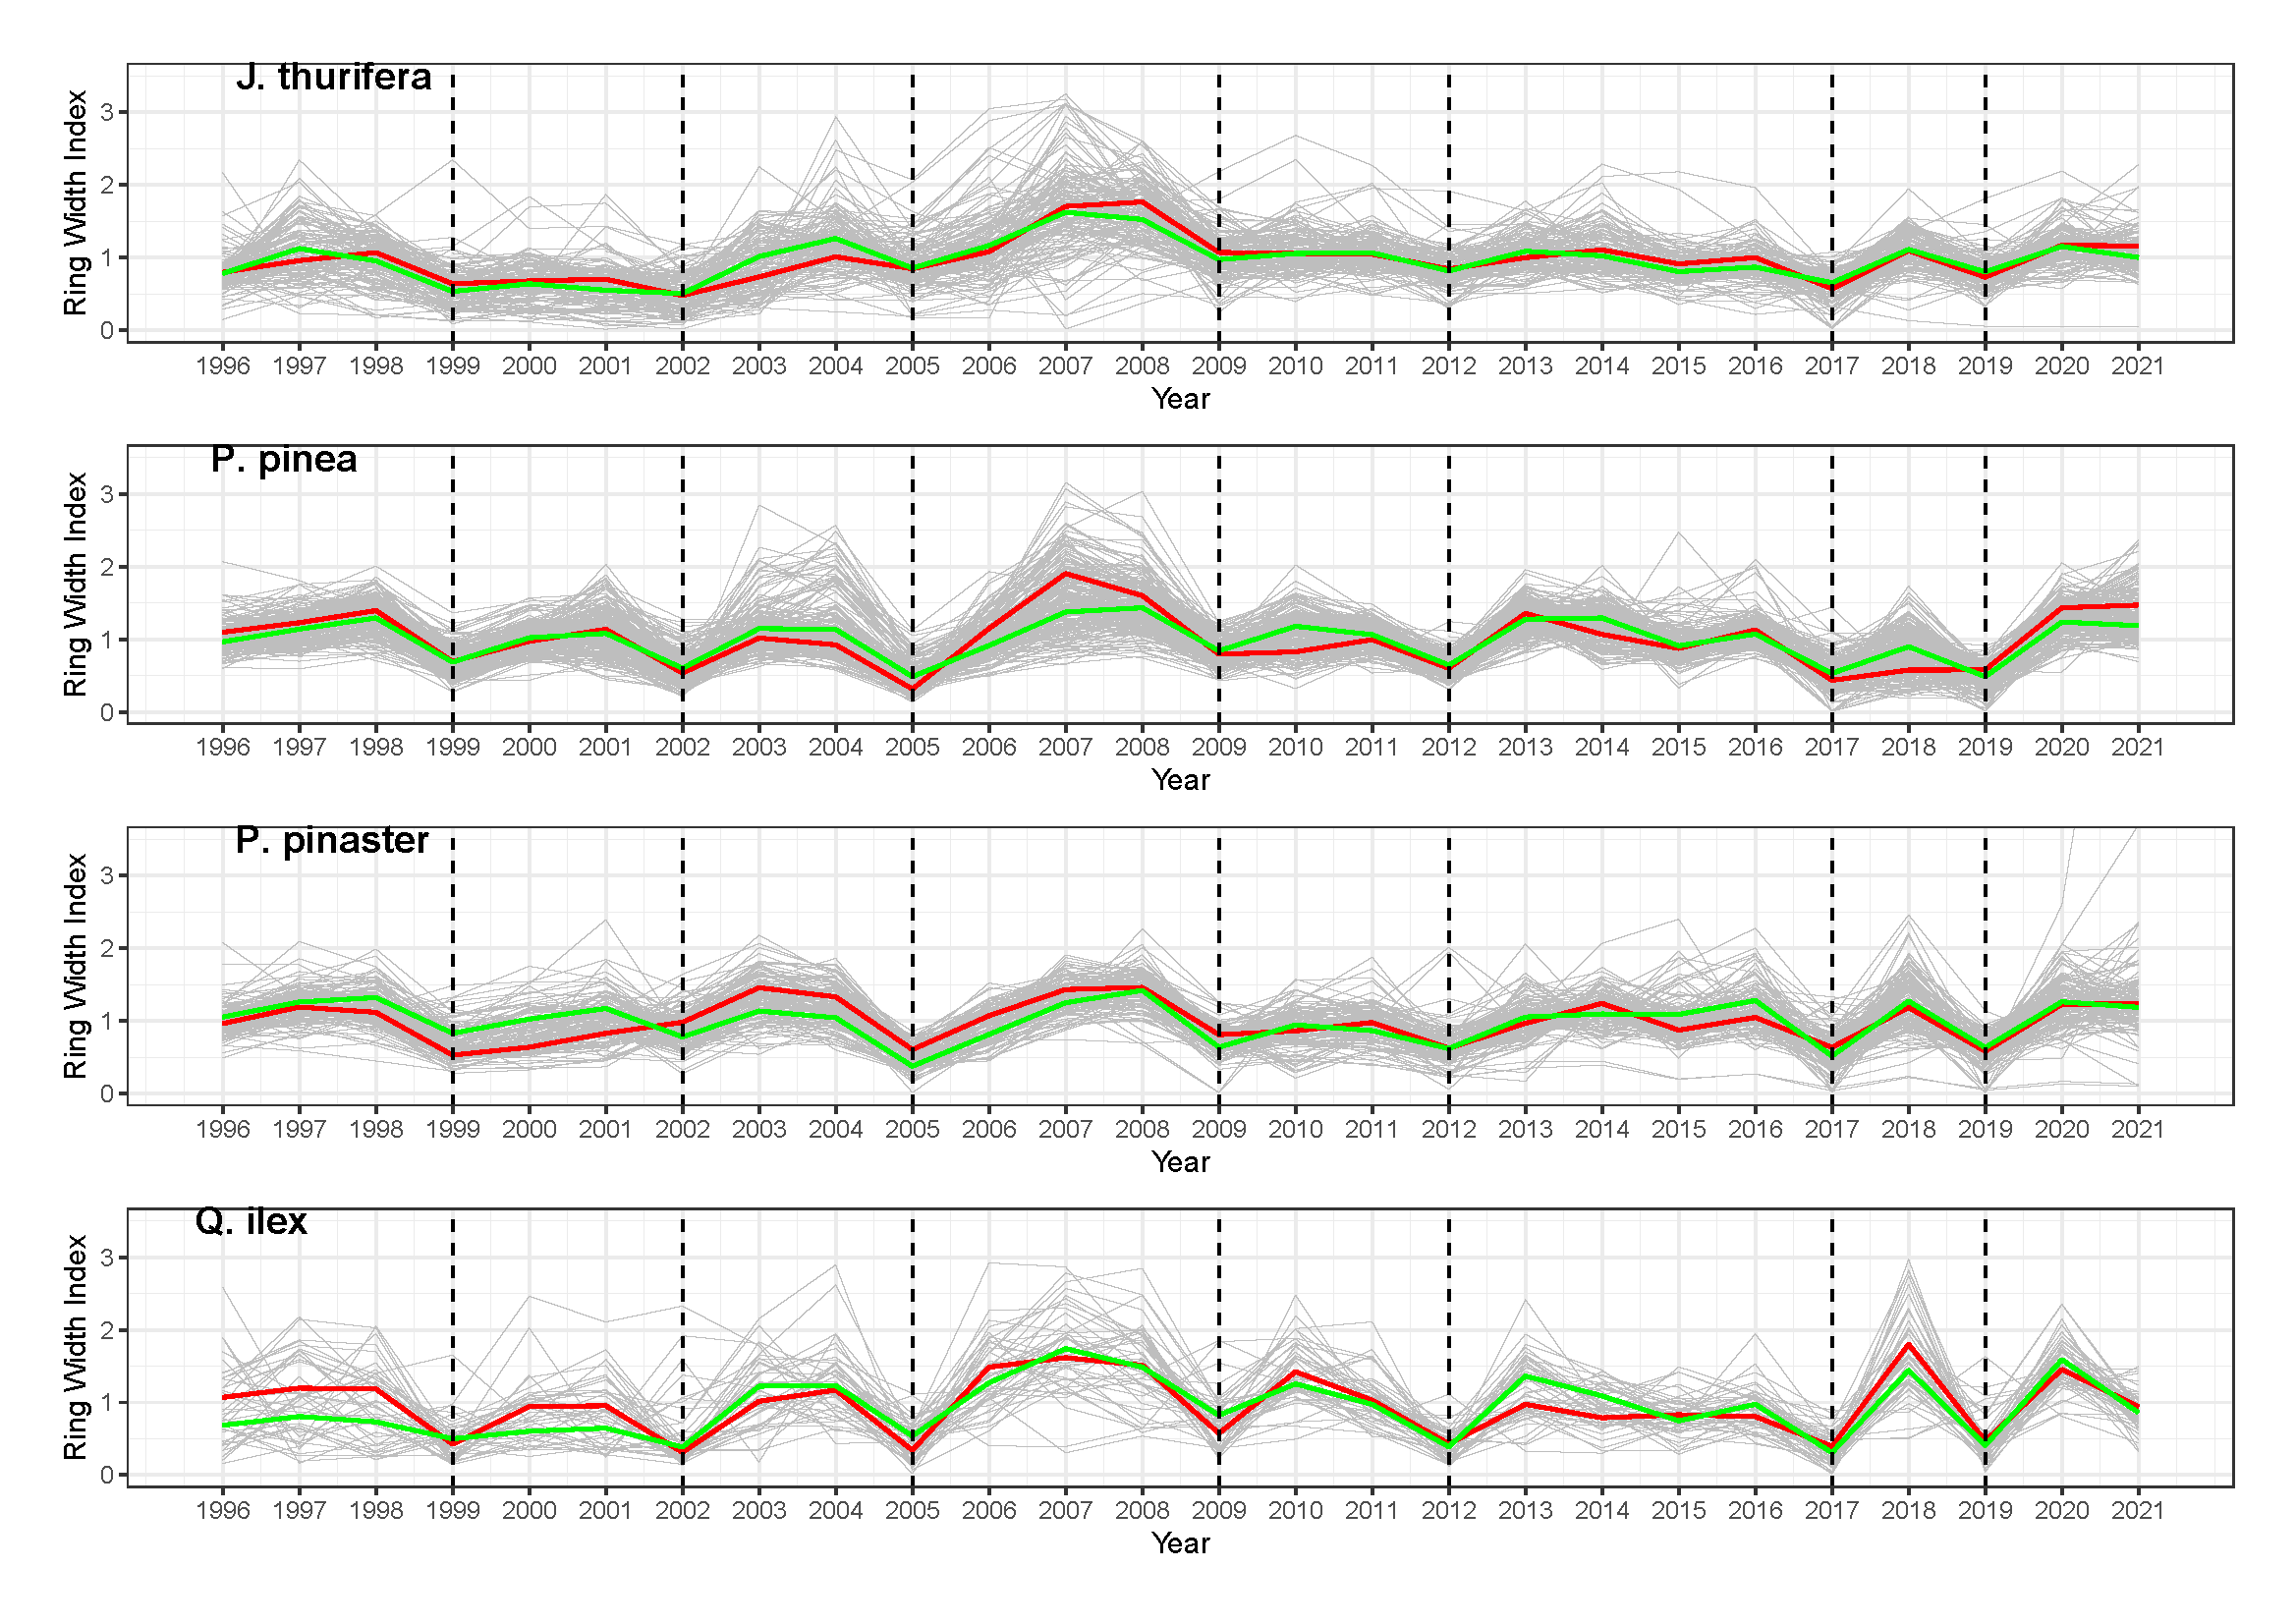
Figure S1. Tree ring width index series (grey lines), plotted against master chronologies built on ring width indexes of trees from pure stands (red line) and mixed stands (green line), separately for analysed species. Drops in RWI values correspond perfectly with identified drought years (dashed vertical black lines).
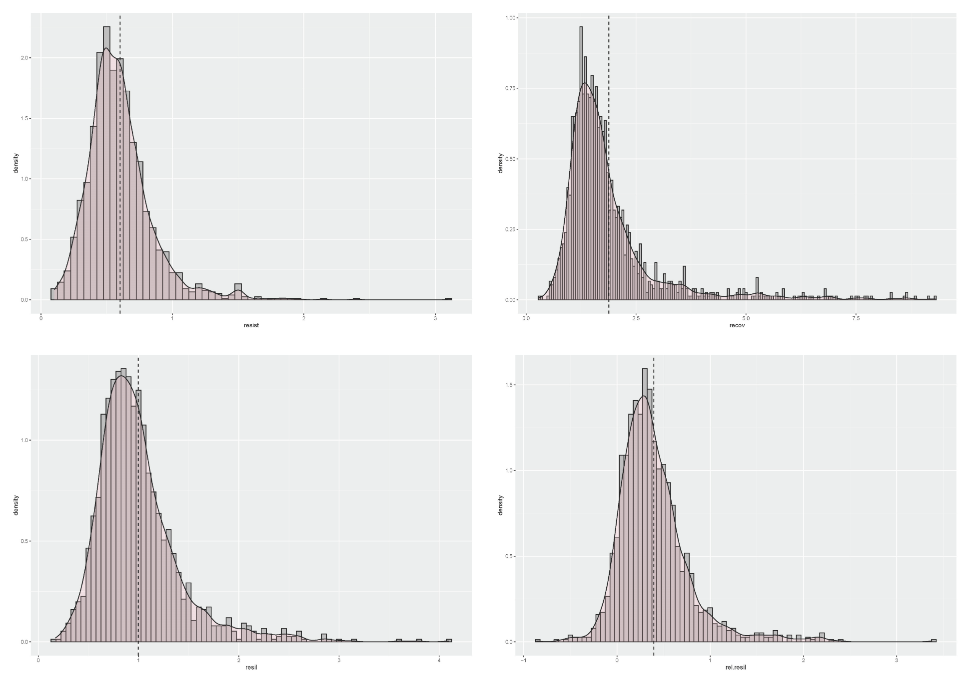
Figure S2. Density distributions of the four complementarity resilience indices used as the response variables in Hypothesis I and separately for each species in Hypotheses III & IV. Vertical dashed black lines represent the mean value of each variable. A smoothing kernel has been applied to each distribution to better visualize the data trend. Resist = resistance; recov = recovery; resil = resilience; rel.resil = relative resilience. The width of the bins of the histogram set to 0.05. Right skewness of the distributions can be observed, which justifies the selection of Gamma or Tweedie conditional distributions for modelling those variables.
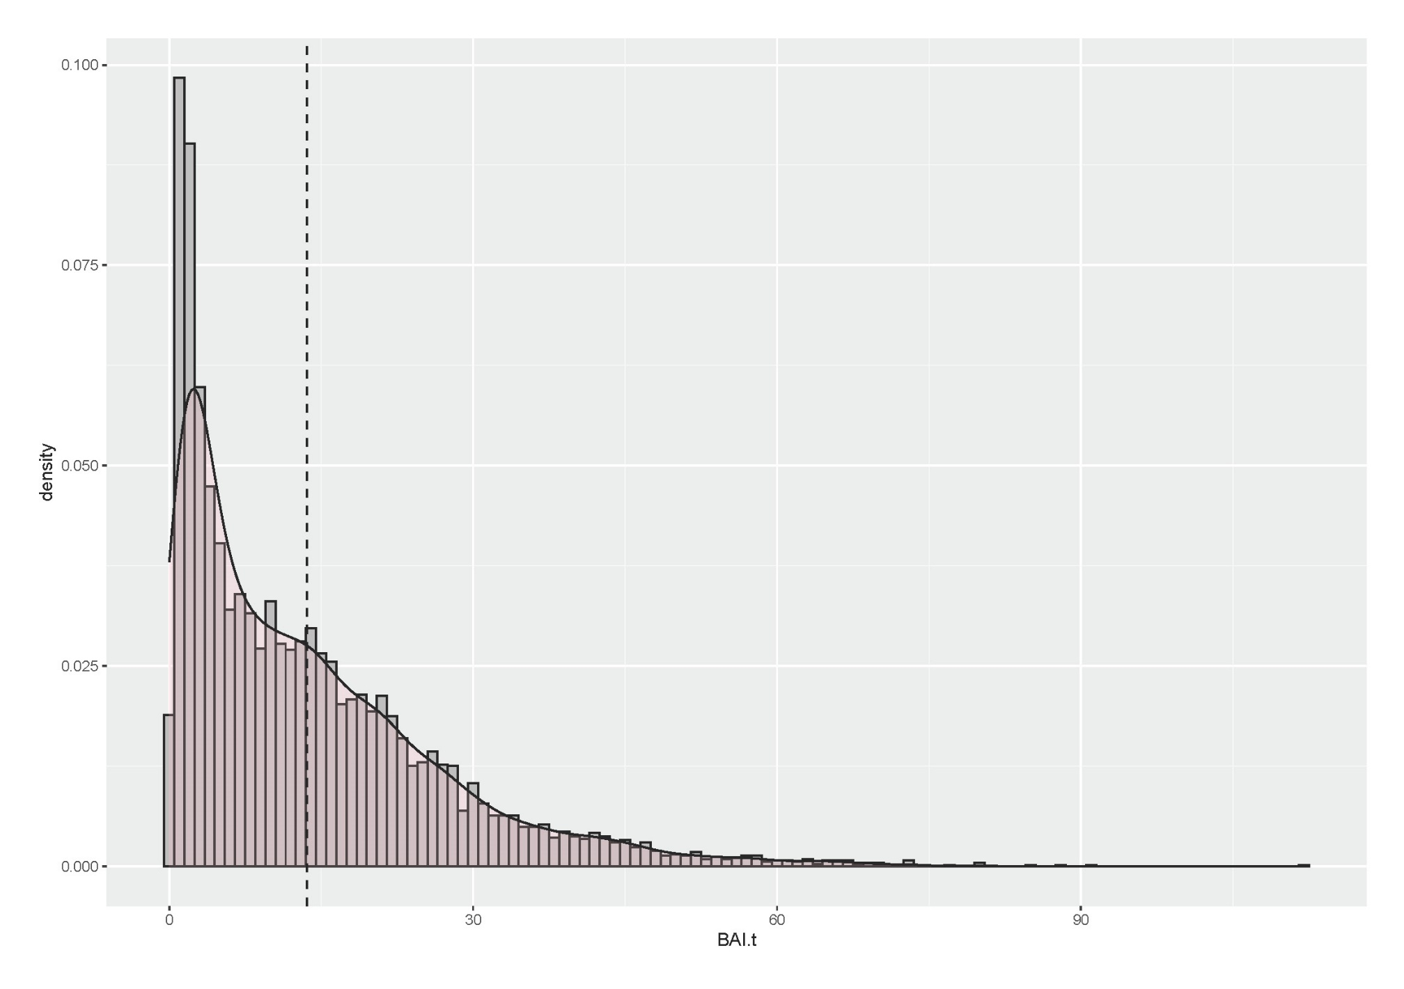
Figure S3. Density distribution of the annual basal area increment (BAI.t) used as the response variable in Hypothesis II and separately for each species in Hypotheses IV & V. Vertical dashed black lines represent the mean value of each variable. A smoothing kernel has been applied to the distribution to better visualize the data trend. The width of the bins of the histogram set to 1 cm² year⁻¹. Right skewness of the distribution can be observed, which justifies the selection of Gamma or Tweedie conditional distributions for modelling that variable.
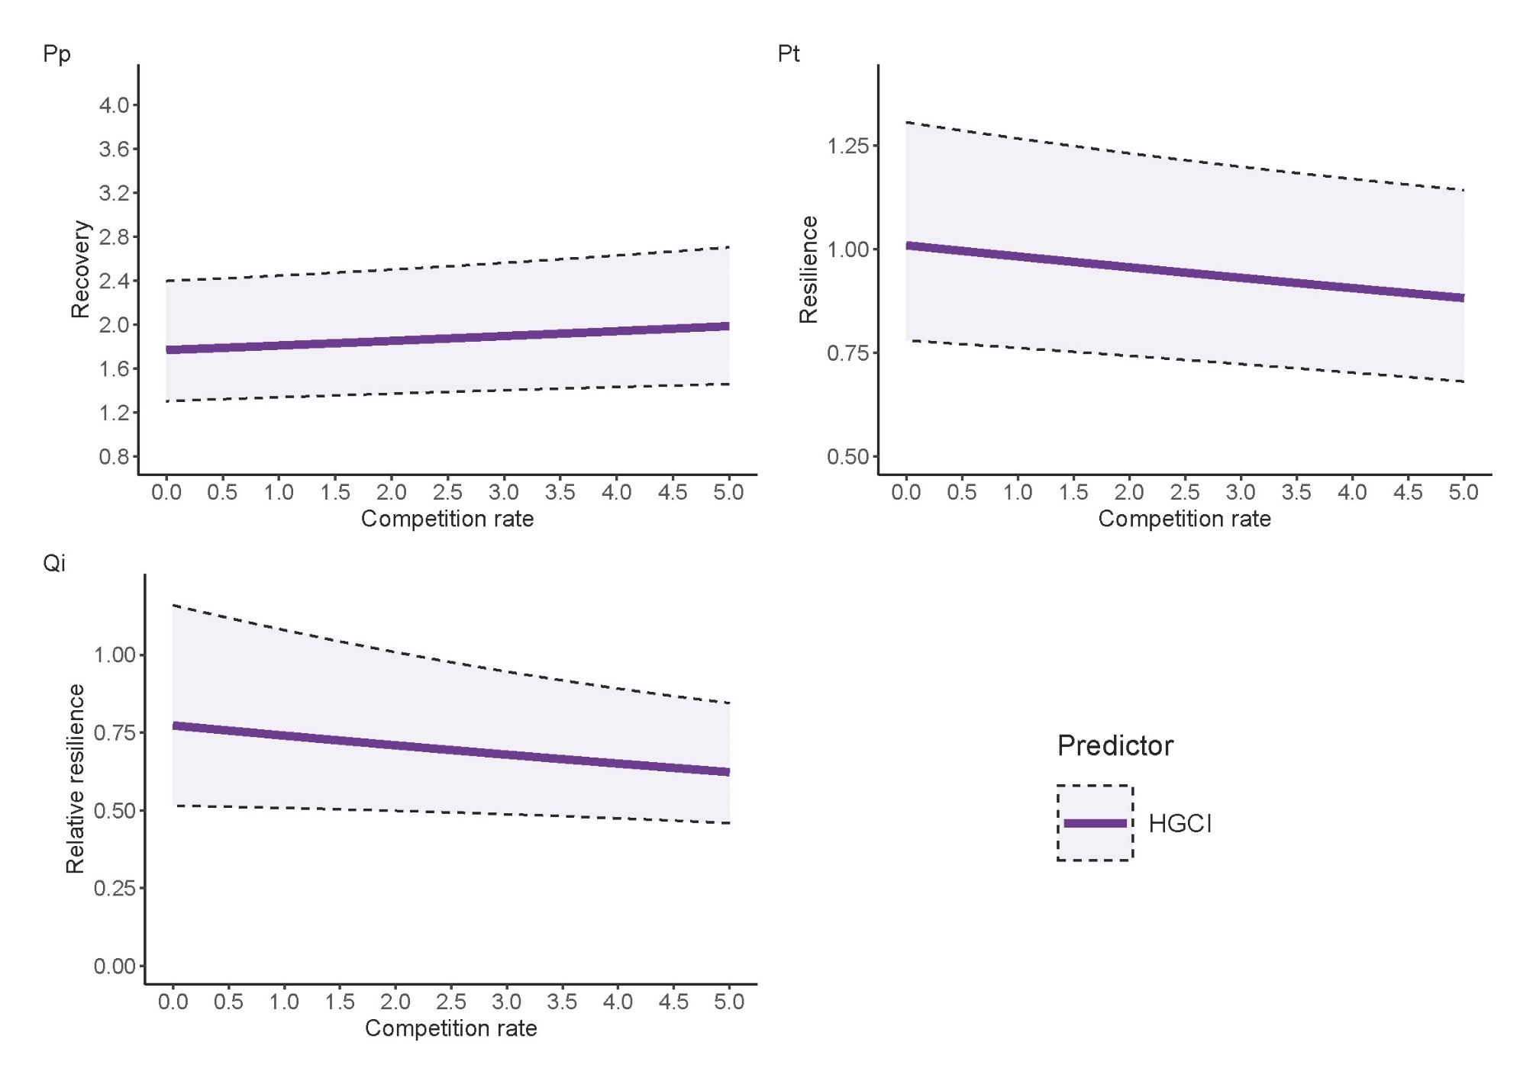
Figure S4. Predictions of recovery, resilience and relative resilience (solid line) conditioned on overall competition rate (HGCI), across the species for which that predictor resulted to be significant (Hypothesis III, Eq. 7 – 9, Table 5). Confidence intervals (95%) are represented by the dashed lines. DBH was maintained at its mean value. Predictions made only accounting for fixed effects.
Figure S5. Predictions for annual basal area increment (BAI) at single tree level (solid line) conditioned on: a) intra – specific competition rate (CI.intra); b) inter – specific competition rate (CI.inter) or overall competition rate (HGCI) (Hypothesis IV, Eq. 10 - 11). 95% confidence intervals enclosed between dashed lines. All other predictors held at their mean values. Competition indices (CI.intra/inter or HGCI) were left at their original (observed) scale. In Pt & Qi models CI.intra/inter predictors not present. Predictions do not take into account random effects.

