SUPPELENTARY METARIALS FOR:
Assessment of soil CO₂, CH_{4,} and N₂O fluxes and their drivers, and their contribution to the climate change mitigation potential of forest soils in the Lublin region of Poland
Anna Walkiewicz, Piotr Bulak, Mohammad I. Khalil, Bruce Osborne

Fig. S1 Monthly measured variations in soil CO₂ fluxes (mean ± sd) and soil temperature (mean) based on two years of measurements in ten different forests (sites are labelled F1 to F10; see Table 1).
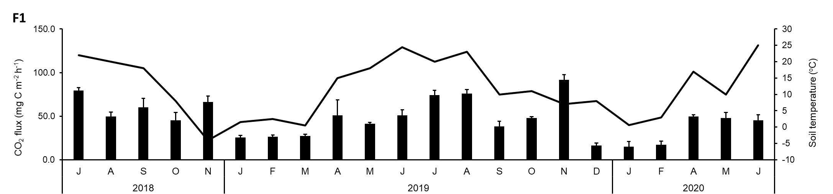

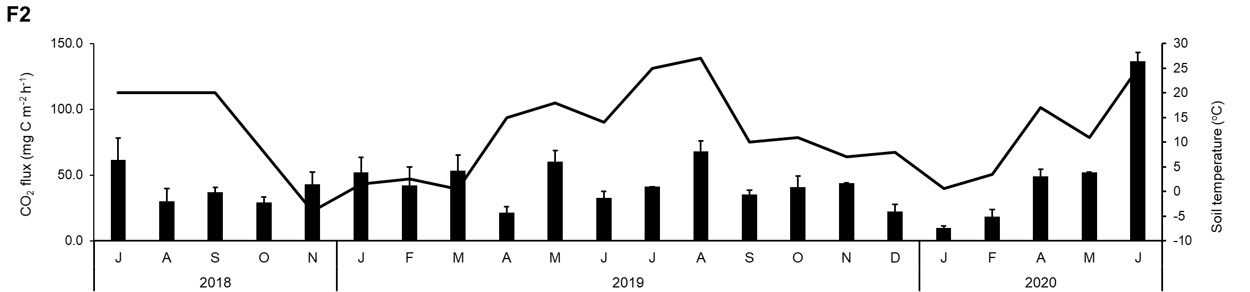
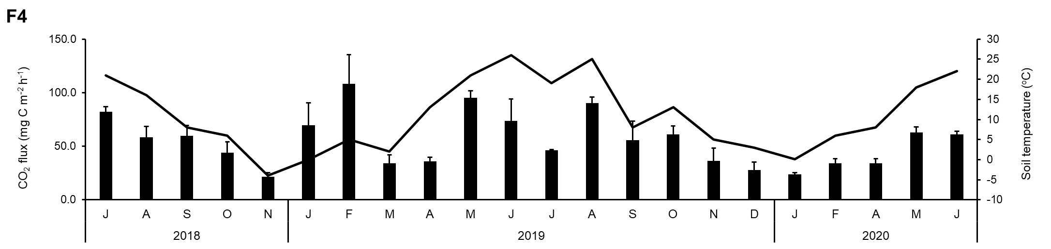
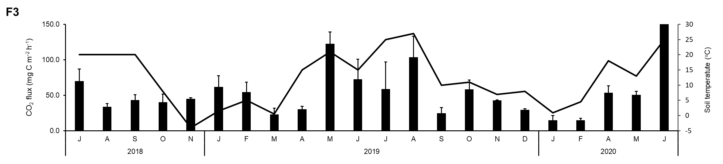
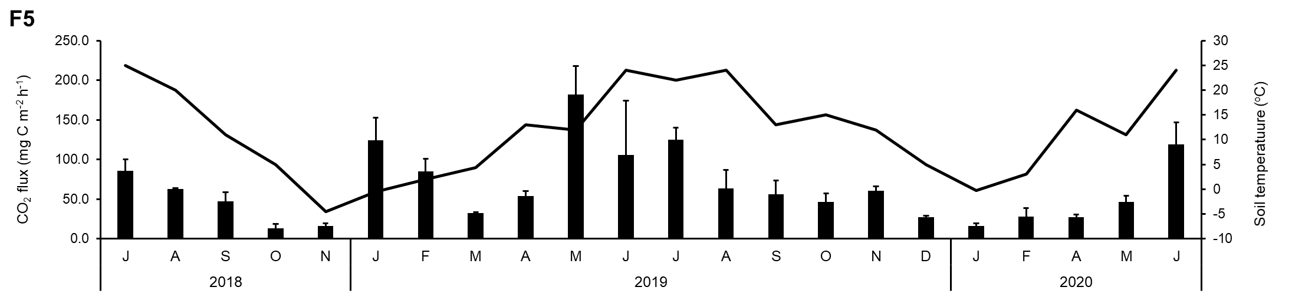

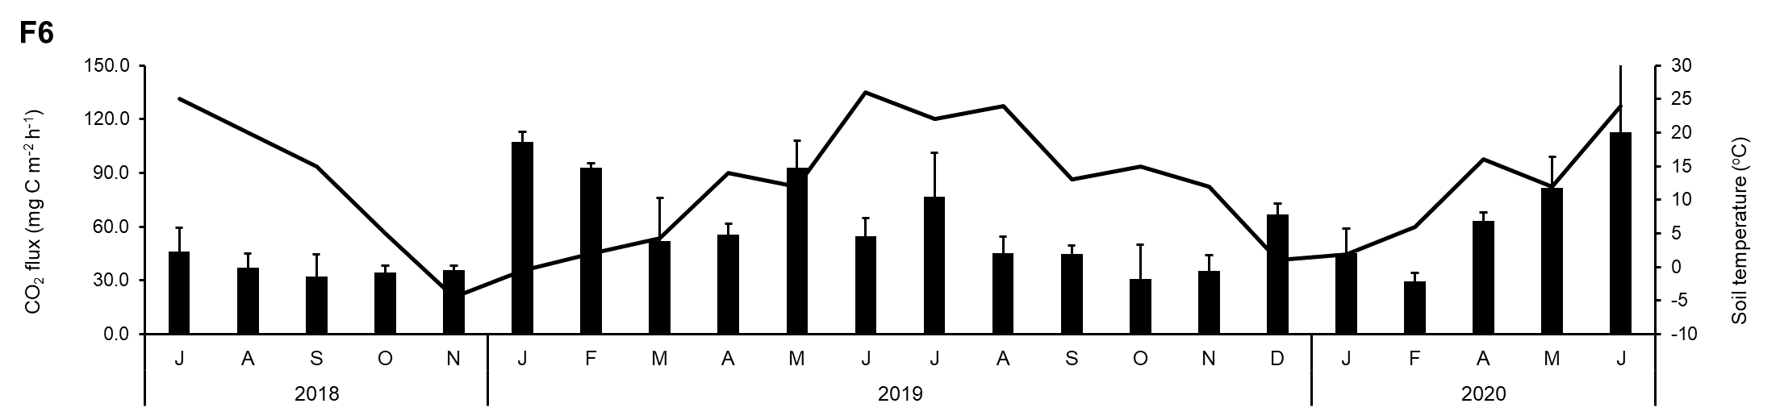

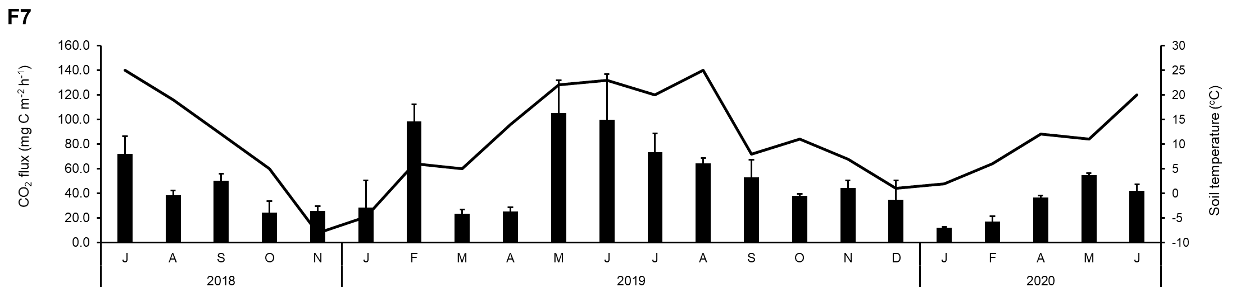

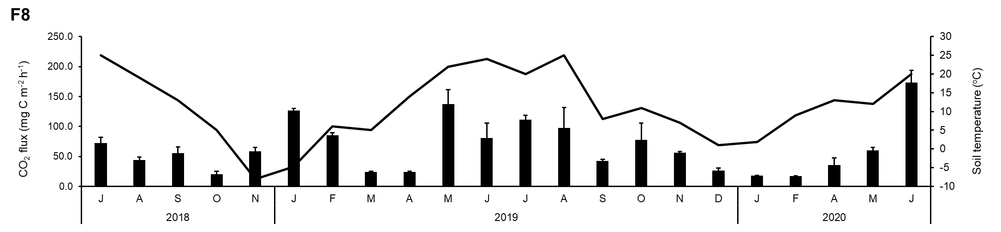

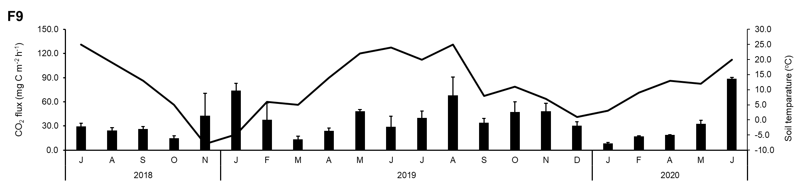

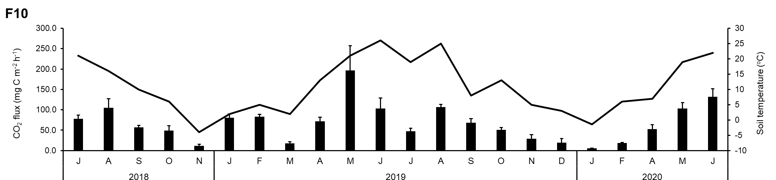

Fig. S2 Monthly measured variantions in soil CH₄ fluxes (mean ± sd) based on two-years of measurements in ten different forests (sites are labelled F1 to F10; see Table 1).
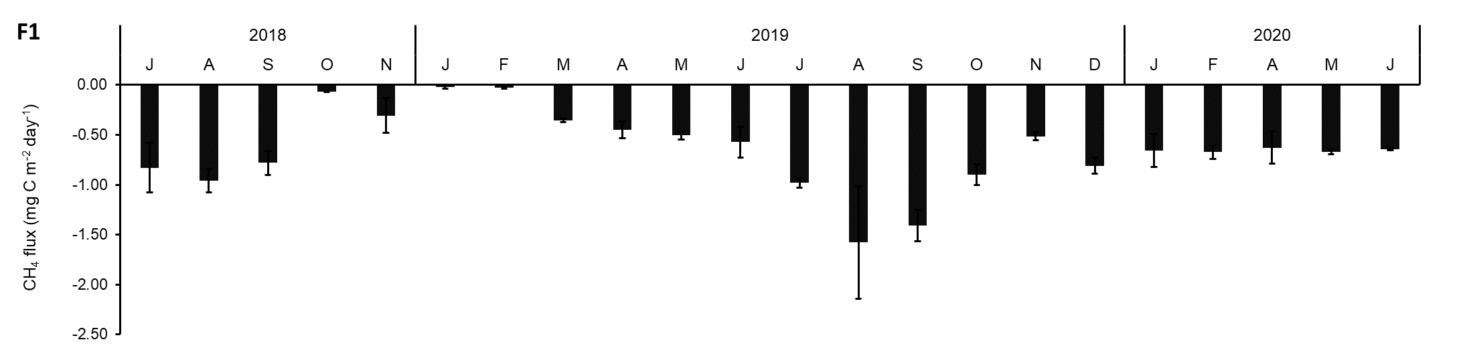

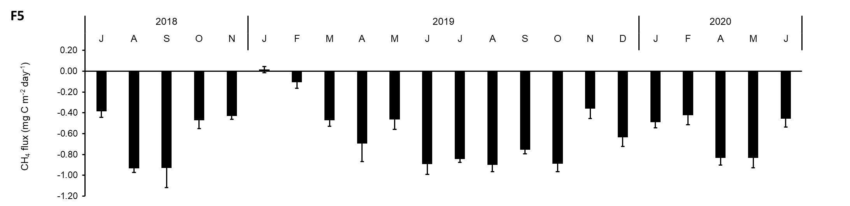
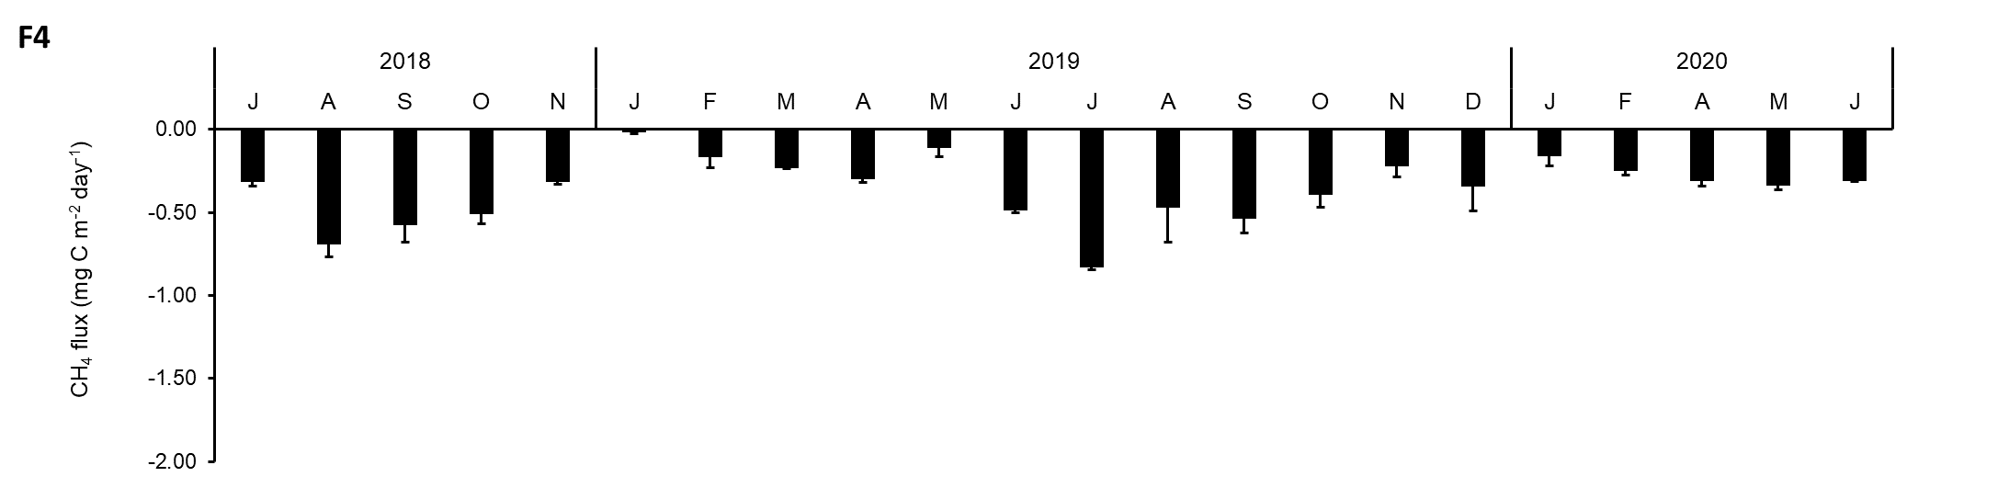
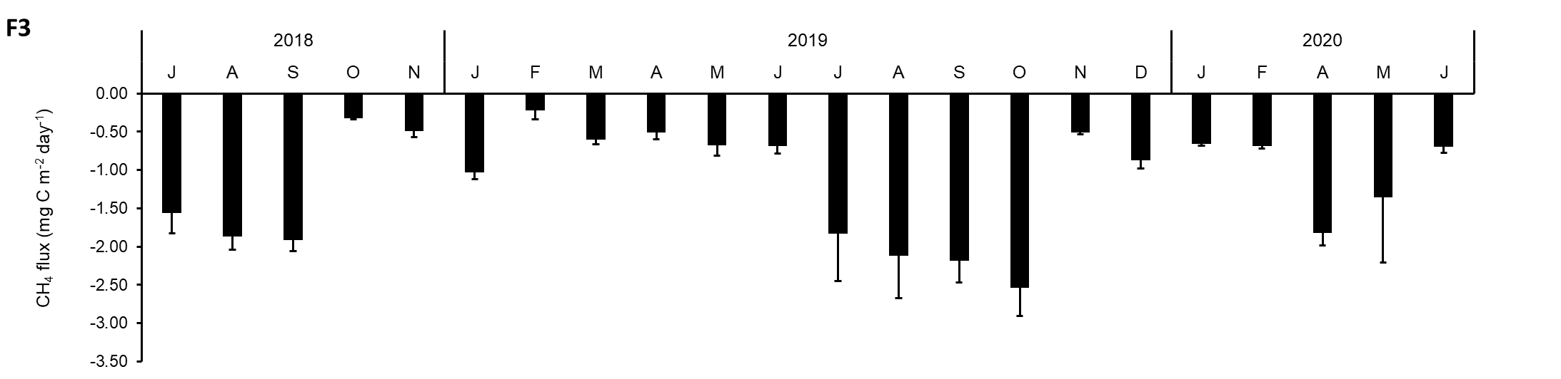
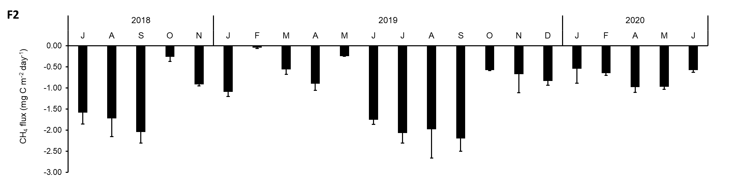
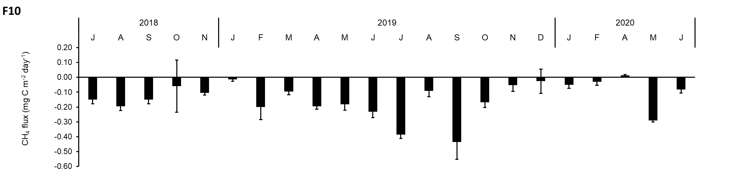
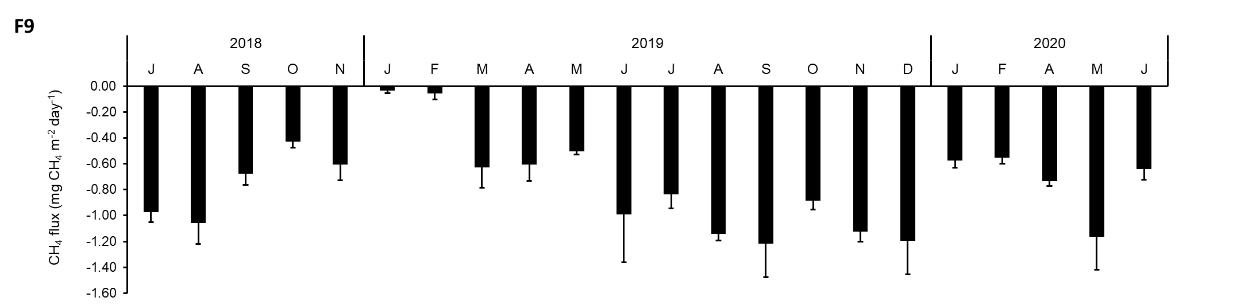
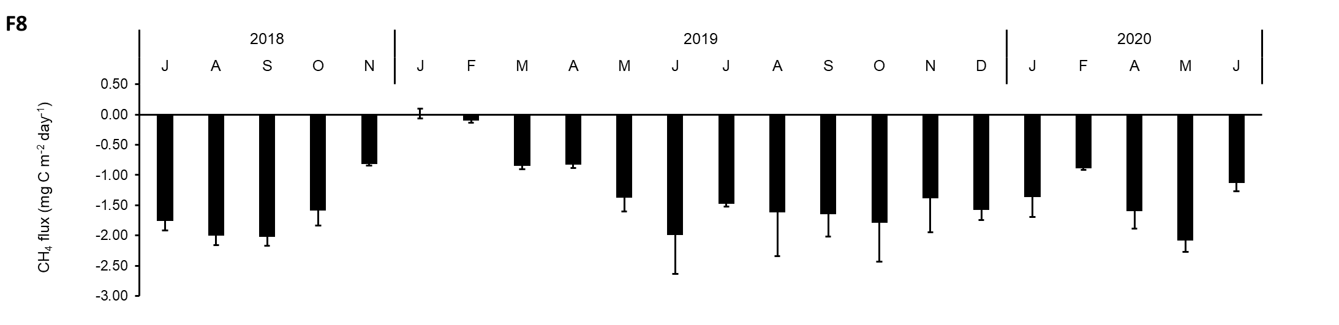
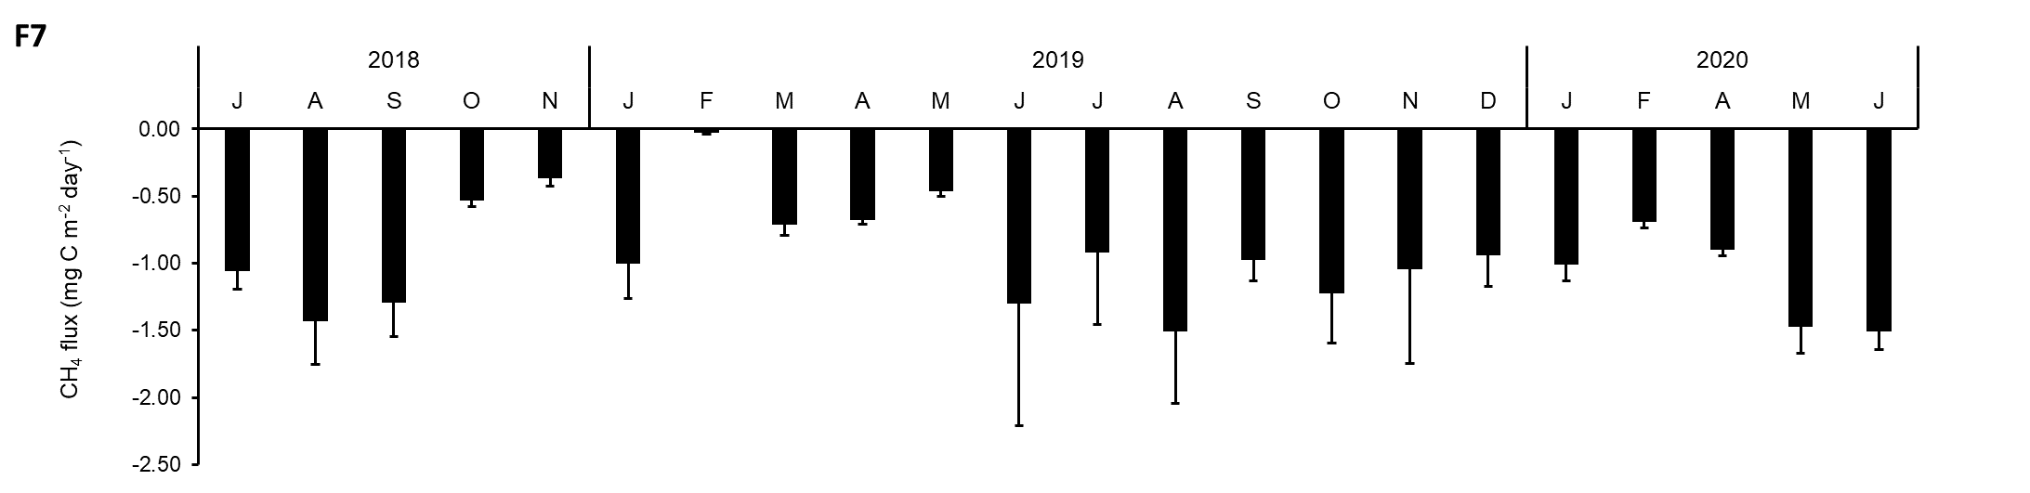
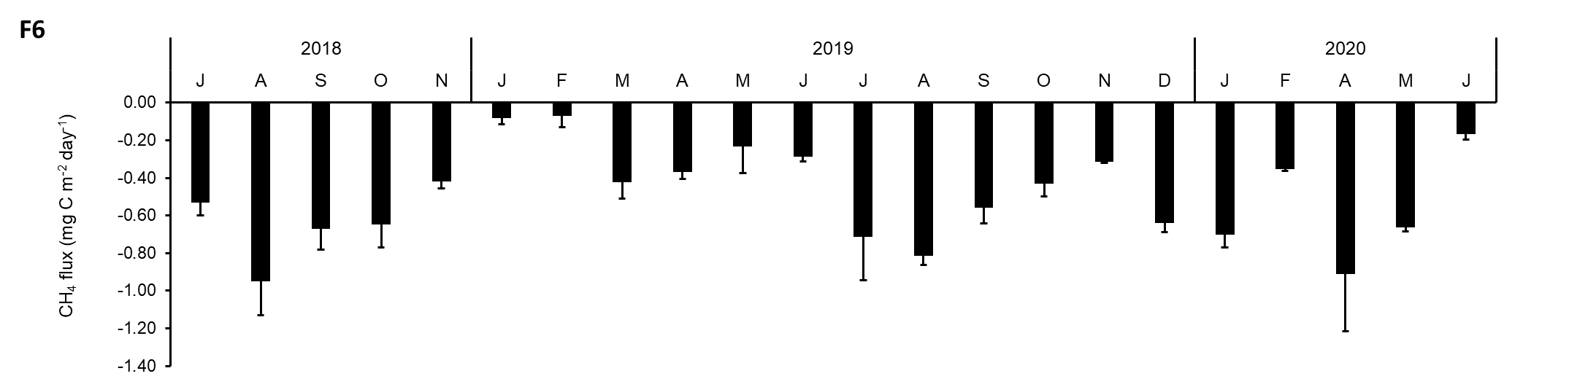
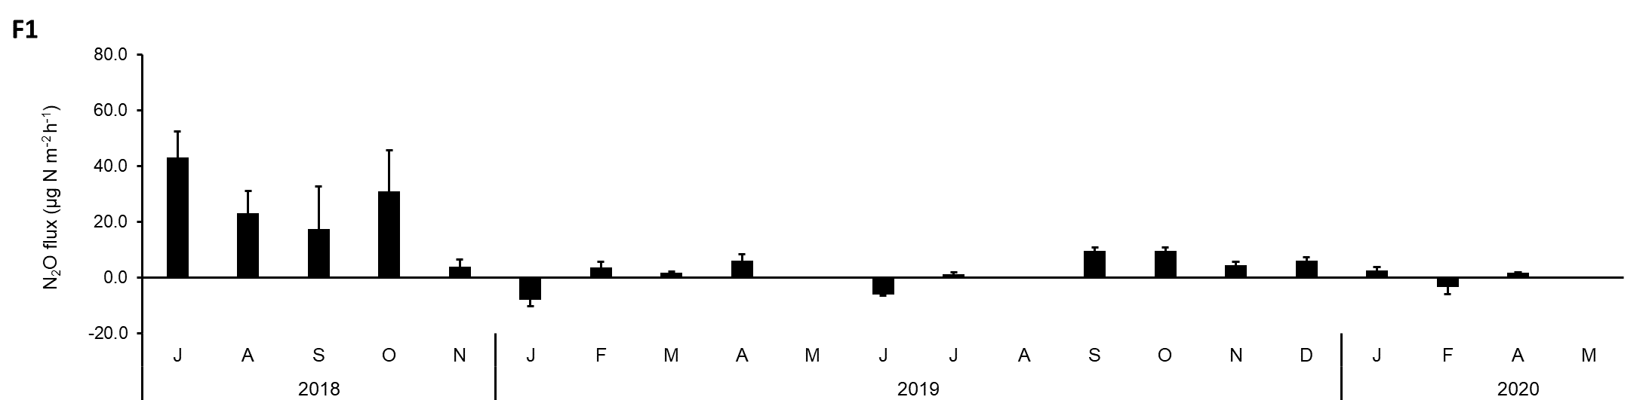
Fig. S3 Monthly measured variations in soil N₂O fluxes (mean ± sd) based on two years of measurements in ten different forests (sites are labelled F1 to F10; see Table 1).

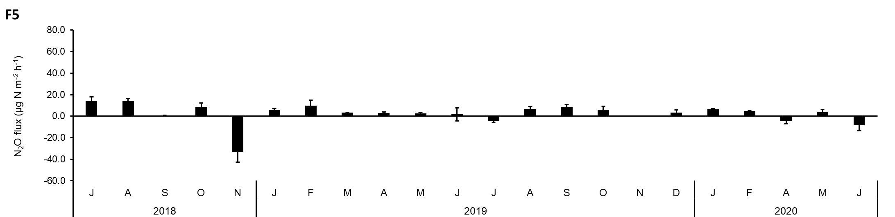
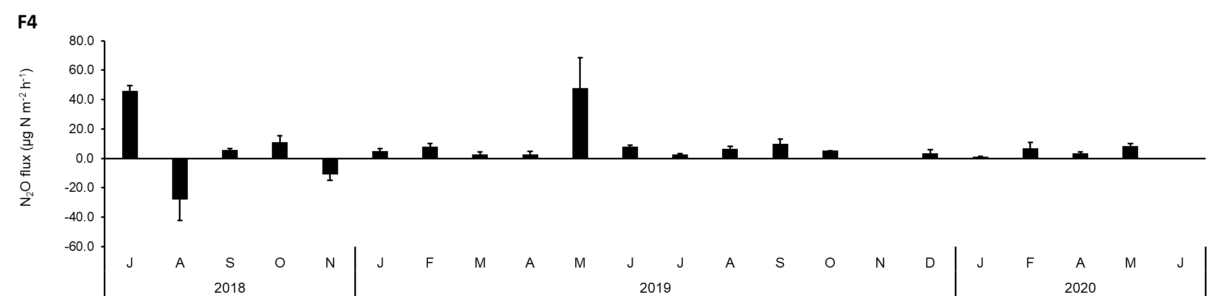
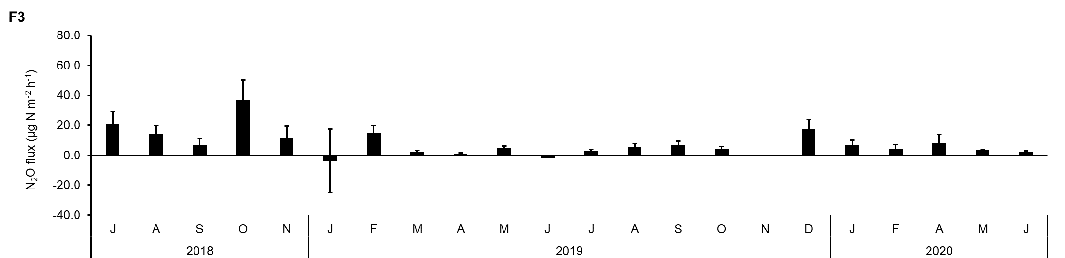
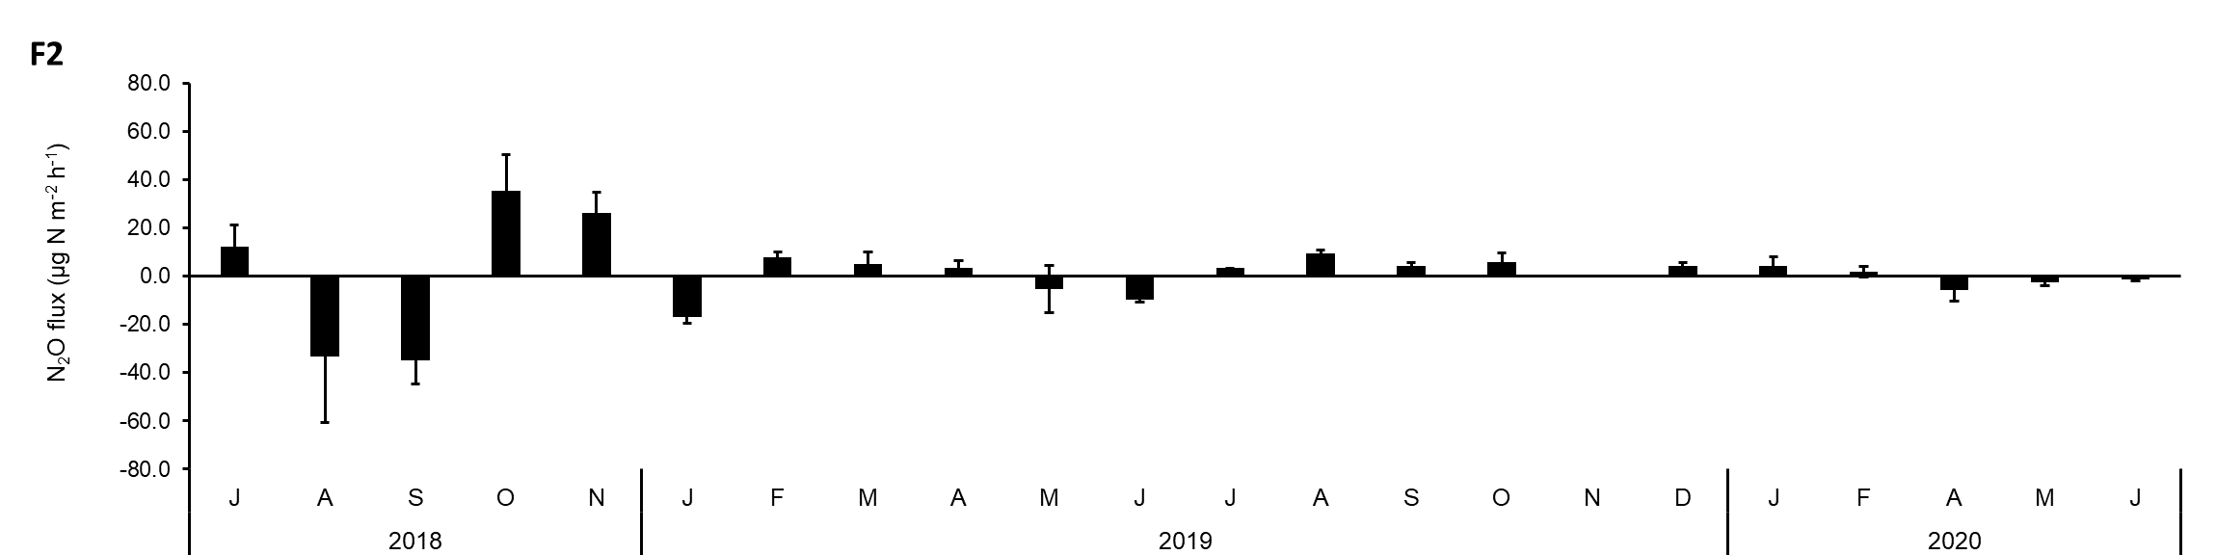
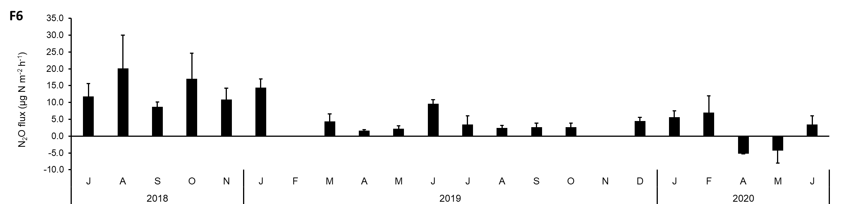

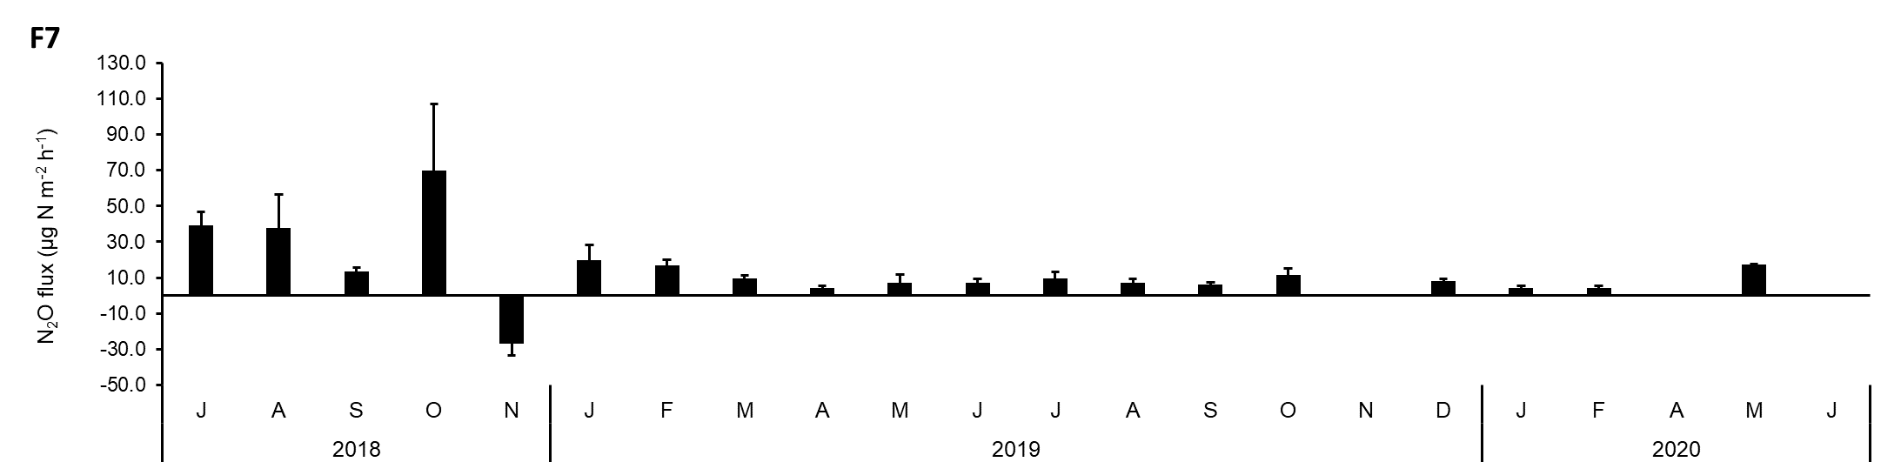

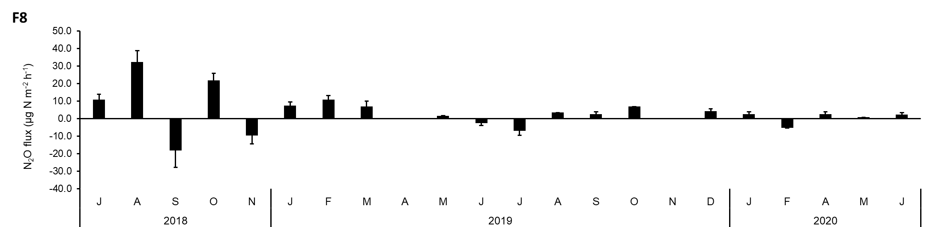

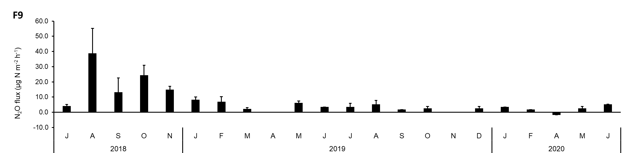

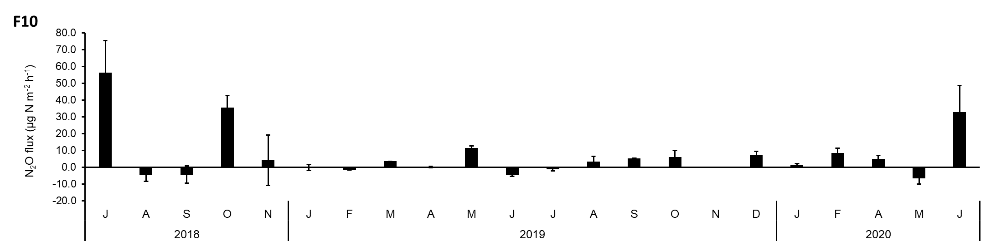

Fig. S4 The combined effect of soil water content (WFPS) and soil temperature on GHG fluxes in the ten forest soils examined.
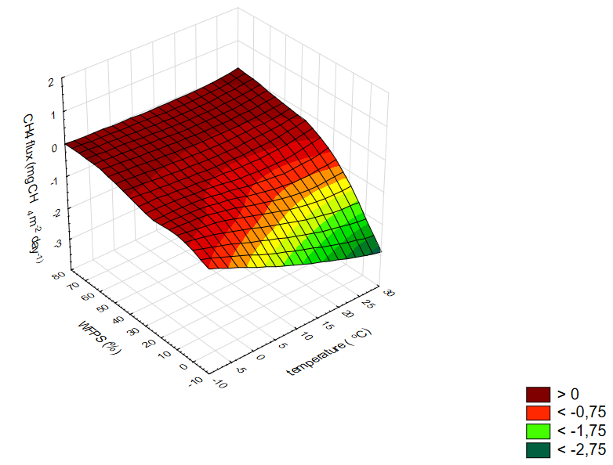
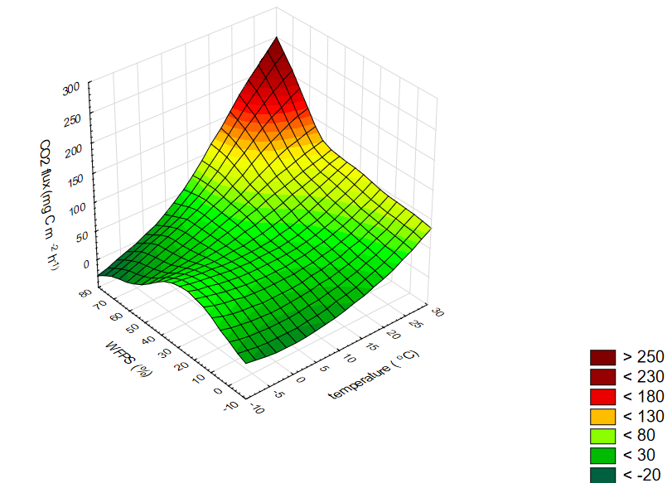
- CO₂ flux B) CH₄ flux

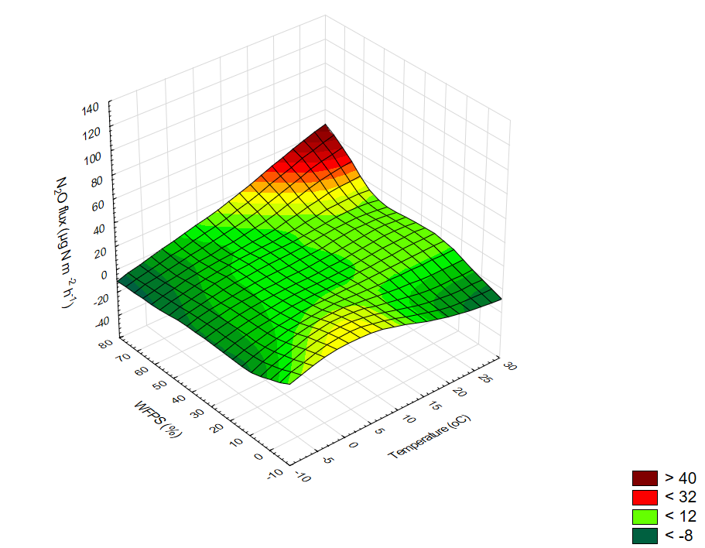
- N₂O flux

Table S1
Seasonal variation in soil properties (mean ±sd) for the two years of measurements on ten different forests and two soil depths: 0-15 cm and 15-30 cm, Sites are as described in Table 1.

 | Summer 2018 | Autumn 2018 | Winter 2018/19 | Spring 2019 | Summer 2019 | Autumn 2019 | Winter 2019/20 | Spring 2020
 | WFPS (0-15 cm)
F1 | 29.2±4.77 | 23.1±7.17 | 13.6±2.51 | 34.5±5.43 | 17.0±9.04 | 19.1±6.71 | 31.7±4.68 | 30.2±2.60
F2 | 13.4±6.84 | 12.9±5.56 | 17.4±1.93 | 30.8±7.13 | 7.07±3.78 | 13.9±10.4 | 18.4±5.70 | 17.4±9.96
F3 | 17.4±9.95 | 13.1±5.77 | 26.6±2.89 | 33.8±8.05 | 7.64±4.85 | 14.0±9.99 | 32.5±5.50 | 24.0±7.28
F4 | 32.7±3.20 | 25.9±5.35 | 33.6±6.02 | 40.4±12.43 | 17.2±4.89 | 24.0±17.3 | 27.8±18.2 | 37.4±10.0
F5 | 29.5±11.00 | 18.9±6.04 | 23.5±5.29 | 32.2±12.89 | 14.8±4.38 | 19.2±11.4 | 32.03±10.6 | 20.8±16.2
F6 | 27.6±8.74 | 18.4±7.32 | 36.2±7.95 | 51.3±5.64 | 15.01±6.99 | 23.8±13.0 | 40.3±12.08 | 39.8±11.1
F7 | 15.5±5.67 | 10.2±3.44 | 24.9±2.48 | 28.2±6.93 | 10.7±3.10 | 14.2±7.15 | 18.6±12.7 | 18.5±11.3
F8 | 15.3±5.32 | 12.4±5.11 | 18.4±1.60 | 23.1±1.79 | 9.40±2.85 | 12.6±6.66 | 20.8±12.1 | 21.5±7.76
F9 | 16.3±3.82 | 11.2±3.14 | 18.4±3.17 | 26.7±7.41 | 9.54±2.13 | 10.0±3.76 | 14.9±8.43 | 16.3±11.6
F10 | 51.0±5.92 | 51.6±14.06 | 63.3±2.76 | 58.3±7.30 | 28.9±6.99 | 48.3±16.84 | 53.1±21.6 | 57.7±9.09
 | WFPS (15-30 cm)
F1 | 32.2±9.86 | 27.6±7.47 | 20.5±2.04 | 52.5±5.24 | 26.5±14.19 | 19.7±8.23 | 42.2±7.55 | 39.2±3.93
F2 | 12.5±4.71 | 12.5±5.19 | 24.5±1.57 | 26.9±5.51 | 5.59±2.02 | 13.2±6.69 | 24.2±5.92 | 17.3±8.79
F3 | 15.9±8.47 | 11.1±3.30 | 22.9±2.20 | 32.0±5.59 | 9.40±6.99 | 11.1±6.59 | 23.5±4.00 | 23.3±6.33
F4 | 32.7±4.97 | 28.6±4.59 | 41.7±7.94 | 42.7±9.82 | 19.2±4.64 | 18.6±11.5 | 31.0±18.9 | 45.4±7.87
F5 | 22.0±9.39 | 22.8±10.1 | 17.31±4.28 | 22.6±8.50 | 20.4±8.89 | 12.7±3.93 | 34.5±13.5 | 18.2±12.0
F6 | 20.6±4.99 | 17.9±4.71 | 40.0±9.0 | 52.7±5.04 | 18.6±10.5 | 15.9±10.7 | 36.5±12.2 | 42.1±6.32
F7 | 9.63±2.52 | 11.1±1.85 | 27.5±3.06 | 33.9±5.13 | 12.4±15.7 | 15.2±8.11 | 11.6±7.66 | 24.1±5.57
F8 | 8.63±1.36 | 9.27±2.84 | 21.7±2.39 | 24.7±1.56 | 7.94±1.99 | 11.9±5.89 | 17.1±10.0 | 21.5±9.18
F9 | 12.5±3.09 | 12.5±2.10 | 17.8±3.62 | 31.5±9.23 | 10.5±2.29 | 11.2±3.93 | 10.5±8.09 | 10.7±5.11
F10 | 46.3±6.13 | 53.6±3.12 | 53.7±4.67 | 55.6±5.38 | 26.3±10.9 | 39.4±16.62 | 44.7±18.5 | 53.9±4.55
 | Eh (0-15 cm)
F1 | 398.8±54.9 | 402.2±32.45 | 405.1±18.71 | 433.3±121.1 | 434.0±27.8 | 377.7±28.1 | 352.3±8.28 | 395.1±53.7
F2 | 350.9±22.1 | 366.9±31.78 | 413.5±29.31 | 450.6±66.8 | 387.7±42.3 | 365.9±14.5 | 346.0±22.0 | 311.6±18.3
F3 | 374.5±45.5 | 375.5±25.05 | 431.3±12.41 | 407.4±43.8 | 387.1±36.5 | 353.8±38.6 | 319.5±49.3 | 310.9±26.0
F4 | 405.1±25.2 | 383.4±18.11 | 484.8±28.12 | 458.0±37.6 | 409.7±33.1 | 375.1±32.9 | 433.8±40.8 | 432.3±21.1
F5 | 344.0±43.3 | 321.4±36.33 | 407.6±29.95 | 394.5±81.4 | 387.6±25.0 | 334.6±69.4 | 305.5±45.2 | 325.9±30.9
F6 | 297.6±40.0 | 367.9±51.95 | 361.6±44.94 | 427.4±48.5 | 345.7±27.7 | 373.5±27.7 | 333.7±29.1 | 298.1±44.6
F7 | 368.2±32.5 | 364.5±29.63 | 427.8±30.05 | 424.1±13.6 | 392.3±13.7 | 351.1±36.6 | 393.2±47.1 | 338.2±46.6
F8 | 375.5±27.1 | 350.5±23.32 | 428.7±17.11 | 436.9±9.25 | 381.9±37.5 | 366.1±17.3 | 381.1±30.3 | 294.6±37.3
F9 | 422.0±10.0 | 384.3±25.92 | 438.3±58.73 | 456.1±21.8 | 423.7±22.2 | 401.8±24.3 | 402.6±62.3 | 373.7±48.7
F10 | 339.3±36.0 | 362.9±42.33 | 433.7±18.00 | 368.9±61.8 | 342.5±24.1 | 321.4±49.1 | 332.3±82.7 | 277.3±103.0
 | Eh (15-30 cm)
F1 | 396.2±34.0 | 419.5±38.7 | 392.2±20.7 | 467.0±20.4 | 463.7±15.4 | 418.6±16.7 | 405.0±12.6 | 381.2±18.3
F2 | 371.5±29.6 | 370.9±37.3 | 440.4±17.3 | 455.1±38.2 | 394.1±20.9 | 404.7±16.9 | 369.0±14.5 | 342.1±23.2
F3 | 345.5±52.3 | 370.7±28.6 | 427.2±9.25 | 441.6±47.5 | 401.7±35.2 | 402.6±22.1 | 377.7±10.7 | 353.9±23.4
F4 | 401.1±37.1 | 438.5±16.2 | 454.9±16.4 | 461.4±33.5 | 435.4±16.6 | 429.9±12.3 | 435.9±33.8 | 435.8±34.1
F5 | 350.5±26.1 | 347.8±25.6 | 407.8±12.6 | 418.5±41.9 | 415.1±18.3 | 398.5±33.3 | 370.0±30.1 | 348.9±33.6
F6 | 355.0±22.2 | 381.7±39.8 | 400.2±18.5 | 454.2±18.0 | 393.8±44.1 | 371.9±55.5 | 345.7±52.7 | 362.8±41.0
F7 | 367.1±32.0 | 390.7±20.5 | 443.8±19.6 | 449.8±16.7 | 412.0±24.6 | 395.7±21.7 | 389.8±16.7 | 376.0±35.7
F8 | 360.8±18.5 | 374.8±21.8 | 440.7±22.0 | 441.5±5.04 | 423.9±31.2 | 412.4±15.4 | 439.5±45.8 | 389.5±13.6
F9 | 417.6±14.2 | 389.9±32.5 | 463.2±25.7 | 461.6±10.6 | 451.8±28.2 | 414.4±21.1 | 432.2±35.1 | 413.8±20.1
F10 | 344.9±33.6 | 376.3±26.9 | 410.8±20.9 | 420.2±43.9 | 379.3±17.7 | 376.2±14.1 | 395.6±38.6 | 286.9±84.8
 | NH₄⁺ concentration (0-15 cm)
F1 | 6.74±1.36 | 8.17±2.43 | 5.01±0.64 | 6.60±1.07 | 7.82±2.01 | 9.40±4.56 | 7.61±2.42 | 4.76±3.19
F2 | 10.9±1.02 | 8.35±5.3 | 7.28±1.34 | 8.27±1.05 | 7.78±3.74 | 7.78±0.51 | 5.69±1.16 | 4.57±2.89
F3 | 12.9±7.2 | 11.6±7.95 | 7.38±1.63 | 8.82±1.56 | 16.1±3.53 | 11.1±0.78 | 7.21±4.56 | 7.54±3.08
F4 | 8.42±0.53 | 10.1±3.51 | 9.8±1.28 | 7.83±1.25 | 10.7±3.07 | 12.8±2.36 | 7.21±1.69 | 3.57±1.91
F5 | 10.5±1.85 | 7.73±4.37 | 5.7±0.62 | 6.38±0.13 | 10.5±3.84 | 7.00±4.20 | 7.18±4.44 | 6.32±5.19
F6 | 11.9±0.62 | 12.0±2.57 | 7.98±1.03 | 11.2±0.30 | 13.0±0.60 | 15.0±4.75 | 6.84±0.66 | 8.62±6.14
F7 | 10.4±3.44 | 10.9±3.22 | 7.79±0.24 | 10.3±1.09 | 11.5±2.84 | 14.9±2.53 | 6.06±1.50 | 9.15±2.62
F8 | 9.62±6.07 | 10.7±4.23 | 7.91±0.91 | 14.0±0.45 | 10.2±3.83 | 15.7±1.60 | 7.31±0.59 | 7.76±6.62
F9 | 7.77±0.04 | 8.86±2.72 | 6.94±0.88 | 9.81±7.76 | 6.42±3.48 | 12.2±5.94 | 6.24±0.60 | 7.65±4.42
F10 | 7.66±0.34 | 10.6±4.13 | 5.50 ±0.41 | 5.28±0.7 | 7.42±1.38 | 8.25±0.39 | 9.31±2.89 | 4.51±1.93
 | NH₄⁺ concentration (15-30 cm)
F1 | 5.23±1.92 | 6.39±3.23 | 4.4±0.59 | 4.05±0.30 | 7.25±1.22 | 7.14±2.49 | 6.86±6.25 | 5.32±5.13
F2 | 6.01±0.57 | 8.89±2.23 | 4.6±1.44 | 3.90±0.59 | 7.60±2.54 | 6.48±0.83 | 6.38±4.36 | 2.96±3.40
F3 | 6.25±0.24 | 8.12±2.34 | 9.26±0.53 | 4.70±1.02 | 7.61±1.50 | 6.09±1.41 | 6.77±2.55 | 2.73±2.06
F4 | 5.64±0.30 | 7.76±2.88 | 6.39±0.86 | 5.72±2.48 | 7.01±2.21 | 7.56±1.62 | 7.62±2.58 | 3.57±3.32
F5 | 6.58±1.22 | 4.39±0.21 | 2.82±0.81 | 6.19±1.40 | 7.88±5.64 | 6.85±2.73 | 6.41±3.59 | 4.23±2.24
F6 | 6.46±0.57 | 9.28±1.21 | 6.89±0.09 | 7.81±0.21 | 11.7±3.29 | 10.4±0.94 | 9.04±4.76 | 3.67±2.48
F7 | 9.53±3.59 | 10.8±4.55 | 8.09±0.21 | 9.84±1.59 | 11.1±2.78 | 12.2±4.86 | 8.35±2.41 | 10.0±5.14
F8 | 6.47±1.71 | 8.33±0.08 | 6.07±0.14 | 7.16±0.82 | 6.55±2.88 | 10.3±0.96 | 9.47±2.45 | 4.06±3.76
F9 | 3.87±0.54 | 5.20±3.27 | 3.82±0.78 | 3.75±1.90 | 6.76±5.74 | 5.06±1.62 | 6.01±0.87 | 2.91±1.99
F10 | 7.13±0.68 | 6.64±2.10 | 2.78±0.45 | 5.18±1.28 | 4.68±1.41 | 3.99±1.79 | 9.03±0.87 | 3.53±1.66
 | NO₃⁻ concentration (0-15 cm)
F1 | 1.55±0.01 | 3.03±1.50 | 2.17±1.21 | 1.65±0.28 | 1.46±0.17 | 0.81±0.62 | 1.19±0.94 | 1.57±0.01
F2 | 1.37±0.04 | 1.70±0.36 | 2.08±0.42 | 4.63±4.01 | 1.35±0.01 | 0.15±0.16 | 1.11±0.98 | 1.40±0.01
F3 | 1.65±0.21 | 1.46±0.00 | 2.57±0.71 | 3.15±1.79 | 1.81±0.78 | 0.41±0.45 | 0.99±0.85 | 1.47±0.06
F4 | 6.59±7.18 | 9.90±3.79 | 3.02±0.66 | 4.32±0.84 | 4.73±5.21 | 0.62±0.48 | 1.49±0.22 | 2.42±1.45
F5 | 1.49±0.09 | 1.41±0.05 | 1.55±0.07 | 1.50±0.07 | 1.40±0.02 | 0.17±0.20 | 1.21±0.68 | 1.49±0.15
F6 | 1.47±0.05 | 1.62±0.18 | 1.55±0.05 | 1.94±0.49 | 1.42±0.01 | 0.60±0.79 | 1.20±0.69 | 1.62±0.04
F7 | 6.69±5.01 | 2.62±0.40 | 5.99±0.70 | 3.00±1.37 | 2.15±1.34 | 1.75±1.53 | 2.09±0.83 | 2.18±1.15
F8 | 1.37±0.01 | 1.39±0.06 | 1.49±0.00 | 1.48±0.02 | 1.35±0.01 | 0.49±0.22 | 1.38±0.21 | 1.45±0.04
F9 | 7.23±2.44 | 4.82±3.17 | 2.90±1.84 | 1.96±0.46 | 2.80±1.00 | 4.94±0.45 | 2.80±1.69 | 1.44±0.05
F10 | 3.30±2.43 | 1.58±0.01 | 2.19±0.62 | 2.48±0.86 | 2.01±0.43 | 0.72±0.09 | 1.73±0.17 | 1.75±0.07
 | NO₃⁻ concentration (15-30 cm)
F1 | 1.73±0.38 | 2.43±1.61 | 2.42±1.24 | 1.87±0.21 | 1.45±0.13 | 0.78±0.50 | 1.02±0.87 | 1.63±0.11
F2 | 1.36±0.01 | 1.58±0.38 | 1.33±0.15 | 1.88±0.41 | 1.35±0.01 | 0.26±0.27 | 0.98±0.84 | 1.40±0.01
F3 | 1.43±0.11 | 1.41±0.01 | 1.40±0.10 | 1.51±0.02 | 1.36±0.03 | 0.33±0.38 | 1.10±0.90 | 1.43±0.05
F4 | 3.68±1.95 | 4.68±2.48 | 1.47±0.21 | 2.55±0.88 | 3.38±2.59 | 0.65±0.44 | 1.24±0.79 | 1.90±0.72
F5 | 1.47±0.07 | 1.40±0.01 | 1.49±0.01 | 1.50±0.03 | 1.43±0.03 | 0.22±0.36 | 1.34±0.43 | 1.51±0.10
F6 | 1.46±0.04 | 1.41±0.04 | 1.53±0.06 | 1.59±0.02 | 1.47±0.07 | 0.34±0.24 | 1.36±0.39 | 1.57±0.05
F7 | 2.88±1.16 | 2.23±1.48 | 2.12±0.87 | 2.53±1.76 | 1.72±0.62 | 1.40±0.38 | 1.87±0.36 | 3.78±3.96
F8 | 1.38±0.01 | 1.37±0.04 | 1.47±0.03 | 1.64±0.28 | 1.34±0.01 | 0.41±0.01 | 1.30±0.28 | 1.43±0.03
F9 | 4.01±0.01 | 4.04±3.26 | 1.52±0.03 | 1.75±0.19 | 3.14±2.9 | 2.81±0.54 | 1.94±0.89 | 1.40±0.04
F10 | 2.33±1.08 | 1.57±0.03 | 1.64±0.06 | 4.42±0.80 | 1.94±0.70 | 0.41±0.07 | 1.56±0.10 | 1.61±0.05
 | pH (0-15 cm)
F1 | 4.22±0.23 | 4.04±0.30 | 4.00±0.23 | 4.13±0.20 | 3.59±0.21 | 4.13±0.20 | 4.62±0.13 | 4.13±0.40
F2 | 4.59±0.30 | 4.38±0.41 | 4.06±0.10 | 3.93±0.16 | 4.38±1.00 | 4.53±0.61 | 4.67±0.38 | 4.16±0.27
F3 | 5.16±0.55 | 4.93±0.29 | 4.52±0.22 | 4.80±0.74 | 5.16±0.72 | 4.76±0.47 | 5.47±0.35 | 5.47±0.43
F4 | 4.91±0.53 | 4.26±0.19 | 4.16±0.06 | 4.08±0.30 | 4.66±0.80 | 4.88±0.70 | 4.58±0.33 | 4.05±0.24
F5 | 4.75±0.35 | 5.18±0.30 | 4.81±0.13 | 4.89±0.53 | 4.74±0.74 | 5.36±0.70 | 5.33±0.86 | 5.45±0.69
F6 | 5.87±0.25 | 5.43±0.28 | 5.20±0.17 | 5.13±0.74 | 5.50±0.69 | 5.35±0.52 | 6.29±0.31 | 5.64±0.51
F7 | 5.34±0.18 | 5.12±0.23 | 5.41±0.20 | 5.34±1.15 | 5.01±0.79 | 5.22±0.46 | 5.36±0.37 | 5.14±0.55
F8 | 4.86±0.35 | 5.11±0.45 | 4.67±0.16 | 4.40±0.5 | 5.07±0.58 | 5.31±0.37 | 5.26±0.20 | 5.50±0.43
F9 | 3.89±0.20 | 4.06±0.39 | 3.66±0.29 | 3.73±0.25 | 3.93±0.71 | 3.93±0.25 | 4.23±0.29 | 3.99±0.24
F10 | 5.70±0.71 | 5.58±0.58 | 5.17±0.37 | 5.10±0.19 | 6.48±0.27 | 6.20±0.47 | 6.54±0.52 | 6.19±0.34
 | pH (15-30 cm)
F1 | 4.50± 0.26 | 4.40±0.29 | 4.09±0.18 | 4.19±0.21 | 3.69±0.18 | 4.42±0.33 | 4.64±0.26 | 4.30±0.39
F2 | 4.39±0.25 | 4.23±0.22 | 4.26±0.27 | 4.25±0.22 | 4.46±0.99 | 4.47±0.44 | 4.89±0.35 | 4.36±0.14
F3 | 4.96±0.16 | 4.96±0.17 | 4.40±0.12 | 4.73±0.30 | 4.82±0.77 | 4.94±0.40 | 5.17±0.18 | 4.87±0.21
F4 | 5.05±0.63 | 4.24±0.16 | 4.28±0.16 | 4.07±0.14 | 4.49±0.43 | 4.52±0.30 | 4.37±0.18 | 4.08±0.14
F5 | 5.14±0.22 | 5.25±0.22 | 4.96±0.23 | 4.65±0.29 | 4.93±0.43 | 5.06±0.20 | 5.72±0.45 | 5.35±0.23
F6 | 5.76±0.33 | 5.15±0.25 | 4.82±0.06 | 4.70±0.29 | 5.44±0.88 | 5.19±0.57 | 6.35±0.46 | 5.08±0.60
F7 | 5.10±0.41 | 5.04±0.20 | 5.00±0.34 | 5.20±0.67 | 5.15±0.55 | 5.11±0.48 | 5.33±0.38 | 4.70±0.53
F8 | 4.81±0.22 | 5.03±0.15 | 4.73±0.43 | 4.50±0.31 | 5.22±0.53 | 5.14±0.55 | 4.85±0.27 | 5.05±0.33
F9 | 3.77±0.25 | 3.99±0.21 | 4.16±0.40 | 3.86±0.19 | 4.17±0.85 | 4.09±0.34 | 4.40±0.70 | 3.94±0.15
F10 | 5.42±0.72 | 5.51±0.16 | 4.98±0.55 | 4.93±0.18 | 6.29±0.16 | 6.15±0.24 | 5.89±0.35 | 5.78±0.39

Table S2
Results of a multifactor analysis of variance (MANOVA) with F-ratios and p-values for the factors, soil type (silty vs sandy), forest types (coniferous vs deciduous vs mixed), and season (summer vs autumn vs winter vs spring), and their interactions.
 | CO₂ flux | CH₄ flux | N₂O flux
Main effects:
soil type | F = 9.27; p < 0.003 | F=308.28; p < 0.0001 | ns
forest type | F = 11.52; p < 0.0001 | F= 10.16; p < 0.0001 | F=11.48 p < 0.0001
season | F = 15.97; p < 0.0001 | F= 72.20; p < 0.0001 | F=3.96; p < 0.05
Interactions:
soil type x forest type | F = 4.84; p < 0.05 | F=26.38; p < 0.0001 | F=3.95; p < 0.05
soil type x season | ns | F=14.45; p < 0.0001 | ns
forest type x season | F = 2.64; p < 0.05 | ns | ns
soil type x forest type x season | F = 2.45; p < 0.05 | F= 3.41; p < 0.05 | ns
ns – not significant

Table S3
Regression coefficients and statistics for the correlations between GHG fluxes and different soil properties.
Variables | TTemperature | The pH | NH₄⁺ | NO₃⁻ | WFPS | C_{org} | N_{tot.} | C/N | Clay | Silt | Sand | Bulk density | R²
CO₂ emission | 1.38**** | ns | -0.73* | ns | 0.49**** | ns | ns | ns | ns | ns | ns | ns | 0.21****
CH₄ uptake | -0.019**** | ns | -0.015*** | ns | 0.013**** | ns | ns | ns | ns | ns | ns | 0.45* | 0.49****
N₂O emission | 0.21* | ns | 0.49** | ns | ns | ns | ns | ns | ns | ns | ns | 30.2*** | 0.07***
Asterisk symbols indicate significant effects: * at p < 0.05; ** at p < 0.01; *** at p < 0.001; **** at p < 0.0001; ns – not significant at p > 0.05

Table S4
Contribution of CO₂, N₂O and CH₄ fluxes to the total GWP separately and for each forest soil (sites F1-F10; see Table 1).
(%) | F1 | F2 | F3 | F4 | F5 | F6 | F7 | F8 | F9 | F10
GWP-CO₂ | 97.0 | 98.1 | 97.6 | 98.5 | 99.5 | 98.1 | 96.6 | 98.6 | 97.01 | 98.4
GWP-CH₄ | -0.44 | -0.97 | -0.73 | -0.24 | -0.32 | -0.34 | -0.66 | -0.80 | -0.68 | -0.08
GWP-N₂O | 2.54 | 0.91 | 1.67 | 1.28 | 0.21 | 1.56 | 2.77 | 0.6 | 2.31 | 1.52

