Table S1 Generalised linear models (GLMs) used to analyse the effect of cork oak harvesting coefficient (HC) on microhabitat diversity (Model 1, Poisson error distribution), probability of occurrence of 6 microhabitats groups (Model 2-7, binomial) and cavity dimensions (Model 8-10, gamma). Columns 2 to 7 show variables included in each GLM, model coefficients and statistical significance (p<0.001***, p<0.01**, p<0.05*). Variables were removed from the global model and changes in model quality were determined using likelihood ratio tests (reported in main text) and Akaike information criterion (AIC) values. Lower (AIC) values indicates that a model better fits the data, although a difference in AIC (ΔAIC) less than 2 is non-significant. Models with the lowest AIC are highlighted grey.
Model | Intercept | Health score | DBH (cm) | HC (linear) | HC (quad) | AIC
Overall microhabitat diversity (Poisson)
1a | 0.049 | 0.289*** | 1.253*** | 0.081 | -0.212** | 1121.8
1b | -0.042 | 0.300*** | 1.246*** | 0.035 | - | 1132.5
1c | -0.030 | 0.303*** | 1.220*** | - | - | 1130.9
VIF | - | 1.023 | 1.017 | 1.057 | 1.027 | -
Probability of bark pockets (binomial)
2a | -1.481 | 0.197 | 2.875* | 0.600** | 0.032 | 390.4
2b | -1.469 | 0.196 | 2.877* | 0.602** | - | 388.5
2c | -1.271 | 0.239 | 2.403 | - | - | 395.6
VIF | - | 1.012 | 1.016 | 1.025 | 1.005 | -
Probability of bark shelters (binomial)
3a | 0.038 | -0.027 | 1.224 | 0.617** | -1.214*** | 392.8
3b | -0.407 | 0.020 | 1.083 | 0.422* | - | 414.2
3c | -0.276 | 0.054 | 0.767 | - | - | 417.2
VIF | - | 1.02 | 1.017 | 1.039 | 1.008 | -
Probability of cavities (Binomial)
4a | -12.515*** | 2.727*** | 8.966*** | 0.160 | -2.115** | 125.8
4b | -12.244*** | 2.540*** | 8.212*** | -0.134 | - | 133.9
4c | -12.254*** | 2.522*** | 8.285*** | - | - | 132.0
VIF | - | 1.376 | 1.291 | 1.130 | 1.159 | -
Probability of course bark (binomial)
5a | -0.133 | 0.130 | -0.666 | -0.222 | -0.834* | 390.8
5b | -0.479 | 0.146 | -0.609 | -0.224 | - | 396.4
5c | -0.544 | 0.127 | -0.446 | - | - | 395.7
VIF | - | 1.017 | 1.015 | 1.040 | 1.016 | -
Probability of insect holes (binomial)
6a | -4.126*** | 0.976*** | 2.375 | -0.298 | -1.197* | 275.4
6b | -4.516*** | 0.966*** | 2.428 | -0.269 | - | 281.6
6c | -4.560*** | 0.937*** | 2.595 | - | - | 280.8
VIF | - | 1.035 | 1.016 | 1.052 | 1.012 | -
Probability of pennyworts (binomial)
7a | -5.658*** | 0.277 | 3.823 | -1.280* | -0.510 | 135.7
7b | -5.852*** | 0.288 | 3.914 | -1.048* | - | 134.2
7c | -5.864*** | 0.175 | 4.520* | - | - | 137.9
VIF | - | 1.035 | 1.007 | 1.709 | 1.688 | -
Cavity entrance height (gamma)
8a | 4.251*** | -0.173 | -0.267 | 0.716* | 0.029 | 545.8
8b | 4.243*** | -0.177 | -0.246 | 0.722** | - | 543.8
8c | 6.244*** | -0.272 | -0.871 | - | - | 548.8
VIF | - | 1.222 | 1.183 | 1.221 | 1.371 | -
Cavity entrance area (gamma)
9a | 8.154*** | 0.532* | -3.145* | -0.752 | -0.438 | 659.6
9b | 8.207*** | 0.590* | -3.456* | -0.814* | - | 658.0
9c | 6.229*** | 0.499* | -2.137 | - | - | 659.5
VIF | - | 1.228 | 1.209 | 1.278 | 1.435 | -
Cavity volume (gamma)
10a | 3.615** | 0.256 | 0.513 | -0.194 | -0.173 | 485.6
10b | 3.645** | 0.274 | 0.369 | -0.208 | - | 483.7
10c | 3.263** | 0.258 | 0.471 | - | - | 482.3
VIF | - | 1.228 | 1.209 | 1.278 | 1.435 | -

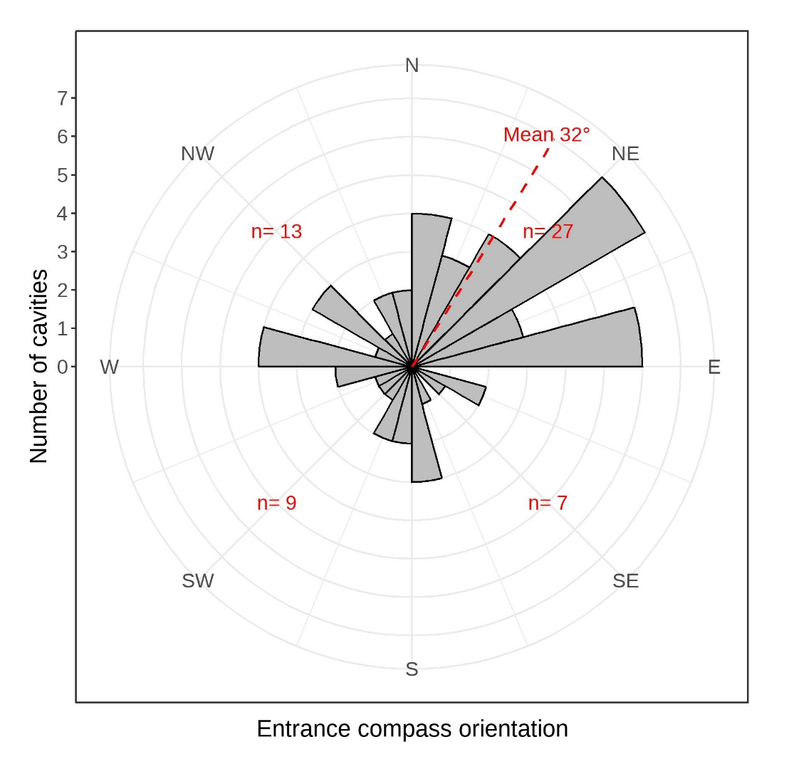
Fig S1. Entrance compass orientations of 57 cavities in oak trees (Quercus spp.) surveyed in two cork oak woodlands in Los Alcornocales Natural Park, Andalusia, Spain. Angles are shown on a polar histogram with 15- (bars) and 90-degree (red numbers in each corner) bins. Entrance orientation could not be recorded for one (2%) of the 57 cavities because it was facing upwards. Entrances were orientated non-randomly (R=0.3, p=0.023) with a mean bearing of 32 degrees (northeast). Almost half (n=27) cavities had entrances orientated between 0 and 90 degrees, which is approximately double the random expectation of 14.

