Supplementary
Table 1. Statistical Comparison of Canopy Height Model (CHM) Data Across Flight Heights.
Two Returns
Flight Height Comparison | Shapiro-Wilk | Kruskal-Wallis | R² | RMSE | BIAS | Wilcox Text
 | 2.12E-16 | 0.57 | 1.000 | 0.064 | -0.021 | 1.000
  50 m vs. 70 m
50 m vs. 90 m | 2.12E-16 | 0.57 | 0.998 | 0.321 | -0.199 | 1.000
50 m vs. 110 m | 2.12E-16 | 0.57 | 0.996 | 0.519 | -0.358 | 1.000
70 m vs. 90 m | 2.12E-16 | 0.57 | 0.999 | 0.268 | -0.178 | 1.000
70 m vs. 110 m | 2.12E-16 | 0.57 | 0.997 | 0.468 | -0.337 | 1.000
90 m vs. 110 m | 2.12E-16 | 0.57 | 0.999 | 0.207 | -0.158 | 1.000
Three Returns
 | 2.12E-16 | 0.13 | 1.000 | 0.192 | -0.152 | 1.000
  50 m vs. 70 m
50 m vs. 90 m | 2.12E-16 | 0.13 | 0.998 | 0.475 | -0.369 | 1.000
50 m vs. 110 m | 2.12E-16 | 0.13 | 0.993 | 0.807 | -0.611 | 0.148
70 m vs. 90 m | 2.12E-16 | 0.13 | 0.999 | 0.287 | -0.217 | 1.000
70 m vs. 110 m | 2.12E-16 | 0.13 | 0.996 | 0.621 | -0.459 | 0.538
90 m vs. 110 m | 2.12E-16 | 0.13 | 0.999 | 0.340 | -0.242 | 1.000

Table 2. Biomass equations for Pinus Pinaster.
Model form
- $W_{i}=β_{0} {DBH}^{β_{1}} {HT}^{β_{2}}$  $(i = s, b)$ |  |  |  | - $W_{i}=β_{0} {DBH}^{β_{1}} {\frac{HT}{DBH}}^{β_{2}}$  (i = br, l)
Component | Model | β₀ | β₁ |  | β₂ | Reference
Stem (ws) | 1 | 0.0146 | 1.9469 |  | 1,1066 | Tomé et al., 2007
Bark (wb) | 1 | 0.0114 | 1.8728 |  | 0.6694
Branches (wbr) | 2 | 0.0031 | 2.7576 |  | -0.3938
Needles (wl) | 2 | 0.0998 | 1.3925 |  | -0.7196
Total (wa) | wa = ws + wb+ wbr + wl
Root (wr) | wr = 0.2756 wa |  |  |  |  |  | Tomé et al., 2007
DBH – diameter at breast height (cm); HT – total height (m); hdom – dominant height (m); W_{i} – biomass component

Table 3. Biomass equations for Eucalyptus spp.
Model form
(1) $W_{i}=β_{0} {DBH}^{β_{1}} {HT}^{β_{2}}$ (i = w, b) (2) $W_{i}=β_{0} {DBH}^{β_{1}} {\frac{HT}{DBH}}^{β_{2}}$ (i = br, l)
Component | Model | β₀ | β₁ | β₂ |  | Fonte
Stem  (ww) | 1 | 0.0099 | $$hdom≤10.7100: \frac{hdom}{-0.7091+0.6279∙hdom}$$  $$hdom>10.710:1.7805$$ | 1.3696 |  | Tomé et al. 2007
Bark  (wb) | 1 | 0.000594 | $$hdom≤18.2691: \frac{hdom}{-0.6995+0.4585∙hdom}$$  $$hdom>18.2691:2.3795$$ | \\
Brances (wbr) | 2 | 0.095603 | 1.6746 | -0.850
Leaves (wl) | 2 | 0.248952 | 1.2640 | -0.712
Total Aboveground Biomass (wa) | wa = ww+wb+wl+wbr
Root (wr) | wr = 0,2487 wa |  |  |  | Soares e Tomé, 2004
DBH – diameter at breast height (cm); HT – total height (m); hdom – dominant height (m).; W_{i} – biomass component

Table 4. Biomass equations for Quercus suber.
Model form
(1) 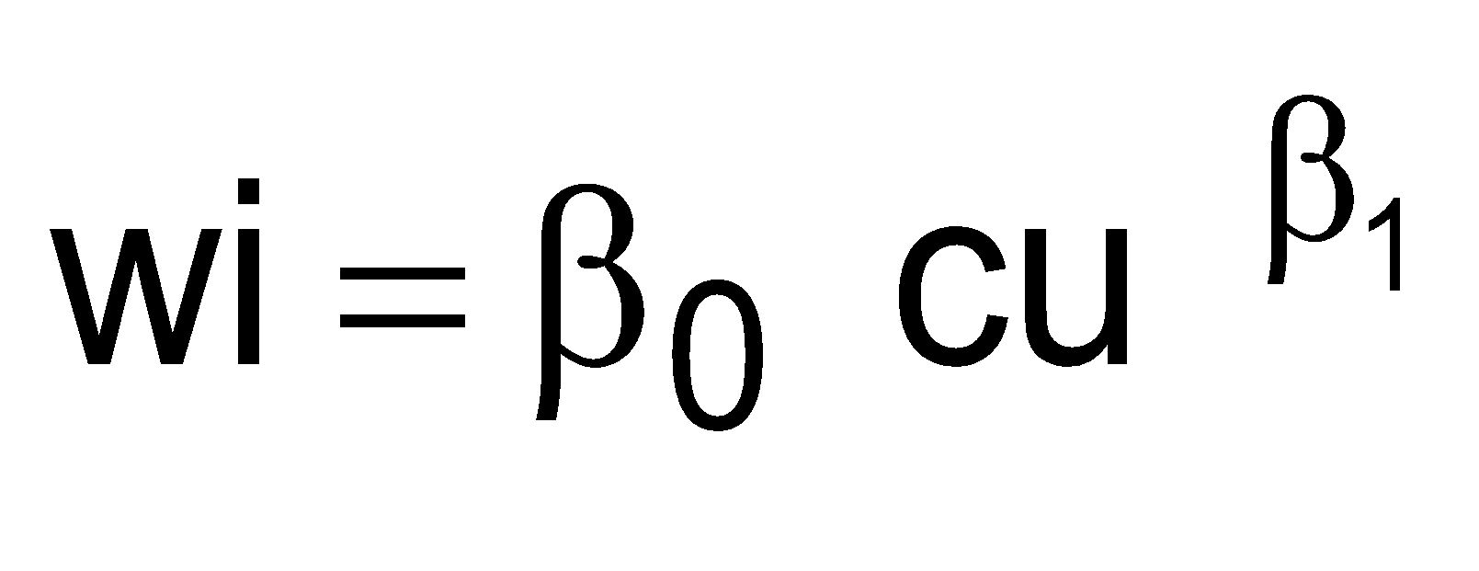 (i = wsbr, br, bv2, l) (2) 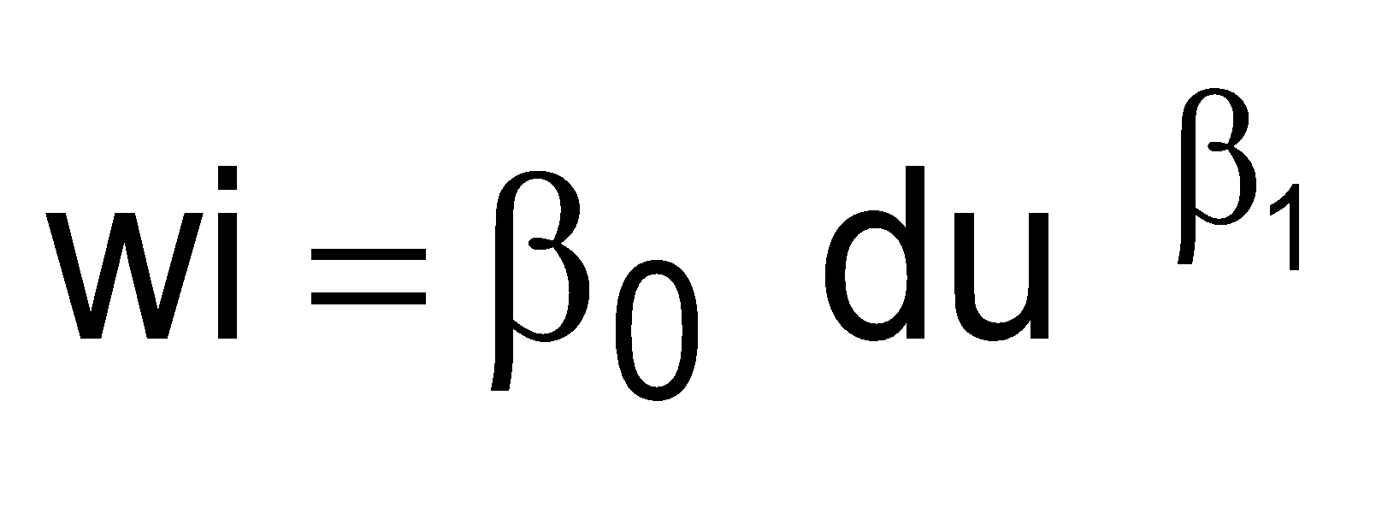 (i = bv1, r)
Component | Model | β₀ |  | β₁ |  | Reference
Stem (ww) | 1 | 284.2881 |  | 2.9646 |  | Tomé et al., 2007
Branches (wbr) | 1 | 108.5769 |  | 1.3464 |  | Tomé et al., 2007
Leaves (wl) | 1 | 22.5773 |  | 1.1690 |  | Tomé et al., 2007
Cork bark in unexplored trees (wbv1) | 2 | 0.960006 |  | 1.300779 |  | Paulo and Tomé, 2006
Cork bark recently explored trees (wbv2) | 1 | 98.137 |  | 2.2999 |  | Tomé et al., 2007
Total Aboveground Biomass (wa) | wa=ww + wbr + wl + wbv
Root (wr) | 2 |  | 0.06378 |  | 2.0778 | Montero et al., 2005
DBH – diameter with bark at breast height (cm) (cm); du – diameter at breast height under bark (cm); cu – circumference at a breast height (m)

Table 5. Biomass equations for Quercus faginea.
Model form
- $W_{i}= β_{0} {DBH}^{2}$  (i=w, b, c, r) |  |  |  |  | (2) $W_{i}= β_{0} {DBH}^{2} β_{1} {DBH}^{2} HT$  (i=wbr2,wl)
Component | Model |  | β₀ | β₁ |  | Reference
Stem (ww) | 1 |  | 0.154 |  |  | Ruiz-Peinado et al., 2012
Thick branches (wbr1) | 1 |  | 0.0861 |  |  | Ruiz-Peinado et al., 2012
Medium branches (wbr2) | 2 |  | 0.127 | 0.00598 |  | Ruiz-Peinado et al., 2012
Thin branches + leaves (wl) | 2 |  | 0.0726 | 0.00275 |  | Ruiz-Peinado et al., 2012
Total Aboveground Biomass (wa) | wa = ww + wb + wc |  |  |  |  | Ruiz-Peinado et al., 2012
Root (wr) | 1 | 0.169 |  |  |  | Montero et al., 2005
DBH – diameter with bark at breast height (cm); HT – total height (m); W_{i} – biomass component

