Table S1. Functional traits in gas exchange and water potentials measured day 136 day after the beginning of the experiment (H2). F-values and p-values between brackets for the studied functional traits of P. pinaster and P. pinea seedlings growing under ambient and e[CO₂] conditions and two watering regimes. Total Biomass = Total dry mass of the plant (g); Diameter = Collar diameter (mm); Height = plant height (cm); SRR = shoot: root mass ratio; WUE = Water use efficiency calculated as dry plant biomass/evapotranspired water (mg/g); Ψ_{predawn} = Predawn water potential (MPa); Ψ_{midday} = Midday water potential (MPa); A_{n} = Photosynthesis rate (μmol CO₂ m⁻² s⁻¹); g_{wv} = Stomatal conductance (mol H₂O m⁻² s⁻¹); WUEi = Intrinsic water use efficiency calculated as A_{n}/g_{wv} (μmol CO₂/ mol H₂O). Significant effects (α=0.05) are shown in bold. Degrees of freedom were 1/40 in all cases

Treatment | CO₂ | Water | Species | CO₂ × Water | CO₂ × Species | Water × Species | CO₂ × Water × Species
Ψ_{predawn} | 1.519 (0.225) | 1.951 (0.170) | 81.674 (<0.001) | 0.380 (0.541) | 0.137 (0.714) | 1.419 (0.241) | 2.437 (0.126)
Ψ_{midday} | 11.738 (0.001) | 0.047 (0.829) | 11.628 (0.001) | 2.321 (0.135) | 0.000 (0.981) | 3.965 (0.053) | 1.015 (0.320)
A_{n} | 15.886 (<0.001) | 7.824 (0.008) | 15.457 (<0.001) | 0.078 (0.782) | 3.824 (0.058) | 1.985 (0.167) | 0.952 (0.335)
g_{wv} | 18.517 (<0.001) | 34.119 (<0.001) | 2.352 (0.133) | 3.751 (0.060) | 1.274 (0.266) | 0.068 (0.796) | 0.105 (0.748)
WUEi | 35.761 (<0.001) | 16.899 (<0.001) | 0.685 (0.413) | 0.389 (0.536) | 4.688 (0.036) | 0.065 (0.800) | 0.586 (0.448)

Table S2. Functional traits in plants from day 161 day after the beginning of the experiment (H3). F-values and p-values between brackets for the studied functional traits of P. pinaster and P. pinea seedlings growing under ambient and e[CO₂] conditions and two water regimes. Total Biomass = Total dry mass of the plant (g); Diameter = collar diameter (mm); Height = plant height (cm); WUE = Water use efficiency calculated as dry plant biomass/evapotranspired water (mg/g); Ψ_{predawn} = Predawn water potential; (MPa); Ψ_{midday} = Midday water potential (MPa); WUEi* = intrinsic water use efficiency derived from C isotopic discrimination (μmol/mol). Significant effects (α=0.05) are shown in bold. Degrees of freedom were 1/57 in all cases.
Treatment | CO₂ | Water | Species | CO₂ × Water | CO₂ × Species | Water × Species | CO₂ × Water × Species
Total biomass | 48.583 (<0.001) | 70.137 (<0.001) | 0.014 (0.906) | 0.057 (0.812) | 0.003 (0.956) | 2.725 (0.104) | 0.000  (0.984)
Diameter | 10.016 (0.002) | 26.301 (<0.001) | 17.035 (<0.001) | 0.042 (0.838) | 0.000 (0.983) | 0.087 (0.769) | 4.081 (0.048)
Height | 1.694 (0.198) | 15.852 (<0.001) | 29.218 (<0.001) | 0.890 (0.349) | 0.303 (0.584) | 0.417 (0.521) | 0.012 (0.913)
WUE | 77.899 (<0.001) | 5.763 (0.020) | 0.098 (0.756) | 7.422 (0.009) | 0.076 (0.783) | 2.097 (0.153) | 0.107 (0.745)
Ψ_{predawn} | 18.640 (<0.001) | 74.751 (<0.001) | 42.847 (<0.001) | 7.633 (0.008) | 0.024 (0.876) | 0.513 (0.477) | 1.172 (0.284)
Ψ_{midday} | 1.228 (0.273) | 55.103 (<0.001) | 36.806 (<0.001) | 0.952 (0.333) | 2.823 (0.098) | 0.305 (0.584) | 1.583 (0.213)
WUEi* | 2.684 (0.107) | 177.009 (<0.001) | 7.718 (<0.001) | 54.775 (<0.001) | 0.866 (0.356) | 1.757 (0.190) | 0.021 (0.887)

Table S3. Biomass allocation estimators in plants from harvested at H3 (161 day after the beginning of the experiment). F-values and p-values between brackets for the biometric indexes measured for P. pinaster and P. pinea seedlings growing under ambient and e[CO₂] and two water regimes. SRR, Shoot: root ratio= shoot: root mass ratio; LMF = Leaf mass fraction: leaf mass/total biomass (g g⁻¹); SMF = Stem mass fraction: stem mass/total biomass (g g⁻¹); RMF = Root mass fraction: root mass/total biomass (g g⁻¹); LAR = Leaf area ratio: total leaf area/total biomass (m² kg⁻¹); SLA = Specific leaf area: total leaf area/total leaf mass (m² kg⁻¹). Significant effects (α=0.05) are shown in bold. Degrees of freedom in all cases were 1/54.
Treatment | CO₂ | Water | Species | CO₂ × Water | CO₂ × Species | Water × Species | CO₂ × Water × Species
SRR | 3.823 (0.056) | 14.291 (<0.001) | 19.297 (<0.001) | 0.013 (0.910) | 5.737 (0.002) | 0.321 (0.573) | 0.605 (0.440)
LMF | 0.5000  (0.482) | 1.988  (0.164) | 3.027  (0.087) | 0.512  (0.477) | 1.787  (0.187) | 7.080  (0.010) | 0.324  (0.571)
SMF | 4.053  (0.049) | 2.641  (0.110) | 3.600  (0.063) | 0.290  (0.592) | 17.088  (<0.001) | 11.584  (0.001) | 0.022  (0.882)
RMF | 0.430  (0.515) | 6.505  (0.014) | 9.445  (0.003) | 0.130  (0.719) | 2.146  (0.149) | 0.149  (0.701) | 0.466  (0.498)
LAR | 37.370  (<0.001) | 4.904  (<0.031) | 15.278  (<0.001) | 4.382  (0.041) | 5.556  (0.022) | 1.552  (0.218) | 0.191  (0.664)
SLA | 72.362  (<0.001) | 2.326  (0.133) | 14.501  (<0.001) | 5.273  (0.026) | 0.741  (0.393) | 2.544  (0.117) | 0.217  (0.643)

Figure S1. Average biomass partition in plants from H3 separated by species, water and CO₂ treatments. WW: Well-watered plants; WS: water-stressed plants. Different letters represent significant differences between groups for the three different functional variables analysed here (i.e. analyses applied by row). Brachyblasts were only present in P. pinaster. Needles accounts only for juvenile needles.

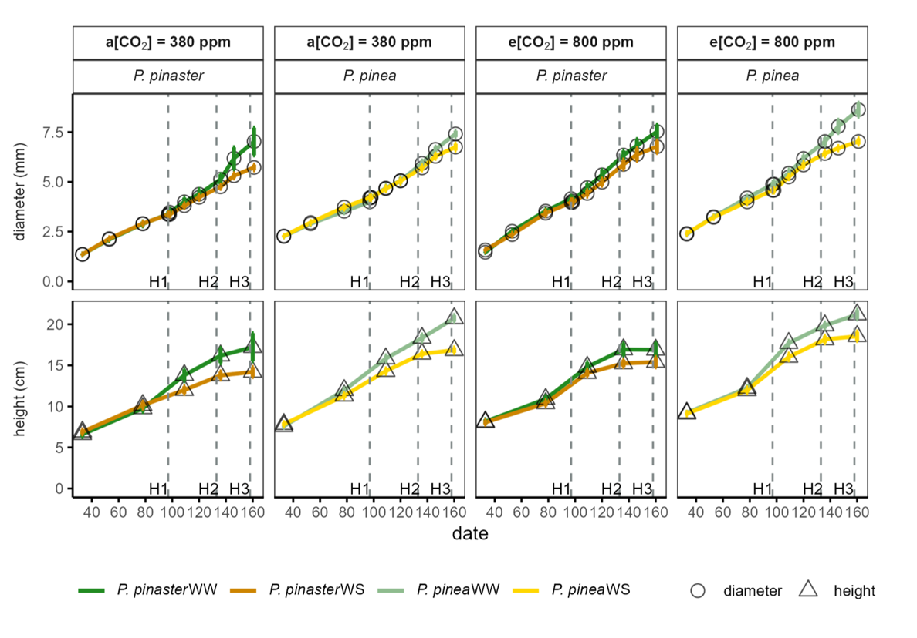
Figure S2. Biweekly diameter (mm) and monthly height (cm) measurements with standard errors during the experiment. Vertical dashed lines indicate dates for Harvests 1, 2 and 3. WW: Well-watered plants; WS: water-stressed plants.

Figure S3. Variation in plant biomass allocation estimators: SRR (Shoot: root ratio); LMF (Leaf Mass Fraction) = leaf mass/total biomass; SMF (Stem Mass Fraction) = stem mass/total biomass; RMF (Root Mass Fraction) = root mass/total biomass; LAR (Leaf Area Ratio) = total leaf area/total biomass and SLA (Specific Leaf Area) = total leaf area/total leaf mass from Harvests 1, 2 and 3. Tendency lines indicate significant linear correlation between plant traits and plant total biomass. WW: Well-watered plants; WS: water-stressed plants.

Figure S4. Total leaf area, including area of young needles in P. pinea and young needles and brachyblasts in P. pinaster of plants from Harvest 3. Number of water-stressed plants (WS): 10 per species and CO₂ treatment. Number of well-watered plants (WW): 6 per species and CO₂ treatment.

Figure S5. Linear regression between plant total leaf mass and plant total transpiration (ET) in 24 hours including all harvested plants (i.e. in H2 and H3).

Figure S6. Measured values of stomatal conductance to water vapour (g_{wv}), intrinsic water-use efficiency (WUEi) and whole-plant water use efficiency (WUE) in relation to measured predawn water potential (Ψ_{predawn}). Number of water-stressed plants (WS): 6 per species and CO₂ treatment (all from Harvest 2). Number of well-watered plants (WW): 12 per species and CO₂ treatment (6 from Harvest 1 and 6 from Harvest 2).

Figure S7. Relationship between intrinsic water use efficiency (WUEi) derived from leaf 13C isotopic discrimination and gas exchange variables. A) Relationship between from leaf 13C-based WUEi instantaneous ci/ca; B) Relationship between from leaf 13C-based WUEi and gas exchange based WUEi. In panel B, the dashed line represents the 1:1 relationship.

