Supplementary material

Advancing the quantification of land-use intensity in forests: the ForMIX index combining tree species composition, tree removal, deadwood availability, and stand maturity

Michael Staab, Nico Blüthgen, Katja Wehner, Peter Schall, Christian Ammer

Contents
Table S1 Deadwood in old-growth European beech forest…………………………………………..….………..2
Table S2 Numbers of large trees in old-growth European beech forest………..………………………..…..3
Table S3 Pairwise contrasts among forest types…………………………..………………………………..….………..4
Fig. S1 Overview of sites………………………………………………….………………………………………………………..6
Fig. S2 Comparison between raw and standardized ForMIX…………………………………………….……….7
Fig. S3 Sensitivity analysis…………………………………………………………………………….………………….……….8
Fig. S4 Comparison with a fictive alternative ForMIX……………………………..……………..…………………8
Fig. S5 Comparison between ForMIX, ForMI and SMI……..………………………………………..………..…10
References in Supplementary material……..………………………….…………………………………..………..…11
Table S1 Overview on studies that have quantified the amount of deadwood in old-growth unmanaged beech forest. Our proposed reference value for deadwood availability of 100 m³/ha is particularly derived from the review by Christensen et al. (2005). The proposed 100 m³/ha are within the reported range and well above the deadwood quantities found in managed forests. We note that the highest quantities in the literature are usually reported from montane sites.
Study | Forest type | Condition | Mean amount of deadwood
Koop and Hilgen (1987) | European beech forest | Strictly protected since 1883, France | 155 (136 and 173) m³/ha
Green and Peterken (1997) | Mixed forest dominated by European beech | Since 1944 strictly protected, in 1997 ca 90 years untouched | 104 m³/ha
Schnitzler and Borlea (1998) | Mixed European-oak forest | 140-200 year old forest. In 1998 since 30 years unmanaged | 91 m³/ha
Commarmot et al. (2005) | European beech forest | 10 ha primeval forest in the Ukrainian Carpathians | 111 (27-255) m³/ha
Christensen et al. (2005) | European beech forest | 86 beech forest reserves across Europe | 130 (6-550) m³/ha
Jaworski and Podlaski (2007) | Mixed mountain forest (European beech, silver fir) | 4 primeval forests in Poland (data from 1997) | 179 (124-293) m³/ha
Holeska et al. (2009) | Mixed forest (mainly silver fir, Norway spruce, European ash, European beech, Sycamore maple) | Strictly protected forest in Slovakia, for at least 44 years not managed | 306 m³/ha
Feldmann et al. (2018) | European beech forest | 3 primeval forests in the Slovakian Carpathians | 156 (123-177) m³/ha
Nagel et al. (2023) | European beech forest | 5 old beech forests in Germany (unmanaged >100 years) | 206 (128-450) m³/ha

Table S2 Overview on studies that have quantified the densities of large living trees in old-growth unmanaged beech forest. Our proposed reference value for stand maturity of an average diameter for the 20 trees with largest DBH is particularly derived from the review by Vandekerkhove et al. (2018). The data show that around 20 trees with DBH above 80 cm are an upper estimate. As there can be some trees considerably larger than 80 cm DBH (and hence increasing arithmetic means), we think that our reference of 80 cm for the average DBH for the 20 largest trees is suitable (even when the median for numbers of large trees is below 20) and representative to describe the conditions for beech forest in Europe.
Study | Forest type | Condition | Trees per ha > 80 cm DBH
Nilsson et al. (2002) | Various broad-leafed forests | >200 years old forests in France, Slovakia and Poland | 5-19
Meyer et al. (2003) | European beech forests | Primeval forests in Albania | 5-19
von Oheimb et al. (2005) | European beech forests | Strictly protected (since 1960) mature forest in Germany | 13
Commarmot et al. (2005) | European beech forest | 10 ha primeval forest in the Ukrainian Carpathians | 21
Holeska et al. (2009) | Mixed forest (mainly silver fir, Norway spruce, European ash, European beech, Sycamore maple) | Strictly protected forest in Slovakia, for at least 44 years not managed | 6
Zenner et al. (2015) | European beech forest | 10 ha primeval forest in the Ukrainian Carpathians | 23
Vandekerkhove et al. (2018) | European beech forest | 68 studies/inventories in lowland old-growth beech forest across Europe | 5-20 (median 13)

Table S3 Pairwise contrasts of ForMIX and its components between forest types (managed spruce, pine, beech, oak forest as well as unmanaged forest) for 150 sites in three regions of Germany (Fig. S1). P-values are derived from the Tukey-method and based on Kenward-Roger approximated degrees of freedom. Significant contrasts (at p<0.05) are shown in bold
Contrast | Estimate ± SE | t-ratio | p-value
ForMIX
Spruce – Pine | -0.104 ± 0.128 | -0.807 | 0.928
Spruce – Beech | 0.977 ± 0.086 | 11.316 | <0.001
Spruce – Oak | 0.997 ± 0.156 | 6.379 | <0.001
Spruce – unmanaged | 1.428 ± 0.103 | 13.819 | <0.001
Pine – Beech | 1.080 ± 0.096 | 11.301 | <0.001
Pine – Oak | 1.101 ± 0.129 | 8.556 | <0.001
Pine – unmanaged | 1.532 ± 0.104 | 14.725 | <0.001
Beech – Oak | 0.021 ± 0.131 | 0.158 | 1.000
Beech – unmanaged | 0.452 ± 0.068 | 6.622 | <0.001
Oak – unmanaged | 0.431 ± 0.137 | 3.143 | 0.017
Tree species composition
Spruce – Pine | 0.065 ± 0.047 | 1.368 | 0.650
Spruce – Beech | 0.906 ± 0.031 | 29.250 | <0.001
Spruce – Oak | 0.942 ± 0.058 | 16.360 | <0.001
Spruce – unmanaged | 0.921 ± 0.037 | 24.601 | <0.001
Pine – Beech | 0.842 ± 0.036 | 23.593 | <0.001
Pine – Oak | 0.878 ± 0.048 | 18.403 | <0.001
Pine – unmanaged | 0.856 ± 0.039 | 22.083 | <0.001
Beech – Oak | 0.036 ± 0.049 | 0.736 | 0.948
Beech – unmanaged | 0.014 ± 0.025 | 0.570 | 0.979
Oak – unmanaged | -0.021 ± 0.051 | -0.419 | 0.994
Deadwood availability
Spruce – Pine | -0.064 ± 0.072 | -0.885 | 0.901
Spruce – Beech | 0.007 ± 0.048 | 0.152 | 1.000
Spruce – Oak | -0.152 ± 0.088 | -1.741 | 0.416
Spruce – unmanaged | 0.083 ± 0.058 | 1.419 | 0.616
Pine – Beech | 0.071 ± 0.054 | 1.326 | 0.677
Pine – Oak | -0.216 ± 0.072 | -3.025 | 0.024
Pine – unmanaged | 0.147 ± 0.058 | 2.512 | 0.100
Beech – Oak | 0.145 ± 0.073 | 1.985 | 0.282
Beech – unmanaged | 0.076 ± 0.038 | 1.984 | 0.279
Oak – unmanaged | -0.070 ± 0.077 | -0.908 | 0.894
Tree removal
Spruce – Pine | 0.114 ± 0.056 | 2.054 | 0.284
Spruce – Beech | 0.050 ± 0.038 | 1.311 | 0.685
Spruce – Oak | -0.099 ± 0.068 | -1.454 | 0.597
Spruce – unmanaged | 0.201 ± 0.047 | 4.295 | <0.001
Pine – Beech | -0.064 ± 0.041 | 1.549 | 0.549
Pine – Oak | -0.213 ± 0.056 | -3.799 | 0.002
Pine – unmanaged | 0.087 ± 0.045 | 1.908 | 0.332
Beech – Oak | -0.149 ± 0.057 | -2.633 | 0.077
Beech – unmanaged | 0.150 ± 0.030 | 5.009 | <0.001
Oak – unmanaged | 0.299 ± 0.060 | 5.009 | <0.001
Stand maturity
Spruce – Pine | -0.261 ± 0.061 | -4.298 | <0.001
Spruce – Beech | -0.005 ± 0.041 | -0.118 | 1.000
Spruce – Oak | -0.041 ± 0.075 | -0.549 | 0.982
Spruce – unmanaged | 0.204 ± 0.049 | 4.163 | 0.001
Pine – Beech | 0.256 ± 0.046 | 5.580 | <0.001
Pine – Oak | 0.220 ± 0.063 | 3.469 | 0.006
Pine – unmanaged | 0.465 ± 0.050 | 9.240 | <0.001
Beech – Oak | -0.036 ± 0.064 | -0.572 | 0.979
Beech – unmanaged | 0.209 ± 0.034 | 6.240 | <0.001
Oak – unmanaged | 0.245 ± 0.067 | 3.671 | 0.003

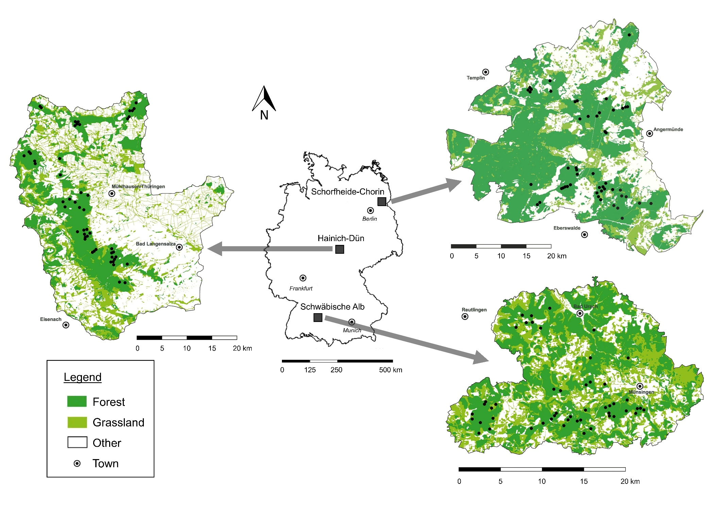
Fig. S1 Overview of sites (indicated by black points) on which forest inventories were conducted. In three regions of Germany (Hainich-Dün: left; Schorfheide-Chorin: top right; Schwäbische Alb: bottom right) 50 plots each were inventoried. Other land use comprises agriculture, settlements and water bodies. Maps use UTM projection and are based on OpenStreetMap© data

Fig. S2 ForMIX based on raw components is highly related (Spearman’s rho=0.993, p<0.001) to ForMIX for which all four components (tree species composition, deadwood availability, tree removal, stand maturity) are standardized between 0 (minimum in raw component) and 1 (maximum in raw component) before the compound index is calculated. Dashed line is the 1:1 diagonal. Data are based on forest inventories conducted on a total of 150 forest sites (size 1 ha) distributed over three regions of Germany (Fig. S1)

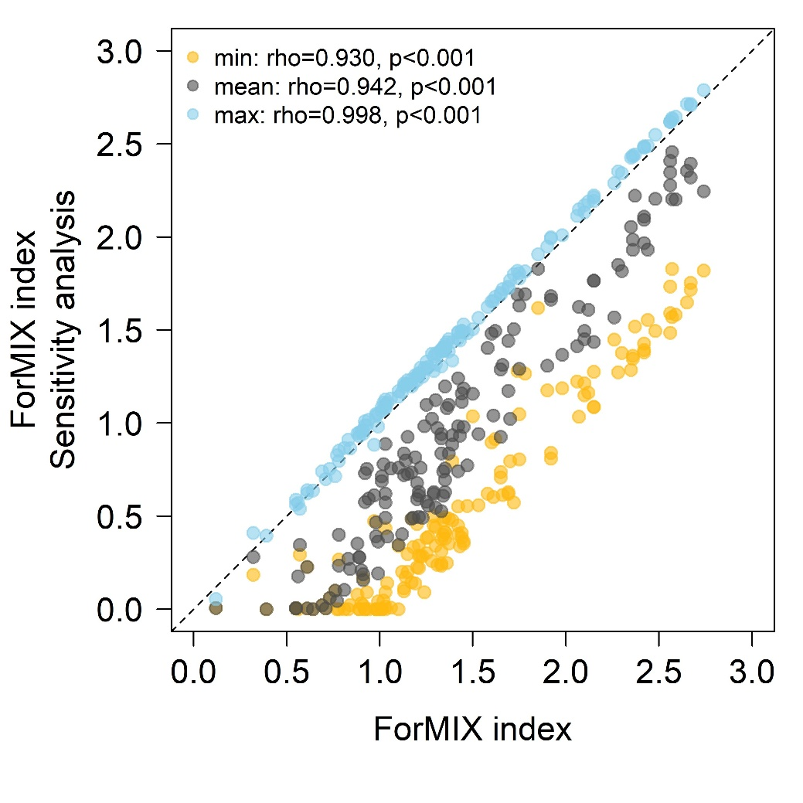
Fig. S3 “Sensitivity analysis” relating the ForMIX index to three alternative calculations that are each based on the observed minimum (min), mean and maximum (max) of deadwood availability (deadwood volume: min=8 m³/ha; mean= 29 m³/ha; max=89 m³/ha) and stand maturity (DBH of 20 largest trees: min=59 cm; mean=75 cm; max= 87 cm) from the 25 unmanaged forest sites in our data. Under all three scenarios, values were highly correlated (Spearman’s rho>0.930, p<0.001) with the “regular” ForMIX based on 100 m³/ha of deadwood and an average DBH of 80 cm for the 20 largest trees. Data are based on forest inventories conducted on a total of 150 forest sites (size 1 ha) distributed over three regions of Germany (Fig. S1)

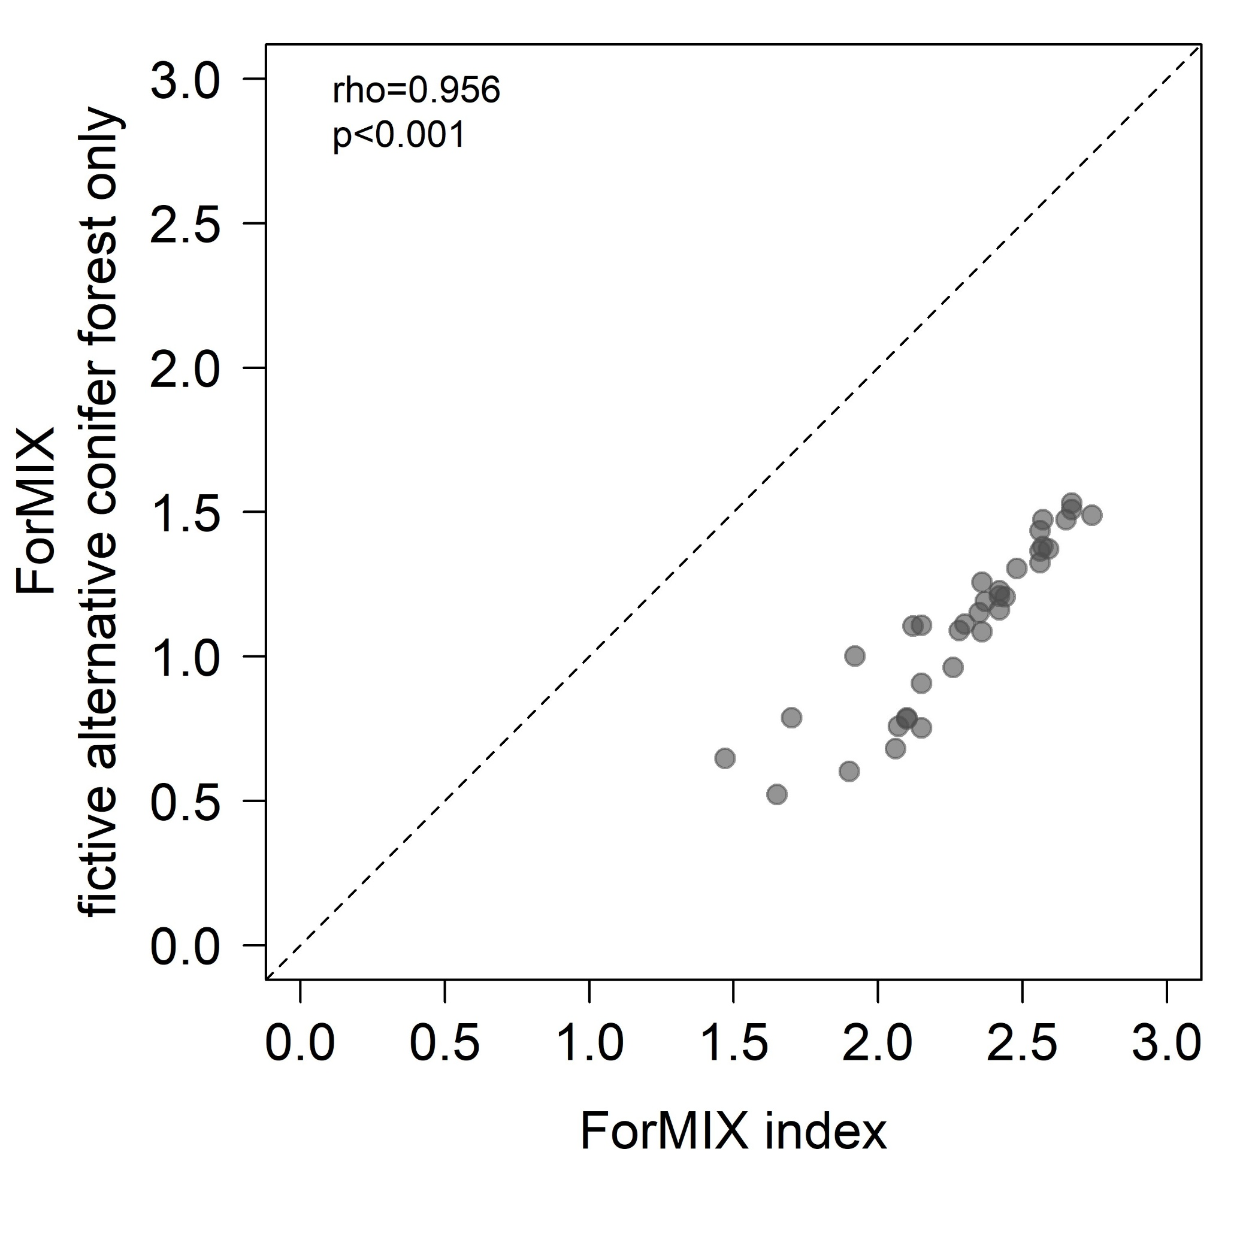
Fig. S4 For the 36 forest sites dominated by non-natural conifers, a fictive alternative ForMIX (assuming that spruce, larch and pine that jointly account for 99.5% of conifer basal area are natural at all sites; expected amount of deadwood 60 m³/ha, average DBH of 20 largest trees 60 cm) is highly related (Spearman’s rho=0.956, p<0.001) to ForMIX using beech forest as reference (larch and pine not considered natural, spruce only when occurring at higher elevation and accounting for less than 1/3 of basal area; expected amount of deadwood 100 m³/ha). Dashed line is the 1:1 diagonal

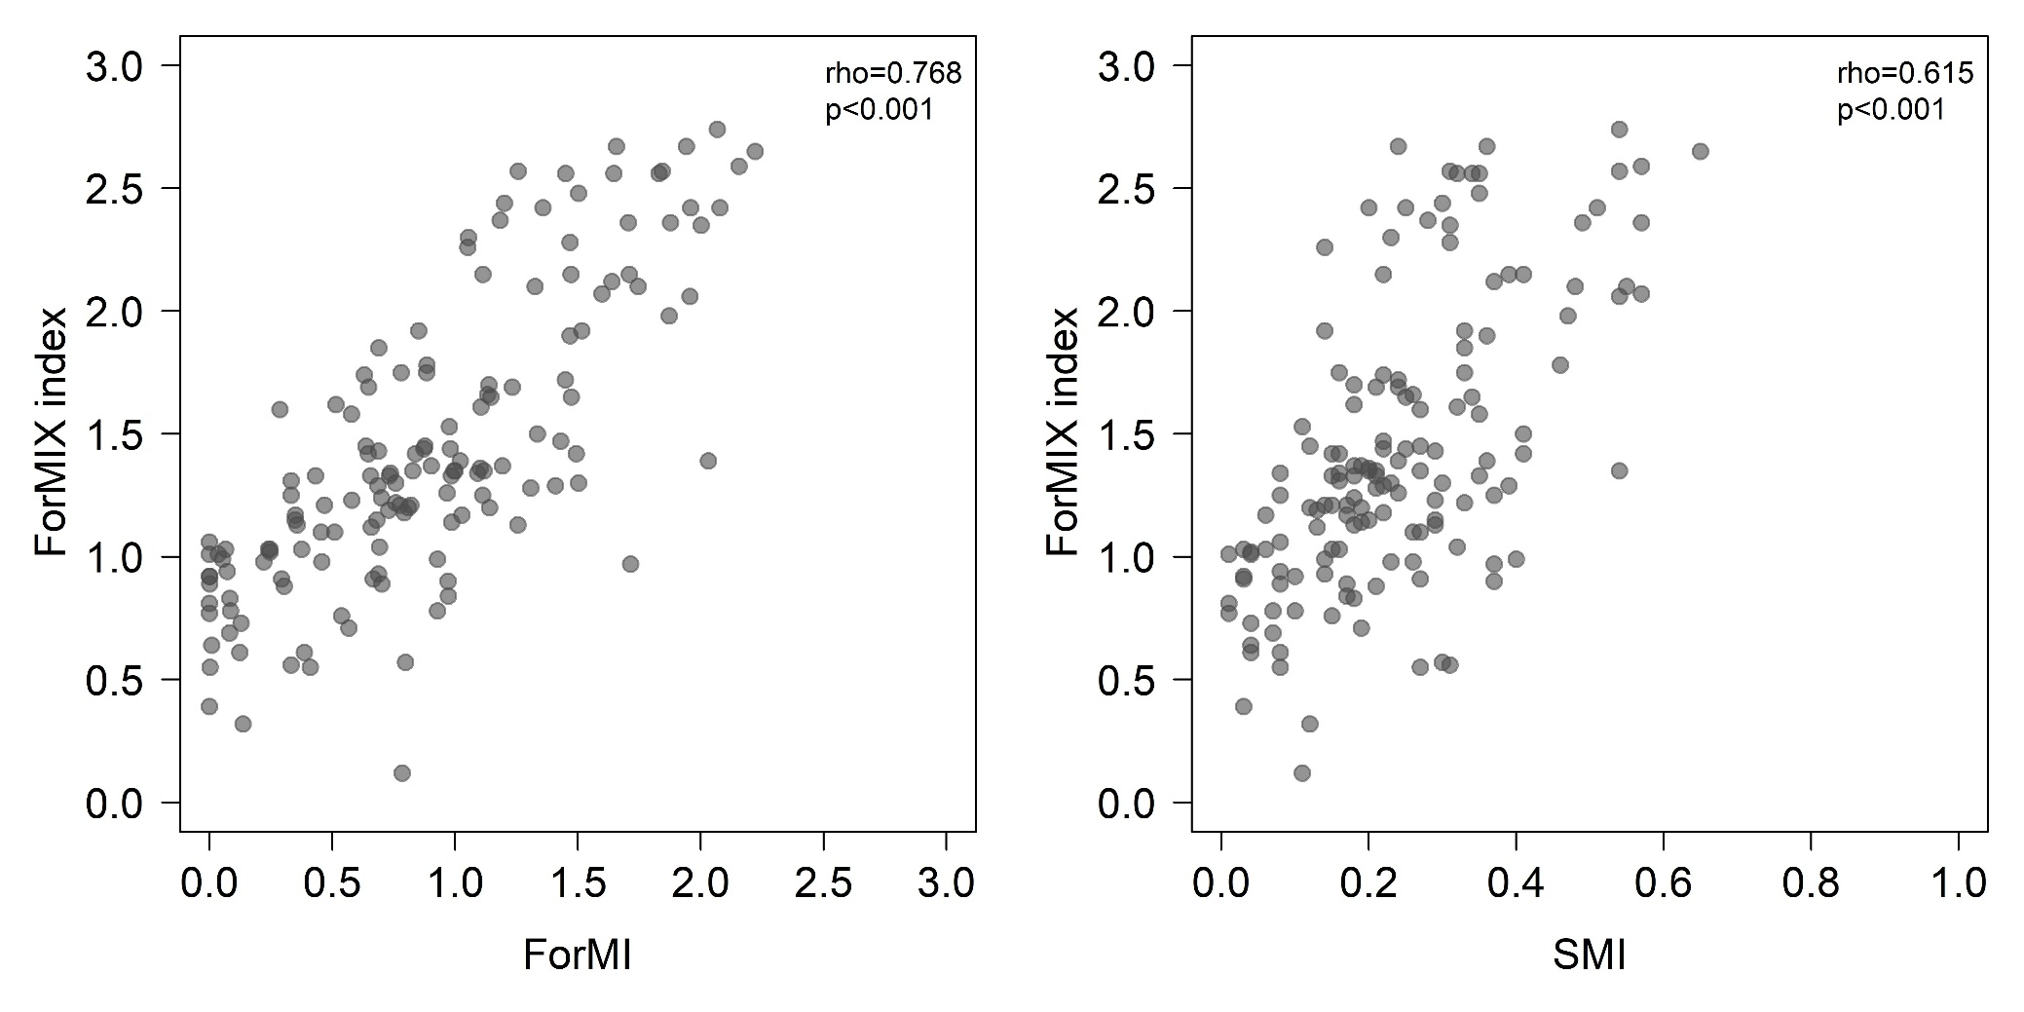
Fig. S5 The ForMIX index correlates with alternative measures of land use in forest. Shown are relationships with the Forest Management Intensity index (ForMI, Kahl & Bauhus 2014, left) and the Silvicultural Management Intensity indicator (SMI, Schall & Ammer 2013, right), which are both highly significant (based on Spearman’s rho). Data are based on forest inventories conducted on a total of 150 forest sites (size 1 ha) distributed over three regions of Germany (Fig. S1)

References cited in Supplementary material
Christensen M, Hahn K, Mountford EP, Odor P, Standovár T, Rozenbergar D, Diaci J, Wijdeven S, Meyer P, Winter S, Vrska T (2005) Dead wood in European beech (Fagus sylvatica) forest reserves. For Ecol Manag 210:267–282. https://doi.org/10.1016/j.foreco.2005.02.032
Commarmot B, Bachofen H, Bundziak Y, Bürgi A, Ramp B, Shparyk Y, Sukhariuk D, Viter R, Zingg A (2005) Structures of virgin and managed beech forests in Uholka (Ukraine) and Sihlwald (Switzerland): a comparative study. For Snow Landsc Res 79:45–56.
Feldmann E, Glatthorn J, Hauck M, Leuschner C (2018) A novel empirical approach for determining the extension of forest development stages in temperate old-growth forests. Eur J For Res 137:321–335. https://doi.org/10.1007/s10342-018-1105-4
Green P, Peterken GF (1997) Variation in the amount of dead wood in the woodlands of the Lower Wye Valley, UK in relation to the intensity of management. For Ecol Manag 98:229–238. https://doi.org/10.1016/S0378-1127(97)00106-0
Holeksa J, Saniga M, Szwagrzyk J, Czerniak M, Staszyńska K, Kapusta P (2009) A giant tree stand in the West Carpathians—An exception or a relic of formerly widespread mountain European forests? For Ecol Manag 257:1577–1585. https://doi.org/10.1016/j.foreco.2009.01.008
Jaworski A, Podlaski R (2007) Structure and dynamics of selected stands of primeval character in the Pieniny National Park. Dendrobiology 58:25–41.
Koop H, Hilgen P (1987) Forest dynamics and regeneration mosaic shifts in unexploited beech (Fagus sylvatica) stands at Fontainebleau (France). For Ecol Manag 20:135–150. https://doi.org/10.1016/0378-1127(87)90155-1
Nagel R, Meyer P, Blaschke M, Feldmann E (2023) Strict forest protection: A meaningful contribution to Climate-Smart Forestry? An evaluation of temporal trends in the carbon balance of unmanaged forests in Germany. Front For Glob Change 6:1099558. https://doi.org/10.3389/ffgc.2023.1099558
Meyer P, Tabaku V, von Lüpke B (2003) Die Struktur albanischer Rotbuchen‐Urwälder–Ableitungen für eine naturnahe Buchenwirtschaft. Forstwissenschaftliches Centralblatt 122:47–58. https://doi.org/10.1046/j.1439-0337.2003.02041.x
Nilsson SG, Niklasson M, Hedin J, Aronsson G, Gutowski JM, Linder P, Ljungberg H, Mikusiński G, Ranius T (2002) Densities of large living and dead trees in old-growth temperate and boreal forests. For Ecol Manag 161:189–204. https://doi.org/10.1016/S0378-1127(01)00480-7
Schnitzler A, Borlea F (1998) Lessons from natural forests as keys for sustainable management and improvement of naturalness in managed broadleaved forests. For Ecol Manag 109:293–303. https://doi.org/10.1016/S0378-1127(98)00263-1
Vandekerkhove K, Vanhellemont M, Vrška T, Meyer P, Tabaku V, Thomaes A, Leyman A, De Keersmaeker L, Verheyen K (2018) Very large trees in a lowland old-growth beech (Fagus sylvatica L.) forest: Density, size, growth and spatial patterns in comparison to reference sites in Europe. For Ecol Manag 417:1–17. https://doi.org/10.1016/j.foreco.2018.02.033
von Oheimb G, Westphal C, Tempel H, Härdtle W (2005). Structural pattern of a near-natural beech forest (Fagus sylvatica) (Serrahn, North-east Germany). For Ecol Manag 212:253–263. https://doi.org/10.1016/j.foreco.2005.03.033
Zenner EK, Peck JE, Hobi ML, Commarmot B (2015) The dynamics of structure across scale in a primaeval European beech stand. Forestry 88:180–189. https://doi.org/10.1093/forestry/cpu042

