European Journal of Forest Research

Supplementary material

Title: The relationship between tree carbon balance and the occurrences of epiphytes of conservation concern in boreal unmanaged forests

Supplementary material

Figures
Figure S 1. The diameter distribution of the study plots in the third measurement time in 2019. 1: Scots pine, 2: Norway spruce, 3: Deciduous trees.

Figure S 2. The year of origin of the study sites based on different data sources. In this study, the stand age was calculated as a mean of two tree ring recordings when available (denoted with black and open dots). If tree ring recordings were not available, we used the latest estimated age of the forest patch surrounding the study plot (denoted with red triangles). The tree ring recordings have been collected by the Natural Resources Institute Finland and the forest patch data by the Parks and Wildlife Finland.

Figure S 3. A correlation matrix of the key stand variables in the third measurement time in 2019. A: the estimated age of the dominant cohort, DBH: Basal area weighted mean diameter (cm) at breast height (1.3 m), H: basal area weighted mean height (m), B: Stand basal area (m² ha⁻¹), N: stand density (number of trees ha⁻¹), V: standing volume (m³ ha⁻¹), GAI: gross annual increment (m³ ha⁻¹ a⁻¹), NPP: Net primary production (kg C m⁻² a⁻¹).

Figure S 4. The relationships between the tree carbon stock and its change in the measurement period 1990-2019, and the studied forest naturalness variables.

Figure S 5. The mean annual gross volume increment by the DBH size class in the first measurement in cubic meters (a, b) and as percentage of the standing volume of the DBH class (c, d), during the measurement periods 1 (a, c; 1990-2006) and 2 (b, d; 2006-2019). Study plot VA210 was excluded because it was measured only in the first and the third survey. The dashed horizontal line denotes the median among the study plots during period 1. The size class 1 refers to a DBH of 5-10 cm, 2 to 10-15 cm, 3 to 15-20 cm, … and 9 to ≥ 45 cm, respectively.

Figure S 6. a) The number of red-listed lichen species that occurred primarily on the given tree species, b) the total number of observed red-listed lichen species per tree species and c) the total number of observed occurrences of red-listed lichen species per tree species in the 27 study sites. IUCN status refers to the International Union for Conservation of Nature (IUCN) Red List categories. The categories critically endangered and endangered were merged and are denoted with EN. VU refers to vulnerable and NT refers to near threatened.

Figure S 7. The relationships between the species richness (a-c) and the number of occurrences (d-f) of red-listed epiphytic lichens, and the studied forest naturalness variables in the study sites.

Tables
Table S 1. The mean values of basal area weighted mean height (H) and basal area weighted diameter at breast height (DBH), stand age (A), stand density (N), basal area (B), standing volume (V), deadwood volume (DW), the relative basal area of Norway spruce (Bspruce), Scots pine (Bpine) and deciduous trees (Bbirch) by study site in the third survey in 2019. The mean and standard deviation (Std) are shown at the bottom.

Table S 2. The 58 red listed epiphytic lichen and allied fungi species recorded from the 27 study sites, including the International Union for Conservation of Nature (IUCN) Red List categories critically endangered (CR), endangered (EN), vulnerable (VU) and near threatened (NT) of the species, taxonomic group (1: lichen species, 2: lichenicolous fungi and lichen-like saprophytic fungi), main habitat old growth forest (1: yes, 0: no), primary growing substratum of the species in the study sites, the number of sites where the species was recorded, and the median of occurrences per study site with the minimum – maximum range in parenthesis. For each species, all the occurrences were recorded from all kinds of wood and bark substrata from the 30-m circular study plot located in each study site.

Table S 3. Municipality and identification code for the studied forest sites, the number of the epiphytic lichens species in the International Union for Conservation of Nature (IUCN) Red List categories critically endangered (CR), endangered (EN), vulnerable (VU) and near threatened (NT), and their summed number of occurrences recorded from the 30-m circular plot in each study site. The dominant tree species is denoted with 1 for spruce dominated and 2 for pine dominated sites.

Table S 4. Results of model selection based on Akaike Information Criterion (AIC). Here, five alternative models with the lowest AIC are shown.

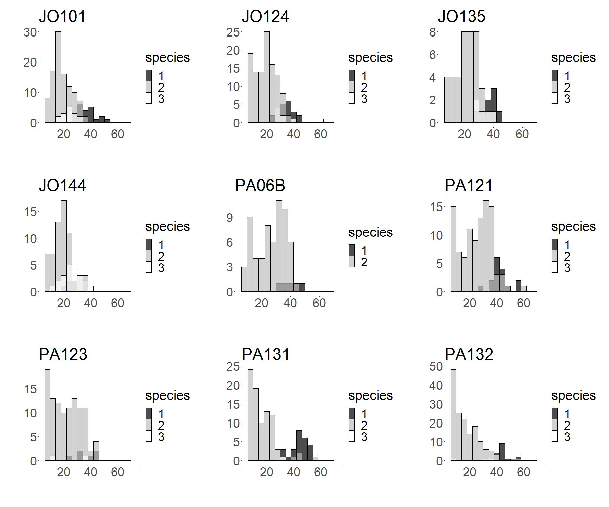
Figure S 1. The diameter distribution of the study plots in the third measurement time in 2019. 1: Scots pine, 2: Norway spruce, 3: Deciduous trees.

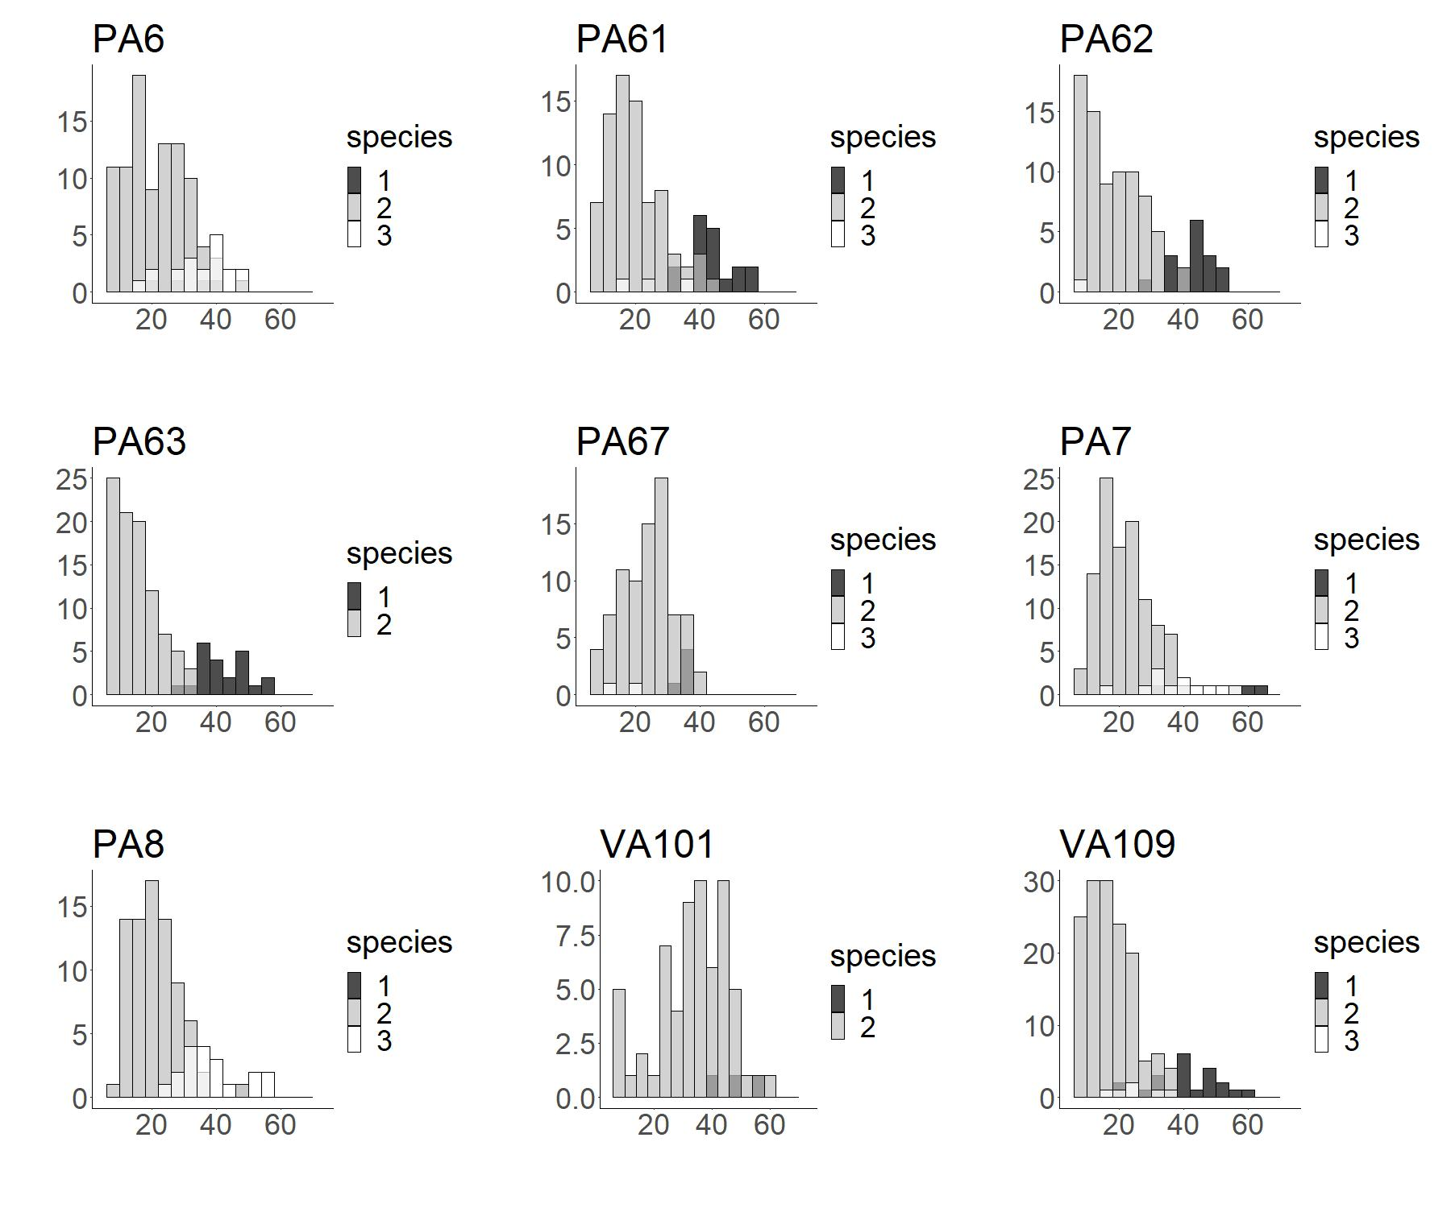

Figure S 1 (continued)

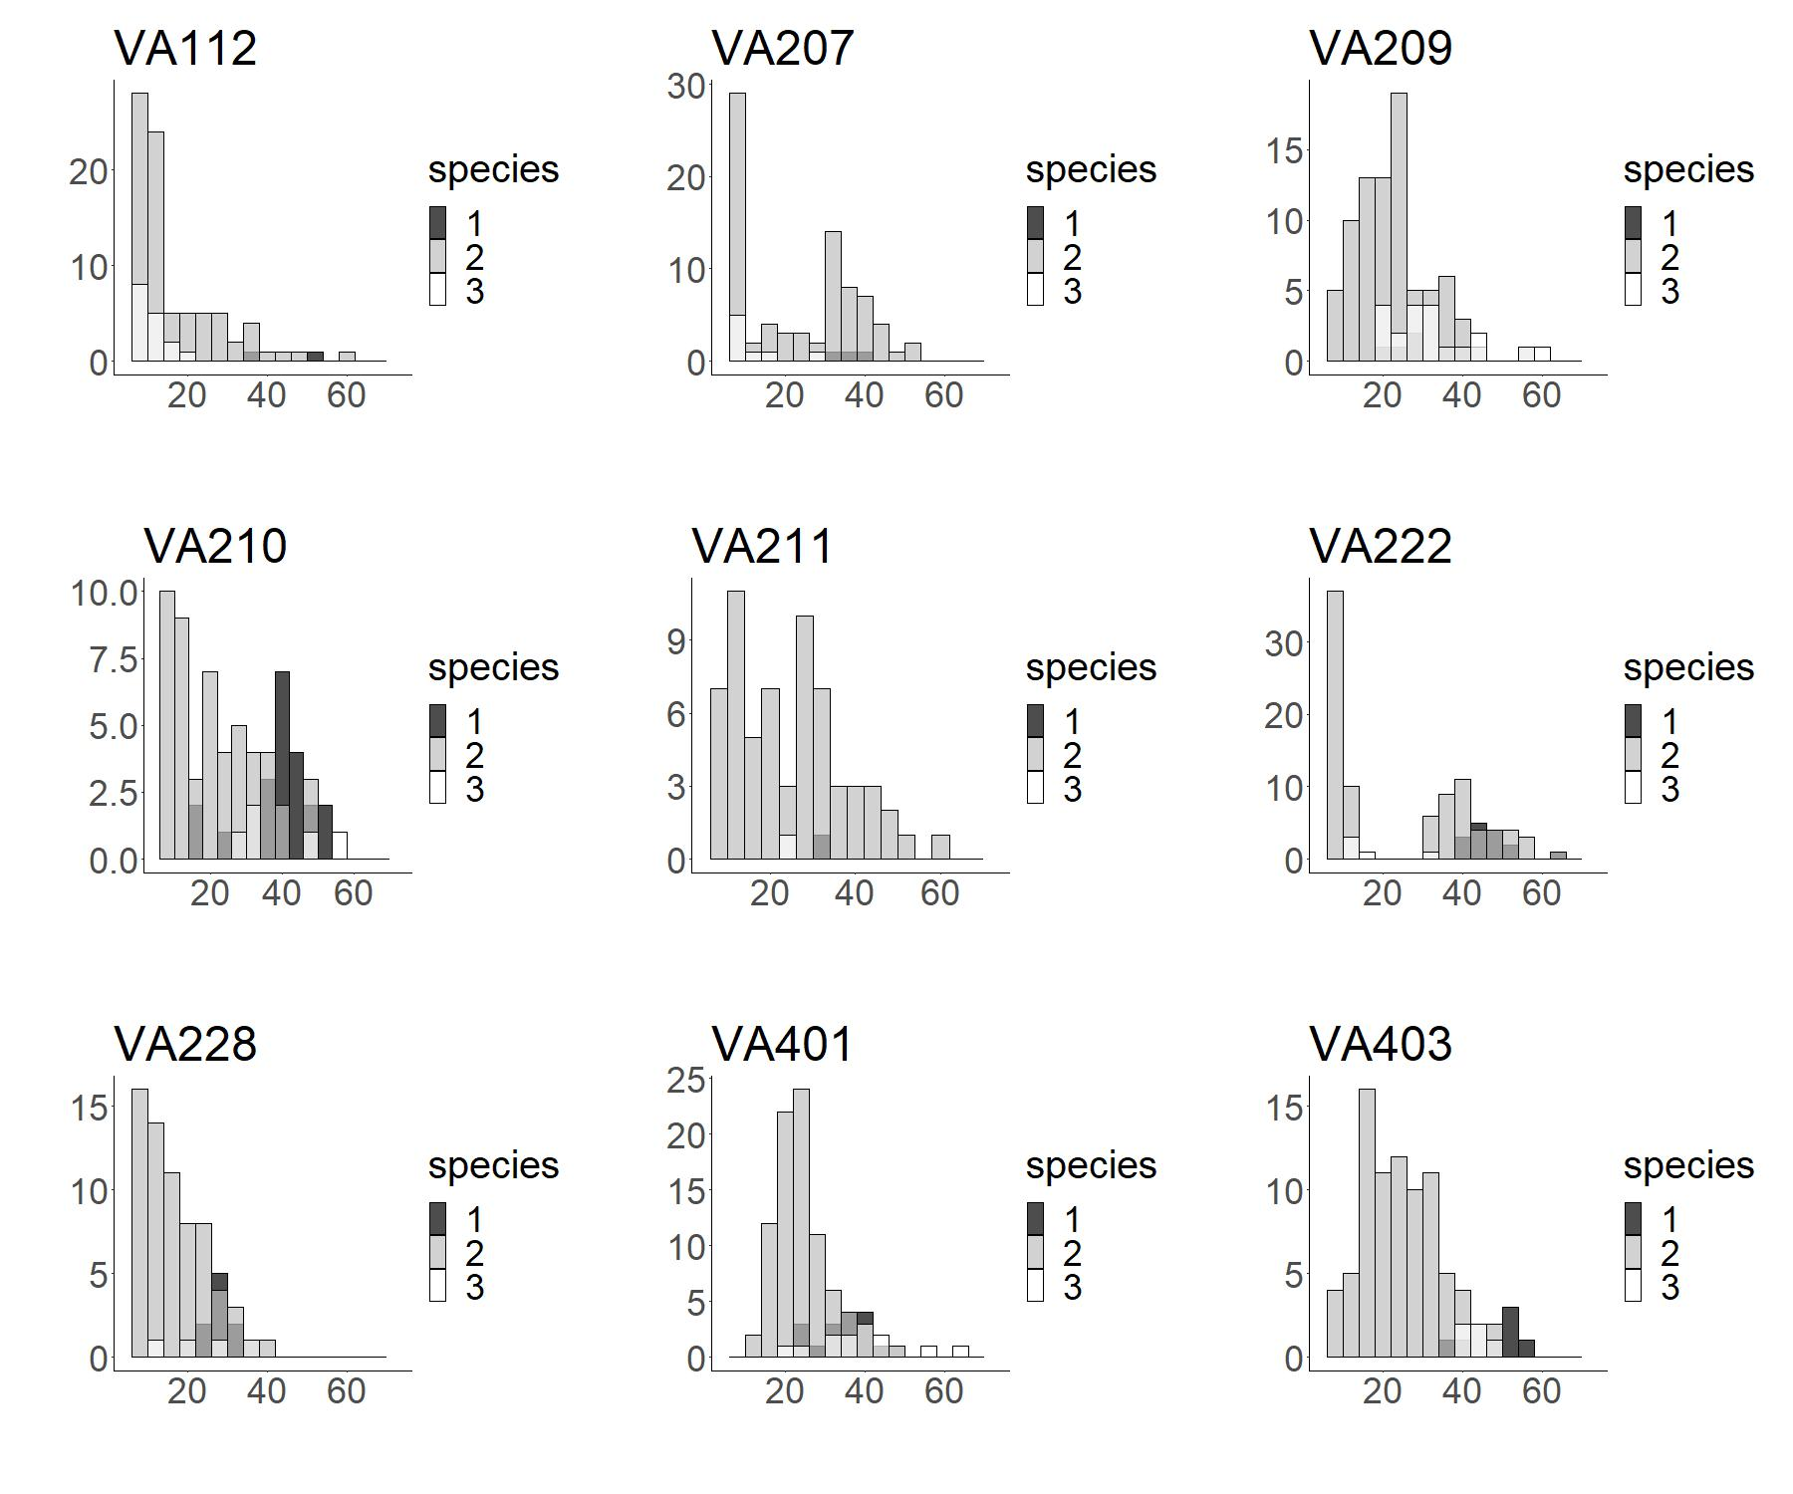

Figure S 1 (continued)

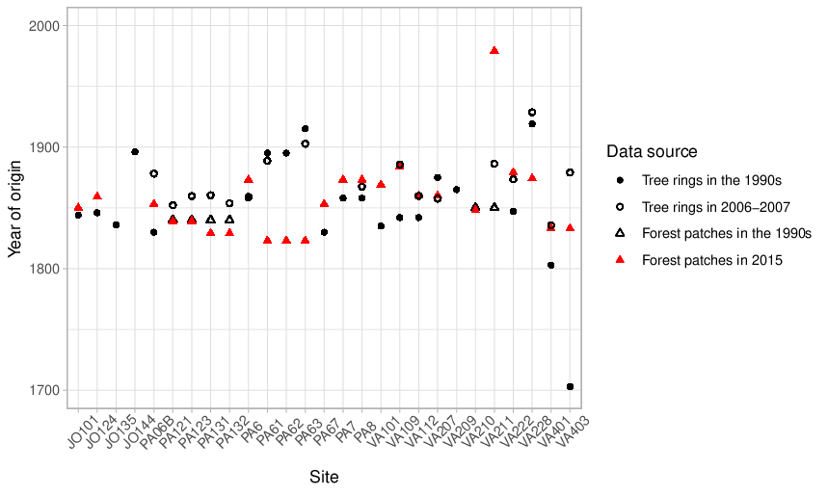
Figure S 2. The year of origin of the study sites based on different data sources. In this study, the stand age was calculated as a mean of two tree ring recordings when available (denoted with black and open dots). If tree ring recordings were not available, we used the latest estimated age of the forest patch surrounding the study plot (denoted with red triangles). The tree ring recordings have been collected by the Natural Resources Institute Finland and the forest patch data by the Parks and Wildlife Finland.

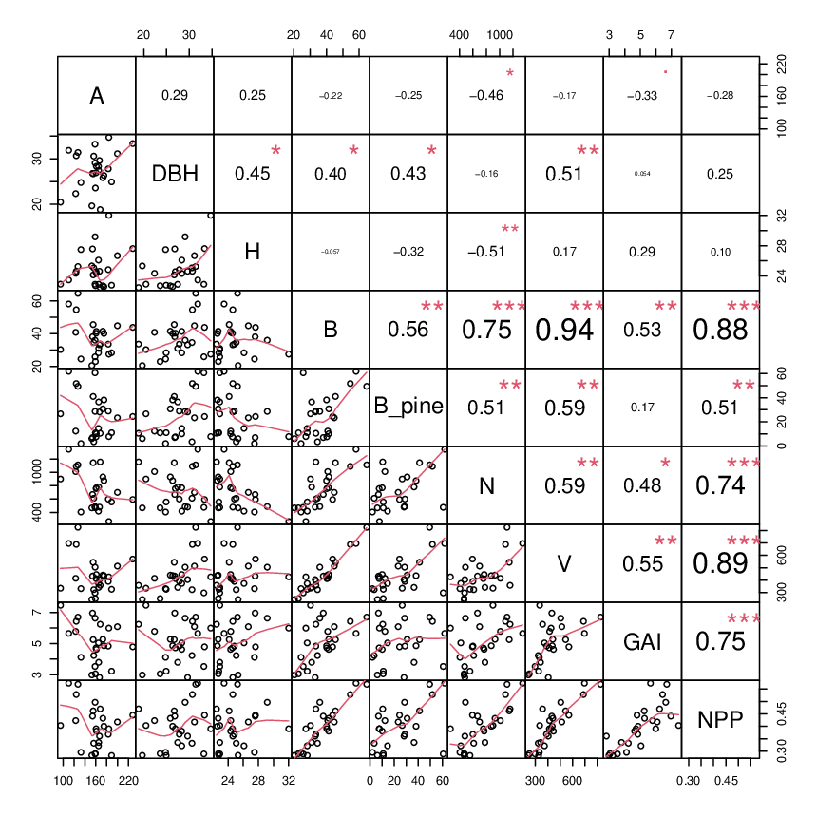
Figure S 3. A correlation matrix of the key stand variables in the third measurement time in 2019. A: the estimated age of the dominant cohort, DBH: Basal area weighted mean diameter (cm) at breast height (1.3 m), H: basal area weighted mean height (m), B: Stand basal area (m² ha⁻¹), N: stand density (number of trees ha⁻¹), V: standing volume (m³ ha⁻¹), GAI: gross annual increment (m³ ha⁻¹ a⁻¹), NPP: Net primary production (kg C m⁻² a⁻¹). The basal area of pine (B_{pine}) is shown because it was positively correlated with standing volume and growth.
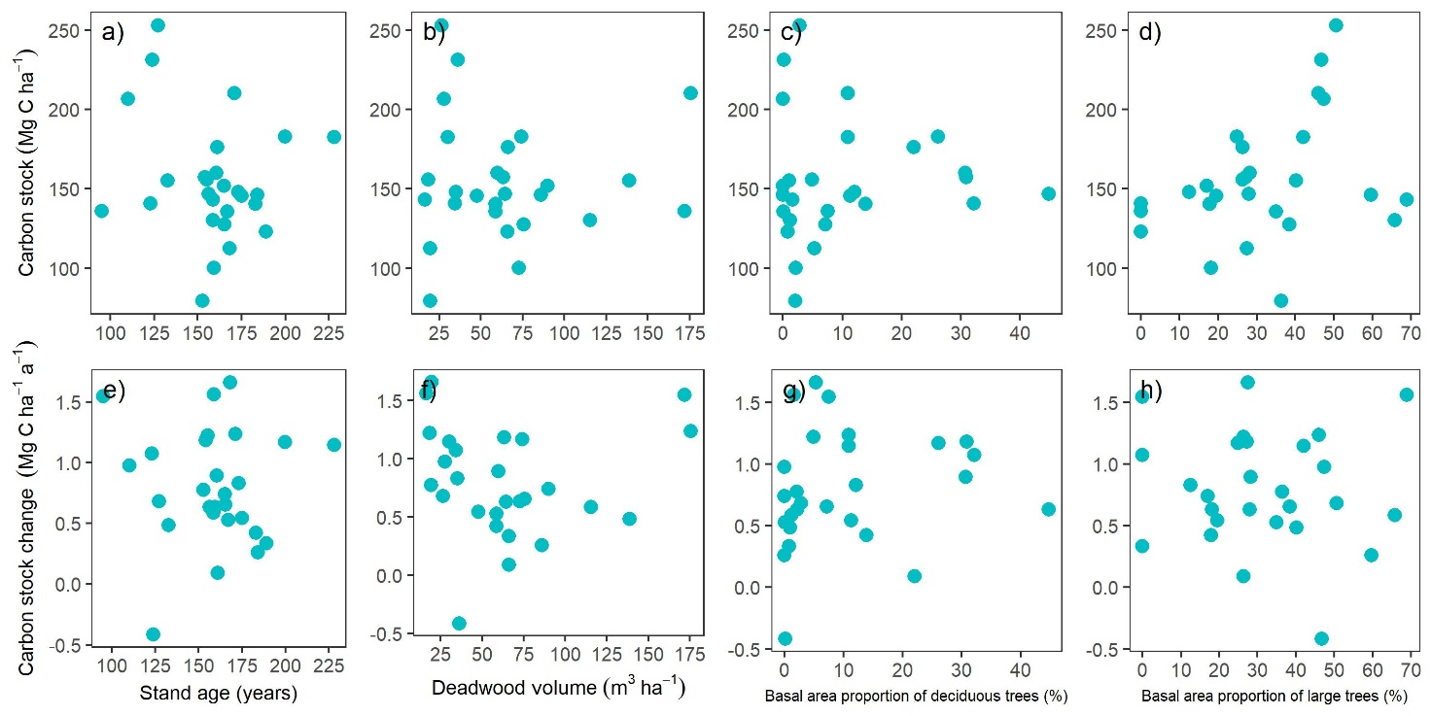

Figure S 4. The relationships between the tree carbon stock and its change in the measurement period 1990-2019, and the studied forest naturalness variables.

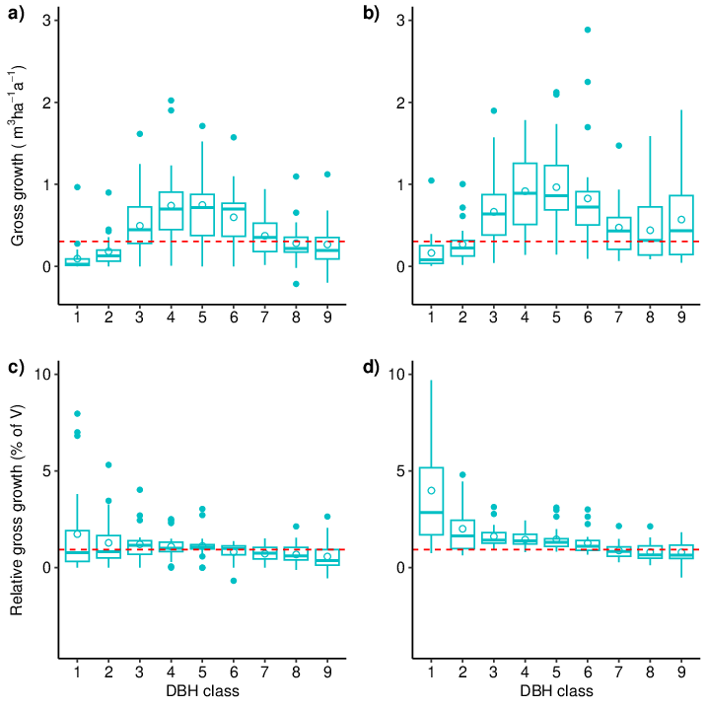
Figure S 5. The mean annual gross volume increment by the DBH size class in the first measurement in cubic meters (a, b) and as percentage of the standing volume of the DBH class (c, d), during the measurement periods 1 (a, c; 1990-2006) and 2 (b, d; 2006-2019). Study plot VA210 was excluded because it was measured only in the first and the third survey. The dashed horizontal line denotes the median among the study plots during period 1. The size class 1 refers to a DBH of 5-10 cm, 2 to 10-15 cm, 3 to 15-20 cm, … and 9 to ≥ 45 cm, respectively.

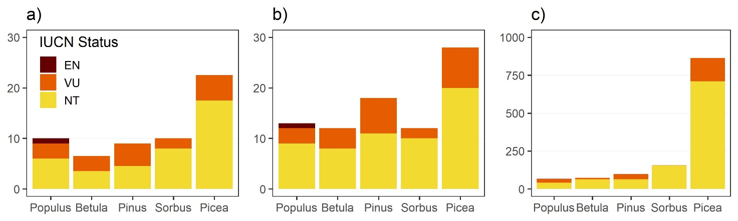
Figure S 6. a) The number of red-listed lichen species that occurred primarily on the given tree species, b) the total number of observed red-listed lichen species per tree species and c) the total number of observed occurrences of red-listed lichen species per tree species in the 27 study sites. IUCN status refers to the International Union for Conservation of Nature (IUCN) Red List categories. The categories critically endangered and endangered were merged and are denoted with EN. VU refers to vulnerable and NT refers to near threatened.

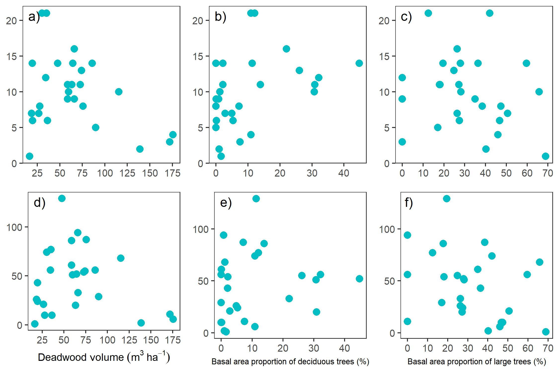
Figure S 7. The relationships between the species richness (a-c) and the number of occurrences (d-f) of red-listed epiphytic lichens, and the studied forest naturalness variables in the study sites.
Table S 1. The mean values of basal area weighted mean height (H) and basal area weighted diameter at breast height (DBH), stand age (A), stand density (N), basal area (B), standing volume (V), deadwood volume (DW), the relative basal area of Norway spruce (B_{spruce}), Scots pine (B_{pine}) and deciduous trees (B_{birch}) by study site in the third survey in 2019. The mean and standard deviation (Std) are shown at the bottom.
Site | H (m) | DBH (cm) | A (years) | N (trees/ha) | B (m²/ha) | V (m³/ha) | DW (m³/ha) | B_{spruce}  (%) | B_{pine}  (%) | B_{birch}  (%)
JO101 | 22.6 | 26.3 | 175 | 875 | 40.1 | 436 | 94 | 51 | 38 | 11
JO124 | 22.7 | 25.8 | 173 | 931 | 41.4 | 440 | 94 | 57 | 31 | 12
JO135 | 24.8 | 27.8 | 183 | 600 | 33.5 | 390 | 123 | 57 | 29 | 14
JO144 | 24.3 | 22.4 | 123 | 1011 | 40.8 | 415 | 59 | 56 | 12 | 32
PA06B | 26.1 | 28.4 | 165 | 419 | 28.2 | 373 | 236 | 85 | 15 | NA
PA121 | 24.6 | 29.6 | 167 | 480 | 33.1 | 404 | 97 | 72 | 28 | 0
PA123 | 22.7 | 23.6 | 159 | 468 | 22.9 | 251 | 104 | 87 | 11 | 2
PA131 | 22.9 | 33.2 | 159 | 476 | 25.8 | 297 | 184 | 38 | 61 | 1
PA132 | 22.9 | 27.4 | 165 | 780 | 31.0 | 342 | 122 | 56 | 36 | 7
PA6 | 24.6 | 26.9 | 161 | 756 | 40.2 | 412 | 158 | 62 | 8 | 31
PA61 | 25.2 | 31.4 | 127 | 1111 | 64.6 | 827 | 203 | 48 | 49 | 3
PA62 | 24.6 | 30.7 | 124 | 1089 | 54.6 | 688 | 254 | 48 | 52 | 0
PA63 | 23.5 | 31.9 | 110 | 1344 | 58.1 | 696 | 96 | 38 | 62 | 0
PA67 | 22.8 | 24.9 | 189 | 556 | 28.3 | 326 | 150 | 88 | 11 | 1
PA7 | 24.3 | 28.3 | 161 | 769 | 41.3 | 446 | 210 | 68 | 10 | 22
PA8 | 25.1 | 30.6 | 156 | 613 | 34.5 | 323 | 187 | 52 | 3 | 45
VA101 | 32.0 | 34.7 | 184 | 264 | 27.4 | 426 | 149 | 92 | 8 | NA
VA109 | 24.1 | 26.7 | 155 | 1144 | 45.5 | 544 | 48 | 54 | 41 | 5
VA112 | 22.5 | 18.8 | 168 | 1156 | 33.6 | 358 | 24 | 84 | 11 | 5
VA207 | 25.3 | 19.7 | 153 | 468 | 20.5 | 244 | 31 | 92 | 6 | 2
VA209 | 27.6 | 26.8 | 154 | 669 | 38.1 | 433 | 120 | 62 | 7 | 31
VA210 | 28.6 | 31.3 | 171 | 513 | 36.9 | 493 | 287 | 41 | 48 | 11
VA211 | 27.5 | 24.8 | 133 | 406 | 24.5 | 332 | 285 | 97 | 2 | 1
VA222 | 29.2 | 29.1 | 159 | 488 | 35.9 | 505 | 24 | 70 | 29 | 2
VA228 | 22.9 | 20.5 | 95 | 900 | 30.2 | 335 | 159 | 66 | 27 | 8
VA401 | 26.7 | 31.1 | 200 | 700 | 44.8 | 513 | 154 | 51 | 23 | 26
VA403 | 27.6 | 33.4 | 228 | 594 | 43.8 | 570 | 133 | 65 | 24 | 11
Mean | 25.1 | 27.4 | 159 | 725 | 37.0 | 438 | 140 | 64 | 25 | 11
Std | 2.4 | 4.2 | 28 | 280 | 10.5 | 148 | 78 | 18 | 18 | 13

Table S 2. The 58 red listed epiphytic lichen and allied fungi species recorded from the 27 study sites, including the International Union for Conservation of Nature (IUCN) Red List categories critically endangered (CR), endangered (EN), vulnerable (VU) and near threatened (NT) of the species, taxonomic group (1: lichen species, 2: lichenicolous fungi and lichen-like saprophytic fungi), main habitat old growth forest (1: yes, 0: no), primary growing substratum of the species in the study sites, the number of sites where the species was recorded, and the median of occurrences per study site with the minimum – maximum range in parenthesis. For each species, all the occurrences were recorded from all kinds of wood and bark substrata from the 30-m circular study plot located in each study site.
Species | IUCN Red List category | Taxonomic group | Main habitat old- growth forest | Primary growing substratum | Number of sites | Median of occurrences per site  (min – max)
Acolium inquinans (Sm.) A. Massal. | NT | 1 | 1 | Trunk of Picea abies | 1 | 1
Agyrium rufum (Pers.) Fr. | NT | 2 | 1 | Coniferous tree logs | 1 | 2
Alectoria sarmentosa (Ach.) Ach. | NT | 1 | 1 | Branches of Picea abies | 22 | 7.5 (1 – 123)
Arthonia incarnata Th. Fr. ex Almq. | VU | 1 | 1 | Trunk of Picea abies | 1 | 1
Arthonia vinosa Leight. | NT | 1 | 0 | Trunk of Picea abies | 3 | 2 (1 – 3)
Arthopyrenia analepta (Ach.) A. Massal. | NT | 2 | 0 | Trunk of Sorbus aucuparia | 3 | 2 (2 – 7)
Arthothelium scandinavicum Th. Fr. | NT | 2 | 1 | Trunk of Picea abies | 18 | 2 (1 – 95)
Bacidia igniarii (Nyl.) Oxner | VU | 1 | 1 | Snag of Betula pubescens | 2 | 2.5 (2 – 3)
Biatora vacciniicola (Tønsberg) Printzen | NT | 1 | 1 | Trunk of Sorbus aucuparia | 1 | 1
Bryoria fremontii (Tuck.) Brodo & D. Hawksw. | NT | 1 | 0 | Trunk and branches of coniferous trees | 1 | 2
Buellia disciformis (Fr.) Mudd | NT | 1 | 0 | Trunk of Sorbus aucuparia | 1 | 1
Buellia erubescens Arnold | VU | 1 | 1 | Trunk of Sorbus aucuparia | 1 | 1
Carbonicola anthracophila (Nyl.) Bendiksby & Timdal | NT | 1 | 1 | Burned stumps of Pinus sylvestris | 10 | 1.5 (1 – 8)
Carbonicola myrmecina (Ach.) Bendiksby & Timdal | NT | 1 | 1 | Burned stumps of Pinus sylvestris | 5 | 1 (1 – 1)
Catinaria atropurpurea (Schaer.) Vězda & Poelt | NT | 1 | 0 | Log of Betula pubescens | 1 | 1
Chaenotheca gracillima (Vain.) Tibell | NT | 1 | 1 | Snag of Betula pubescens | 1 | 2
Chaenotheca stemonea (Ach.) Müll. Arg. | VU | 1 | 1 | Snag of Pinus sylvestris | 1 | 1
Chaenotheca subroscida (Eitner) Zahlbr. | NT | 1 | 1 | Trunk of Picea abies | 4 | 4 (1 – 4)
Chaenothecopsis epithallina Tibell | VU | 2 | 1 | Lichenicolous on Chaenotheca trichialis on Betula pubescens | 1 | 1
Chaenothecopsis nana Tibell | NT | 2 | 1 | Trunk of Picea abies | 1 | 1
Cheiromycina flabelliformis B. Sutton | VU | 1 | 1 | Trunk of Sorbus aucuparia | 1 | 1
Cladonia norvegica Tønsberg & Holien | NT | 1 | 1 | Log of Picea abies | 9 | 1 (1 – 10)
Cladonia parasitica (Hoffm.) Hoffm. | VU | 1 | 1 | Log of Pinus sylvestris | 5 | 1 (1 – 2)
Cliostomum leprosum (Räsänen) Holien & Tønsberg | NT | 1 | 1 | Trunk of Picea abies | 13 | 2 (1 – 18)
Evernia divaricata (L.) Ach. | VU | 1 | 1 | Snags and branches of coniferous trees | 1 | 2
Felipes leucopellaeus (Ach.) Frisch & G. Thor. | VU | 1 | 1 | Trunk of Picea abies | 10 | 5 (1 -43)
Gyalecta fagicola (Hepp ex Arnold) Kremp. | NT | 1 | 0 | Trunk of Sorbus aucuparia | 2 | 1 (1 -1)
Gyalecta truncigena (Ach.) Hepp | EN | 1 | 1 | Trunk of Sorbus aucuparia | 1 | 1
Hertelidea botryosa (Fr.) Printzen & Kantvilas | VU | 1 | 0 | Snags and logs of Pinus sylvestris | 2 | 1 (1 – 1)
Japewia subaurifera Muhr & Tønsberg | NT | 1 | 1 | Trunk of Picea abies | 23 | 9 (1 – 24)
Japewia tornoënsis (Nyl.) Tønsberg | NT | 1 | 0 | Branches of Picea abies | 2 | 1 (1 – 1)
Lecanora hypopta (Ach.) Vain. | NT | 1 | 1 | Trunk of Picea abies | 6 | 1 (1 – 3)
Lecidea albofuscescens Nyl. | NT | 1 | 1 | Trunk of Sorbus aucuparia | 16 | 4 (1 – 17)
Leptogium saturnimum (Dicks.) Nyl. | NT | 1 | 0 | Trunk of Populus tremula | 4 | 1 (1 – 1)
Leptorhapsis atomaria (Ach.) Szatala | NT | 1 | 0 | Trunk of Populus tremula | 1 | 1
Lobaria pulmonaria (L.) Hoffm. | NT | 1 | 1 | Trunk of Populus tremula | 6 | 1.5 (1 – 4)
Lopadium disciforme (Flot.) Kullh. | VU | 1 | 1 | Trunk of Populus tremula | 9 | 4 (1 – 10)
Micarea contexta Hedl. | NT | 1 | 1 | Snag of Pinus sylvestris | 2 | 1.5 (1 – 2)
Micarea elachista (Körb.) Coppins & R. Sant. | VU | 1 | 1 | Snag of Pinus sylvestris | 8 | 1 (1 – 7)
Micarea globulosella (Nyl.) Coppins | NT | 1 | 0 | Trunk of Picea abies | 1 | 1
Micarea hedlundii Coppins | VU | 1 | 1 | Base and stump of Picea abies | 1 | 2
Micarea myriocarpa V. Wirth & Vězda ex Coppins | VU | 1 | 1 | Roots of windfall Picea abies | 1 | 1
Micarea tomentosa Czarnota & Coppins | VU | 1 | 1 | Snag of Betula pubescens | 4 | 1 (1 – 1)
Microcalicium arenarium (Hampe ex A. Massal.) Tibell | NT | 1 | 1 | Roots of windfall Picea abies | 2 | 1 (1 -1)
Nephroma bellum (Spreng.) Tuck. | NT | 1 | 1 | Trunk of Populus tremula | 4 | 1 (1 – 3)
Nephroma resupinatum (L.) Ach. | VU | 1 | 1 | Trunk of Populus tremula | 1 | 1
Opegrapha vulgata (Ach.) Ach. | NT | 1 | 1 | Trunk of (dead) Sorbus aucuparia | 1 | 1
Parmeliella triptophylla (Ach.) Müll. Arg. | NT | 1 | 1 | Branches of Picea abies | 4 | 2.5 (1 – 23)
Pertusaria carneopallida (Nyl.) Anzi ex Nyl. | NT | 1 | 0 | Trunk of Sorbus aucuparia | 15 | 2 (1 – 27)
Protopannaria pezizoides (Weber) P. M. Jørg. & S. Ekman | NT | 1 | 1 | Trunk of Populus tremula | 1 | 1
Pseudosagedia aenea (Wallr.) Hafellner & Kalb | NT | 1 | 0 | Trunk of Sorbus aucuparia | 3 | 1 (1 – 2)
Puttea caesia (Fr.) M. Svenss. & T. Sprib. | NT | 1 | 1 | Roots of windfall Picea abies | 2 | 1 (1 – 1)
Puttea margaritella (Hulting) S. Stenroos & Huhtinen | NT | 1 | 1 | Log of Picea abies, on Ptilidium pulcherrinum | 12 | 1 (1 – 1)
Rinodina septentrionalis Malme | NT | 1 | 0 | Trunk of Sorbus aucuparia | 1 | 1
Sarcosagium campestre (Fr.) Poetsch & Schied. | VU | 1 | 0 | Snag of Betula pubescens | 1 | 1
Scytinium subtile (Schrad.) Otálora, P. M. Jørg. & Wedin | VU | 1 | 1 | Trunk of Populus tremula | 1 | 1
Usnea glabrescens (Nyl. ex Vain.) Vain. ex Räsänen | NT | 1 | 1 | Trunk of old Betula and dead decorticated Pinus sylvestris | 2 | 1 (1 -1)
Xylographa trunciseda (Th. Fr.) Minks ex Redinger | VU | 1 | 1 | Log of Picea abies | 10 | 2 (1 – 8)

Table S 3. Municipality and identification code for the studied forest sites, the number of the epiphytic lichens species in the International Union for Conservation of Nature (IUCN) Red List categories critically endangered (CR), endangered (EN), vulnerable (VU) and near threatened (NT), and their summed number of occurrences recorded from the 30-m circular plot in each study site. The dominant tree species is denoted with 1 for spruce dominated and 2 for pine dominated sites.
Municipality | Study site code | Number of red-listed epiphytic lichen species | Number of red-listed epiphytic lichen species occurrences | Dominant tree species
Lieksa | JO101 | 14 | 172 | 1
Lieksa | JO124 | 21 | 89 | 1
Joensuu | JO135 | 11 | 108 | 1
Joensuu | JO144 | 12 | 72 | 1
Ruovesi | PA06B | 5 | 32 | 1
Ylöjärvi | PA121 | 9 | 61 | 1
Ylöjärvi | PA123 | 11 | 59 | 1
Ylöjärvi | PA131 | 10 | 94 | 2
Ylöjärvi | PA132 | 8 | 152 | 1
Ikaalinen | PA6 | 10 | 54 | 1
Ruovesi | PA61 | 7 | 23 | 2
Ruovesi | PA62 | 6 | 10 | 2
Ruovesi | PA63 | 8 | 10 | 2
Ruovesi | PA67 | 9 | 97 | 1
Ikaalinen | PA7 | 16 | 41 | 1
Ikaalinen | PA8 | 14 | 52 | 1
Padasjoki | VA101 | 14 | 86 | 1
Padasjoki | VA109 | 7 | 28 | 1
Padasjoki | VA112 | 6 | 25 | 1
Hämeenlinna | VA207 | 14 | 52 | 1
Hämeenlinna | VA209 | 11 | 21 | 1
Sipoo | VA210 | 4 | 6 | 2
Sipoo | VA211 | 2 | 2 | 1
Tammela | VA222 | 1 | 1 | 1
Salo | VA228 | 3 | 12 | 1
Ruovesi | VA401 | 13 | 55 | 1
Ruovesi | VA403 | 21 | 74 | 1

Table S 4. Results of model selection based on Akaike Information Criterion (AIC). Here, five alternative models with the lowest AIC are shown.
 | Model | df | logLik | AIC | ΔAIC | Weight
Species richness
 | Age + C-Change + BA-Decid + DW | 5 | -69.20 | 151.3 | 0 | 0.505
 | Age + C-Change + BA-Decid + DW + C-Stock | 6 | -68.66 | 153.5 | 2.26 | 0.163
 | Age + C-Change + BA-Decid + DW + BA-Large | 6 | -68.98 | 154.1 | 2.90 | 0.119
 | Age + BA-Decid + DW | 4 | -73.05 | 155.9 | 4.67 | 0.049
 | Age + C-Change + BA-Decid | 4 | -73.47 | 156.8 | 5.51 | 0.032
Number of occurrences
 | Age + C-Change + BA-Large | 5 | -121.36 | 255.6 | 0 | 0.203
 | Age + C-Change + BA-Large + C-Stock | 6 | -119.90 | 256.0 | 0.44 | 0.163
 | Age + C-Change + C-Stock | 5 | -122.21 | 257.3 | 1.71 | 0.086
 | Age + BA-Large | 4 | -123.85 | 257.5 | 1.95 | 0.077
 | Age + BA-Large + C-Change + DW | 6 | -120.99 | 258.2 | 2.61 | 0.055
Number of occurrences (without the most frequent species)
 | Age + C-Change + BA-Large | 5 | -100.81 | 214.5 | 0 | 0.421
 | Age + C-Change + BA-Large + BA-Decid | 6 | -100.34 | 216.9 | 2.42 | 0.126
 | Age + C-Change + BA-Large + DW | 6 | -100.53 | 217.3 | 2.79 | 0.104
 | Age + C-Change + BA-Large + C-Stock | 6 | -100.82 | 217.8 | 3.33 | 0.079
 | Age + BA-Large | 4 | -104.033 | 217.9 | 3.41 | 0.076

