Appendix A. Supplementary materials data
Table A.1 Distribution by land use type of the whole study site based on FMP data
Land use class | Area in 2010, ha | Area in 2020, ha | Divergence, ha | Divergence, %
Forest | 1894.0 | 2195.9 | 301.9 | 6.8
Woodland | 1085.9 | 601.0 | -484.9 | -10.9
Grassland | 506.5 | 281.8 | -224.7 | -5.0
Cropland | 572.3 | 998.4 | 426.1 | 9.6
Wetland | 240.9 | 222.6 | -18.3 | -0.4
Water | 7.5 | 7.6 | 0.1 | 0.0
Shrubland | 0.2 | 0.2 | 0.0 | 0.0
Other | 148.6 | 148.4 | -0.2 | 0.0
Total | 4455.9 | 4455.9 | 0.0 | 0.0

Table A.2 Annual growing stock increment in forest stands by tree species and age groups, m³·ha⁻¹·year⁻¹
Species | Unstocked |  | Young stands |  | Middle-aged stands |  | Immature |  | Mature and overmatured stands
Species | 2010 | 2020 | 2010 | 2020 | 2010 | 2020 | 2010 | 2020 | 2010 | 2020
Black alder | 1.4 |  | 4.2 | 4.7 | 3.7 | 4.8 | 2.11 | 2.2 | 1.7 | 1.6
Silver birch | 3.2 |  | 2.7 | 4.0 | 4.1 | 4.9 | 2.4 | 3.5 | 1.7 | 2.0
Scots pine | 2.2 | 2.9 | 5.0 | 5.4 | 4.7 | 5.4 | 3.4 | 3.6 | 2.4 | 2.6
Common aspen |  |  |  | 11.7 | 6.7 |  | 6.6 | 5.9 | 3.0 | 3.5
Common oak |  |  |  |  | 2.4 | 2.4 | 2.6 | 2.2
Other | 1.7 |  | 1.8 | 2.5 | 4.4 | 3.8 |  | 4.1 | 2.7 | 2.3
Average | 2.2 | 2.8 | 3.6 | 4.9 | 4.3 | 4.9 | 3.0 | 3.4 | 2.0 | 2.2

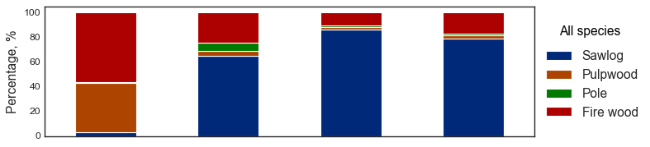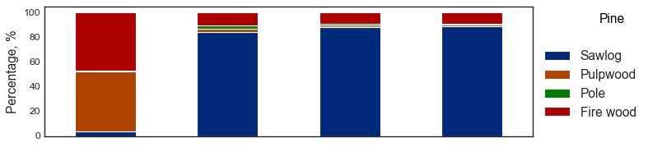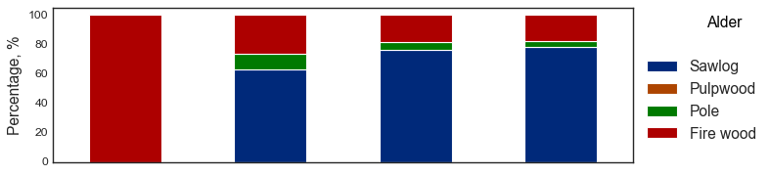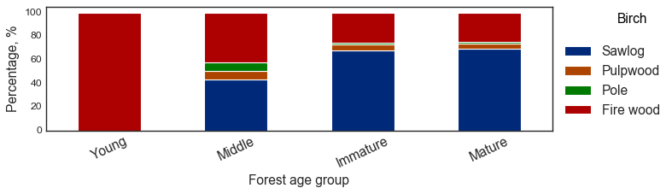
Fig. A1 Distribution of the market value of wood annual increment by type of production.

Appendix B Supplementary results data

Table B1 The economic value of current timber increment of forest stand, USD·ha⁻¹·year⁻¹
Species | Unstocked |  | Young stands |  | Middle-aged stands |  | Immature |  | Mature and overmatured stands
Species | 2010 | 2020 | 2010 | 2020 | 2010 | 2020 | 2010 | 2020 | 2010 | 2020
Black alder | 1.7 | 0.01 | 5.9 | 7.5 | 57.3 | 80.1 | 40.2 | 40.5 | 34.4 | 30.4
Silver birch | 3.9 |  | 3.6 | 6.2 | 72.4 | 41.4 | 50.1 | 73.8 | 35.1 | 41.3
Scots pine | 6.2 | 3.7 | 11.2 | 59.1 | 156.6 | 182.7 | 129.0 | 136.4 | 100.2 | 101.0
Common aspen | 0.0 |  |  | 18.6 | 97.1 |  | 95.9 | 84.4 | 44.1 | 52.5
Common oak |  |  |  |  | 119.1 | 88.9 | 152.6 | 112.4
Other | 2.0 |  | 2.9 | 3.9 | 61.1 | 48.1 |  | 60.3 | 114.9 | 90.1
Average | 4.0 | 3.6 | 6.6 | 38.6 | 113.6 | 71.8 | 96.9 | 117.8 | 55.7 | 67.7

Table B2 The average economic value of CO₂ sequestration in forest stands, USD·ha⁻¹·year⁻¹
Species | Unstocked |  | Young stands |  | Middle-aged stands |  | Immature |  | Mature and overmatured stands
Species | 2010 | 2020 | 2010 | 2020 | 2010 | 2020 | 2010 | 2020 | 2010 | 2020
Black alder | 29.2 | 0.0 | 20.6 | 24.1 | 9.4 | 11.4 | 4.6 | 4.8 | 3.0 | 3.0
Silver birch | 22.5 |  | 12.0 | 23.1 | 15.6 | 21.7 | 7.3 | 10.5 | 6.1 | 6.6
Scots pine | 11.5 | 21.8 | 22.6 | 23.1 | 14.1 | 15.4 | 9.0 | 9.6 | 13.8 | 5.8
Common aspen | 0.0 |  |  | 63.1 | 31.6 |  | 26.8 | 27.1 | 14.1 | 17.0
Common oak |  |  |  |  | 14.5 | 11.1 | 14.6 | 5.9
Other | 10.7 |  | 48.7 | 39.0 | 17.3 | 31.7 |  | 9.3 | 15.0 | 10.7
Average | 17.9 | 20.9 | 16.7 | 23.2 | 13.2 | 17.7 | 8.1 | 9.2 | 8.8 | 6.0

Table B3 Annual revenue provided by the NWFP harvesting
HWFP species | Current average harvest, kg·ha⁻¹·year⁻¹ |  | Economic value,  USD·ha⁻¹·year⁻¹
HWFP species | 2010 | 2020 | 2010 | 2020
Slippery Jack | 10.9 | 14.7 | 5.5 | 7.4
Penny bun | 4.6 | 4.3 | 14.6 | 13.7
Girolle | 12.1 | 11.0 | 30.3 | 27.6
Average mushrooms | 27.6 | 30.1 | 50.4 | 48.7
Raspberry | 9.8 | 10.4 | 14.7 | 15.6
Wild strawberry | 0.3 | 0.4 | 0.7 | 0.8
Average berries | 10.2 | 10.8 | 15.4 | 16.4
Average NWFP | 37.8 | 40.9 | 65.8 | 65.1

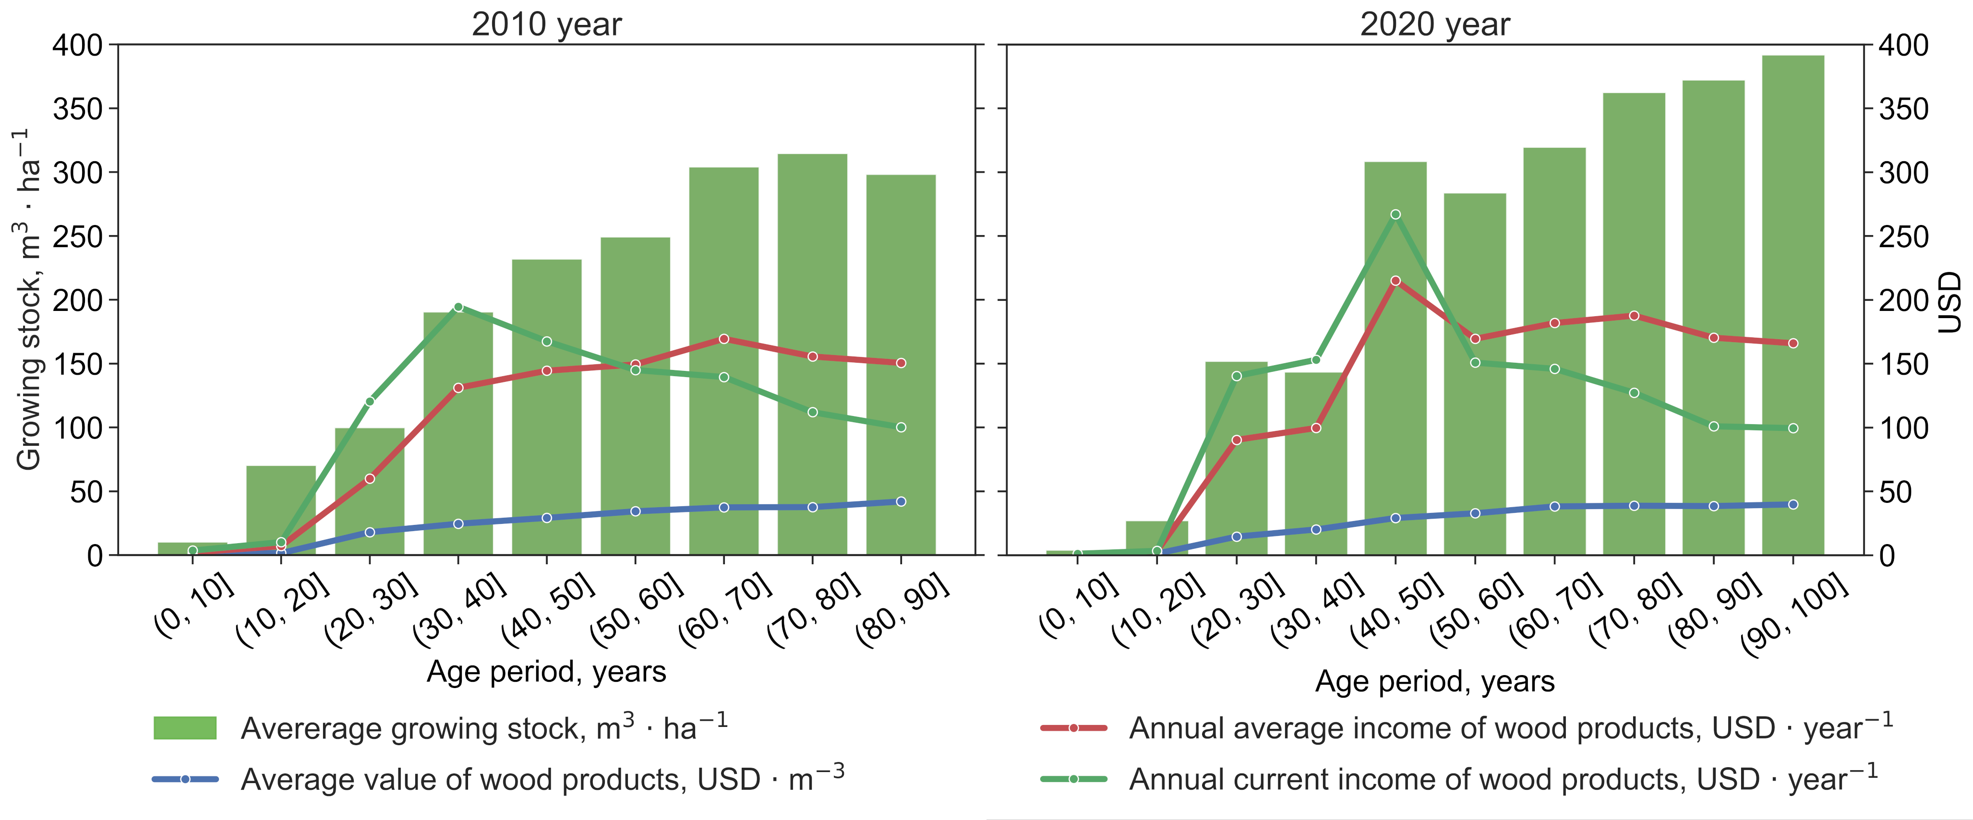
Fig. B1 Estimated temporal dynamics of the distribution of growing stock and revenue from wood products provided by pine forest stands.
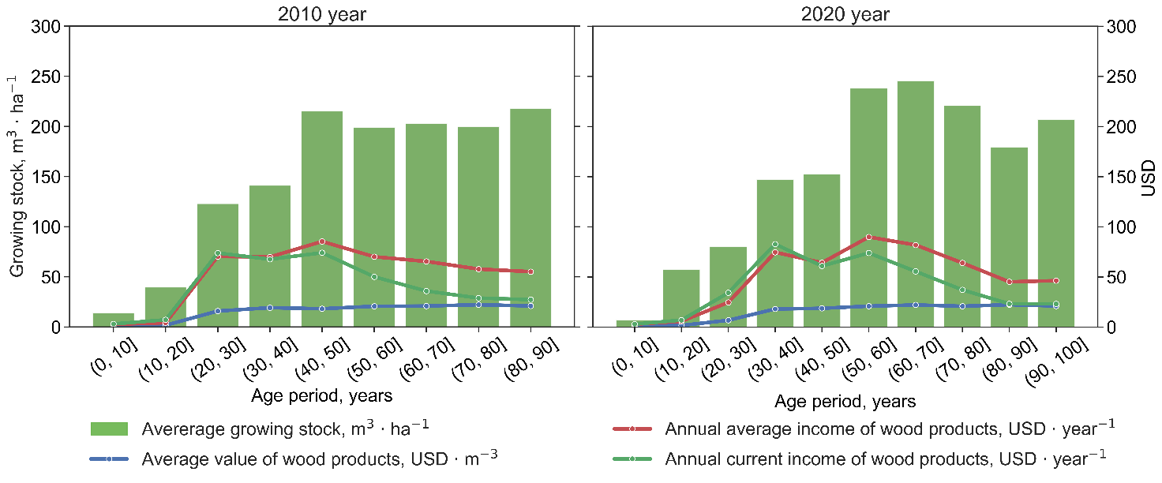Fig. B2 Estimated temporal dynamics of the distribution of growing stock and revenue from wood products provided by birch forest stands.

