Decoupling of larch growth from temperature in the Central Eastern Alps is modulated by stand density

Viktoria Frank^{1,2,3}, Erich Tasser⁴, Nikolaus Obojes⁴, Walter Oberhuber⁵*

¹Department of Ecology, University of Innsbruck, 6020 Innsbruck, Austria
²WSL Institute for Snow and Avalanche Research SLF, Davos 7260, Davos Dorf, Switzerland
³Climate Change, Extremes and Natural Hazards in Alpine Regions Research Centre CERC, 7260, Davos Dorf, Switzerland
⁴Institute for Alpine Environment, Eurac Research, 39100 Bolzano, Italy
⁵Department of Botany, University of Innsbruck, 6020 Innsbruck, Austria

*Correspondence
Walter Oberhuber: walter.oberhuber@uibk.ac.at; Orcid iD: 0000-0002-5197-7044
phone: +43 512 507-51048

Supplementary Figures S1–S3 and Tables S1–S4

Fig. S1 Changes in stand density at the N1 sites between 1970/74 and 2023. In 2023, the managed stand (left) shows sparse canopy cover (20%), whereas the abandoned stand (right) has a nearly closed canopy (65%). In each stand, 10 larches were cored, and stand basal area was calculated within a selected 400 m² plot (boldly highlighted). Data source: Land Tirol - data.tirol.gv.at.

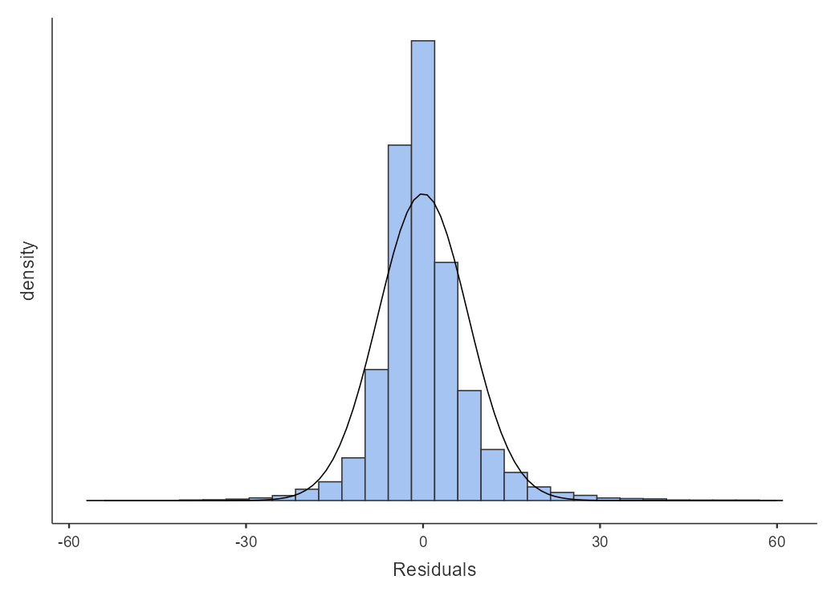
Fig. S2 Histogram of model residuals used to assess the normality assumption of the final generalized linear mixed model (GLMM).

Fig. S3 Time series of basal area increments (BAI) in open (blue) and closed (green) stands from 2000 to 2022, excluding the MA stands. Symbols indicate years in which BAI differed significantly between open and closed stands: orange asterisks for α = 0.05 and black dots for α = 0.1. Shaded areas represent the standard deviation.

Table S1 Historical and current land use of open (O) and closed (C) stands. Site codes: M1, M2 = Mieders; MA = Matsch/Mazia; N1, N2 = Neustift; NA = Navis; OB = Obernberg (Brenner).
Site | Land use
M1O | - Mowing and thinning (ongoing)
M1C | - Abandoned (since 1950)
M2O | - Mowing and thinning (until 1999)  - Abandoned (2000–2017)  - Grazing and thinning (since 2018)
M2C | - Abandoned (since 1950)
MAO | - Grazing and thinning (ongoing)
MAC | - Abandoned and afforested with spruces (1980)
N1O | - Mowing and thinning (ongoing)
N1C | - Abandoned and afforested for avalanche protection with larches and spruces (1980)
N2O | - Mowing (until 2017)  - Abandoned (since 2018)
N2C | - Abandoned (since 1980)
NAO | - Mowing and thinning (ongoing)
NAC | - Abandoned (since 1970)
OBO | - Mowing and thinning (ongoing)
OBC | - Abandoned (since 1980)

Table S2 Results of the Durbin-Watson test for autocorrelation.
Autocorrelation | DW-statistic | p
-0.0752 | 2.15 | <.001

Table S3 Collinearity diagnostics for predictor variables based on variance inflation factors (VIF) and tolerance values.

 | VIF | Tolerance
Elevation | 1.79 | 0.557
Slope | 1.33 | 0.751
Southerness | 1.37 | 0.728
Stand basal area | 2.07 | 0.484
Summer temperature (curr) | 1.31 | 0.763
October temperature (prev) | 1.09 | 0.914
March precipitation (curr) | 1.05 | 0.948
July precipitation (curr) | 1.1 | 0.909
Time lag | 1.21 | 0.828
Mowing/grazing | 2.04 | 0.489
Larch budmoth | 1.02 | 0.98
Afforestation | 1.44 | 0.696

Table S4 Summary statistics of Cook’s distance for identifying influential observations.
 |  |  | Value range
Mean | Median | SD | Min | Max
1.05e⁻⁴ | 1.28e⁻⁵ | 4.70e⁻⁴ | 8.64e⁻¹³ | 0.0116

